Situation Analysis

| Project Sponsor | Donon Y. |
| --- | --- |
| Project Manager | Rodin I. |
| Author | Rodin I. |
| Classification | CLASSIFIED |
| Status | Pending |
|  |  |

List of Changes

| Date | Version | Changes | Author |
| --- | --- | --- | --- |
| 4.4.2019 | 1.1. | Init | Rodin I. |
|  |  |  |  |
|  |  |  |  |

List of Contents

1 Description of Current System 2

1.1 Documentation 2

1.2 System Description 2

1.2.1 Description of System Landscape and System Architecture 2

1.2.2 System: S01 *System Name* 2

1.3 Description of Organizational Structure 3

2 Analysis of Strengths and Weaknesses 3

# Description of Current System

Currently system has three modules: parser, linker and drawer.

Linker is an entry point of program, here all the params are specified, camera position, light angle, source file and so one. Linker calls parser to read all the required information and to give it back in specific format. This information later is given to drawer module, which make all the needed calculation to draw the final result.

## Documentation

| Document Title | Description |
| --- | --- |
|  |  |
|  |  |

**Requirements**

| Document Title | Description |
| --- | --- |
| *Common codestyle* | *Common codestyle is required because of diiff feature in VCS* |
|  |  |

## System Description

### Description of System Landscape and System Architecture

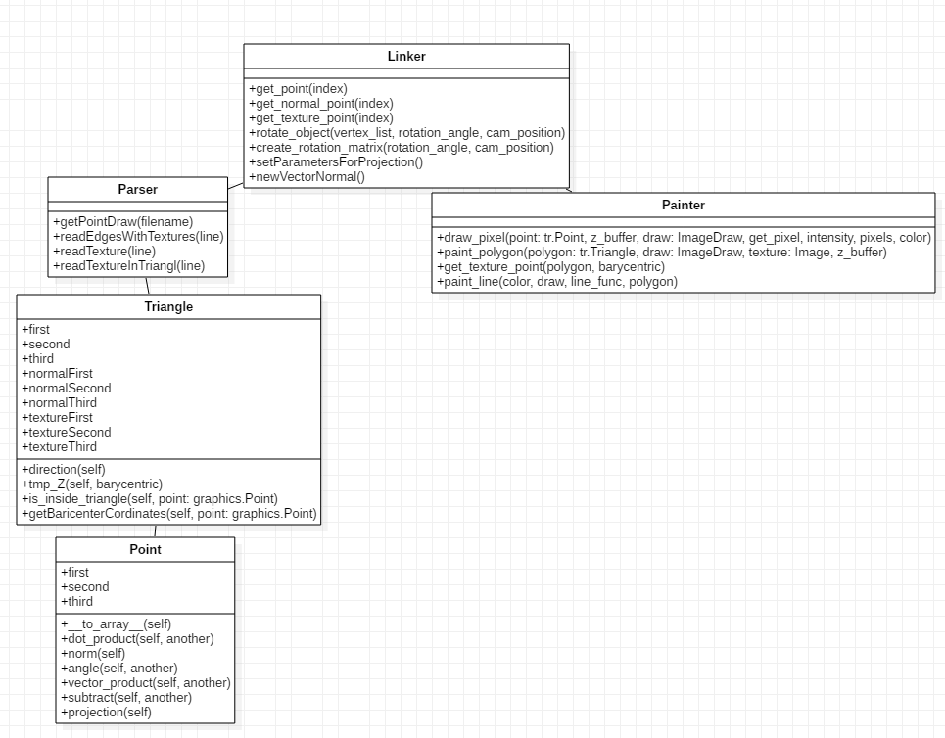

### System: S01 *System Name*

## Description of Organizational Structure

# Analysis of Strengths and Weaknesses

**Strengths**

**Weaknesses**

| No. | Description | Evaluation | Cause |
| --- | --- | --- | --- |
|  |  |  |  |
|  |  |  |  |