Using: Good Town Demo dataset no deadheads.xlsx

1. Start point

KPIs

|  |  |  |  |  |
| --- | --- | --- | --- | --- |
| Duties | Vehicles | Veh Efficiency (%) | Crew Efficiency (%) | Total Cost |
| 0 | 0 | 0 | 0 | 0 |

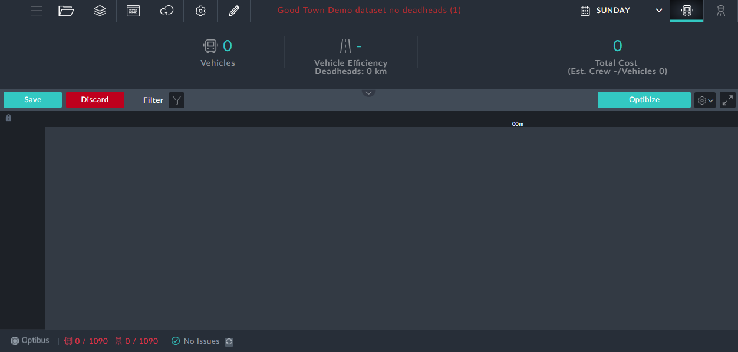

1. Vehs only

KPIs

|  |  |  |  |  |
| --- | --- | --- | --- | --- |
| Duties | Vehicles | Veh Efficiency (%) | Crew Efficiency (%) | Total Cost |
| 0 | 88 | 90 | 0 | 238304 |

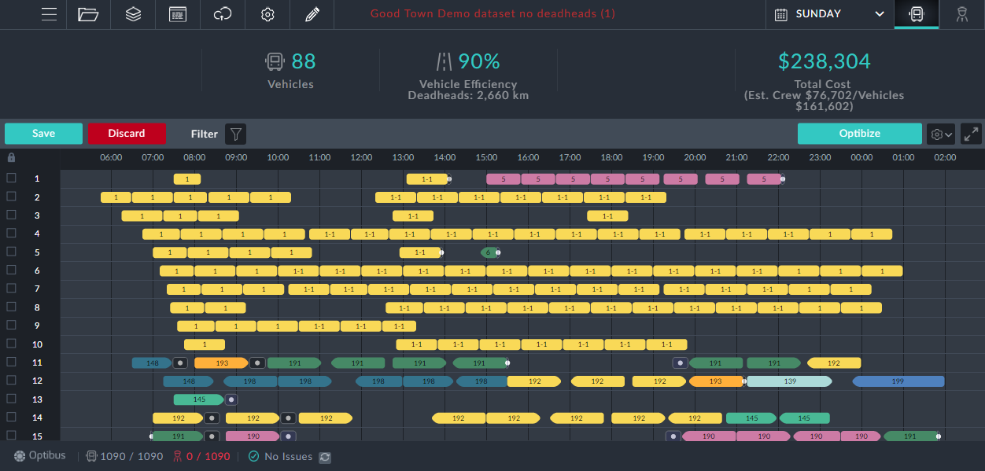

1. Item 2 + Duties – No veh.mod

KPIs

|  |  |  |  |  |
| --- | --- | --- | --- | --- |
| Duties | Vehicles | Veh Efficiency (%) | Crew Efficiency (%) | Total Cost |
| 186 | 88 | 90 | 79 | 254922 |

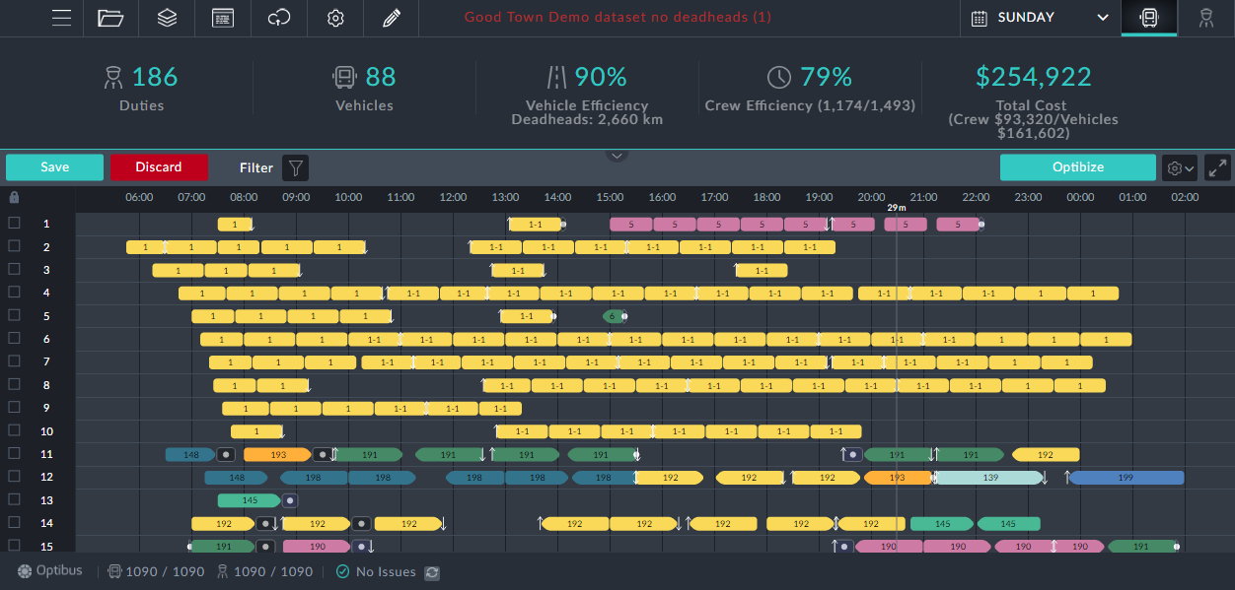

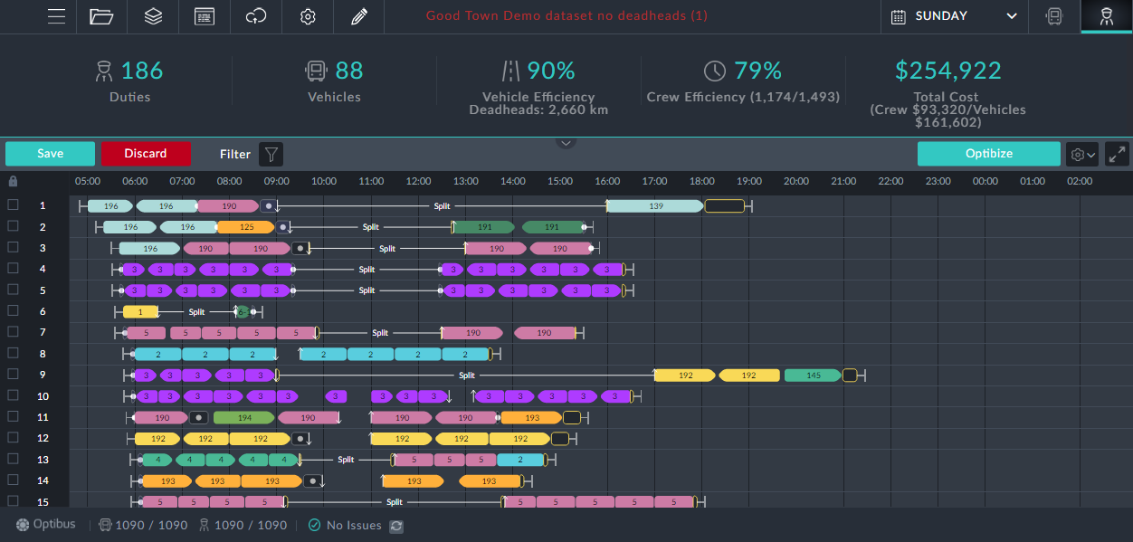

1. Item 2 + Duties With veh mod

KPIs

|  |  |  |  |  |
| --- | --- | --- | --- | --- |
| Duties | Vehicles | Veh Efficiency (%) | Crew Efficiency (%) | Total Cost |
| 159 | 88 | 89 | 81 | 254240 |

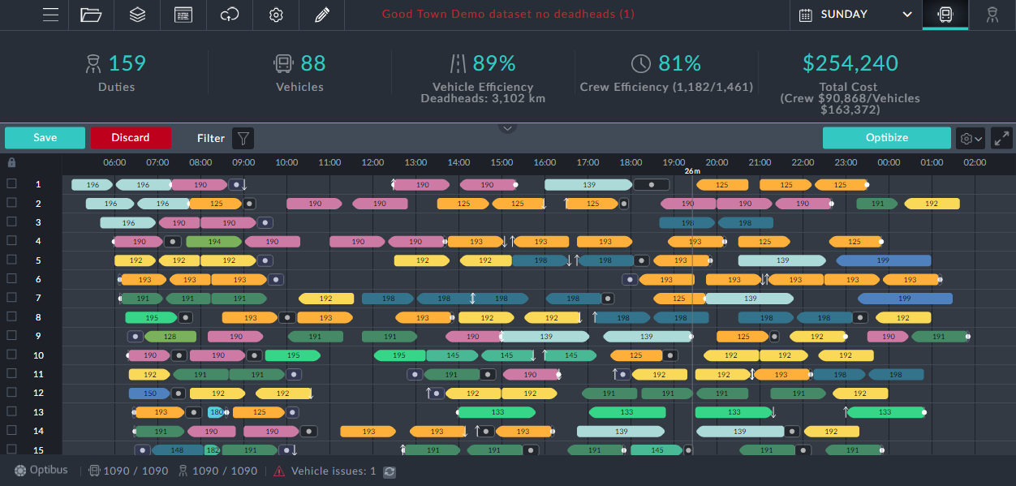

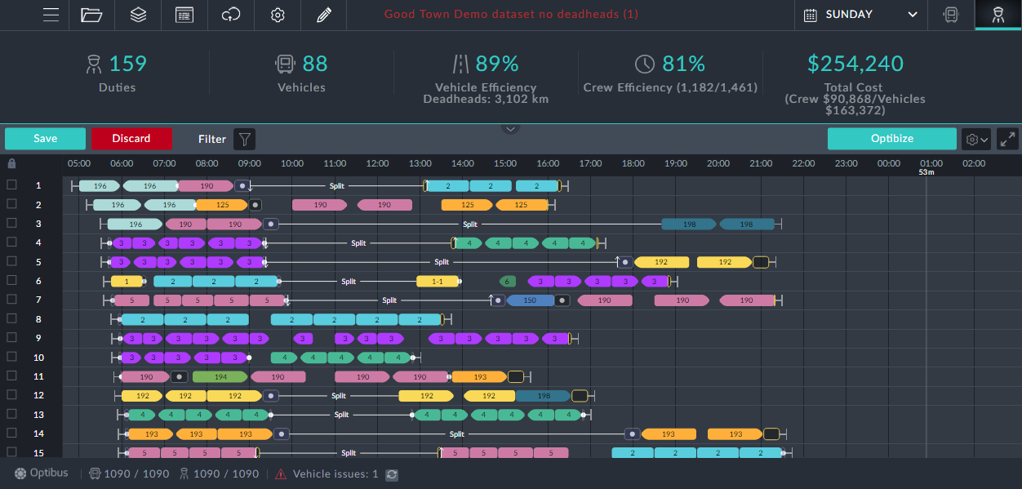

1. Veh + Duties together

KPIs

|  |  |  |  |  |
| --- | --- | --- | --- | --- |
| Duties | Vehicles | Veh Efficiency (%) | Crew Efficiency (%) | Total Cost |
| 159 | 88 | 89 | 81 | 254240 |

Pictures as fore Case 4.

1. Importing a schedule

KPIs – pre optimization

|  |  |  |  |  |
| --- | --- | --- | --- | --- |
| Duties | Vehicles | Veh Efficiency (%) | Crew Efficiency (%) | Total Cost |
| 173 | 95 | 86 | 77 | 268959 |

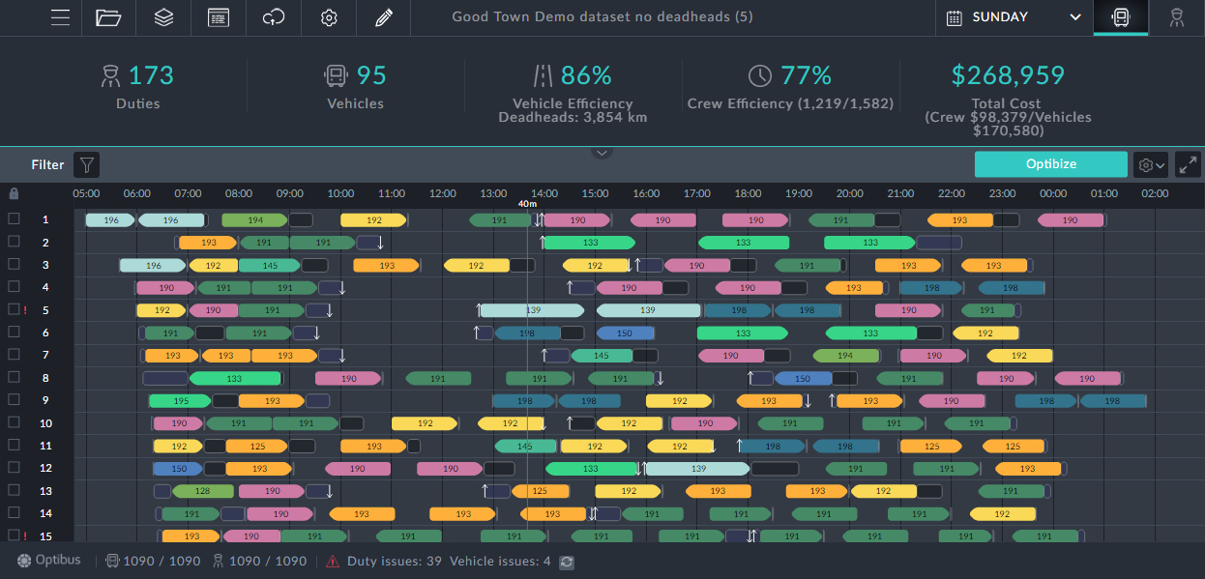



* 1. Optimize without veh modification

KPIs

|  |  |  |  |  |
| --- | --- | --- | --- | --- |
| Duties | Vehicles | Veh Efficiency (%) | Crew Efficiency (%) | Total Cost |
| 173 | 95 | 86 | 77 | 268933 |

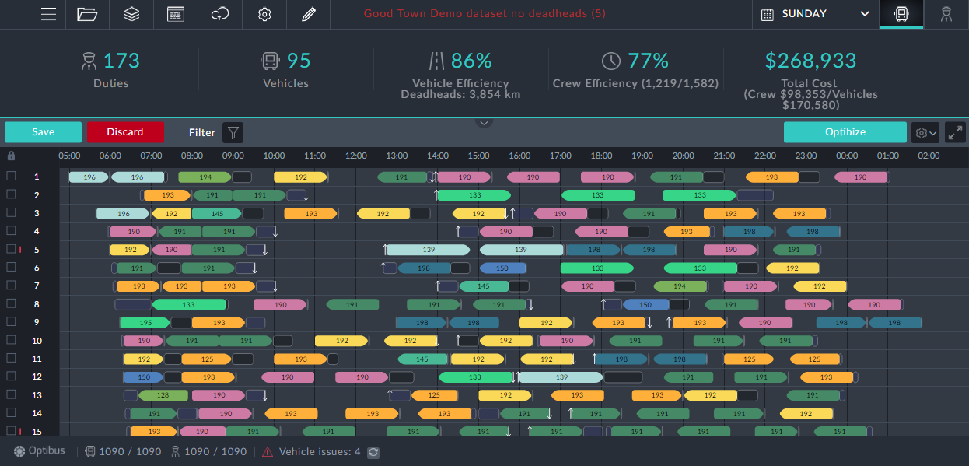

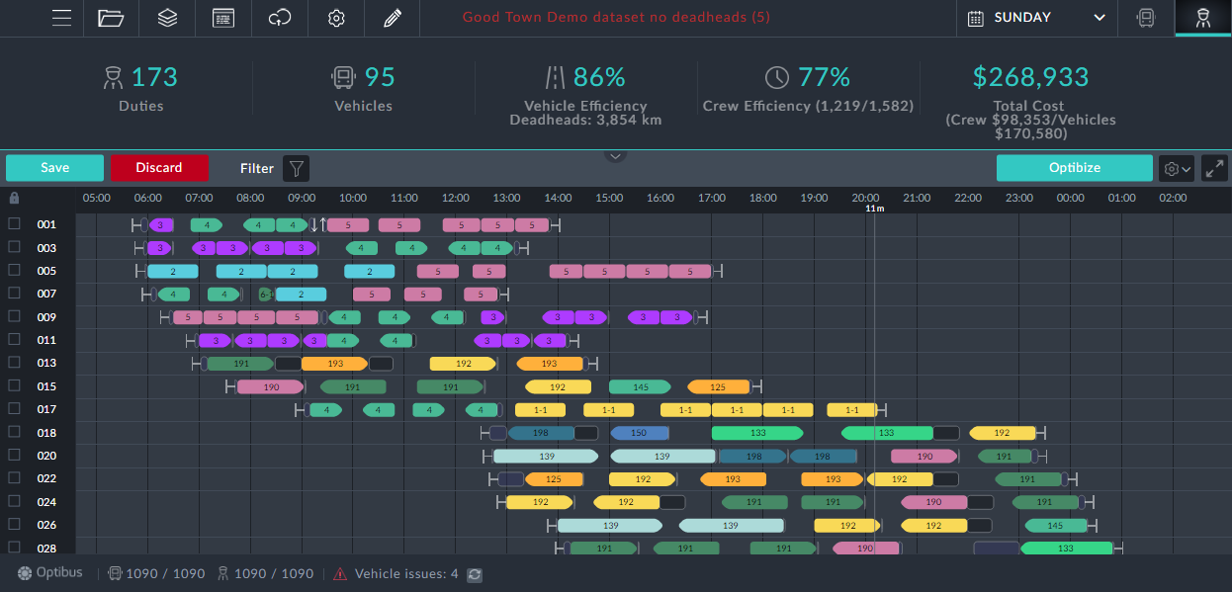

* 1. Optimize with veh modification

KPIs

|  |  |  |  |  |
| --- | --- | --- | --- | --- |
| Duties | Vehicles | Veh Efficiency (%) | Crew Efficiency (%) | Total Cost |
| 173 | 95 | 87 | 77 | 266037 |

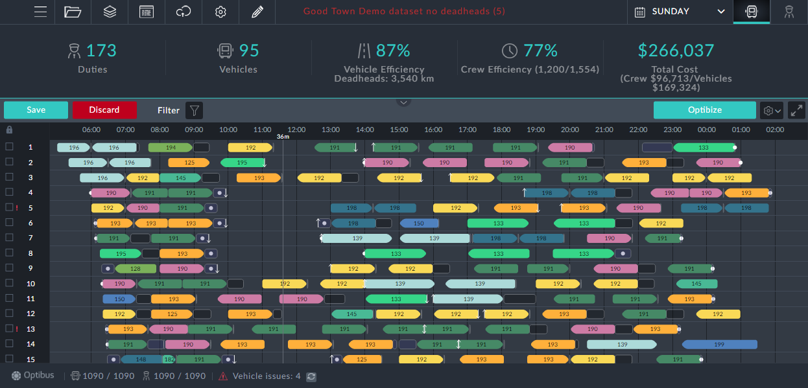

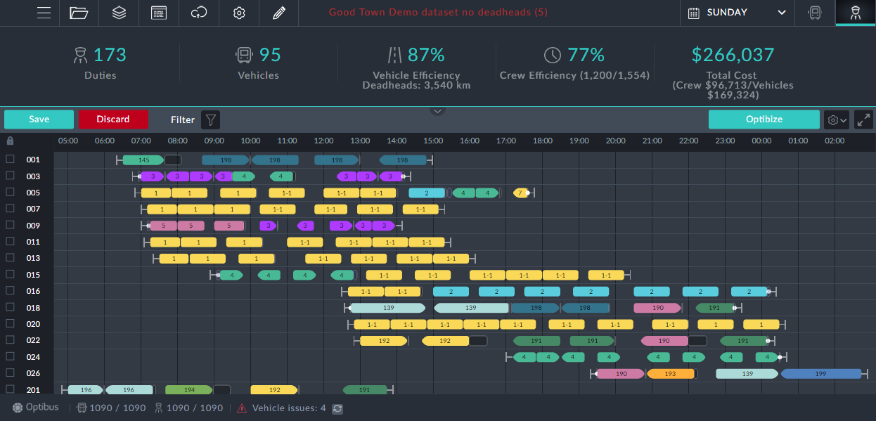

* 1. Full optimize

KPIs

|  |  |  |  |  |
| --- | --- | --- | --- | --- |
| Duties | Vehicles | Veh Efficiency (%) | Crew Efficiency (%) | Total Cost |
| 151 | 88 | 90 | 88 | 244501 |

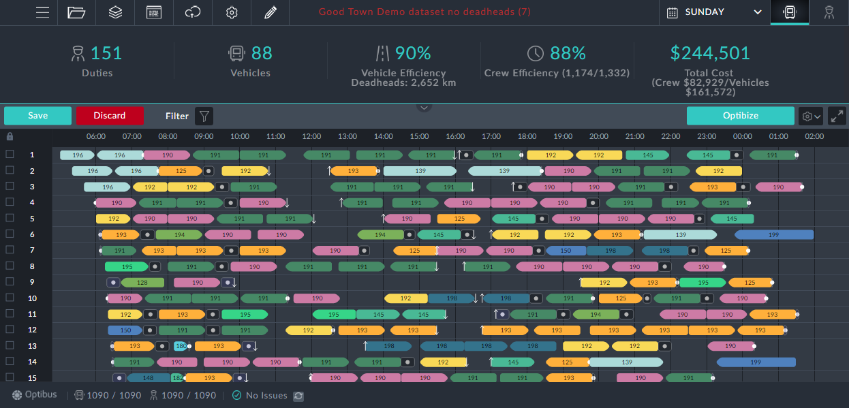

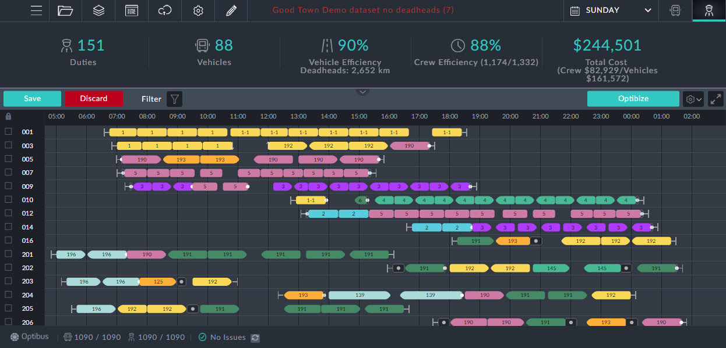

1. Use Case KPIs Summary

|  |  |  |  |  |  |  |
| --- | --- | --- | --- | --- | --- | --- |
| Case | Description: Optimization type | Duties | Vehicles | Veh Eff. (%) | Crew Eff.(%) | Total Cost |
| 1 | Start point | 0 | 0 | 0 | 0 | 0 |
| 2 | Vehs only | 0 | 88 | 90 | 0 | 238304 |
| 3 | Item 2 + Duties – No veh.mod | 186 | 88 | 90 | 79 | 254922 |
| 4 | Item 2 + Duties With veh mod | 159 | 88 | 89 | 81 | 254240 |
| 5 | Veh + Duties together | 159 | 88 | 89 | 81 | 254240 |
| 6 | Import a schedule – start point | 173 | 95 | 86 | 77 | 268959 |
| 6a | Optimize without veh mod | 151 | 88 | 90 | 88 | 244647 |
| 6b | Optimize with veh mod | 151 | 88 | 90 | 88 | 244501 |
| 6c | Veh + Duties togeteher | 151 | 88 | 90 | 88 | 244501 |