**Filtering the Drivers Gantt**

We will use the following Vehicles Gantt to illustrate the filters:

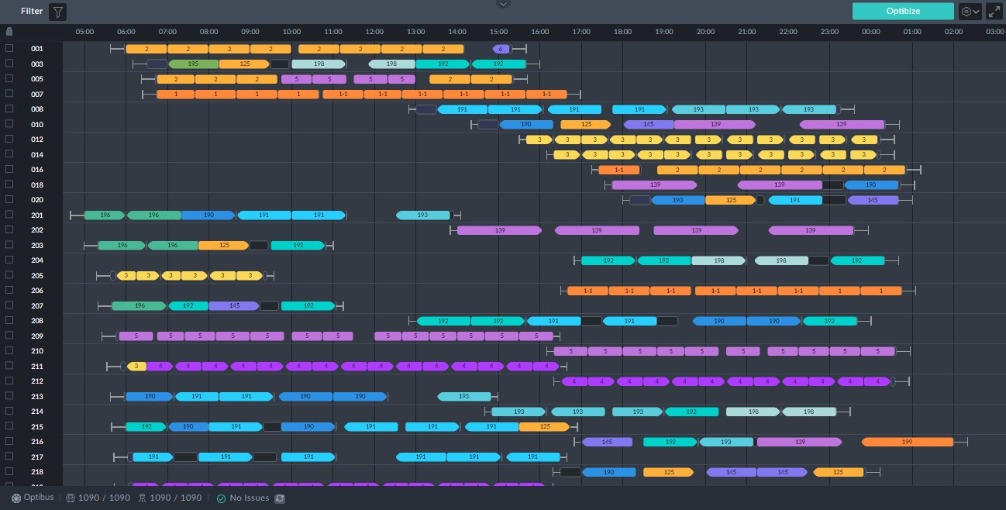

*Figure 1-8: Drivers Gantt to illustrate filters*

Clicking the filter button opens the filter selection window:

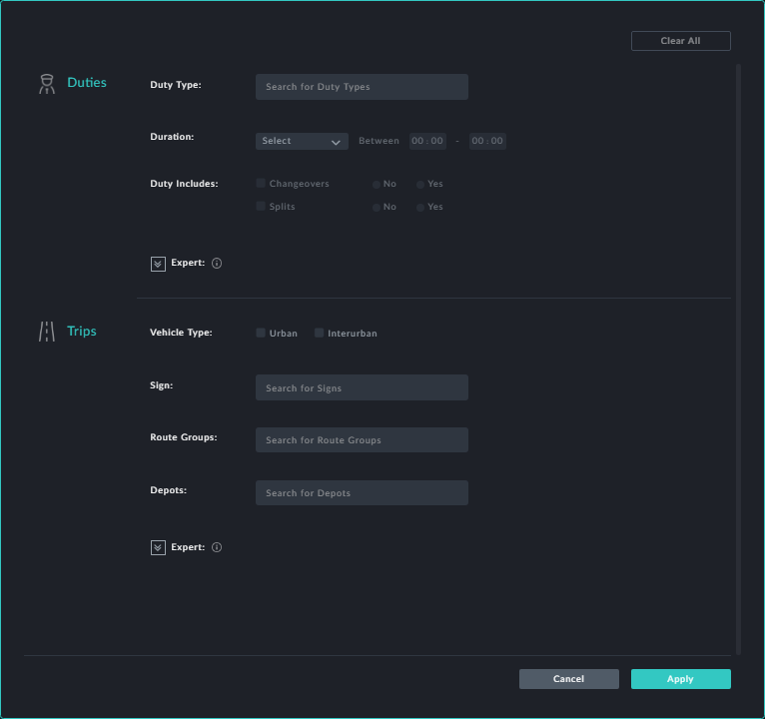

Whenever you choose a filter click **Apply** to put it into effect.

**Filter by Duties Characteristics**



***Duty Type***

Clicking the **Duty Type** field opens a drop list of available duty types. (Duty types are- defined using the **Duty Types** preference). You may choose one or more from the list:

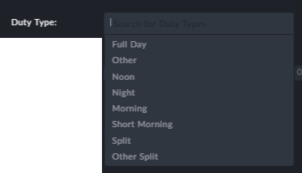

For our example we will choose Morning and Short Morning.

***Duration***

Clicking the **Duration** field opens a drop list of duration types. Choose the desired type and enter a duration

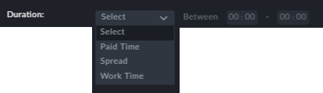

For our example we will choose Work Time between 4 to 10 hours.

***Duty Includes***

Here you can specify whether changeovers and split duties are allowed. We will set

**Changeovers** to Yes and **Splits** to No.

**Filter by Trip Attributes**

The trip attributes (Vehicle Type, Sign, Route Groups and Depots) work the same way here as they do for the Vehicles Gantt. See **Filtering the Vehicles Gantt**. For the pur- poses of our example, we will leave these items "as is".

Here is the result of our filter:

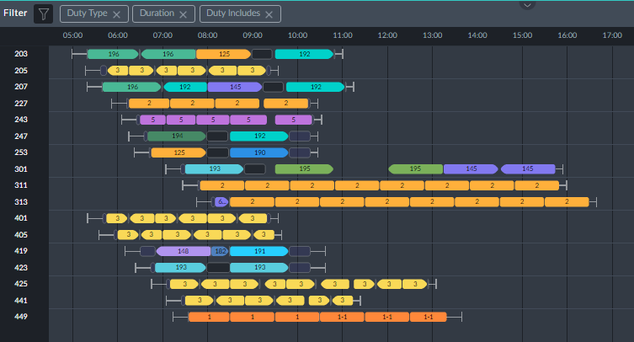

**Points to note:**

At the top left corner of the window there is a filter indicator (in the red rectangle):

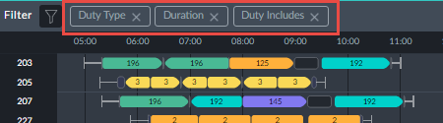

Apart from telling you what filters are in use, you can click them to selectively cancel them

Filters are cumulative: In the example, each of the filters shown add additional restric- tions

**Sorting the Drivers Gantt**

Recall the service trip information box:

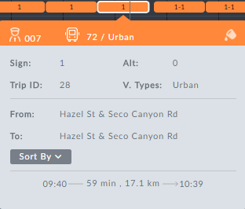

Clicking the **Sorted By** button opens the following pick list:

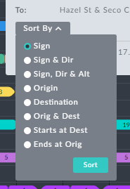

*Figure 1-9: Display sort options*

The usage is the same as that for **Sorting the Vehicles Gantt**.