**Drivers Gantt**

**Drivers Gantt Overview**

Like the Vehicles Gantt, the Drivers Gantt also contains a vast amount of information. We start with an example:

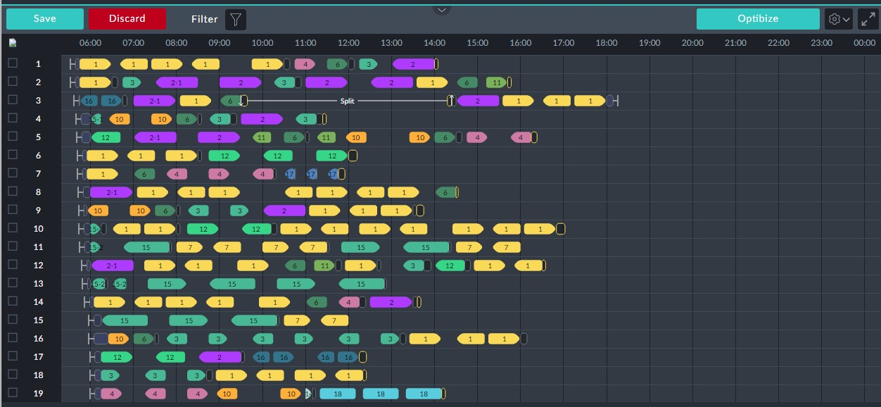

*Figure 1-1: A typical Drivers Gantt*

For the Drivers Gantt, the left hand numbering is for drivers. Thus, each numbered row on the Gantt shows the work day for one driver. otherwise the graphic elements are very similar to those used in the Vehicles Gantt. The emphasis in this section will be on the element specific to the Drivers Gantt or elements having a different meaning.

The following graphic elements are the same as those for the Vehicles Gantt: Service trip



Pre-trip and Post-trip



Pull out and Pull in



Deadhead



Up and down arrows have a different meaning in the Drivers Gantt: Here they indicate a **vehicle changeover** for the same driver. The changeover may be separated by other events, as we will see below.

There are two additional elements:

When a driver completes a service trip, he may be required to leave his vehicle and then go to a different location for his next trip or even to take a break. To get there, he may require transport such as a taxi or a shuttle.

The **Taxi** icon denotes the driver movement. It looks similar to a Deadhead icon but



it has a thin yellow frame. Left clicking it opens its information box:

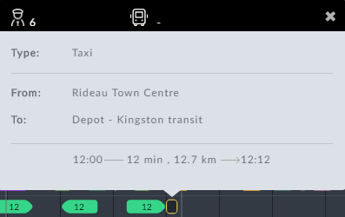

The box indicates that a taxi or a shuttle is required.



The use or otherwise, of Taxi icons is determined in the Preferences. See

TBD.

The second additional graphic describes a **Split**:



*Figure 1-2: Split example*



The part of the driver's duty before a split is called his **first stretch** and the

duty following the split, his **second stretch**.

To follow the narrative of **Figure 1-2**, we need to open the information box of each con-

stituent element in order from left to right:

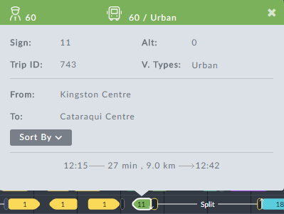

*Figure 1-3: Last service trip of first stretch completed prior to split*

The driver with ID as shown, has completed the service trip of **Figure 1-3**. In **Figure 1-2**, following the service trip element there is a down arrow. The driver has left the vehicle as first part of a changeover. The next element is a Taxi icon showing that the driver requires transport as shown in **Figure 1-3**:

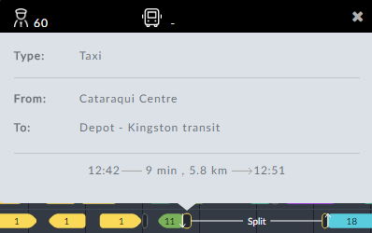

*Figure 1-4: Taxi taken before split*

Having arrived at the **To:** location, the driver goes off duty as shown in the split break. The driver's split break details are shown in the split break information box:

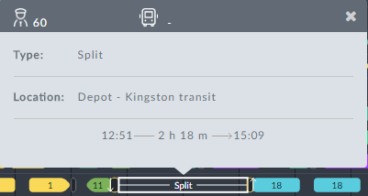

*Figure 1-5: Split break information box*

At the end of the break shown at the bottom of **Figure 1-5**, another Taxi icon is dis- played indicating a requirement for transport to take the driver to his next duty trip. An up arrow shows the driver taking over the vehicle for the next service trip, the second part of his changeover. At this point, the procedure flow should be evident and we will not show all of the information boxes.

As for the Vehicles Gantt, each row number in the Drivers Gantt has an information box. For drivers there is a difference. Left-clicking row 1 shows the following information box:

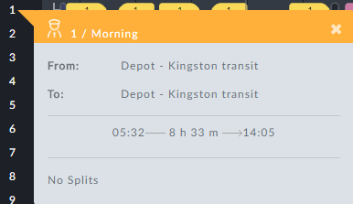

The only new item is the No Splits indicator, showing that the duty in the line above is continuous.



The **Duty Type** shown is Operator defined.

If we left-click row 3, which has a split, the information box is different:

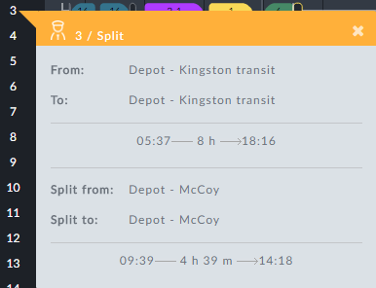

We have already encountered the contents of this box in the split narrative above: The

driver comes on duty at the **From:** location and finishes his day at the **To:** location (often the same), starting and finishing as shown:



The worked hours shown in the middle are total worked hours less the split hours. The lower **Split from: / Split to:** section shows the split break period only:



At this point, it is quite straight forward to follow the work day on the Drivers Gantt for any driver.

**The Drivers Gantt in Detail**

In this section we look at the driver specific information boxes in detail.

**Workday Overview for a Driver**

Left-clicking a row number pops up a work day overview for the driver:

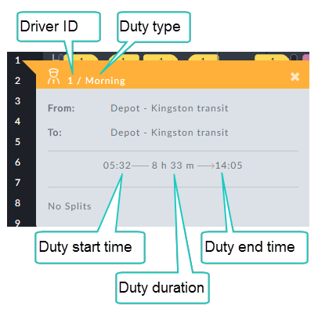

*Figure 1-6: Workday Overview - no splits*

The **Duty Type** is Operator defined.

If the day's work is split by a rest period, the information box has extra details:

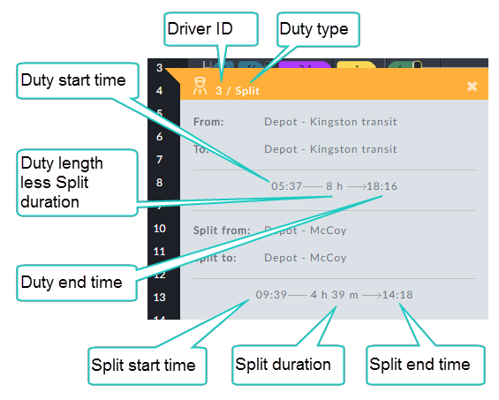

*Figure 1-7: Split workday Overview*

*Table 1-1: Row overview information box*

|  |  |
| --- | --- |
| **Information Box Item** | **Description** |
| From: | Start location of the driver at the beginning of the work day |
| To: | The final location of the driver at the end of the work day |
| Split from: | Split start location |
| Split to: | Split end location |

**Split Information Box**

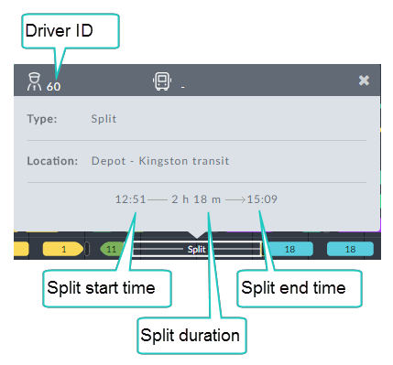

*Table 1-2: Split information box*

|  |  |
| --- | --- |
| **Information Box Item** | **Description** |
| Type | Information box type |
| Location: | Split location - typically break location |

**Taxi**

Recall that, when a driver completes a service trip, he may be required to leave his

vehicle and then go to a different location for his next trip or even to take a break. To get there, he may require transport such as a taxi or a shuttle.

The taxi icon is used to represent this driver movement.

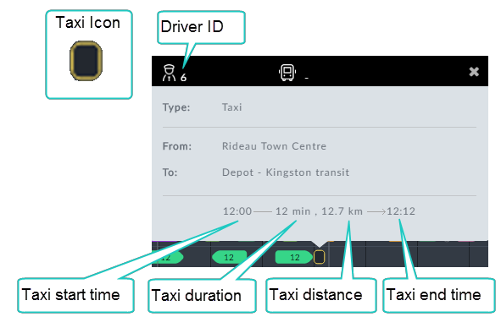

*Table 1-3: Taxi information box*

|  |  |
| --- | --- |
| **Information Box Item** | **Description** |
| Type | Information box type -Taxi |
| From: | Taxi start location |
| To: | Taxi end location |

**Filtering the Drivers Gantt**

We will use the following Vehicles Gantt to illustrate the filters:

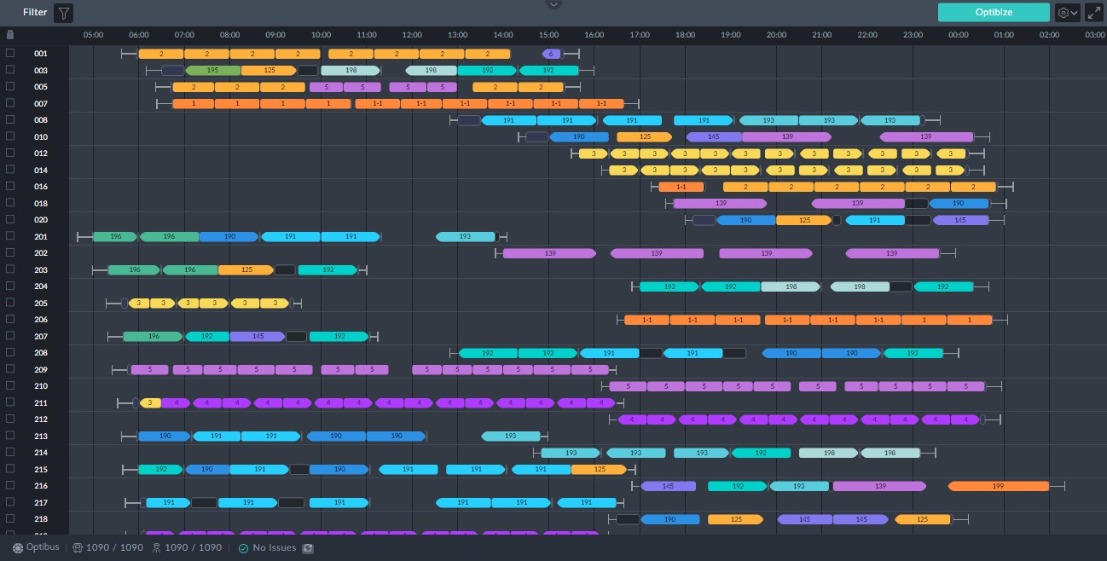

*Figure 1-8: Drivers Gantt to illustrate filters*

Clicking the filter button opens the filter selection window:

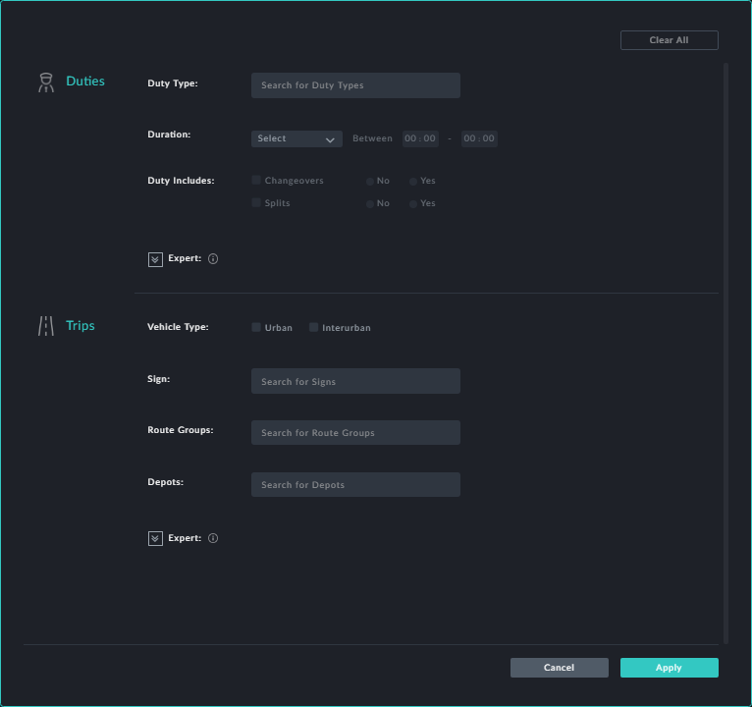

Whenever you choose a filter click **Apply** to put it into effect.

**Filter by Duties Characteristics**



***Duty Type***

Clicking the **Duty Type** field opens a drop list of available duty types. (Duty types are- defined using the **Duty Types** preference). You may choose one or more from the list:

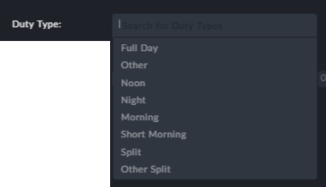

For our example we will choose Morning and Short Morning.

***Duration***

Clicking the **Duration** field opens a drop list of work types. You may choose one or more from the lis. In addition you may set a shift duration range.

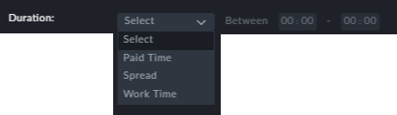

For our example we will choose Work Time between 4 to 10 hours.

***Duty Includes***

Here you can specify whether chageovers and split duties are allowed. We will set

**Changeovers** to Yes and **Splits** to No.

**Filter by Trip Attributes**

The trip attributes (Vehicle Type, Sign, Route Groups and Depots) work the same way here as they do for the Vehicles Gantt. See **Filtering the Vehicles Gantt**. For the pur- poses of our example, we will leave these items "as is".

Here is the result of our filter:

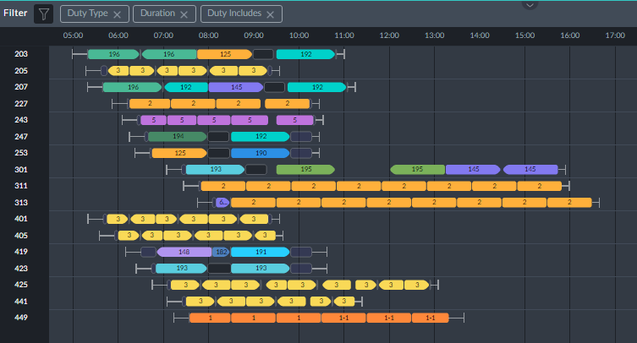

**Points to note:**

At the top left corner of the window there is a filter indicator (in the red rectangle):

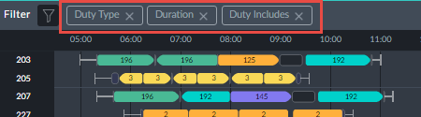

Apart from telling you what filters are in use, you can click them to selectively cancel them



Filters are cumulative: In the example, each of the filters shown add additional restric- tions



**Sorting the Drivers Gantt**

Recall the service trip information box:

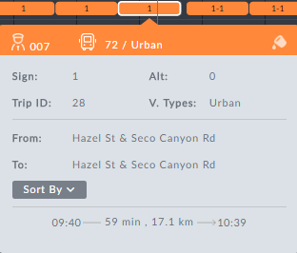

Clicking the **Sorted By** button opens the following pick list:

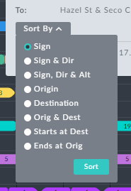

*Figure 1-9: Display sort options*

The usage is the same as that for **Sorting the Vehicles Gantt**.