**Vehicles Gantt**

**Vehicles Gantt Overview**

The Vehicles Gantt is opened by default. You can always return to it from the Drivers

Gantt by clicking the vehicle icon in the Options tool bar.



If you need more space on your screen, you can hide the KPI by clicking the

button. To restore the KPI, just click it again.

The window contains a vast amount of detail, but nevertheless, it is very easy to follow.

For example:

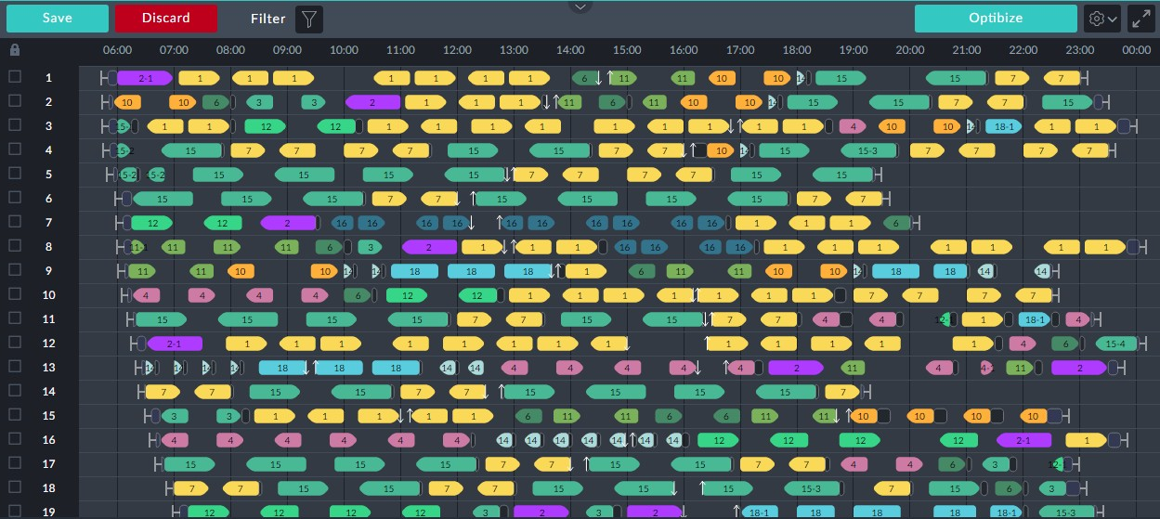

*Figure 1-1: A typical Vehicles Gantt*

Each numbered row on the Gantt shows the day's itinerary of one vehicle. Take for example, row 1:



First, you can see a quick row overview by left-clicking the row number:

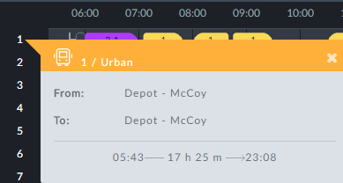

The start and end times relate to the day's work for the vehicle. The duration is also dis-

played.

Let us return to the Gantt itself:

The graphic shapes are called **elements**.

Each colored bullet shaped element represents a **service trip**.



*Figure 1-2: Service trip element*



A service trip is a revenue-earning vehicle journey.

The number is the route **sign**. In the left hand example , the

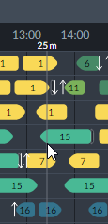

route as seen by a passenger, is 2-1. The difference between a simple number and a hyphenated number such as 2-1 will be explained shortly. Looking at the Gantt, It's **row number** is the **vehicle ID**. The position of the left end of the element is the time of the beginning of the trip and the position of right end is the time of completion. You can see the times precisely by mov- ing the mouse horizontally along the row. A vertical cursor line indicates the time. Observe the vertical cursor line at 13:25 at

the mouse position.



The service trip coloring is determined by the system to make the display

easy to understand. **Each sign has its own color.**

From the transport operator's perspective, a route has three parameters. Referring to

**Figure 1-2** above, they are:

A sign defining the service trip terminus points - in the example it is 2



A direction - at which terminus the trip starts and which terminus the trip finishes determines the direction on the Gantt of the bullet shape



An alternate number indicating a route variant. A route variant for example may add or skip stops in the base route. In the example it is 1 and the passenger sees 2-1 as shown.



Further information may be obtained by left-clicking an element. Let us take another example, left-clicking the third service trip element in row 1. An information box pops up:

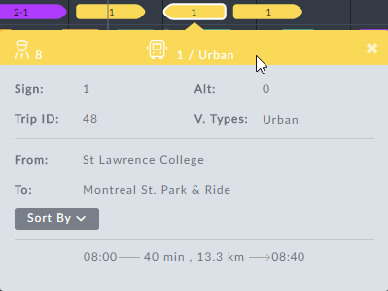

*Figure 1-3: Element information box*

Notice the **From: ... To: ...** locations. If you left click-the fourth item following, you will see that the **From: ... To: ...** locations are reversed - the vehicle is scheduled for a return trip.



Left-clicking any active element in the display will open an information box

describing it in detail. In most cases, the chosen element has a white border as seen in **Figure 1-3**.

Sometimes a trip icon may be an oblong shape instead of a bullet shape. It

indicates a round-trip that starts and finishes at the same terminus.

To complete your understanding of the example, we will look at several other elements



appearing on row 1.

The row commences with the symbol .Left clicking it opens an information box:

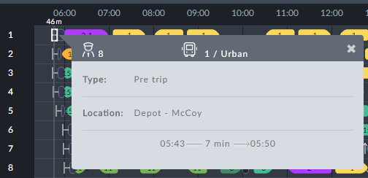

The symbol represents pre-trip activity. It may also show as **Vehicle Preparation**. This is an Operator choice.



The next graphic element looks like this: Left clicking it shows a **Pull out** information box:

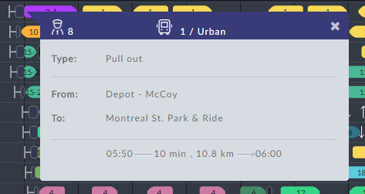

The length of the Pull out graphic reflects the time required. The same graphic at the

end of a trip or at the end of a day denotes a **Pull in**.



**Pull out** and **Pull in**: Moving a vehicle from a depot to the first stop of a ser-

vice trip is called a Pull out. What is considered to be a "Depot" here, is determined by the Operator. In the opposite direction, a Pull in is moving a vehicle from the last terminus of a service trip back to the depot.

Once again, on the top row at about 18:13, there is a similar graphic with a black back-

ground, . Left-clicking it shows **Deadhead** information:

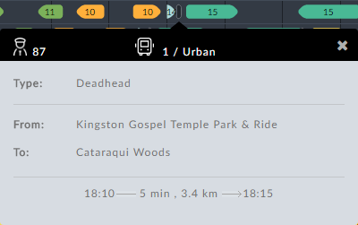

Again, the length of the graphic reflects the time required for the deadhead trip.



A deadhead is any non-revenue earning vehicle movement other than pull

out and pull in.



Deadhead, pull out or pull in icons with a white dot in the center, for

example like this, are auto-generated by the system. You can edit them in your Deadhead Catalog (see TBD).

The down arrow to the right of sign 6 indicates that the driver has

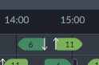

left the vehicle (for example going off-duty or taking a break). The up arrow following indicates that a **different** driver has taken the vehicle.

Finally, at the end of row 1 is a post-trip symbol, . Left clicking it, displays post-trip



activity:

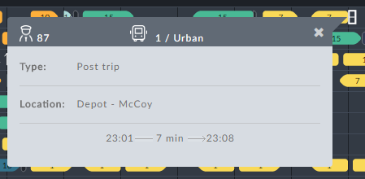

**The Vehicles Gantt in Detail**

In this section we look at the information boxes in detail.



The Vehicles Gantt information boxes become active data entry panels dur-

ing Manual Vehicle-only Scheduling. See TBD.

An open information box may be dismissed in three ways:

Clicking the x in the top right corner of the box

Opening another box

Clicking an unused area on the display

**Workday Overview for a Vehicle**



Left-clicking a row number pops up a work day overview for the vehicle:

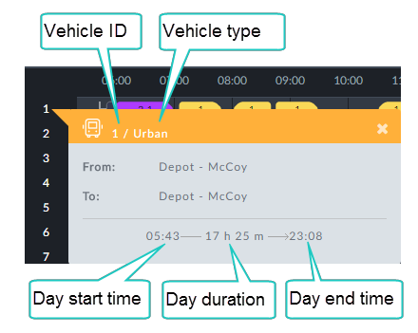

*Table 1-1: Row overview information box*

|  |  |
| --- | --- |
| **Information Box Item** | **Description** |
| From: | Start location at the beginning of the work day |
| To: | The final location of the vehicle at the end of the work day |

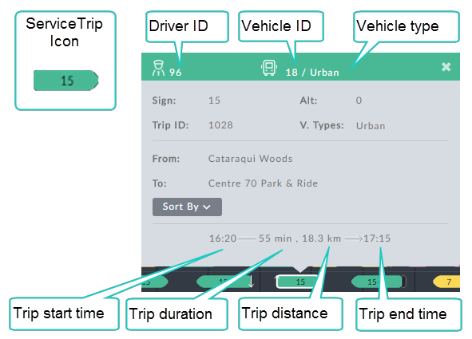

The remaining items inside the gray area are described in **Table 1-2** below:

*Table 1-2: Service trip information box*

|  |  |
| --- | --- |
| **Information Box Item** | **Description** |
| Sign | Route number as seen by the passengers |
| Alt | Alternative route: Used for route variations. A variation for example, may skip or add some stops. An Alt is one of the following:  0 or # - indicates the base route  Anything else indicates an alternate route |
| Trip ID | Operator's trip ID. Every trip has its own unique ID |
| V. Types | Eligible vehicle types for this trip. Several types may be dis- played. |
| From: | Service trip origin |

|  |  |
| --- | --- |
| **Information Box Item** | **Description** |
| To: | Service trip destination |
| Sorted by | See section **Sorting the Vehicles Gantt** below. |

*About direction:* The Operator distinguishes route direction for a service trip

using the **From:/To:** fields.Visually, they determine the direction of the bullet shape on the Gantt. To show the opposite direction, you swap the **From:/To:** locations and the resulting bullet shape points in the opposite direction.

**Deadhead**

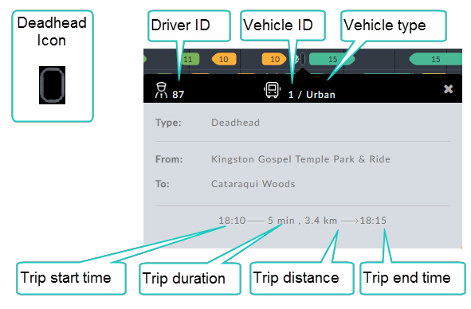

*Table 1-3: Deadhead information box*

|  |  |
| --- | --- |
| **Information Box Item** | **Description** |
| Type | Information box type - Deadhead |
| From: | Deadhead start - typically the end point of a service trip |
| To: | Deadhead end - typically the start point of a service trip |

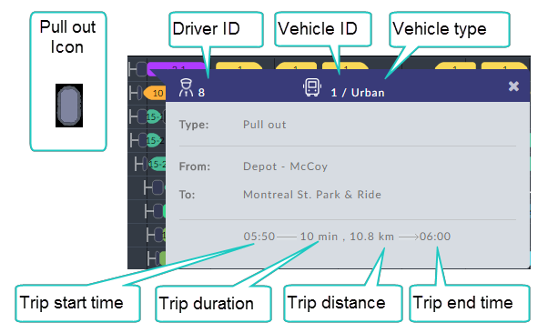

*Table 1-4: Pull out information box*

|  |  |
| --- | --- |
| **Information Box Item** | **Description** |
| Type | Information box type - Pull out |
| From: | Pull out location - typically a depot |
| To: | Origin of first service trip |

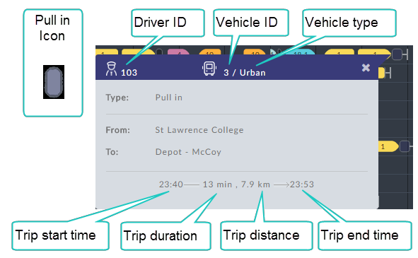

*Table 1-5: Pull in information box*

|  |  |
| --- | --- |
| **Information Box Item** | **Description** |
| Type | Information box type - Pull in |
| From: | Pull in location - typically the end point of a service trip |
| To: | The final location of the vehicle at the end of the day, typ- ically a depot. |

**Pre-trip**

The Pre-trip element only appears at the beginning of a vehicle work day. It provides for all required vehicle preparation by the driver before he moves the vehicle.

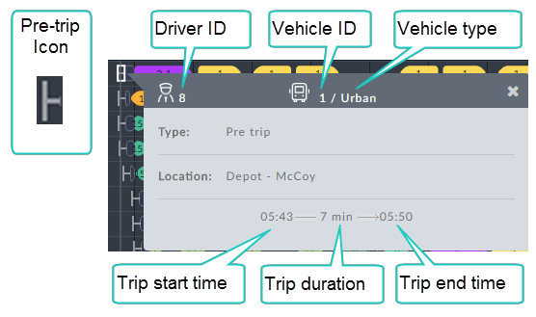

*Table 1-6: Pre-trip information box*

|  |  |
| --- | --- |
| **Information Box Item** | **Description** |
| Type | Information box type - Pre trip |
| Location | Work day departure point, typically a depot |

**Post-trip**

The Post-trip element appears at the end of a vehicle work day. It provides for all required vehicle activities by the driver after parking the vehicle and before going off- duty.

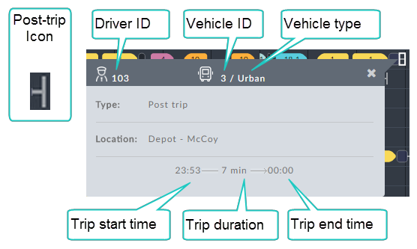

*Table 1-7: Post-trip information box*

|  |  |
| --- | --- |
| **Information Box Item** | **Description** |
| Type | Information box type - Post trip |
| Location | Work day termination point, typically a depot |

**Filtering the Vehicles Gantt**

We will use the following Vehicles Gantt to illustrate the filters:

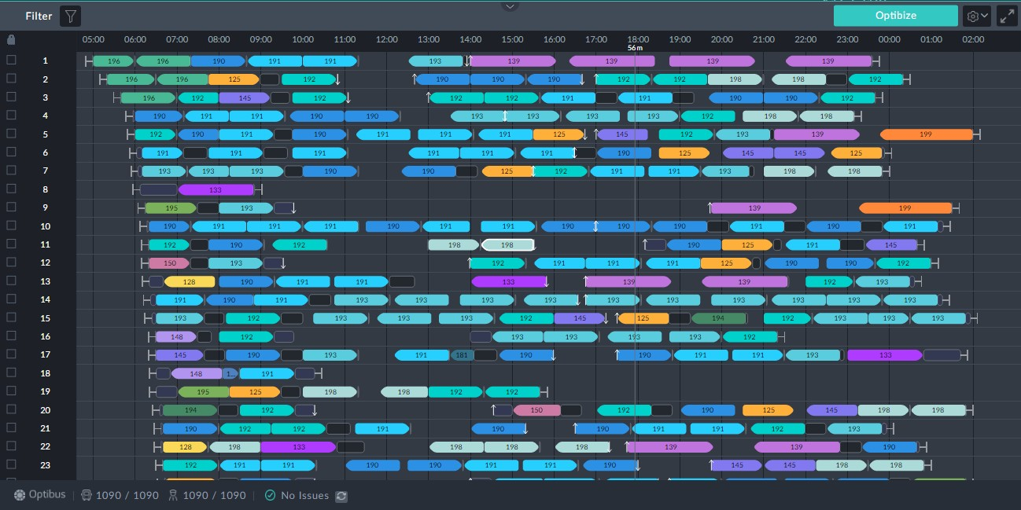

*Figure 1-4: Vehicles Gantt to illustrate filters*

Clicking the filter button opens the filter selection window:

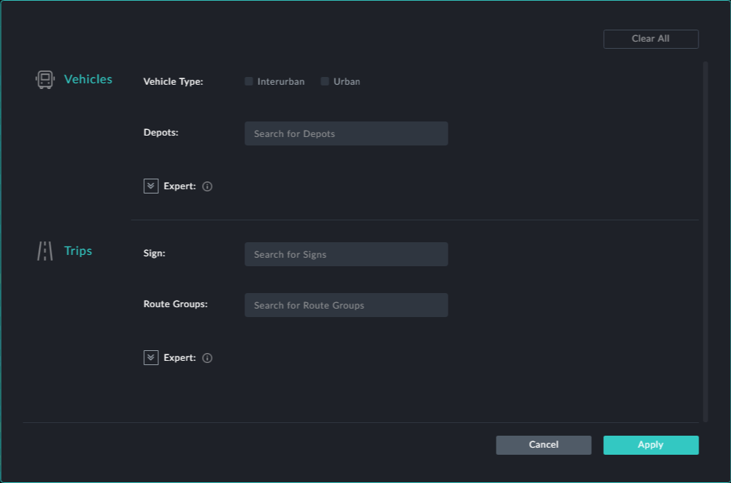

Whenever you choose a filter click **Apply** to put it into effect.

**Filter by Vehicle Characteristics**

***Vehicle Type***

The vehicle types shown are based on user data. If you have more or other vehicle types, you will see them here.

If for eample, you check Urban, the Vehicles Gantt in **Figure 1-4** looks like this:

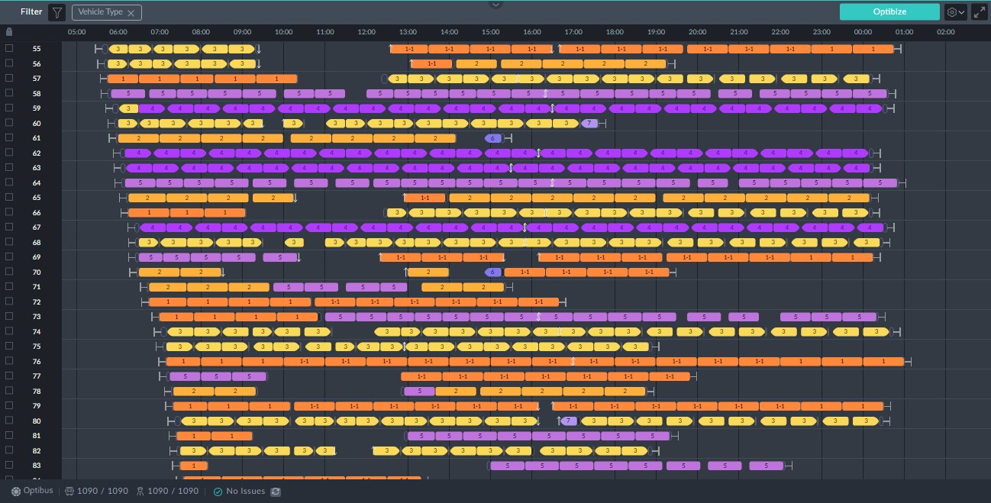

The trips shown are all Urban as can be checked by opening an information box for any

of them.

***Depots***

Clicking the **Depots** field opens a drop list of available depots. You may choose one or more from the lis:

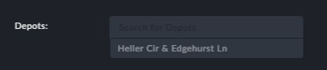

We only have one in this example.

**Filter by Trip Attributes**

***Sign***

Clicking the **Sign** field opens a drop list of available signs. You may choose one or more from the list:

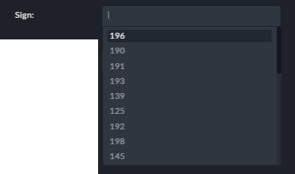

***Route Group***

Clicking the **Route Group** field opens a drop list of route groups. You may choose one or more from the list:

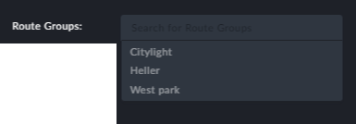

**Points to note:**

At the top left corner of the window there is a filter indicator (in the red rectangle):

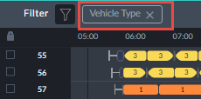

Apart from telling you what filter(s) are in use, you can click it to cancel the filter



Filters are cumulative: If you choose the Urban vehicle type and one of the filters fol- lowing, for example route group, you will only see Urban vehicles of the route groups (s) chosen.



**Sorting the Vehicles Gantt**

Recall the service trip information box:



Clicking the **Sorted By** button opens the following pick list:

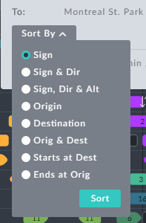

*Figure 1-5: Display sort options*

**Sign** – Sort by the chosen trip sign number



**Sign & Dir** – Sort by a combination of the chosen trip sign number and direction.



**Sign, Dir & Alt** – Sort by a combination of the chosen trip sign number and direction and Alternative



**Origin** – Sort by the chosen trip origin stop



**Destination** – Sort by the chosen trip destination stop



**Origin & Dest** – Sort by a combination of the chosen trip origin and destination stop



**Starts at Dest** - Sorted trips origin stop will match the chosen trip destination stop



**Ends at Orig** - Sorted trips destination stop will match the chosen trip origin stop.

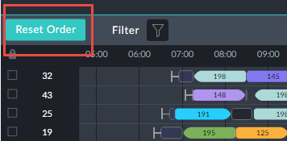

You can reset the Gantt trips by clicking the **Reset Order** button next to the

Filter button:

These sort functions are intended as a planning aid. They are often used to best effect in

conjunction with the filters described above in **Filtering the Vehicles Gantt** and **Fil- tering the Drivers Gantt**.

We will show an example using sort by sign on the Gantt in **Figure 1-4**:

Ø **To sort a Vehicle Gantt:**

1. Go to the information box for the indicated trip at vehicle block 11:

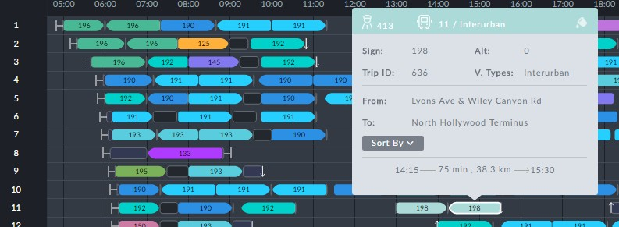

2. Open the **Sort By** list:

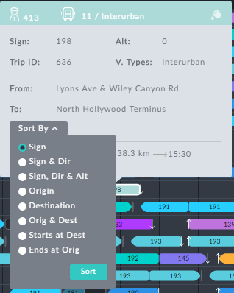

3. Ensure that **Sign** is selected and click **Sort**. The Vehicles Gantt is reaaranged as

follows:

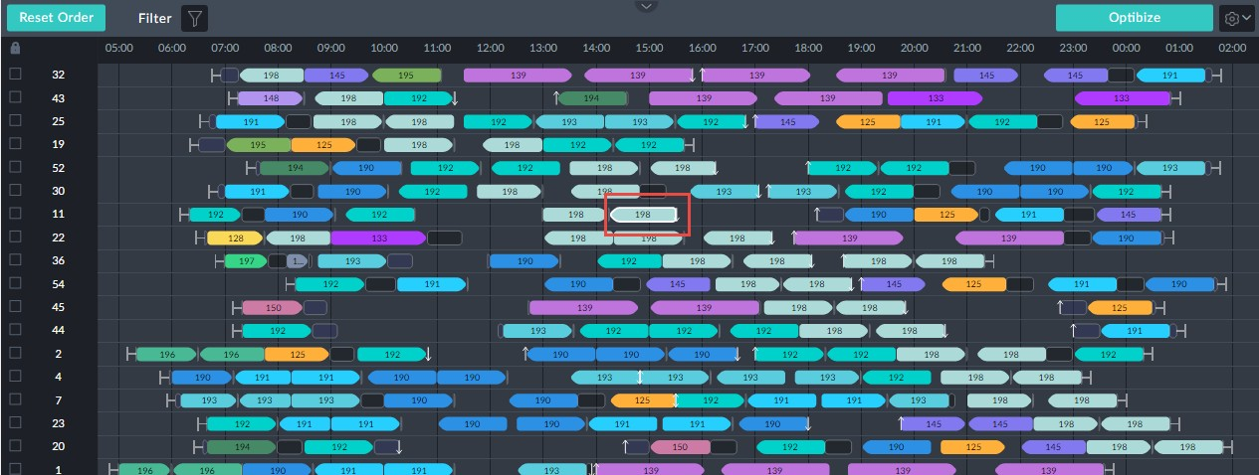

The system takes each vehicle block with a 198 trip and sorts then in order of start time placing them for convenience at the top of the Gantt. The original trip of interest is enclosed in a red rectangle. For planning purposes, we see that there is a pair of 198 trips immediately below it on vehicle 22. Under some circumstances they could be swapped. An informative view can be seen by filtering on sign198:

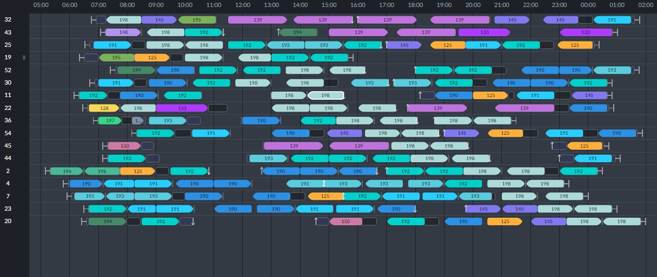

Clearly, this device is of best use when you have a very large number of vehicles doing

trips with this sign.