**Filtering the Vehicles Gantt**

We will use the following Vehicles Gantt to illustrate the filters:

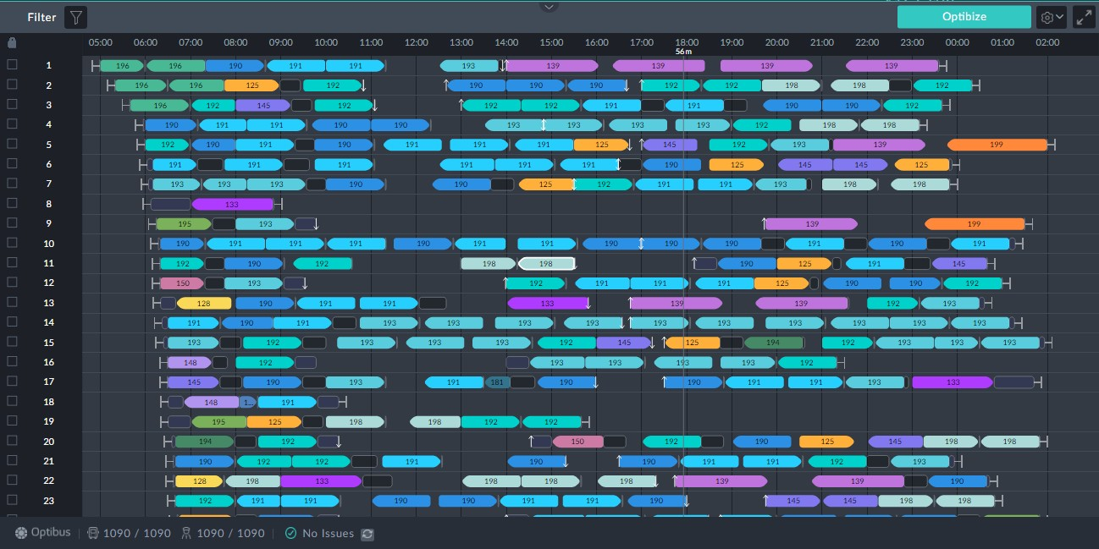

*Figure 1-4: Vehicles Gantt to illustrate filters*

Clicking the filter button opens the filter selection window:

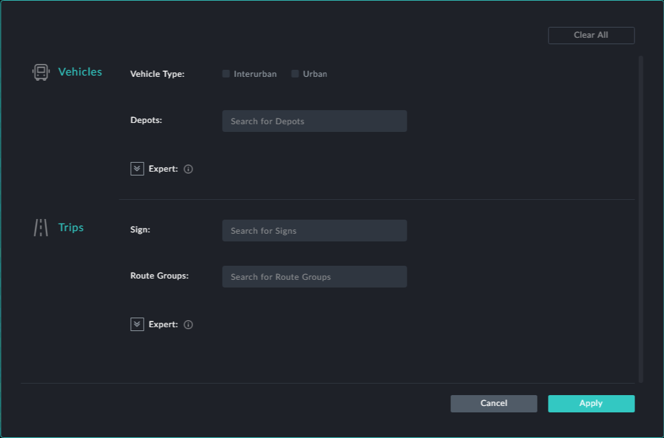



Whenever you choose a filter click **Apply** to put it into effect.

**Filter by Vehicle Characteristics**

***Vehicle Type***

The vehicle types shown are based on user data. If you have more or other vehicle types, you will see them here.

If for eample, you check Urban, the Vehicles Gantt in **Figure 1-4** looks like this:

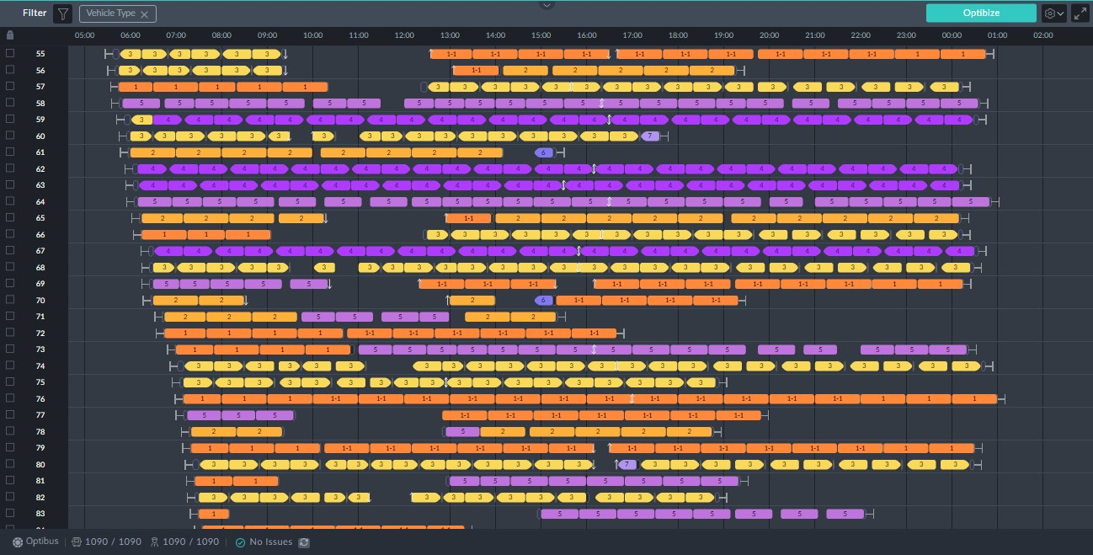

The trips shown are all Urban as can be checked by opening an information box for any

of them.

***Depots***

Clicking the **Depots** field opens a drop list of available depots. You may choose one or more from the lis:

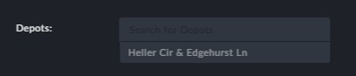

We only have one in this example.

**Filter by Trip Attributes**

***Sign***

Clicking the **Sign** field opens a drop list of available signs. You may choose one or more from the list:

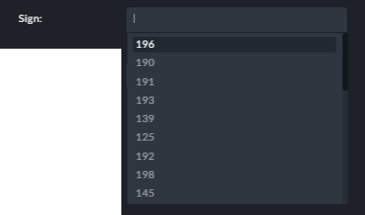

***Route Group***

Clicking the **Route Group** field opens a drop list of route groups. You may choose one or more from the list:

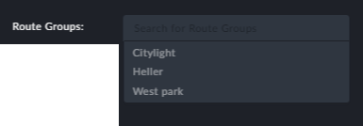

**Points to note:**

At the top left corner of the window there is a filter indicator (in the red rectangle):

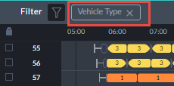

Apart from telling you what filter(s) are in use, you can click it to cancel the filter

Filters are cumulative: If you choose the Urban vehicle type and one of the filters fol- lowing, for example route group, you will only see Urban vehicles of the route groups (s) chosen.

**Sorting the Vehicles Gantt**

Recall the service trip information box:

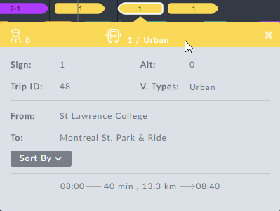

Clicking the **Sorted By** button opens the following pick list:

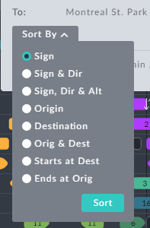

*Figure 1-5: Display sort options*

**Sign** – Sort by the chosen trip sign number

**Sign & Dir** – Sort by a combination of the chosen trip sign number and direction.

**Sign, Dir & Alt** – Sort by a combination of the chosen trip sign number and direction and Alternative

**Origin** – Sort by the chosen trip origin stop

**Destination** – Sort by the chosen trip destination stop

**Origin & Dest** – Sort by a combination of the chosen trip origin and destination stop

**Starts at Dest** - Sorted trips origin stop will match the chosen trip destination stop

**Ends at Orig** - Sorted trips destination stop will match the chosen trip origin stop.

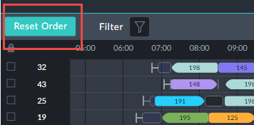

You can reset the Gantt trips by clicking the **Reset Order** button next to the

Filter button:

These sort functions are intended as a planning aid. They are often used to best effect in

conjunction with the filters described above in **Filtering the Vehicles Gantt** and **Fil- tering the Drivers Gantt**.

We will show an example using sort by sign on the Gantt in **Figure 1-4**:

Ø **To sort a Vehicle Gantt:**

1. Go to the information box for the indicated trip at vehicle block 11:

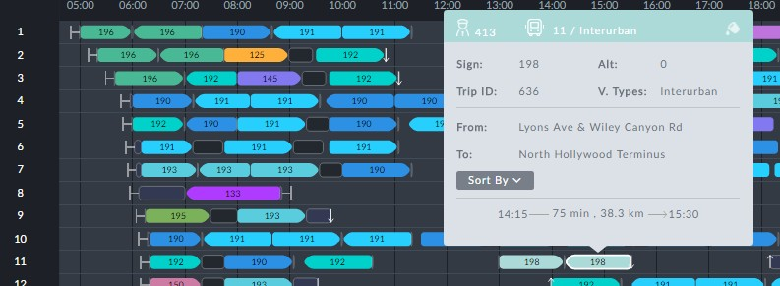

2. Open the **Sort By** list:

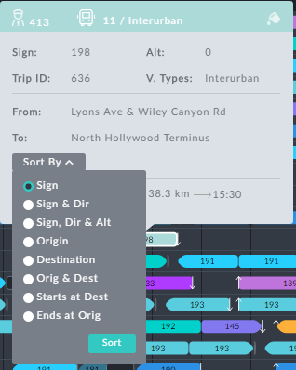

3. Ensure that **Sign** is selected and click **Sort**. The Vehicles Gantt is reaaranged as

follows:

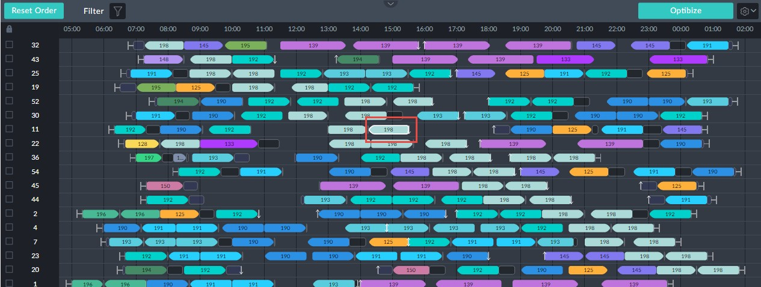

The system takes each vehicle block with a 198 trip and sorts then in order of start time placing them for convenience at the top of the Gantt. The original trip of interest is enclosed in a red rectangle. For planning purposes, we see that there is a pair of 198 trips immediately below it on vehicle 22. Under some circumstances they could be swapped. An informative view can be seen by filtering on sign198:

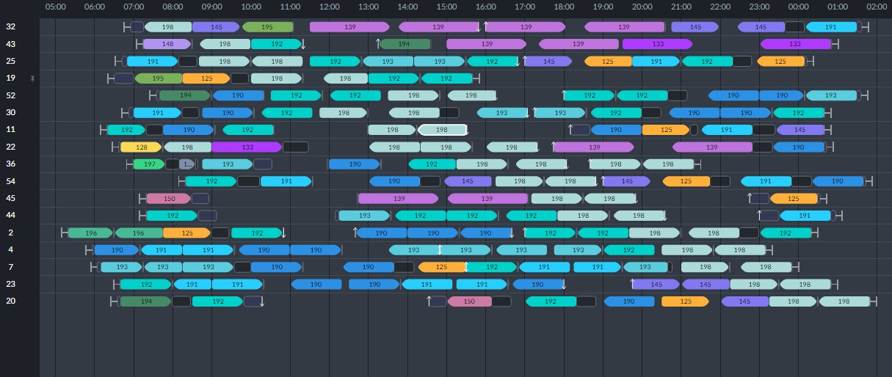

Clearly, this device is of best use when you have a very large number of vehicles doing

trips with this sign.