Optibus

User Manual

Version 1.0.000

Notice

© Copyright 2016 Optibus. All rights reserved.

Information in this document is subject to change without notice. The software described in this document is furnished under a license agreement or nondisclosure agreement. The software may be used or copied only in accordance with the terms of those agreements. No part of this publication may be reproduced, stored in a retrieval system, or transmitted in any form or any means electronic or mechanical, including photocopying and recording for any purpose other than the purchaser's personal use without the written permission of Optibus.

Optibus

1234 Lorem Ipsum

9999999

654321

Contents at a Glance

Contents

User Manual 1

Notice 2

Contents at a Glance 3

Contents 4

Getting Started 7

Chapter 1: About this User Manual 8

Manual Structure 8

Typographical Conventions 8

Viewing and Printing 8

Notifications 8

Terminology 8

Chapter 2: Introduction 1

Welcome 1

Key Features 1

Major Benefits 1

Prerequisites 1

Chapter 3: A Quick Tour of Optibus OnSchedule 1

Logging in to the Demonstration Site 1

Choosing a Dataset 1

Choosing a Schedule 1

Exploring the Vehicle Schedule 1

Exploring the Driver Schedule 1

Scheduling 2

Chapter 4: Preparing a Schedule 1

Preparing the Vehicle Schedule 1

Preparing the Driver Schedule 1

Optimizing a Schedule 1

Fine Tuning the Schedule 1

Setting Preferences 2

Chapter 5: Preferences Window 1

Vehicles 1

Drivers 1

Depots 1

Miscellaneous Settings 1

Technical Reference 2

Chapter 6: Logging in to OptibusOnSchedule 3

Chapter 7: Datasets 4

Chapter 8:  OnSchedule Main Window 5

Top Pane Tool Bar 5

The Context Menu 6

Schedule Updates 6

Export Schedules 6

Import Schedules 6

Preferences 6

Manual Scheduling 6

Select a Day Within Current Week 7

Switch Between Vehicle and Driver Schedules 7

Optimization Tool Bar 7

The Key Performance indicators (KPI) Window 8

KPI Window Overview 8

Indicator Details 8

Driver Duty Histograms 10

Distribution of Driver Duties by Duty Type 10

Distribution of Driver Duties by Duty Paid Time 11

Distribution of Driver Duties Across Vehicle Type 11

Vehicle Gantt 12

Vehicle Gantt Overview 12

The Vehicle Gantt in Detail 17

Workday Overview for a Vehicle 17

Service trip 19

Deadhead 20

Pull out 21

Pull in 22

Pre-trip 22

Post-trip 23

Sorting the Vehicle Gantt 24

Driver Gantt 25

Driver Gantt Overview 25

The Driver Gantt in Detail 29

Workday Overview for a Driver 29

Split Information Box 32

Taxi 32

Chapter 9: Input Data Formats 34

Glossary 35

INDEX 36

Customer Response 37

Getting Started

Chapter 1: About this User Manual

Manual Structure

Delete this text and replace it with your own content.

Typographical Conventions

Delete this text and replace it with your own content.

Viewing and Printing

Delete this text and replace it with your own content.

Notifications

Delete this text and replace it with your own content.

Terminology

Delete this text and replace it with your own content.

Chapter 2: Introduction

Delete this text and replace it with your own content.

Welcome

Delete this text and replace it with your own content.

Key Features

Delete this text and replace it with your own content.

Major Benefits

Delete this text and replace it with your own content.

Prerequisites

On a Laptop, use best power mode - do not use power saving.

Chapter 3: A Quick Tour of Optibus OnSchedule

Delete this text and replace it with your own content.

Logging in to the Demonstration Site

Delete this text and replace it with your own content.

Choosing a Dataset

Delete this text and replace it with your own content.

Choosing a Schedule

Delete this text and replace it with your own content.

Exploring the Vehicle Schedule

Delete this text and replace it with your own content.

Exploring the Driver Schedule

Delete this text and replace it with your own content.

Scheduling

Chapter 4: Preparing a Schedule

Delete this text and replace it with your own content.

Preparing the Vehicle Schedule

Delete this text and replace it with your own content.

Preparing the Driver Schedule

Delete this text and replace it with your own content.

Optimizing a Schedule

Delete this text and replace it with your own content.

Fine Tuning the Schedule

Delete this text and replace it with your own content.

Setting Preferences

Chapter 5: Preferences Window

Delete this text and replace it with your own content.

Vehicles

Delete this text and replace it with your own content.

Drivers

Delete this text and replace it with your own content.

Depots

Delete this text and replace it with your own content.

Miscellaneous Settings

Delete this text and replace it with your own content.

Technical Reference

Chapter 6: Logging in to OptibusOnSchedule

Delete this text and replace it with your own content.

Chapter 7: Datasets

Delete this text and replace it with your own content.

Chapter 8:  OnSchedule Main Window

The OnSchedule main window is shown in Figure 8-1 below:

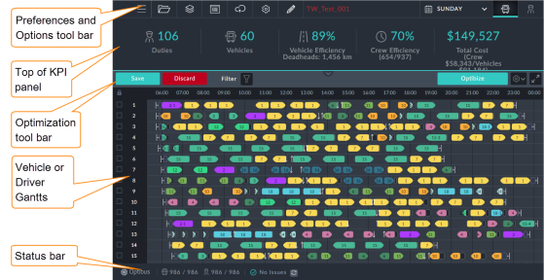

OnScheduleFigure 8-1: Main window

The main window is divided in to four panes:

* The top pane contains a tool bar of functions to set up and control the scheduling process
* The second pane contains key performance indicators (KPIs). It is updated dynamically as schedules are added and optimized.
* The large third pane contains the vehicle or driver Gantts. You can view them in turn.
* The bottom pane is a status bar

Top Pane Tool Bar

The top pane provides the management functions for the application:



Table 8-1: Top pane tool bar

| Icon | Purpose | Reference |
| --- | --- | --- |
|  | Opens up a pull-out context menu on the left with various save options | The Context Menu |
|  | Returns you to the schedule selection window, one level back. |  |
|  | Schedule updates | Schedule Updates |
|  | Export schedules | Export Schedules |
|  | Import schedules | Import Schedules |
|  | Preferences | Preferences |
|  | Manual scheduling | Manual Scheduling |
|  | Select a day within the current week | Select a Day Within Current Week |
|  | Enter the vehicle scheduler (default) | Switch Between Vehicle and Driver Schedules |
|  | Enter the driver scheduler |

The Context Menu

Delete this text and replace it with your own content.

Schedule Updates

Delete this text and replace it with your own content.

Export Schedules

Delete this text and replace it with your own content.

Import Schedules

Delete this text and replace it with your own content.

Preferences

Delete this text and replace it with your own content.

Manual Scheduling

Delete this text and replace it with your own content.

Select a Day Within Current Week

Delete this text and replace it with your own content.

Switch Between Vehicle and Driver Schedules

Delete this text and replace it with your own content.

Optimization Tool Bar

The tool bar above the vehicle and driver Gantts is used for optimization and saving results:



Following any editing change or optimization run, the tool bar changes to this:



The Key Performance indicators (KPI) Window

KPI Window Overview

In the main window (Figure 8-1), click the expand icon, . The full KPI area opens:

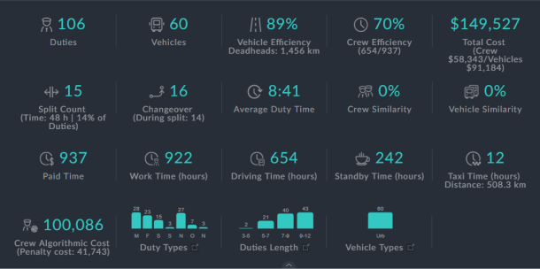

Figure 8-2: The KPI window

Clicking the  icon at the bottom of the window, reverts it.

These indicators provide a projected performance summary for the schedule. It will of course change under manual editing and optimization.

Indicator Details

Table 8-1: KPI details

| Item # | Indicator | Description |
| --- | --- | --- |
|  |  | Total number of driver duties |
| 2. |  | Total number of vehicles |
| 3. |  | Vehicle efficiency: Ratio of total service trip distance to aggregate traveled distance for the day. The difference is the deadhead distance shown on the last line. The latter distance also includes Pull ins and Pull outs. |
| 4. |  | Crew efficiency: Ratio of driving time (item 13) to paid time (item 10). |
| 5. |  | Total cost for the day: Crew cost + vehicle costs (based on running cost and an overhead contribution. See TBD.) |
| 6. |  | This item shows the number of split duties, split time and the ratio of the number of split duties to the total number of duties |
| 7. |  | Total number of driver changeovers and the total number of driver changeovers during a split |
| 8. |  | Average driver duty time: Total work time (item 12) divided by the number of duties (item 1) in hours:minutes |
| 9. |  | Crew similarity: A measure of similarity between the current changed duties schedule to the previous one. See Preferences TBD. |
|  |  | Vehicle similarity: A measure of similarity between the current changed vehicles schedule to the previous one. See Preferences TBD. |
| 11. |  | Paid time consists of components defined by the Operator. It typically includes driving time and paid breaks and other paid elements. |
|  |  | Actual work time usually consists paid time and unpaid elements, not including split time |
|  |  | Driving time consists of all driving events, such as service trips, deadheads, pull ins and pull out. |
| 14. |  | Standby time consist of any time not occupied by an element in the Driver Gantt. (Split time is not included.) |
| 15. |  | Taxi time and distance. Recall that When a driver completes a trip, he may be required to go to a different location for his next trip or even to take a break. To get there, he may require transport such as a taxi , a shuttle or perhaps walk. |
| 16. |  | This is a hypothetical costing using theoretical "penalties" associated with Preferences. It provides an expert planner with a tool for assessing his choices. |
| 17. |  | Distribution of driver duties by duty type. See Figure 8-3 below. |
| 18. |  | Distribution of driver duties by duty paid time. See Figure 8-4 below. |
| 19. |  | Distribution of driver duties across vehicle type. See Figure 8-5 below. |

Driver Duty Histograms

The last three items in Table 8-1 above expand into histograms. To see them, click the appropriate item in Figure 8-2.

|  |
| --- |
| {b}Note: {/b}You can move between the histograms by clicking the < and > buttons on the sides of the displays. |

The following three examples are drawn from several unrelated Datasets, purely for illustrative purposes:

Distribution of Driver Duties by Duty Type

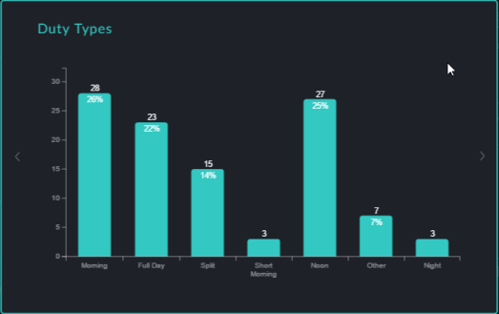

Figure 8-3: Duty by Duty Type

Recall that the Duty Type is defined by the Operator.The chart shown the number of duties and the percentage of duties per Duty Type.

Distribution of Driver Duties by Duty Paid Time

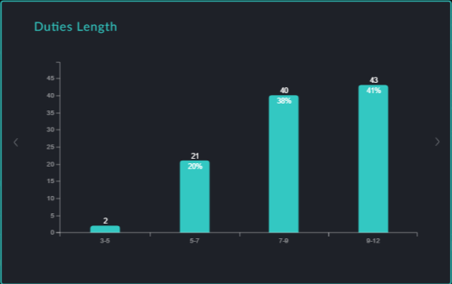

Figure 8-4: Duty by Duty Paid Time

The duty paid time intervals for this histogram are grouped by the Operator. Again, the number of duties in each interval and the percentage are shown.

Distribution of Driver Duties Across Vehicle Type

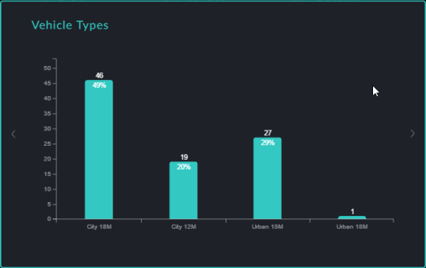

Figure 8-5: Duty by Vehicle Type

The number of vehicles and the vehicle percentages are shown by vehicle type. Vehicle types are defined by the Operator.

Vehicle Gantt

Vehicle Gantt Overview

The Vehicle Gantt is opened by default. You can always return to it from the Driver Gantt by clicking the vehicle icon in the Options tool bar.

|  |
| --- |
| {b}Note: {/b}If you need more space on your screen, you can hide the KPI by clicking the  button. To restore the KPI, just click it again. |

The window contains a vast amount of detail, but nevertheless, it is very easy to follow. For example:

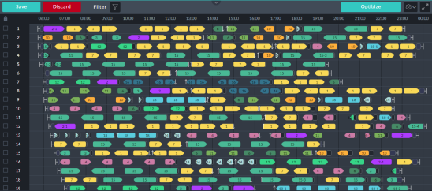

Figure 8-6: A typical Vehicle Gantt

Each numbered row on the Gantt shows the day's itinerary of one vehicle. Take for example, row 1:



First, you can see a quick row overview by left-clicking the row number:

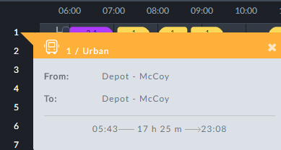

The start and end times relate to the day's work for the vehicle. The duration is also displayed.

Let us return to the Gantt itself:

The graphic shapes are called elements.

Each colored bullet shaped element represents a service trip.



Figure 8-7: Service trip element

|  |
| --- |
| {b}Note: {/b}A service trip is a revenue-earning vehicle journey. |

The number is the route sign. In the above example , the route as seen by a passenger, is 2-1. The difference between a simple number and a hyphenated number such as 2-1 will be explained shortly. Looking at the Gantt, It's row number is the vehicle ID. The position of the left end of the element is the time of the beginning of the trip and the position of right end is the time of completion. You can see the times precisely by moving the mouse horizontally along the row. A vertical cursor line indicates the time:

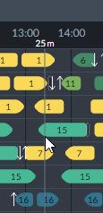

Observe the vertical cursor line at 13:25 at the mouse position.

|  |
| --- |
| {b}Note: {/b}The service trip coloring is determined by the system to make the display easy to understand. Each sign has its own color. |

From the transport operator's perspective, a route has three parameters. Referring to Figure 8-7 above, they are:

* A sign defining the service trip terminus points - in the example it is 2
* A direction - at which terminus the trip starts and which terminus the trip finishes determines the direction on the Gantt of the bullet shape
* An alternate number indicating a route variant. A route variant for example may add or skip stops in the base route. In the example it is 1 and the passenger sees 2-1 as shown.

Further information may be obtained by left-clicking an element. Let us take another example, left-clicking the third service trip element in row 1. An information box pops up:

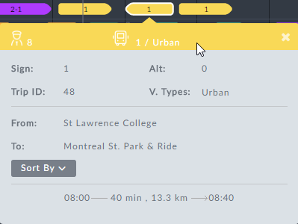

Figure 8-8: Element information box

Notice the From: ... To: ... locations. If you left click-the fourth item following, you will see that the From: ... To: ... locations are reversed - the vehicle is scheduled for a return trip.

|  |
| --- |
| {b}Note: {/b}Left-clicking any active element in the display will open an information box describing it in detail. In most cases, the chosen element has a white border as seen in Figure 8-8. |

We will return to the information box in detail below.

|  |
| --- |
| {b}Note: {/b}Sometimes a trip icon may be an oblong shape instead of a bullet shape. It indicates a round-trip that starts and finishes at the same terminus. |

To complete your understanding of the example, we will look at several other elements appearing on row 1.

The row commences with the symbol .Left clicking it opens an information box:

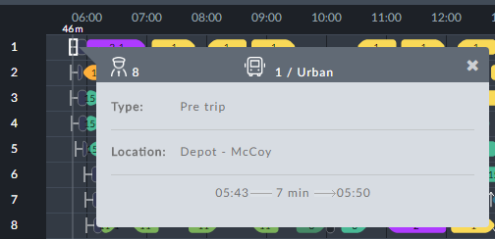

The  symbol represents pre-trip activity. It may also show as Vehicle Preparation. This is an Operator choice.

The next graphic element looks like this:  Left clicking it shows a Pull out information box:

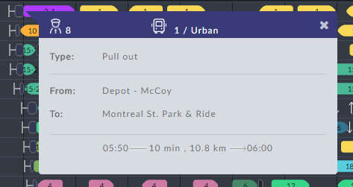

The length of the Pull out graphic reflects the time required. The same graphic at the end of a trip or at the end of a day denotes a Pull in.

|  |
| --- |
| Pull out{b}Note: {/b} and Pull in: Moving a vehicle from a depot to the first stop of a service trip is called a Pull out. What is considered to be a "Depot" here, is determined by the Operator. In the opposite direction, a Pull in is moving a vehicle from the last terminus of a service trip back to the depot. |

Once again, on the top row at about 18:13, there is a similar graphic with a black background, . Left-clicking it shows Deadhead information:

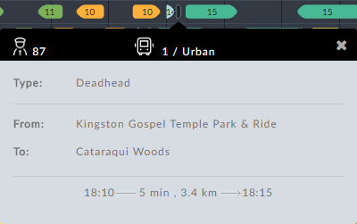

Again, the length of the graphic reflects the time required for the deadhead trip.

|  |
| --- |
| {b}Note: {/b}A deadhead is any non-revenue earning vehicle movement other than pull out and pull in. |

|  |
| --- |
| {b}Note: {/b}Deadhead, pull out or pull in icons with a white dot in the center, for example like this,  are auto-generated by the system. You can edit them in the Deadhead Catalog (see TBD). |

Look now, at the period between 14:00 and 15:15:

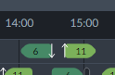

The down arrow to the right of sign 6 indicates that the driver has left the vehicle (for example going off-duty or taking a break). The up arrow following indicates that a different driver has takien the vehicle.

Finally, at the end of row 1 is a post-trip symbol, . Left clicking it, displays post-trip activity:

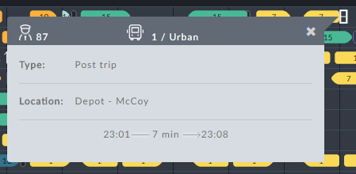

The Vehicle Gantt in Detail

In this section we look at the information boxes in detail.

|  |
| --- |
| {b}Note: {/b}The Vehicle Gantt information boxes become active data entry panels during Manual Vehicle-only Scheduling. See TBD. |

|  |
| --- |
| {b}Note: {/b}An open information box may be dismissed in three ways:   * Clicking the x in the top right corner of the box * Opening another box * Clicking an unused area on the display |

Workday Overview for a Vehicle

Left-clicking a row number pops up a work day overview for the vehicle:

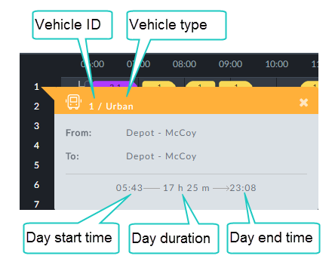

Table 8-1: Row overview information box

| Information Box Item | Description |
| --- | --- |
| From: | Start location at the beginning of the work day |
| To: | The final location of the vehicle at the end of the work day |

Service trip

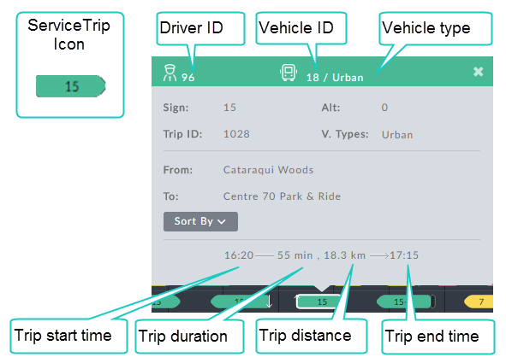

The remaining items inside the gray area are described in UNRESOLVED CROSS-REFERENCEbelow:

Table 8-2: Service trip information box

| Information Box Item | Description |
| --- | --- |
| Sign | Route number as seen by the passengers |
| Alt | Alternative route: Used for route variations.  A variation for example, may skip or add some stops. An Alt is one of the following:  0 or # - indicates the base route  Anything else indicates an alternate route |
| Trip ID | Operator's trip ID. Every trip has its own unique ID |
| V. Types | Eligible vehicle types for this trip. Several types may be displayed. |
| From: | Service trip origin |
| To: | Service trip destination |
| Sorted by | See section Sorting the Vehicle Gantt below. |

|  |
| --- |
| About direction:{b}Note: {/b} The Operator distinguishes route direction for a service trip using the From:/To: fields.Visually, they determine the direction of the bullet shape on the Gantt. To show the opposite direction, you swap the From:/To: locations and the resulting bullet shape points in the opposite direction. |

Deadhead

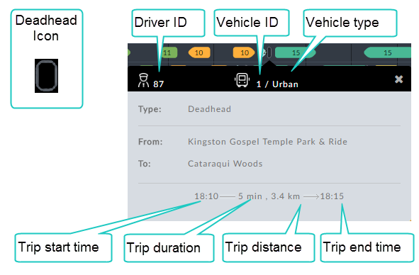

Table 8-3: Deadhead information box

| Information Box Item | Description |
| --- | --- |
| Type | Information box type - Deadhead |
| From: | Deadhead start - typically the end point of a service trip |
| To: | Deadhead end - typically the start point of a service trip |

Pull out

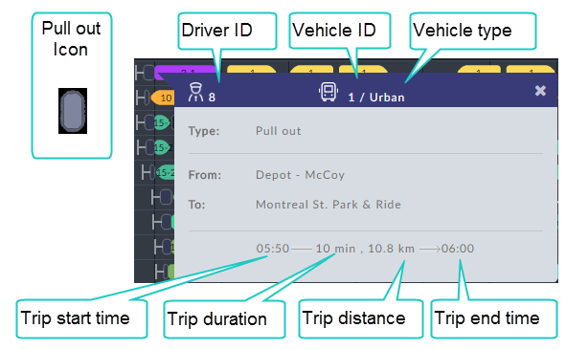

Table 8-4: Pull out information box

| Information Box Item | Description |
| --- | --- |
| Type | Information box type - Pull out |
| From: | Pull out location - typically a depot |
| To: | Origin of first service trip |

Pull in

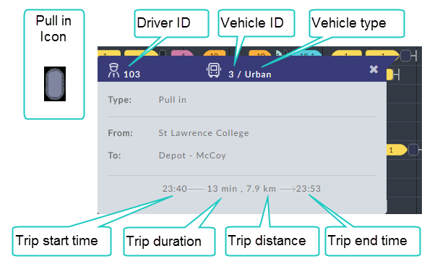

Table 8-5: Pull in information box

| Information Box Item | Description |
| --- | --- |
| Type | Information box type - Pull in |
| From: | Pull in location - typically the end point of a service trip |
| To: | The final location of the vehicle at the end of the day, typically a depot. |

Pre-trip

The Pre-trip element only appears at the beginning of a vehicle work day. It provides for all required vehicle preparation by the driver before he moves the vehicle.

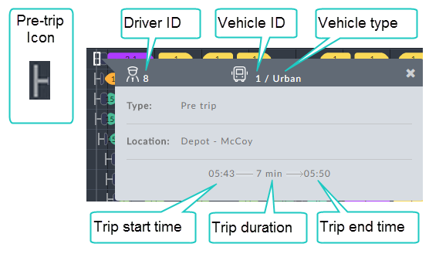

Table 8-6: Pre-trip information box

| Information Box Item | Description |
| --- | --- |
| Type | Information box type - Pre trip |
| Location | Work day departure point, typically a depot |

Post-trip

The Post-trip element appears at the end of a vehicle work day. It provides for all required vehicle activities by the driver after parking the vehicle and before going off-duty.

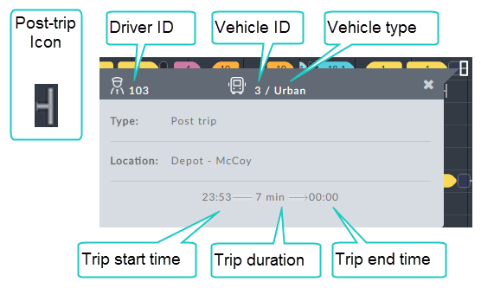

Table 8-7: Post-trip information box

| Information Box Item | Description |
| --- | --- |
| Type | Information box type - Post trip |
| Location | Work day termination point, typically a depot |

Sorting the Vehicle Gantt

Recall the service trip information box:



Clicking the Sorted By button opens the following pick list:

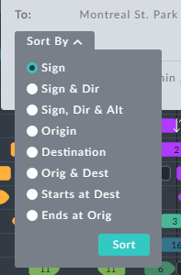

Figure 8-9: Display sort options

Explanation ...TBD

Driver Gantt

Driver Gantt Overview

Like the Vehicle Gantt, the Driver Gantt also contains a vast amount of information. We start with an example:

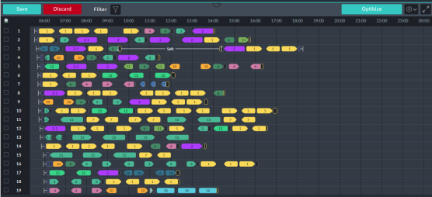

Figure 8-10: A typical Driver Gantt

For the Driver Gantt, the left hand numbering is for drivers. Thus, each numbered row on the Gantt shows the work day for one driver. otherwise the graphic elements are very similar to those used in the Vehicle Gantt. The emphasis in this section will be on the element specific to the Driver Gantt or elements having a different meaning.

The following graphic elements are the same as those for the Vehicle Gantt:

* Service trip
* Pre-trip and Post-trip
* Pull out and Pull in
* Deadhead

A picture for the changeover elemnt is missing…

Up and down arrows have a different meaning in the Driver Gantt: Here they indicate a vehicle changeover for the same driver. The changeover may be separated by other events, as we will see below.

There are two additional elements:

When a driver completes a service trip, he may be required to leave his vehicle and then go to a different location for his next trip or even to take a break. To get there, he may require transport such as a taxi or a shuttle.

The Taxi icon  denotes the driver movement. It looks similar to a Deadhead icon but it has a thin yellow frame. Left clicking it opens its information box:

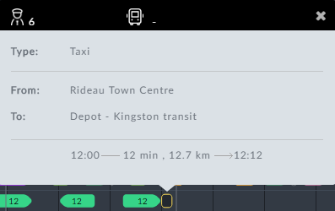

The box indicates that a taxi or a shuttle is required.

|  |
| --- |
| {b}Note: {/b}The use or otherwise, of Taxi icons is determined in the Preferences. See TBD. |

The second additional graphic describes a Split:



Figure 8-11: Split example

|  |
| --- |
| {b}Note: {/b}The part of the driver's duty before a split is called his first stretch and the duty following the split, his second stretch. |

To follow the narrative of Figure 8-11, we need to open the information box of each constituent element in order from left to right:

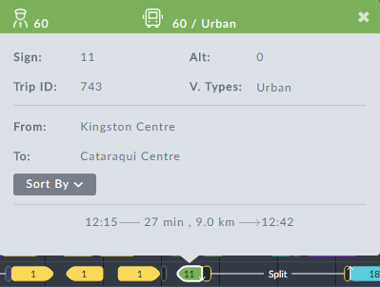

Figure 8-12: Last service trip of first stretch completed prior to split

The driver with ID as shown, has completed the service trip of Figure 8-12. In Figure 8-11, following the service trip element there is a down arrow. The driver has left the vehicle as first part of a changeover. The next element is a Taxi icon showing that the driver requires transport as shown in Figure 8-13:

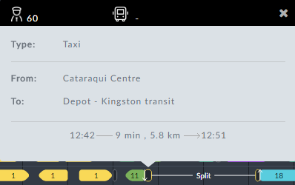

Figure 8-13: Taxi taken before split

Having arrived at the To: location, the driver goes off duty as shown in the split break. The driver's split break details are shown in the split break information box:

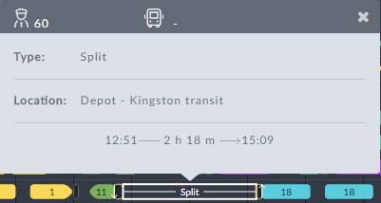

Figure 8-14: Split break information box

At the end of the break shown at the bottom of Figure 8-14, another Taxi icon is displayed indicating a requirement for transport to take the driver to his next duty trip. An up arrow shows the driver taking over the vehicle for the next service trip, the second part of his changeover. At this point, the procedure flow should be evident and we will not show all of the information boxes.

As for the Vehicle Gantt, each row number in the Driver Gantt has an information box. For drivers there is a difference. Left-clicking row 1 shows the following information box:

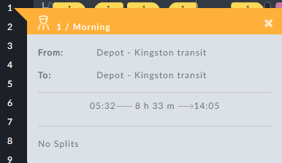

The only new item is the No Splits indicator, showing that the duty in the line above is continuous.

|  |
| --- |
| {b}Note: {/b}The Duty Type shown is Operator defined. |

If we left-click row 3, which has a split, the information box is different:

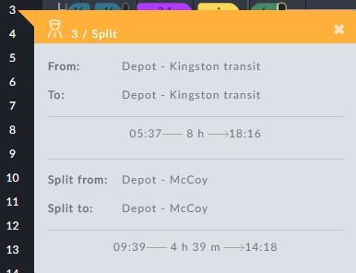

We have already encountered the contents of this box in the split narrative above: The driver comes on duty at the From: location and finishes his day at the To: location (often the same), starting and finishing as shown:



The worked hours shown in the middle are total worked hours less the spli hours.

The lower Split from: / Split to: section shows the split break period only:



At this point, it is quite straight forward to follow the work day on the Driver Gantt for any driver.

The Driver Gantt in Detail

In this section we look at the driver specific information boxes in detail.

Workday Overview for a Driver

Left-clicking a row number pops up a work day overview for the driver:

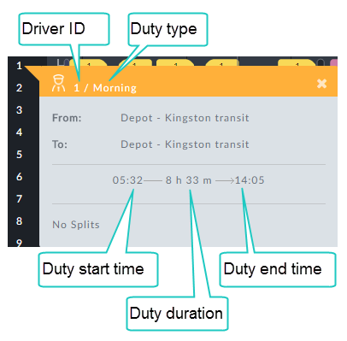

Figure 8-15: Workday Overview - no splits

|  |
| --- |
| {b}Note: {/b}The Duty Type is Operator defined. |

If the day's work is split by a rest period, the information box has extra details:

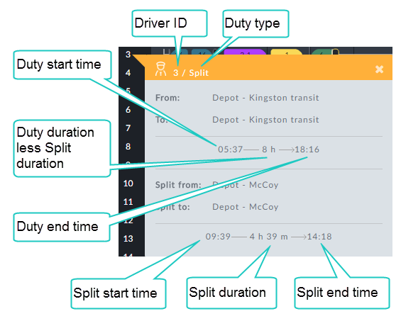

Figure 8-16: Split workday Overview

In the box “Duty duration” needs to change to “duty length” (terminology wise)

Table 8-1: Row overview information box

| Information Box Item | Description |
| --- | --- |
| From: | Start location of the driver at the beginning of the work day |
| To: | The final location of the driver at the end of the work day |
| Split from: | Split start location |
| Split to: | Split end location |

Split Information Box

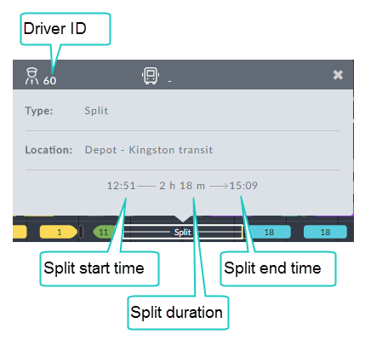

Table 8-2: Split information box

| Information Box Item | Description |
| --- | --- |
| Type | Information box type |
| Location: | Split location - typically break location |

Taxi

Recall that, when a driver completes a service trip, he may be required to leave his vehicle and then go to a different location for his next trip or even to take a break. To get there, he may require transport such as a taxi or a shuttle.

The taxi icon is used to represent this driver movement.

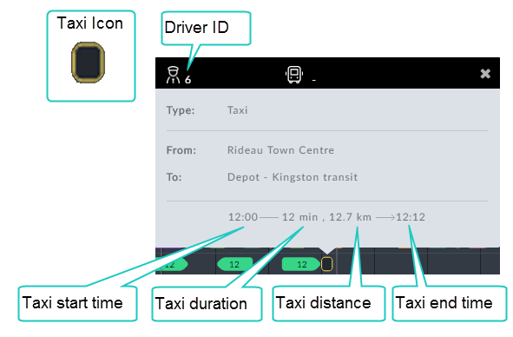

Table 8-3: Taxi information box

| Information Box Item | Description |
| --- | --- |
| Type | Information box type -Taxi |
| From: | Taxi start location |
| To: | Taxi end location |

Chapter 9: Input Data Formats

Delete this text and replace it with your own content.

Glossary

M

MyTerm

INDEX

**No index entries found.**

Customer Response

Delete this text and replace it with your own content.

End Page

Delete this text and replace it with your own content.