1. ***Introduction***

An insurance company provides services to the people who wants to get a rid of the different risks that they are expose in a certain time lapse, it can be in a short or a long term and different types like: cars, life, uncertain about unemployment, medical risks and other.

Taking that on account the insurance company provides contracts to that people, this contract can be personalize depending on the risk that they want to cover or the contract can be a standard contract because is a common risk that people face, the main topic of the contract is that the people transfer the risk that they face for a certain amount of money and in the case of that risk take place the company cover it up.

But to cover up that risk the company needs to calculate the probability that the risk occurs depending on some characteristics of the insured, the product that the company cover up and other criteria. With that information the company can decide how much money they need to keep available in every moment of the contract to face the possible risk, and the remainder they can investing to produce more income to the company, during the contract time there are some scenarios that can happen:

* The risk never happens: in this scenario the company never pays something to the insurer ant they keep the money and the yields of the investments.
* The risk happens and it’s notified to the company: in this scenario the company have the duty to pay the fix amount that the company agreed in the contract, other scenario can be pay less or the maximum amount that the company promise to cover like in the case of cars insurances.
* The risk happens and the insured does not notify to the company: in this scenario the risk happen but the company does not pay nothing because the insured never told anything to the company.

Finally, it’s too important to the company knowing how much money they have the probability to pay or to lose in a certain future for that reason is important to make a good study about how much money they need to reserve to face the risk materialization because if they underestimate that amount, they can lose money because they may face liquidity problems to pay the amount that they insured, and if the company overestimates that amount they can lose profits of possible investments that were not made.

For that reason, the main topic of this work is to make competent research that provides a result of how much the company needs to reserves to face possible claims, all of this information is going to derivates from the historical data of the company, but we emphasize that this work corresponds to a theorical research with only academic purpose

1. ***Organization chart***

To elaborate our theorical research we are going to imagine that our problem is solving the reserves levels for an international insurance company from Europe, thinking on the company problem the first problem in our research is to see the organization chart to set with which areas we are going to work, the Organization chart of the company is below.

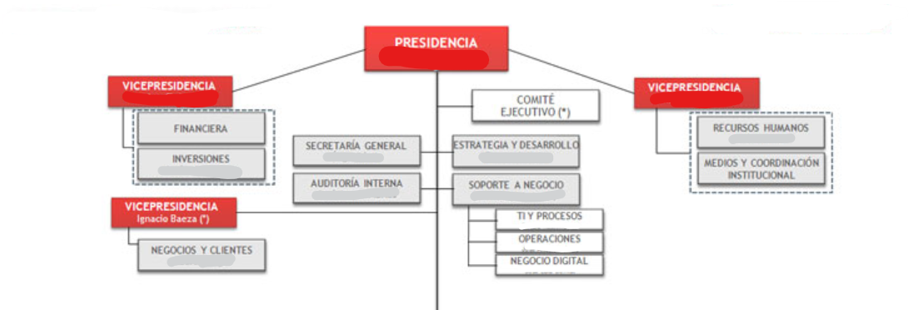

Looking into the organization chart we can see that we do not need to work with all the areas, we need to work with certain areas to define the main product that we are going to select for our study for example: cars insurances, life insurances, health insurances, or other. Por this we need to work with the strategy and development group.

Second, we need the information about all the businesses that the company have or had in the past to can define which information is relevant for our study and which information do we have, for that reason we need the business support group in our study and the business and costumer group.

Tirth, we need to define the financial path that the company can support, thinking of that we need to talk with the financial and investment groups to research about the ease and possibilities of get liquidity in the case that the company requires and maybe how much money do this groups needs to invest to get yields.

* 1. ***Requirements***

Talking with the business manager of the company he told us that the company right now is having problems with the calculations of the reserve's levels for cars insurance, so he asks us for focus our study to this product because this can improve the revenue for the company or at least stop to losing money.

* 1. ***Risks and contingencies***

Thinking on the problem of the company is important to taking in consideration that this insurance product is difficult to define the exact probability and amount that can face the company if a risk materialize because it depends on the severity of the accident, and in other hand we have that not all the cars have the same value. Anyway, it's important to say that the study can solve the problem but maybe not for all the cases, because every car insurance is unique, and every insured have different characteristics and behaviours.

* 1. ***Data mining goals***

Our problem is solving de reserves levels for the cars insurances and thinking on the problem we thought that the best way to solve it is defining the different characteristics of the insured and see if exist some patter between that data and the amount of the claims, for that reason our goal is getting a dataset that contain multiple characteristics of the insured.

***2.4 Project Plan***

Once defined with which areas we are going to work we need to set the phases of the research and the time for each phase, the phases and the time are below:

1. Business understanding: that correspond to define and understand the problem that we are solving, in this case the reserves levels for the company. (2-3 days)
2. Data understanding: correspond to understand which data is available to our study, define which data we are going to use and which data isn’t relevant for the study. (1 week)
3. Data preparation: correspond to clean the data sets that we have and we need for the study and get prepare the data sets prepare to work in the modelling phase. (1 week)
4. Modelling: correspond to star modelling in a computer software to solve our problem. (1 week)
5. Evaluation: correspond to see the results and how it works our models and if our model may resolve the research problem of the company (3 days)
6. Deployment: correspond to start working with our model in the production line to see how it works. (1 week)