

Custom MKeyboards 101

Project Report

DT228/TU856

Computer Science

**C20483514**

School of Computer Science

Technological University Dublin

**19/12/2020**

Declaration

I hereby declare that the work described in this dissertation is, except where otherwise stated, entirely my own work and has not been submitted as an exercise for a degree at this or any other university.

Signed:

_________________________

Kieran Silada

19/12/2020

Table of Contents

*1.* Problem Description 4

*2.* Research 4

*3.* Technology Selection and Site Architecture 4

*4.* Low Fidelity Prototype 4

*5.* Development Plan 4

*6.* Testing Plan 4

*7.* Site Evaluation 4

*8.* Deployment 4

Appendices 5

# Problem Description

**Detailed description of the website and the content on offer:**

Custom MKeyboards 101 is an informational website concerning mechanical keyboards and the various customisation options available out there. There are many example photos and some video guides for easier understanding. A personal page of my own custom keyboard is present too. Also, if anyone wants further information, they can contact me on the contact page.

**Describe the archetypical users of the site:**

This website is for people interested in getting to know more about mechanical keyboards and wanting to delve into customising a keyboard. Maybe if any experts were to stumble onto my website, they can offer me some advice or possible changes to the site through the contact page.

**What problem does the site solve?:**

There is a wide range of information about mechanical keyboards and customisation out there. People can be almost overwhelmed by what they can read and look for. I wanted to be able to gently introduce people to the niche area. By giving simple and straightforward info, I’m hoping to lend some direction so no-one hits the ground running. It’s a very interesting topic and once you get sucked into it, the rabbit hole is forever reaching. This centralised hub of information will hopefully be helpful.

# Research

**Research other websites similar to your site:**

<https://www.wasdkeyboards.com/mechanical-keyboard-guide>

<https://kbdfans.com/pages/build-kb>

<https://candykeys.com/category:keycaps>

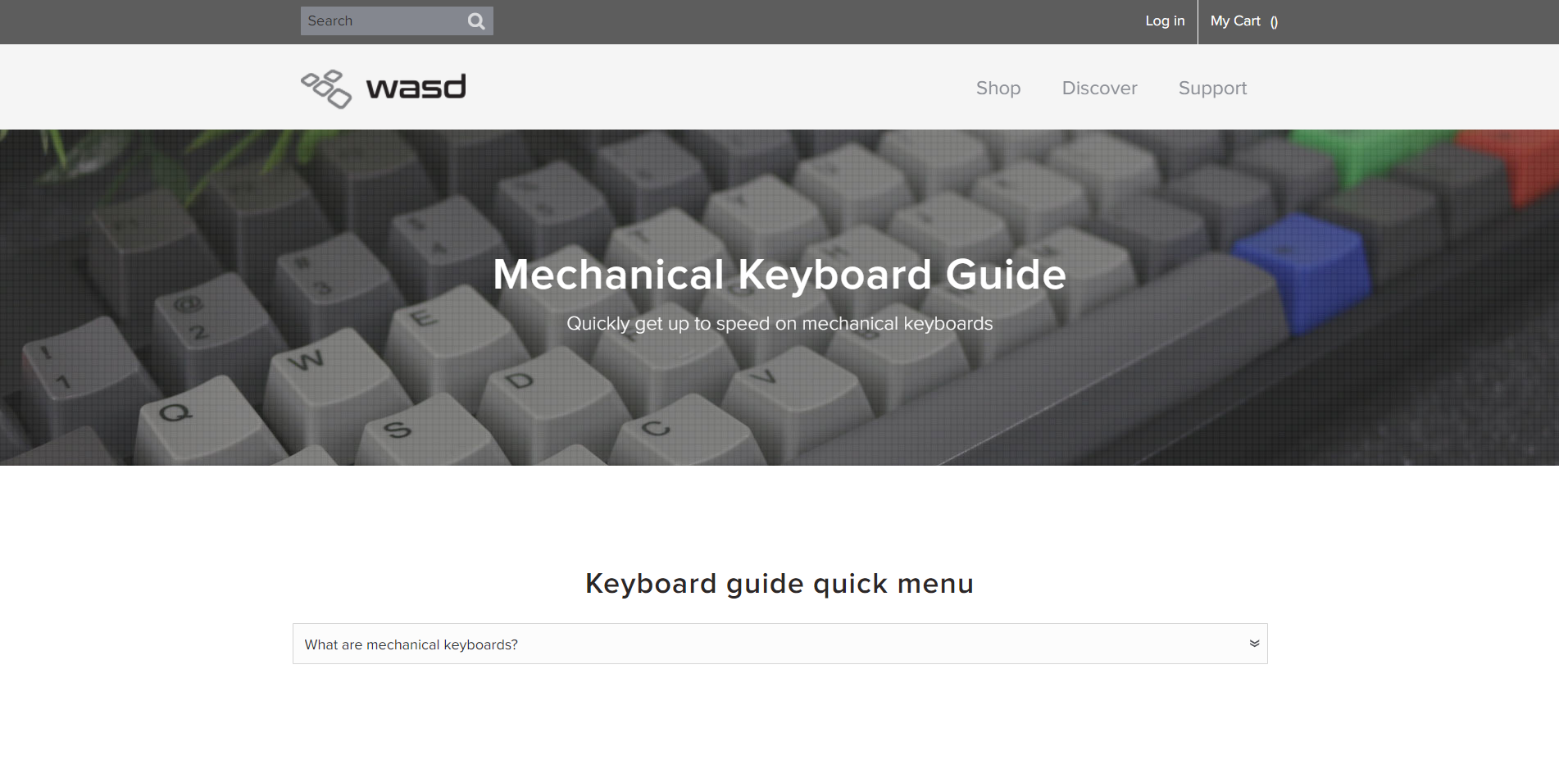**Evaluate the site layout and site content:**

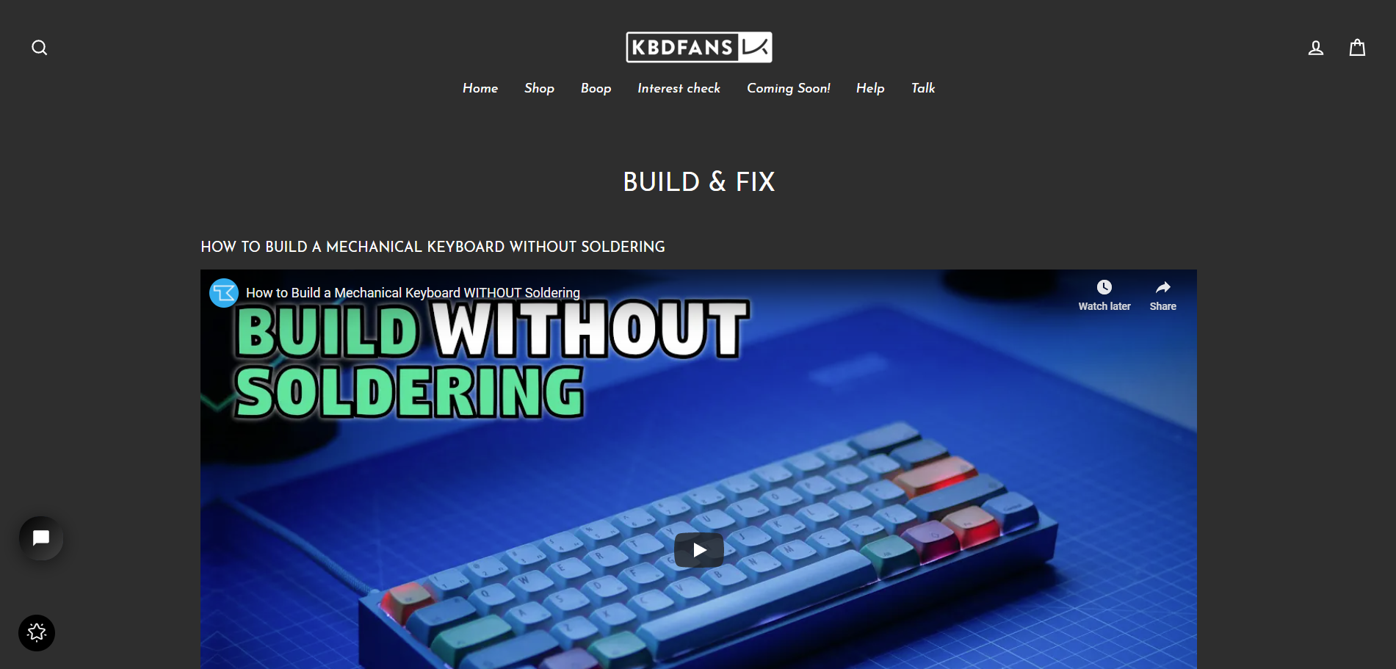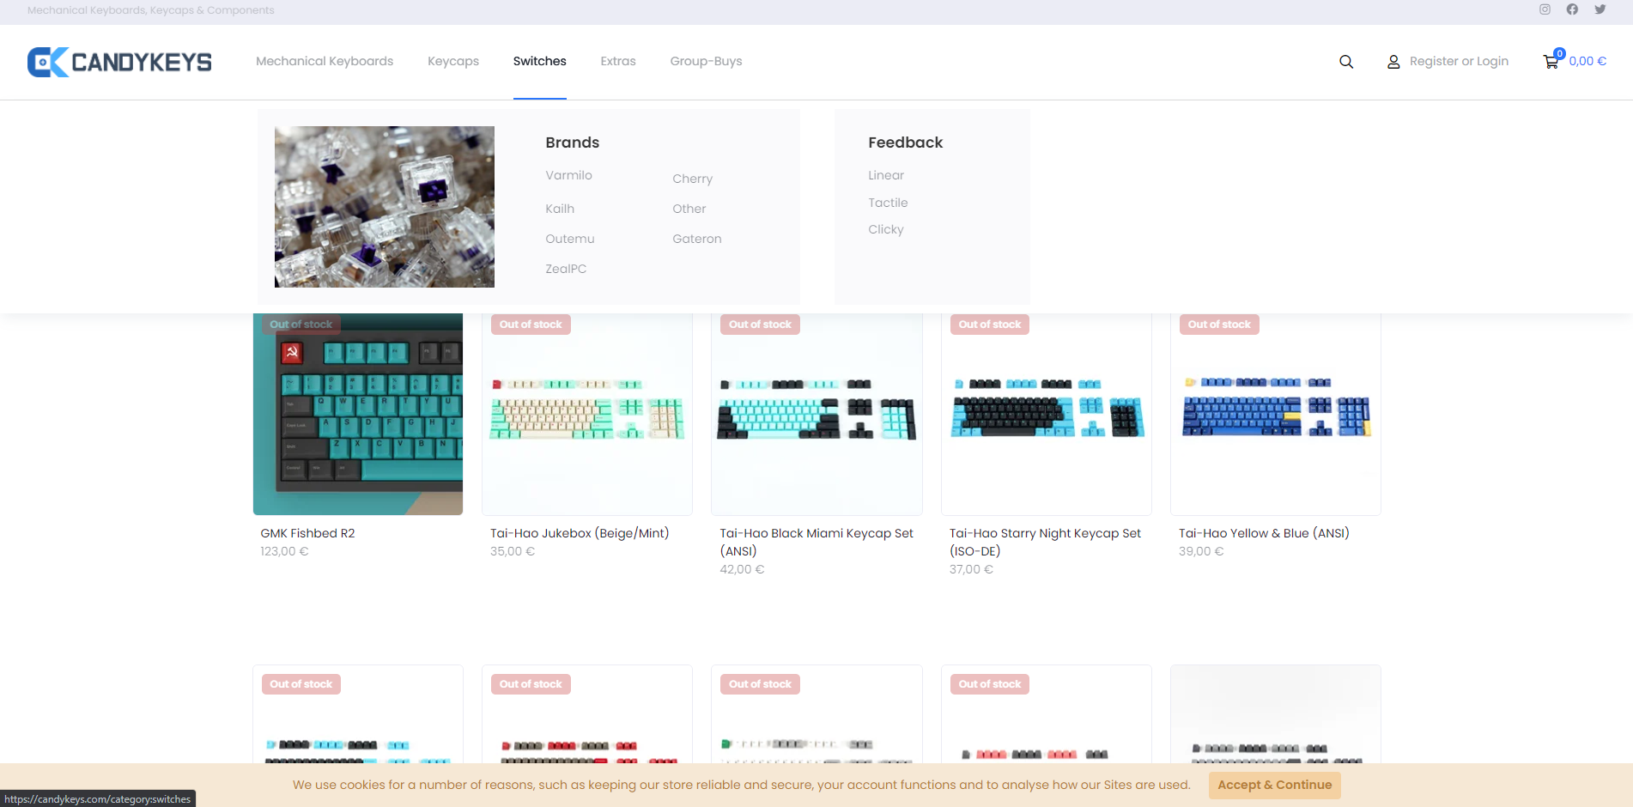

# 

This website has a lot of meaningful content about some aspects of mechanical keyboards. Good inspiration can be taken from it.

One takeaway from this website which was pretty appealing was the navigation bar styling. I liked the line underneath and the highlighting of the link so I will incorporate it into my site.

I like the dark minimalistic theme of this website and the navigation bar. It’s very soft on the eyes and the font is nice and easy to read.

# Technology Selection and Site Architecture

**Version of HTML/CSS to be used:**

HTML5 and CSS3 are to be used.

**Plan for site layout and responsive design:**

My goal is to inform users of the site so I want the information as straightforward and readable as possible. To do this, the layout will be simplistic and minimalistic as well as sporting a dark theme. It will be easy to follow info and soft on the eyes. Relative measurements will be used so resizing the browser will not be an issue. On top of that media queries will be in place for the various device types that the site may be displayed on.

**How do we expect users to view the site (Phone/tablet/PC etc...)?**

I expect more users to be on PC but cross-device compatibility will be put in place. In order to test it, Chrome Developer Tools can be used.

**Cross Browser Compatibility strategy?:**

Compatibility will be easily tested by opening the site on various browsers. Meta tags and DOCTYPEs will also increase compatibility between browsers.

# Low Fidelity Prototype

**Create a Lo-Fi prototype to describe the site content and layout for the customer/stakeholder:**

# 

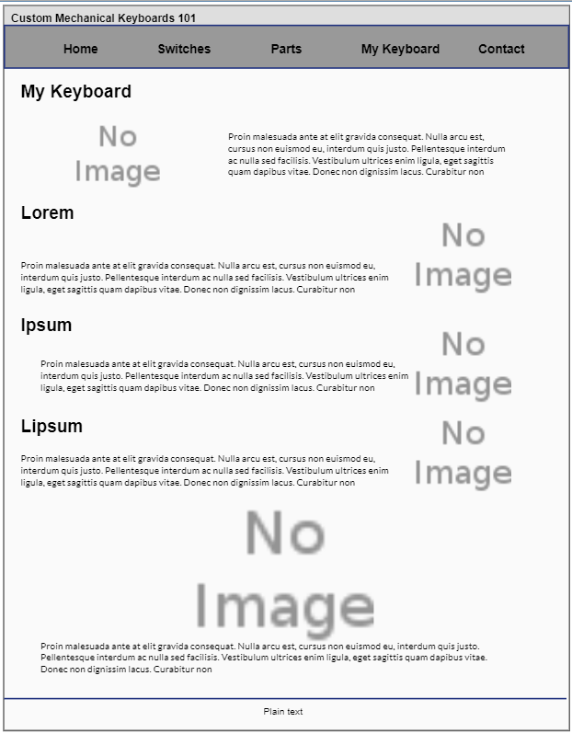

# 

# Development Plan

**Describe the process of how the site will be created:**

All the files will be made and edited on Microsoft Visual Studio Code. The prototypes will be followed with additional ideas along the way so a few discrepancies will be visible from the prototype to the final site which is normal.

# Testing Plan

**Explain in detail the strategies used to test the website. (eg. HTML validation, CSS validation):**

First of all, once the website was finished, I went onto <https://validator.w3.org/nu/> and <https://jigsaw.w3.org/css-validator/> to check the HTML and CSS respectively. There were a few errors like missing img names and section tags where there should have been divs. These were resolved from top to bottom until no errors were found by the validator. In order to test different devices, Chrome’s in-built developer tools were used. This was very helpful in emulating the various device sizes and seeing my website with their media queries.

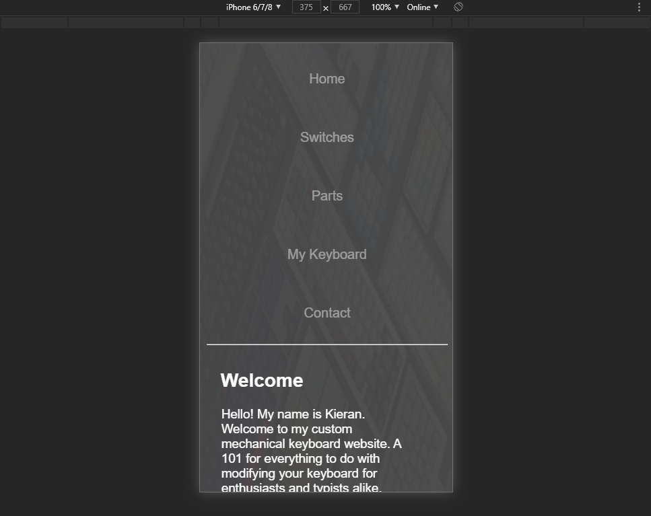

**Is the site Cross Browser Compatible?:**

The website was opened on Chrome, Edge, Firefox and Opera with no issues. Compatibility with Safari on Mac is unknown but it’s likely to work.

# Site Evaluation

**You must describe how you evaluated your website using appropriate heuristics:**

In accordance with Nielsens 10 Usability Heuristics for User Interface Design:

1. **Visibility of system status** - Appropriate error messages are visible when required fields on the contact page aren’t filled in.
2. **Match between system and the real world** – The language of the website is English and the terms are all explained in detail pertaining to mechanical keyboards. The layout of the page is in a structured manner.
3. **User control and freedom** – The navigation bar clearly shows to the user which section of the website they are on with the highlighted word.
4. **Consistency and standards** – A navigation bar and footer section are present as to the normal convention. It is very simple clicking and scrolling.
5. **Error prevention** – There aren’t any errors that can really break the site. The only thing that can happen is if one of the embedded links get shut down. Also the submission of the contact page isn’t setup for actual use unless the website was properly deployed.
6. **Recognition** – The separate pages have independent content to each other and operating the website is as easy as scrolling up and clicking one of the other navigation buttons.
7. **Flexibility and efficiency of use** – The navigation bar is only 5 words for 5 pages. It stays the same for all pages and can be clicked pretty much immediately.
8. **Aesthetic and minimalist design** – The website is short and concise with its topics. Font size makes everything pop out and there is a clear contrast with the background to have easy readability.
9. **Help users recover from errors** – Contact page errors clearly tells the user what is wrong and how to correct the error.
10. **Help and documentation** – There isn’t really a need for much help in traversing the website but if there is anything that the user finds confusing or hard to understand, the contact page is available for them to contact me about issues and problems.

The website seems to follow most of the heuristics for good website user interface design and so it can be evaluated that the website is well-made and user friendly

# Deployment

**Describe how the website was made available online:**

Once the website was made, hosting was done on <https://www.hostingireland.ie/hosting.php>. Meta tags were put in place inside the head section tag of the pages. The keywords meta tag allows for search engines to find the website easier through keywords about the topic when they are searched up. Afterwards, Filezilla, an FTP client, was logged into. All the relevant files for the website was copied onto the hosting via FTP. Finally, the link was added to Google!

# 

# Appendices

Weekly Logs

**Week 1:**

For week 1 I haven’t done much thinking for the project. I have some general ideas none of which have been expanded on due to poor time management so far. Some ideas right now are cats, LittleBigPlanet series and custom keyboard modifications. Cats isn’t a very likely topic I’d do despite my interest in them as it’s a very broad subject and text would feel very generic and non-meaningful. The LittleBigPlanet series and custom keyboard topics are what I’m leaning towards as I have a lot of interest in those as well as some experience to give personal input on. I will plan to do some sketches of possible layouts and content for both by the next lab report so I can finalise what topic my project will be on.

**Week 2:**

To be completely honest, not much was done on week 2 however I have decided to do a custom keyboard website. I have modified my own keyboard so I already have some experience in the sort of content I could put on it. In line with the project report, I’m hoping to get some research done through this week to get a general idea of my layout.

**Week 3:**

I got some research done this week. I looked up a few websites about custom mechanical keyboards and found some content and videos I could use as a reference for my website. There was also a very interesting navigation bar I saw on one of websites that I really liked and plan to include it in my own. I have a good enough idea for my content and layout to be confident enough to start this week so I would like to get my index page done this week.

**Week 4:**

I got my home(index) page done this week and I’m pretty satisfied with how it looks. I’ve implemented a navigation bar similar to what I’ve researched and the content I’ve included is very meaningful to my website topic. I know I’ve still got a lot of work cut out for me with only a bit of time left and so i’m hoping to get at least 2 pages done this week, preferably 3 if I can commit enough. With that, it’ll leave me with just the contact form page which I can do at the end of one of the days before the Saturday deadline.