AI Property Matching Agent
Real estate lead automation · n8n workflow · Telegram
21 October 2026
Optimity Logics | info@optimitylogics.com

Both test searches ended as designed
2 / 2  test searches handled |  | 100  live listings scanned per search |  | Top 5  matches ranked and scored |  | 6 hrs  listing cache per city

1. At a glance
Item | Detail
Task | AI Property Matching Agent (Real Estate)
What it does | Takes a buyer's property requirement from a Telegram chat, searches live listings, ranks the best matches, saves the lead and alerts the sales team
Built with | n8n, Telegram, Google Gemini, Apify, Google Sheets, Gmail
Tested with | 2 live Telegram searches in Ahmedabad: one with no match and one with three matches
Core idea | The buyer always gets an answer, the sales team gets a ready lead, and nothing is sent to the buyer as a promise without human review

2. The business problem
Property buyers send their needs as short chat messages, such as a budget, a BHK type and an area. A sales team then has to turn each message into a property search, and this takes time. Leads wait, details get missed, and buyers move to another agency.
The manual process today:
- Read the buyer message and note the budget, BHK and area.
- Search property portals one by one.
- Compare prices and locations against the buyer's budget.
- Copy the buyer and property details into a sheet.
- Write a follow-up message and brief the sales team.

3. The solution
An n8n workflow that works as a property advisor on Telegram. The buyer writes a normal message. Google Gemini understands it, and the workflow fetches live listings, filters them by the buyer's needs and scores each one out of 100. The buyer receives the top matches in the same chat. In the background, the lead is saved to Google Sheets and the sales team receives an email with a follow-up draft to review. If nothing fits, the buyer gets clear suggestions instead of an empty reply.
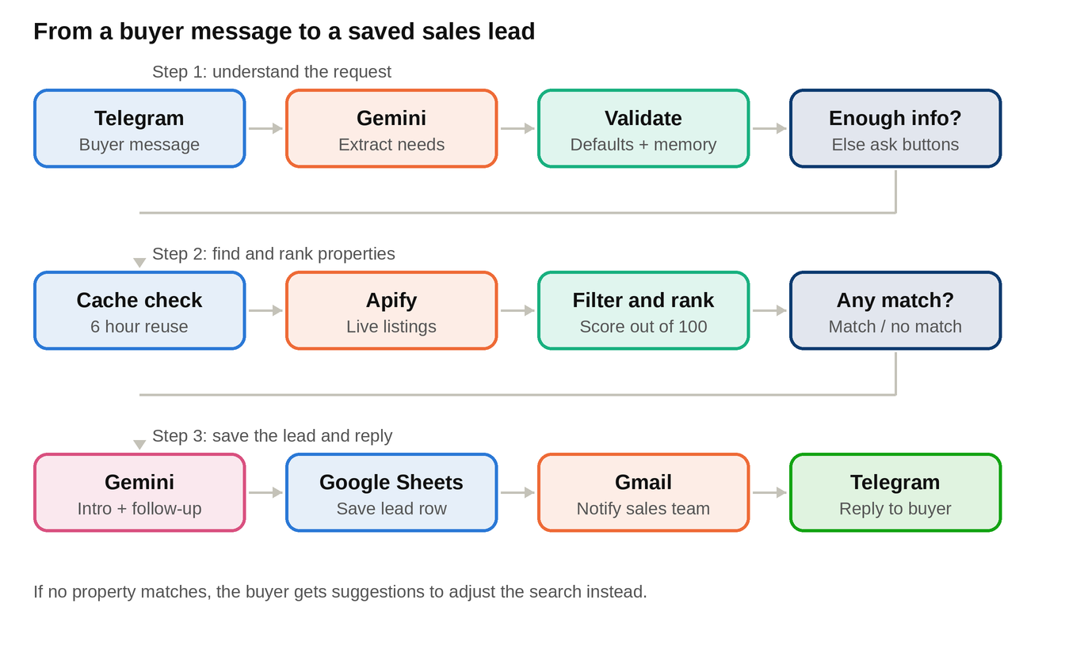
The workflow in three steps: understand the request, find and rank properties, then save the lead and reply.

4. How it works
Part | Node | What it does
Understand | Telegram Trigger | Receives the buyer's message from Telegram
Understand | Gemini: Extract Requirements | Reads the message and returns the buyer name, phone, email, city, localities, budget, BHK, area, amenities, possession and property type. Lakh and crore are converted to rupees, and nothing is invented
Understand | Validate Requirements | Joins the new message with earlier ones from the same chat (kept for 2 hours), so short follow-ups like '90 lakh' work. Fills safe defaults and builds a one-line summary
Understand | Need More Info? | Asks only when there is no budget, BHK or locality at all. Otherwise the search starts
Understand | Ask With Quick Buttons | Sends a question with tap buttons such as 2 BHK under 60 lakh and 3 BHK under 1 crore
Find | Searching Message | Tells the buyer that the live search has started
Find | Load Cache, Cache Hit? | Checks if listings for the city were fetched in the last 6 hours and reuses them if so
Find | Apify: Fetch Live Listings | If there is no cache, fetches up to 100 live listings for sale in the city
Find | Save Cache | Stores the fresh listings for the next search
Find | Normalize, Filter & Rank | Removes listings that do not fit, scores the rest out of 100 and keeps the top 5
Find | Any Matches? | Splits the flow into a match path and a no-match path
Reply | Gemini: Explain + Follow-up Draft | Writes a short friendly intro with one honest trade-off if there is one, and a follow-up draft offering site visits
Reply | Prepare Lead Row | Builds the buyer reply and the lead record
Reply | Google Sheets: Save Lead | Adds one row per lead
Reply | Gmail: Notify Sales | Emails the sales team the requirement, top matches and the draft for review
Reply | Final Reply, Send Reply | Sends the matches to the buyer with a note that an advisor will confirm availability
Reply | No Match Reply | Sends suggestions to raise the budget, add nearby areas or change the BHK

5. How matches are scored
Each listing is first checked against the hard rules: the BHK must match, the starting price must not be more than 10% above the budget, and the locality must match when the buyer names one. Listings that pass receive a transparent score out of 100.
Factor | Max points | How it is scored
Budget | 30 | Full points if the whole price range is within budget. Fewer points if only the starting price fits
Location | 25 | Full points when the requested locality is matched
BHK | 20 | Matches the requested configuration
Amenities | 15 | Share of requested amenities found in the listing
Possession | 10 | Fits ready to move or under construction, as requested
Ties are broken in favour of verified listings.

6. Lead data saved to Google Sheets
Every search that finds matches adds one row, so the sales team can follow up without retyping anything.
Telegram username, buyer name, phone, email, requirement text, city, localities, maximum budget, BHK, amenities, possession, top matches, top match links, follow-up draft, status and the reply sent to the buyer.
The status starts as 'New - awaiting sales approval'.

7. Tools and technologies
Tool | Used for | Why
n8n | Building and running the whole workflow | Visual builder with ready nodes for chat, AI, sheets and email
Telegram | Buyer chat and quick buttons | Easy for buyers, no app to build
Google Gemini | Understanding the message and writing the reply and draft | Returns structured JSON that the workflow can use
Apify | Live property listings | Gives fresh data without building a scraper
Google Sheets | Lead storage | Simple, visible and easy for sales to filter
Gmail | Sales team alert | Puts the lead and draft in the team's inbox for approval

8. Testing
The workflow was tested through Telegram with two real searches in Ahmedabad.
# | Search | Expected | Result
1 | 3 BHK flat in Vaishnavdevi Circle, Ahmedabad, under ₹90 lakh | Search live listings, find no suitable match and guide the buyer | Passed. 100 live listings scanned, no match. Suggested raising the budget by 10 to 15%, adding nearby areas or changing the BHK
2 | 3 BHK in Gota, Ahmedabad, under ₹90 lakh | Return ranked matches and save the lead | Passed. Three matches returned, then the requirement was saved and the sales advisor flow was explained

Matches returned in test 2:
Property | Match score | Location | Price
The Olive | 92 / 100 | Near Vandematram Road, Gota | ₹72.8 lakh to ₹1.03 crore
Khwaish Blue Bell | 92 / 100 | Jagatpur | ₹72.53 lakh to ₹1.13 crore
Festival Vibes | 82 / 100 | Gota | About ₹91.35 lakh, slightly above budget

9. Human approval and safety points
- The follow-up draft goes to the sales team first. It is reviewed before anything is sent to the buyer.
- The reply never claims that availability is confirmed. An advisor confirms availability and site visits.
- Amenities and possession status are not in the listing data, so the reply says the advisor will confirm them.
- Gemini is told never to invent values. Anything not stated by the buyer stays empty.
- A slightly over-budget match is pointed out honestly instead of being hidden.

10. Limitations and what production needs
- Chat memory and the listing cache are kept in n8n workflow data. Production needs a proper database.
- The search depends on 100 listings per city. A very specific locality can return no match even when a property exists, as in test 1.
- Listing data does not include amenities, possession status or area, so those cannot be scored exactly.
- Each search adds a new row, so a buyer who refines a search appears more than once. Production should merge repeat leads.
- Production also needs secure credential handling and error alerts.

11. Key learnings and improvements
- Never block the buyer. Safe defaults let the search start with a city and one detail, and buttons help only when there is nothing to search with.
- Transparent scoring builds trust. A score out of 100 with fixed factors is easy to explain to buyers and to sales.
- Caching saves time and cost. Reusing listings for 6 hours makes repeat searches faster and reduces scraper usage.
- Next improvements: a persistent database, more listing sources, amenity and possession data, merging repeat leads, sending the approved follow-up on WhatsApp, and a simple dashboard for lead status.
Optimity Logics | Email: info@optimitylogics.com

