Delivery Exception Agent
Logistics exception handling · n8n workflow · Human approval
21 October 2026
Optimity Logics | info@optimitylogics.com

Both test cases ended as designed
2 / 2  test cases handled |  | 6  sample shipments in the demo |  | 4  next actions the agent can choose |  | 0.7  minimum confidence to act alone

1. At a glance
Item | Detail
Task | Delivery Exception Agent (Logistics)
What it does | Reads a delivery exception report, checks shipment and SLA facts, picks one next action, prepares the customer message or escalation, and logs the decision
Built with | n8n, Google Gemini, Google Sheets, a web interface for reporting and approval
Tested with | 2 live test cases: a damaged package and a weather delay
Core idea | Rules compute the facts and set the limits, the AI only classifies and drafts, and a person approves before anything reaches a customer

2. The business problem
Delivery teams receive exceptions from drivers, customers and systems all day. Each one needs a quick, correct decision. Some only need a polite update, some need an address, and some are already breaking the delivery promise (SLA). When teams handle these by hand, urgent cases wait and customers are not informed.
The manual process today:
- Read the exception report from the driver, customer or system.
- Look up the shipment, the customer and the delivery address.
- Check how much time is left on the SLA.
- Decide whether to inform the customer, ask for an address, escalate or review.
- Write the message and record what was done.

3. The solution
An n8n workflow that receives each exception through a webhook. A code step looks up the shipment and customer and calculates the SLA facts by fixed rules. Google Gemini then classifies the exception and suggests one action. A guardrail step checks the suggestion against business rules and can override it. The result is routed to the right path, a draft message or escalation is prepared, and the decision is logged in Google Sheets. Customer messages wait for human approval.
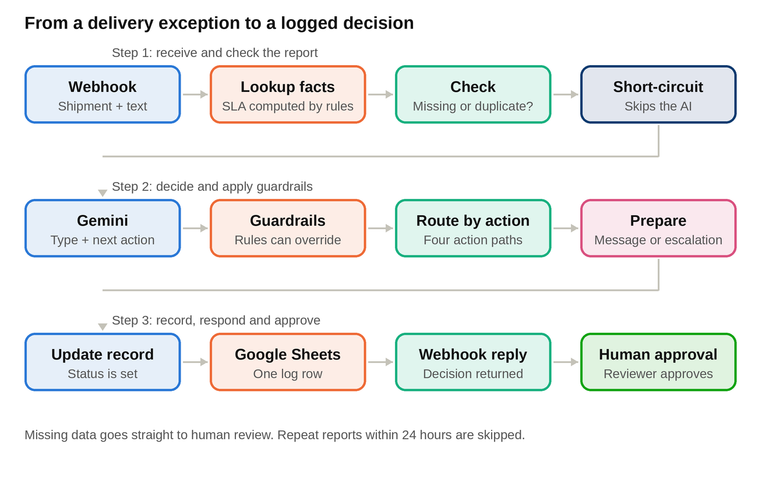
The workflow in three steps: receive and check, decide with guardrails, then record, respond and approve.

4. How it works
Part | Node | What it does
Receive | Webhook - Delivery Exception | Receives the shipment ID and the exception text as a POST request
Receive | Lookup Data & Compute Facts | Finds the shipment and customer, then calculates SLA hours left, breached or at risk, and who to escalate to. Also builds the AI prompt
Receive | Missing Data or Duplicate? | Stops the flow if data is missing or the same report was handled in the last 24 hours
Receive | Short-circuit (no LLM) | Missing data goes to human review with high priority. Duplicates are skipped. The AI is not called
Decide | Gemini - Classify & Decide | Returns the exception type, one action, a confidence score, a reason and a draft message. Temperature is low (0.1) for steady answers
Decide | Apply Guardrails | Checks the AI answer against the rules, applies overrides and sets the priority
Decide | Route by Action | Sends the case to one of five paths
Act | Draft Customer Notification | Prepares an email to the customer, approval required
Act | Draft Address Clarification | Prepares an email asking for a full address, landmark and phone number, approval required
Act | Prepare SLA Escalation | Prepares an internal alert to the ops team or ops manager, with priority and hours left
Act | Send to Human Review | Puts the case in the support lead's queue with the reason and the original report
Act | Skip Duplicate | Marks the repeat report as ignored
Record | Update Record & Log | Sets the record status and keeps the last 200 records
Record | Respond to Webhook | Returns the decision to the interface
Record | Google Sheets - Log Record | Adds one row for every processed exception

5. Rules that control the decision
The AI suggests an action, but these rules have the final say. The rules for SLA risk use facts calculated by the workflow, never numbers written by the AI.
Rule | What happens
Unknown action from the AI | Changed to human review
Confidence below 0.7 | Changed to human review
Damaged or lost, customer complaint, or unknown type | Always human review
SLA already breached | Changed to SLA escalation, unless it is already human review
SLA at risk and the AI says notify customer | Changed to SLA escalation

Customer tier | SLA at risk when hours left are below | Escalated to
Standard | 12 hours | ops-team
Premium | 24 hours | ops-manager

Priority is critical when the SLA is breached, high when the SLA is at risk or the customer is premium, and normal otherwise.

6. Decision data saved to Google Sheets
Every processed exception adds one row, so the team can review how each case was handled.
Timestamp, shipment ID, exception type, action, priority, confidence, channel, recipient, message, reason, approval required, record status and guardrail overrides.
Record status is one of: pending approval, awaiting human, actioned or ignored duplicate.

7. Tools and technologies
Tool | Used for | Why
n8n | Webhook, rules, routing and the whole flow | Visual builder with webhook, code, switch and Sheets nodes
Google Gemini | Classifying the exception and drafting the message | Returns structured JSON with a confidence score
Google Sheets | Decision log | Simple, visible and easy to audit
Agent interface | Reporting, decision view, approval and session history | Lets a person review the AI decision before action

8. Testing
The agent was tested through its interface with two shipments. All data is sample data.
# | Shipment and report | Expected | Result
1 | SHP-1002 (standard, Surat to Pune, out for delivery): 'Package crushed, box wet.' | Damaged item goes to a person, no automatic customer message | Passed. Human review, confidence 98%. Approved in the interface and saved to the session history
2 | SHP-1005 (premium, Rajkot to Chennai): 'Heavy rain delayed the truck.' | Weather delay with a safe SLA gets a customer update draft | Passed. Notify customer, confidence 98%, SLA safe with 30 hours left. Draft email to the customer is pending approval

Both cases appeared as separate rows in the Delivery Exception Log, with the type, priority, action, reason, message, approval requirement and status.

9. Human approval and safety points
- Customer emails and address requests are drafts that wait for approval before sending.
- Damaged, lost, complaint and unclear cases always go to a person.
- Missing shipment, customer or address data is never guessed. It goes to human review.
- The AI cannot change SLA facts. Those are calculated by rules.
- Low confidence answers are sent to a person.
- Repeat reports within 24 hours are skipped, so customers are not messaged twice.

10. Limitations and what production needs
- The shipments, customers and SLA rules are sample data inside the workflow. Production needs a live shipping and customer system.
- The workflow prepares the message, channel and recipient. A sending step for email, Telegram or Slack still needs to be connected after approval.
- Duplicate memory and history are kept in n8n workflow data. Production needs a database.
- The webhook has no authentication. Production needs a secret key or signed requests.
- The log sheet stores only the first guardrail override when there is more than one.
- Production also needs error alerts and a review of AI accuracy on real driver messages.

11. Key learnings and improvements
- Rules for facts, AI for language. Calculating SLA risk by rules keeps the decision reliable, and the AI handles the free text.
- Guardrails after the AI. Checking the AI answer against fixed rules stops risky actions even when the AI is confident.
- Skip the AI when it is not needed. Missing data and duplicates are handled without an AI call, which saves time and cost.
- Next improvements: live shipment data, sending after approval, a secured webhook, a database for history, and a dashboard for pending approvals.
Optimity Logics | Email: info@optimitylogics.com

