Healthcare Patient Intake & Appointment Agent
Healthcare front desk automation · n8n workflow · Telegram
21 October 2026
Optimity Logics | info@optimitylogics.com

Built to keep patients safe first
2  safety layers before any booking |  | 6  departments for routing |  | 4  tools the agent can use |  | 12  messages remembered per patient chat

1. At a glance
Item | Detail
Task | Healthcare Patient Intake & Appointment Agent
What it does | Collects patient details on Telegram, routes the patient to the right department, offers real appointment slots, books the confirmed slot and saves the appointment. Urgent messages go to clinic staff, not to the AI
Built with | n8n, Telegram, Google Gemini (AI agent), Google Sheets
Languages | English, Hindi and Gujarati. The agent replies in the language the patient uses
Core idea | The AI handles only front desk work. It never gives medical advice, and anything urgent or unclear goes to a person

2. The business problem
Clinics receive appointment requests as messages at all hours. Front desk staff have to collect the same details again and again, check which doctor is free, and book the slot by hand. A message about a serious symptom can also be buried among routine requests.
The manual process today:
- Read the patient's message and reply.
- Ask for the name, age, phone number and reason for the visit.
- Decide which department fits the reason.
- Check which doctor slots are free in that department.
- Confirm the slot with the patient and record the appointment.
- Spot urgent messages and pass them to a doctor or senior staff.

3. The solution
An n8n workflow that acts as a virtual front desk on Telegram. Every message first passes a keyword safety check. If it sounds urgent, the clinic staff are alerted and the patient is told to call the emergency number. Otherwise, a Google Gemini agent continues the conversation, collects the intake details, checks free slots in Google Sheets, books the slot the patient confirms and saves the appointment.
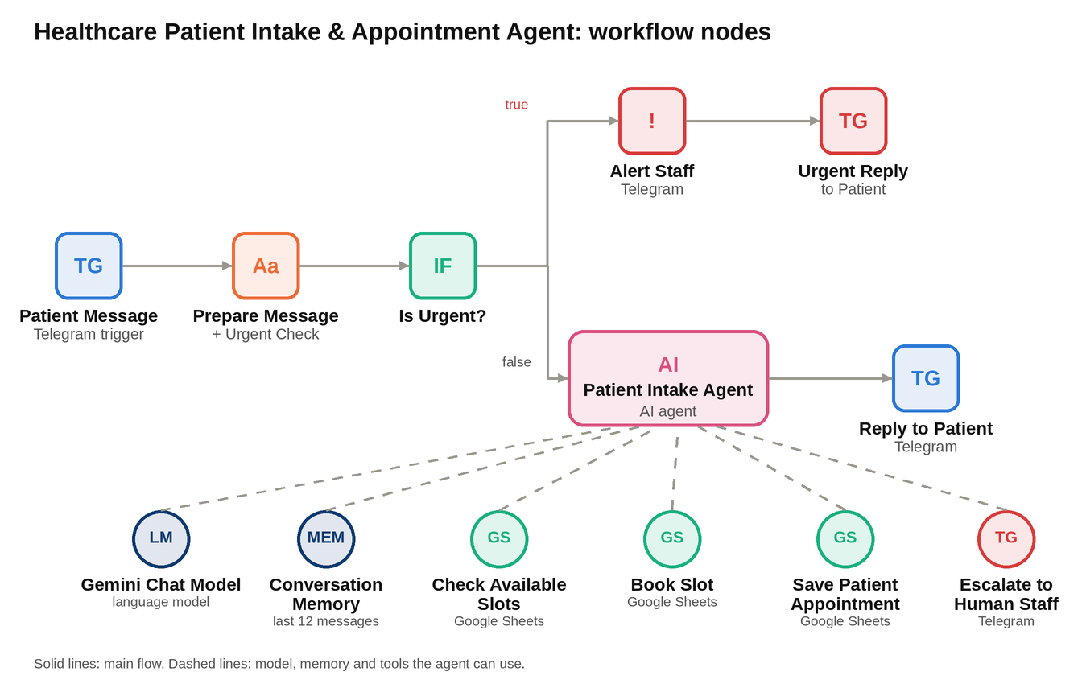
The workflow as nodes: a safety check first, then the AI agent with its model, memory and four tools.

4. How it works
Part | Node | What it does
Safety | Patient Message (Telegram) | Receives each patient message
Safety | Prepare Message + Urgent Check | Takes the chat ID, text and first name. Checks the text for urgent words such as chest pain, trouble breathing, heavy bleeding, stroke, seizure, poisoning and self-harm, including some Hindi and Gujarati phrases
Safety | Is Urgent? | Sends urgent messages to the staff path and all others to the AI agent
Safety | Alert Staff (Urgent) | Sends the clinic staff the patient name, chat ID, message and time, and states that no appointment was booked
Safety | Urgent Reply to Patient | Tells the patient this may be an emergency, to call 112 or go to the nearest emergency room, and that staff were alerted
Agent | Patient Intake Agent | Runs the conversation using strict rules: collect details, pick a department, offer slots, book only after clear confirmation
Agent | Gemini Chat Model | The language model behind the agent
Agent | Conversation Memory | Remembers the last 12 messages of each patient chat
Tools | Check Available Slots | Reads the Slots sheet for open slots in the chosen department
Tools | Book Slot | Marks the confirmed slot as Booked
Tools | Save Patient Appointment | Adds the appointment to the Appointments sheet with status Confirmed
Tools | Escalate to Human Staff | Sends staff a short summary when the agent cannot or should not continue
Reply | Reply to Patient | Sends the answer as plain text by removing markdown symbols

5. Rules the agent follows
- It only does admin work. It never diagnoses, names medicines, gives treatment advice or reads symptoms. It offers a doctor appointment instead.
- If something sounds urgent, it stops booking, tells the patient to call 112 or go to an emergency room, and alerts staff.
- If it is unsure, the patient is upset or the patient asks for a human, it escalates to staff.
- It collects the full name, age, a valid 10-digit Indian mobile number and the reason for the visit, one or two questions at a time.
- It books only after the patient clearly confirms one slot, and calls the tools one at a time.
- It confirms the appointment only after both Book Slot and Save Patient Appointment have succeeded. If either fails, it apologises and escalates.
- It never invents doctors, dates or times. It uses only what the slot tool returns.
- It says it is an AI assistant whenever asked.

Department routing (for scheduling only, not diagnosis):
Department | Used for
General Medicine | Fever, cold, cough, weakness, check-ups and unclear complaints
Orthopedics | Bone, joint, knee, back, shoulder and sports injuries
Dermatology | Skin, rash, hair, nail and skin allergy
Pediatrics | Children under 14 years
ENT | Ear, nose, throat, sinus and hearing
Gynecology | Pregnancy, periods and women's health

6. Data saved to Google Sheets
Slots sheet: Slot ID, department, doctor, date, time and status (Available or Booked).
Appointments sheet: timestamp, Telegram chat ID, patient name, age, phone, department, reason for visit, slot ID, doctor, date, time and status.

7. Tools and technologies
Tool | Used for | Why
n8n | Building and running the whole workflow | Visual builder with Telegram, AI agent and Sheets nodes
Telegram | Patient chat and staff alerts | Patients already use it, so no new app is needed
Google Gemini | Understanding the patient and running the conversation | Handles English, Hindi and Gujarati replies
Google Sheets | Doctor slots and the appointment record | Simple for clinic staff to view and update

8. Scenarios the agent is built to handle
These describe the designed behavior of the workflow. Test results are not part of this document.
Scenario | Designed behavior
Normal booking | Collects details, offers up to 3 slots, books the confirmed one, saves it and confirms
Vague reason, such as 'I do not feel good' | Asks one simple follow-up, then routes to General Medicine if still unclear
Invalid phone number | Asks for a valid 10-digit mobile number again
No slots available | Says so and offers another date, another doctor in the same department, or staff help
Urgent message | Skips the AI, alerts staff and tells the patient to call 112 or go to an emergency room
Request for medical advice | Politely refuses, says a doctor must answer, and offers an appointment
Patient asks for a human | Escalates to staff and tells the patient someone will contact them
A booking tool fails | Does not claim success. Apologises and escalates to staff

9. Human approval and safety points
- Urgent messages are caught by a keyword check before the AI sees them, and staff are alerted.
- The agent rules add a second layer for urgent signs the keyword list may miss.
- No medical advice is ever given. Doctors answer medical questions.
- Nothing is booked without explicit confirmation from the patient.
- The agent cannot say 'booked' unless both booking tools succeeded.
- Staff receive an alert for every escalation, with the patient's chat ID so they can follow up.

10. Limitations and what production needs
- This document has no recorded test results. The scenarios in section 8 should be run before go-live.
- Patient details are personal health-related data. Telegram and Google Sheets need access control, consent and a privacy review before real use.
- The urgent check is a keyword list, so differently worded emergencies depend on the agent rules.
- Booking and saving are two separate steps. If the second fails, the slot is already marked Booked and staff must fix it.
- Two patients choosing the same slot at the same moment is not locked.
- Staff alerts go to one fixed Telegram chat, and there is no check that someone has read them.
- There is no cancel, reschedule or reminder flow yet.

11. Key learnings and improvements
- Two safety layers. A fast keyword check before the AI and clear rules inside the agent protect patients better than either one alone.
- One tool at a time. Booking first and saving second, with confirmation only after both, avoids false confirmations.
- Plain text replies. Removing markdown symbols keeps Telegram messages clean.
- Next improvements: cancel and reschedule, reminders, calendar sync, slot locking, a secure patient database, and a staff dashboard.
Optimity Logics | Email: info@optimitylogics.com

