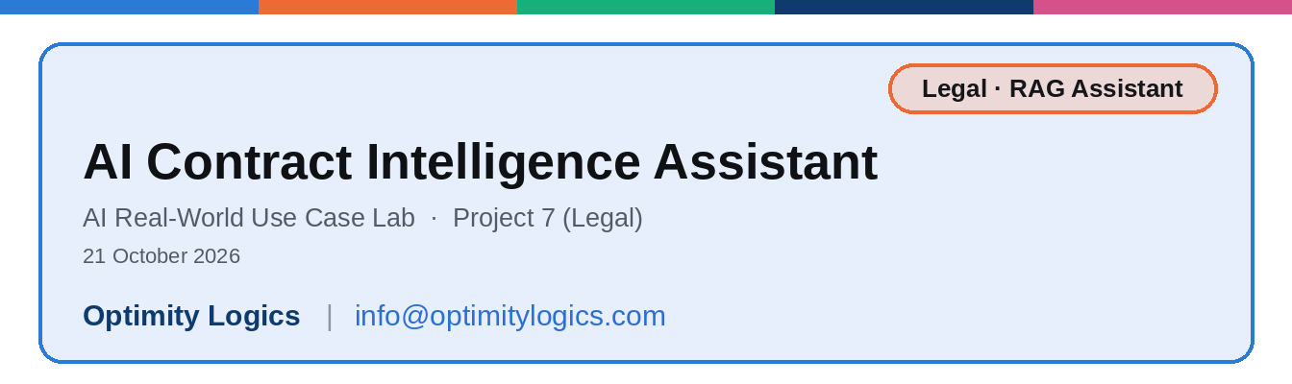

1. At a glance
Item | Detail
Project | AI Contract Intelligence Assistant (Legal)
What it does | Answers questions about company contracts in plain English and shows the contract, clause and exact words behind every answer
Who it is for | Legal and procurement teams
Built with | n8n, Google Gemini (embeddings and chat model), RAG with an in-memory vector store, Simple Memory
Tested with | 4 sample contracts (Orbit Cloud, Premier Facility, Vertex Logistics, Zenith Software) and 10 test questions
Core idea | The AI answers only from the clauses it retrieves, never from its own knowledge, and always shows its source

2. The business problem
Companies sign many contracts: cloud services, facility management, logistics, software and more. Each one has its own renewal, termination, payment and liability terms, and the same topic is often written differently from one contract to the next. When someone asks a simple question such as how much notice is needed to end an agreement, a person has to find the right PDF, scroll to the right clause and read it carefully.
This takes time, and mistakes can be costly. A missed notice period can mean an unwanted renewal, and a misread payment term can mean a late payment.
The manual process today:
- Find the right contract PDF in a folder or an email.
- Search through the pages for the relevant clause.
- Read it carefully, because renewal, non-renewal notice, termination for convenience and termination for cause are different clauses.
- Copy the answer and clause number into a message for the person who asked.
- Ask the legal team to double-check.

3. The solution
Optimity Logics built a contract assistant in n8n using RAG (retrieval-augmented generation). The contracts are loaded once and stored in a searchable library. When a user asks a question, the assistant first searches the library for the matching clauses and then writes a short answer from those clauses only, with the evidence and the source.
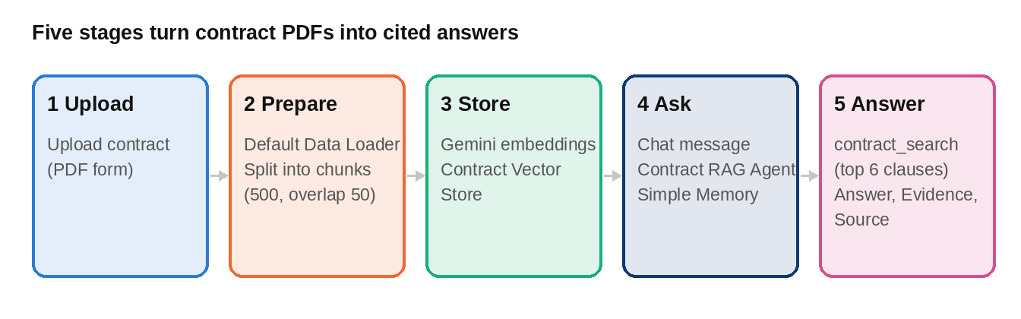

Core idea: the AI is a reader, not an author. It can only use the clauses the search returns, so it cannot invent dates, amounts or terms, and every answer can be checked against the contract.

What the assistant changes:
Task | Manual | With the assistant
Finding a clause | Open and search each PDF | Ask in plain English in a chat
Trusting the answer | The reader must check everything | Contract, clause number and exact words are shown
Comparing contracts | Read each contract in turn | One question is answered for every contract found, each in its own block
Follow-up questions | Start the search again | Chat memory keeps the last 10 messages

4. Flow 1: Load contracts
This flow reads each contract PDF and builds the searchable library. It is run once per contract.
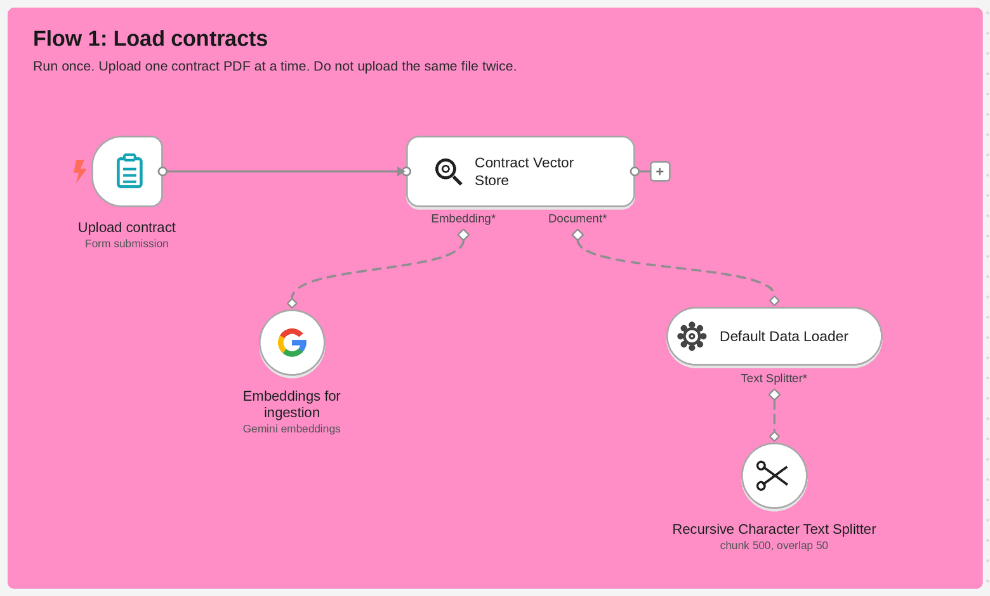
Flow 1 in n8n: the upload form feeds the Contract Vector Store, which uses Gemini embeddings and the PDF loader with its text splitter.
Step | Node | What it does
1 | Upload contract | A form with one required PDF upload. One contract is uploaded at a time
2 | Default Data Loader | Reads the PDF and saves the file name as the source of every piece of text, so answers can name the document
3 | Recursive Character Text Splitter | Cuts the text into chunks of 500 characters with an overlap of 50, so a clause is not cut in the middle of its meaning
4 | Embeddings for ingestion | Google Gemini turns each chunk into numbers (an embedding) that capture its meaning
5 | Contract Vector Store | Saves the chunks and their embeddings in an in-memory library named contracts_kb

Do not upload the same file twice, because the same clauses would be stored again.

5. Flow 2: Ask questions
This flow is the chat. The agent searches the library and answers with the contract, clause and evidence.
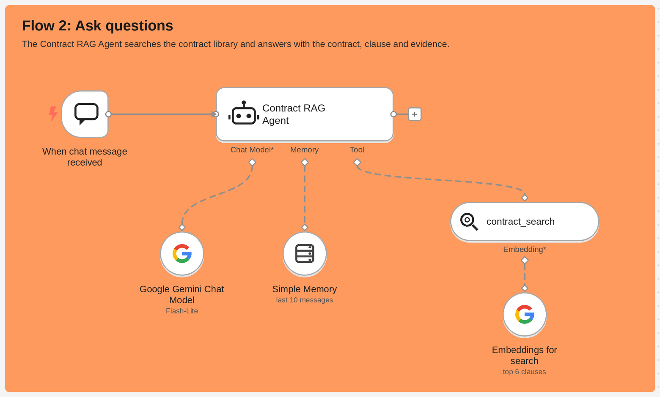
Flow 2 in n8n: the Contract RAG Agent uses a Gemini chat model, Simple Memory and the contract_search tool.
Step | Node | What it does
1 | When chat message received | The chat window where the user types a question
2 | Contract RAG Agent | The central AI node. It follows the instructions, searches the library and writes the answer
3 | Google Gemini Chat Model | The language model (Gemini Flash-Lite) that reads the retrieved clauses and writes the answer
4 | Simple Memory | Keeps the last 10 messages so follow-up questions work
5 | contract_search | Searches the same contracts_kb library and returns the 6 closest clauses. It covers term, renewal, termination, payment, liability, confidentiality, governing law and other clauses
6 | Embeddings for search | Turns the question into the same kind of numbers so it can be matched with the stored clauses

How one question is answered:
- The user types a question in the chat.
- The agent builds a search using the contract name and the topic, for example the contract name plus "termination notice".
- contract_search finds the 6 closest clauses in the library.
- The agent keeps only clauses that belong to the contract that was asked about.
- It writes the answer in a fixed layout: Answer, Evidence and Source.
- If there is no matching clause, it says so instead of guessing.

6. Retrieval check
A separate small flow tests the search without the AI. It runs one search and shows which clauses come back.
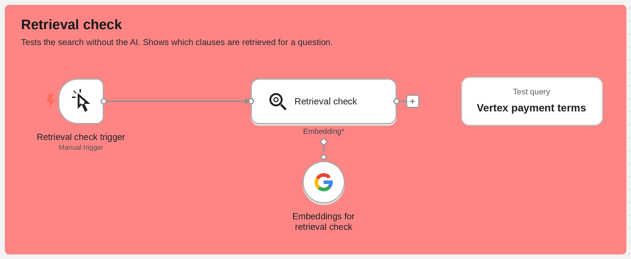
The retrieval check runs the test query "Vertex payment terms" against the library.
Why it helps:
- Finding the cause quickly. If the right clause does not appear here, the problem is in the search, such as chunking or embeddings.
- Separating search from AI. If the right clause appears but the answer is wrong, the problem is in the AI instructions.

7. The answer format
Every answer uses the same clean layout, so a reader can check it in seconds:
Answer: one or two clear sentences that answer only what was asked
Evidence: "the key words from the clause"
Source: Contract name, Clause number: Clause title (document file name)

Part | What it contains | Rule
Answer | The direct answer, with dates, amounts and periods exactly as written. If a date is calculated, the clause values used are shown | Answers only what was asked
Evidence | The key words from the clause, in quotation marks | Never more than 25 words; long clauses are shortened with "..."
Source | Contract name, clause number, clause title and file name | Lets the reader open the exact clause

When several contracts are involved, each contract gets its own block that starts with the contract name in bold, and the blocks are separated by a line.

8. What users can ask
Question type | Example | What the assistant does
One contract, one topic | What are the payment terms in the Vertex Logistics contract? | Searches that contract and topic and answers from the matching clause
Notice period | How much notice is needed to terminate the Orbit Cloud Services Agreement? | Answers only the termination notice, not renewal or other terms
No contract named | Which contracts mention renewal, and what do they say? | Searches the topic and answers for every contract found, each with its own source
Term not in the contract | A question about a term the contract does not contain | Says: "This is not stated in the [contract name]."
Contract not in the library | A question about a contract that was never uploaded | Says: "I could not find this contract in the library."
Opinion or advice | Is this liability cap fair? | Reports only what the contract says and suggests legal review

9. Guardrails and design decisions
Decision | Where | Why it matters
Answer only from retrieved clauses | Agent instructions | Stops the AI from inventing dates, amounts, notice periods or terms
Search with the contract name and topic | Agent instructions | The same topic, such as payment or renewal, has different terms in different contracts
Use a clause only if it belongs to the contract asked about | Agent instructions | Avoids mixing the terms of one contract into the answer for another
Chunks of 500 characters, overlap of 50 | Text splitter | Small chunks keep the search precise; the overlap keeps the meaning of a clause intact at the cut
Return the 6 closest clauses | contract_search | Enough to cover a question across contracts without flooding the model
File name saved with every chunk | Data loader metadata | Lets every answer cite its document
Quote limit of 25 words | Agent instructions | Shows the evidence without copying whole clauses
Keep similar terms apart | Agent instructions | Renewal, non-renewal notice, termination for convenience and termination for cause are different clauses
Fixed "not found" replies | Agent instructions | An honest "not stated" or "not in the library" instead of a guess
No legal advice | Agent instructions | Only reports what the contract says and suggests legal review for decisions
Same Gemini embeddings for loading and searching | All embedding nodes | The question and the clauses must be turned into numbers the same way to be matched

10. Tools and technologies
Tool | Used for | Why
n8n | Building and running both flows | Visual builder with ready nodes for forms, chat, AI agents and vector stores
Google Gemini (embeddings) | Turning clauses and questions into searchable numbers | Matches by meaning, so a question can find a clause even when the words differ
Google Gemini (chat model) | Writing the final answer | Fast model that follows the answer layout and rules
In-memory vector store | The searchable contract library | Simple to set up inside n8n and easy to demonstrate
Simple Memory | Conversation context | Lets users ask follow-up questions

11. Testing
The workflow was tested with 4 sample contracts (Orbit Cloud, Premier Facility, Vertex Logistics and Zenith Software) and 10 test questions. Each question is checked against the points below.
Check | What is verified
Right contract | The answer comes from the contract that was named in the question
Right clause | Similar clauses are kept apart, for example renewal, non-renewal notice and termination
Exact values | Dates, amounts and periods are stated exactly as written in the clause
Evidence and source | A short quote of up to 25 words and a complete source line are shown
Missing information | A term that is not in the contract gets "This is not stated in the [contract name]."
Unknown contract | A contract that is not in the library gets "I could not find this contract in the library."
No contract named | The assistant answers for every contract found, each with its own source

12. Human review and responsible use
- Not legal advice. The assistant reports what a contract says. It does not give legal advice or say whether a term is fair, valid or enforceable.
- Easy to verify. The source line lets a reviewer open the exact clause and confirm the answer.
- Decisions stay with people. For any decision, such as ending, renewing or signing a contract, the legal team should review the clause.
- Read-only. The assistant only reads contracts. It never changes a contract or sends anything on its own.

13. How to run it
- Open Flow 1 and upload each contract PDF once, one file at a time.
- Optionally run the retrieval check to confirm that the search finds the right clauses.
- Open the chat and ask a question in plain English. Naming the contract and the topic gives the best result.
- Check the source line against the contract before acting on an answer.
- To add a new contract later, upload it through Flow 1.

14. Where it can be used
Team | Example use
Legal | Quick clause lookup before a detailed review
Procurement | Checking vendor payment, renewal and termination terms
Finance | Finding payment terms and notice periods for planning
Sales and operations | Checking the terms of customer and service agreements
Other document libraries | The same pattern works for policies, SOPs and other agreements

15. Limitations and what production needs
- The contract library is stored in memory inside n8n. If n8n restarts, the contracts may need to be loaded again. Production should use a persistent vector database.
- Uploading the same file twice stores its clauses twice. Production should check for duplicates.
- It reads text-based PDFs. Scanned contracts would need text recognition (OCR) first.
- The text splitter cuts by size, not by clause heading. Splitting by clause would keep each clause whole.
- The assistant sees only the 6 closest clauses for each search, so a very broad question may not cover everything.
- Chat memory holds the last 10 messages only.
- There is no access control, so everyone who can open the chat can ask about every contract.
- Production also needs an audit log of questions and answers, monitoring, and a regular test set to catch wrong answers.

16. Key learnings and improvements
- Ground the AI. Letting the AI answer only from retrieved clauses makes it trustworthy and easy to check.
- Always show the source. Showing the contract, clause and exact words builds trust with legal teams.
- Test search on its own. A separate retrieval check shows quickly whether a problem is in the search or in the AI.
- Search precisely. Telling the AI to search with the contract name and topic keeps similar terms from different contracts apart.
- Next improvements: use a persistent vector database, split contracts by clause, store key dates for renewal reminders, add role-based access and an audit log, support scanned PDFs, and add the chat to Slack or Teams.

