**HTML/HTML 5 /XHTML(BASIC)**

* Hypertext / markup language
* Hypertext:

Page with in page

(or)

**Link available** webpage

* Markup Languages:

Tell to the browser how to display the structure.

* WWW language
* Developer - **Tim berners Lee** Year –
* Extension -
* Tag :

enclosed within angle braces <Tag Name>.

* Tags :

It contains three parts:

Open tag -

Content - placed between tags to **display data** on webpage

Close tag -

* Basic Tags:

<!**DOCTYPE...>** -document type and HTML version.

web browser to understand the version of the HTML

<!DOCTYPE html> - **HTML 5** version

<html> - represent the complete HTML document

header represented -<head>...</head>

body represented - <body>...</body>

**Attributes:**

**Manifest**  - URL - offline browsing

<head> - represents the document's header

- keep other HTML tags like <title>, <link>, <script>

<title> - mention the document title.

<body> - represents the document's body

- keeps other HTML tags like <h1>, <div>, <p> etc.

|  |
| --- |
| Important Abbrivations:  W3C -World Wide Web **Consortium** |

**Heading Tags** :

six levels of headings:

Example:

<h> -(like a paragraph) (O/P) -This is heading

<h1>**This is heading 1**

<h2> **This is heading 2**

<h3> **This is heading 3**

<h4> **This is heading 4**

<h5> **This is heading 5**

<h6> **This is heading 6**

**Paragraph Tag:**

**<p> - your text into different paragraphs**

|  |  |
| --- | --- |
| **<br/>** | **Empty Element** |
| **<hr />** | **Empty Element** |

**Line Break Tag:**

**Syntax :** <br /> - Anything starts from the next line **emptyelement -** Do not need opening and closing tags and

Content

* **Do not put forward slash** Work in html
* Not valid in **XHTML**.

**Center Tag :**

<center> - **content in the center** or table cell.

**Horizontal Tag :**

<hr> - **line from the current position in the document to the right margin**

**Preserve Formatting Tag :**

<pre> - **exact format** of HTML document

**Nonbreaking Spaces Tag :**

&nbsp; - **normal space**.

**3.HTML ELEMEMTS**

**Tag vs Element**

**Tag :**

Enclosed with angle Brackets

**Element :**

HTML element is defined by a starting tag. If the element contains other content, it ends with a closing tag.

|  |
| --- |
| **Void Elements** |
| **<img/>** |
| **<br/>** |
| **<hr/>** |

**Italic & Underline Tag:**

<i>italic</i>

<u>This is <u>

**4.HTML – ATTRIBUTES**

**Attribute** :

- define the **characteristics of an HTML element** and is placed inside the element's opening tag

- made up of two parts:

- **name** and  **value:**

name : name of the property

value : value of the property

put within quotation

**align attribute**: left, center and right.

- Attribute names and attribute values are **case-insensitive**.

**Core Attributes** :

**four** core attributes:

* + **Id**
  + **Title**
  + **Class**
  + **Style**

**Id Attribute**:

**uniquely identify** any element within an HTML page.

Same name used to **Create set of element** to use common style applying purpose

Ex:

<p id="html">This para explains what is HTML</p>

**Title Attribute**: "Pop-up"

**suggested title** for the element

cursor comes over the element or while the element is loading.

Ex:

<h3 title="Hello HTML!">Titled Heading Tag Example</h3>

**class Attribute** :

**specifies the class** of element

**space-separated** list of class names

Ex:

class="className1 className2 className3"

**style Attribute** :

**specify Cascading Style Sheet (CSS) rules** within the element.

Ex:

<p style="font-family:arial; color:#FF0000;">Some text...</p>

**Internationalization Attributes**

Three internationalization attributes:

* + **dir**
  + **lang**
  + **xml:lang**

**dir Attribute**:

**direction** in which the **text should flow**.

* ltr Left to right (the default value)
* rtl Right to left ( Hebrew or Arabic that are read right to left)

Ex:

<html dir="rtl"> 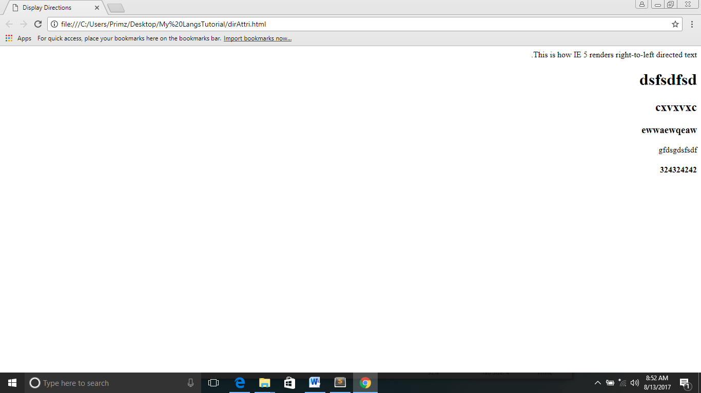

**Lang Attribute**:

indicate the **main language**

HTML Language Codes: **ISO 639<**Ex:

Ex:

<html lang="en">

**Attribute Options :**

**Align** : (Horizontal Align Tags)

right, left, center

**valign** (Vertical Align Tags)

top, middle, bottom .

**bgcolor** :

numeric, hexidecimal, RGB values

**Background**:

URL - background image behind an element

**width** :

Numeric Value - width of tables, images, or table cells.

**Height:**

Numeric Value - height of tables, images, or table cells.

**5. HTML – FORMATTING**

**Bold Tag:**

<b>bold</b> - displayed in bold

**Italic Tag:**

<i>italicized</i> - displayed in italicized

**Underlined Tag:**

<u>underlined</u>- displayed in underline

**Strike Tag:**

<strike>strikethrough</strike> - displayed with strikethrough

**Monospaced Font Tag:**

<tt>monospaced</tt> - written in monospaced font

**Superscript Tag:**

<sup>superscript</sup> - written in superscript

**Subscript Tag:**

<sub>subscript</sub> - written in subscript

**Inserted Tag:**

<ins>wine</ins> - displayed as inserted text.

**Deleted Tag:**

<del>cola</del> - displayed as deleted text.

**Larger Tag:**

<big>big</big> - displayed one font size larger

**Smaller Tag:**

<small>small</small> - displayed one font size smaller

**Grouping Content Tag:**

**Div tag:**

<div>…..</div> - subsections of a page

<span>…..</span> - group inline elements only

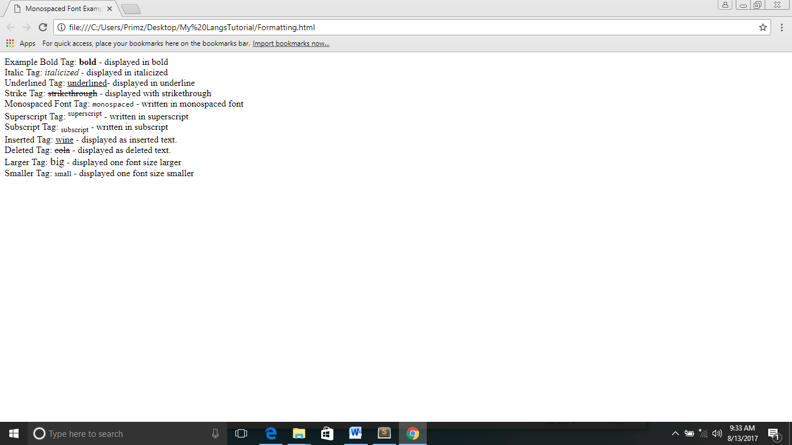­­­­

**6.HTML – PHRASE TAGS**

**Emphasized Tag:**

<em>emphasized</em> - displayed as emphasized text.

**Marked Tag:**

<mark>marked</mark> - displayed as marked with yellow ink.

**Strong Tag:**

<strong>strong</strong> - displayed as important text.

**Text Abbreviation Tag:**

<abbr title="Abhishek">Abhy</abbr> - abbreviate a text by putting it inside opening <abbr> and closing </abbr> tags

**Acronym Element Tag:**

<acronym>XHTML</acronym>

<acronym> element allows you to indicate that the text between <acronym> and </acronym>

**Text Direction bdo Tag:**

<bdo dir="rtl">This text will go right to left.</bdo>

Bi-Directional Override and it is used to override the current text direction

**Special Terms dfn Tag:**

<dfn>special</dfn> - introducing a special term

- similar to italic words in the midst of a paragraph

**Quoting blockquote Tag:**

<blockquote>XHTML 1.0 HTML 2.0.</blockquote>

- quote a passage from another source

**Short Quotations q Tag:**

<q>I think I am wrong</q> - add a double quote within a sentence

**Text Citations cite Tag:**

<cite>W3 Standard for HTML</cite> - print publication

**Code Tag:**

<code>This is code.</code> - Any programming code to appear on a Web page should be placed inside <code>...</code>tags. **monospaced font**

**Keyboard Text Tag:**

<kbd>This is inside kbd element</kbd> - indicate what should be typed in

**Variables Tag:**

<var>user-name</var> - content of that element is a variable,

used in conjunction

**Output Tag:**

<samp>Hello World!</samp> - output from a program, and script

**Address Text Tag:**

<address>388A, Road No 22, Jubilee Hills - Hyderabad</address> - contain any address.

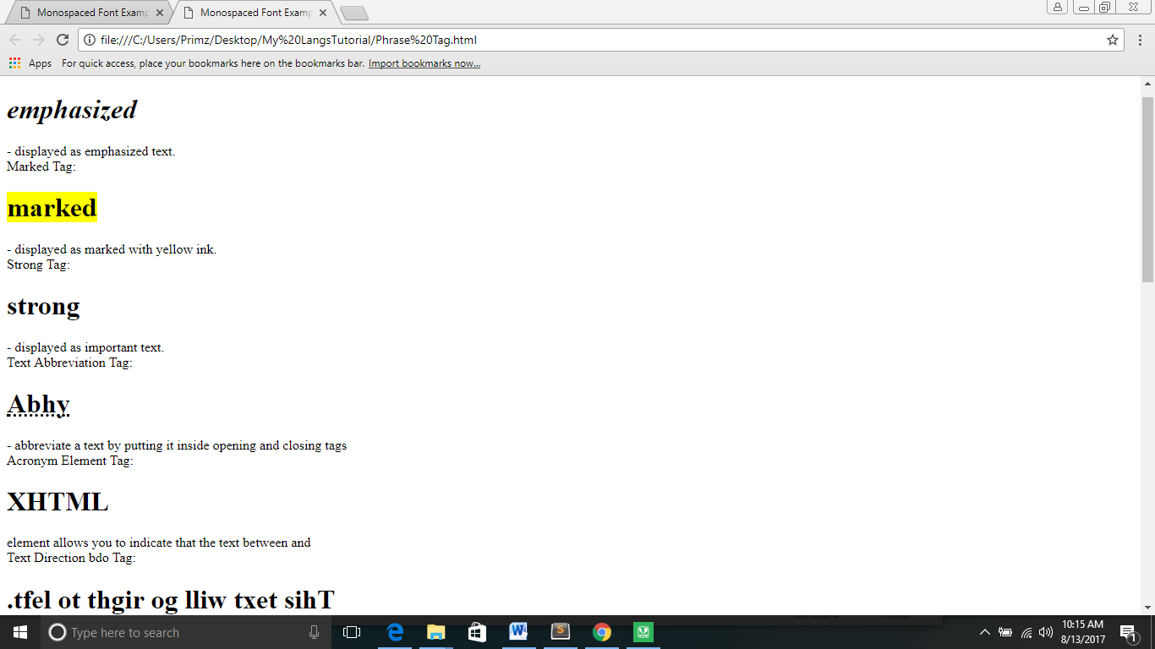

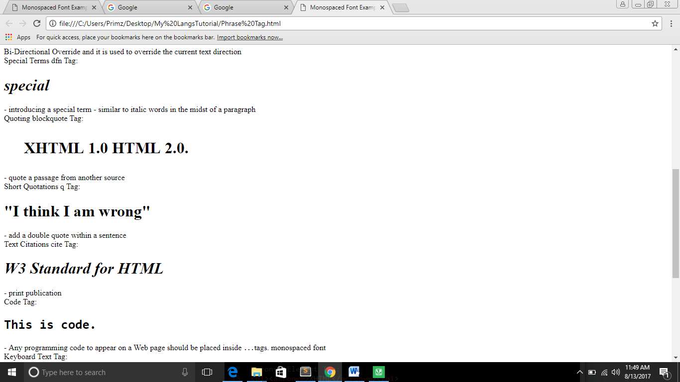

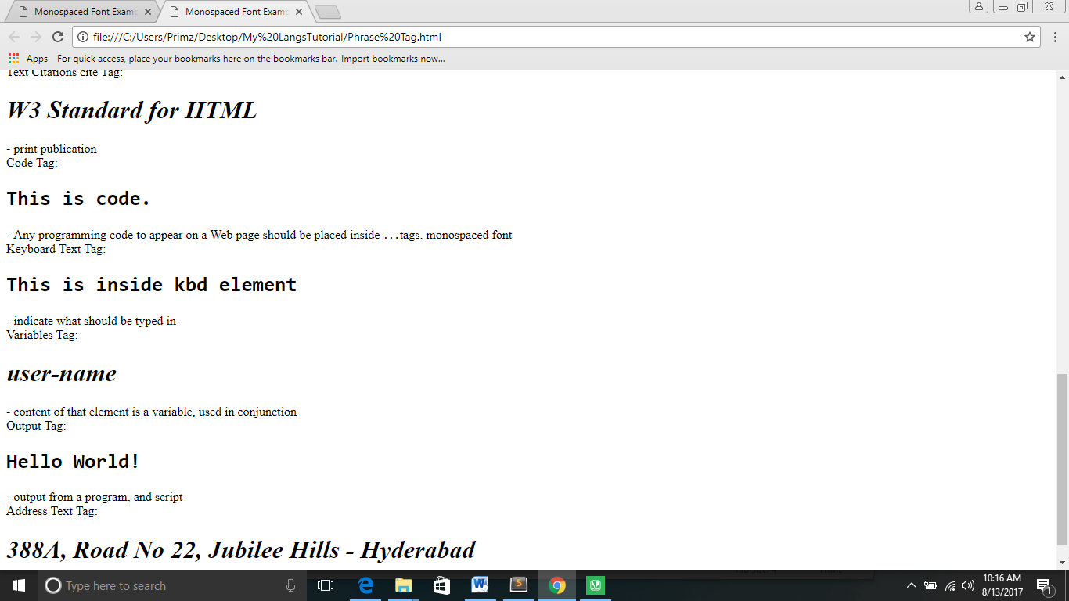

**7.HTML – META TAGS**

<meta> - provide such **additional information.** This tag is an **empty element** ,do not impact **physical appearance**

**Keywords :**

<meta name="keywords" content="HTML, Meta Tags, Metadata" />

search engines while **indexing your webpage** for searching purpose.

**Document Description** :

<meta name="description" content=" Learning about Meta Tags " />

search engines while **indexing your webpage** for searching purpose.

**Document Revision Date** :

<meta name="revised" content="Tutorialspoint, 3/7/2014" />

last time the document was **updated**

**Document Refreshing** :

<meta http-equiv="refresh" **content="5"** /> (5 seconds)

specify a **duration after** which your web page will **keep refreshing** automatically.

**Page Redirection** :

< meta httpequiv="refresh"content="5;url=http://www.tutorialspoint.com" />

**redirect the page** after a certain number of seconds

**Cookies:**

<meta http-equiv="cookie" content="userid=xyz; expires=Wednesday, 08-Aug-15 23:59:59 GMT;" />

Cookies are **data,** stored in small **text files** on your computer and it is exchanged between **web browser and web server**

store cookies on client side and later this information can be used by the Web Server to **track a site visitor**.

If you do not include the **expiration date and time**, the cookie is considered a **session cookie** and will be deleted when the **user exits the browser.**

**Setting Author Name :**

<meta ame="author" content="Mahnaz Mohtashim" />

set an author name

**Specify Character Set :**

<meta http-equiv="Content-Type" content="text/html; charset=UTF-8" />

**specify character set** used within the webpage.

default - ISO-8859-1 (Latin1)

UTF-8 encoding

traditional Chinese characters Big5 encoding

**8. HTML – COMMENTS**

**Comment :**

**piece of code which is ignored by any web browser**

<!-- Document Header Starts -->

**Valid vs Invalid Comments:**

Valid:

<!-- This is valid comment -->

Invalid:

< !-- This is valid comment --> ( space contain **left side**)

**Multiline Comments :**

<!--

This is a multiline comment and it can

span through as many as lines you like.

-->

**Conditional Comments** :

**only work in Internet Explorer (IE)** on Windows ,supported from Explorer 5 onwards

<!--[if IE 6]> Special instructions for IE 6 here <![endif]-->

**Comment Tag** :

**few browsers that support**

<comment>not</comment>

**Commenting Script Code:**

<script> **<!--**  **document.write("Hello World!")**  **//-->** </script>

**Commenting Style Sheets :**

<style> <!-- .example { border:1px solid #4a7d49; } //--> </style>

**9.HTML -IMAGES**

**Image Tag: (Empty Element)**

**Syntax**: <img src="Image URL" ... attributes-list/>

- PNG, JPEG or GIF

- **src** attribute => point out to the image location

src="test.png"

- **alt** attribute => alternate text for an image

alt="Test Image"

- **case sensitive**.

- Ex of **Same** Directory:

<img src="test.png" alt="Test Image" />

- Ex of **Different** Directory

<img src="images/test.png" alt="Test Image" />

**Image** **Width/Height** :

**pixels** or **percentage** of its actual size.

Ex: <img src="test.png" alt="Test Image" width="150" height="100"/>

**Image Border :**

border thickness in terms of **pixels** using **border** attribute(**0** means, no border)

Ex :<img src="test.png" alt="Test Image" border="3"/>

**Image Alignment** :

**align** attribute to set it in the **center or right**.

Ex :<img src="test.png" alt="Test Image" border="3" align="right"/>

**10.HTML -TABLES**

**Tags:**

|  |  |  |
| --- | --- | --- |
| **Tag Name** | **Syntax** | **Description** |
| Table | <table></table> | create Table |
| row | <tr></tr> | create table rows |
| data Tag | <td></td> | create data cells(normal,left) |
| head Tag | <th></th> | Define table head(bold,center) |
| caption | <caption></caption> | title or explanation for the table |
| Thead | <thead></thead> | create a separate table header. |
| Tbody | <tbody></tbody> | indicate the main body of the table |
| Tfooter | <tfooter></tfooter> | create a separate table footer |

**Attributes:**

|  |  |  |
| --- | --- | --- |
| **Name** | **Descp** | **Size** |
| Border | Border Size | 0…(0 no border) |
| Cellpadding | distance between cell borders and the content within a cell | 0… |
| Cellspacing | width of the border | 0… |
| Colspan | merge two or more columns into a single column | 0… |
| Rowspan | merge two or more rows | 0… |
| Bgcolor | set background color | Name,hxd,RGB |
| Background | set background image | URL |
| Bordercolor | set border color | Name,hxd,RGB |
| Width | Set table , row, cell width | Num,px,% |
| Height | Set table , row, cell height | Num,px,% |

**Note:** background image did not apply to table's header.

**11.HTML – LISTS**

|  |  |  |  |
| --- | --- | --- | --- |
| **List** | **Syntax** | **Attributes** | **Description** |
| unordered list | <ul></ul> | * type="square" * type="disc" * type="circle” | no special order or sequence,  marked with a bullet |
| ordered list | <ol></ol> | **Type:**  type="1"- Numerals.  type="I" - Upper-Case  type="i" - Lower-Case  type="a" - Lower-Case  type="A" - Upper-Case  **Start:**  type="1" start="4”  reversed  start number | numbered list instead of bulleted |
| Definition list  Contain  Three Tags | <dl>  <dt>  <dd>  <dl> |  | * HTML and XHTML supports a list style * like in a dictionary or encyclopedia   Defines the start of the list  A term  Term definition  List end |

**12.HTML – TEXT LINKS**

**Hyperlinks :**

allow visitors to **navigate** **between Web sites by clicking on words, phrases, and images**

**anchor Tag:**

<a href="http://www.tutorialspoint.com" target="_self">Tutorials Point</a>

Target Attribute:

specify the location where linked document is opened

|  |  |
| --- | --- |
| **Option** | **Option Description** |
| _blank. | Opens the linked document in a new window or tab. |
| _self | Opens the linked document in the same frame. |
| _parent | Opens the linked document in the parent frame. |
| _top. | Opens the linked document in the full body of the window. |
| targetframe | Opens the linked document in a named targetframe. |

**Base Tag**: (Inside Header)

<base href="http://www.tutorialspoint.com/">

give a base path for all the links

concatenate given relative path to this base path and will make a complete URL

**Name Attribute:**

<h1>HTML Text Links <a name="top"></a></h1>

<a href="/html/html_text_links.htm#top">Go to the Top</a>

**Link Attribute:** (with in<body> tag)

Link - link

Active link - alink

Visitedlink - vlink

Note : give Color Only

**Download Link:**

give complete URL of the downloadable file

**13. HTML – IMAGE LINKS**

<a href="http://www.tutorialspoint.com" target="_self">

<img src="/images/logo.png" alt="Tutorials Point" border="0"/> </a>

**Map Attributes:**

Server-side image maps - **ismap**

<img ismap src="/images/logo.png" alt="Tutorials Point" border="0"/>

Client-side image maps **- usemap**

<img src=/images/html.gif alt="HTML Map" border="0" usemap="#html"/>

<!-- Create Mappings -->

<map name="html">

<area shape="circle"

coords="80,80,20" href="/css/index.htm" alt="CSS Link" target="_self" />

<area shape="rect"

coords="5,5,40,40" alt="jQuery Link" href="/jquery/index.htm" target="_self" />

</map>

rect = x1 , y1 , x2 , y2

x1 and y1 are the coordinates of the upper left corner of the rectangle; x2 and y2 are the coordinates of the lower right corner.

circle = xc , yc , radius

xc and yc are the coordinates of the center of the circle, and radius is the circle's radius. A circle centered at 200,50 with a radius of 25 would have the attribute coords="200,50,25"

poly = x1 , y1 , x2 , y2 , x3 , y3 , ... xn , yn

oords="20,20,40,40,20,60,0,40".

**14.HTML – EMAIL LINK**

<a href= **"mailto: abc@example.com"**>Send Email</a>

**15.HTML – FRAMES**

**Frames:**

**divide** your browser window into multiple sections

section can load a **separate HTML document**

**FrameSet:**

collection of frames in the browser window

**Disadvantages :**

* smaller devices cannot cope
* back button might not work
* page will be displayed differently
* still few browsers that do not support

<frameset> - Defines, how **to divide the window** into frames

rows="10%,80%,10%”(similar way specify all the things of cols)

- Defines **horizontal frames**

cols="25%,50%,25%” (or) cols="3*,2*,1*" (or ) cols=” 10%, *,10%” cols =” 100, 500,100” - Defines **vertical frames**

<frame> - which HTML document shall open into the frame

Note : Initialize above the body Tag

**Rows Attribute Ex:**

<frameset rows="10%,80%,10%">

<frame name="top" src="/html/top_frame.htm" />

<frame name="main" src="/html/main_frame.htm" />

<frame name="bottom" src="/html/bottom_frame.htm" />

<noframes>

<body>

Your browser does not support frames.

</body>

</noframes>

</frameset>

**cols Attribute Ex:**

<frameset cols="25%,50%,25%">

<frame name="left" src="/html/top_frame.htm" />

<frame name="center" src="/html/main_frame.htm" />

<frame name="right" src="/html/bottom_frame.htm" />

<noframes>

<body>

Your browser does not support frames.

</body>

</noframes>

</frameset>

**Frameset Arttributes:**

border="25" (0..)

frameborder="1" (Either 0 or 1)

framespacing="10"(0…)

**Frame Attributes:**

src - src="/html/top_frame.htm"

frameborder - either 1 (yes) or 0 (no).

marginwidth - space between the left to right(0…)

marginheight - space between top to bottom (0…)

noresize - frame position doesnot drag(“noresize”)

scrolling - (yes or no)

longdesc - longdesc="Phrase Tag.html"

**16. HTML – IFRAMES**

**Iframe Tag:(inside body tag)**

Inline frame

<iframe src="/html/menu.htm" width="555" height="200"> </iframe>

**iFrame Attributes:**

src - src="/html/top_frame.htm"

frameborder - either 1 (yes) or 0 (no).

marginwidth - space between the left to right(0…)

marginheight - space between top to bottom (0…)

noresize - frame position doesnot drag(“noresize”)

scrolling - (yes or no)

longdesc - longdesc="Phrase Tag.html"

sandbox - allow-forms allow-same-origin (set of extra restrictions)

seamless - look like it is a part of the containing document (seamless)

srcdoc - Specifies the HTML content of the page(HTML_code)

**17. HTML – BLOCKS**

**Two Categories :**

**Block Level Elements -** New line automatically generate elements.

**Inline Elements -** Does not generate .need (<br/> Tag)

**Grouping HTML Elements -** div and span Tag

**18. HTML – BACKGROUNDS**

Background with **Colors -** bgcolor=”name or hx or rgb”

Html Background **with Images** - background=”url”

**19.HTML – COLORS**

**Set color for this:**

**Bgcolor**=”blue”

**text** =”green”

**alink** =”yellow”

**link** =”black”

**vlink**=”light green”

**Color Coding Methods :**

**Color names -** green, blue or red.

**Hex codes -** six-digit code - #RRGGBB

**Rgb** -rgb(r,g,b) - integer between 0 and 255 or a percentage.

Note

**History:**

**16** basic color names

**200** different color names

**216** safest Colors

**256** hex colors

**20. HTML – FONTS**

**Font tag:**

<font>

Attributes :

**Size -** <font size="1">Font size="1"</font><br />

<font size="+n"> or <font size="-n">

(-1,+1,+2,+3,+4)

**Color -** <font color="red">This text is red</font>

**Face -** <font face="Times New Roman" size="5">Times New Roman</font><br />

<font face="arial,helvetica">

**Size:**

values is from 1(smallest) to 7(largest)

**Default size :**

font is **3**

**21. HTML – FORMS**

**Form :**

collect some data from the site visitor

**From tag:**

<form action="Script URL" method="GET|POST">

form elements like input, textarea etc.

</form>

**Form Attributes:**

Action - Backend script ready to process your passed data.

Method - upload data( GET and POST )

Target - where the result of the script will be displayed( _blank, _self, _parent )

enctype - encode type

application/x-www-form-urlencoded – mostly uesd

mutlipart/form-data - binary data in the form of files like image, word file

autocomplete - autocomplete on or off(on or off)

novalidate - should not validated

**Eight HTML Form Controls** :

* **Text Input Controls**
* **Checkboxes Controls**
* **Radio Box Controls**
* **Select Box Controls**
* **File Select boxes**
* **Hidden Controls**
* **Clickable Buttons**
* **Submit and Reset Button**

**Text Input Controls:**

Single-line text input controls

<input **type="text"** name="first_name" />

**Attributes:**

|  |  |
| --- | --- |
| Names | Description |
| Type | Type of input control |
| Name | Name to the control for server identity |
| Value | Initial input control value |
| Size | Width of input control |
| Maxlength | Maximum no of character to enter |
| Autocomplete | On or off |
| Autofocus | autofocus |
| Form | Form_id(Identity) |
| (all form attributes) |  |
| Height | Px - Specifies the height |
| List -datalist_id |  |
| Max -autofocus | Specify maximum value |
| Min -number | Specify minimum value |
| Multiple - multiple | Specify user enter multiple values |
| Pattern - pattern | Specify regular Expression |
| Placeholder |  |
| Required |  |
| Step -number |  |
| Width |  |

Password Input controls

<input **type="password"** name="password" />

**Attributes:**

|  |  |
| --- | --- |
| Names | Description |
| Type | Type of input control |
| Name | Name to the control for server identity |
| Value | Initial input control value |
| Size | Width of input control |
| Maxlength | Maximum no of character to enter |

Multiple-Line Text Input Controls

<**textarea** rows="5" cols="50" name="description"> </textarea>

**Attributes:**

|  |  |
| --- | --- |
| Names | Description |
| Name | Name to the control for server identity |
| Rows | Initialize no of row in textarea |
| Cols | Initialize no of col in textarea |
| Wrap | Soft or hard |

**Checkbox Control:**

<input **type="checkbox"** name="maths" value="on">

**Attributes:**

|  |  |
| --- | --- |
| Names | Description |
| Type | Type of input control |
| Name | Name to the control for server identity |
| Value | used if the checkbox is selected |
| Checked | select it by default |

**Radio Button Control:**

<input **type="radio"** name="subject" value="maths">

**Attributes:**

|  |  |
| --- | --- |
| Names | Description |
| Type | Type of input control |
| Name | Name to the control for server identity |
| Value | used if the radio button is selected |
| Checked | select it by default |

**Select Box Control:**

<**select** name="dropdown">

<**option** value="Maths" selected>Maths</option>

<option value="Physics">Physics</option>

</select>

**Attributes:**

|  |  |
| --- | --- |
| Names | Description |
| Size | present a scrolling list box |
| Name | Name to the control for server identity |
| Multiple | select multiple items from the menu. |
| Value | used if the option is selected |
| Label | alternative way of labeling options |

**File Upload Box**

<input **type="file"** name="fileupload" **accept="image/*"** />

**Attributes:**

|  |  |
| --- | --- |
| Names | Description |
| Accept | Mention accept file type |
| Name | Name to the control for server identity |

**Button Controls:**

<input **type="submit"** name="submit" value="Submit" />

<input **type="reset"** name="reset" value="Reset" />

<input **type="button"** name="ok" value="OK" />

<input **type="image"** name="imagebutton" src="/html/images/logo.png" />

**Hidden Form Controls**

<input **type="hidden"** name="pagename" value="10" />

**HTML 5:**

|  |  |  |
| --- | --- | --- |
| **Attribute** | **Values** | **Description** |
| Autofocus | autofocus | input focus when the page loads |
| Disabled | disable | button is disabled |
| Form | Form_id | Specify forms to which button belongs |
| Formaction | URL | Specifies the link where the form submits |
| Formmethod | Get post | Specifies how to send form data |
| formnovalidate | formnovalidate | form data should not be validated. |
| Formtarget | _blank _self _parent _top | response should be validated.  Name |

**22. HTML – EMBED MULTIMEDIA**

**Embed Tag :**

<embed> - add music or video into your web page

**Attributes:**

|  |  |
| --- | --- |
| Names | Description |
| Align | Center, right or left |
| Autostart | True, false(automatically start) |
| Loop | the sound should be played continuously (true ),  particular no of time (positive value)  not at all (false) |
| Playcount | number of times to play the sound |
| Hidden | No or yes |
| Width | Px |
| Height | Px |
| Name | Reference the object |
| Src | URL of the object |
| Volume | 0 to 100 |
| Type | MIME_type |

**Supported Video Types**

.**swf** files - Macromedia's Flash program.

.**wmv** files - Microsoft's Window's Media Video

.**mov** files - Apple's Quick Time Movie format

.**mpeg** files - Moving Pictures Expert Group.

**HTML Object tag:**

offers an all-purpose solution to generic **object inclusion**

<object data="data/test.htm" type="text/html" width="300" height="200"></object>

**23. HTML – MARQUEES**

**Marquee Tag :**

scrolling piece of text displayed either horizontally across or vertically

**Attributes:**

|  |  |
| --- | --- |
| Names | Description |
| Width | Width of the marquee (20…) or (20 %......) |
| Height | height of the marquee (20…) or (20 %......) |
| Direction | up, down, left or right |
| Behavior | scroll, slide and alternate |
| Scrolldelay | delay between each jump like 10 |
| scrollamount | speed of marquee text like 10 |
| Loop | Default INFINATE |
| Bgcolor | Hex |
| Hspace | horizontal space around the marquee(10…) or (20 %......) |
| Vspace | vertical space around the marquee (20…) or (20 %......) |

**24. HTML – HEADER**

**<title> -** specifying the title of the HTML

- <title>HTML link Tag Example</title>

**<meta> -** metadata about the HTML document

- <meta name="keywords" content="C, C++, Java, PHP, Perl, Python">

**<link> -** specify relationships between the current document and external resource

**-** <link rel="stylesheet" type="text/css" href="/css/style.css">

**<base> -** specifying the base URL for all relative URLs

**-** <base href="http://www.tutorialspoint.com/" />

**<style> -** specify style sheet for the current HTML document

- <style type="text/css"> </style>

**<script> -** include either external script file

- <script type="text/JavaScript"> </script>

**<noscript>**

**25. HTML – STYLE SHEET**

**Cascading Style Sheets (CSS):**

Year**: 1994**

provide **easy and effective alternatives** to specify various attributes for the HTML tags

name / value - (;) / (:)

**Sheet Types**

**External Style Sheet:**

separate .css file and then include that file in your HTML document using HTML <link> tag.

**Internal Style Sheet:**

header section of the HTML document using <style> tag.

<style type="text/css"> </style>

**Inline Style Sheet:**

directly along-with the HTML elements using style attribute

<p style="font-size:20px;">This is thick</p>

**26. HTML JAVASCRIPT**

**Script:**

small piece of program that can add interactivity to your website

JavaScript - associated framework ,most web developers,

VBScript - not supported various browsers.

**External:**

<script src="/html/script.js" type="text/JavaScript"/></script>

**Internal:**

<script></script>

**Event handlers :**

Functions

**27. HTML – LAYOUTS**

**Layout :**

give **better look** to your website

**28. HTML – TAG REFERENCE**

**HTML 4.01 has 3 possible doctypes :**

**HTML 4 Strict**

**HTML 4 Transitional**

**HTML 4 Frameset**

**HTML <applet> Tag:**

|  |  |
| --- | --- |
| <applet> | indicating an acronym |
| <applet code="newClass.class" width="300" height="200">  </applet> | |

**HTML <area> Tag:**

|  |  |
| --- | --- |
| <area> | area in an image map |
| <area shape="rect"  coords="22,83,126,125"  alt="HTML Tutorial"  href="/html/index.htm"  target="_blank" /> | |

**HTML <article> Tag:**

|  |  |
| --- | --- |
| <article> | specifies self-contained composition in a site |
| <article>  <h2>PHP</h2>  <p>PHP is PHP Hypertext Preprocessor</p>  </article> | |

**HTML <aside> Tag:**

|  |  |
| --- | --- |
| <aside> | section of a page aside from the related section |
| <aside>  <h3>Java History</h3>  <p>Java is a programming language developed by James Gosling in 1994.</p>  </aside> | |

**HTML <audio> Tag:**

|  |  |
| --- | --- |
| <audio> | embed audio in web pages |
| <audio controls>  <source src="/html/Kalimba.mp3" type="audio/mpeg">  </audio> | |

**HTML <basefont> Tag:**

|  |  |
| --- | --- |
| **<basefont>** | specify a base font for the document |
| <basefont face="cursive,serif" color="#ff9900" size="4"/> | |

**HTML <bdi>Tag:**

|  |  |
| --- | --- |
| **<bdi>** | embed text with a different direction from another text |
| <li>Programming: <bdi>Java</bdi></li> | |

**HTML <bgsound> Tag:**

|  |  |
| --- | --- |
| **<bgsound>** | play a soundtrack in the background |
| <bgsound src="/html/yourfile.mdi"/> | |

**HTML blink Tag:( not support most browser)**

|  |  |
| --- | --- |
| **<blink>** | enclose a text to make it blink |
| <blink>This text will blink in Netscape Version 5.0</blink>  </ | |

**HTML <canvas> Tag:**

|  |  |
| --- | --- |
| **<canvas>** | drawing graphics, animations |
| <canvas id="newCanvas">Your browser does not support canvas tag.</canvas>  <script>  var c=document.getElementById('newCanvas');  var ctx=c.getContext('2d');  ctx.fillStyle='#00FD00';  ctx.fillRect(0,0,200,60); </script> | |

**Attributes :**

**Height - px**

**Width - px**

**HTML <col> <colgroup>Tag :**

|  |  |
| --- | --- |
| **<col><colgroup>** | Give different width of the column |
| <colgroup span="3">  <col width="50"></col>  <col width="100"></col> </colgroup> | |

**HTML <datalist> Tag:**

|  |  |
| --- | --- |
| **<datalist>** | specifies set of options for <input> element |
| <datalist id="tutorials">  <option value="Java">  <option value="ASP"> </datalist> | |

**HTML <dialog> tag :**

|  |  |
| --- | --- |
| **<dialog>** | defining a dialog box |
| <dialog **open**>this will be shown in a dialog</dialog> | |

**HTML <dir> Tag:**

|  |  |
| --- | --- |
| **<dir>** | Similar to <ul> |
| <dir>  <li>dir</li>  <li>menu</li> </dir> | |

**HTML <fieldset> Tag:**

|  |  |
| --- | --- |
| **<fieldset>** | grouping related form elements |
| <fieldset>  <legend>Details</legend>  Student Name: <input type="text"><br />  MCA Subjects:<input type="text"><br />  Course Link:<input type="url" name="websitelink">  </fieldset> | |

**HTML 5:**

|  |  |  |
| --- | --- | --- |
| **Attribute** | **Values** | **Description** |
| Align(html 4) | left right center top bottom | Specifies the content alignment |
| Disabled | disabled | elements should be disabled |
| Form | Form_id | Specifies forms which belongs to fieldset |
| Name | text | Specifies a name for fieldset |

**HTML Figcaption Tag:**

|  |  |
| --- | --- |
| **<figcaption>** | specifies a caption for an element |
| <figcaption>Tutorials Point Logo</figcaption> | |

**HTML Figure Tag:**

|  |  |
| --- | --- |
| **<figure>** | specifies self-contained content |
| <figure><img src="http://www.tutorialspoint.com/scripts/img/logo.png"/>  </figure> | |

**HTML Footer Tag:**

|  |  |
| --- | --- |
| **<footer>** | specifies a footer for a document |
| <footer> © Copyright 2014, All Rights Reserved </footer> | |

**HTML Header Tag:**

|  |  |
| --- | --- |
| **<header>** | specifies a header for a document or section |
| <header><p></p> </header> | |

**HTML <ilayer> Tag:**

|  |  |
| --- | --- |
| **<ilayer>** | create a layer that occupies space in the containing text flow |
| <ilayer top="-4">up</ilayer> and to the <ilayer left="-10">left</ilayer | |

**HTML <isindex> tag:**

|  |  |
| --- | --- |
| **<isindex>** | querying a document through a text field  best head tag is preferable |
| <head>  <title>HTML isindex Tag</title>  <isindex prompt = "Search" /> </head> | |

**HTML keygen Tag:**

|  |  |
| --- | --- |
| **<keygen>** | process Web forms with certificate management systems  element generates a secure key and submits the public key |
| <keygen name="random_key" challenge="0987654321"> | |

**HTML keygen Tag:**

|  |  |
| --- | --- |
| **<keygen>** | process Web forms with certificate management systems  element generates a secure key and submits the public key |
| <keygen name="random_key" challenge="0987654321"> | |

**HTML 5:**

|  |  |  |
| --- | --- | --- |
| **Attribute** | **Values** | **Description** |
| Keytype | Rsa / dsa /ec | Specifies secret algorithm |
| Disabled | disabled | elements should be disabled |
| Form | Form_id | Specifies forms which belongs to fieldset |
| Name | text | Specifies a name for fieldset |

**HTML <label> Tag:**

|  |  |
| --- | --- |
| **<label>** | add a label to a form control like text, textarea |
| <label for="email">EMAIL-ID:<br /> <input type="email" value="" name="emailid" size="30" placeholder="Enter a valid email address"><br /><br /> | |

**HTML <layer> Tag:**

|  |  |
| --- | --- |
| **<layer>** | position and animate (through scripting) elements in a page |
| <layer id="layer1" top="250" left="50" width="200"  height="200" bgcolor="red">  <p>layer 1</p>  </layer> | |

**HTML <legend> Tag:**

|  |  |
| --- | --- |
| **<legend>** | define a caption for <fieldset> tag |
| <fieldset>  <legend>Details</legend> </fieldset> | |

**HTML Main Tag:**

|  |  |
| --- | --- |
| **<main>** | specifies main or important content in the document |
| <main>….</main> | |

**HTML <map> Tag:**

|  |  |
| --- | --- |
| **<map>** | defining an image map along with <img> tag |
| <map name="html">  <area shape="circle"  coords="154,150,59" href="about/about_team.htm" alt="Team"  target="_self" />  </map> | |

**HTML <menu> Tag:**

|  |  |
| --- | --- |
| **<menu>** | creating a menu list |
| <menu>  <li>ol - ordered list</li>  <li>ul - unordered list</li>  </menu> | |
| label - text Specifies a visible label.  type - popup toolbar context  Specifies the type of menu to be displayed. | |

**HTML <menuitem> tag:**

|  |  |
| --- | --- |
| **<menuitem>** | efining a menu item for a menu |
| <menu type="context" id="clickmenu">  <menuitem label="Tutorialspoint" onclick="">  </menuitem>  </menu> | |
| checked -checked - checked command  default -default - default command  disabled -disabled - cannot be clicked  icon - url - icon for a menuitem  label - text - which is displayed to the user  radiogroup - groupname - which only one can be selected | |

**HTML <meter> tag:**

|  |  |
| --- | --- |
| **<meter>** | scalar measurement within a known range |
| <meter value="7" min="0" max="10">2 out of 10</meter> | |
| Form - form_ - one or more forms.  High - number - high value range.  low - number - low value range.  max - number - maximum value of the range  min - number - minimum value of the range  optimum - number - optimal value.  value - number - current value of the gauge – Required | |

**HTML <** **multicol> tag:**

|  |  |
| --- | --- |
| **<** **multicol>** | create multiple columns of text |
| <multicol cols=3> <p>State media said more than 2,000 soldiers, police and miners closed the breach in the dike in Shandong province early Sunday and installed pipes and five high-speed pumps, but gave no indication if there were any signs of life.<p> <p>The Huayuan Mining Co. mine flooded on Friday afternoon when the Wen river burst a dike, sending water pouring into a shaft and trapping 172 miners, Xinhua and state television said.<p> </multicol> | |

**HTML <nav> Tag:**

|  |  |
| --- | --- |
| **<nav>** | specifies a section that contains only navigation links |
| <nav>  <a href="dbms/index.htm">DBMS</a> |  <a href="mongodb/index.htm">MongoDB</a> |</nav> | |

**HTML <nobr> <wbr>Tag:**

|  |  |
| --- | --- |
| **<nobr>**  **<wbr>** | instruct the browser not to break the specified text  break the specified text |
| <nobr>  This is a very long sequence of text that is  forced to be on a single line, even if doing so causes  <wbr />  the browser to extend the document window beyond the  size of the viewing pane and the poor user must scroll right  <wbr />  to read the entire line.  </nobr> | |

**HTML <optgroup> Tag:**

|  |  |
| --- | --- |
| **<optgroup>** | grouping related options within your select list. |
| <optgroup label="India">  <option value ="mumbai">Mumbai</option>  <option value ="delhi">Delhi</option>  </optgroup> | |

**HTML <param> Tag:**

|  |  |
| --- | --- |
| **<param>** | passing parameters to an embedded object using <object> tag. |
| <object title="Test Object." classid="java.class">  <param name="audio" value="music.wav" />  <param name="width" value="600" />  <param name="height" value="400" />  </object> | |
| Form - form_ - one or more forms.  High - number - high value range.  low - number - low value range.  max - number - maximum value of the range  min - number - minimum value of the range  optimum - number - optimal value.  value - number - current value of the gauge – Required | |

**HTML <param> Tag:**

|  |  |
| --- | --- |
| **<param>** | passing parameters to an embedded object using <object> tag. |
| <object title="Test Object." classid="java.class">  <param name="audio" value="music.wav" />  <param name="width" value="600" />  <param name="height" value="400" />  </object> | |

**HTML <pre> Tag**

|  |  |
| --- | --- |
| **<pre>** | indicating preformatted text |
| <pre>  This text is  in a fixed-pitch </pre> | |

**HTML Progress Tag**

|  |  |
| --- | --- |
| **<progress>** | specifies a completion progress of a task |
| <progress value="20" max="100"/> | |
| max -max -greater than zero and a valid floating point number.  value -value -task that has been | |

**HTML Ruby , Rp and Rt Tag**

|  |  |
| --- | --- |
| **<ruby>**  **<rp>**  **<rt>** | ruby annotations which are for East Asian characters’ pronunciation  show browsers that do not support the ruby annotations  pronunciation of ruby annotations |
| <ruby>  漢 <rp>(</rp><rt>Kan</rt><rp>)</rp>  字 <rp>(</rp><rt>ji</rt><rp>)</rp>  </ruby> | |

**HTML Section Tag:**

|  |  |
| --- | --- |
| **<section>** | specifies a section in a document |
| <section> <h1>Java</h1> <h3>Inheritance</h3> </section> | |

**HTML <spacer> Tag**

|  |  |
| --- | --- |
| **<spacer>** | specifies a whitespace |
| Create some space <spacer type="block" width="50" /> here | |

**HTML <source> Tag**

|  |  |
| --- | --- |
| **<source>** | defining multimedia resources for <audio> and <video> elements. |
| <source src = "yourfile.mp3"> | |

**HTML Summary Tag**

|  |  |
| --- | --- |
| **<summary>** | specifies a summary, caption or legend for a given details |
| <summary>Some details</summary> | |

**HTML <time> tag**

|  |  |
| --- | --- |
| **<time>** | displaying the human readable date and time |
| <p>The time is <time>12:51 pm</time></p | |

**HTML <track> tag:**

|  |  |
| --- | --- |
| **<track>** | used for defining captions, subtitles, and other content for <audio> and <video> tags |
| <track src = "subtitles.vtt" kind="subtitles" srclang="en" label="English"> | |

**HTML <video> Tag:**

|  |  |
| --- | --- |
| **<video>** | embed video into your web page |
| <video width="500" height="300" controls>  <source src="/html/compileonline.mp4" type="video/mp4">  This browser doesn't support video tag.  </video> | |
| autoplay - autoplay - play automatically.  controls - controls -video controls gets displayed.  height - pixels - height  loop - loop -video will start again every time after finish  muted - muted - audio should be muted  poster - URL - image to be shown while the video is downloading.  preload - auto metadata none  - lead to user experience at its best.  src - URL - URL  width - pixels - width | |

**HTML <xmp> Tag:**

|  |  |
| --- | --- |
| **<xmp>** | pecifies preformatted text |
| <xmp>HTML tags include <b> for bold text, <i> for italic text.</xmp> | |

**29. HTML – ATTRIBUTE REFERENCE**

**Global Attributes:**

|  |  |  |
| --- | --- | --- |
| **Attribute** | **HTML 5** | **Description** |
| accesskey |  | Specifies a shortcut key |
| spellcheck | Yes | spelling or grammar checked |
| Translate | Yes | content of an element should be translated or not |

**Language Attributes:**

|  |  |  |
| --- | --- | --- |
| **Attribute** | **Value** | **Description** |
| Dir | Rtl / ltr | Sets the text direction |
| Lang | Language_code | Sets the language code |

**30. HTML EVENTS REFERENCE**

HTML 4.01 - 19 events

HTML5a - added many other events

**EVENT ATTRIBUTES:**

|  |  |
| --- | --- |
| **Attribute** | **Description** |
| onclick | when a mouse click |
| Onmousedown | when mouse button is pressed |
| Onmouseup | when mouse button is released |
| Onmouseover | when mouse pointer moves over an element |
| Onmousemove  Ondblclick | when mouse pointer moves  when a mouse double-click |
| Onmouseout | when mouse pointer moves out of an element |
| Onkeypress | when key is pressed and released |
| Onkeydown | when key is pressed |
| onkeyup | when key is released |

**Window Events Attributes:**

|  |  |  |
| --- | --- | --- |
| **Attribute** | **HTML 5** | **Description** |
| 1. onafterprint Triggers **after** a document is **printed** 2. onbeforeprint Triggers **before** a document is **printed** 3. onbeforeonload Triggers **before** a document **loads** 4. onerror Triggers when an **error occurs** 5. onhaschange Triggers when a document has **changed** 6. onload Triggers when a document **loads** 7. onmessage Triggers when a **message is triggered** 8. onoffline Triggers when a document **goes offline** 9. ononline Triggers when a document **comes online** 10. onpagehide Triggers when a **window is hidden** 11. onpageshow Triggers when a window becomes **visible** 12. onpopstate Triggers when a window's **history changes** 13. onredo Triggers when a document **performs a redo** 14. onresize Triggers when a **window is resized** 15. onstorage Triggers when a **document loads** 16. onundo Triggers when a document **performs an undo** 17. onunload Triggers when a user **leaves the document** | | |

**Form Events :**

|  |  |  |
| --- | --- | --- |
| **Attribute** | **HTML 5** | **Description** |
| 1. onblur Triggers when a **window loses focus** 2. onchange Triggers when an **element changes** 3. oncontextmenu Triggers when a **context menu is triggered** 4. onfocus Triggers when a **window gets focus** 5. onformchange Triggers when a **form changes** 6. onforminput Triggers when a **form gets user input** 7. oninput Triggers when an **element gets user input** 8. oninvalid Triggers when an **element is invalid** 9. onreset Triggers when a **form is reset** 10. onselect Triggers when an **element is selected** 11. onsubmit Triggers when a **form is submitted** | | |

**KeyBoard Events :**

|  |  |  |
| --- | --- | --- |
| **Attribute** | **HTML 5** | **Description** |
| 1. onkeydown Triggers when a **key is pressed** 2. onkeypress Triggers when a **key is pressed and released** 3. onkeyup Triggers when a **key is released** | | |

**Mouse Events :**

|  |  |  |
| --- | --- | --- |
| **Attribute** | **HTML 5** | **Description** |
| 1. onclick Triggers on a **mouse click** 2. ondblclick Triggers on a **mouse double-click** 3. ondrag Triggers when an **element is dragged** 4. ondragend Triggers at the **end of a drag operation** 5. ondragenter Triggers when an element has been **dragged to a valid drop target** 6. ondragleave Triggers when an element **leaves a valid drop target** 7. ondragover Triggers when an element is being **dragged over a valid drop target** 8. ondragstart Triggers at the **start of a drag operation** 9. ondrop Triggers when a **dragged element is being dropped** 10. onmousedown Triggers when a **mouse button is pressed** 11. onmousemove Triggers when the **mouse pointer moves** 12. onmouseout Triggers when the mouse pointer **moves out of an element** 13. onmouseover Triggers when the mouse **pointer moves over an element** 14. onmouseup Triggers when a mouse button is **released** 15. onmousewheel Triggers when the mouse **wheel is being rotated** 16. onscroll Triggers when an **element's scrollbar is being scrolled** | | |

**Media Events :**

|  |  |  |
| --- | --- | --- |
| **Attribute** | **HTML 5** | **Description** |
| 1. onabort Triggers on **an abort event** 2. oncanplay Triggers when **a media can start play, but might has to stop for buffering** 3. oncanplaythrough Triggers when a **media can be played to the end, without stopping for buffering** 4. ondurationchange Triggers when the **length of a media is changed** 5. onemptied Triggers when a **media resource element suddenly becomes empty.** 6. onended Triggers when a **media has reached the end** 7. onerror Triggers when an **error occurs** 8. onloadeddata Triggers when **media data is loaded** 9. onloadedmetadata Triggers when the **duration and other media data of a media element is loaded** 10. onloadstart Triggers when the **browser starts loading the media data** 11. onpause Triggers when **media data is paused** 12. onplay Triggers when **media data is going to start playing** 13. onplaying Triggers when **media data has started playing** 14. onprogress Triggers when the **browser is fetching the media data** 15. onratechange Triggers when the **playing rate of media data has changed** 16. onreadystatechange Triggers when the **ready-state changes** 17. onseeked Triggers when the **seeking attribute of a media element is no longer true, and the seeking has ended** 18. onseeking Triggers when the **seeking attribute of a media element is true, and the seeking has begun** 19. onstalled Triggers when there is an **error in fetching media data** 20. onsuspend Triggers when the browser has been fetching media data, but stopped before the entire media file was fetched 21. ontimeupdate Triggers when media **changes its playing position** 22. onvolumechange Triggers when a media **changes the volume, also when volume is set to "mute"** 23. onwaiting Triggers when media **has stopped playing, but is expected to resume** | | |

**31. HTML – FONTS REFERENCE**

|  |
| --- |
| Font Font Font  Andale Mono Arial Arial Bold  Arial Italic Arial Bold Italic Arial Black  Comic Sans MS Comic Sans MS Bold Courier New Courier New Bold Courier New Italic Courier New Bold Italic Georgia Georgia Bold Georgia Italic Georgia Bold Italic Impact Lucida Console  Lucida Sans Unicode Marlett Minion Web  Symbol Times New Roman Times New Roman Bold  Times New Roman Italic Times New Roman Bold Italic Tahoma  Trebuchet MS Trebuchet MS Bold Trebuchet MS Italic  Trebuchet MS Bold Italic Verdana Verdana Bold  Verdana Italic Verdana Bold Italic Webdings |

**33. HTML – COLOR NAMES**

Name - Hex code

Aqua - #00ffff

fuchsia - #ff00ff

lime - #00ff00

silver - #c0c0c0

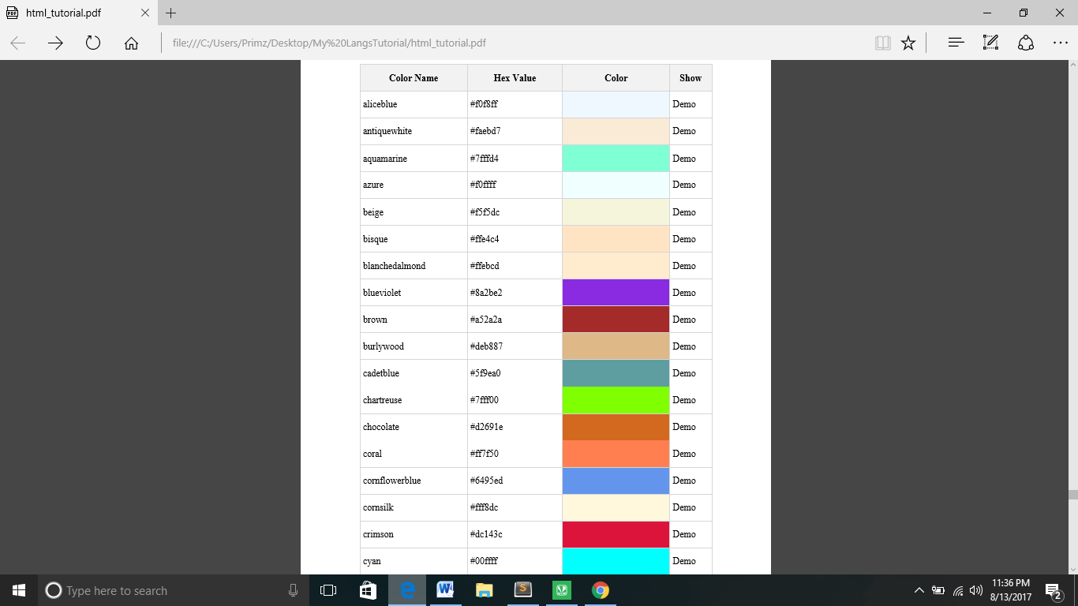

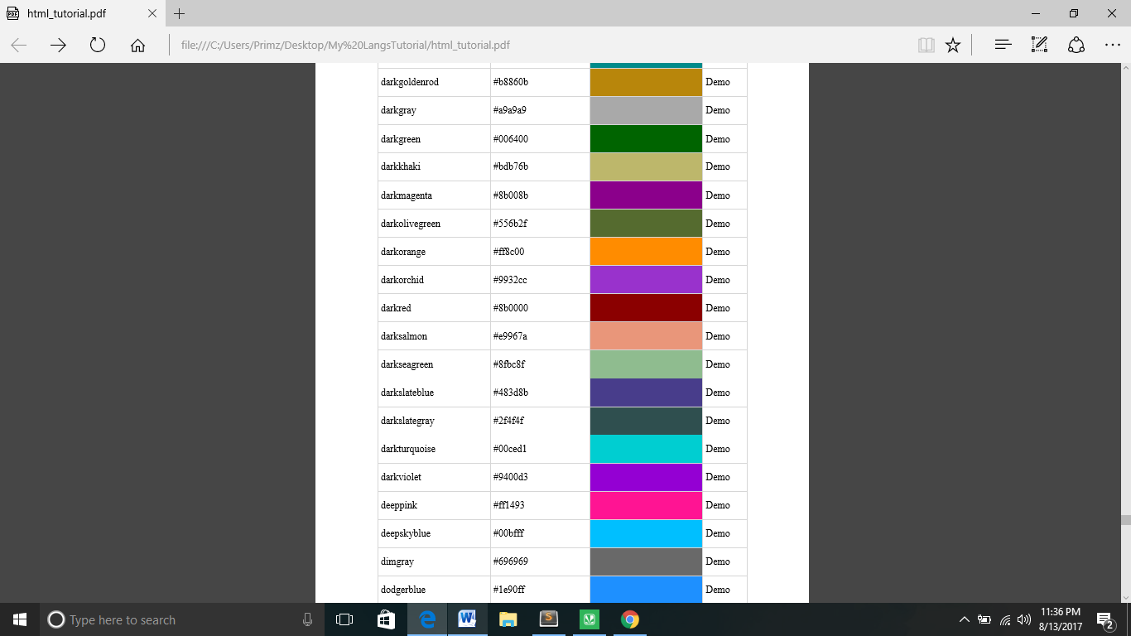

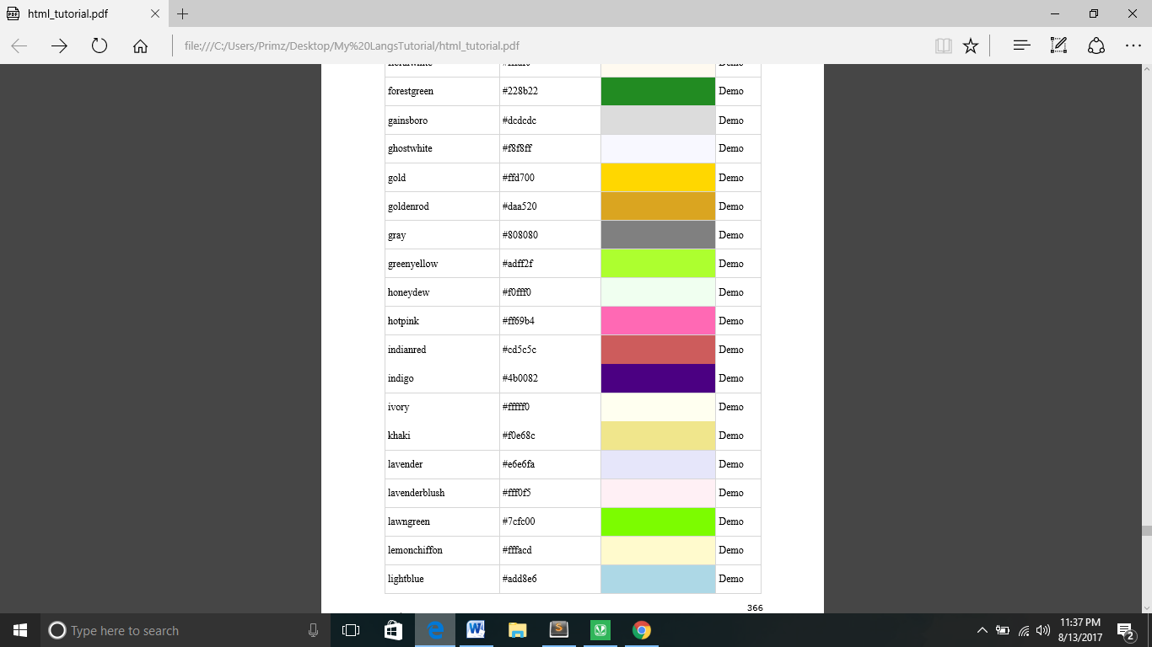

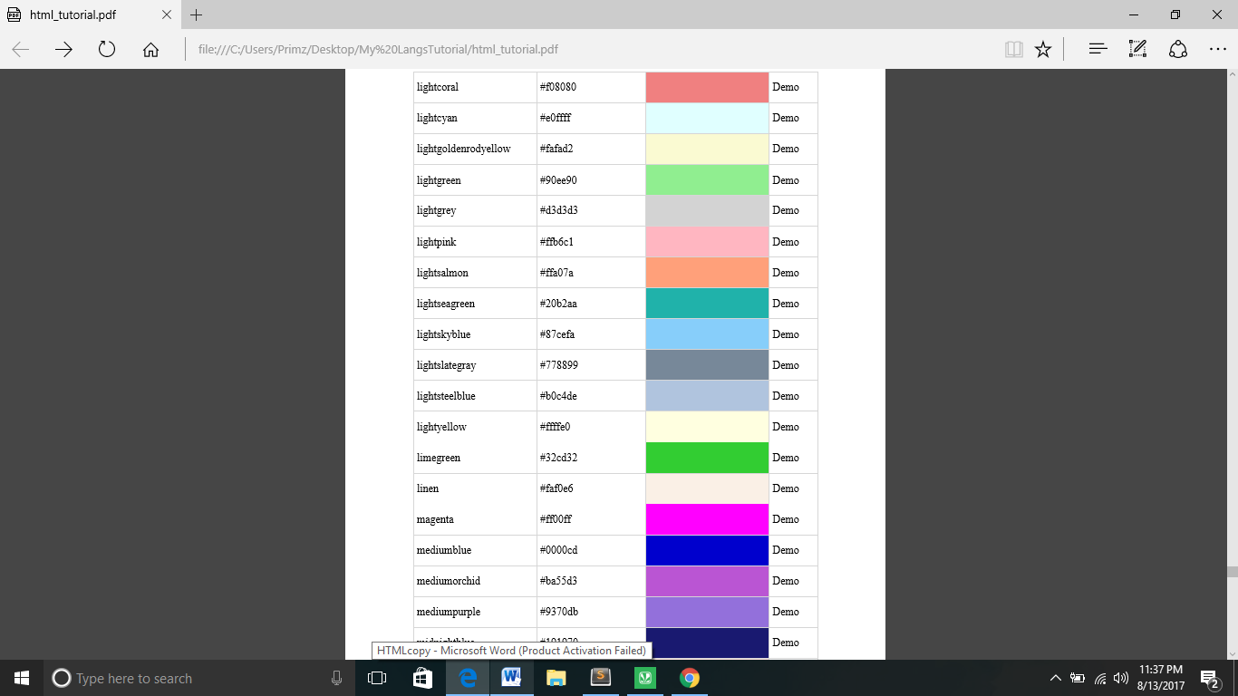

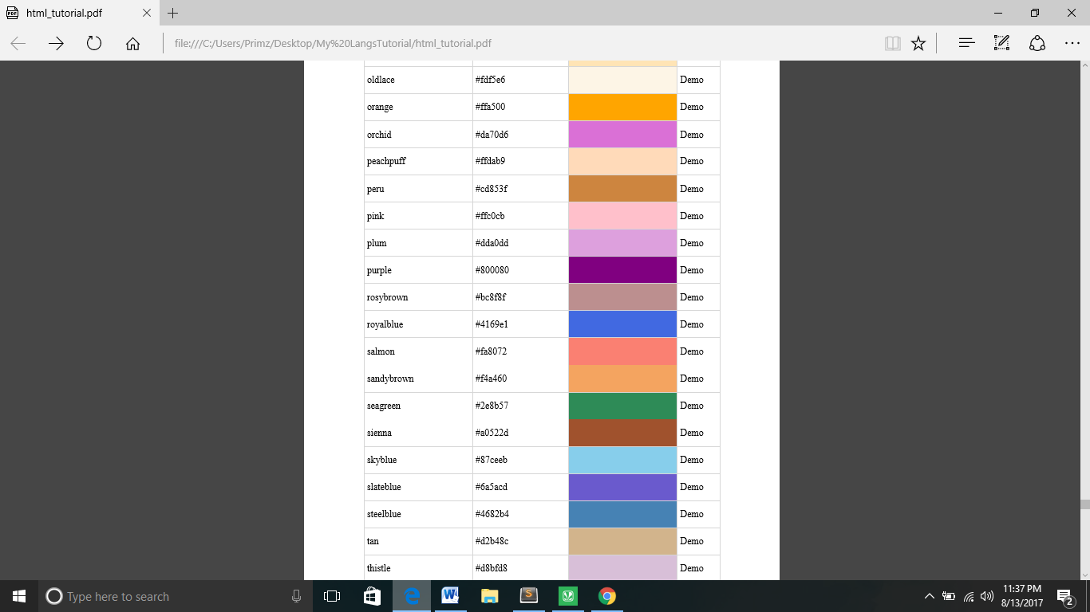

**34. HTML – ENTITIES**

**Symbol - Entity**

**" - &quot**

**' - &apos**

**& - &amp**

**< - &lt**

**> - &gt**

**37. LANGUAGE ISO CODES**

**Language ISO Code Windows Name Win Code**

**Tamil ta LANG_TAMIL 0x49**

**GLOBAL ATTRIBUTES:**

**HTML 5:**

|  |  |  |
| --- | --- | --- |
| **Attribute** | **Values** | **Description** |
| Download | Filename |  |
| Media | media_query | specifies what media the linked document  name |
| Type | mime_type | Specifies the MIME (Multipurpose Internet Mail Extensions) |

**HTML 4:**

|  |  |  |
| --- | --- | --- |
| **Attribute** | **Values** | **Description** |
| Cords | shape="rect"coords="left,top,right,bottom"  shape="circ"coords="centerx,centery,radius" shape="poly" coords="x1,y1,x2,y2,..,xn,yn | Specifies the coordinates |
| Href | URL | Specifies the URL |
| Rel |  | Relation between current doc &destination URI. |
| Target | _blank _parent _self _top | New window  Same frame  Parent frameset  Open full boy of window |