Experiment 3
LO4: Containerize, orchestrate, and deploy applications using Docker, Docker Compose, Kubernetes, and cloud infrastructure tools.
Aim: To deploy multi-service applications using Docker Compose.

Theory:
Docker Compose is a tool used to define and manage multi-container Docker applications. Instead of running multiple docker run commands for each container, Docker Compose allows all services to be configured in a single docker-compose.yml file. This file specifies the services, images, ports, networks, volumes, and environment variables required for the application.
A multi-service application consists of two or more containers that work together. For example, a web application may require a web server, a database, and a caching service. Docker Compose automatically creates a network that enables these containers to communicate with each other using their service names.
To deploy an application, Docker Compose reads the docker-compose.yml file, builds any required images, creates the necessary containers, configures networking and storage, and starts all services with a single command:
docker compose up --build
The --build option ensures that the Docker images are rebuilt before the containers are started. Docker Compose also manages the lifecycle of the application, allowing users to stop and remove all services with:
docker compose down
Advantages of Docker Compose
- Simplifies deployment of multi-container applications.
- Uses a single configuration file for all services.
- Automatically creates a network for container communication.
- Supports persistent storage using volumes.
- Makes development, testing, and deployment consistent across different environments.
- Reduces manual configuration and improves maintainability.
Applications
- Web applications with backend and database services.
- Microservices-based applications.
- Development and testing environments.
- Continuous Integration and Continuous Deployment (CI/CD) workflows.
Implementation:
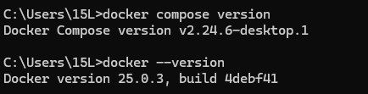
Step 1: Create the Project Directory
File structure:
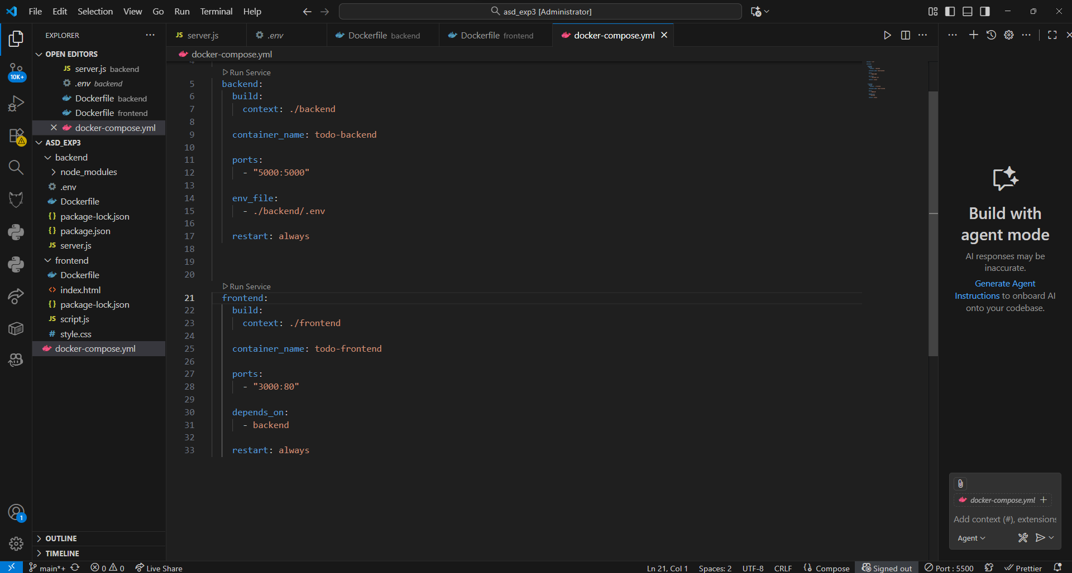

Step 2: create docker file
Dockerfile:

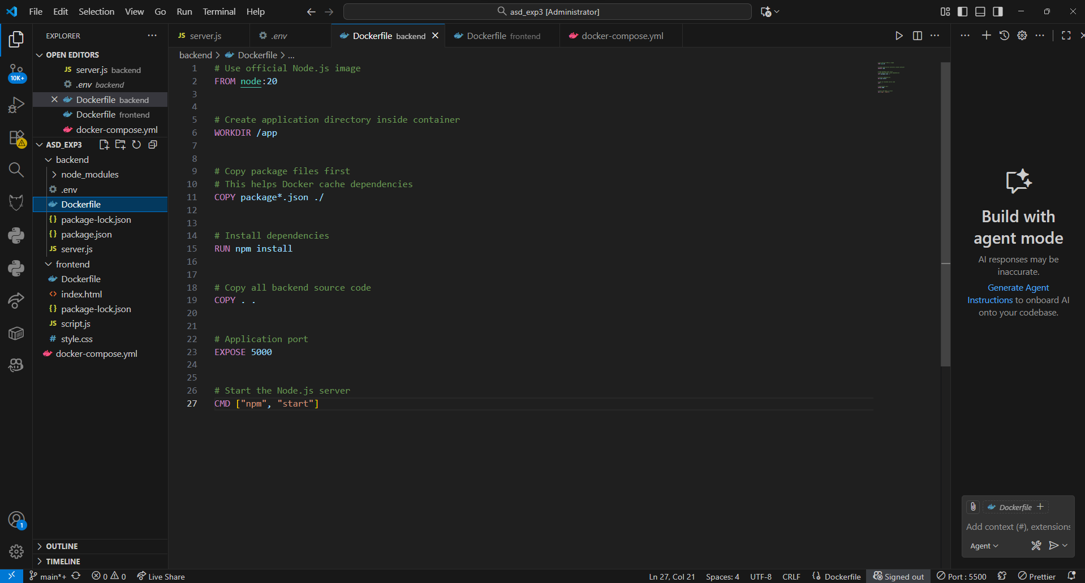
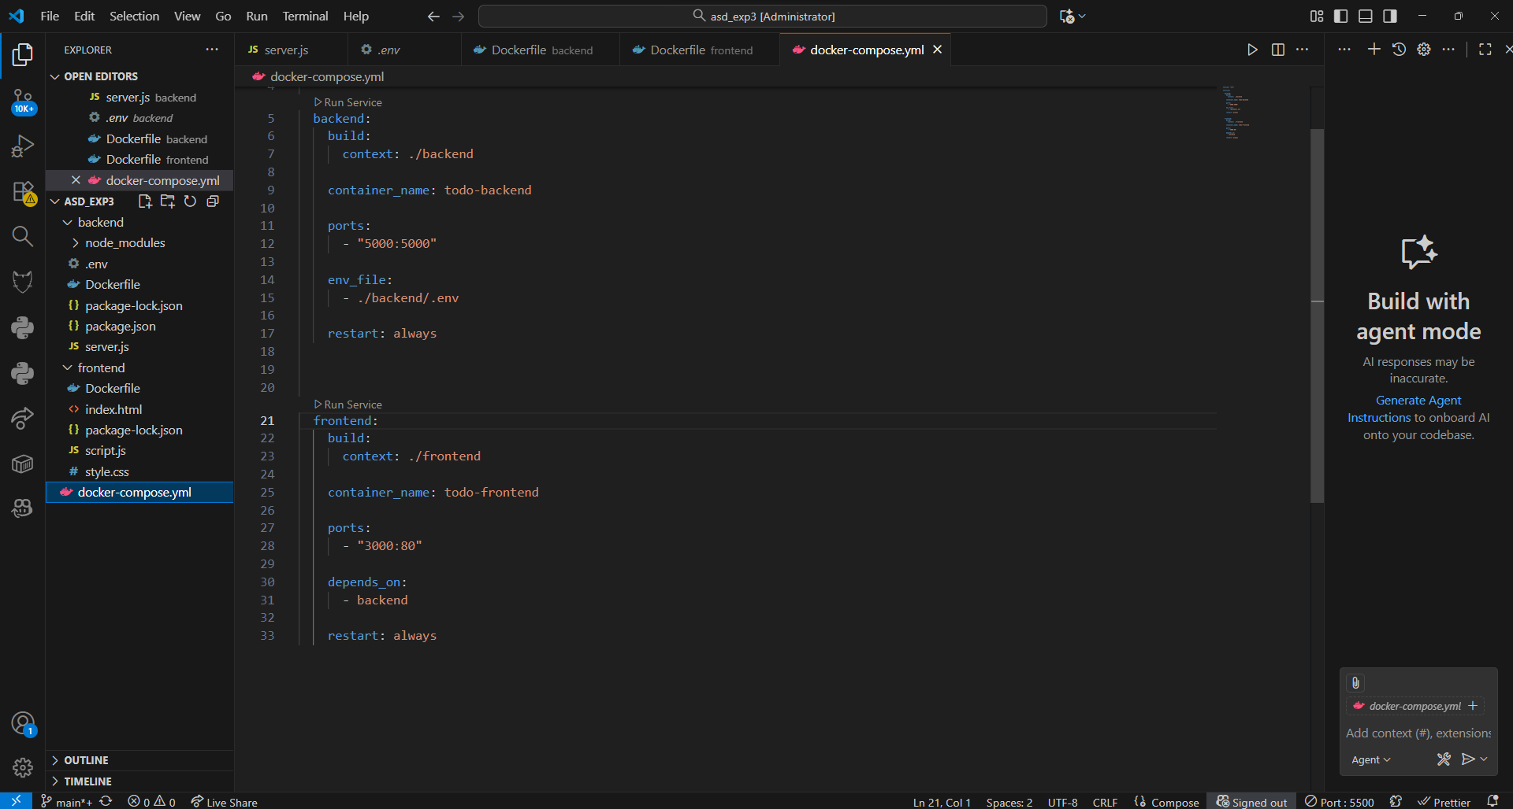
Step 3:create docker-compose.yml
Docker-compose.yml:
server.js
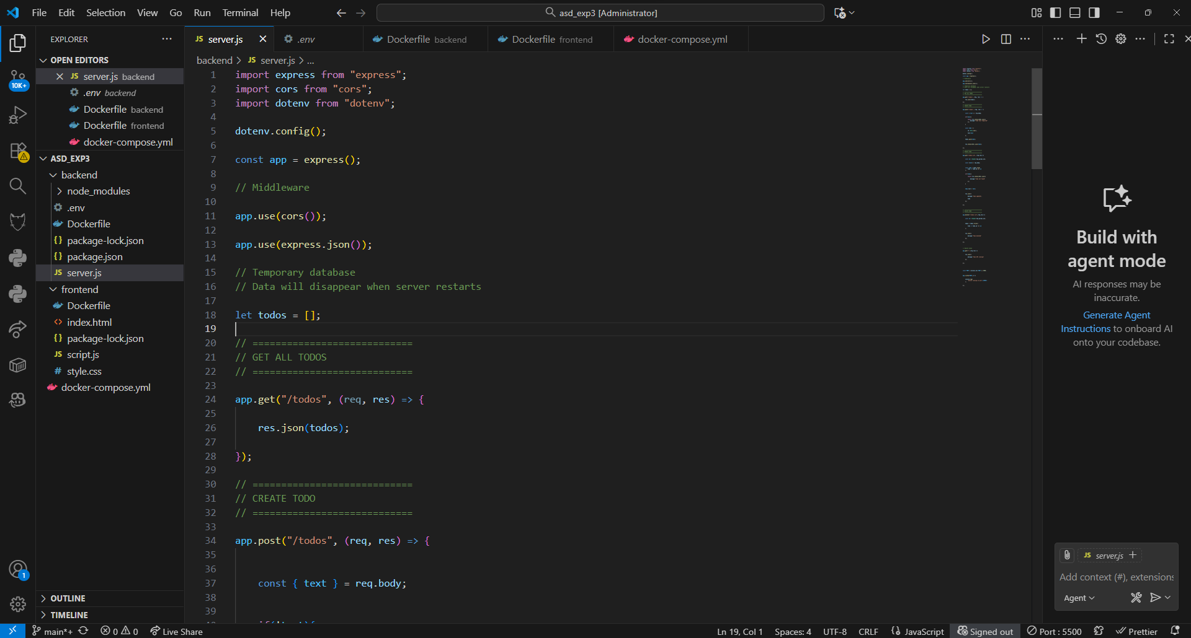
Step 4:build and start the services
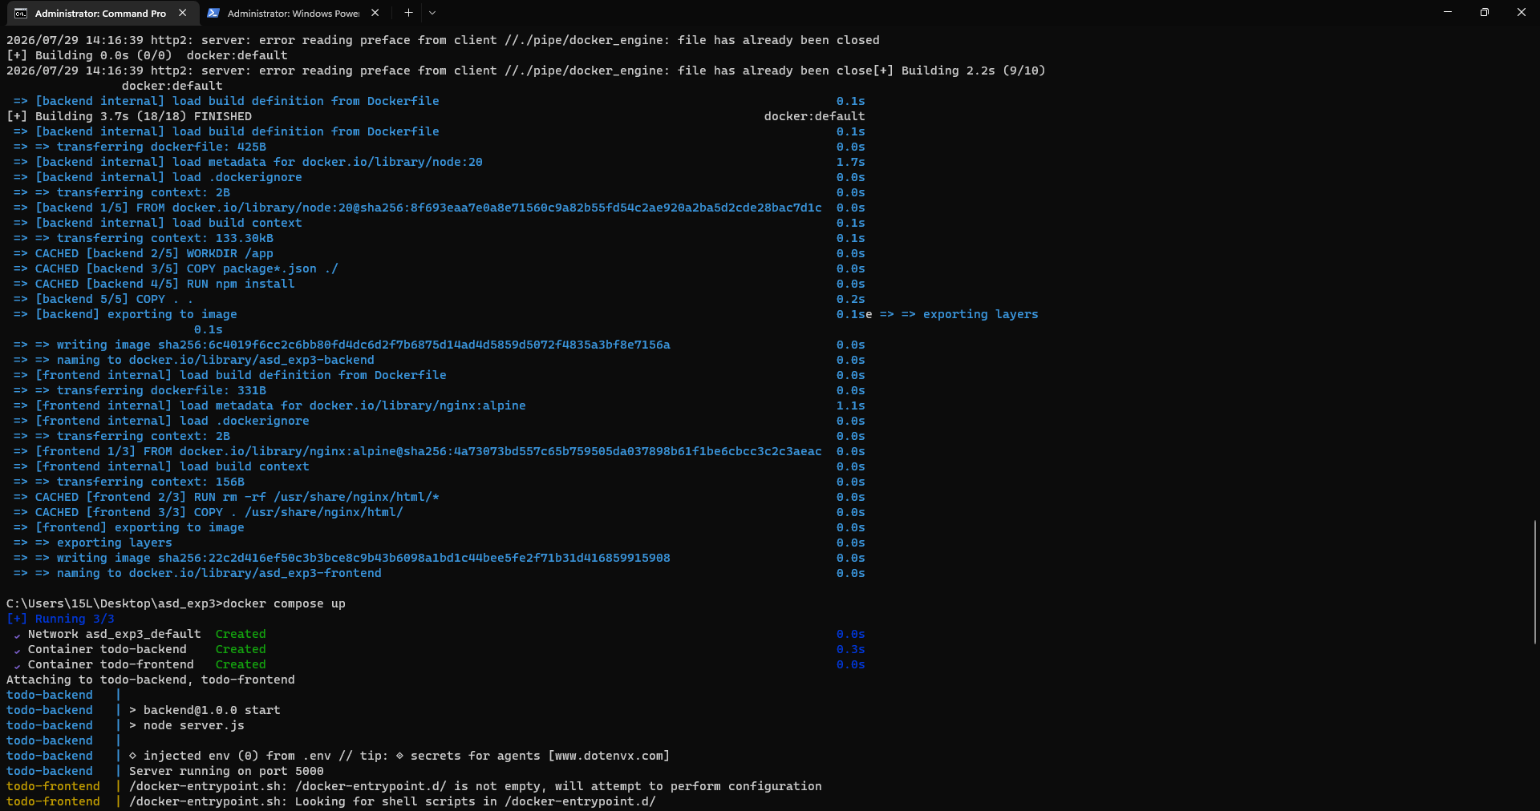
Step 5: verify the deployment
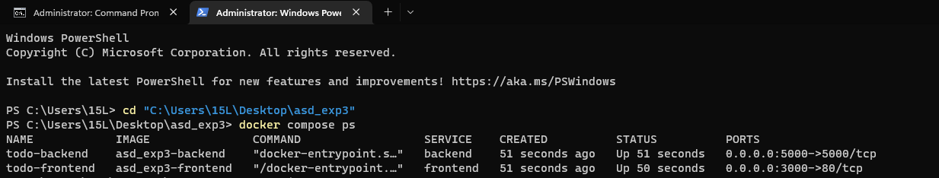
Step 6: view application logs
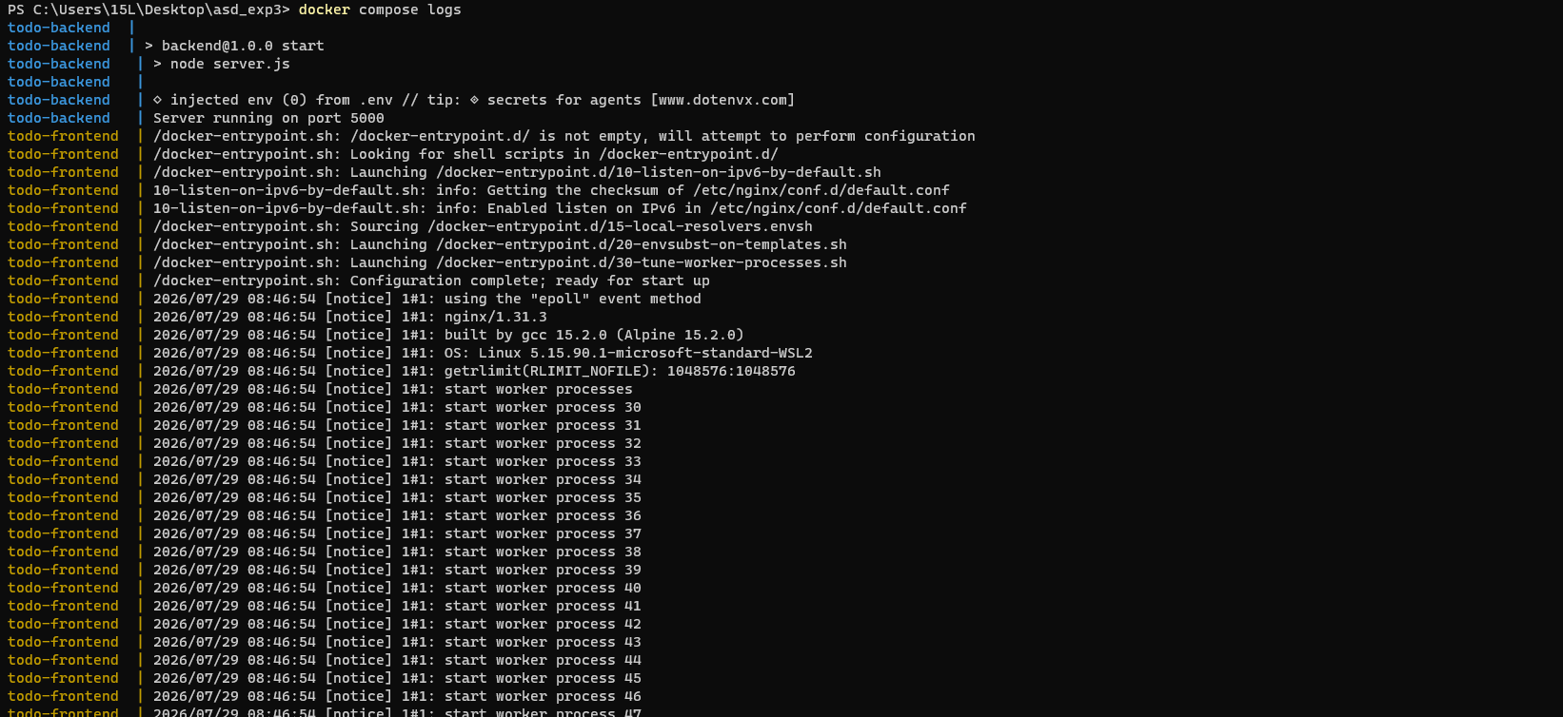
Step 7: open project on local host:5000
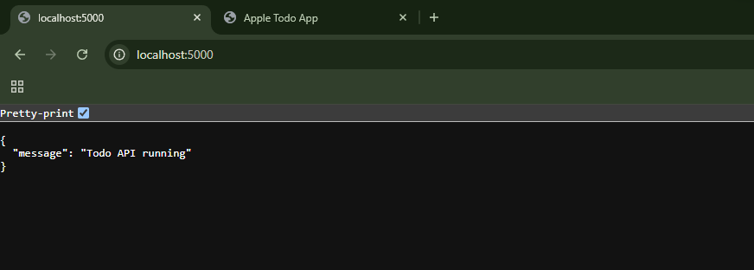

Step 8: stop and remove services
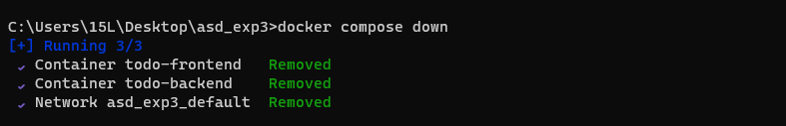
Conclusion:
Docker Compose is an efficient tool for deploying and managing multi-service applications using a single configuration file. It automates the process of building images, creating containers, configuring networks, and starting services with minimal effort. By simplifying container orchestration, Docker Compose ensures consistency across development, testing, and deployment environments, making application management easier, faster, and more reliable.

