KWIC Implemented with Event Based Architectural Style

KWIC Implemented with Event Based Architectural Style 2
1 Event Based Systems in General 2
1.1 Strategy of Events Handling 2
2 Architecture 3
2.1 Run-Time Event Interactions 4
2.2 Event Dispatching Strategy 4
2.3 Java Support for Observer 4
2.4 Java Support for Observable 5
2.5 Implementation 6
2.6 Event Class 6
3 Students’ Assignment 6
3.1 Implement Interactive KWIC System 6
3.2 Extend the System Functionality 7
3.3 Answer understanding questions 8

KWIC Implemented with Event Based Architectural Style

Event Based Systems in General
In event based systems procedures are not invoked directly, but rather a component can announce or broadcast one or more events. Other components in the system can register an interest in an event by associating a procedure with it. When the event is announced, the system itself invokes all of the procedures that have been registered for the event. Thus, an event announcement "implicitly" causes the invocation of procedures in other modules. For example, let us consider an Integrated Development Environment for Java. Such IDE consists of tools such as editors for source code, variable monitors, a debugger, etc. Usually, such systems utilize event based architecture. Thus, editors and variable monitors register for the debugger's breakpoint events. When a debugger stops at a breakpoint, it announces an event that allows the system to automatically invoke procedures of those registered tools. These procedures might scroll an editor to the appropriate source line or redisplay the value of monitored variables. In this scheme, the debugger simply announces an event, but does not know what other tools or actions (if any) are concerned with that event, or what they will do when the event is announced.

Strategy of Events Handling
When an event is announced in an event based system, the system itself invokes automatically all of the procedures that have been registered for that event. That means that the system must implement a certain strategy how events are handled in the system, i.e., how events are being dispatched to registered components in the system. There exist a number of different strategies of dispatching events. Generally, we may divide these strategies into two groups:
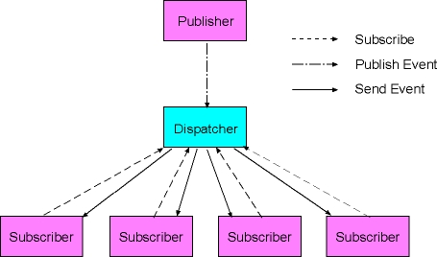
Figure 1: Publish/subscribe strategy
- Systems with separate dispatcher module, which is responsible for receiving all incoming events and dispatching them to other modules in the system. The implementation of the dispatcher decides how events are sent to other modules. For example, the dispatcher may broadcast events to all modules in the system, and then modules themselves need to decide what they want to do with events. Alternatively, dispatcher may manage lists of modules interested in particular events. In that case the dispatcher sends an event just to those modules that registered for that event. This strategy is usually called Publish/Subscribe strategy and may be seen on the following picture:
- Systems without a central dispatcher module, where each module allows other modules to declare interest in events that they are sending. Thus, whenever a module sends an event it sends that event to exactly those modules that registered interest in that event. This strategy is usually called Observable/Observer and may be depicted as follows:
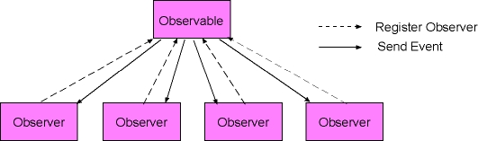
Figure 2: Observable/observer strategy

Architecture
Event based KWIC system is composed of the following components:
- Two LineStorage modules. The first LineStorage module holds original lines, second holds circular shifts.
- Input module reads the data from a file and storing it in the first LineStorage module.
- CircularShifter module produces circular shifts and stores them in the second LineStorage module.
- Alphabetizer module, responsible for sorting circular shifts alphabetically.
- Output module, responsible for printing the sorted shifts.
- Master control module, responsible for overall control of the system.
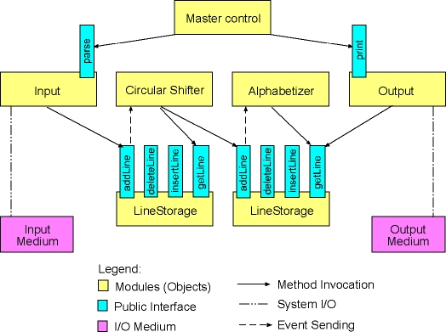
Figure 3: Architecture of event based KWIC system

Run-Time Event Interactions
The existing KWIC system works as follows. The act of adding a new line to the first LineStorage causes an event to be sent to the CircularShifter module. This allows the CircularShifter module to produce all circular shifts of the line and to store them into the second line storage. This in turn causes another event to be sent to the Alphabetizer module, so that this module may sort the newly added circular shifts.
Thus, we have the following event based interactions in the system:
- The CircularShifter registers its interest in the first LineStorage module. The first LineStorage module sends an event whenever a new line has been added to it. The CircularShifter module receives the event sent by the first LineStorage module. As a response to receiving the event the CircularShifter module produces all circular shifts of the newly added line and stores those shifts in the second LineStorage module.
- The Alphabetizer module registers its interest in the second LineStorage module. The second LineStorage module sends an event whenever a new circular shift has been added to it. The Alphabetizer module receives the event sent by the second LineStorage module. As a response to receiving that event the Alphabetizer module sorts circular shifts.

Event Dispatching Strategy
The current KWIC system implements Observable/Observers pattern for handling events in the system. Thus, the two LineStorage modules (the first one applied to store the original lines, and the second one applied to store the circular shifts) are implemented as Observable modules. On the other hand the CircularShifter and the Alphabetizer module are implemented as Observers. Thus, the CircularShifter is an Observer of the first LineStorage module, whereas the Alphabetizer is an Observer of the second LineStorage module.

Java Support for Observer
Since the standard Java library, more specifically the standard java.util package provides the Observable class and the Observer interface, which implement the described behavior, these elements were reused to implement the Observable/Observers mechanism in the KWIC system. The following diagram shows the CircularShifter and the Alphabetizer class.

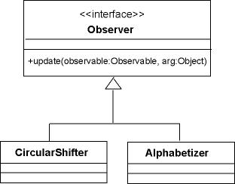
Figure 4: Observers in KWIC system

Thus, the Observer interface from the standard java.util package has only one public method: update. This method is invoked each time when an Observable object (observed by that specific Observer object) sends an event in the system. Thus, the CircularShifter and the Alphabetizer class implement this method to take their action whenever the LineStorage module that they observe sends an event. The event itself is passed as the second argument in the update method.

Java Support for Observable
The second diagram shows the LineStorageWrapper class which reuses the LineStorage class from the second assignment, but extends its functionality by inheriting from the Observable class from the java.util package.
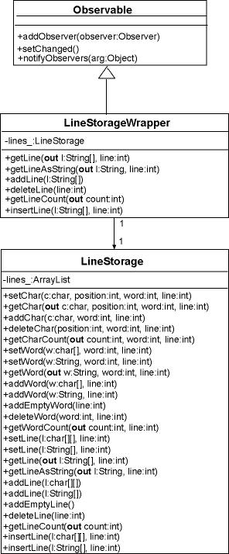
Figure 5: Observable in KWIC system
Thus, the Observable class from the standard java.util interface provides public methods that allow other objects to register themselves as Observers of objects of that class (addObserver() method). Further, the Observable class provides a method to notify Observers by sending an event in the system (notifyObservers() method). This method takes as an argument a single object of an Event class.

Implementation
In the current KWIC system we apply two LineStorageWrapper objects to store the original lines and circular shifts respectively. The added functionality from the Observable class allows us to invoke notifyObservers() method whenever a new line is added, deleted or inserted in any of these two objects. This in turn causes update method in the CircularShifter or Alphabetizer to be implicitly invoked, thus allowing us to take desired actions, i.e., to produce and add circular shifts in the case of CircularShifter object or to sort circular shifts alphabetically in the case of the Alphabetizer object.

Event Class
Finally, here is the diagram of the Event class from the existing KWIC system.
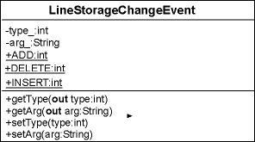
Figure 6: Event in KWIC system

Note that the Event class implements a simple protocol for describing the type of an event that occurred in a LineStorageWrapper object. Thus, by setting the type of the event we may tell the Observers what happened exactly. For example, if we set type of the event to ADD, we are telling Observers that a new line has been added to a LineStorageWrapper object. On the other hand, by setting the type of the event to DELETE, we are informing Observers that a line was deleted.

Students’ Assignment

Implement Interactive KWIC System
You need to implement an interactive version of the KWIC index system. That means the system won't read lines from a file but lines may be entered interactively by means of a simple command line. Here is a transcript of a sample session:

Add, Delete, Print, Quit: a
> Star Wars
Add, Delete, Print, Quit: a
> The Empire Strikes Back
Add, Delete, Print, Quit: a
> The Return of the Jedi
Add, Delete, Print, Quit: p
-----------------------------
Back The Empire Strikes
Empire Strikes Back The
Jedi The Return of the
Return of the Jedi The
Star Wars
Strikes Back The Empire
The Empire Strikes Back
The Return of the Jedi
Wars Star
of the Jedi The Return
the Jedi The Return of
-----------------------------
Add, Delete, Print, Quit: d
> Star Wars
Add, Delete, Print, Quit: p
-----------------------------
Back The Empire Strikes
Empire Strikes Back The
Jedi The Return of the
Return of the Jedi The
Strikes Back The Empire
The Empire Strikes Back
The Return of the Jedi
of the Jedi The Return
the Jedi The Return of
-----------------------------

Thus, commands that should be supported are:
- Add command for adding a new line with key binding 'a'
- Delete command for deleting a line with key binding 'd'
- Print command for printing shifts sorted alphabetically with key binding 'p'
- Quit command for exiting the system with key binding 'q'
Hint: The current implementation of the system and the LineStorageChangeEvent already supports sending/dispatching a delete event. Thus, when a line is deleted from the first LineStorage a LineStorageChangeEvent with the DELETE type is sent to the CircularShifter object. Now, to implement the delete functionality you need to handle the DELETE event inside the update method in CircularShifter class and to delete all circular shifts of the deleted line as well.

Extend the System Functionality
To extend the functionality of the existing KWIC system you need to implement words index. This index should keep all words that appear in the original lines and the number of their occurrences in the original lines. For example, the words index for the following original lines looks as follows:
Original Lines:
Star Wars
The Empire Strikes Back
The Return of the Jedi
The Phantom Menace
The Clone Wars
Words Index:
Star: 1
Wars: 2
The: 4
Empire: 1
Strikes: 1
Back: 1
Return: 1
of: 1
the: 1
Jedi: 1
Phantom: 1
Menace: 1
Clone: 1

Further, you need to incorporate a new command in the command line. This new command should allow users to print out the words index. Thus, your KWIC system need to support the following commands:
- Add command for adding a new line with key binding 'a'
- Delete command for deleting a line with key binding 'd'
- Print command for printing shifts sorted alphabetically with key binding 'p'
- Index command for printing words index with key binding 'i'
- Quit command for exiting the system with key binding 'q'
Hint: To implement the words index you may add a new module into the system, e.g. WordsIndex module. The new module should be declared as an additional Observer of the first LineStorage module. Thus, each event sent by the first LineStorage module will be sent to the WordsIndex module in addition to the CircularShifter module. In the update method of the WordsIndex you should then provide an implementation that will keep the WordsIndex up-to-date. In the figure below is the architecture of the extended KWIC system.

Answer understanding questions
Please, answer the following questions:
- Which modules from the original KWIC system did you need to modify to implement the WordsIndex module? What can you conclude here? Do systems implemented with event based architecture allow for easy adding of new modules, assuming that the new modules apply the already existing event protocol?
- Please, describe a simple solution to implement a WordsIndex that should keep all words that appear in the original lines and the number of their occurrences in the circular shifts.

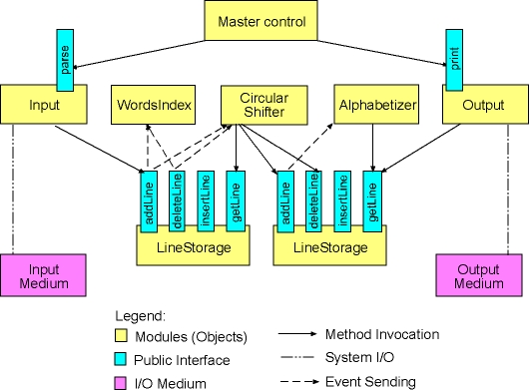

Figure 7: Architecture of the modified KWIC system

