KWIC Implemented with Main/Subroutine Architectural Style

KWIC Implemented with Main/Subroutine Architectural Style 2
1 Architecture 2
1.1 Data Representation 2
1.2 Processing Algorithm 4
2 Students’ Assignment 4
2.1 Modify data representation 4
2.2 Modify functionality of the system 5
2.3 Answer understanding questions 6

KWIC Implemented with Main/Subroutine Architectural Style

Architecture
The solution with main/subroutine architectural style with shared data decomposes the system according to the four basic functions performed: input, shift, alphabetize and output. These functions are coordinated as subroutines by a main program that sequences through them.

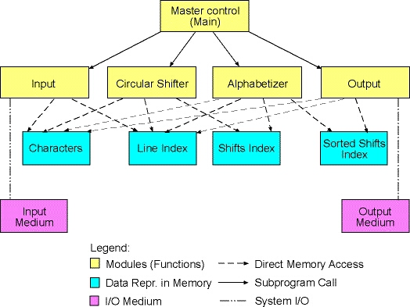

Figure 1: Architecture of KWIC system

Data Representation
The current KWIC system represents its data in the following format. Characters from the input file are stored in a character array named chars_. Words are delimited by a single space character.

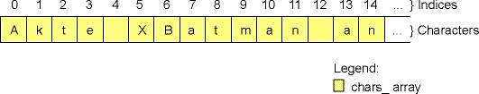
Figure 2: Character array keeping all characters

There is an integer array called line_index_, which keeps indices of characters from the character array. Each index kept in the line index array is the index of the first character of a particular line.

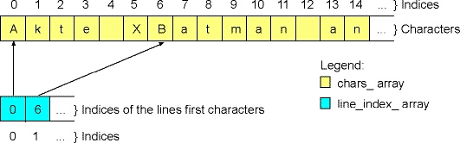
Figure 3: Line index array

Two dimensional integer array (matrix) named circular_shifts_ represents the set of all circular shifts of all original lines. A particular circular shift is represented as a pair of indices. The first value in such a pair is an index of the original line from the line index array. The second value in the pair is an index of a character from the character array. The character pointed by this index is the first character of a particular circular shift.

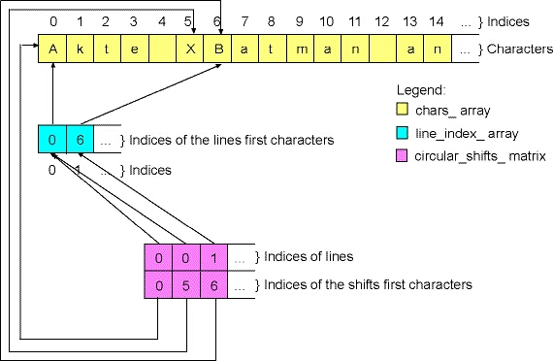
Figure 4: Shifts matrix

Two dimensional integer array (matrix) named alphabetized_ represents the sorted lines. This array has the same format as the circular shifts array. The difference is that in the alphabetized array lines come in a different order, i.e., they are sorted alphabetically.

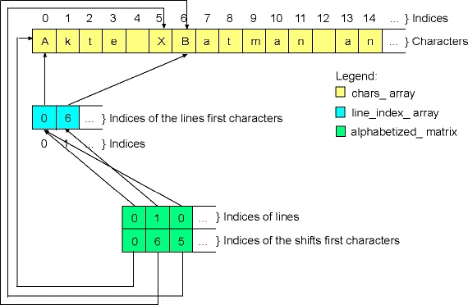
Figure 5: Sorted shifts matrix

Processing Algorithm
The main function controls the execution of the KWIC program:
- The input function is called to read and parse the lines from an input file. This function reads and processes all lines at once and represents it by means of the character (chars_) and line index (line_index_) array, as described before.
- The main function calls the circularShift function, which produces circular shifts of each particular line and stores it in the circular shifts array (circular_shifts_), as discussed before.
- After the circular shifts have been produced, the main function calls the alphabetize function, which sorts circular shifts alphabetically. The result is stored in the alphabetized array (alphabetized_), as described before.
- Finally, the main function calls the output function, which prints the sorted lines.

Students’ Assignment

Modify data representation
You need to modify the way how circular shifts and sorted circular shifts are represented by the KWIC system. In the new version, circular shifts should be now represented in the same way as the original lines. All characters from all circular shifts should be stored in a new character array. For instance, consider the following original line: "Akte X". This line has two circular shifts (the first circular shift is equal to the original line): "Akte X", "X Akte". All characters from both circular shifts should be stored completely in the new character array one after another, as shown in the following figure.
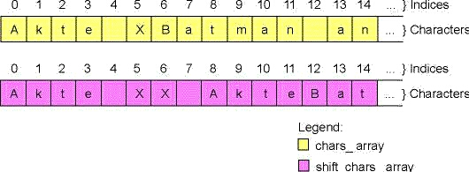
Figure 6: New character array containing all shifts’ characters

Shift index is an integer array, which keeps indices of the first characters of circular shifts stored in the new character array.

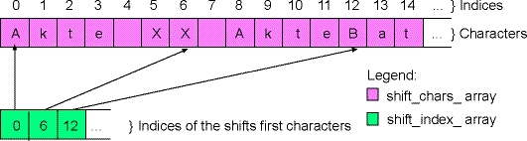
Figure 7: New array keeping shifts’ indices

The sorted shifts are represented with a new integer array (alpha_index_), keeping indices of shifts from shifts_index_ array. Of course, indices in the new array are sorted alphabetically.

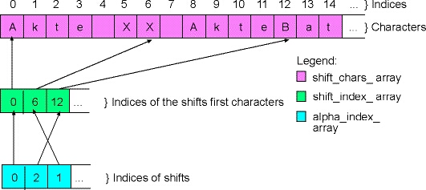
Figure 8: New array keeping sorted shifts’ indices

Modify functionality of the system
You need to provide the existing KWIC system with additional functionality. The new KWIC system should be able to filter out some of the circular shifts that are produced. All circular shifts that start with a number, i.e., all shifts where the first character is a character between '0' and '9' should be removed from the shifts array before the sorting starts.

Hint: Add a new module, i.e., a new function to the existing system. The name of the new module can be filter, and it should be responsible for iterating through the produced shifts and removing all the shifts that starts with a number. The main function should call the filter function right after the circularShift function and just before the call of the alphabetizing function.
Thus, the architecture of the new system looks as shown in the following picture. Note, that the modification in data representation is already visible in the figure.

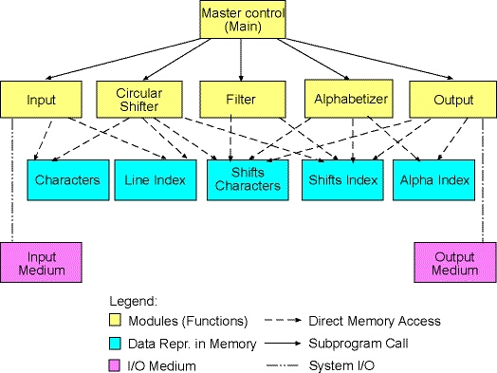
Figure 9: New system architecture

Answer understanding questions
Please, answer the following questions:
- Which modules from the original KWIC system did you need to modify to implement the new data representation of circular shifts? What conclusion can you draw here? How does the KWIC system implemented by means of main/subroutine architecture with shared data withstand design changes in data representation?
- Which modules from the original KWIC system did you need to modify to add filtering function to the system? Was it difficult to add a new processing component (filter function) accessing the shared data? Can we conclude here that the KWIC system with main/subroutine architecture with shared data is robust to design changes in system's function (assuming that new functions access the shared data)?

Hints:
- Modules in the case of main/subroutine architectural style are functions.
- The original KWIC system was composed out of 5 modules (functions). If you needed to modify 2 or more of the original modules (that is 40% or more of the original code) to implement a certain modification that means that the style is NOT robust to design changes requested in the modification.
- If you needed to modify only 1 module from the original system (do not count here new modules that you added), then the style is robust to design changes requested in the modification.
- Do not write essays! Concise, small and simple answers are preferred!

