KWIC Implemented with Object-Oriented Architectural Style

KWIC Implemented with Object-Oriented Architectural Style 2
1 Architecture 2
1.1 Class Diagram: System Statics 3
1.2 Sequence Diagram: System Dynamics 4
2 Students’ Assignment 6
2.1 Modify data representation 6
2.2 Modify processing algorithm 7
2.3 Answer understanding questions 8

KWIC Implemented with Object-Oriented Architectural Style

Architecture
The solution with object-oriented architectural style decomposes the system into six modules:
- LineStorage module, responsible for holding all characters from all words and lines.
- Input module, responsible for reading the data from a file and storing it in LineStorage module.
- CircularShifter module, responsible for producing circular shifts of lines stored in LineStorage module.
- Alphabetizer module, responsible for sorting circular shifts alphabetically.
- Output module, responsible for printing the sorted shifts.
- Master control module, responsible for controlling the sequence of method invocations in other modules.
Contrary to the main/subroutine solution, in the object-oriented solution the data is not shared between the computational components. Instead, each module provides an interface that permits other components to access data only by invoking methods in that interface. For example, LineStorage module provides the public interface that allows other modules to set character in a particular word in a particular line, read a specific character, read, set or delete a particular word in a specific line, read whole line at once, etc.

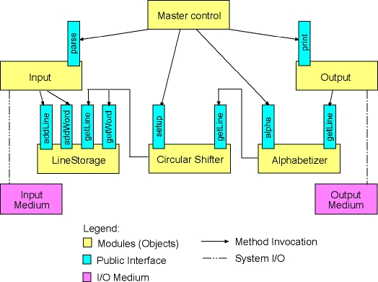

Figure 1: Architecture of KWIC system

Class Diagram: System Statics

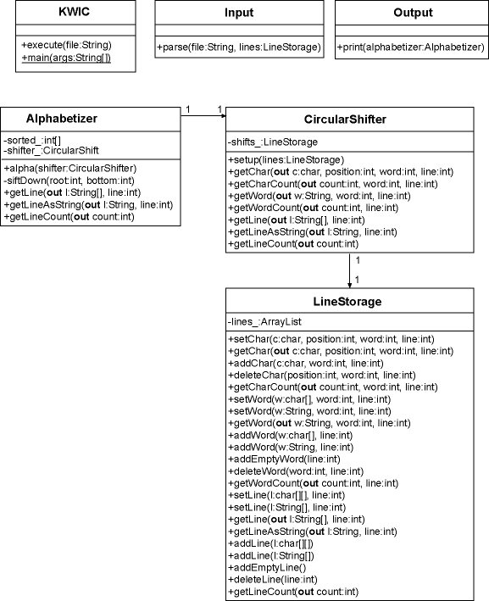

Figure 2: Class diagram of KWIC system
Class diagram is the result of static analysis, architectural design, and class design of an object-oriented software system. Usually, we develop class diagrams by using Unified Modeling Language (UML). Such UML class diagram includes the following information:
- It describes how modules from the original architectural solution map onto classes. Thus, it depicts all classes from the system we are implementing.
- For each class it depicts its public interface, i.e., public methods that we may invoke to manipulate instances of that class.
- For each class it depicts its instance variables.
- Finally, the diagram shows how classes relate to each other. Class relations are represented with so-called associations, their type and attributes.
Each module from the architectural design maps exactly onto one class. Thus, there exist KWIC class (Master Control module), Input class, Output class, LineStorage class, CicrularShifter class and Alphabetizer class. Each class is represented as a rectangle box, having three horizontally arranged sub-boxes. The name of each class is written in the top sub-box.

Public interface of each class is written into the bottom sub-box, as a list of method declarations. The plus (+) sign in front of a method name means that the method is defined as public and may be invoked by objects of other classes. The argument list is written within parenthesis. Each argument is represented with the name, its type and the direction in which the argument is passed. If there is no direction modifier that means that this method takes this argument, and if there is out modifier that means that the method returns this argument as a return value to the calling object. For example, +getChar(out c:char, position:int, word:int, line:int) method from the LineStorage class takes as arguments three integere values: position of the character, index of the word, and index of the line, and returns the value of that character.

Instance variables (attributes) of a class are shown in the middle sub-box. The minus (-) sign in front of an instance variable means that the variable is defined as private and may not be manipulated by other objects directly. Instead, the public interface of the class should be applied to do so. That is completely in accordance with object-oriented principles of data encapsulation and information hiding. After the minus sign, the name and the type of a particular instance variable are shown. For example, the LineStorage class has one private instance variable: lines_. This instance variable is of type ArrayList, and holds a list of lines.

Finally, we have a number of associations between some of the classes. A directed association means that the originating class has as an instance variable an object of the associated class. For example, the Alphabetizer class has an association with the CircularShift class. That means that an object of the Alphabetizer class has as an instance variable an object of the CircularShift class. This variable is also depicted in the middle box of the Alphabetizer class. We can spot there shifter_ variable, which is of type CircularShifter. The numbering at each association end means that exactly one object of the Alphabetizer class holds exactly one object of the CircularShifter class.

Sequence Diagram: System Dynamics
In UML dynamic (interaction) diagrams describe how group of objects collaborate to execute a certain task in a running program. In other words these diagrams show graphically the processing algorithm and the dynamic behaviour of a running system. Sequence diagram is a special type of dynamic diagrams that describes the time sequence of method invokations on the run-time:
- Objects are shown as boxes at the top of the diagram.
- Time is represented with the so-called object's lifeline - vertical line beneath the object's box. The time increases downward along the vertical object's lifeline.
- Method invokation is simbolized through a horizontal line connecting two vertical object's lifelines. The name of the method is written above such horizontal line. Methods which are further down on an object's lifeline are invoked later than methods that are closer to the top.
- Conditions for method invokation and iterative method invokations may be simbolized with special signs. For example, iterative method invokation is depicted with the * sign.
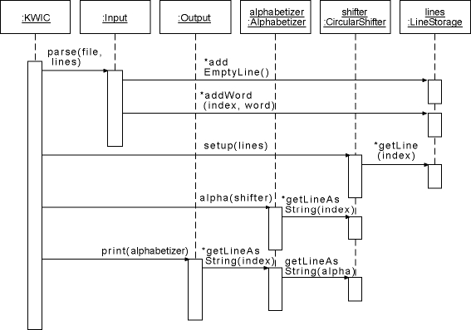
Figure 3: Sequence diagram of KWIC system
An instance of the KWIC class controls the execution of the program. Firstly, parse method of an instance of the Input class is invoked. This method takes as arguments the name of the file containing lines, and an instance of the LineStorage class to store the data. The parse method reads the data from the file. For each line in that file it creates a new line in the LineStorage by invoking its addEmptyLine method. To add words to the new line Input object invokes addWord method on LineStorage. The iterative nature of this process is symbolized in the diagram with * sign in the front of the addWord method name. Once when the parsing of lines is finished the KWIC object invokes the setup method of the CircularShifter instance. The single argument for this method is LineStorage holding the lines. The CircularShifter object iterates through all lines in the LineStorage and produces circular shifts of these lines. At the next step the KWIC object invokes the alpha method of Alphabetizer instance. This method takes as an argument the CircularShifter object. It then sorts shifts alphabetically, retrieving each of them from CircularShifter object by invoking its getLineAsString method. Finally, the KWIC object invokes the print method on Output instance. This method takes as an argument the Alphabetizer object from the previous step. It iterates then through all lines from the Alphabetizer object by invoking getLineAsString method. Notice that this method just forwards the request to the CircularShifter object to retrieve the data. Of course, the forwarded request does not include the original index, but the sorted one. When the print method returns, the execution of the program is finished.

Students’ Assignment

Modify data representation
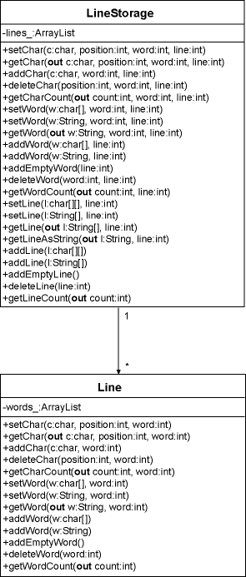
Figure 4: Class diagram with the new Line class
In the current version of the LineStorage class we have the following data structure for storing lines:
- An instance variable with the name lines_ of type ArrayList holds all lines. The ArrayList class implements all standard dynamic list operations, i.e., we can add elements at the end of the list, we can insert elements in an arbitrary position in the list, we can delete elements, etc. An element stored in an ArrayList can be any Java object since ArrayList holds instances of the Object class. The Object class is the root of the single rooted Java class hierarchy, i.e., any Java class is a subclass of the Object class.
- In the current implementation lines_ variable holds objects of the ArrayList class. That means that each line is stored within another object of ArrayList class. Inside that second list words of a particular line are stored. Words are stored as instances of the String class.
You need to modify the data structure for storing lines in LineStorage objects. The new data representation should look as follows:
- A new class should be defined, providing the storage for a single line and a public interface to manipulate the content of a line. The name of the new class should be Line.
- The Line class stores a line into an object of the ArrayList class. The name of this instance variable should be words_. Words should be stored as instances of the String class in the words_ object.
- The LineStorage class keeps lines in the same lines_ object. However, this list is now filled with instances of the Line class.
The above class diagram depicts the modifications you need to implement. Note, that the diagram shows only classes relevant for your current task. All other classes remain the same.

Modify processing algorithm
First, you need to implement an interactive version of the KWIC index system. That means the system won't read lines from a file but lines are inserted interactively by means of a simple command line user interface. Here is a transcript of a sample session:
- Add, Print, Quit: a
- > Star Wars
- Add, Print, Quit: a
- > The Empire Strikes Back
- Add, Print, Quit: a
- > The Return of the Jedi
- Add, Print, Quit: p
- Back The Empire Strikes
- Empire Strikes Back The
- Jedi The Return of the
- Return of the Jedi The
- Star Wars
- Strikes Back The Empire
- The Empire Strikes Back
- The Return of the Jedi
- Wars Star
- of the Jedi The Return
- the Jedi The Return of
Further, you need to modify how line shifting is performed. In the current version all lines are read at once, and line shifting is done on all lines at once after they are read. In the new version you need to perform line shifting on each line as it is read from the command line. The following sequence diagram depicts the new situation.
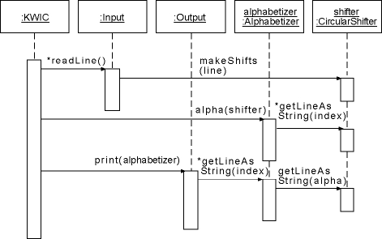
Figure 5: New sequence diagram

Thus in the new system KWIC object controls the command line interface. After a command for adding a line has been issued, the KWIC object invokes readLine method of the Input object. The Input reads the line and passes it to the CircularShifter object by invoking its makeShifts method. After shifts have been made, makeShifts and readLine methods return and the KWIC object is again in charge, waiting for a new command from the user.

Answer understanding questions
Please, answer the following questions:
- Which modules from the original KWIC system did you need to modify to implement the new data representation of lines within the LineStorage class? What conclusion can you draw here? How does the KWIC system implemented by means of object-oriented architecture withstand design changes in data representation within a particular module? Is this true for any other object-oriented system?
- Which modules from the original KWIC system did you need to modify to implement a new processing algorithm in the system? Can we conclude here that the KWIC system with object-oriented architecture is robust to desing changes in processing algorithm of the system?

Hints:
  - Modules in the case of object-oriented architectural style are classes.
  - The original KWIC system was composed out of 6 modules (classes). If you needed to modify 2 or more of the original modules (that is 33% or more of the original code) to implement a certain modification that means that the style is NOT robust to design changes requested in the modification.
  - If you needed to modify only 1 module from the original system (do not count here new modules that you added), then the style is robust to design changes requested in the modification.
  - Do not write essays! Concise, small and simple answers are preferred!

