**Project Report Template**

**Name:** Aldrin Filbert D. Maaño  
**Student ID:** 105667785  
**Project Title:** Project Part 1  
**GitHub Repository Link:** <https://github.com/Optional-WebTechGroup/OptionalGroupProject01>

**Jira Project Link:** <https://nagooptional.atlassian.net/jira/software/projects/SCRUM/summary> **Discord channel name for your group:** rahul-wed-1430-g02

**1. GitHub Contribution Summary**

**1.1 Commit History**

* **Branch Name:** apply, main, live_server
* **Total Number of Commits:** 67
* **Commit Frequency:** Daily
* **Example of Meaningful Commit Messages:**
  + changed dream_job id to text_gradient class for better css stucture – Apr 14, 2025
  + change color of index jobs position button for contrast – Apr 13, 2025
  + adjusments to make it responsive. styled the apply button – Apr 7, 2025
  + added class row and questions. added style to those class – Apr 5, 2025
  + added first name, last name, and date of birth – Apr 2, 2025
  + Put the template to all html files - Mar 31, 2025
  + Added the folder images to project1/ and project1/styles/ - Mar 29, 2025

**1.2 Contribution Breakdown**

* **Major Features or Sections Worked On:**
  + Navigation Bar – Made the navigation bar with logo, the nav links, and the email us button. It’s also flexible and change flex direction as a response to smaller screen sizes.
  + Footer – Made the footer with logo, the nav links, the link to the Jira project and GitHub repo, and the copy right section at the very bottom. It is flexible and responsive as well.
  + Apply Page – The apply page features all the requirements along with added sections. The requirements include the personal details, while the added sections are the experience, education, profile, resume, and message to the team section. Each of part of the section is flexible and responsive.
  + Additional content for other pages
    - Index Page – I’ve added the hero section, the services section, and the contact section. I’ve improved some of the design of the page and made it responsive.
    - About Page – I’ve added the h1 heading, with the gradient design. I’ve also added our story, mission, vision, impact, and testimonials section.
    - Jobs Page – I’ve added the gradient title, added the margin, and fixed some of the styles.
* **List of User Stories Handled:**
  + As a user, I want to be able to answer a form about my personal details, so that the company know about me. – This includes all the requirements for the apply page.
  + As a user, I want a form that has a simple and consistent design, so that I can easily answer it. – This includes all the CSS tasks, getting inspiration from other website forms, and making the form follow the accessibility guidelines.
  + As a user, I want to be able to add my work experience in the forms, so that the company will know what I have done in my previous job. – This includes the section that ask the user about their previous experience.
  + As a user, I want to be able to add my education background, so that the company knows my knowledge for the role I’m applying for. – This includes the section that ask the user about their educational background.
  + As a user, I want to be able to add my profile links, so that I can showcase my career and projects. – This includes the section that ask the user about 4 major online platforms that showcases their career.
  + As a user, I want to be able to add a message to the hiring team, so that they will know why I want to work in their company. – This is just a section that have a textarea where the user can input their message to the hiring team.
  + As a user, I want to be able to add my resume, so that the employers can see my credentials. – This is the section that lets the user upload their resume. It only accepts pdf docx and doc.
* **Challenges Faced and How I Overcame Them:**
  + Most of the challenges I faced are from the styles. I want it to look like a certain way, but don’t I previously don’t know how to. I searched in google and asked AI how to do a certain thing in CSS tried to understand all of it before implementing it to my code. Tailoring it for my use case.
  + Another challenge I faced was contrast issues from wave and I fixed it just by changing the color to allow proper contrast between the text and the background.
  + One more issue I faced was the pattern in the inputs was not working. I’ve noticed that I have errors with my regex and fixed it accordingly.
  + One more issue I had was from the html validator. It says that button tag can’t be enclosed in a tag. The solution I come up with is just style the a tag to look like a button.
* **Code Quality and Best Practices Used:**
  + Followed the file structure from the project description
  + Careful use of id and classes
  + Added css variable for our highlight color
  + Followed contrast conventions as per the wave extension
  + Used sections and div appropriately
  + Have proper heading for each section
  + Have labels for all inputs

**2. Discord Participation**

**2.1 Contribution Rating**

**Self-rating (1-5):** 5

**2.2 Evidence of Participation**

* **Examples of Helpful Contributions:**
  + Recommended a resource to learn about git and github.
  + Send an image of my vision of what our website should look like along with my suggestions.
  + Answered question about merging, pulling and pushing in github
  + Explained some of the project description or requirements if one of my group members have a trouble understanding what needs to be done.
  + Help when group members are experiencing errors with their page.
* **Did I Seek or Offer Help?** Yes
* **If Yes, Describe an Example:** Since I’ve finished my page early, I’ve offered to help with the other web pages. I’ve added other optional sections and improved some of the designs.

**3. Final Project Assessment**

* **Did the final project meet my expectations? Why or why not?** I think the final project somewhat meet my expectations. Our team manage to meet all the requirements along with additional sections to make the website feel more complete. I think we could’ve added more and made our code cleaner, but I’m overall happy with our output.
* **What was the strongest part of my contribution?** I think the strongest part of my contribution is my initiative. I’ve started the template for our project during week 4, finished my assigned tasks early, and was able to offer help and add sections to the other webpages.
* **What did I do for improving the accessibility of our website? (Include accessibility screenshots - WAVE)**   
    
  Two things that I did to improve the accessibility of our website is by improving the contrast between the text and the background, and by adding labels to all the input tags. I had errors for these two when I first used the wave extension. I was able to fix them by following the suggestions by wave.

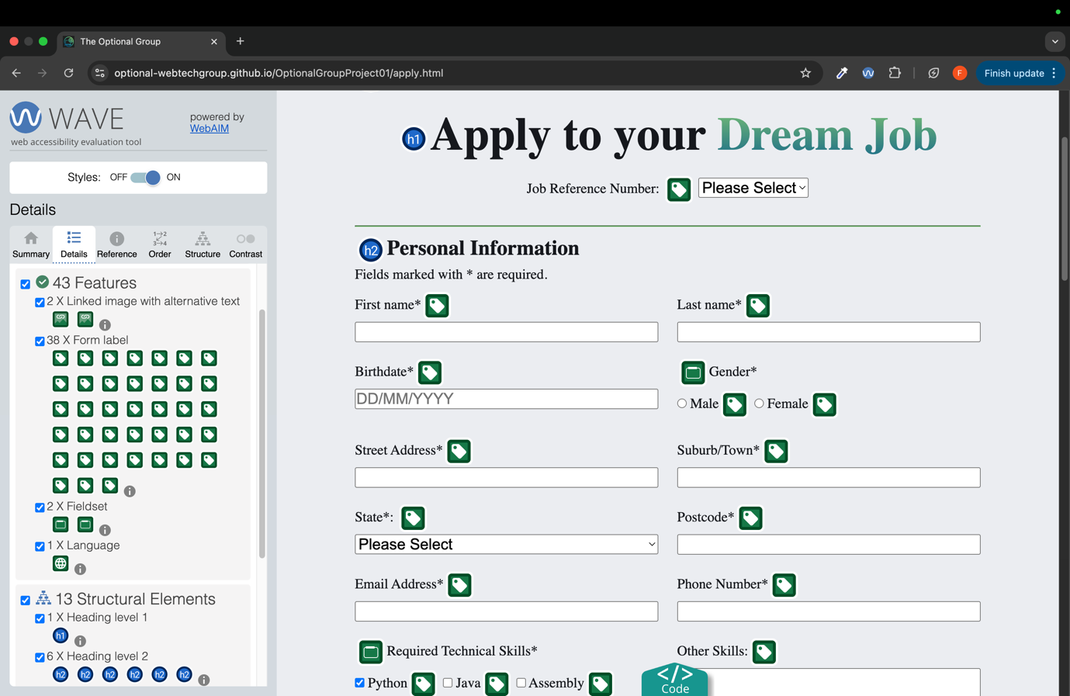

**4. Reflection on Learning and Collaboration**

* **What did I learn from this project?**

I’ve used google and ai during this project mainly for searching things I didn’t know and to understand concepts a lot better. It’s a skill to use these tools effectively to problem solve and understand concepts deeper. I’ve also learned how to use Jira and GitHub, which are platforms that are widely used in the industry. One more thing that I learned from this project is that communication with your groupmates is essential to produce high quality work. I’ve learned to communicate my thoughts and offer help to others.

* **What would I do differently next time?**
* I would’ve have tried to finish my assigned tasked sooner so that I can ask for feedback on what I can improve on my page. I would also be a lot more vocal about my ideas and give more frequent updates on my progress to our group, so we are all on the same page. Aside from that I wouldn’t change much as it was a fun experience working in this group.