ITBDA4-14 Big Data Analytics Techniques
Project 2
Name | Sherman Opperman
Student number | CON-1375611-S5S8
Lecturer | Gilbert Lekula
Campus | Tyger Valley
GitHub repository | https://github.com/Opzalas369/ITBDA4-14_Big_Data_Analytics_Project_2

Question 1: MapReduce keyword location search

1.1 Logical layout
The diagram shows the six stages the job goes through for the keyword "africa". Only the documents that contain the keyword are drawn in the middle stages. The numbers are the real results of the run shown in section 1.4.
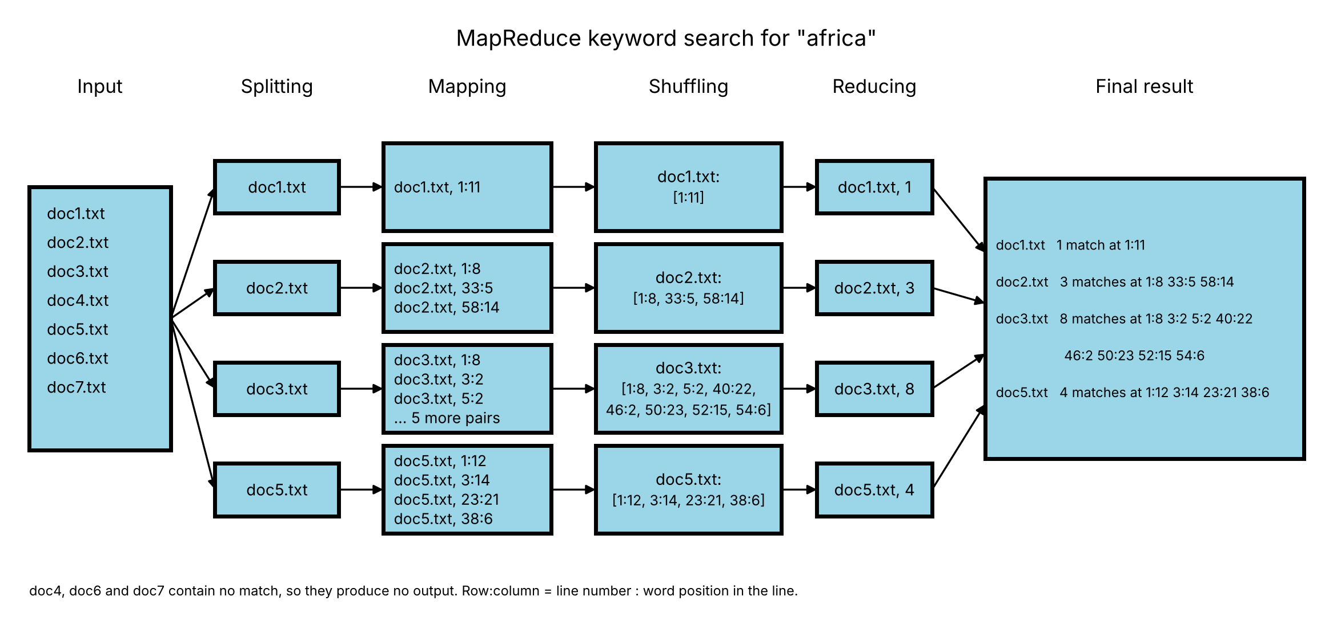
Figure 1: Logical layout of the MapReduce job for the keyword "africa"
- Input: the seven documents (doc1.txt to doc7.txt) are stored in HDFS.
- Splitting: each document becomes one split, so each document is handled by its own Mapper.
- Mapping: the Mapper reads its document line by line and writes (document, row:column) for every word that equals the keyword.
- Shuffling: Hadoop groups all the pairs with the same document name together and sends them to the Reducer.
- Reducing: the Reducer sorts the locations of each document by row and then column, and counts them.
- Final result: one line per document with the number of matches and their row:column positions.

1.2 Mapper
The Mapper is run once per document. It reads the keyword from the job configuration, so nothing is hard-coded. For every line it counts the row, cleans the line, splits it into words and writes one pair for every word that equals the keyword.
import java.io.IOException;
import org.apache.hadoop.io.Text;
import org.apache.hadoop.mapreduce.Mapper;
import org.apache.hadoop.mapreduce.lib.input.FileSplit;

// Q1.2 Mapper: finds the keyword in every line of a document and emits <document, row:column>
public class Q1_2_Mapper extends Mapper<Object, Text, Text, Text> {

private String keyword;
private Text fileName = new Text();
private int row = 0;

@Override
protected void setup(Context context) {
// the keyword comes from the job configuration, so it is not hard-coded
keyword = context.getConfiguration().get("keyword").toLowerCase();
// name of the document this Mapper is reading
fileName.set(((FileSplit) context.getInputSplit()).getPath().getName());
}

@Override
public void map(Object key, Text value, Context context)
throws IOException, InterruptedException {
row++; // current line (row)
String line = value.toString().toLowerCase().replaceAll("(?U)^\\W+", "");
String[] words = line.split("(?U)\\W+"); // words in the line

for (int col = 0; col < words.length; col++) {
if (words[col].equals(keyword)) {
context.write(fileName, new Text(row + ":" + (col + 1))); // <document, row:column>
}
}
}
}

- setup() runs once: it reads the keyword, changes it to lower case, and gets the name of the document from the input split.
- map() runs for every line: row++ gives the row number, and the line is changed to lower case so the search is not case sensitive.
- The line is split on anything that is not a letter or a digit, and the index in the word array plus one is the column.
- The output pair is (document name, "row:column"), for example (doc2.txt, 33:5).

1.3 Reducer
After the shuffle, the Reducer receives one document name together with all of its row:column locations. It sorts them and writes a single line for that document.
import java.io.IOException;
import java.util.ArrayList;
import java.util.Collections;
import java.util.List;
import org.apache.hadoop.io.Text;
import org.apache.hadoop.mapreduce.Reducer;

// Q1.3 Reducer: receives one document with all its row:column locations and writes one line
public class Q1_3_Reducer extends Reducer<Text, Text, Text, Text> {

@Override
public void reduce(Text key, Iterable<Text> values, Context context)
throws IOException, InterruptedException {
List<String> locations = new ArrayList<String>();
for (Text value : values) { // every row:column found in this document
locations.add(value.toString());
}

// Hadoop does not keep the values in the order they were found, so sort by row then column
Collections.sort(locations, (a, b) -> {
String[] x = a.split(":");
String[] y = b.split(":");
int byRow = Integer.compare(Integer.parseInt(x[0]), Integer.parseInt(y[0]));
return byRow != 0 ? byRow : Integer.compare(Integer.parseInt(x[1]), Integer.parseInt(y[1]));
});

context.write(key, new Text(locations.size() + " match(es) at " + String.join(" ", locations)));
}
}

- Hadoop does not keep the values in the order they were found, so the Reducer sorts them by row first and then by column.
- The output line holds the document name, the number of matches, and the locations, for example "doc2.txt 3 match(es) at 1:8 33:5 58:14".

1.4 Hadoop configuration
The Driver class sets up the job. It receives the input folder, the output folder and the keyword as arguments, which is what makes the job dynamic.
import org.apache.hadoop.conf.Configuration;
import org.apache.hadoop.fs.Path;
import org.apache.hadoop.io.Text;
import org.apache.hadoop.mapreduce.Job;
import org.apache.hadoop.mapreduce.lib.input.FileInputFormat;
import org.apache.hadoop.mapreduce.lib.output.FileOutputFormat;

// Q1.4 Driver: Hadoop MapReduce configuration settings
public class Q1_4_Driver {

public static void main(String[] args) throws Exception {
// args[0] = input folder, args[1] = output folder, args[2] = keyword
if (args.length != 3) {
System.err.println("Usage: Q1_4_Driver <input folder> <output folder> <keyword>");
System.exit(2);
}
Configuration conf = new Configuration();
conf.set("keyword", args[2]); // keyword passed in dynamically

Job job = Job.getInstance(conf, "keyword location search");
job.setJarByClass(Q1_4_Driver.class);
job.setMapperClass(Q1_2_Mapper.class);
job.setReducerClass(Q1_3_Reducer.class);
job.setOutputKeyClass(Text.class);
job.setOutputValueClass(Text.class);

FileInputFormat.addInputPath(job, new Path(args[0]));
FileInputFormat.setMinInputSplitSize(job, Long.MAX_VALUE); // one Mapper per document, so row numbers stay correct
FileOutputFormat.setOutputPath(job, new Path(args[1]));

System.exit(job.waitForCompletion(true) ? 0 : 1);
}
}

- conf.set("keyword", args[2]) passes the keyword to every Mapper.
- setMinInputSplitSize with Long.MAX_VALUE stops Hadoop from cutting a document into pieces, so one Mapper reads one whole document and its row numbers are correct.
- The Mapper and Reducer classes are registered, and both the output key and the output value are Text.
- Environment: Hadoop 3.2.4 on Windows with Java 8, running HDFS and YARN on one machine (pseudo-distributed mode). Hadoop was started from an Administrator window, because the ResourceManager failed with "Access is denied" in a normal window.
- YARN marked the node unhealthy because the C: drive was over 90% full, so the limit yarn.nodemanager.disk-health-checker.max-disk-utilization-per-disk-percentage was raised to 99 in yarn-site.xml.

1.4 Demonstration on Hadoop
Step 1: Hadoop is started and the four services are checked with jps. NameNode and DataNode belong to HDFS, ResourceManager and NodeManager belong to YARN.
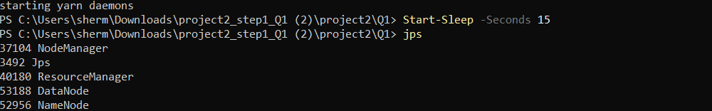
Figure 2: jps shows NameNode, DataNode, ResourceManager and NodeManager running
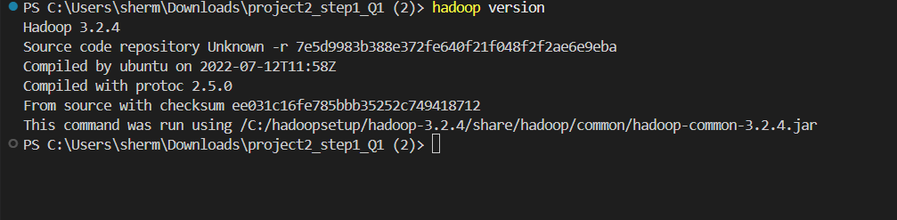
Figure 3: The installed Hadoop version
Step 2: The three classes are compiled against the Hadoop libraries and packed into q1.jar.
$cp = hadoop classpath
javac -cp $cp -d build Q1_2_Mapper.java Q1_3_Reducer.java Q1_4_Driver.java
jar cf q1.jar -C build .
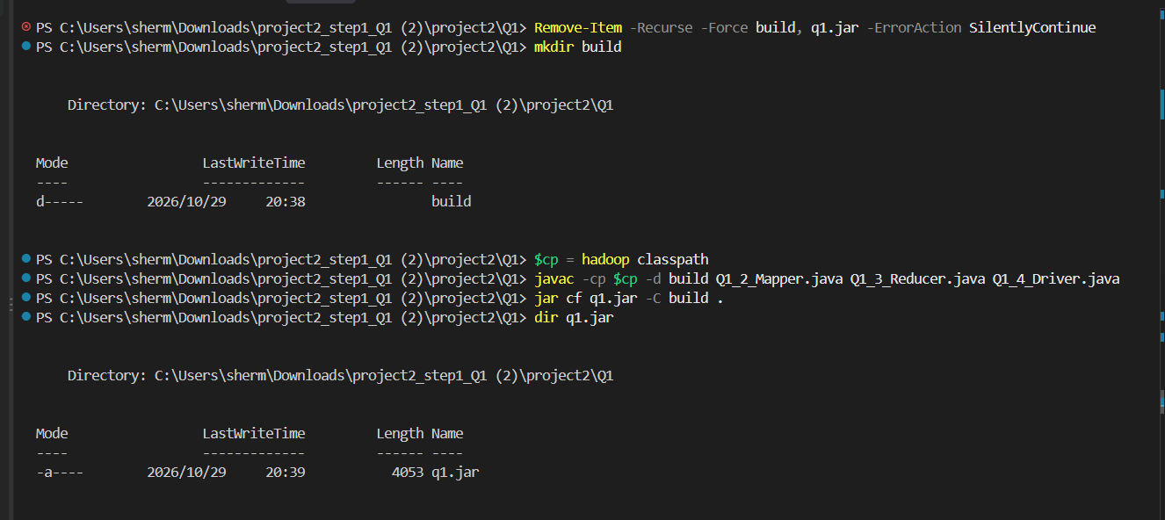
Figure 4: Compiling and building q1.jar
Step 3: The seven documents are copied into HDFS. This copy is the input of the job.
hdfs dfs -mkdir -p /user/sherm/docs
Get-ChildItem ..\datasets\map_reduce_test_docs\*.txt | ForEach-Object { hdfs dfs -put -f $_.FullName /user/sherm/docs }
hdfs dfs -ls /user/sherm/docs
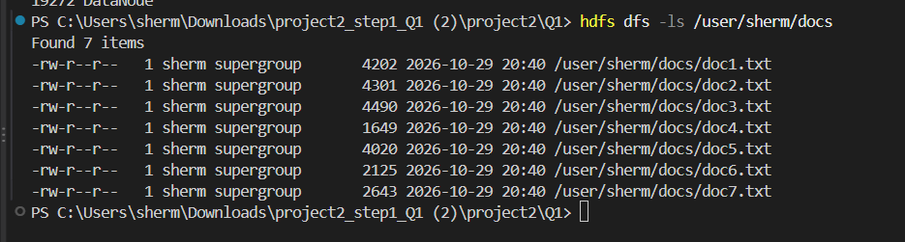
Figure 5: The seven input documents in HDFS
Step 4: The job is run with the keyword africa. The three arguments are the input folder, the output folder and the keyword.
hadoop jar q1.jar Q1_4_Driver /user/sherm/docs /user/sherm/out_africa africa
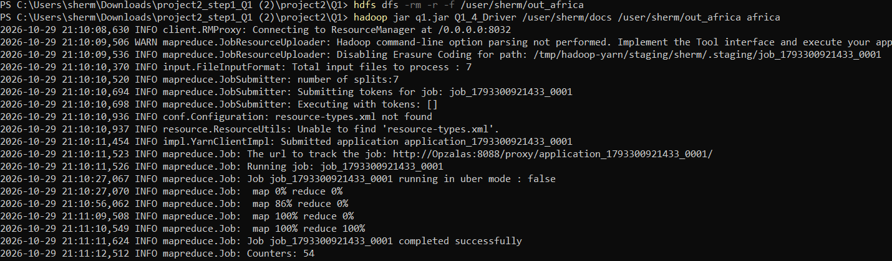
Figure 6: The job for "africa": 7 splits, map 100%, reduce 100%, completed successfully
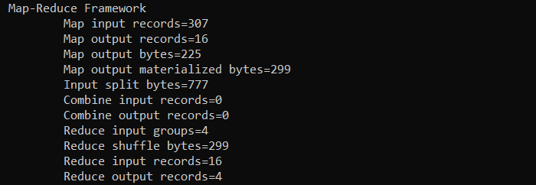
Figure 7: Counters for "africa": 307 lines read, 16 matches found, 4 documents in the output
Step 5: The result is read from the output folder.
hdfs dfs -cat /user/sherm/out_africa/part-r-00000
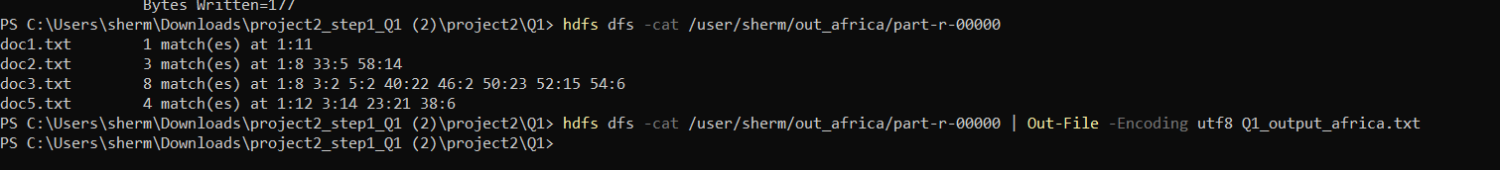
Figure 8: Result for "africa"
Document | Matches | Row:column
doc1.txt | 1 | 1:11
doc2.txt | 3 | 1:8 33:5 58:14
doc3.txt | 8 | 1:8 3:2 5:2 40:22 46:2 50:23 52:15 54:6
doc5.txt | 4 | 1:12 3:14 23:21 38:6

The counters agree with the result: 16 pairs came out of the Mappers (1 + 3 + 8 + 4), and the Reducer grouped them into 4 documents. doc4, doc6 and doc7 do not contain the word, so they do not appear.
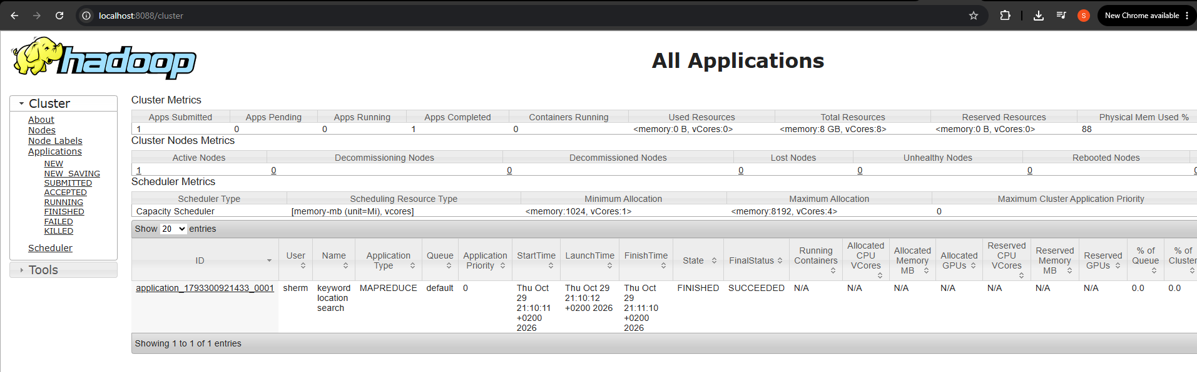
Figure 9: The YARN web page shows the application as FINISHED and SUCCEEDED
Step 6: To show that the job is dynamic, the same jar is run again with another keyword and a new output folder. Nothing in the code was changed.
hadoop jar q1.jar Q1_4_Driver /user/sherm/docs /user/sherm/out_SARS SARS
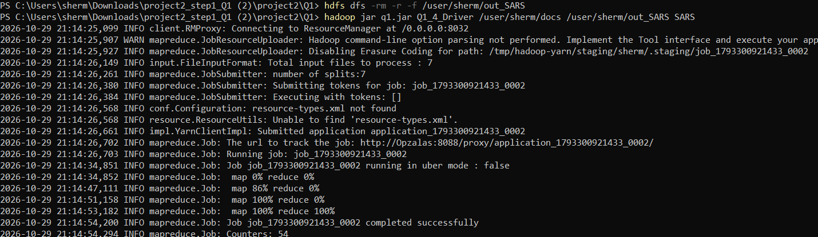
Figure 10: The same job for the keyword "SARS"
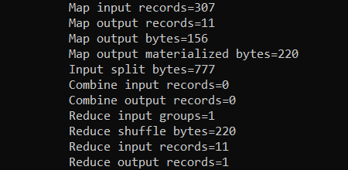
Figure 11: Counters for "SARS": 11 matches, 1 document
hdfs dfs -cat /user/sherm/out_SARS/part-r-00000
Figure 12: Result for "SARS": all 11 matches are in doc1.txt
The same Mapper and Reducer were used for both keywords. Only the arguments on the command line changed, and because the keyword and every line are converted to lower case before they are compared, the search does not depend on how the word is capitalised.

Question 2: Topic modelling of the news articles

2.1 Data frame and denoising
Each article is read into one row of a data frame. The first column (file_name) holds the file name and the second column (content) holds the full text. A third column (denoised) holds the cleaned text that is used for the model.
library(tm)
library(topicmodels)
library(ggplot2)
library(wordcloud)

data_dir <- "../datasets/sa_news"
files <- list.files(data_dir, pattern = "\\.txt$", full.names = TRUE)
if (length(files) == 0) stop("No .txt files found. setwd() to the Q2 folder first.")
files <- files[order(as.numeric(gsub("\\D", "", basename(files))))]

news_df <- data.frame(
file_name = basename(files),
content = sapply(files, function(f) paste(readLines(f, warn = FALSE, encoding = "UTF-8"), collapse = " ")),
stringsAsFactors = FALSE
)
rownames(news_df) <- NULL

# words that carry no topic information in these articles
noise <- c(stopwords("en"), "said", "also", "will", "may", "sanews", "south", "africa",
"african", "including", "expected", "gov",
month.name, tolower(month.name), "monday", "tuesday", "wednesday", "thursday", "friday",
"saturday", "sunday")

denoise <- function(text) {
text <- tolower(text)
text <- gsub("[^a-z ]", " ", text) # keep letters only (removes numbers and punctuation)
words <- strsplit(text, "\\s+")[[1]]
words <- words[nchar(words) > 2 & !(words %in% noise)]
paste(words, collapse = " ")
}
news_df$denoised <- sapply(news_df$content, denoise)

# show the start of each article before and after denoising
print(data.frame(file_name = news_df$file_name,
content = substr(news_df$content, 1, 60),
denoised = substr(news_df$denoised, 1, 60)))
write.csv(news_df, "Q2_1_dataframe.csv", row.names = FALSE)

The denoising function does the following:
- changes all text to lower case, so "Eskom" and "eskom" are the same word;
- removes numbers and punctuation, keeping letters only;
- removes English stop words (such as "the" and "and"), month and day names, and words that appear in almost every article and say nothing about a topic ("said", "south", "africa", "sanews" and similar);
- removes words with two letters or fewer.
The ten articles contained 3,832 words before cleaning and 2,101 words after, so about 45% of the text was noise. The table shows the start of each article before and after cleaning.
file_name | content (start) | denoised (start)
news_1.txt | Eskom former official, service provider appear i... | eskom former official service provider appear co...
news_2.txt | Gauteng Education commits to implementing Mayibu... | gauteng education commits implementing mayibuye...
news_3.txt | New Labour Minister charts the way forward Tues... | new labour minister charts way forward newly app...
news_4.txt | Police recue two kidnapped victims in Benoni Tue... | police recue two kidnapped victims benoni swift...
news_5.txt | President Ramaphosa sends condolences to decease... | president ramaphosa sends condolences deceased s...
news_6.txt | Accounting officers must be accountable for non-... | accounting officers must accountable non payment...
news_7.txt | Democratic dispensation necessitated a complete... | democratic dispensation necessitated complete ov...
news_8.txt | Trust and relationships key ingredients to coali... | trust relationships key ingredients coalition go...
news_9.txt | PSC applauds officials who refuse to accept a br... | psc applauds officials refuse accept bribes publ...
news_10.txt | Wet, cold weather expected to continue in Wester... | wet cold weather continue western cape cold wet...

2.2 LDA topic model
LDA treats every article as a mixture of topics and every topic as a mixture of words. The cleaned text is turned into a document-term matrix, words that appear only once are dropped, and a model with three topics (k = 3) is fitted with Gibbs sampling. Three topics suit ten short articles, because more topics would leave only a few documents in each. A fixed seed makes the result repeatable. The top 10 words per topic (top-k = 10) come from the word distribution of the model, and the topic mix of each article comes from the document distribution.
corpus <- VCorpus(VectorSource(news_df$denoised))
dtm <- DocumentTermMatrix(corpus)
dtm <- dtm[, colSums(as.matrix(dtm)) >= 2] # drop words that appear only once

k <- 3 # number of topics
top_k <- 10 # words shown per topic
lda <- LDA(dtm, k = k, method = "Gibbs", control = list(seed = 1234, burnin = 500, iter = 2000))

word_dist <- posterior(lda)$terms # topic x word probabilities
doc_dist <- posterior(lda)$topics # document x topic probabilities

top_terms <- do.call(rbind, lapply(1:k, function(t) {
p <- sort(word_dist[t, ], decreasing = TRUE)[1:top_k]
data.frame(topic = paste("Topic", t), word = names(p), probability = round(as.numeric(p), 4))
}))
print(top_terms)

doc_topics <- data.frame(file_name = news_df$file_name, round(doc_dist, 3))
colnames(doc_topics)[-1] <- paste("Topic", 1:k)
doc_topics$main_topic <- paste("Topic", apply(doc_dist, 1, which.max))
print(doc_topics)

write.csv(top_terms, "Q2_2_top_words.csv", row.names = FALSE)
write.csv(doc_topics, "Q2_2_document_topics.csv", row.names = FALSE)

Top 10 words of each topic, with the probability of the word in that topic (the word distribution):
Rank | Topic 1 | Topic 2 | Topic 3
1 | eskom (0.027) | invoices (0.0313) | government (0.0356)
2 | police (0.0248) | public (0.0294) | department (0.025)
3 | department (0.0225) | service (0.0294) | coalition (0.0232)
4 | cape (0.0181) | days (0.0255) | national (0.0232)
5 | cold (0.0158) | psc (0.0235) | administration (0.0215)
6 | weather (0.0158) | gxoyiya (0.0216) | country (0.0179)
7 | west (0.0158) | departments (0.0196) | public (0.0179)
8 | western (0.0158) | report (0.0196) | governments (0.0161)
9 | sandf (0.0136) | management (0.0177) | power (0.0144)
10 | service (0.0136) | officials (0.0138) | role (0.0144)

Topic mix of each article (the document distribution). Each row adds up to 1, and the main topic is the largest value:
Article | Topic 1 | Topic 2 | Topic 3 | Main topic
news_1.txt | 0.494 | 0.242 | 0.265 | Topic 1
news_2.txt | 0.203 | 0.613 | 0.184 | Topic 2
news_3.txt | 0.175 | 0.131 | 0.695 | Topic 3
news_4.txt | 0.633 | 0.191 | 0.176 | Topic 1
news_5.txt | 0.694 | 0.153 | 0.153 | Topic 1
news_6.txt | 0.134 | 0.761 | 0.106 | Topic 2
news_7.txt | 0.166 | 0.522 | 0.312 | Topic 2
news_8.txt | 0.08 | 0.105 | 0.815 | Topic 3
news_9.txt | 0.143 | 0.632 | 0.225 | Topic 2
news_10.txt | 0.707 | 0.111 | 0.182 | Topic 1

What the topics mean:
- Topic 1: Eskom, police, weather and the SANDF. This is crime, emergency and weather news. Its main articles are the Eskom court case (news_1), the Benoni kidnapping rescue (news_4), the SANDF deaths (news_5) and the Western Cape cold weather (news_10).
- Topic 2: invoices, public service, PSC and Gxoyiya. This is public service accountability. Its main articles are the Mayibuye school report (news_2), non-payment of invoices (news_6), public administration reform (news_7) and bribery at ports of entry (news_9).
- Topic 3: government, coalition, national and administration. This is government, labour and coalition governance. Its main articles are the new Labour Minister (news_3) and coalition governments (news_8).

2.3 Visualisations
Two visualisations are used. The code is below.
# Visualisation 1: top words of each topic (bar chart)
top_terms$label <- reorder(paste(top_terms$topic, top_terms$word, sep = "__"), top_terms$probability)
bar_chart <- ggplot(top_terms, aes(x = label, y = probability, fill = topic)) +
geom_col(show.legend = FALSE) +
scale_x_discrete(labels = function(x) sub("^.*__", "", x)) +
coord_flip() +
facet_wrap(~ topic, scales = "free_y") +
labs(title = "Top 10 words in each topic", x = "Word", y = "Probability in topic")
ggsave("Q2_3_bar_chart.png", bar_chart, width = 10, height = 5, dpi = 150)
print(bar_chart)

# Visualisation 2: word clouds, one per topic
png("Q2_3_wordclouds.png", width = 1500, height = 500, res = 130)
par(mfrow = c(1, k), mar = c(0, 0, 2, 0))
for (t in 1:k) {
p <- sort(word_dist[t, ], decreasing = TRUE)[1:30]
wordcloud(names(p), p, scale = c(2.2, 0.5), random.order = FALSE, colors = c("#1B9E77", "#D95F02", "#7570B3")[t])
title(paste("Topic", t))
}
dev.off()

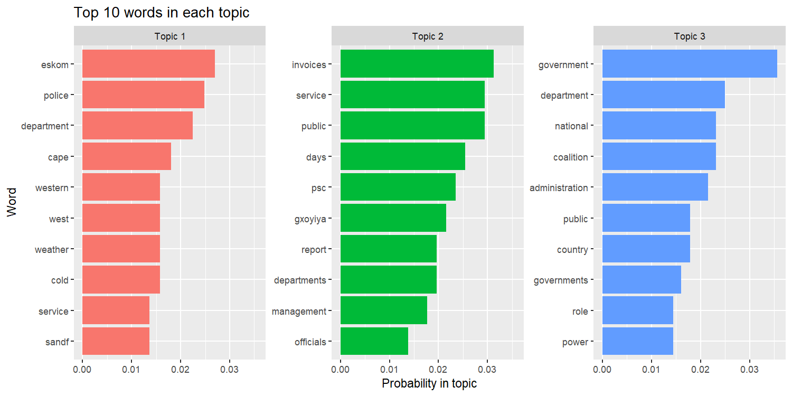
Figure 13: Bar chart of the top 10 words in each topic
The bar chart shows the words with the highest probability in each topic. The length of a bar is the probability of the word, so it is easy to compare the words inside one topic. It confirms the topic meanings: "eskom" and "police" lead Topic 1, "invoices" and "service" lead Topic 2, and "government" leads Topic 3. The words "public" and "department" appear in more than one topic, which shows that the topics overlap a little.
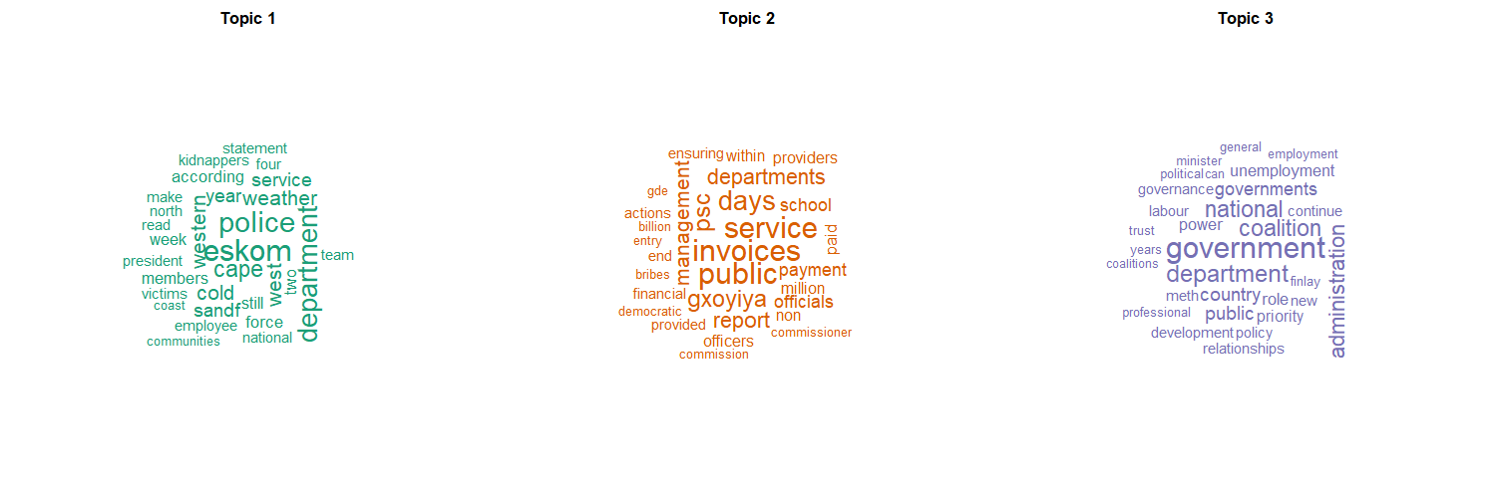
Figure 14: Word clouds of the top 30 words in each topic
The word clouds show the top 30 words of each topic, and a bigger word means a higher probability. They give a quick picture of what each topic is about and show more words than the bar chart, such as "kidnappers" and "weather" in Topic 1, "bribes" and "payment" in Topic 2, and "coalition" and "unemployment" in Topic 3.

Question 3: Web scraping and text summarisation

3.1 Web scraping and fair use
The script reads the qualifications page, collects the link to every qualification, and then opens each qualification page and keeps its title and its paragraphs of text. The result is saved in Q3_1_qualifications.csv.
library(rvest)
library(httr)
library(stringr)

base_url <- "https://www.eduvos.com"
ua <- user_agent("EduvosStudentProject/1.0 (non-commercial, educational)")

# fair use: read robots.txt, identify ourselves, and wait between requests
cat(httr::content(GET(paste0(base_url, "/robots.txt"), ua), "text", encoding = "UTF-8"))

get_page <- function(url) {
Sys.sleep(2)
read_html(GET(url, ua))
}

# the qualifications page links to one page per qualification
list_page <- get_page(paste0(base_url, "/qualifications/"))
links <- html_attr(html_elements(list_page, "a[href*='/programmes/']"), "href")
links <- unique(links[grepl("/programmes/.+", links) & !grepl("\\?", links)])
links <- ifelse(startsWith(links, "http"), links, paste0(base_url, links))

# open each qualification page and keep its title and paragraphs
qualifications <- data.frame(url = links, title = NA, text = NA)
for (i in seq_along(links)) {
page <- tryCatch(get_page(links[i]), error = function(e) NULL)
if (is.null(page)) { cat("Skipped (page not found):", links[i], "\n"); next }
paragraphs <- html_text2(html_elements(page, "p"))
qualifications$title[i] <- html_text2(html_element(page, "h1"))
qualifications$text[i] <- paste(paragraphs[nchar(paragraphs) > 60], collapse = " ")
}
qualifications <- qualifications[!is.na(qualifications$text), ]
write.csv(qualifications, "Q3_1_qualifications.csv", row.names = FALSE)

The robots.txt file of the website, as printed by the script:
User-agent: *
Allow: /

User-agent: GPTBot
Allow: /

(the same "Allow: /" rule is repeated for ChatGPT-User, OAI-SearchBot,
Google-Extended, ClaudeBot and PerplexityBot)

Sitemap: https://www.eduvos.com/sitemap-ai.xml
Sitemap: https://www.eduvos.com/sitemap.xml

The line printed for the one page that was not found:
Skipped (page not found): https://www.eduvos.com/programmes/bachelor-of-science-honours-in-information-
technology-security-and-network-engineering/

How the scraping respects fair use:
- The script first reads the robots.txt file of the website and prints it. The file of Eduvos allows all crawlers to read the site and has no Disallow rule, so the qualification pages may be read.
- Every request carries a user agent that names the project and says it is non-commercial and educational, so the website owner can see who is reading the pages.
- The script waits 2 seconds before every request (Sys.sleep), so the server is never put under load.
- Only public pages are read, each page is read once, and only the text is kept. Nothing behind a login is used.
- The data is used only for this assignment and is not published or sold. The text belongs to Eduvos, and the repository contains only the scraped file needed to mark the work.
Duplicate links that only differ in the delivery mode (the ones with "?id=" in the address) are skipped, and one programme page returned an HTTP 404 error. The script catches the error, prints "Skipped (page not found)" and carries on. The scrape therefore gave 66 qualification pages, which is the 66 rows of the data frame.

3.2 Text preprocessing
The text of all 66 pages is joined and split into sentences, and each sentence is cleaned. The steps are:
- Bullet points are changed to full stops, so every bullet becomes its own sentence, and duplicate sentences are removed.
- Sentences with the word "credits" are dropped, because they are module lists and not descriptions.
- Stray endings left by the bullet points (such as ". ." or ";.") are tidied to a single full stop.
- Only sentences of 8 to 60 words are kept, which removes headings, short fragments and very long run-on lists.
- Each sentence is changed to lower case, all numbers and punctuation are removed, English stop words (such as "the" and "and") are removed, and words with two letters or fewer are removed.
library(tm)

# split the text into sentences (bullet points count as separate sentences)
text <- str_replace_all(paste(qualifications$text, collapse = " "), "[•▪◦]", ". ")
sentences <- unique(unlist(str_split(text, "(?<=[.!?])\\s+(?=[A-Z])")))
sentences <- sentences[!grepl("credits", sentences)] # drop the module lists
sentences <- str_replace_all(sentences, "[\\s.;]+\\.$", ".") # remove stray endings such as ". ." and ";."
sentences <- sentences[str_count(sentences, "\\S+") %in% 8:60] # keep sentences of 8 to 60 words

# lower case, letters only, remove stop words and very short words
clean <- function(s) {
w <- strsplit(gsub("[^a-z ]", " ", tolower(s)), "\\s+")[[1]]
w[nchar(w) > 2 & !(w %in% stopwords("en"))]
}
tokens <- lapply(sentences, clean)

cat("Sentences:", length(sentences), "\n")
cat("Words before:", sum(str_count(sentences, "\\S+")), " after:", sum(lengths(tokens)), "\n")
cat("Before:", sentences[1], "\nAfter: ", paste(tokens[[1]], collapse = " "), "\n")

Result of the preprocessing:
Measure | Value
Qualification pages scraped | 66
Sentences kept | 485
Words before cleaning | 10,653
Words after cleaning | 6,917
Different words left | 1,470

Example of one sentence before and after cleaning:
 | Text
Before | Eduvos is a private higher education institution in South Africa, registered with the DHET as Eduvos (Pty) Ltd (2001/HE07/008).
After | eduvos private higher education institution south africa registered dhet eduvos pty ltd

About 35% of the words were removed as noise, and the sentences are now ready to be scored.

3.3 Summarisation and visualisations
The summary of the whole set of qualification pages is built by extraction: the five best sentences are selected and kept in the order in which they appear. Two different techniques decide which sentences are the best.
- Technique 1, word frequency: every word gets a weight between 0 and 1 from how often it appears in all the text. A sentence is scored by the average weight of its words, so a sentence made of common topic words scores high.
- Technique 2, TextRank: every sentence is a node in a graph. Two sentences are linked when they use the same words (the link strength is the correlation of their word counts), and the PageRank algorithm then scores each sentence. A sentence scores high when it is similar to many other sentences that are also important.
library(igraph)

# Technique 1: word frequency. A sentence scores high when it uses many frequent words.
freq <- sort(table(unlist(tokens)), decreasing = TRUE)
weight <- as.numeric(freq) / max(freq)
names(weight) <- names(freq)
score_freq <- sapply(tokens, function(w) mean(weight[w]))

# Technique 2: TextRank. Sentences that are similar to many other sentences score high.
tf <- t(sapply(tokens, function(w) as.numeric(table(factor(w, levels = names(freq))))))
sim <- cor(t(tf)) # similarity between sentences
sim[is.na(sim) | sim < 0] <- 0
diag(sim) <- 0
score_rank <- page_rank(graph_from_adjacency_matrix(sim, mode = "undirected", weighted = TRUE))$vector

# the 5 best sentences of each technique, in the order they appear
top5 <- function(score) sort(order(score, decreasing = TRUE)[1:5])
cat("\nSUMMARY 1: word frequency\n"); cat(paste("-", sentences[top5(score_freq)]), sep = "\n")
cat("\nSUMMARY 2: TextRank\n"); cat(paste("-", sentences[top5(score_rank)]), sep = "\n")

Summary 1 (word frequency):
- International students are welcome to apply for this programme.
- Students develop an advanced level of knowledge and skills in the field of accounting.
- Students develop an advanced level of knowledge and skills in the field of human resources.
- Students develop an intermediate level of knowledge and skills in marketing.
- Students develop an advanced level of knowledge and skills in the field of tourism.

Summary 2 (TextRank):
- It also provides an access pathway for students who do not meet the entry requirements for a degree and wish to apply for admission to an Eduvos Bachelor of Commerce programme after successfully completing the Higher Certificate, subject to the applicable admission requirements.
- Work Readiness Skills A and B support the development of critical thinking and practical workplace capabilities and enable students to apply knowledge acquired across the programme.
- Second-year-level modules are built on the foundation developed through the first-year modules, and students develop an intermediate level of knowledge in the field of business. * Students who pass the Human Resource Information Systems exams with 75% or more will receive a Sage payroll certificate.
- Students develop an advanced level of knowledge and skills in the field of accounting.
- Students develop an intermediate level of knowledge and skills in Human Resource Management. *Students who pass the Human Resource Information Systems exams with 75% or more will receive a Sage Payroll certificate.

Comparison of the two summaries:
- The word frequency summary picks short sentences that are full of the most common words ("students", "programme", "knowledge", "skills", "level"). It is easy to read, but it is repetitive: four of the five sentences are the same template with a different field of study, because a short sentence made of common words scores well.
- The TextRank summary picks longer sentences that say more. They describe the access pathway into a degree, the work readiness skills, and the structure of the years of study, which is a better picture of what the qualifications offer.
- Only one sentence is in both summaries (the accounting sentence). The scores of the two techniques are still strongly related (correlation of 0.93, see Figure 16), but the techniques disagree on the very top sentences.
- The same template sentences ("Students develop an advanced level of knowledge and skills in the field of ...") are written on many programme pages. Both techniques rate them highly because they repeat many common words, which shows how much of the text is shared between programmes.
- Two of the TextRank sentences carry a footnote that starts with "*" (about the Sage payroll certificate). The footnote is part of the text of those pages and is not split off, which is a small limitation of the simple sentence splitting.
The two visualisations are made with the code below.
library(ggplot2)

# Visualisation 1: the 15 most frequent words
top_words <- data.frame(word = names(freq)[1:15], count = as.numeric(freq)[1:15])
words_chart <- ggplot(top_words, aes(x = reorder(word, count), y = count)) +
geom_col(fill = "#2C7FB8") + coord_flip() +
labs(title = "15 most frequent words", x = "Word", y = "Count")
ggsave("Q3_3_top_words.png", words_chart, width = 8, height = 5)

# Visualisation 2: the sentence scores of the two techniques compared
scores_chart <- ggplot(data.frame(freq = score_freq, rank = score_rank), aes(x = freq, y = rank)) +
geom_point(colour = "#2C7FB8", alpha = 0.7) +
labs(title = "Sentence scores of the two techniques", x = "Word frequency score", y = "TextRank score")
ggsave("Q3_3_sentence_scores.png", scores_chart, width = 8, height = 5)

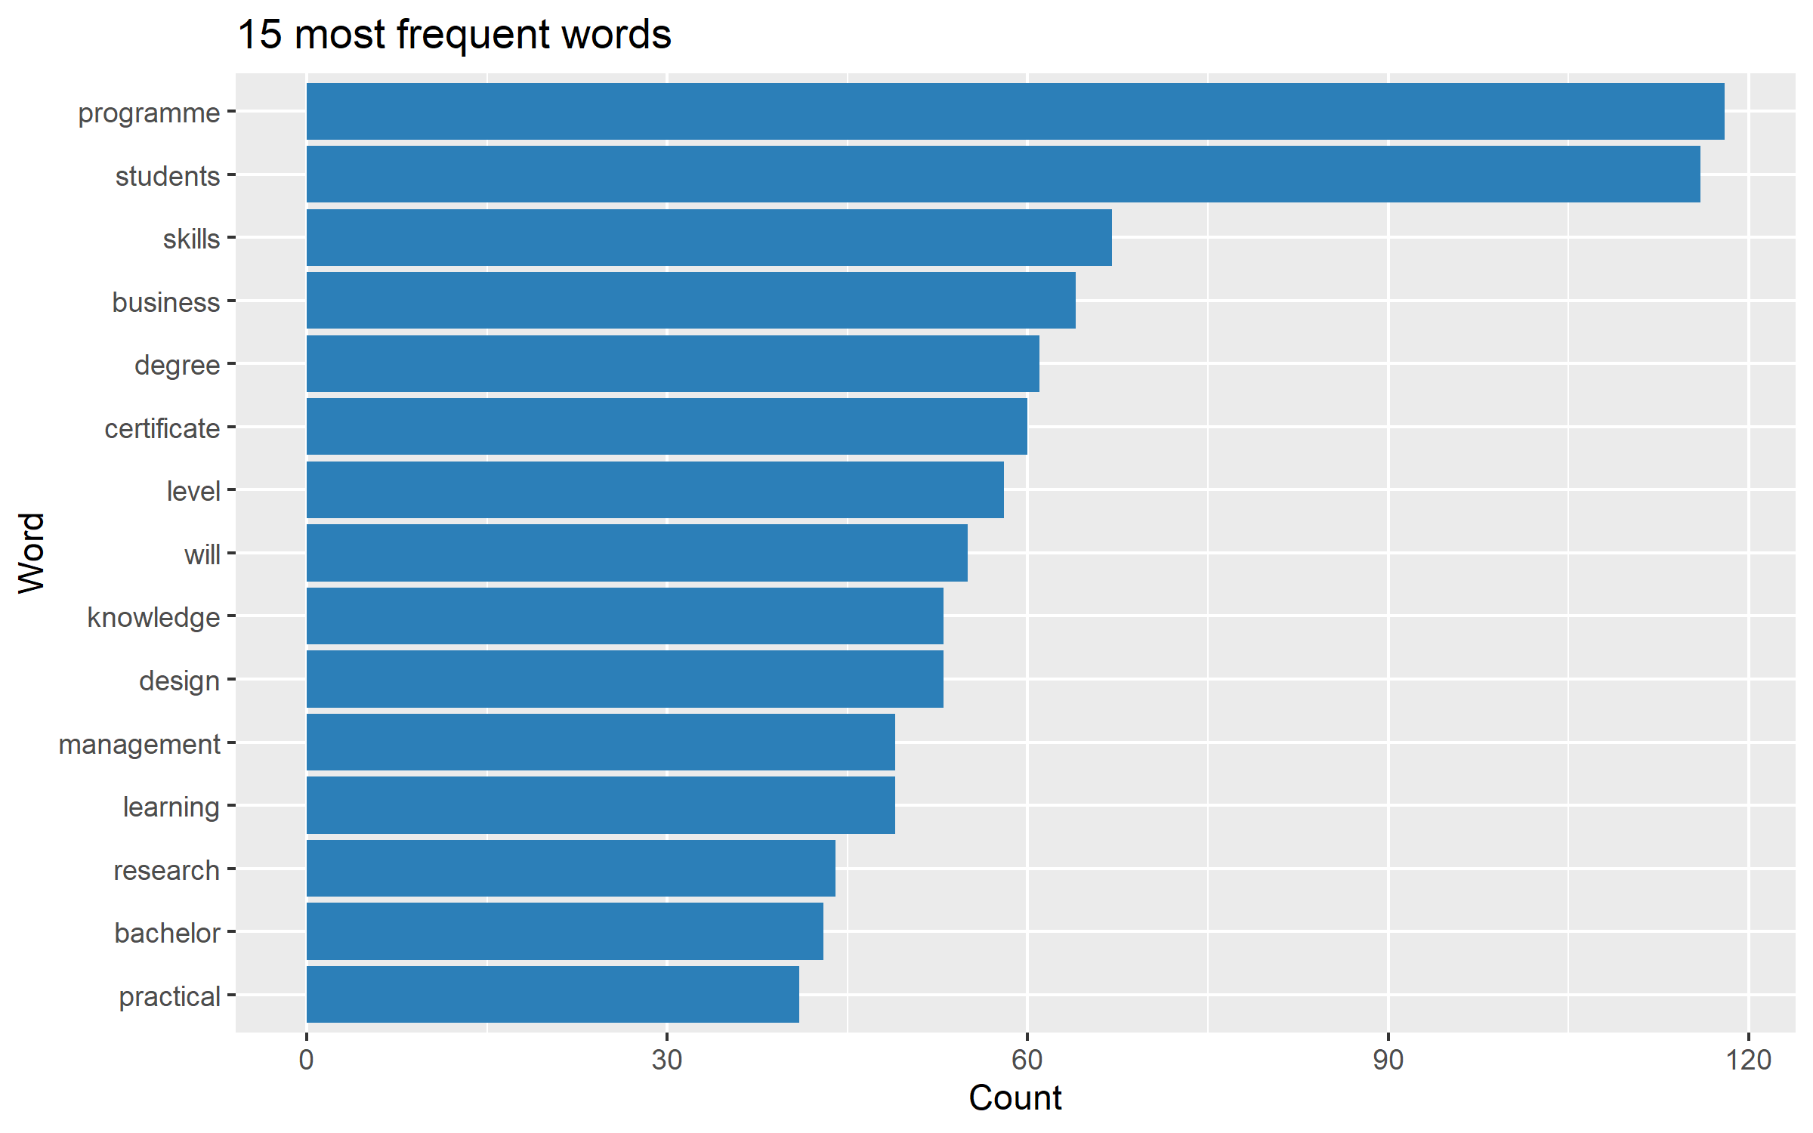
Figure 15: The 15 most frequent words in the cleaned text
The bar chart shows the 15 words with the highest counts, which are the words behind the word frequency scores. "programme" (118) and "students" (116) lead by a wide margin, followed by "skills", "business", "degree" and "certificate". The list shows that the text is about programmes, the students who take them, the skills they build, and the level of the qualification (degree, certificate, bachelor). The words "will" (55) and "level" (58) are frequent because of the repeated template sentences.
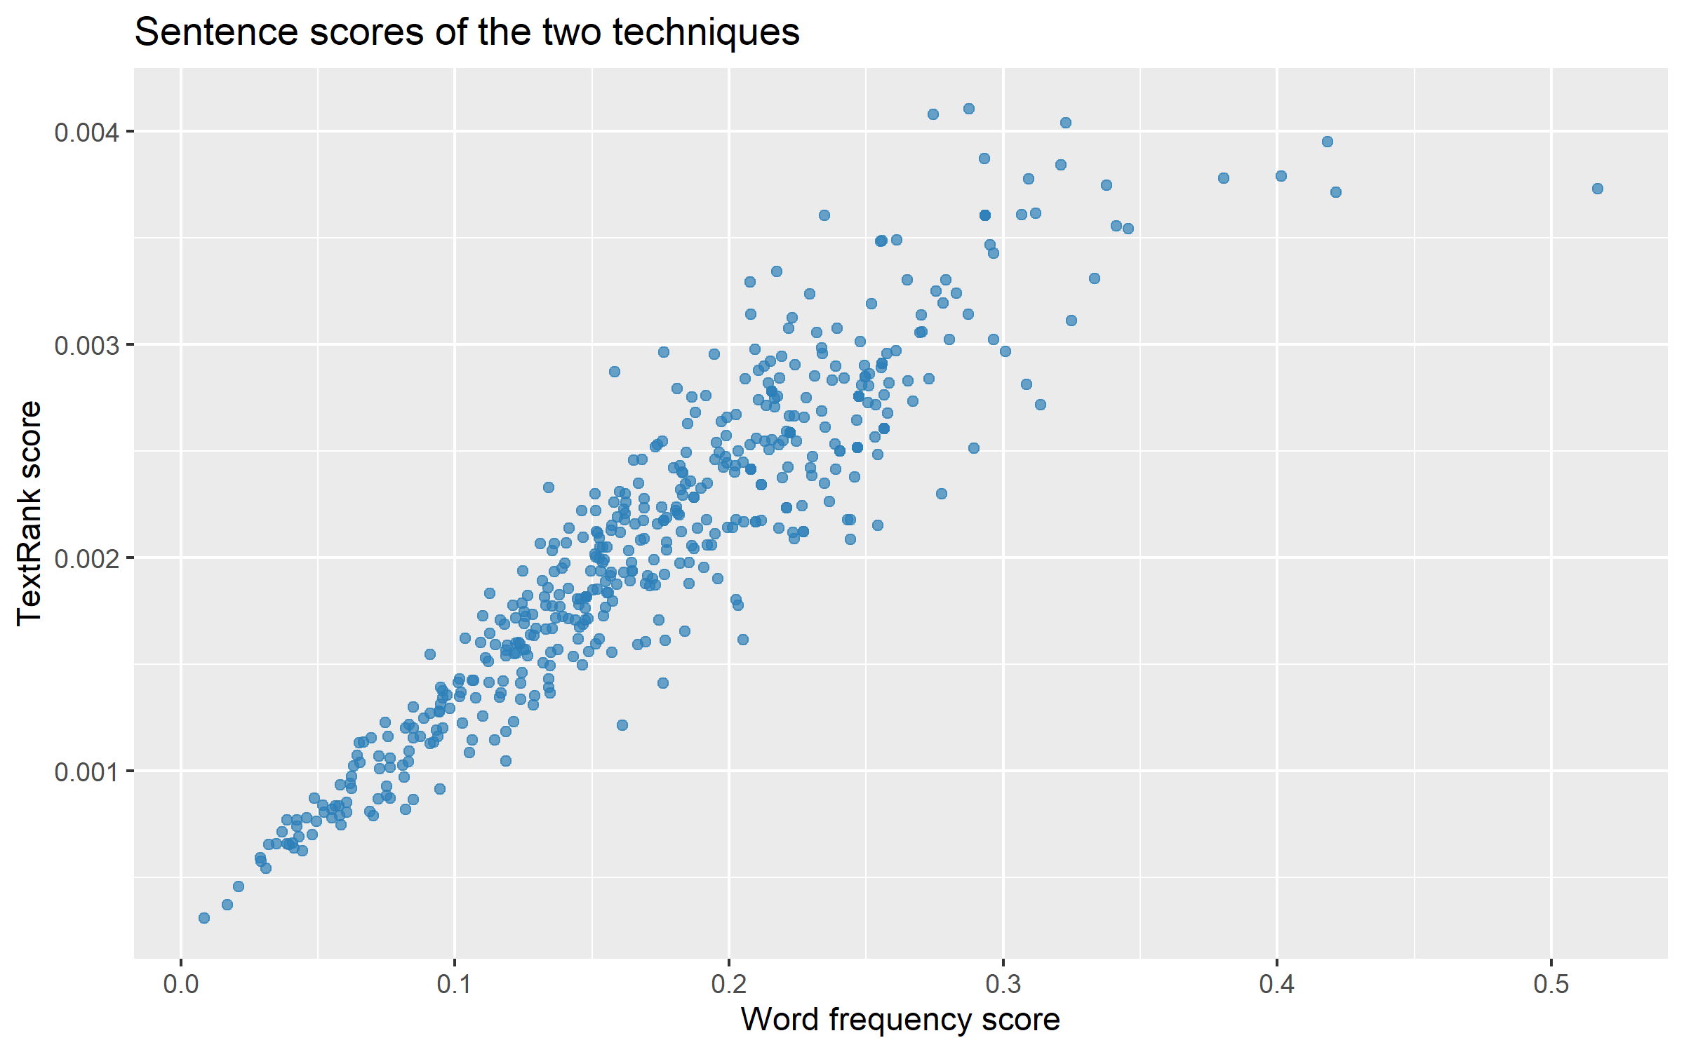
Figure 16: Sentence scores of the two techniques compared
The scatter plot shows each of the 485 sentences as one point, with the word frequency score on the horizontal axis and the TextRank score on the vertical axis. The points rise from the bottom left to the top right, so a sentence that scores well with one technique usually scores well with the other. The spread at the top right shows where they differ: sentences with the highest word frequency scores (above 0.4, such as the one near 0.5) do not always get the highest TextRank scores, which is why the two summaries are different.

Question 4: ETL with R and PostgreSQL

4.1 Extract: web scraping and regex
The qualifications page shows one card per programme. Each card holds a programme type, a faculty, a title, a shortened description, the learning modes and a start date. The script reads the 65 cards and builds a data frame. Regex is then used to extract the start date from the text "Start date: 15 February 2027", and to create two numerical attributes from the text: the number of learning modes (n_modes) and the number of words in the description (desc_words).
library(rvest)
library(httr)
library(stringr)

ua <- user_agent("EduvosStudentProject/1.0 (non-commercial, educational)")
Sys.sleep(2)
page <- read_html(GET("https://www.eduvos.com/qualifications/", ua))
cards <- html_elements(page, "article.qf-card") # one card per programme

raw <- data.frame(
title = html_text2(html_element(cards, ".qf-card-title")),
faculty = html_attr(cards, "data-faculty"),
programme_type = html_attr(cards, "data-programme-type"),
learning_modes = html_attr(cards, "data-learning-mode"),
description = html_text2(html_element(cards, ".qf-card-description")),
start_text = html_text2(html_element(cards, ".qf-start-date"))
)

# regex: pull the date out of "Start date: 15 February 2027"
raw$start_date <- str_extract(raw$start_text, "\\d{1,2} [A-Za-z]+ \\d{4}")
# regex: count the learning modes in the text (numerical attribute, inferred)
raw$n_modes <- str_count(raw$learning_modes, "(?i)full[- ]time|part[- ]time|remote learning")
# regex: count the words of the description (numerical attribute, inferred)
raw$desc_words <- str_count(raw$description, "\\S+")

cat("Records scraped:", nrow(raw), "\n")
print(table(raw$learning_modes)) # shows the inconsistent labels
cat("Descriptions ending in '...':", sum(str_detect(raw$description, "\\.\\.\\.$")), "\n")
cat("Empty learning modes:", sum(raw$learning_modes == ""), "\n")
write.csv(raw, "Q4_1_raw.csv", row.names = FALSE)

The data frame has these columns:
Column | Type | Content
title, faculty, programme_type | Text | Name, faculty and type of the programme
learning_modes, description | Text | Free text from the card
start_date | Date | Extracted with regex from the start date text
n_modes | Number (inferred) | Count of the learning modes in the text, by regex
desc_words | Number (inferred) | Count of the words in the description, by regex

Output of the scrape on my computer:
Records scraped: 65

Campus Full Time 3
Campus Full Time, Online Full Time, Online Part Time 40
Distance (Online) Full Time, Distance (Online) Part-Time 1
Distance Full Time 1
Distance Full Time, Distance Part Time 1
Online Full Time, Online Part Time 8
Remote Learning 10
(empty) 1

Descriptions ending in '...': 64
Empty learning modes: 1

The first rows of the raw data frame (Q4_1_raw.csv):
Title | Type | n_modes | desc_words | start_date
Bachelor of Arts Access Programme: ENG | Access | 3 | 19 | 15 February 2027
Bachelor of Arts Honours in Graphic Design | Honours | 2 | 24 | 15 February 2027
Bachelor of Arts in Graphic Design | Degree | 3 | 22 | 15 February 2027
Bachelor of Science in IT: Security and Network Engineering | Degree | 0 | 17 | 15 February 2027
Short Course in Managing Teams | Corporate Training | 1 | 20 | 11 January 2027

The raw data has the problems that real web data has:
- Spurious text: 64 of the 65 descriptions are cut off by the website with "...", and the start date comes as the text "Start date: 15 February 2027".
- Inconsistent labels: the same idea is written in different ways ("Distance", "Distance (Online)" and "Online"; "Part-Time" and "Part Time"), and the long type name "Postgraduate Certificates & Diplomas".
- Incomplete data: one programme (the BSc in IT: Security and Network Engineering) has an empty learning mode, so its n_modes is 0.
- Repeated content: the description of the Higher Certificate in Cyber Security is a copy of the description of Cloud and Network Engineering on the website, and the five Pre-Degree programmes show the same description text.

4.2 Transform: cleaning, denoising and imputation
clean <- raw
clean$start_text <- NULL

# denoise: remove the "..." the website adds when it cuts a description short
clean$description <- str_trim(str_remove(clean$description, "\\s*\\.\\.\\.$"))

# make the labels consistent: Distance and Distance (Online) are online, Part-Time is Part Time
clean$learning_modes <- str_replace_all(clean$learning_modes, "Distance \\(Online\\)|Distance", "Online")
clean$learning_modes <- str_replace_all(clean$learning_modes, "Part-Time", "Part Time")
clean$programme_type <- str_replace(clean$programme_type, "Postgraduate Certificates & Diplomas", "Postgraduate")

# missing value: an empty learning mode becomes NA and is imputed with the most
# common learning mode of the same programme type
clean$learning_modes[clean$learning_modes == ""] <- NA
most_common <- function(x) names(which.max(table(x)))
by_type <- tapply(clean$learning_modes, clean$programme_type, most_common)
missing <- is.na(clean$learning_modes)
clean$learning_modes[missing] <- by_type[clean$programme_type[missing]]

# recalculate the numerical columns on the cleaned text and fix the date type
clean$n_modes <- str_count(clean$learning_modes, "(?i)full time|part time|remote learning")
clean$desc_words <- str_count(clean$description, "\\S+")
clean$start_date <- as.Date(clean$start_date, format = "%d %B %Y")
clean <- unique(clean) # remove duplicate records

cat("Records after cleaning:", nrow(clean), "\n")
print(table(clean$learning_modes))
cat("Missing values left:", sum(is.na(clean)), "\n")
write.csv(clean, "Q4_2_cleaned.csv", row.names = FALSE)

The cleaning steps:
- Denoising: the "..." is removed from the descriptions, and the start date text is turned into a real date.
- Consistency: "Distance (Online)" and "Distance" become "Online", "Part-Time" becomes "Part Time", and the long type name is shortened to "Postgraduate". The numerical columns are calculated again on the cleaned text.
- Imputation: the empty learning mode is changed to NA and filled with the most common learning mode of the same programme type. The BSc in IT: Security and Network Engineering is a Degree, so it received "Campus Full Time, Online Full Time, Online Part Time" and its n_modes changed from 0 to 3.
- Duplicates: unique() confirmed that there are no duplicate records.

The learning modes before and after cleaning:
Learning modes (cleaned label) | Before | After | Change
Campus Full Time | 3 | 3 | none
Campus Full Time, Online Full Time, Online Part Time | 40 | 41 | 1 imputed
Online Full Time | 0 | 1 | from "Distance Full Time"
Online Full Time, Online Part Time | 8 | 10 | 2 relabelled
Remote Learning | 10 | 10 | none
Empty or other labels | 4 | 0 | cleaned

After cleaning there are 65 records and no missing values. The cleaned data is exported as Q4_2_cleaned.csv, with 8 columns: title, faculty, programme_type, learning_modes, description, start_date, n_modes and desc_words.

4.3 Load and analyse in PostgreSQL
The table is created in the Project_2 schema, with the title as the primary key, and the cleaned CSV is imported with the pgAdmin Import/Export tool (CSV format, header on).
-- Question 4.3: import the cleaned CSV into PostgreSQL and analyse it

-- 1. Create the table in the Project_2 schema
CREATE SCHEMA IF NOT EXISTS "Project_2";
DROP TABLE IF EXISTS "Project_2".programmes;
CREATE TABLE "Project_2".programmes (
title TEXT PRIMARY KEY,
faculty TEXT,
programme_type TEXT,
learning_modes TEXT,
description TEXT,
start_date DATE,
n_modes INTEGER,
desc_words INTEGER
);

-- 2. Import Q4_2_cleaned.csv with the pgAdmin Import/Export tool (csv, header on),
-- or with: COPY "Project_2".programmes FROM 'path/to/Q4_2_cleaned.csv' WITH (FORMAT csv, HEADER true);

After the import, a check query counts the records in the table. It returns the 65 programmes of the cleaned data set.
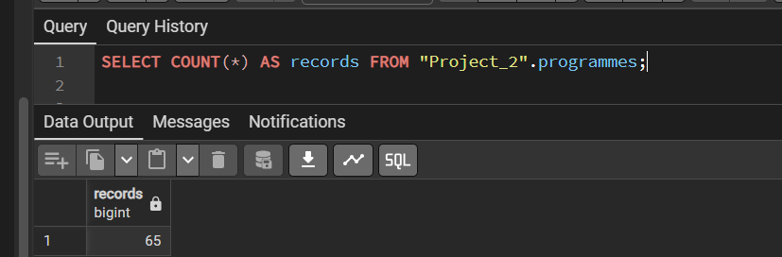
Figure 17: Check query after the import, 65 records

Investigation 1: which faculties offer the most programmes, and how flexible are they?
The query counts the programmes per faculty, averages the numerical attribute n_modes, and uses the window function RANK() to rank the faculties by size.
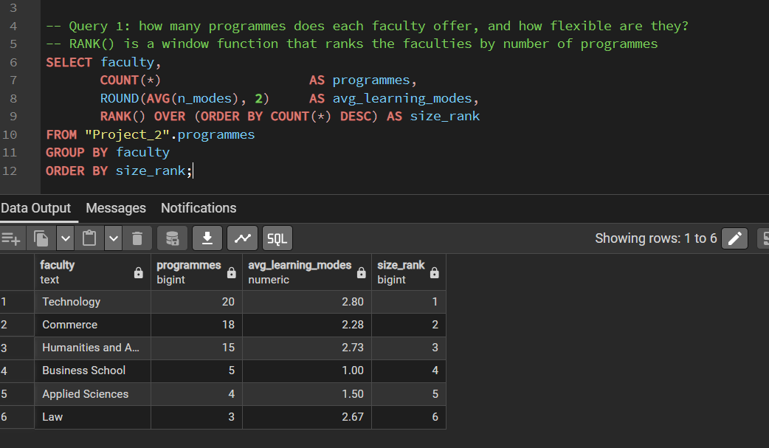
Figure 18: Query 1 and its result
Interpretation: Technology (20 programmes) and Commerce (18) are the largest faculties and together offer 38 of the 65 programmes (58%). Technology is also the most flexible faculty, with 2.80 learning modes on average, which means that most of its programmes can be studied on campus, online full time and online part time. Business School has the lowest average (1.00) because all of its 5 programmes are short courses with only remote learning. Applied Sciences is next (1.50), because three of its four programmes (Biomedicine, Biotechnology Management and the Higher Certificate in Bioscience) are offered on campus full time only.

Investigation 2: which programme types can be studied part time?
The query uses the case-insensitive POSIX regex operator ~* on the learning modes text to count the programmes that offer part time study for each programme type.
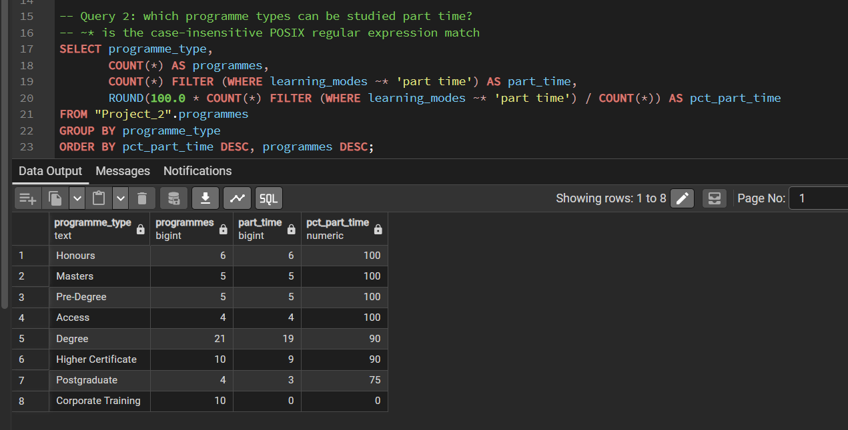
Figure 19: Query 2 and its result
Interpretation: all Honours, Masters, Pre-Degree and Access programmes (100%) can be studied part time, which suits working students and students who are preparing to enter a degree. Degrees (19 of 21) and Higher Certificates (9 of 10) are close behind at 90%, and the exceptions are the three campus only science programmes. Postgraduate certificates and diplomas reach 75% because the Postgraduate Diploma in Accounting is offered online full time only. Corporate Training is the only type with no part time option (0 of 10), because the short courses are delivered by remote learning. The query only works because the cleaning in 4.2 made "Part-Time" and "Part Time" the same label.

4.4 GitHub repository
All the work for Questions 1 to 4 is in one GitHub repository: https://github.com/Opzalas369/ITBDA4-14_Big_Data_Analytics_Project_2
The repository has this structure:
Project_2/
README.md what the project is and how to run it
docs/ the project document (Questions 1 to 4)
datasets/ the data supplied with the project
map_reduce_test_docs/ doc1.txt to doc7.txt (Question 1)
sa_news/ news_1.txt to news_10.txt (Question 2)
Q1/ Java code (Mapper, Reducer, Driver), run steps and outputs
Q2/ notebook, data frame, topic tables and charts
Q3/ notebook, scraped data, summaries and charts
Q4/ notebook, raw and cleaned data, PostgreSQL script

The documentation is in the docs folder and the data sets are in the datasets folder and in the question folders (the data that the scrapes in Questions 3 and 4 produced). The notebooks in Q2, Q3 and Q4 are R notebooks that show the flow of the analysis with their output. Question 1 is Java code, as the question asks, so it has the code files, the run steps and the real output of the job instead of a notebook. The repository is public so that it can be marked.

