**Test Case**

Name: Steven Oquin

Date: 02/06/2023

CMIS 141/6380

|  |  |  |  |  |
| --- | --- | --- | --- | --- |
| **Test case #** | **Input** | **Expected Output** | **Actual Output** | **Pass?** |
| 1 | Do you want to enter the gamer’s data?=Yes  Name=Mark Smith  L1=90 L2=90 L3=80 ES=75  Do you want to enter another gamer’s data=Yes  Name=Sara Parker  L1=75 L2=85 L3=85 ES=75  Do you want to enter another gamer’s data=No | Welcome to the Total XP calculator!  Student Name: Mark Smith  Level 1=90  Level 2=90  Level 3=80  Engagement=75  Total XP + Bonus=465  Do you want to enter another gamer’s data?  Student Name: Sara Parker  Level 1=75  Level 2=85  Level 3=85  Engagement=75  Total XP + Bonus=448  Do you want to enter another gamer’s data?  Thank you for using the Total XP calculator! | Welcome to the Total XP calculator!  Student Name: Mark Smith  Level 1=90  Level 2=90  Level 3=80  Engagement=75  Total XP + Bonus=465  Do you want to enter another gamer’s data?  Student Name: Sara Parker  Level 1=75  Level 2=85  Level 3=85  Engagement=75  Total XP + Bonus=448  Do you want to enter another gamer’s data?  Thank you for using the Total XP calculator! | **yes** |
| 2 | Do you want to enter the gamer’s data?=Yes  Name=Steven Oquin  L1=95 L2=90 L3=60 ES=30  Do you want to enter another gamer’s data=No | Welcome to the Total XP calculator!  Student Name: Steven Oquin  Level 1=95  Level 2=90  Level 3=60  Engagement=30  Total XP + Bonus=369  Do you want to enter another gamer’s data?  Thank you for using the Total XP calculator! | Welcome to the Total XP calculator!  Student Name: Steven Oquin  Level 1=95  Level 2=90  Level 3=60  Engagement=30  Total XP + Bonus=369  Do you want to enter another gamer’s data?  Thank you for using the Total XP calculator! | **yes** |
| 3 | Do you want to enter the gamer’s data?=No | Welcome to the Total XP calculator!  Thank you for using the Total XP calculator! | Welcome to the Total XP calculator!  Thank you for using the Total XP calculator! | **yes** |

**Test case 1**

**Test case 2**

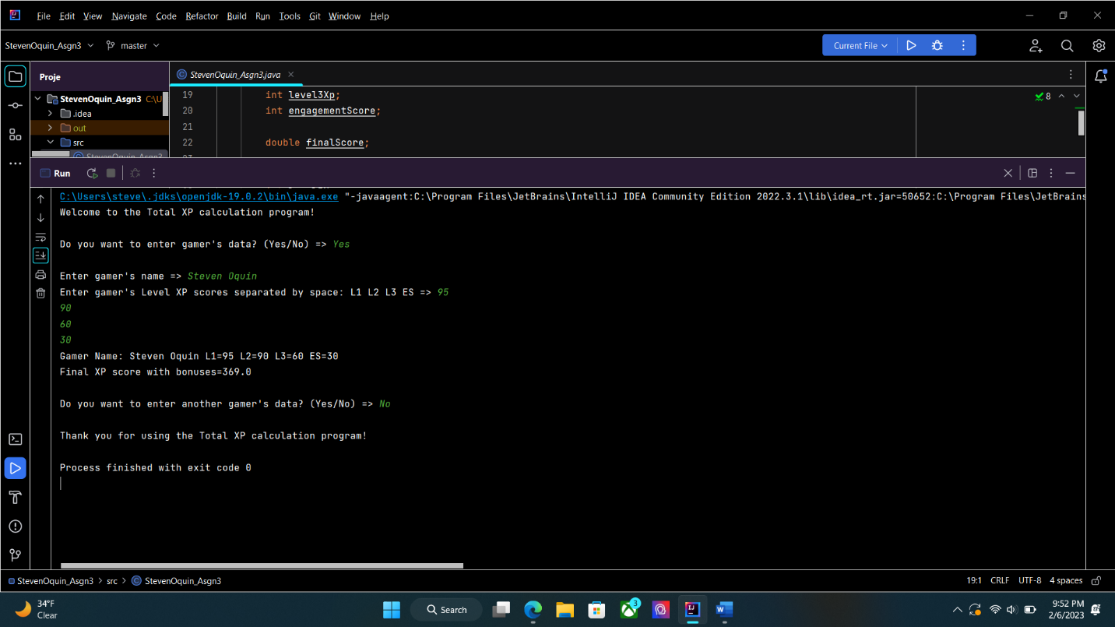

**Test case 3**