System Flowchart
The flowcharts below trace the MERAS web and mobile system from the moment the URL is entered. An oval marks the start or end, a parallelogram an input, a rectangle a page or process, a diamond a decision, a cylinder a database table, a circle an on-page connector, and a downward pentagon an off-page connector that continues on the chart bearing the same code.

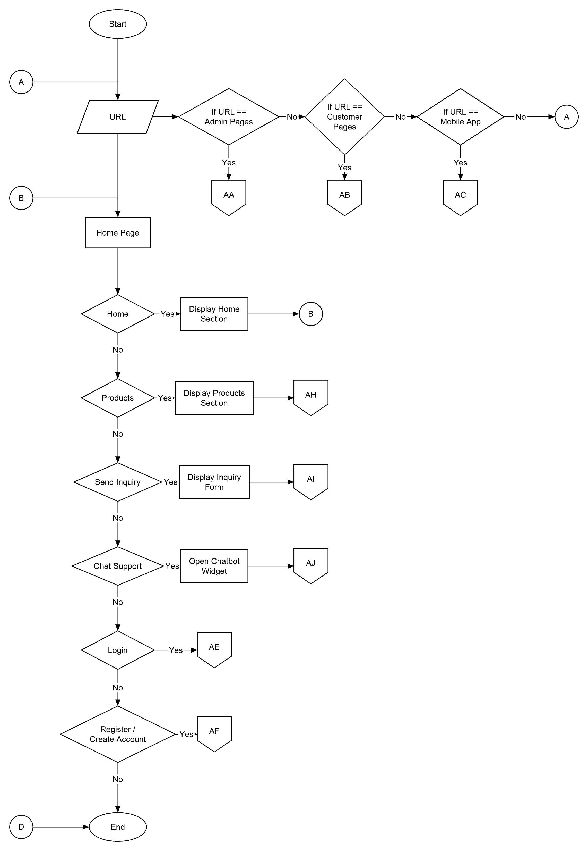
Flowchart 1. Start, URL and Home Page

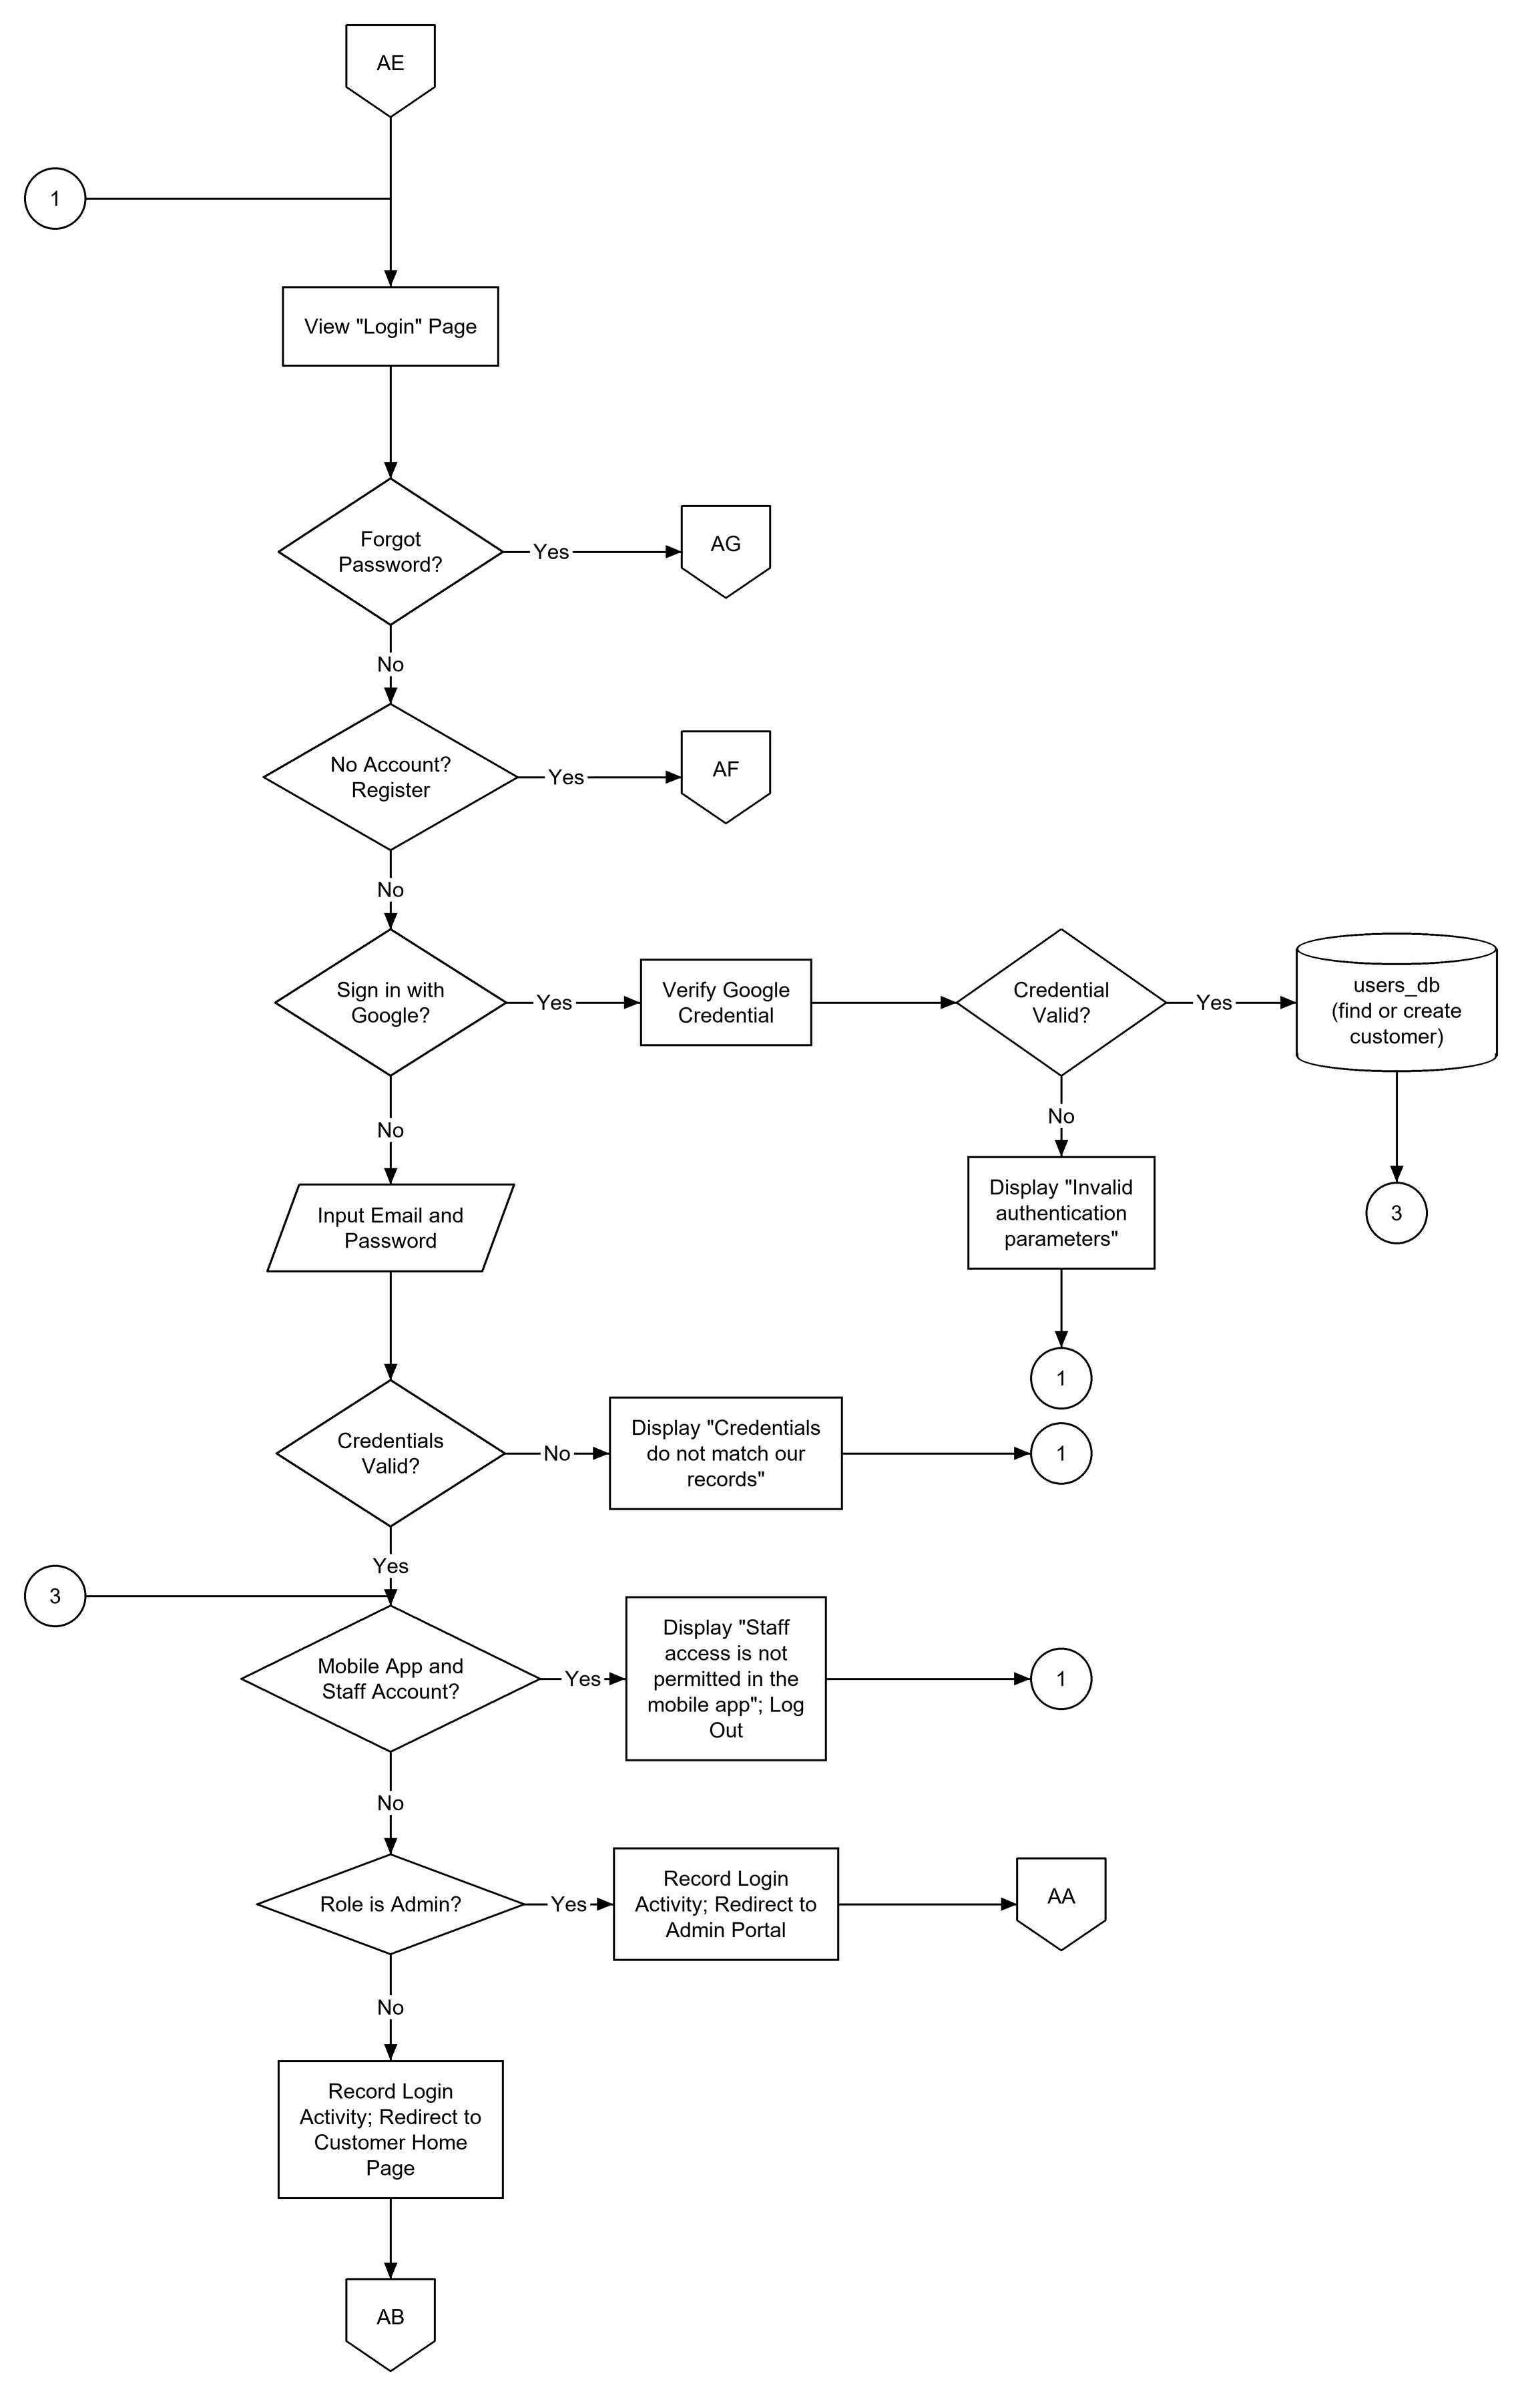
Flowchart 2. Log In (AE)

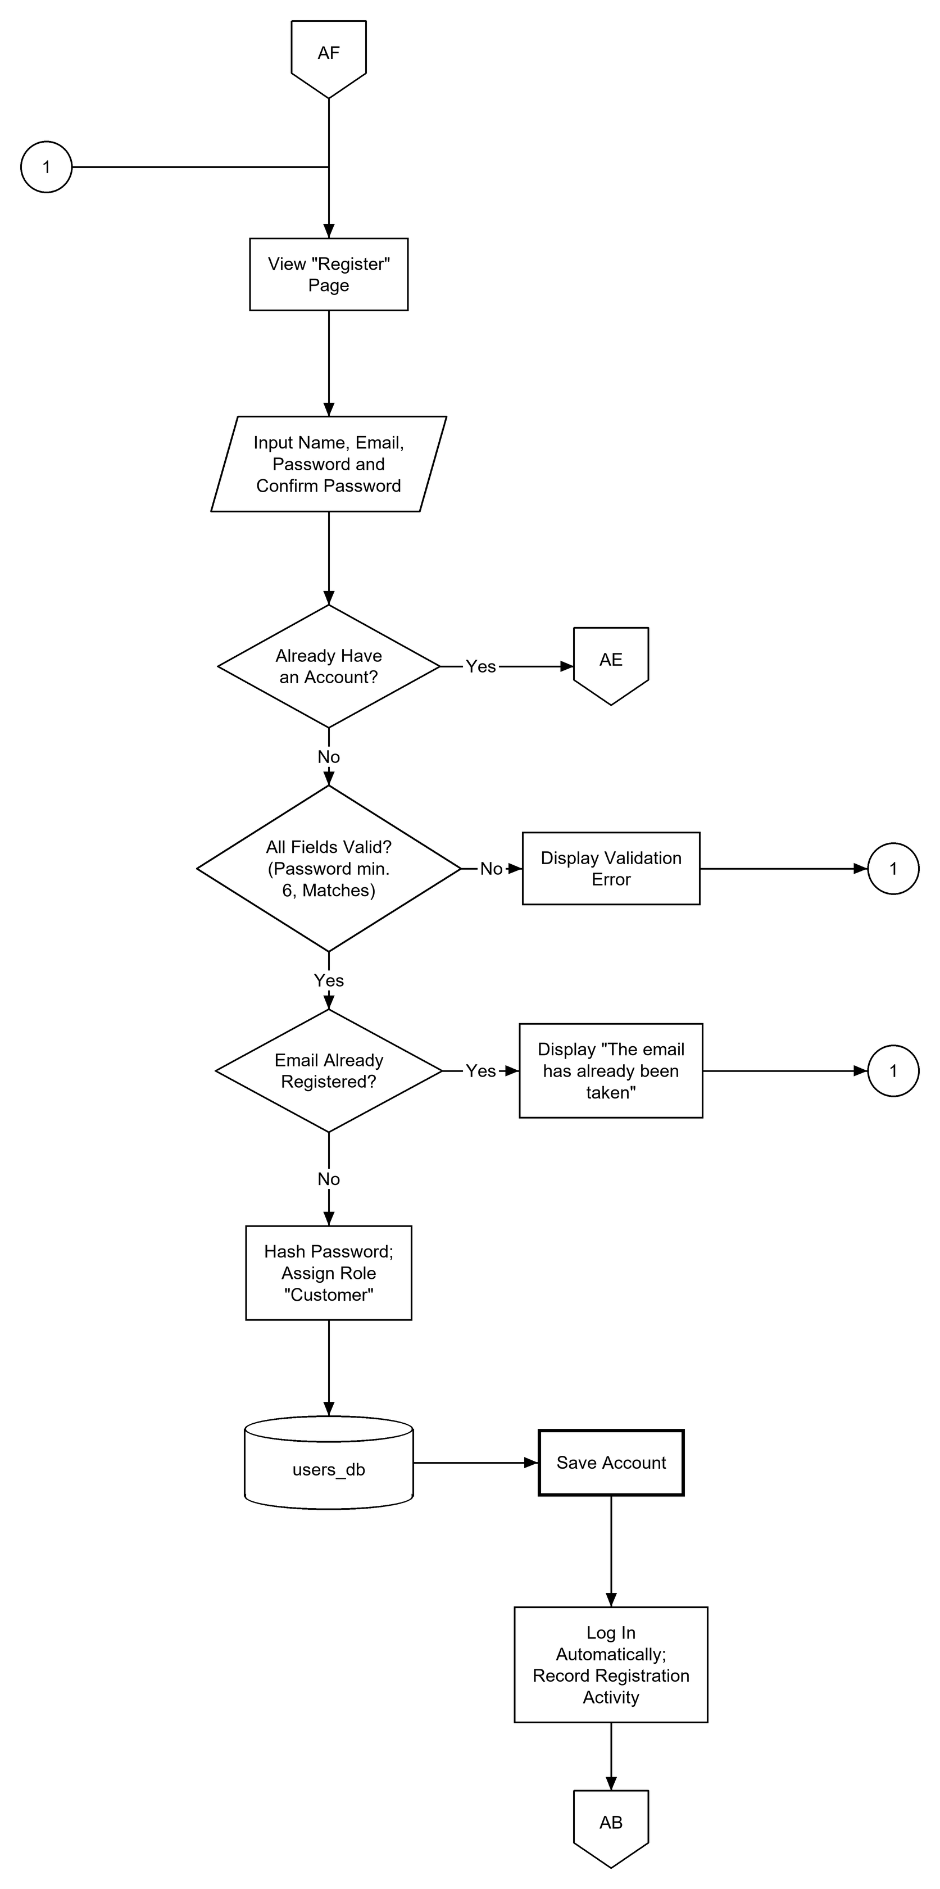
Flowchart 3. Register / Create Account (AF)

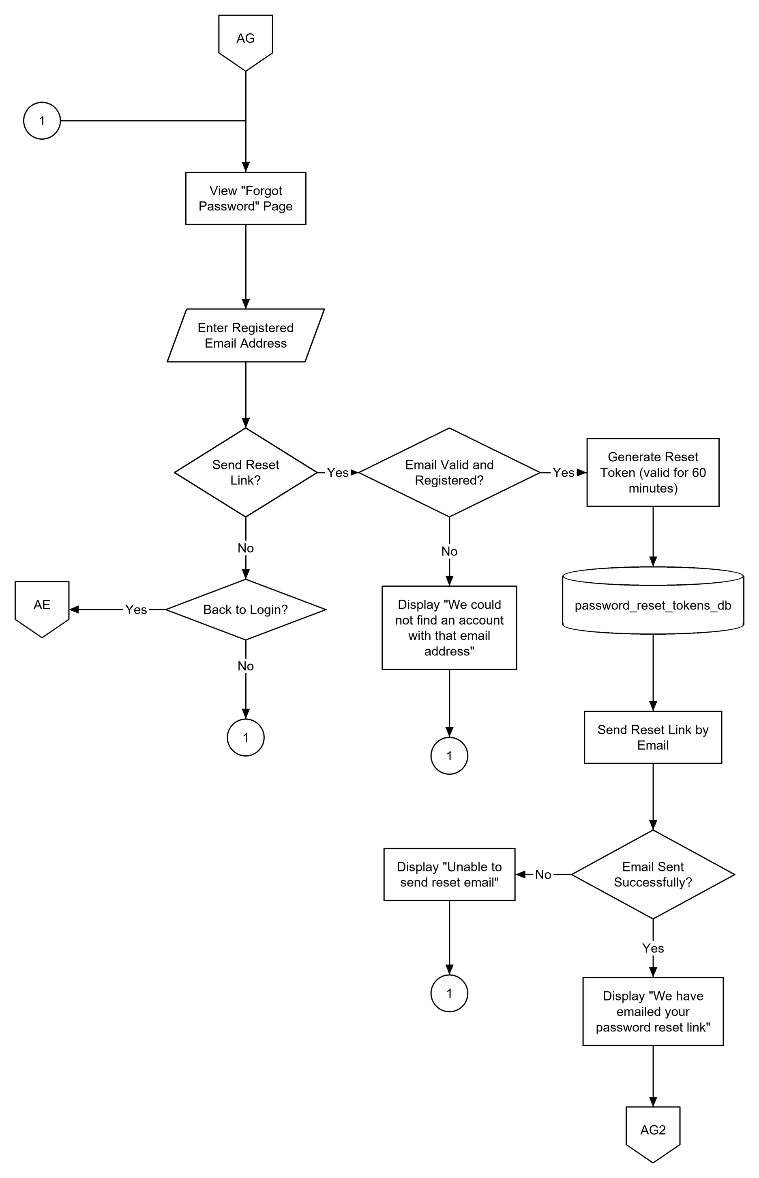
Flowchart 4. Forgot Password (AG)

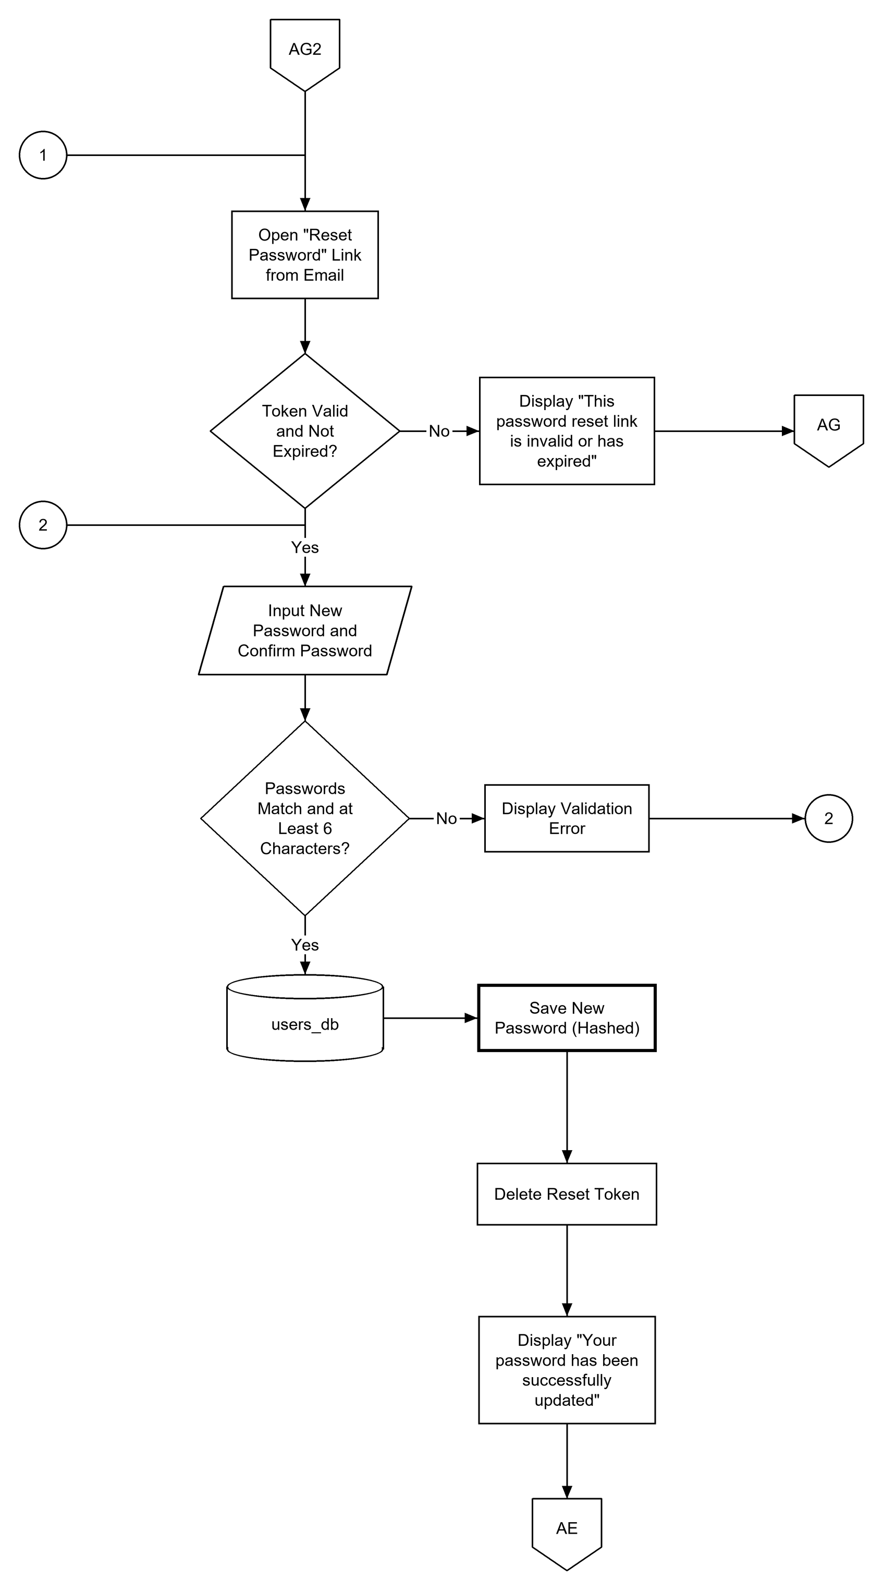
Flowchart 5. Reset Password from the Emailed Link (AG2)

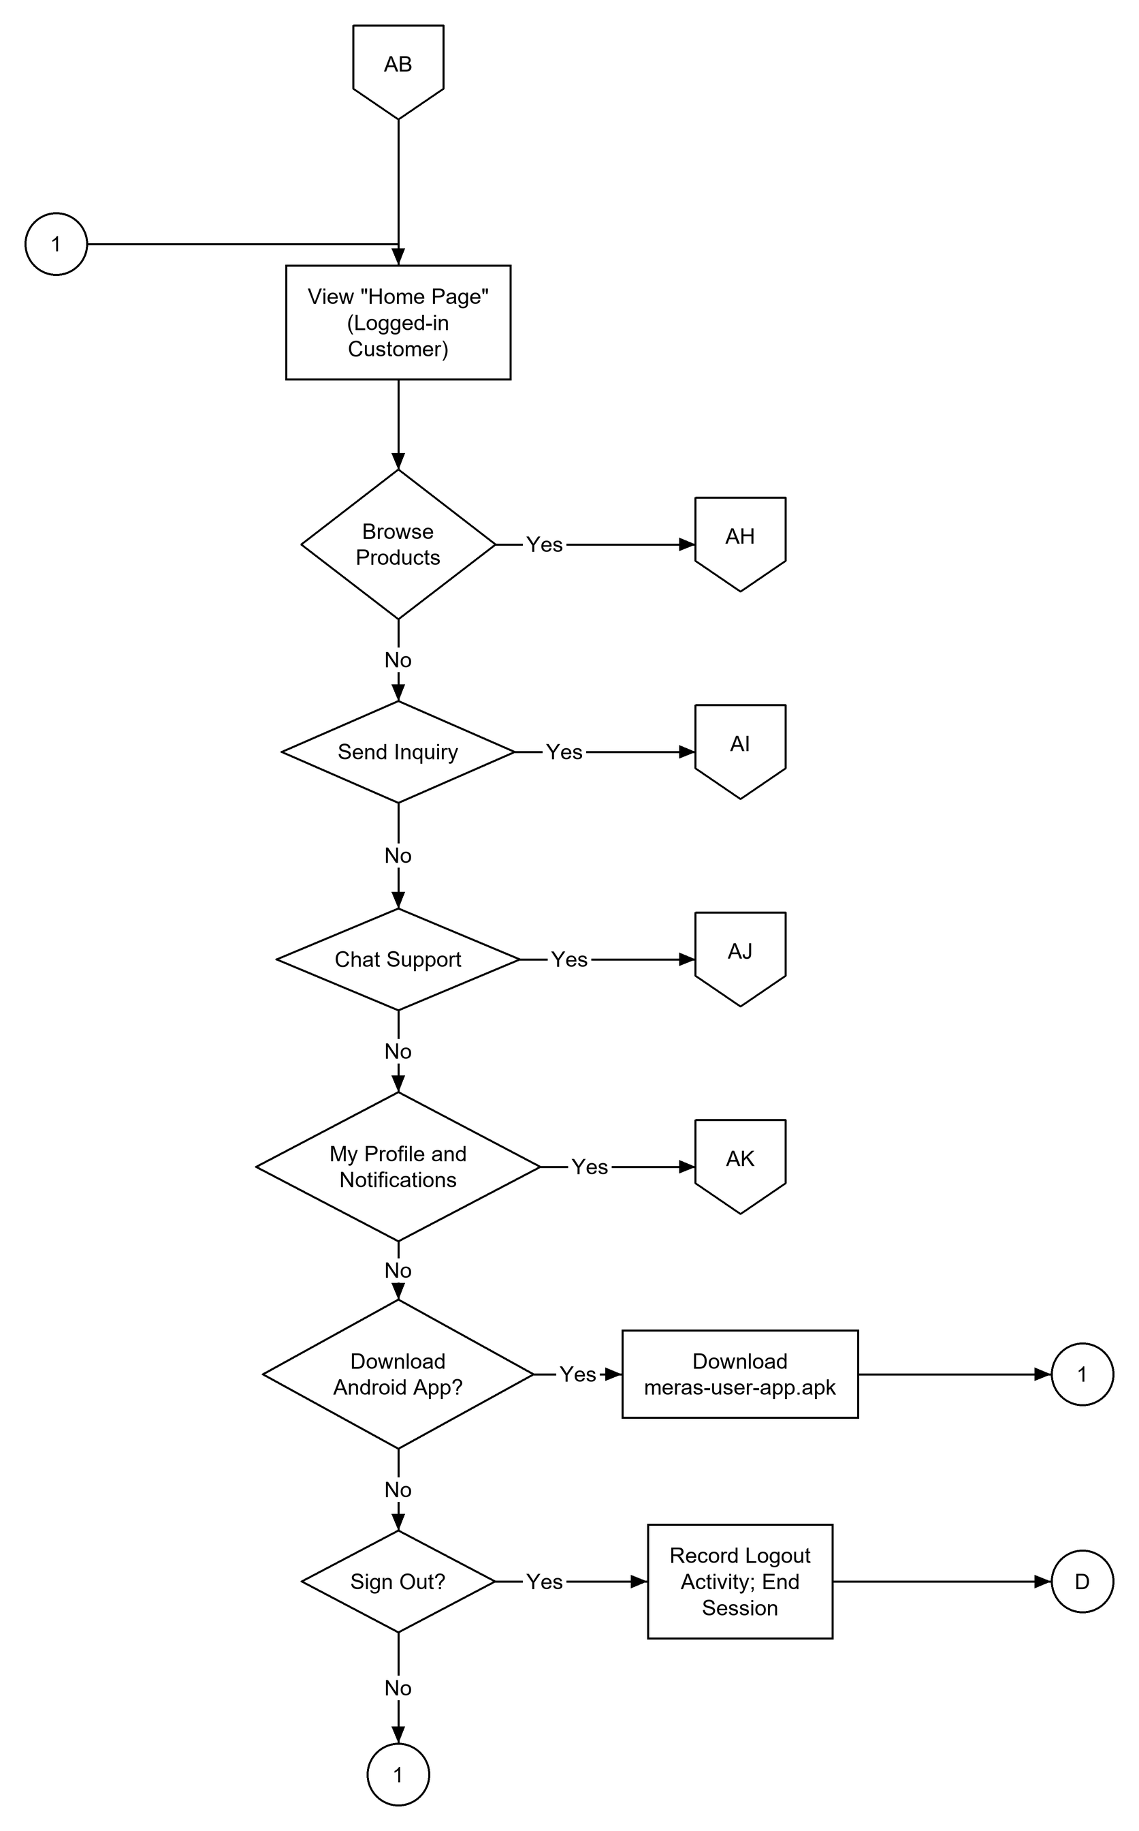
Flowchart 6. Customer Home Page / Portal (AB)

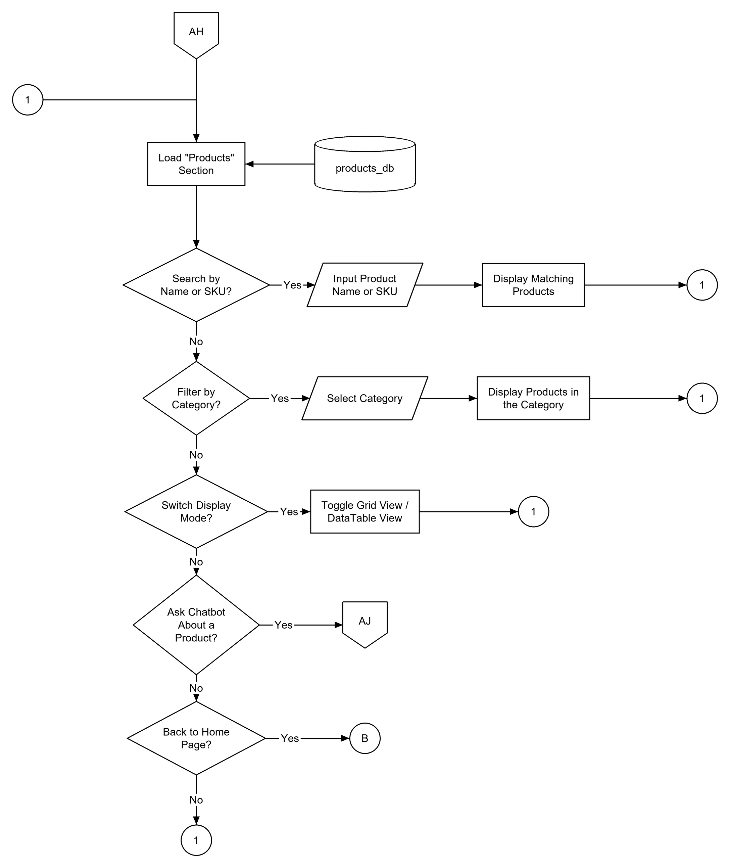
Flowchart 7. Browse Products (AH)

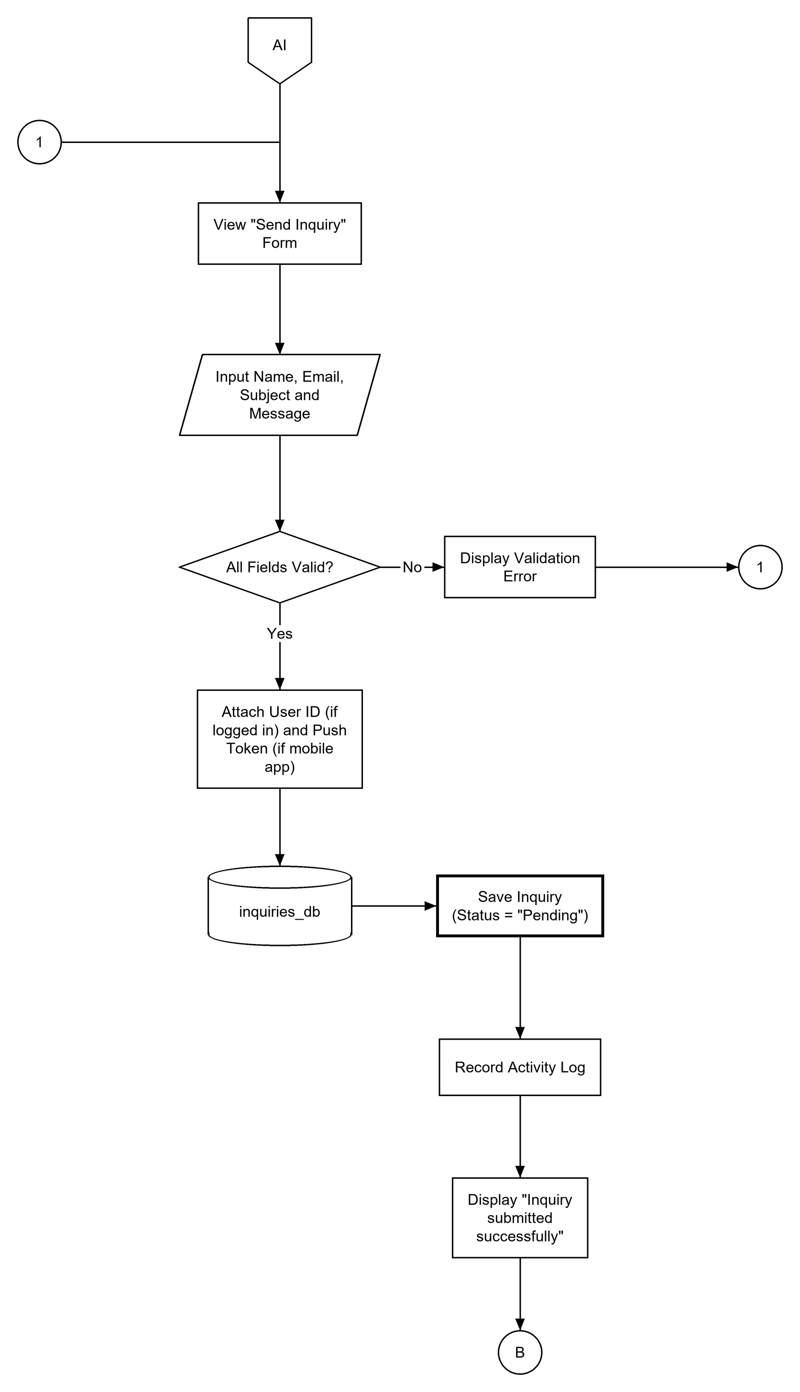
Flowchart 8. Send Inquiry (AI)

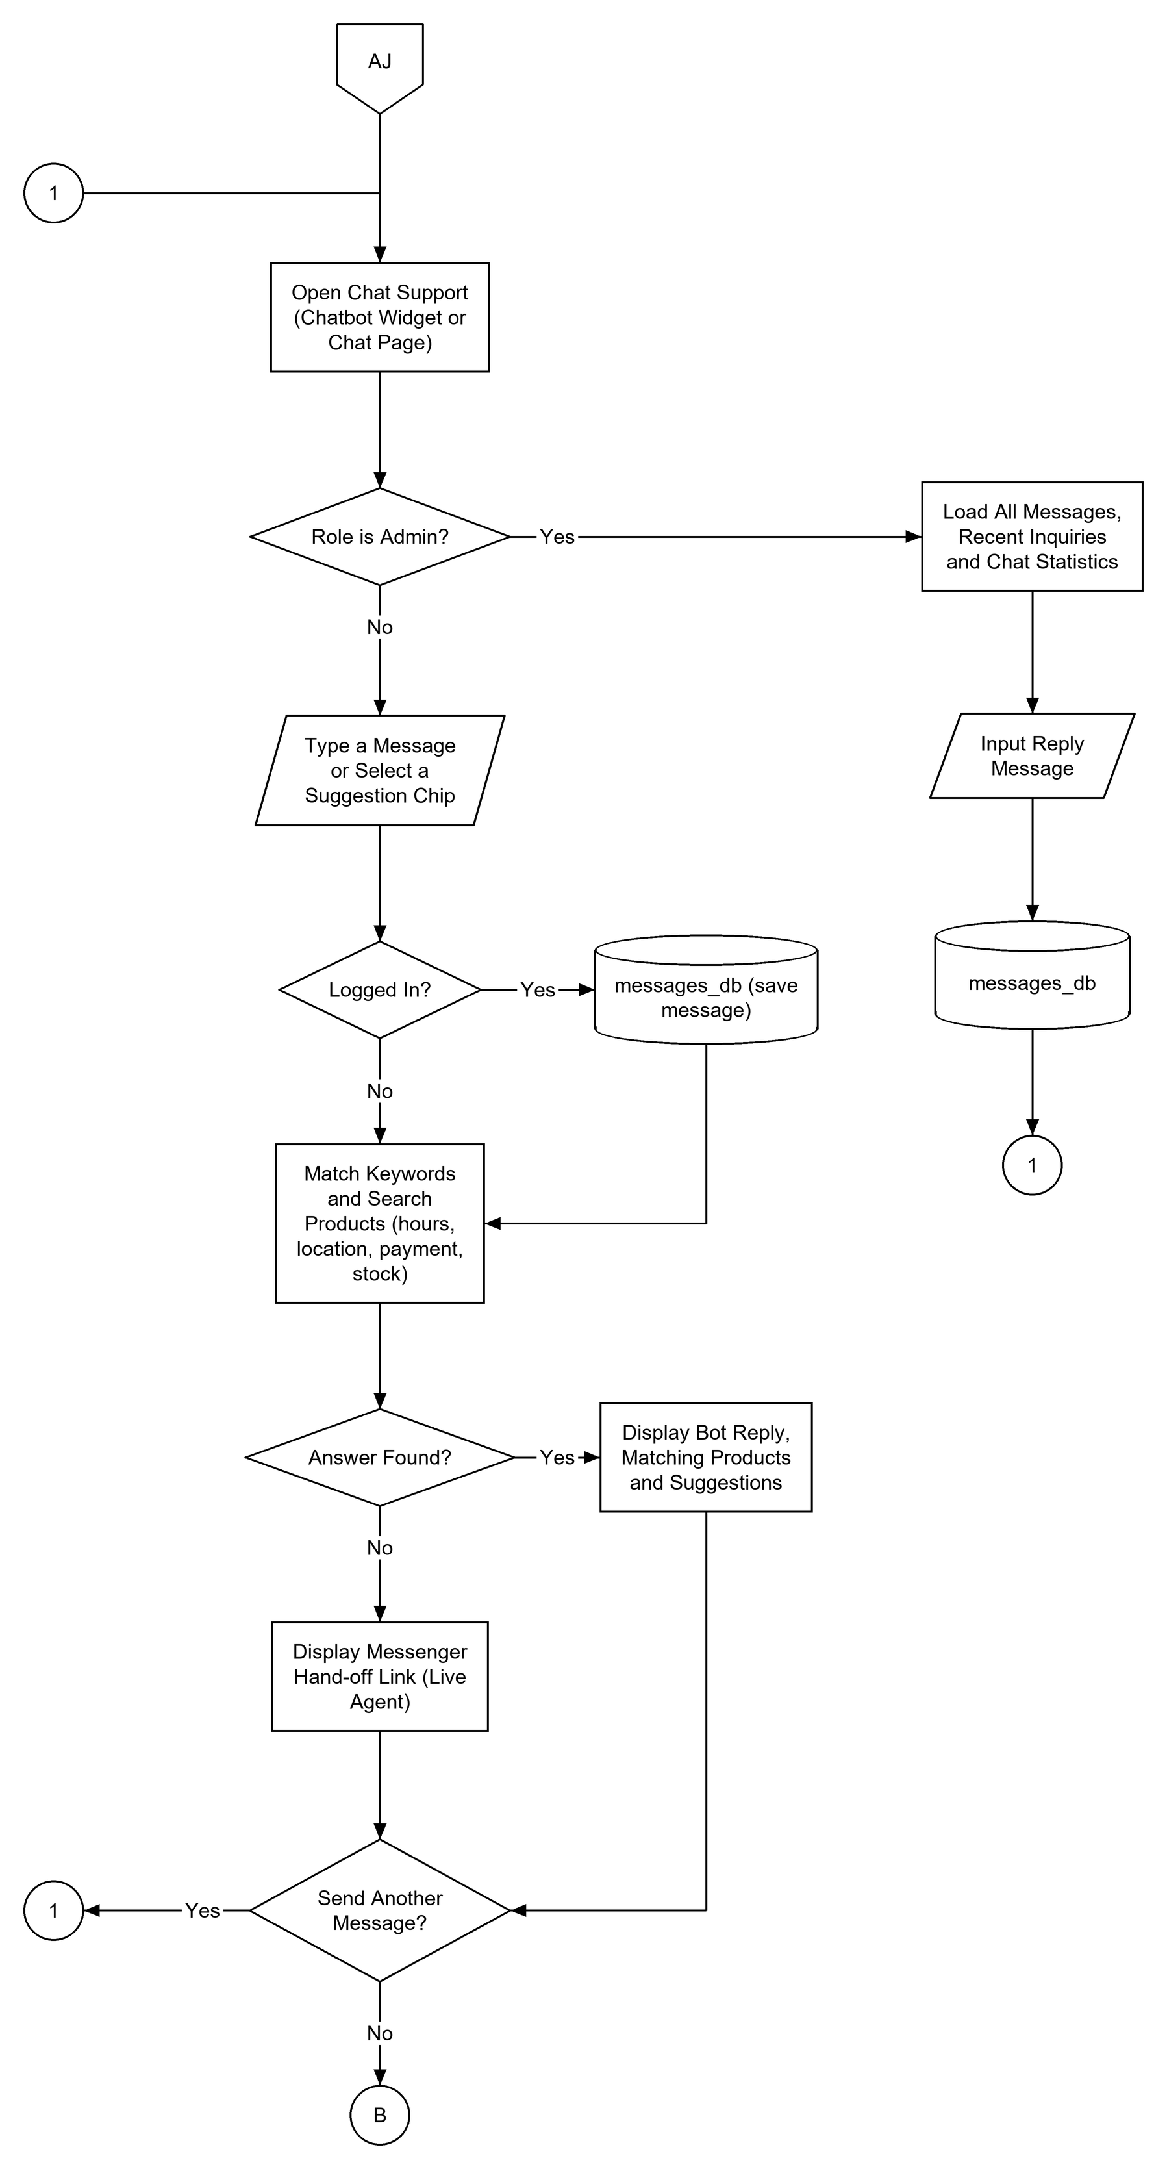
Flowchart 9. Chat Support / Chatbot (AJ)

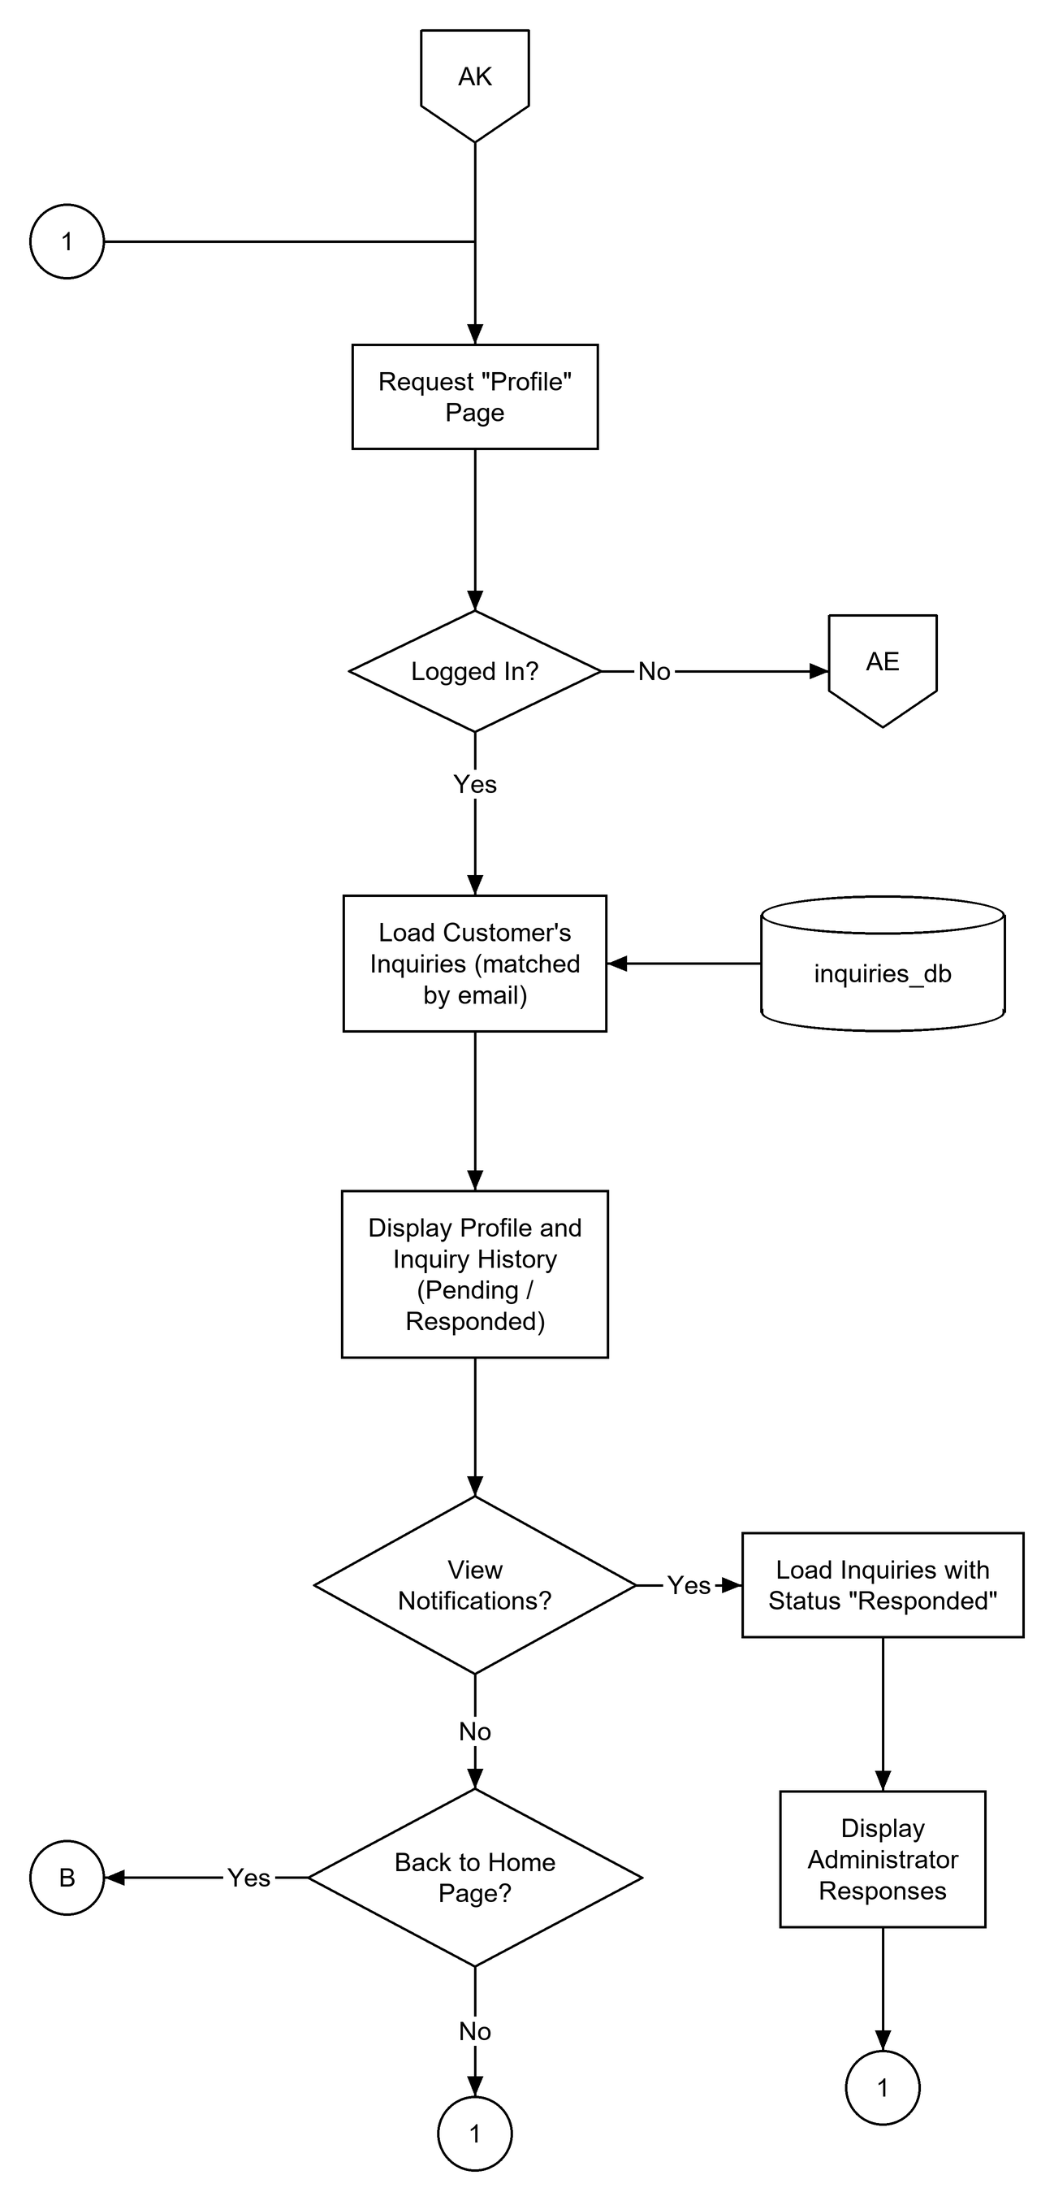
Flowchart 10. My Profile and Notifications (AK)

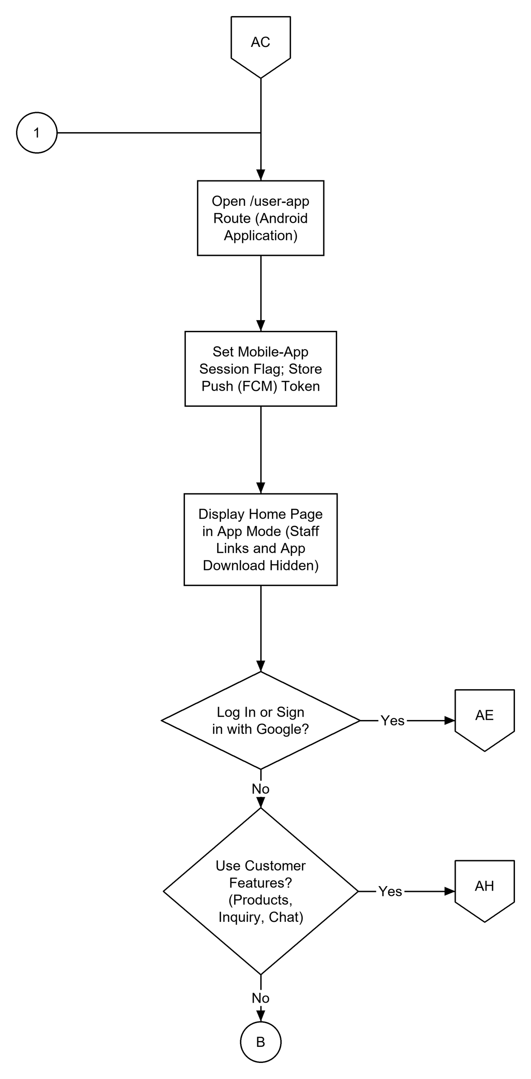
Flowchart 11. Mobile App Access (AC)

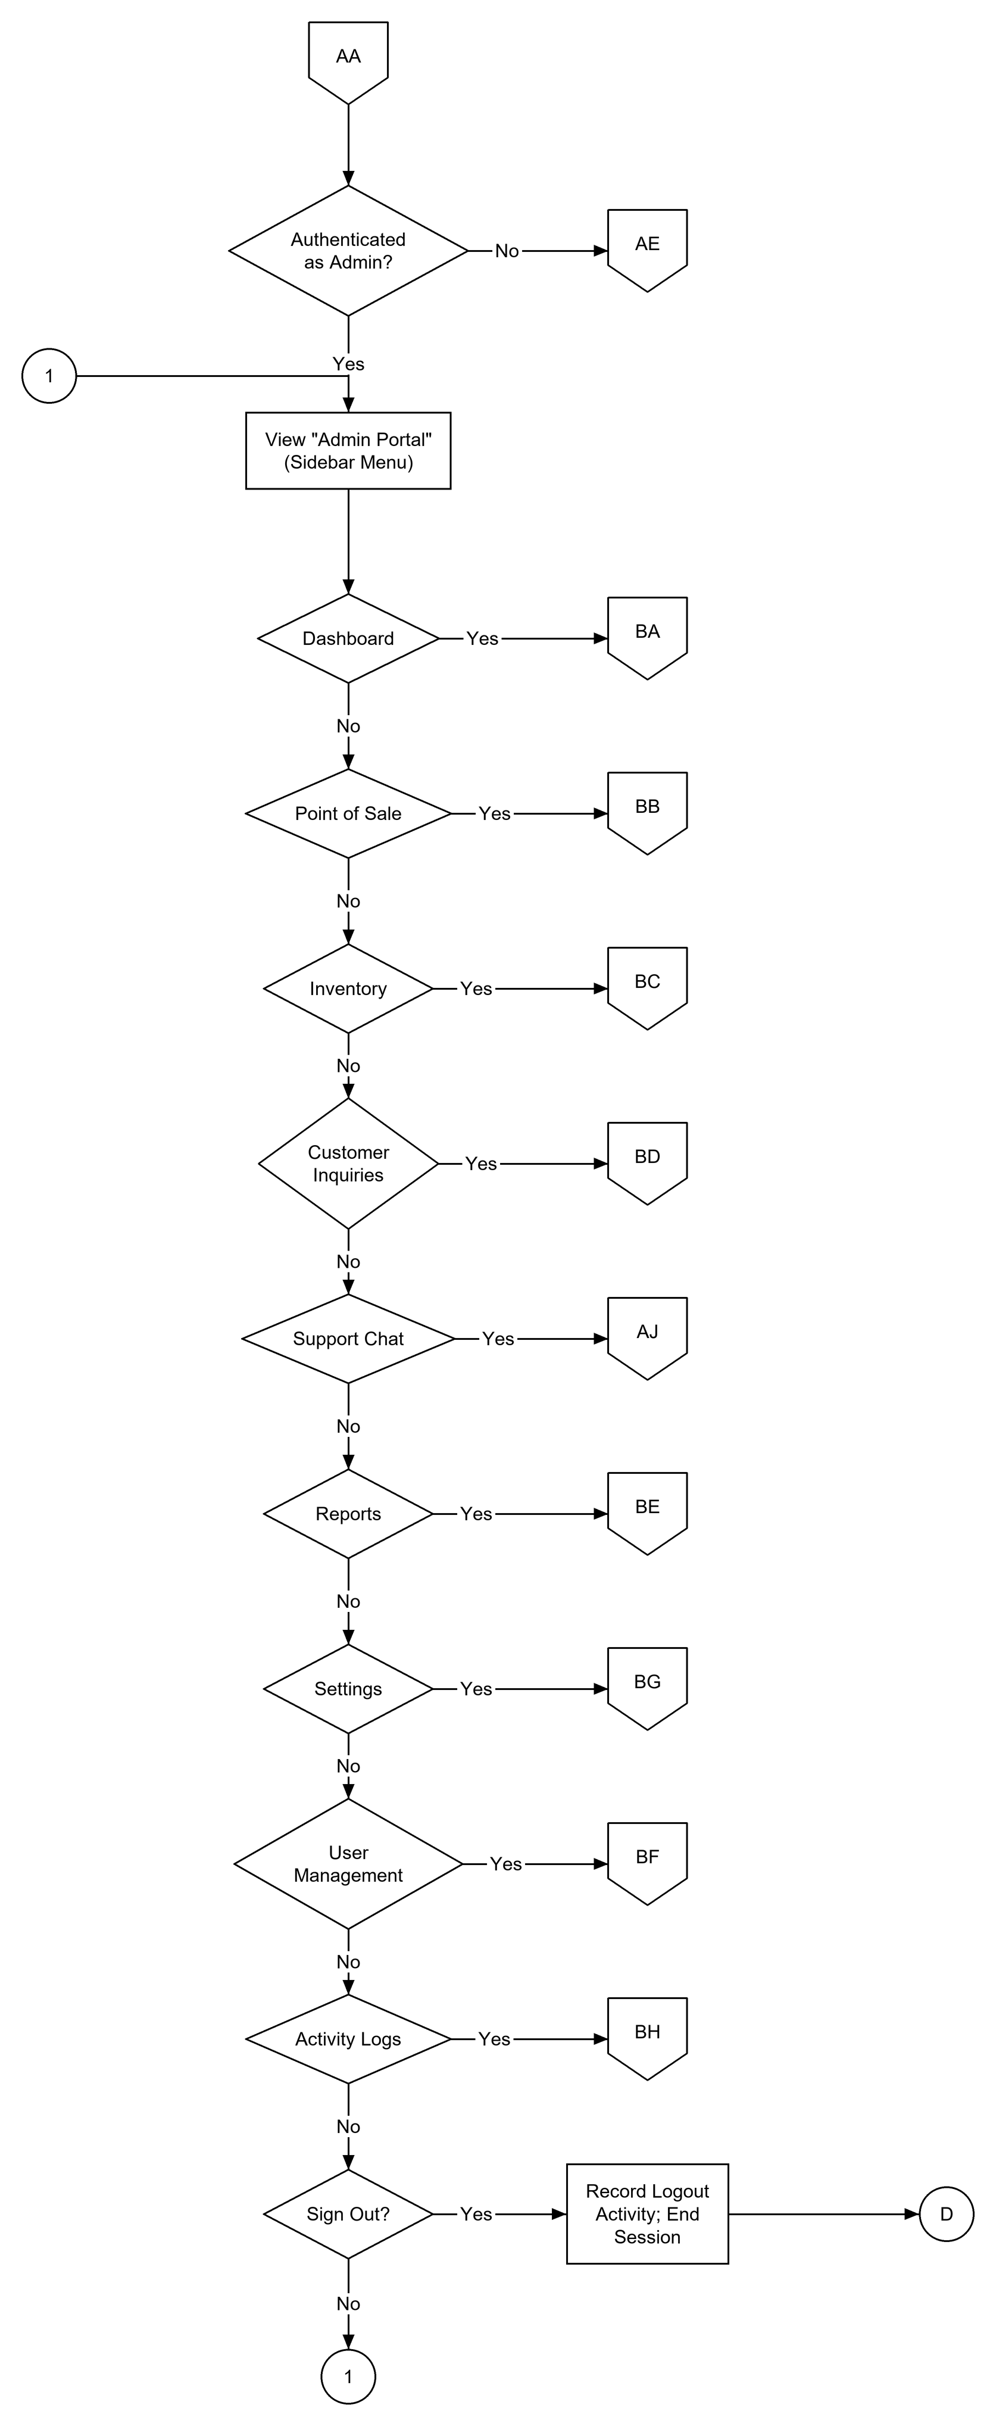
Flowchart 12. Administrator Portal (AA)

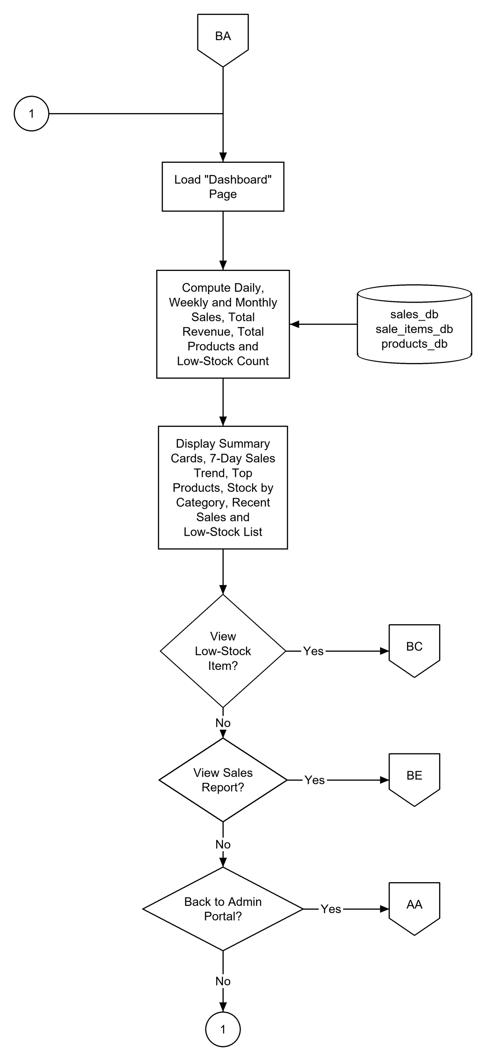
Flowchart 13. Dashboard (BA)

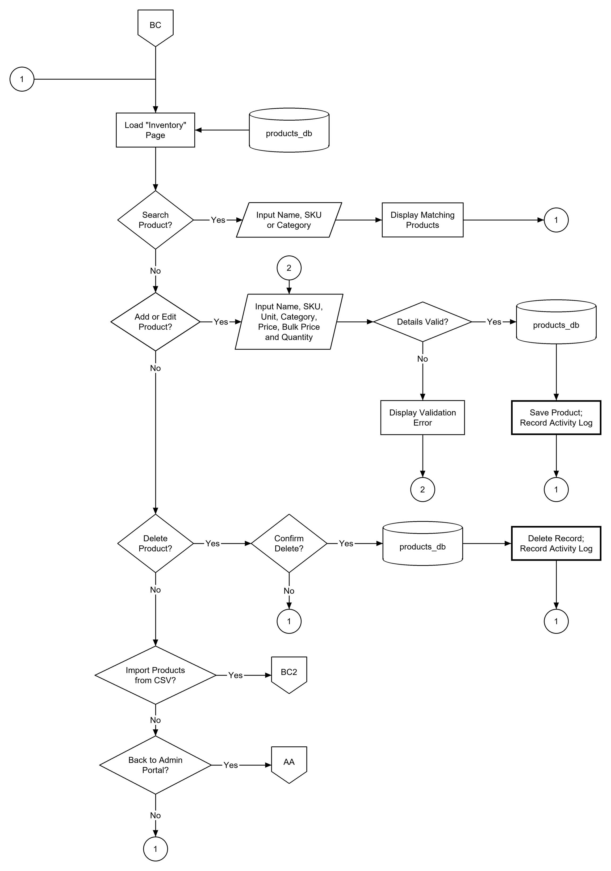
Flowchart 14. Inventory (BC)

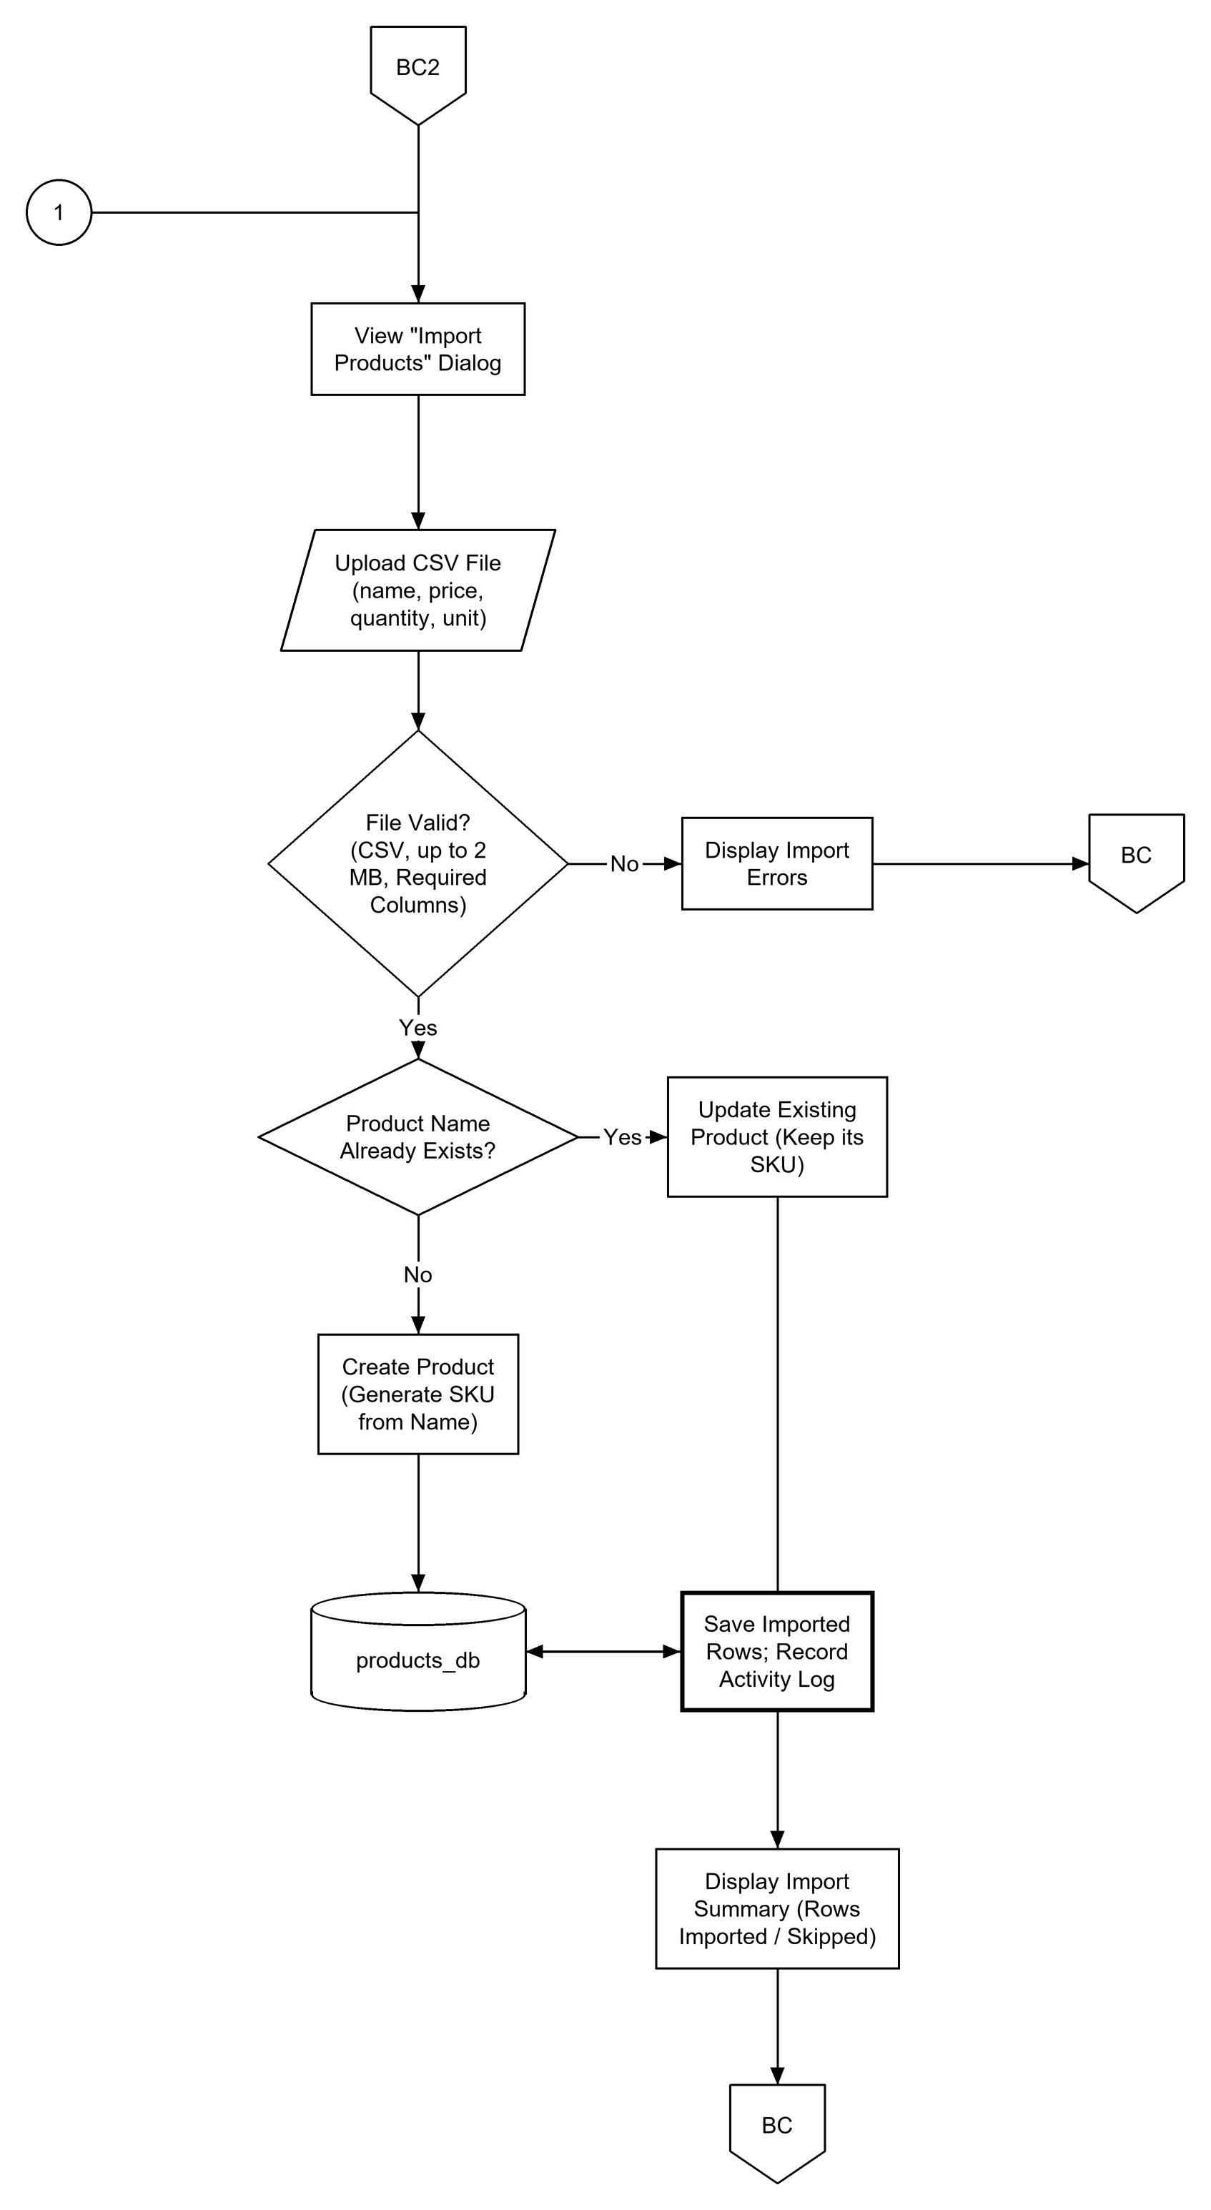
Flowchart 15. Import Products from CSV (BC2)

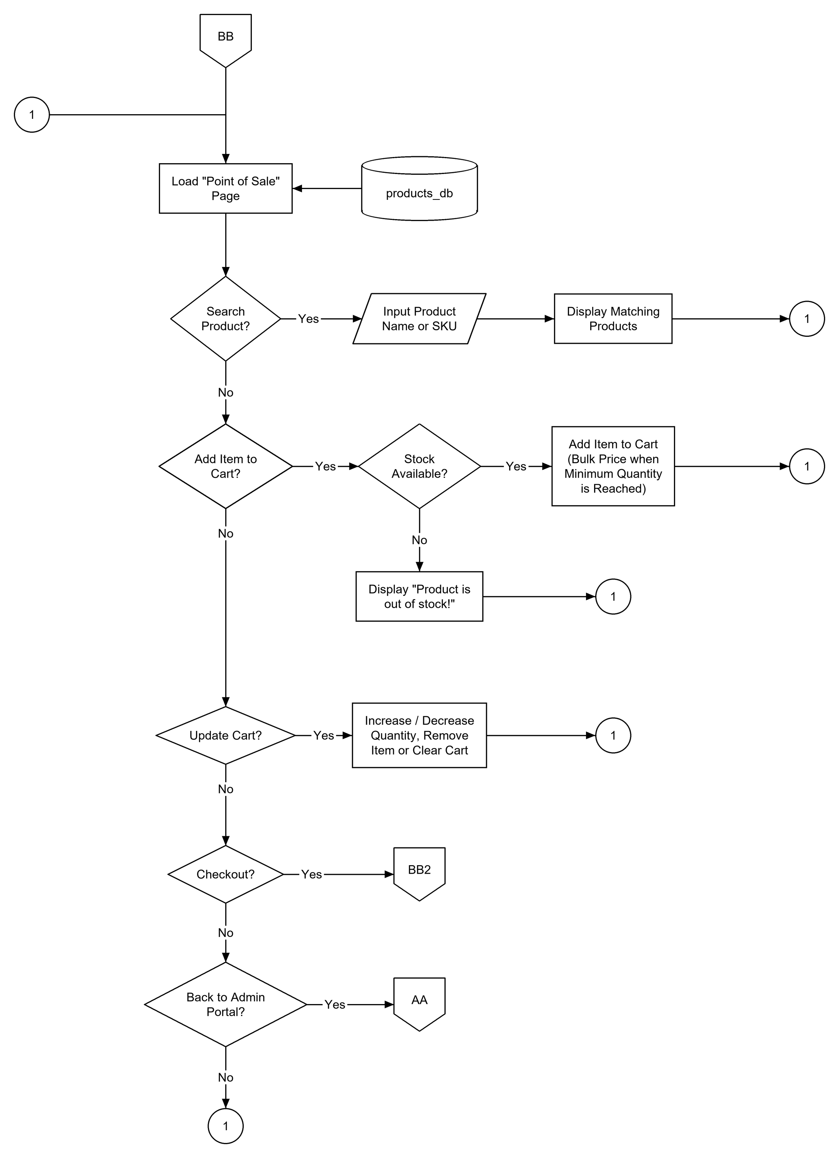
Flowchart 16. Point of Sale: Build the Cart (BB)

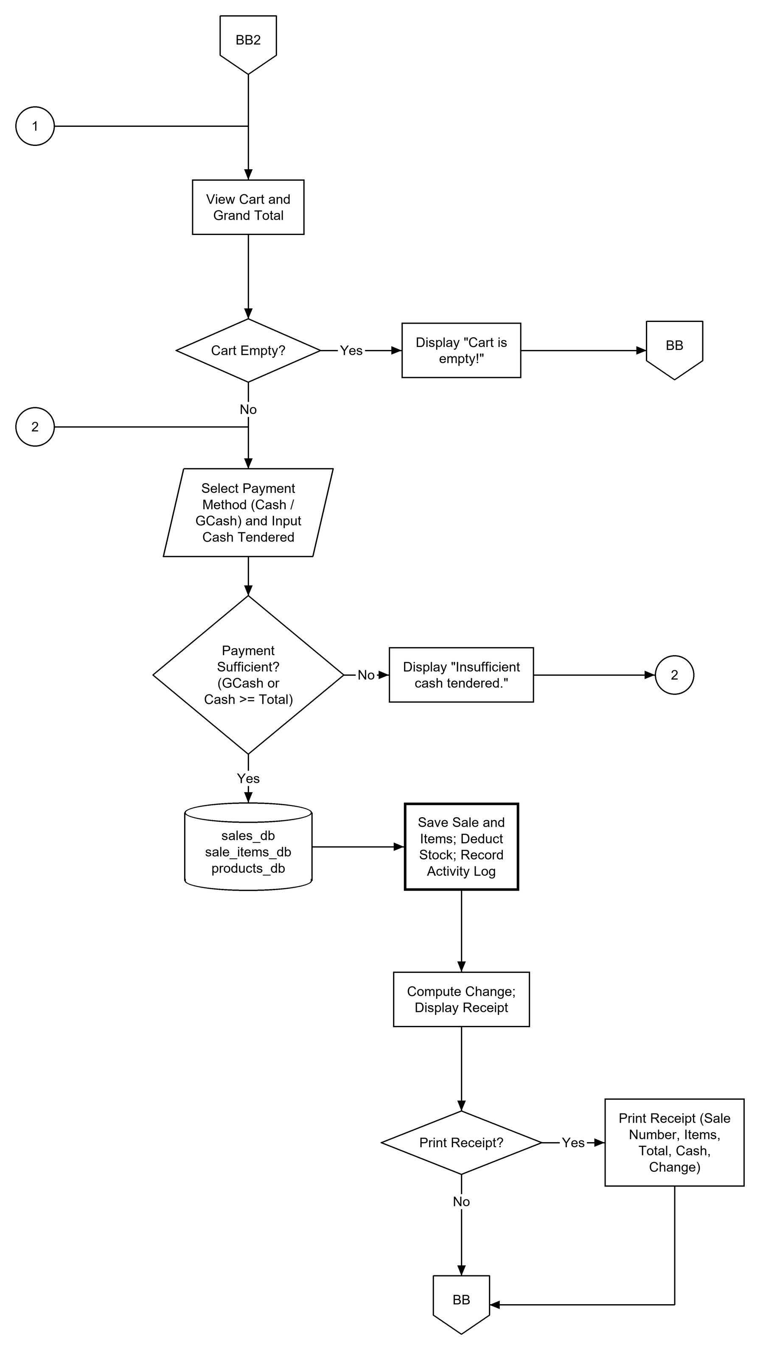
Flowchart 17. Point of Sale: Checkout and Receipt (BB2)

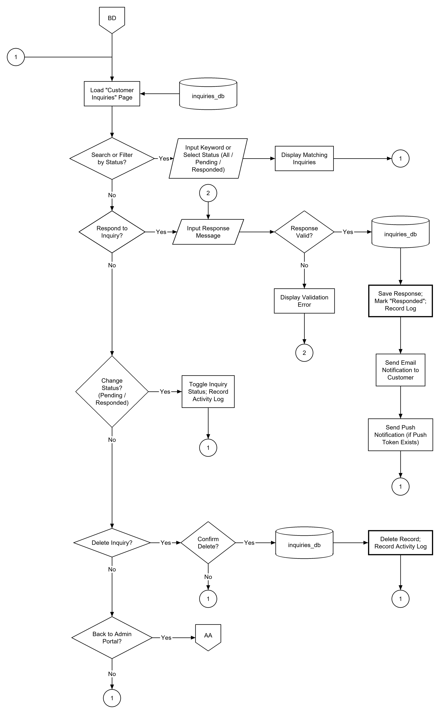
Flowchart 18. Customer Inquiries (BD)

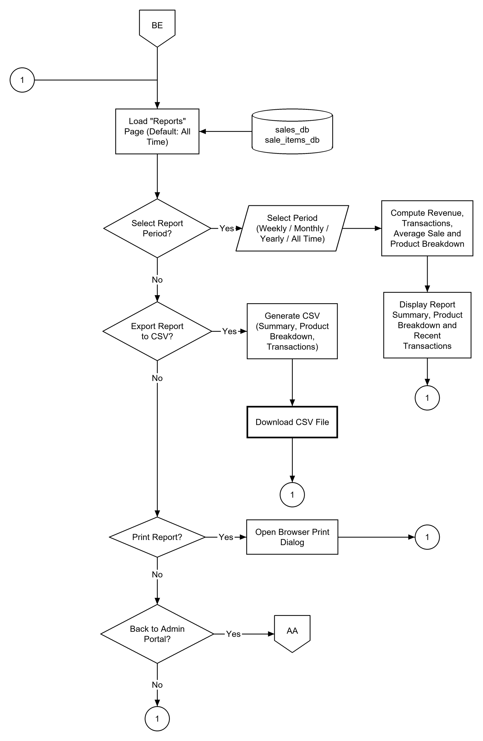
Flowchart 19. Sales Reports (BE)

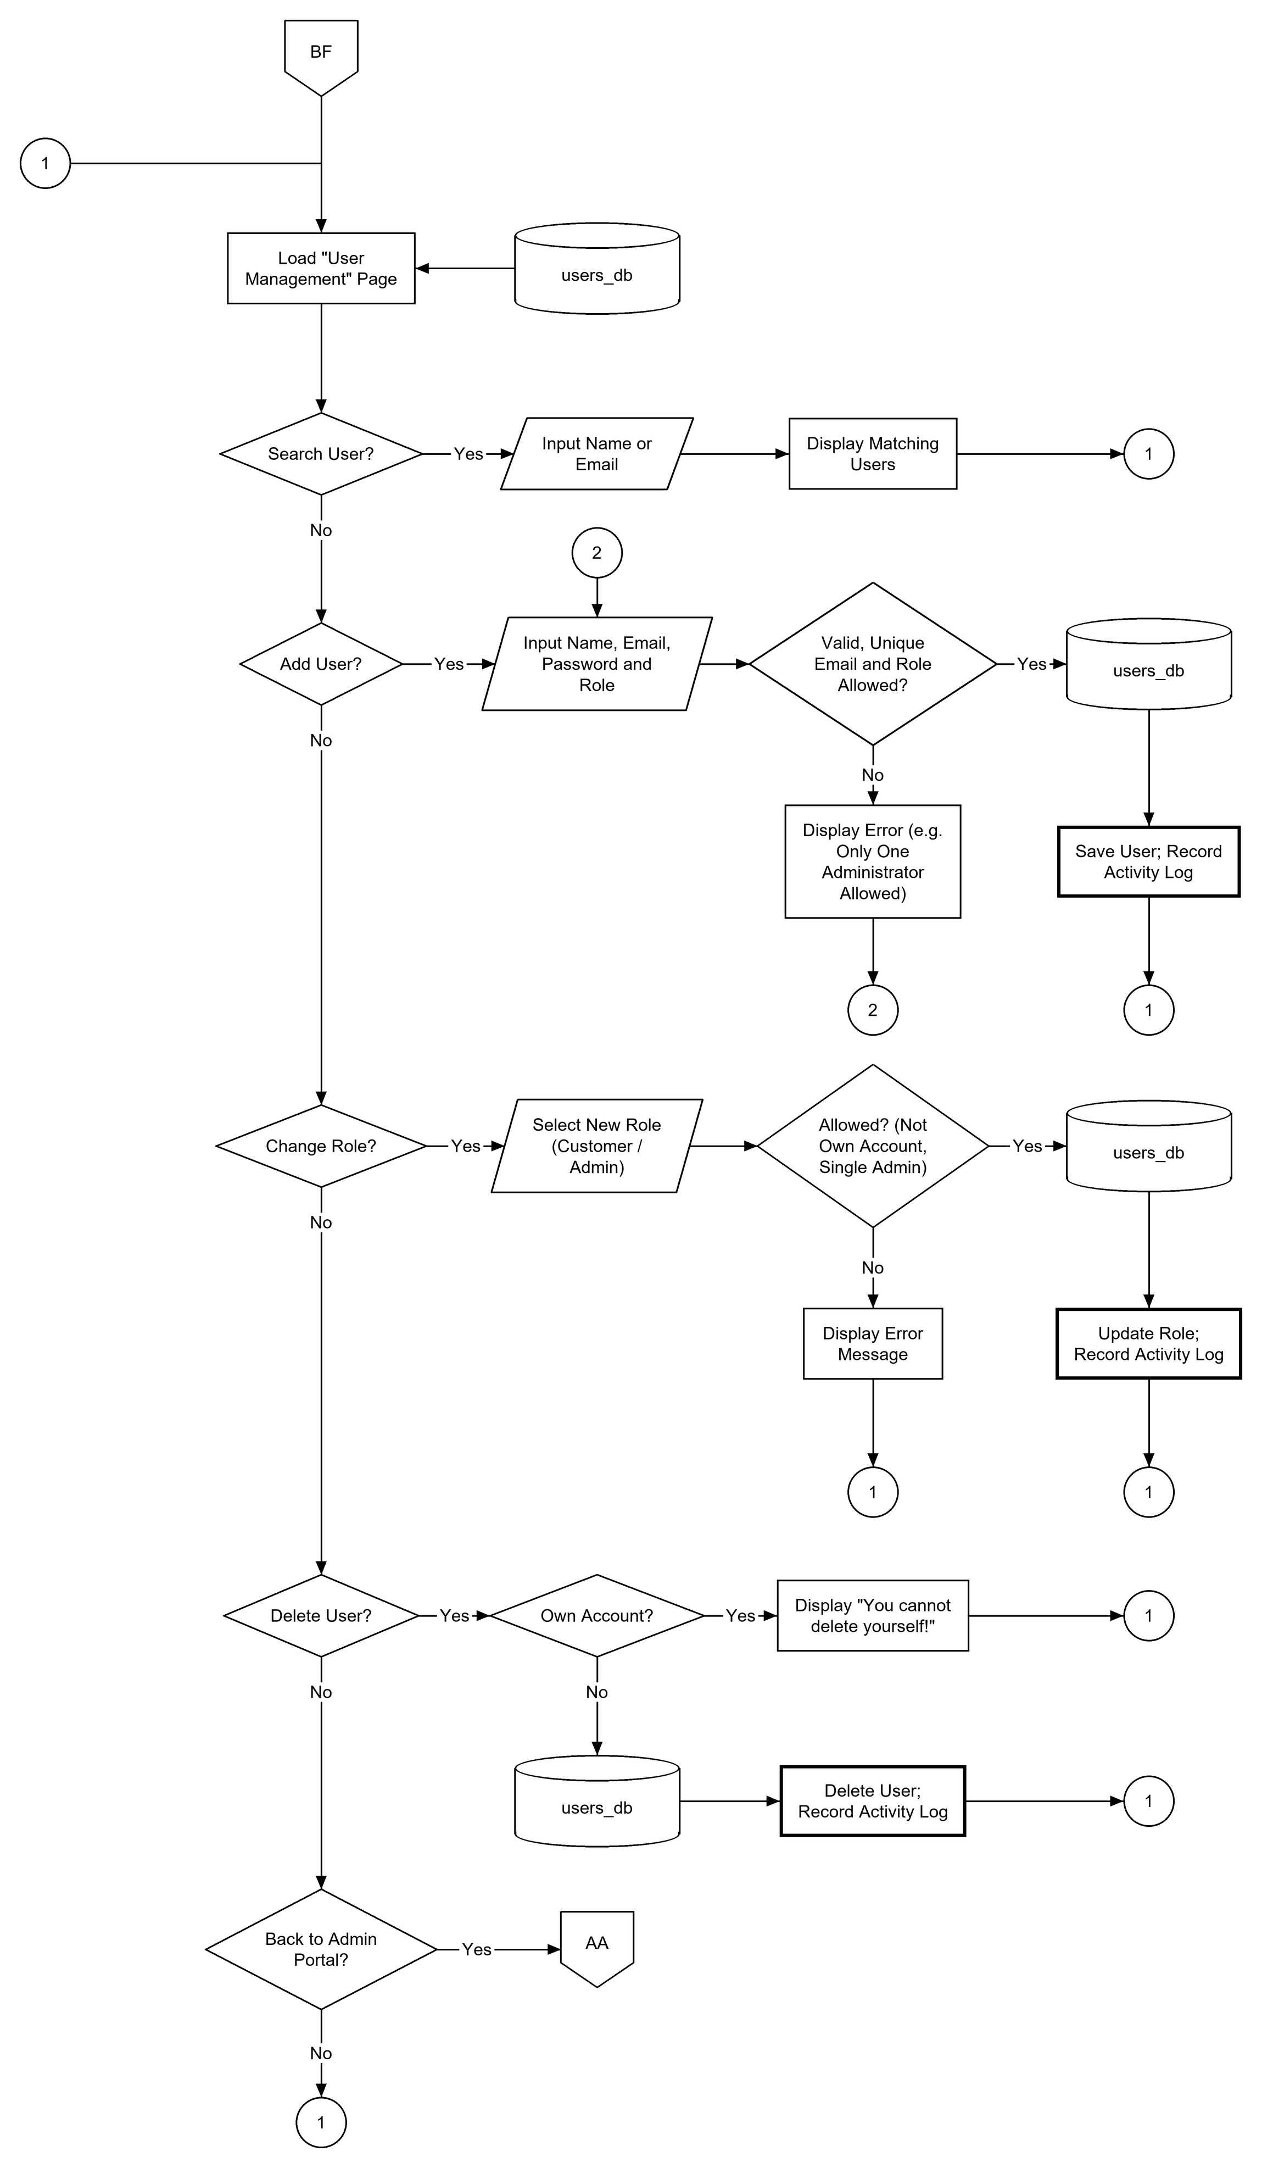
Flowchart 20. User Management (BF)

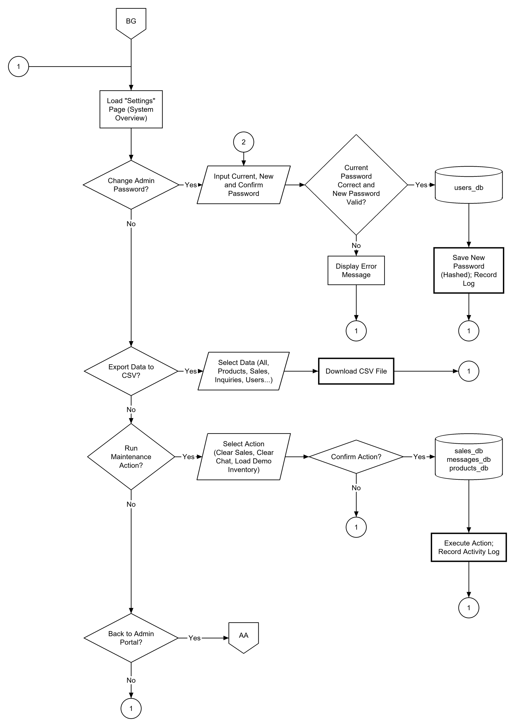
Flowchart 21. System Settings (BG)

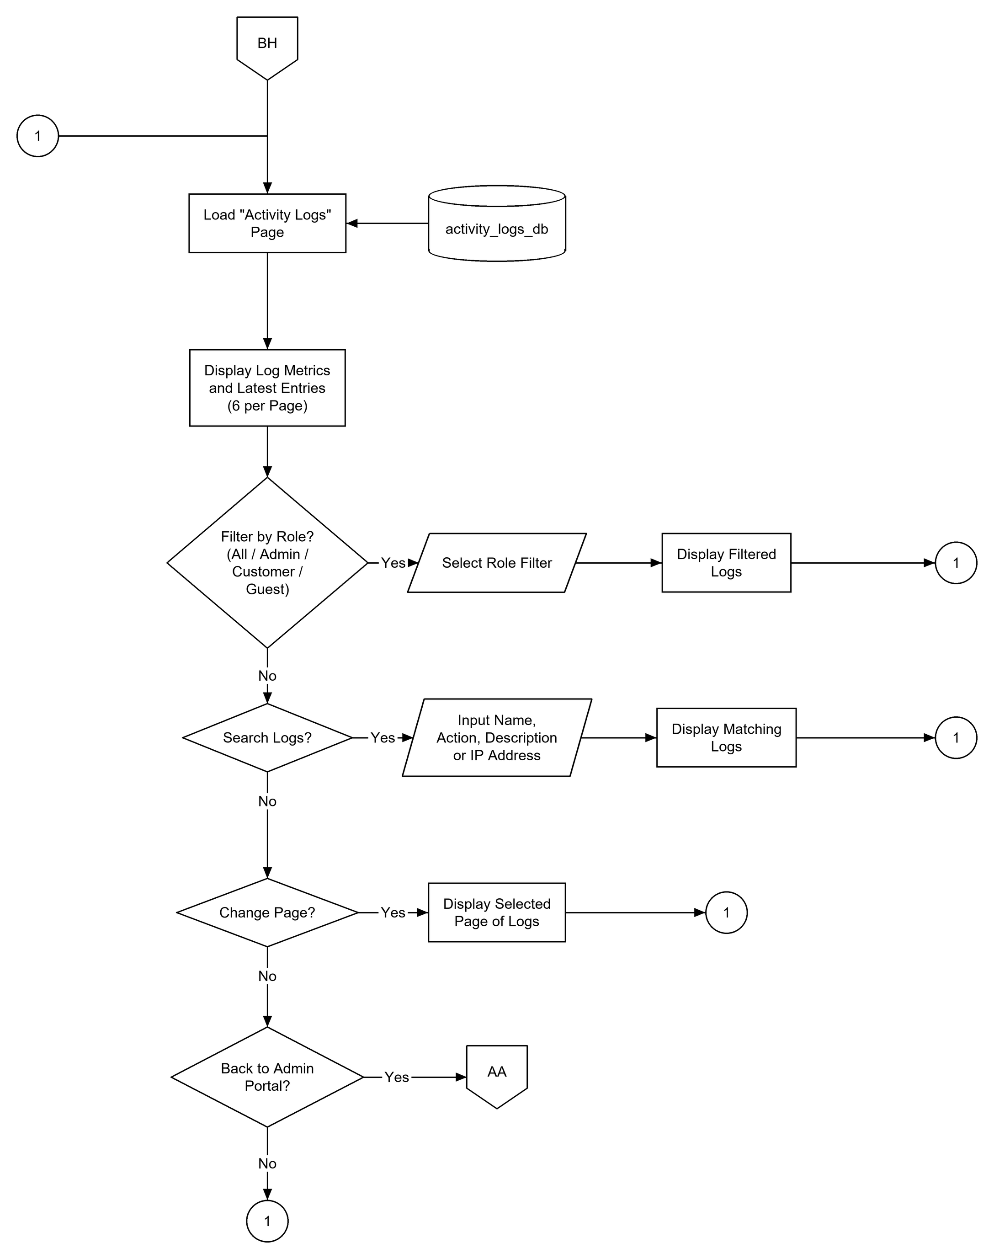
Flowchart 22. Activity Logs (BH)

