CHAPTER III
METHODOLOGY
This chapter presents the methods and procedures that will be used in the development and evaluation of Mera’s General Merchandise Store Management System with POS and Chat Support. It describes the research design, the software development model, the requirements gathering procedure, the system design, the development tools and technologies, the testing procedures, the respondents of the study, the research instruments, the statistical treatment of data, and the ethical considerations observed by the researchers.

Research Design
This study will use the developmental research design supported by descriptive evaluation. Developmental research is appropriate because the study aims to design, build, and refine a working software product that addresses a real business need, namely the manual handling of sales, inventory, reports, and customer communication at Mera’s General Merchandise Store. The descriptive component will be used to gather and describe the ratings of the respondents on the quality and usability of the developed system, based on the ISO/IEC 25010:2011 Systems and Software Quality Model and the usability criteria of usefulness, satisfaction, and ease of use and learning.

Software Development Model
The researchers will adopt the Agile development model, specifically an iterative, Scrum-based approach. Agile is suitable for this study because the system has several connected modules, such as the POS, inventory, reports, mobile application, chat support, and GCash payment, that can be developed, tested, and improved in short cycles. This allows the researchers to present working parts of the system to the store owner and employees early, gather feedback, and adjust the requirements before the next cycle begins. Figure 14 shows the phases of the model as applied in this study.
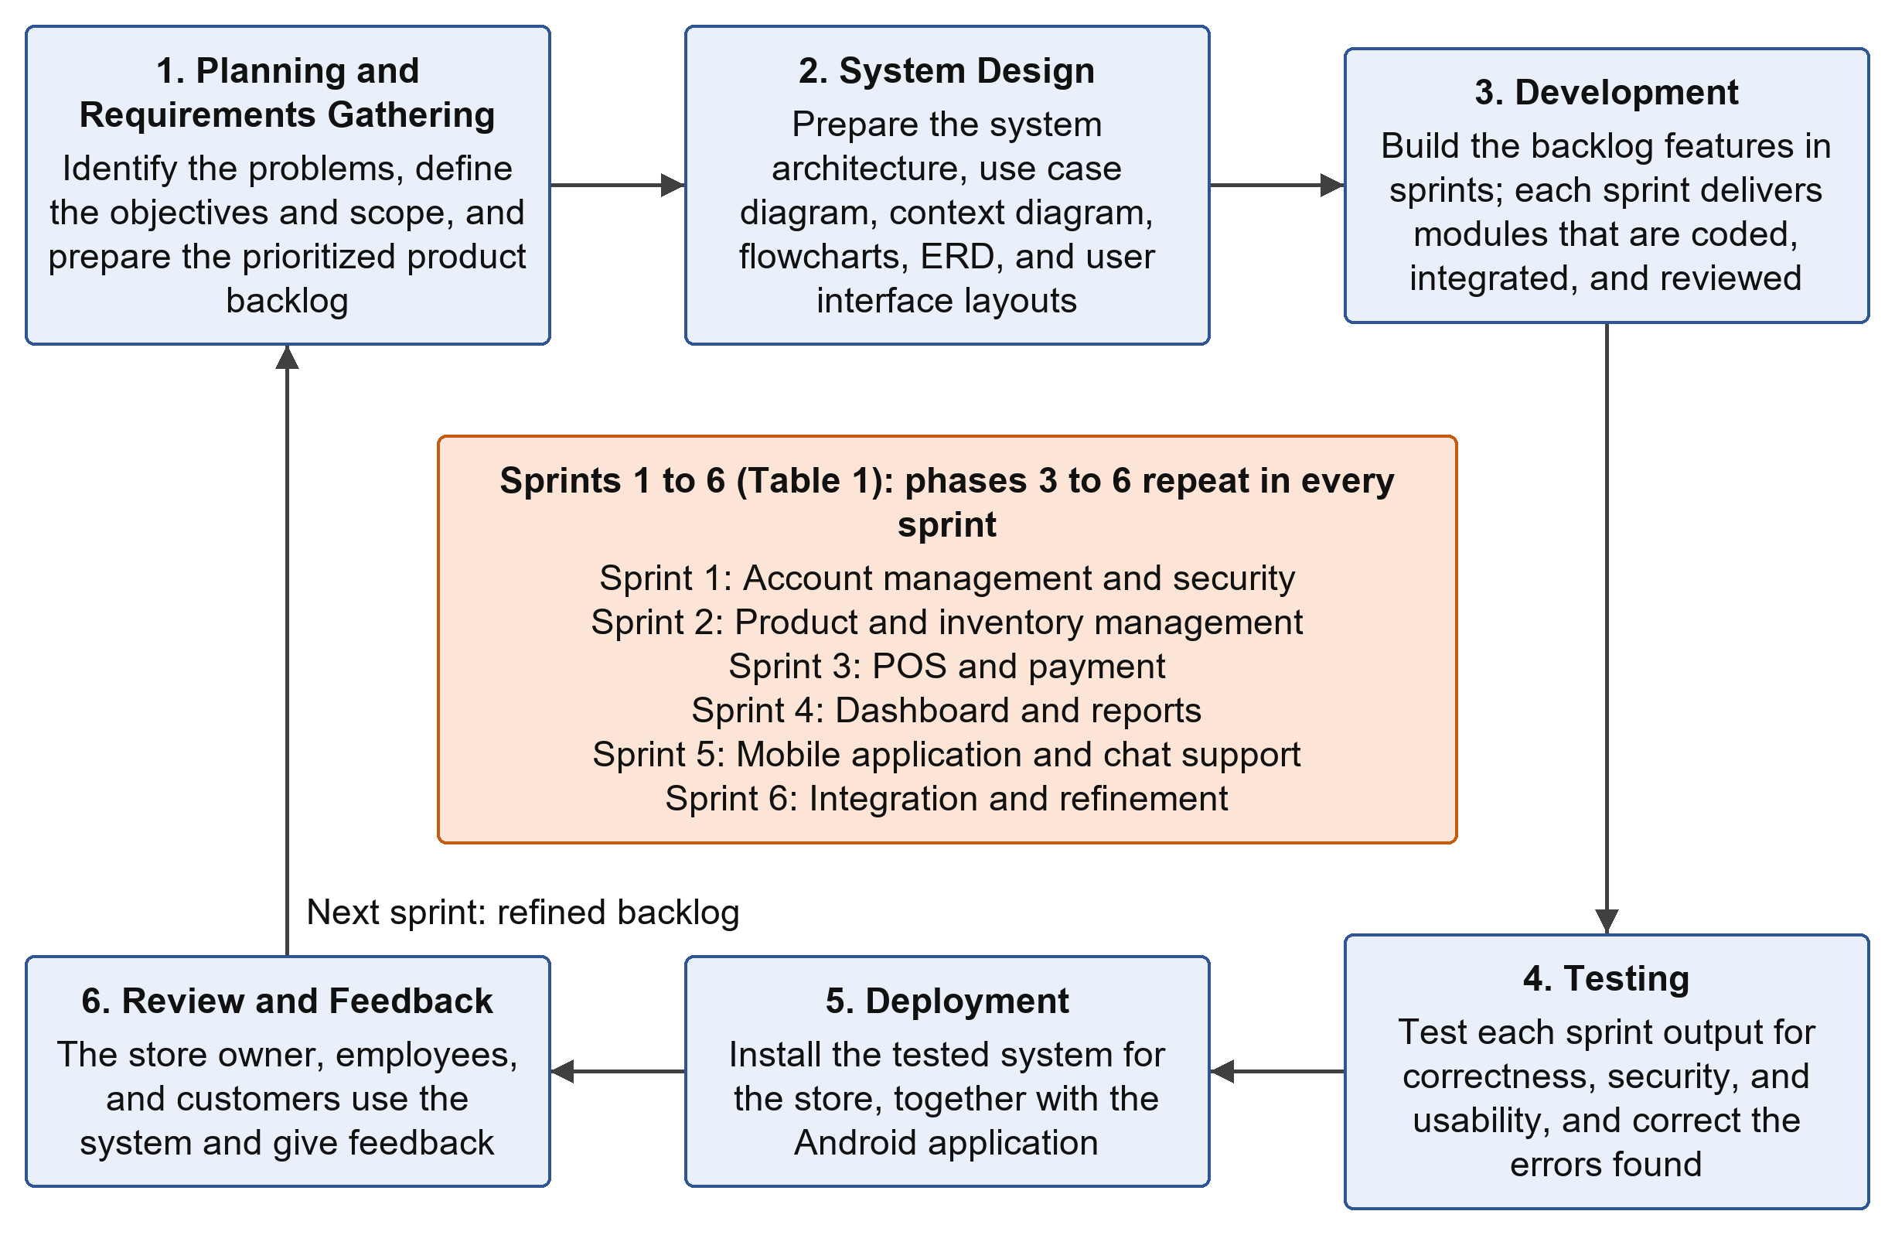
Figure 14. Agile Development Model Applied in the Study
Planning and Requirements Gathering. The researchers will identify the problems in the current store operations, define the objectives and scope of the system, and prepare a list of features (product backlog) arranged by priority.
System Design. The researchers will prepare the system architecture, use case diagram, context diagram, flowcharts, entity relationship diagram, and user interface layouts for the web portal and the mobile application.
Development. The features in the backlog will be built in sprints. Each sprint delivers a working set of modules, which are coded, integrated, and reviewed by the researchers.
Testing. Each sprint output will be tested for correctness, security, and usability. Errors found will be recorded and corrected before the next sprint proceeds.
Deployment. The tested system will be installed and made available to the store for actual use, together with the Android mobile application for merchants and customers.
Review and Feedback. The store owner, employees, and sample customers will use the system and give feedback. Their comments will be used for refinements in the next sprint, and the final version will be evaluated using the instruments described later in this chapter. Table 1 shows the planned sprints.
Table 1. Planned Development Sprints
Sprint | Focus | Planned Deliverables
1 | Account management and security | User registration, login, role-based access, email verification, and password recovery through email (reset link )
2 | Product and inventory management | Product and category records, stock quantity and price updates, low-stock detection
3 | POS and payment | Cart and checkout, receipt generation, cash and GCash payment, automatic stock deduction
4 | Dashboard and reports | Dashboard indicators and charts, daily, weekly, monthly, and yearly sales reports, top-selling products, recent transactions, CSV export, and print
5 | Mobile application and chat support | Android application for merchants and customers, ordering, purchase history, and chat support
6 | Integration and refinement | System-wide testing, correction of errors, user feedback, and system evaluation

Requirements Gathering Procedure
To ensure that the system responds to the actual needs of Mera’s General Merchandise Store, the researchers will use the following techniques to gather the requirements:
- Interview. The researchers will interview the store owner and employees to identify how sales are recorded, how stock is monitored, how reports are prepared, how customers send inquiries, and what difficulties they experience in these activities.
- Observation. The researchers will observe the daily operations of the store, particularly the handling of sales transactions, the checking of stock, and the receiving of customer inquiries.
- Document Analysis. The researchers will examine existing records such as sales records, receipts, stock lists, and other documents used by the store to determine the data that the system must store and produce.
- Review of Related Systems. The related literature and prior arts presented in Chapter II will be studied to identify features that are useful for the proposed system.
The information gathered will be organized into functional and non-functional requirements, which will serve as the basis of the system design.

Requirements Analysis
Table 2 presents the functional requirements of the system according to the type of user, while Table 3 presents the non-functional requirements based on the quality characteristics of ISO/IEC 25010.
Table 2. Functional Requirements by User
User | Functional Requirements
Administrator | Create sales records and process transactions (cash or GCash QR code); read and respond to customer inquiries; create, update, and import products, stock quantities, and prices; delete discontinued products, inactive accounts, and spam inquiries; clear the sales and chat history; view the dashboard; generate, export (CSV), and print sales reports; view the activity logs; manage user accounts and system settings; change the administrator password and recover the account through the registered email address.
Customer | Register an account; log in with an email address and password or with a Google account; recover the account through a password reset link; browse, search, and filter the products and check their prices and stock status; send inquiries to the store; use the chatbot and chat support; read the reply of the store, received by email or push notification, under Notifications; download and use the Android application.

Table 3. Non-Functional Requirements
ISO/IEC 25010 Characteristic | Requirement
Functionality | All modules must perform the functions specified in the objectives and produce correct results, such as accurate totals, stock deductions, and report figures.
Usability | The interfaces must be simple, consistent, and easy to learn, even for users with limited technical knowledge.
Reliability | Transactions must be saved completely and consistently, and stored records must remain available to authorized users.
Efficiency | Common actions such as searching a product, checking out, and loading the dashboard must respond within a reasonable time under normal store use.
Security | Passwords must be stored in hashed form; access must be based on user roles; email verification and password reset links or OTPs must expire; data transmitted between the applications and the server must be protected; GCash payment details must be processed through the payment gateway and not stored by the system.
Maintainability | The system must be built in separate modules with organized and documented code so that errors can be corrected and features can be updated easily.

System Design

System Architecture
Figure 15 shows the architecture of the system. The web browser, which serves the admin portal and the customer website, and the Android mobile application communicate with the application server through secure requests. The application server processes the business logic, including authentication, POS transactions, inventory, reports, inquiries, and chat, and stores all data in the MySQL database. It also connects to external services for email, push notifications, and Google sign-in.
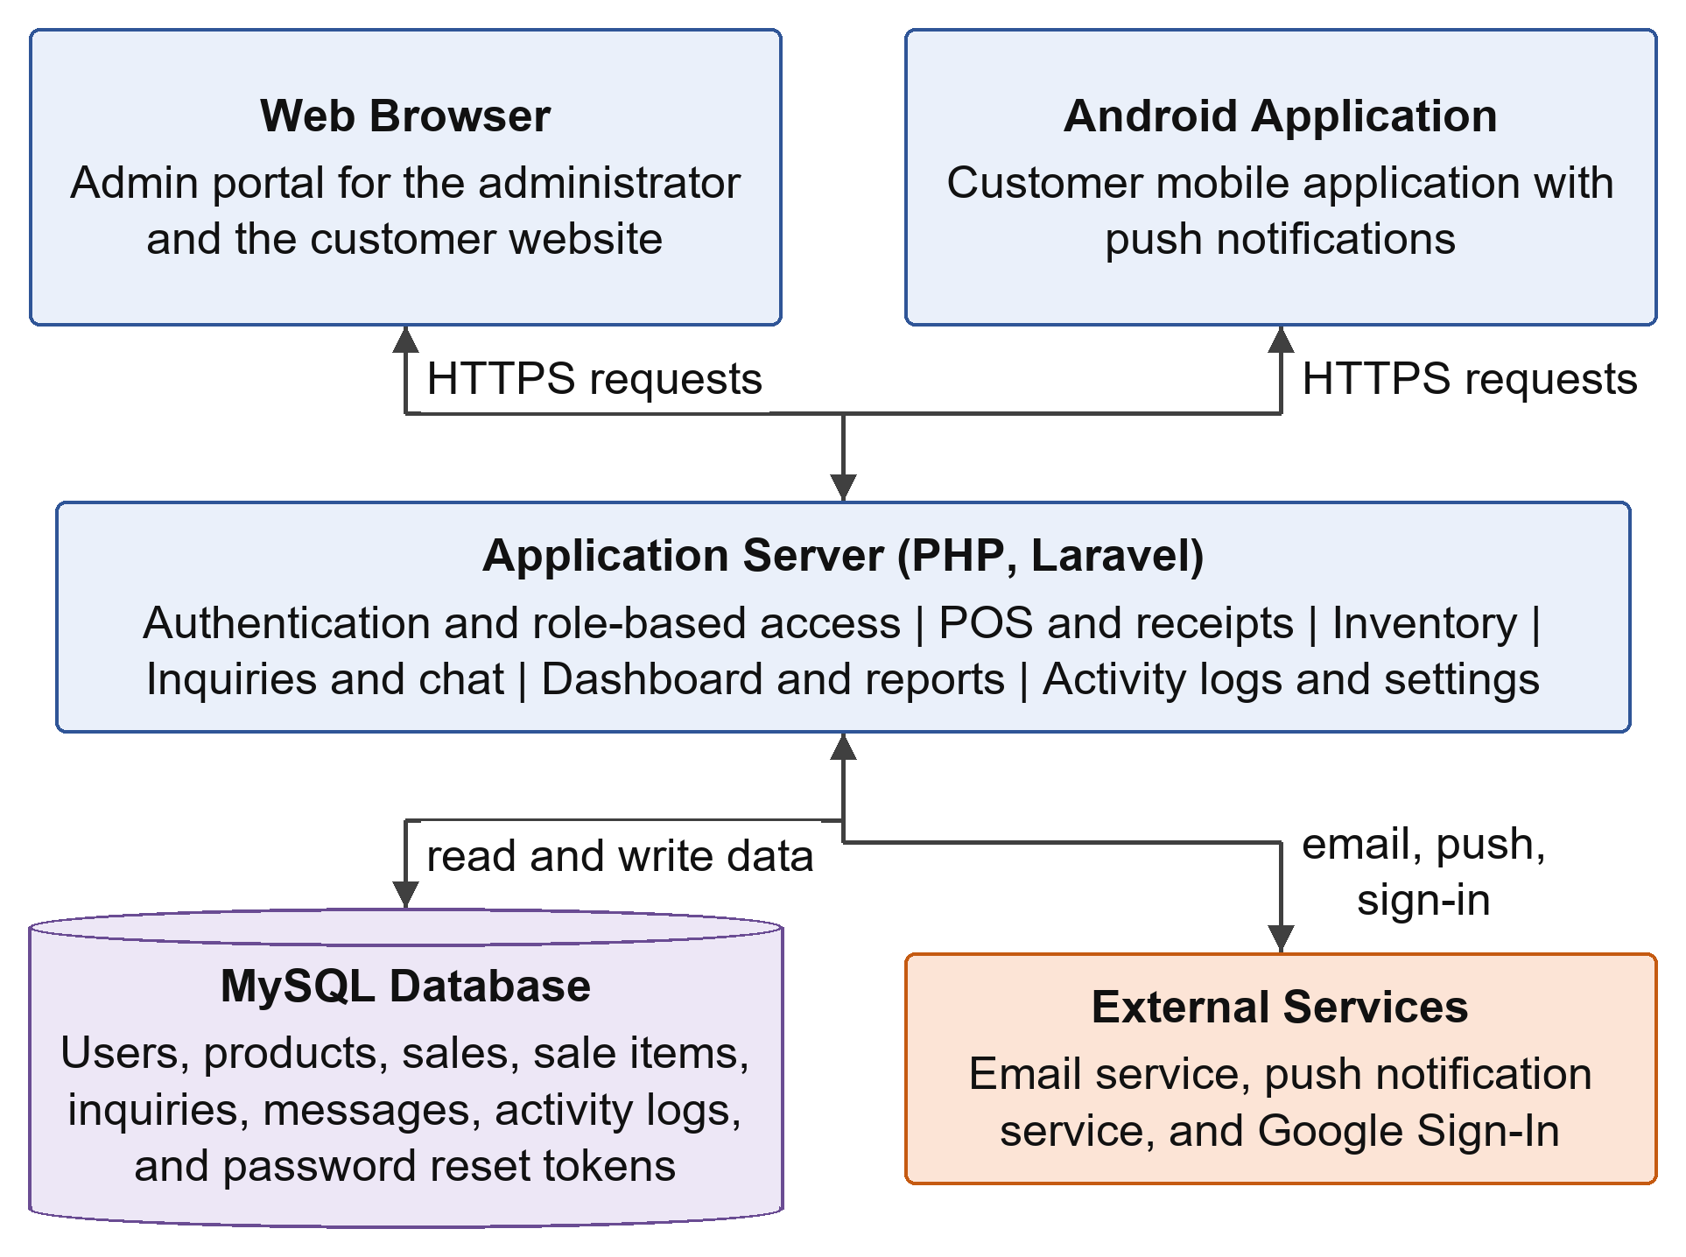
Figure 15. System Architecture

Use Case Diagram
Figure 16 shows the use case diagram of the system and how the two types of users, the administrator and the customer, interact with its main functions. Table 4 summarizes the access of each user type to the system modules.
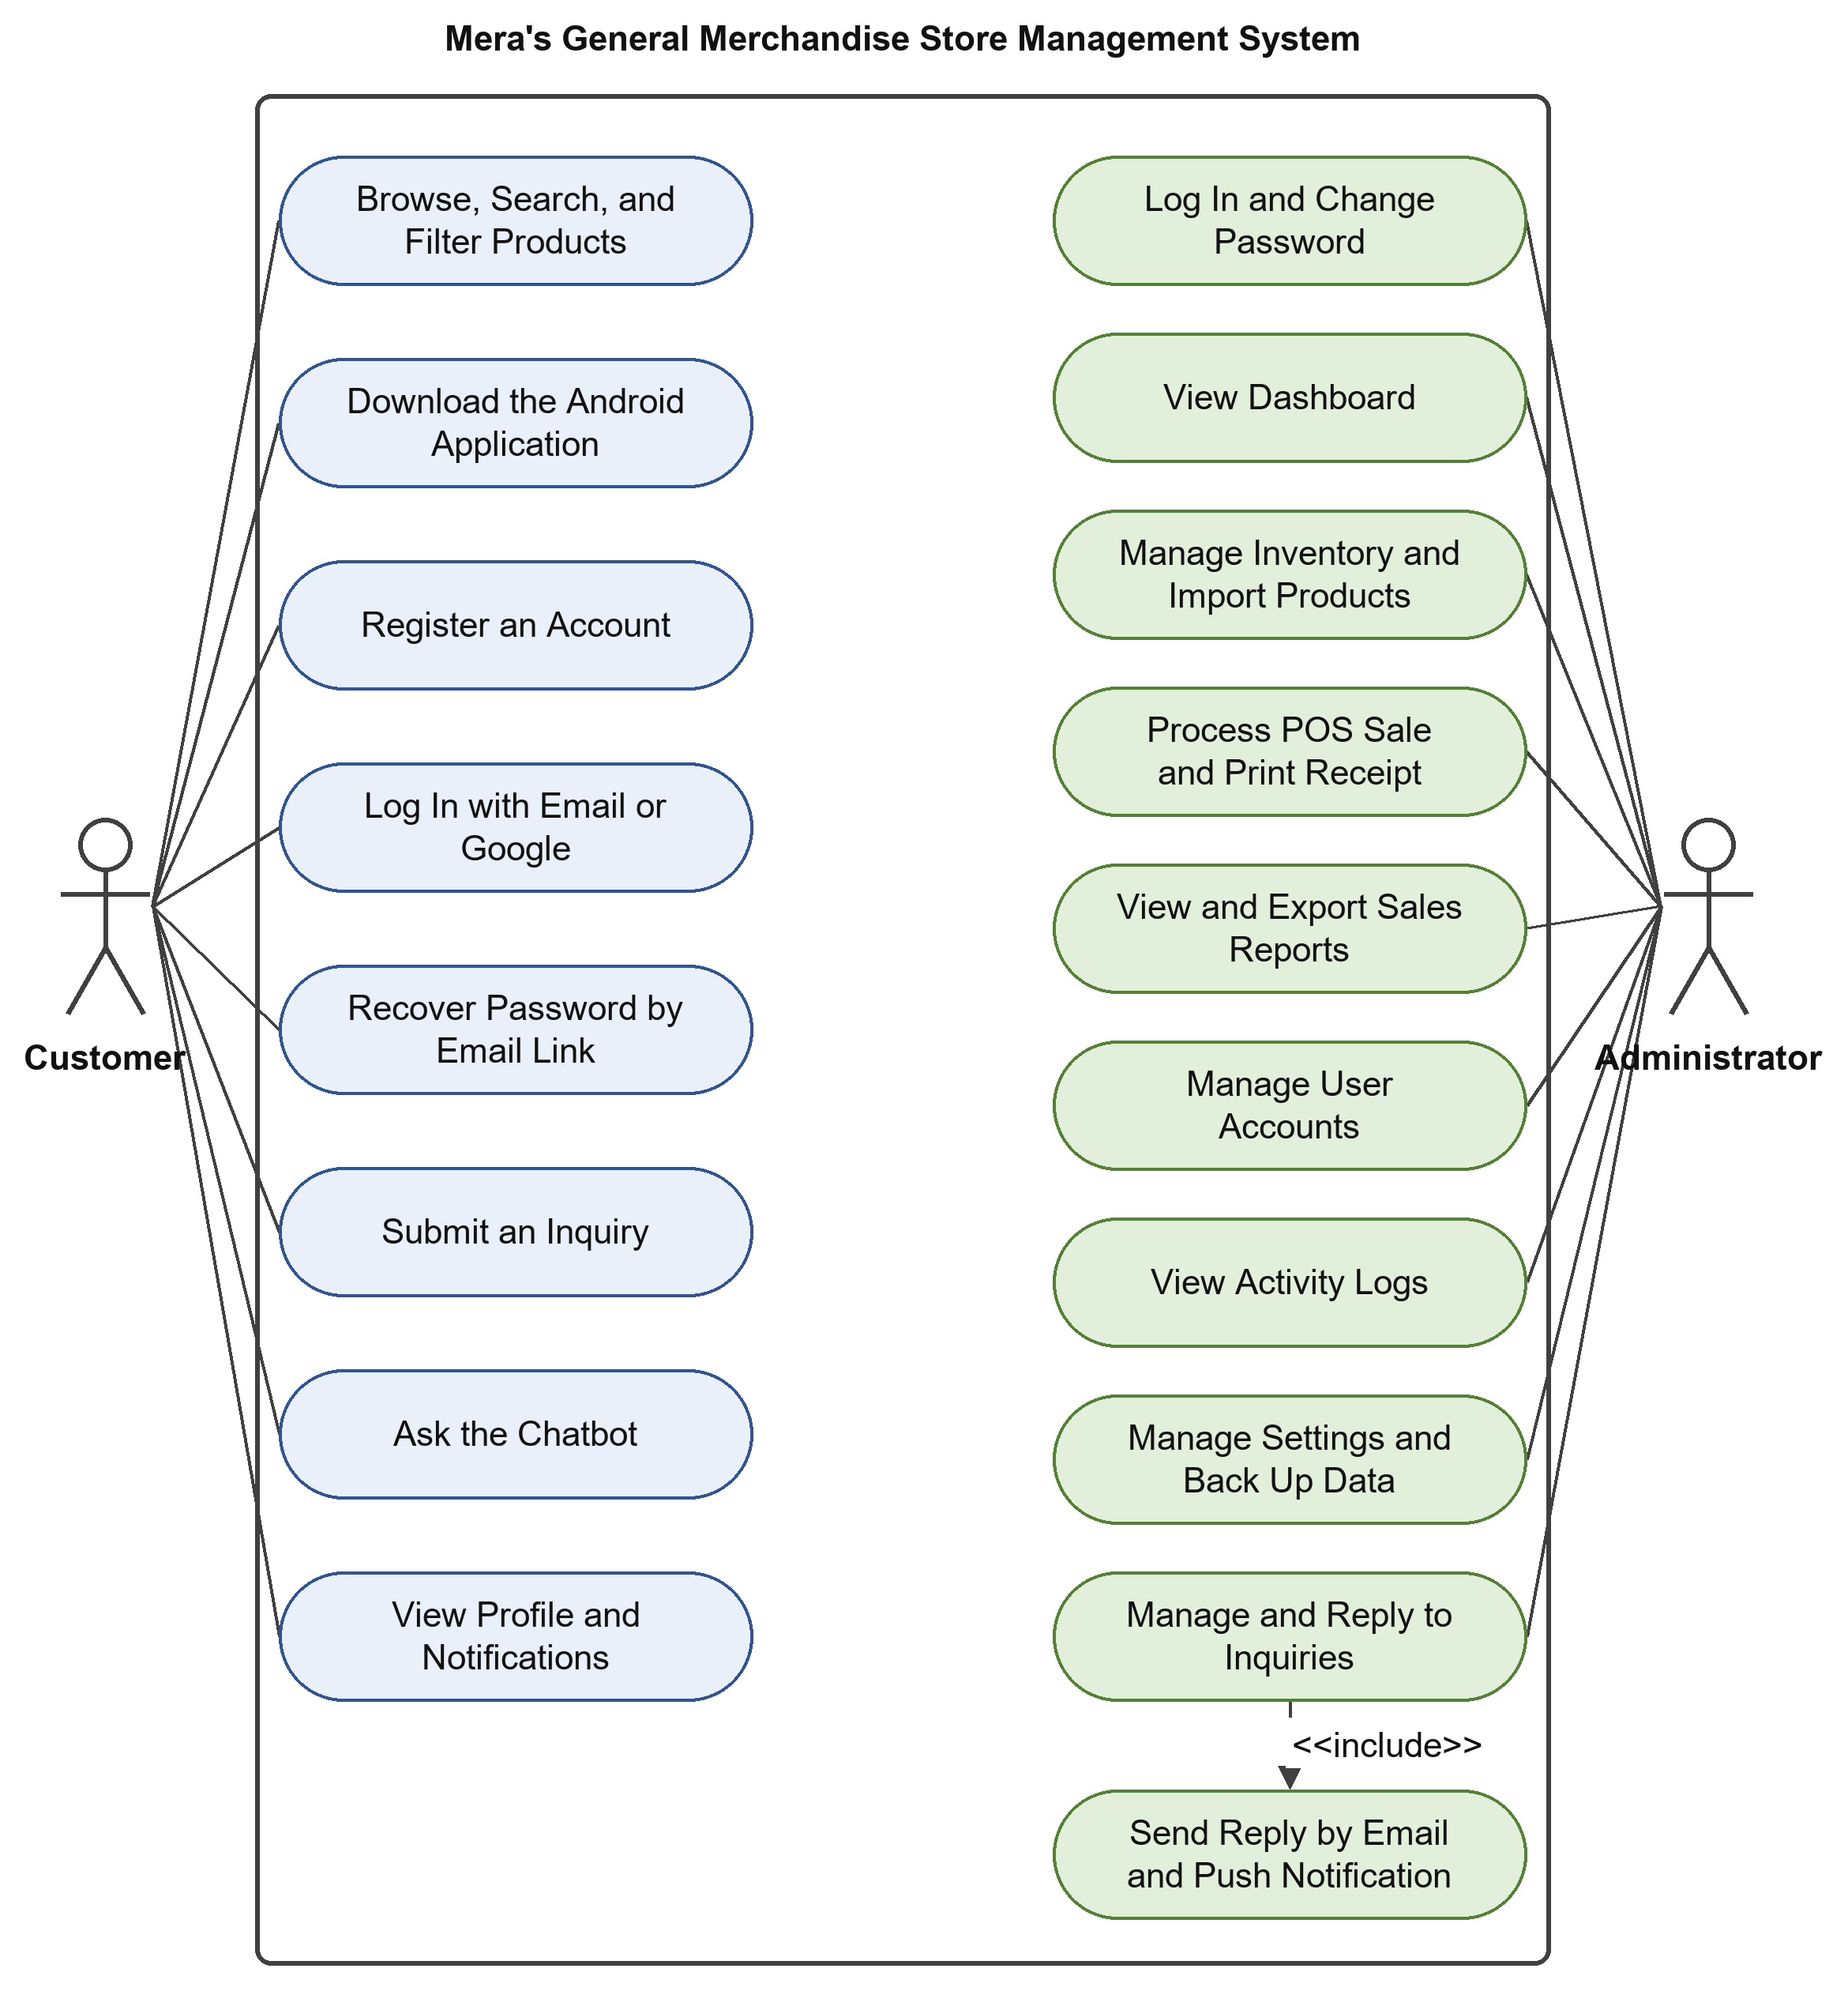
Figure 16. Use Case Diagram
Table 4. Access of Users to System Modules
Module | Admin | Customer
POS Checkout | Yes | No
Inventory Management | Yes | No
Dashboard | Yes | No
Sales Reports | Yes | No
User and Record Management | Yes | No
Activity Logs | Yes | No
Inquiries and Chat Support | Reply | Send
Browse Products | Yes | Yes
GCash Payment (QR code at the POS) | Yes | No

Context Diagram
Figure 17 presents the context diagram, which shows the system as a single process and the data that flow between the system and its external entities: the administrator, the customer, Google Sign-In, the email service, and the push notification service.
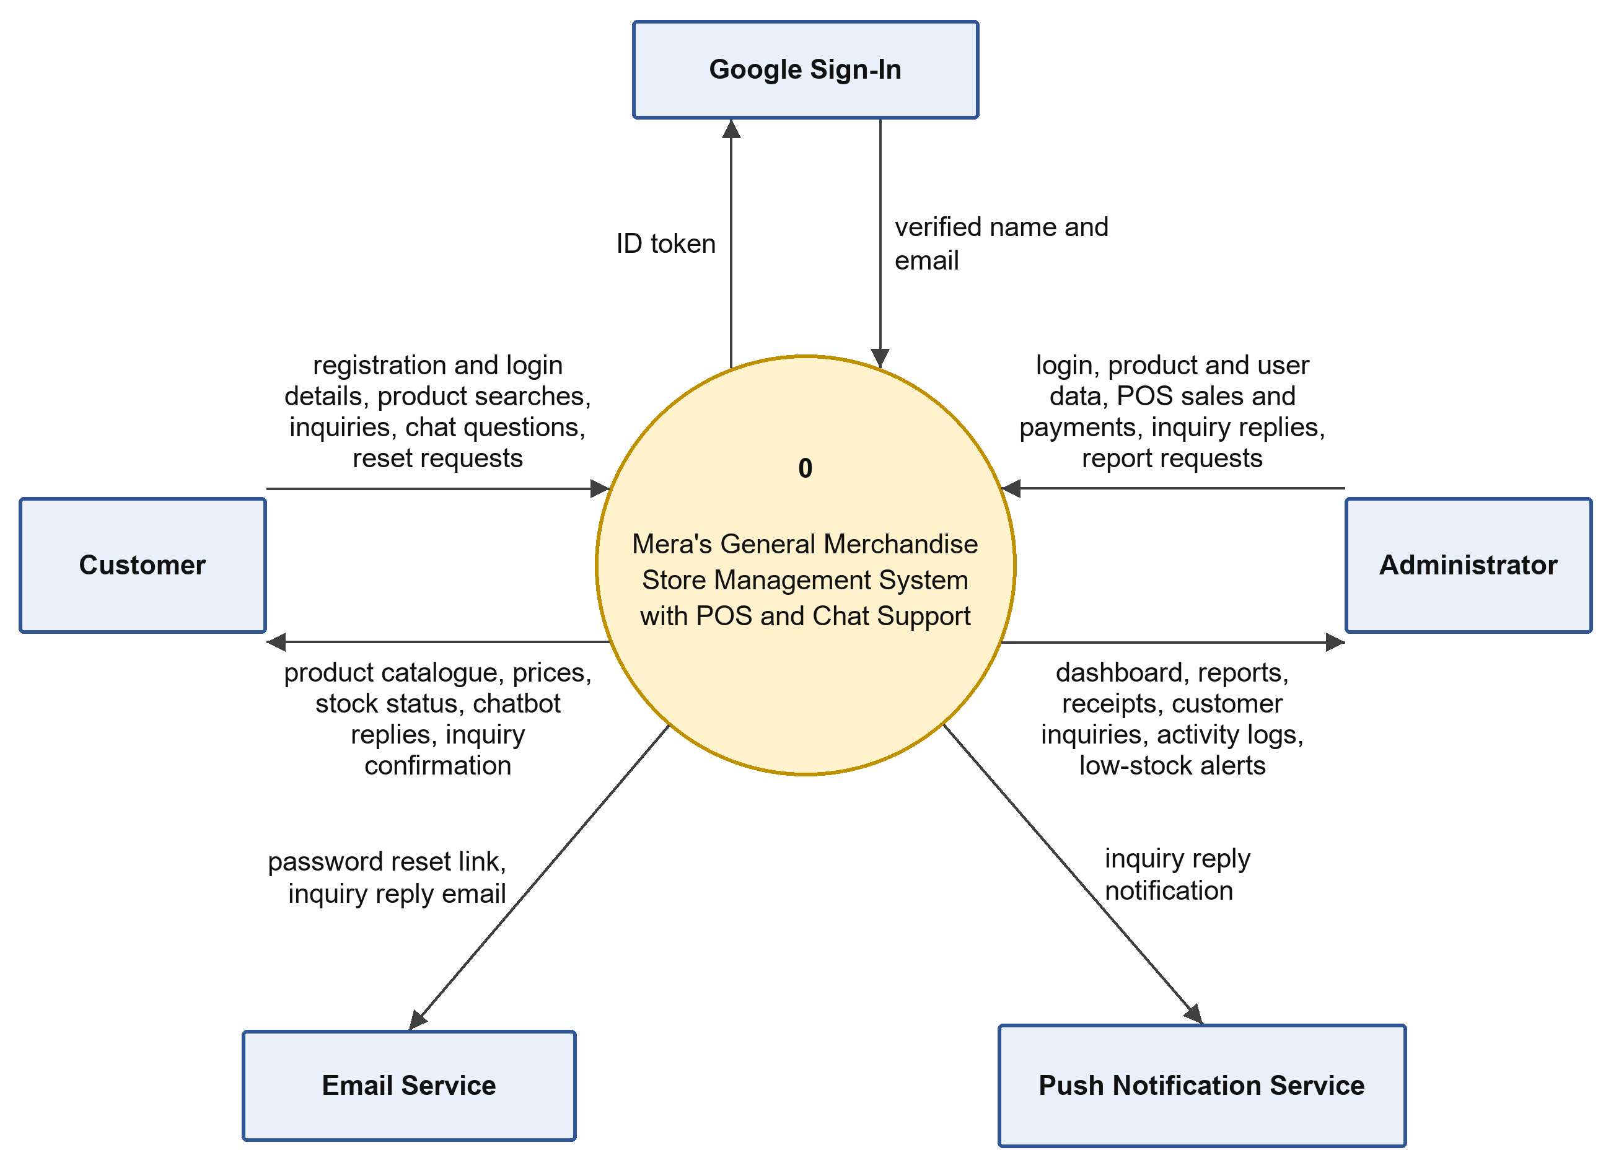
Figure 17. Context Diagram

System Flowchart
The flowcharts in this section show the logic of the system from the first visit of a user to the end of the session. Figure 18 presents the overall flow of the system, while Figures 19 to 28 present the detailed flow of each process. In the flowcharts, the green rounded shapes mark the start and end of a process, the blue rectangles are processes, the yellow diamonds are decisions, the cylinders are the data stores (D1 Users, D2 Products, D3 Inquiries, D4 Messages, D5 Sales, D6 Sale Items, D7 Activity Logs, and D8 Password Reset Tokens), and the orange boxes direct the reader to the flowcharts of the processes that follow.
Figure 18 shows the overall flow of the system. A user opens the MERAS website or the Android application and either registers a new customer account or logs in with an existing account. If the credentials are not valid, an error is shown and the user may retry or recover the password. After a successful login, the system checks the role of the user: an administrator is directed to the admin operations (inventory, POS, inquiries, dashboard, reports, users, activity logs, and settings), while a customer is directed to the customer operations (browsing the products, sending inquiries, and using the chat). The session ends when the user logs out.
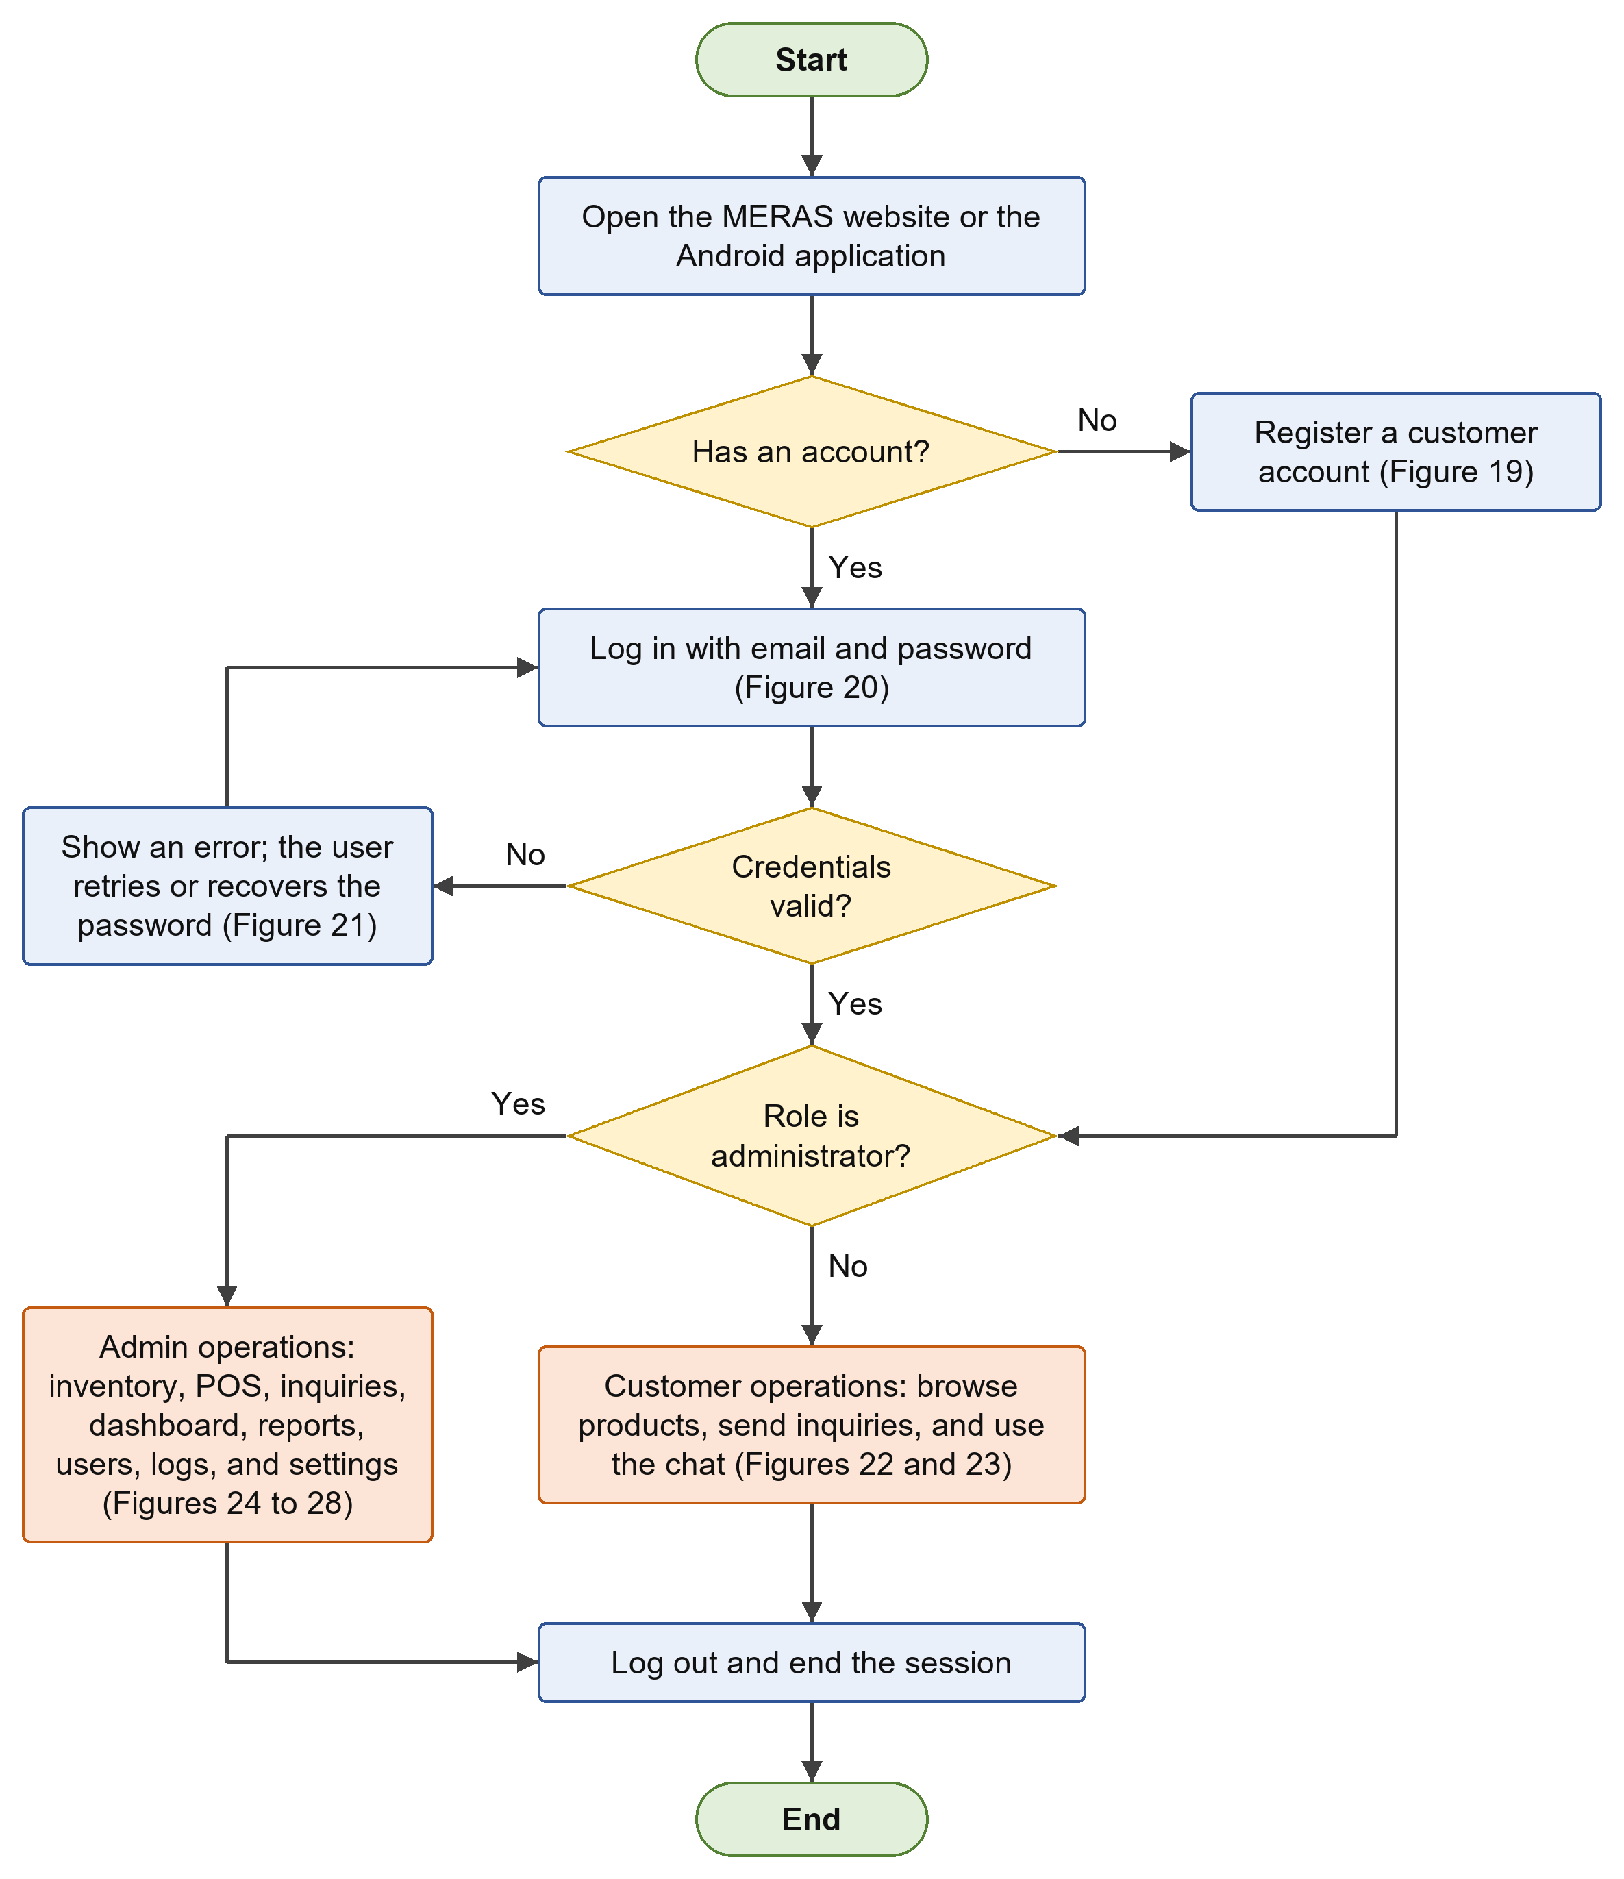
Figure 18. Overall System Flowchart
Figure 19 shows the registration of a customer account. The customer fills in the full name, email address, password, and password confirmation. The system validates the required fields, the email format, the uniqueness of the email address, and the password length. If the data are not valid, the errors are shown and the customer corrects them; otherwise, the account is saved with a hashed password, the customer is logged in automatically, and the registration is recorded in the activity log.
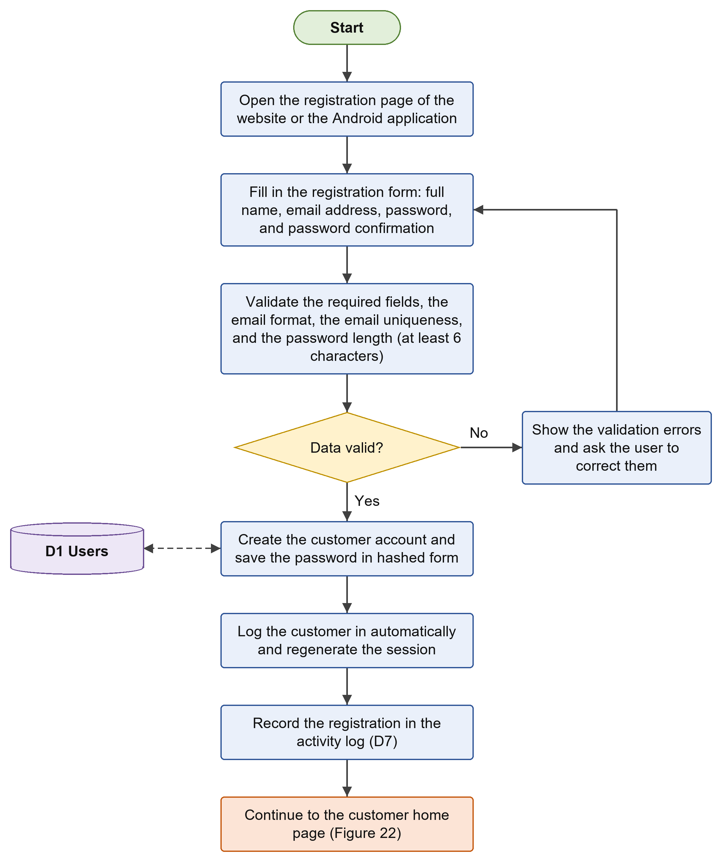
Figure 19. Customer Registration Flowchart
Figure 20 shows the login process. The user enters the email address and password, or chooses to sign in with a Google account, and the system checks the credentials against the user records. An error message is shown when the credentials are not valid, and the user may retry or select Forgot Password. Staff accounts are not allowed to log in inside the mobile application and must use the web portal. For a valid login, the system regenerates the session, records the login in the activity log, and directs an administrator to the admin portal and a customer to the home page.
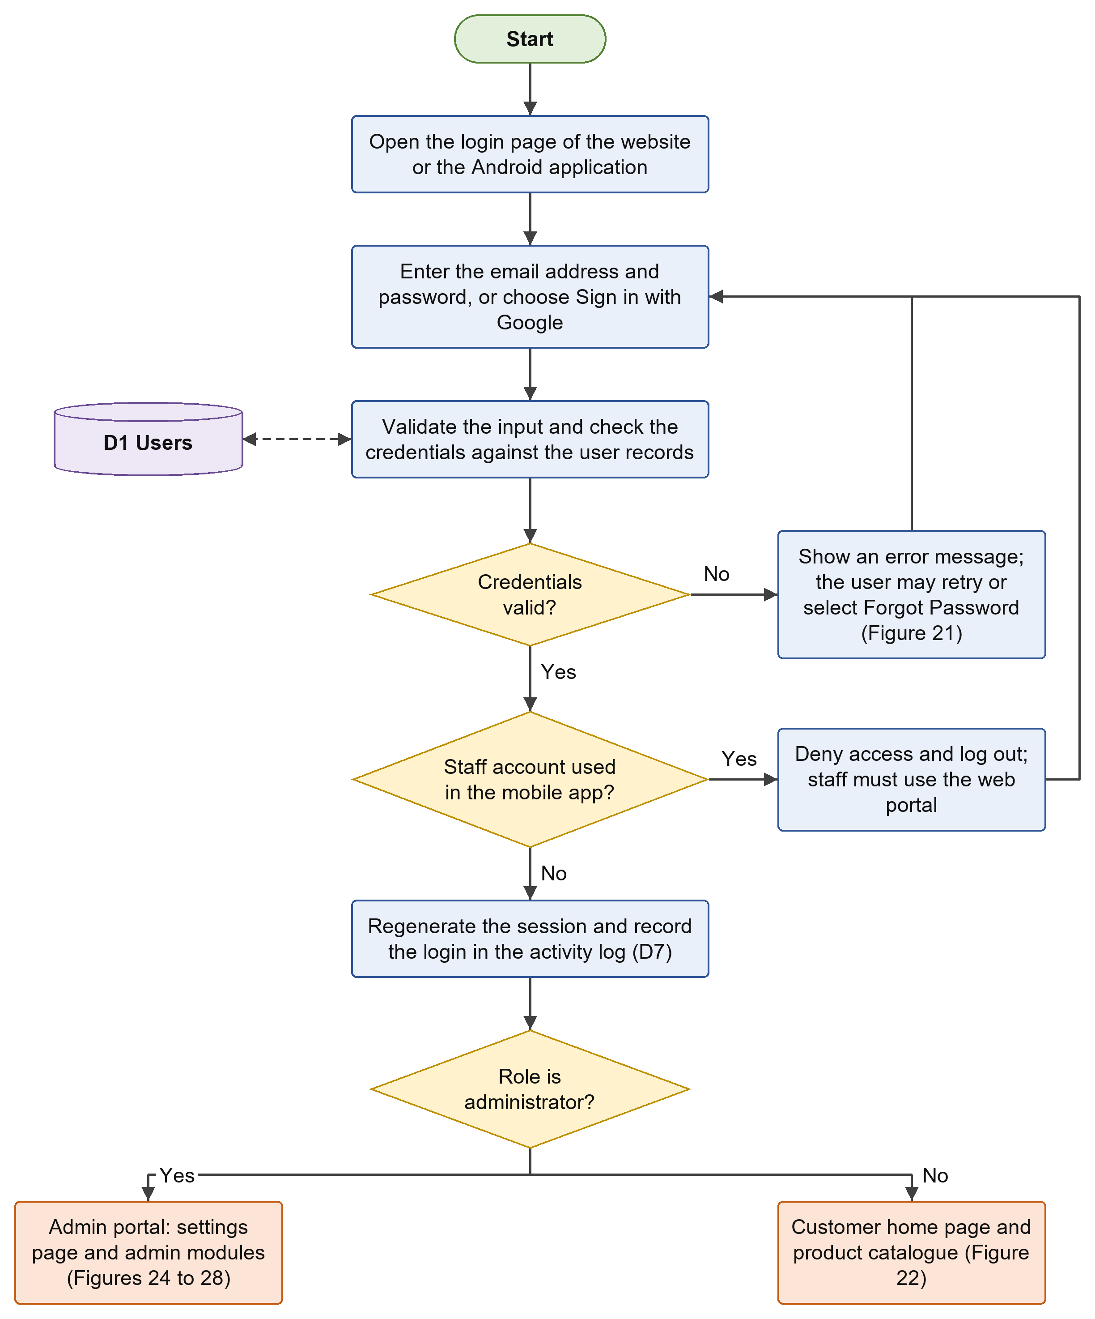
Figure 20. Login Flowchart
Figure 21 shows how a user recovers an account. The user enters the registered email address; if no account is found, a message is shown. Otherwise, the system generates a random token, saves it in hashed form, and sends a reset link to the email address, which is valid for 60 minutes. When the user opens the link and enters a new password, the system verifies the token and its expiry and validates the password. If these are valid, the password hash is updated, the used token is deleted, and the user returns to the login page; if not, the user is asked to request a new link.
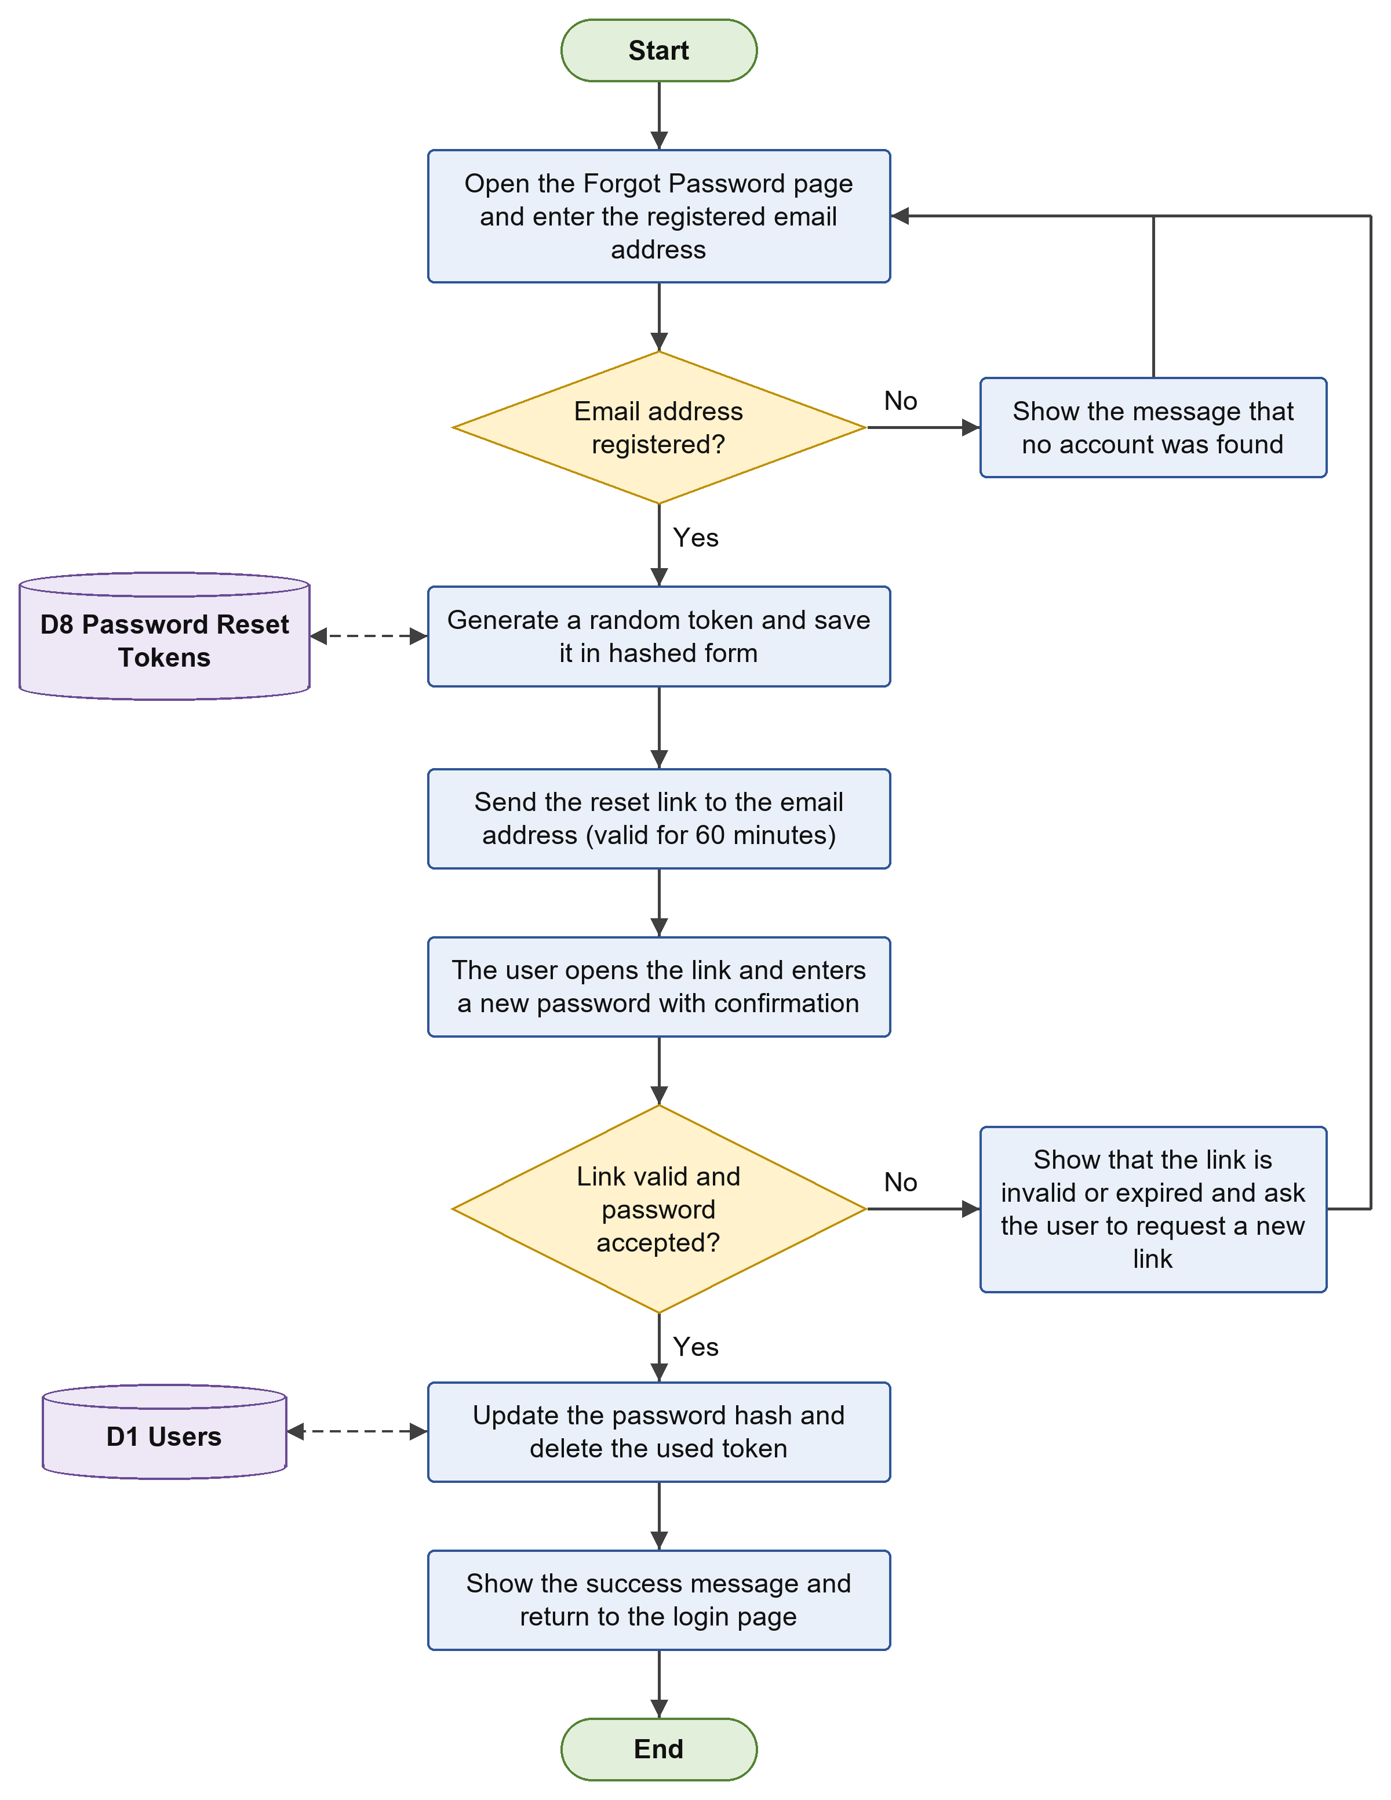
Figure 21. Password Recovery Flowchart
Figure 22 shows how a customer browses the products and sends an inquiry. The home page loads the product catalogue with the prices and the stock status, and the customer can search by name or SKU, filter by category, and switch between the grid view and the table view. A customer who wants to ask about bulk sales, availability, or pickup fills in the inquiry form with the name, email, subject, and message. After the details are validated, the pending inquiry is saved together with the device token of the mobile application, the activity is recorded, and a confirmation is shown. The reply of the store is later received by email or push notification and can be read under Profile or Notifications.
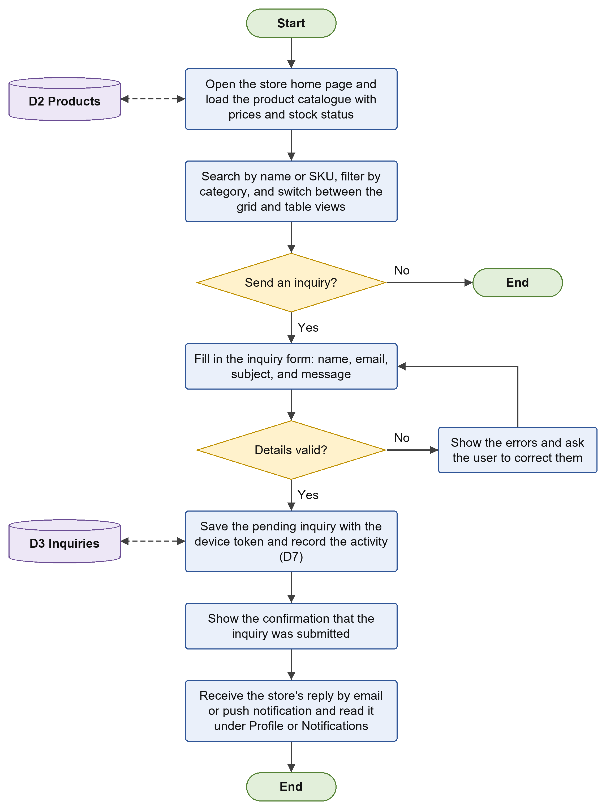
Figure 22. Customer Product Browsing and Inquiry Flowchart
Figure 23 shows the chat support. The customer opens the chat widget and types a question or chooses a quick button such as Store Hours, Location, Products, or Payment. The question is sent to the chatbot, which determines the intent and saves the conversation when the customer is logged in. For product-related questions, the system searches the matching products and their stock. The chatbot returns a reply with suggestions and product cards, and when live help is needed, it offers the Facebook Messenger link. The customer may ask another question until the conversation ends.
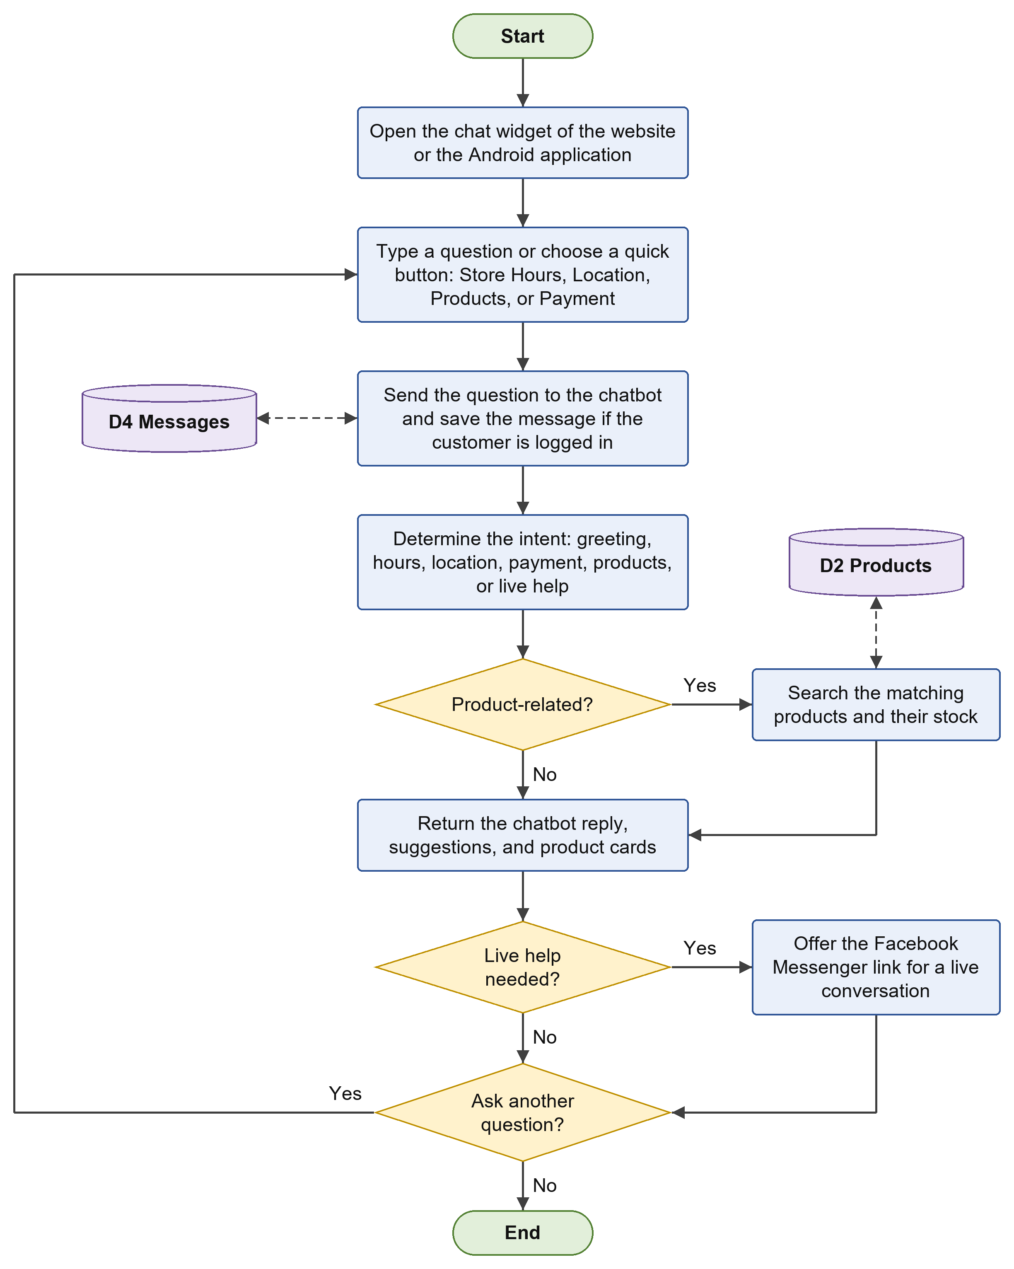
Figure 23. Customer Chat Support Flowchart
Figure 24 shows the management of the inventory. The administrator views and searches the product list and then chooses to add or edit, import, or delete products. In adding or editing, the product form is validated (the name, price, and stock are required, and a bulk price must be given together with the quantity at which it starts) before the product is inserted or updated. In importing, a CSV file is validated and each row is processed, adding new products with generated SKUs and updating existing products by name. In deleting, the administrator confirms the deletion before the record is removed. Every action is recorded in the activity log.
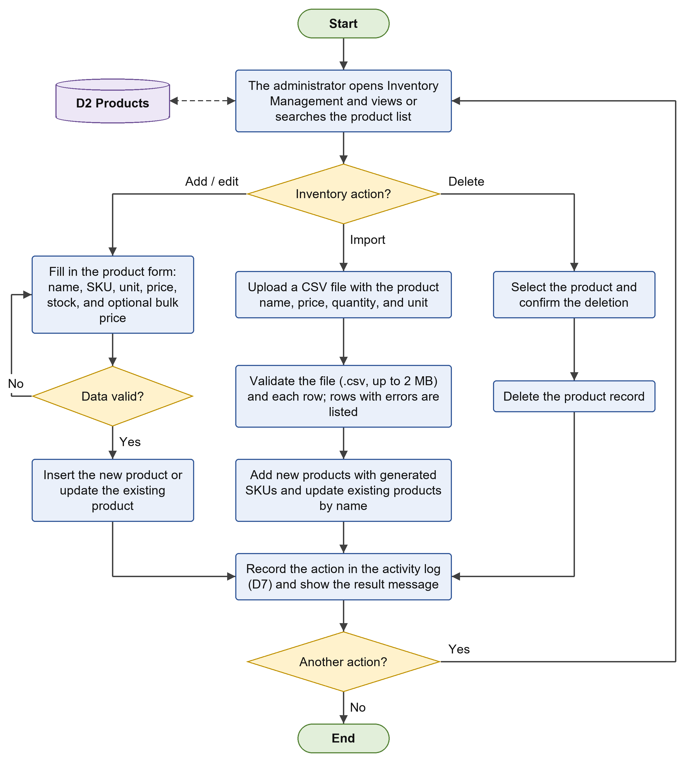
Figure 24. Inventory Management Flowchart
Figure 25 shows the flow of a POS transaction. The administrator searches the catalogue and selects a product and quantity. The system checks the available stock; if the product is out of stock, a message is shown. Otherwise, the item is added to the cart, limited to the available stock, and the bulk price is applied when the bulk quantity is reached. When no more items are to be added, the payment method is selected. For a GCash payment, the GCash QR code is shown and the payment is confirmed; for a cash payment, the cash tendered must be at least equal to the total. The system then saves the sale and its items in one database transaction, decreases the product stock, records the sale in the activity log, computes the change, and shows the printable receipt.
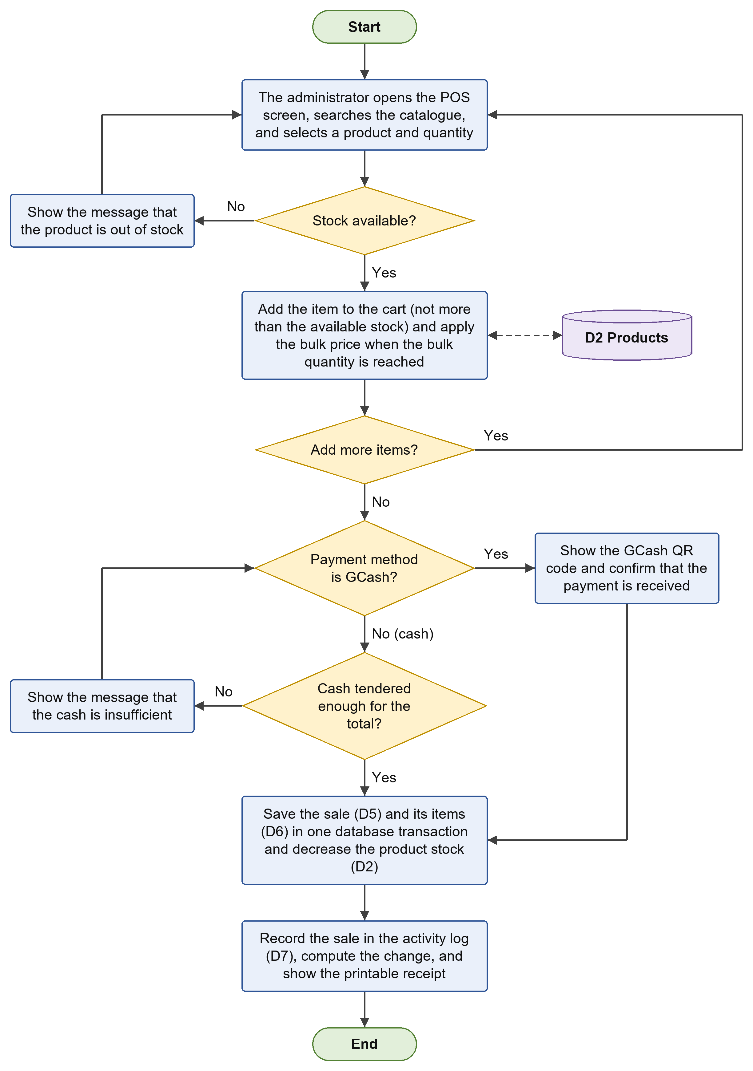
Figure 25. POS Transaction Flowchart
Figure 26 shows how the administrator handles customer inquiries. The inquiry history can be searched and filtered by status (Pending or Responded). The administrator may respond to an inquiry, switch its status between Pending and Responded, or delete it. When a response is saved, the inquiry is marked as Responded together with the responding administrator, and the reply is sent to the customer by email and, when the device token of the customer is saved, by push notification to the Android application. The action is then recorded in the activity log.
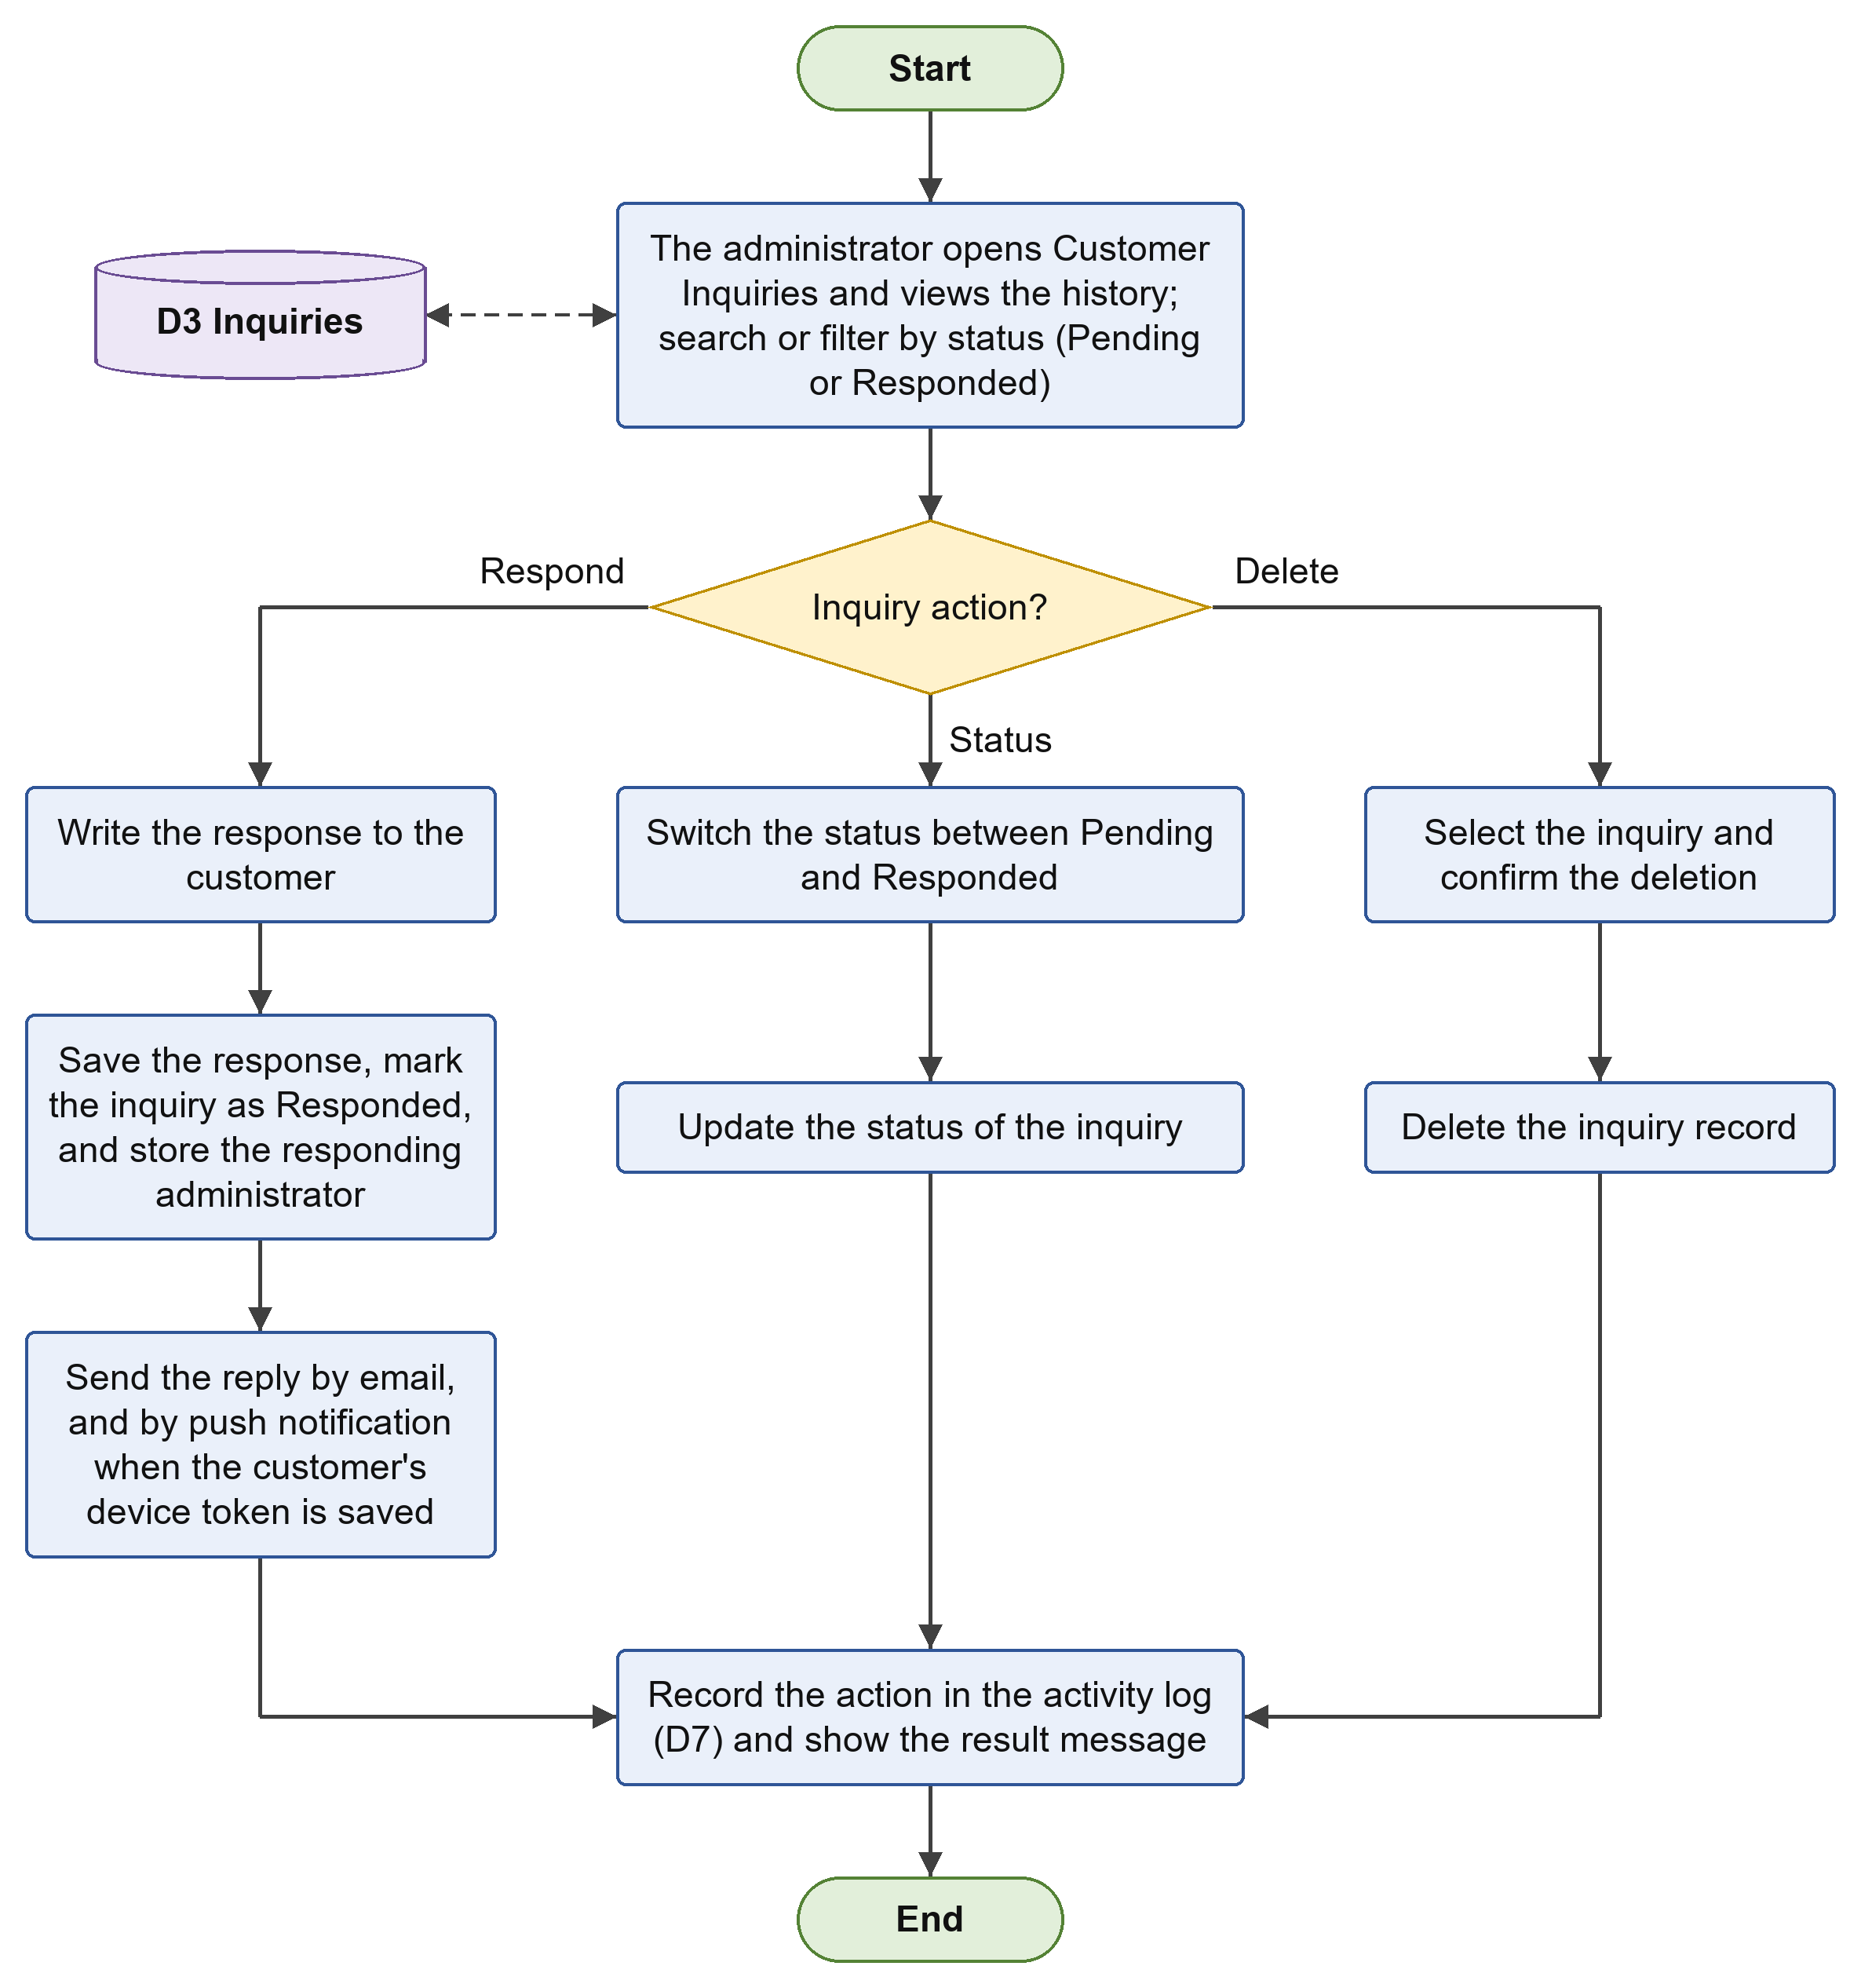
Figure 26. Inquiry Management Flowchart
Figure 27 shows the flow of the dashboard and the sales reports. The dashboard reads the daily, weekly, and monthly sales, the total revenue, and the number of products, and displays them with the seven-day sales trend, the top-selling products, the stock by category, the recent sales, and the low-stock alerts for products with a stock of less than five. In the sales reports, the administrator selects the period (weekly, monthly, yearly, or all records), and the system computes and displays the revenue, the number of transactions, the average sale, the top-selling products, and the recent transactions, which can be downloaded as a CSV file or printed.
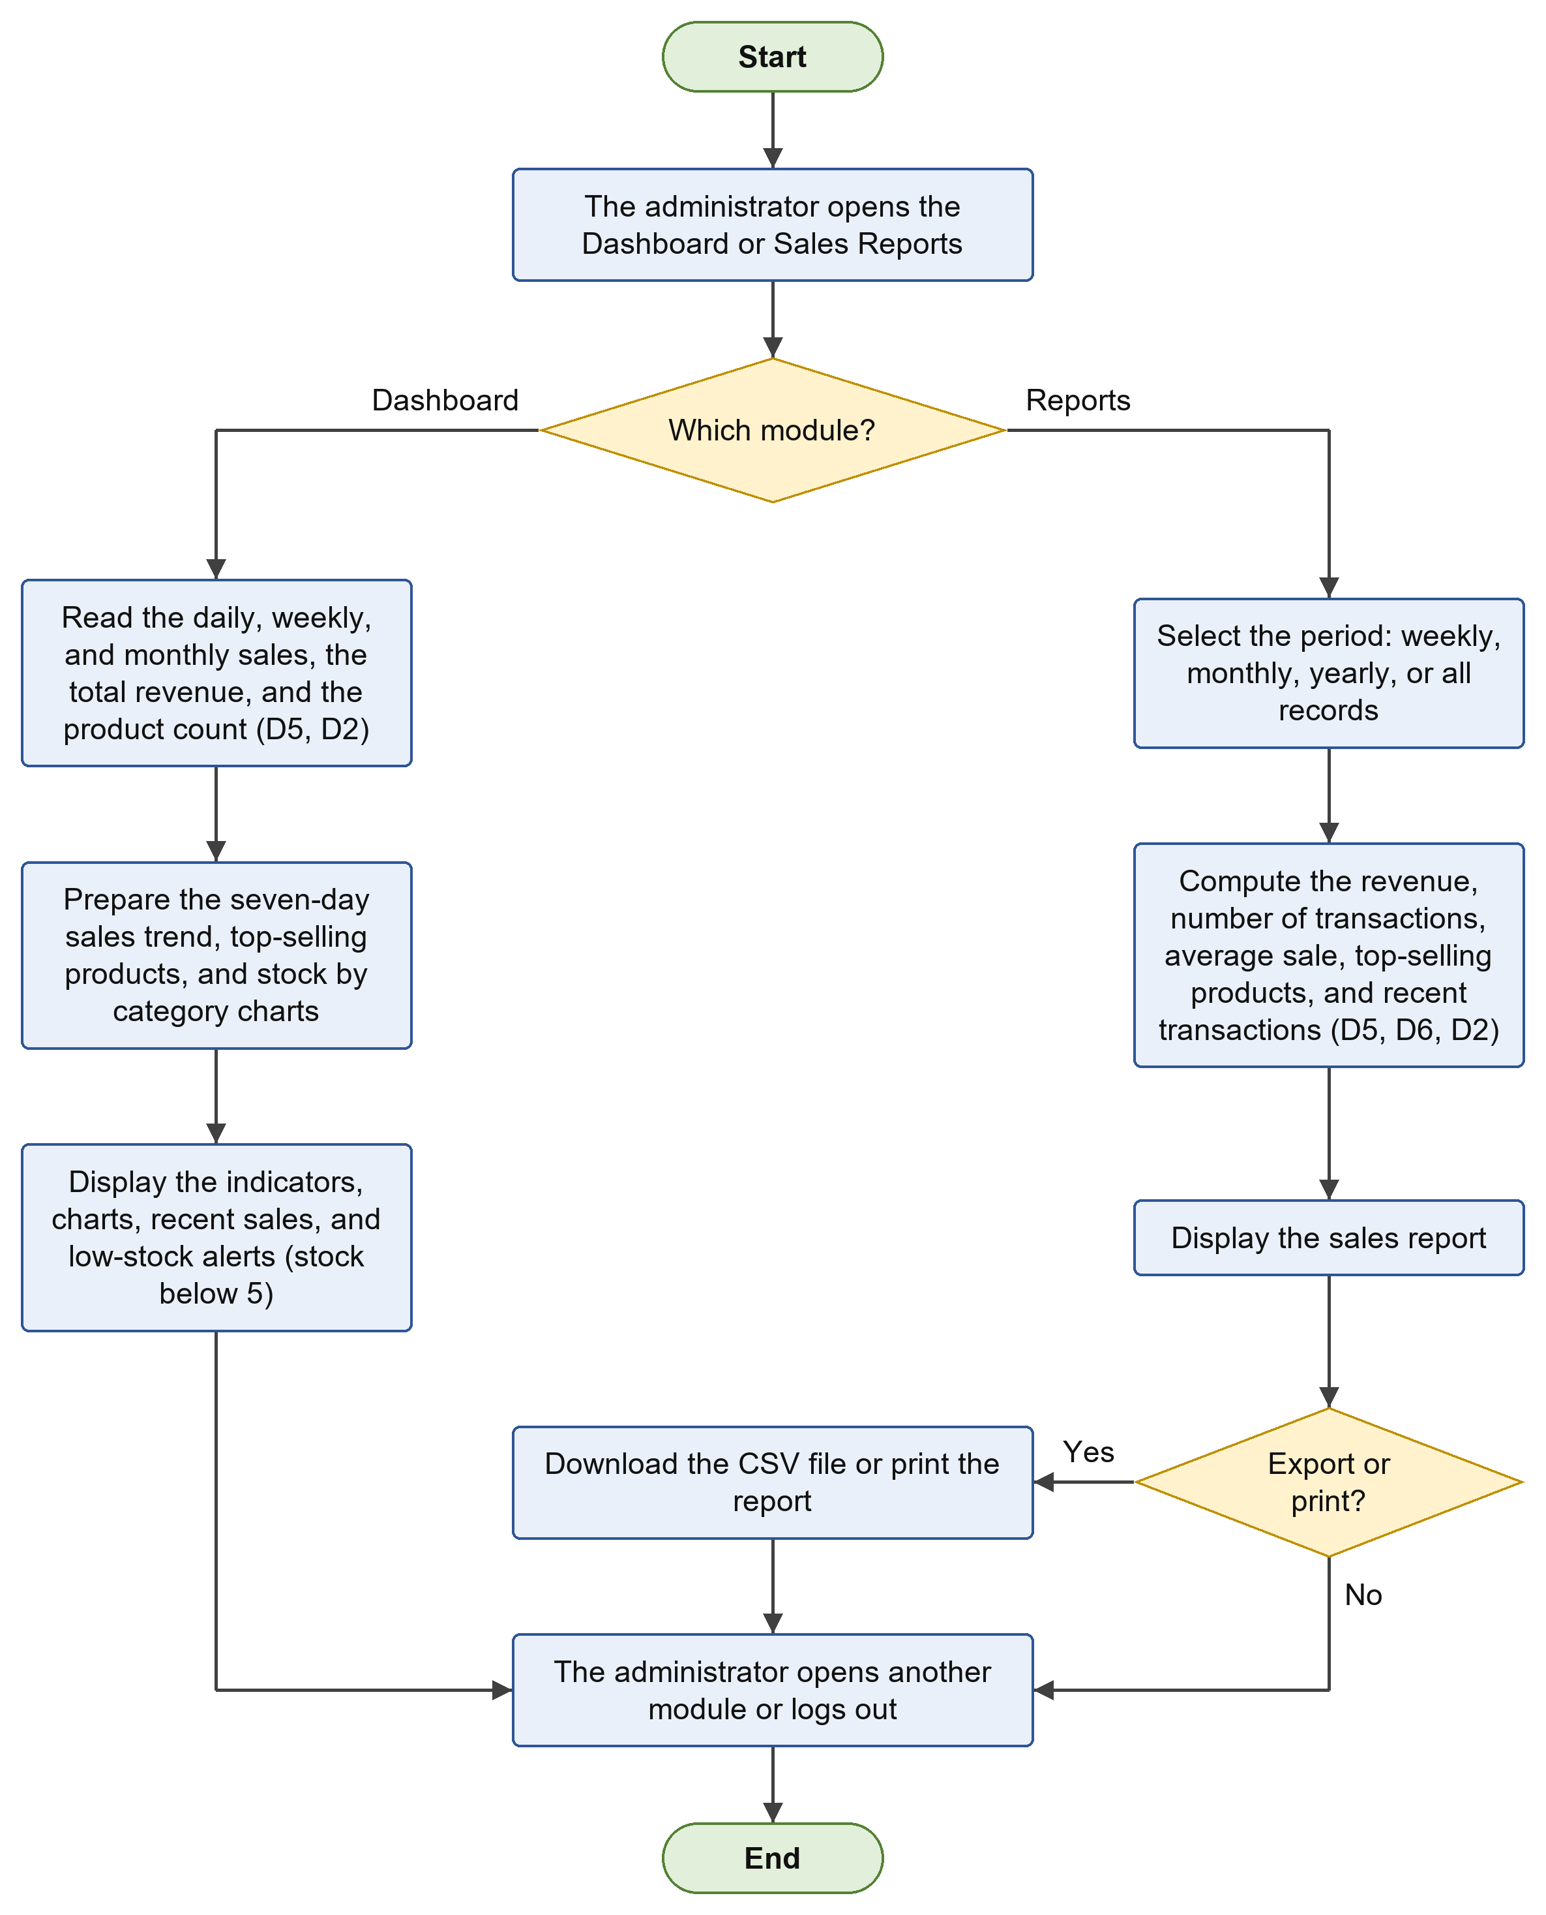
Figure 27. Dashboard and Sales Reports Flowchart
Figure 28 shows the flow of the user accounts, the activity logs, and the system settings. In the user accounts, the administrator views and searches the accounts and creates an account, changes a role, or deletes an account; the system allows only one administrator and does not allow the administrator to change the role of or delete the own account. The activity logs can be filtered by role or searched by user, action, details, or IP address. In the system settings, the administrator views the system overview, exports and backs up the records to a CSV file, changes the administrator password, or runs a maintenance action such as seeding demo products, resetting the sales history, or clearing the chat history. Changes are recorded in the activity log.
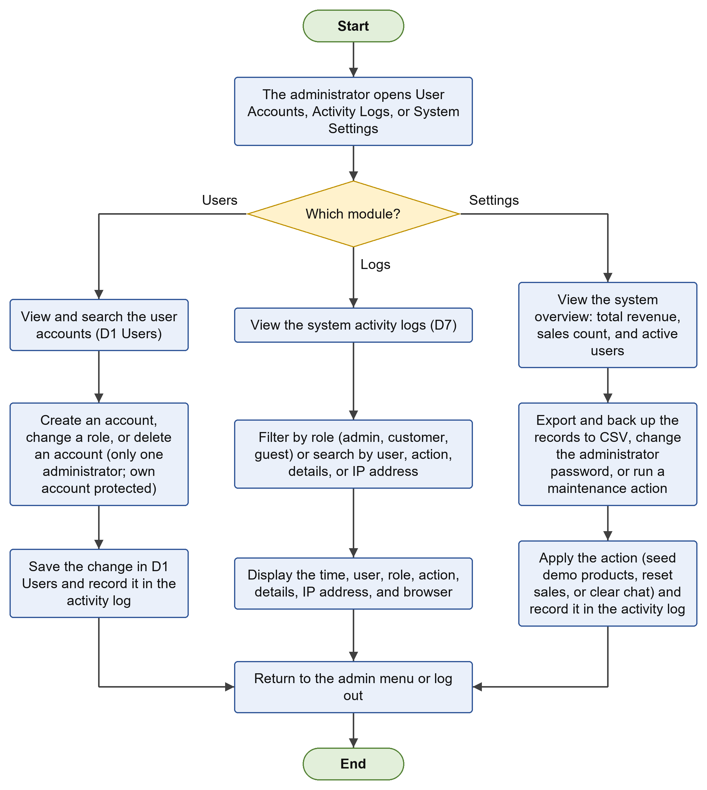
Figure 28. User Accounts, Activity Logs, and System Settings Flowchart

Entity Relationship Diagram
Figure 29 shows the entity relationship diagram of the MySQL database, and Table 5 describes each table. The design links users, products, sales, sale items, inquiries, messages, activity logs, and password reset tokens so that every transaction, communication, and user action can be traced and reported accurately.
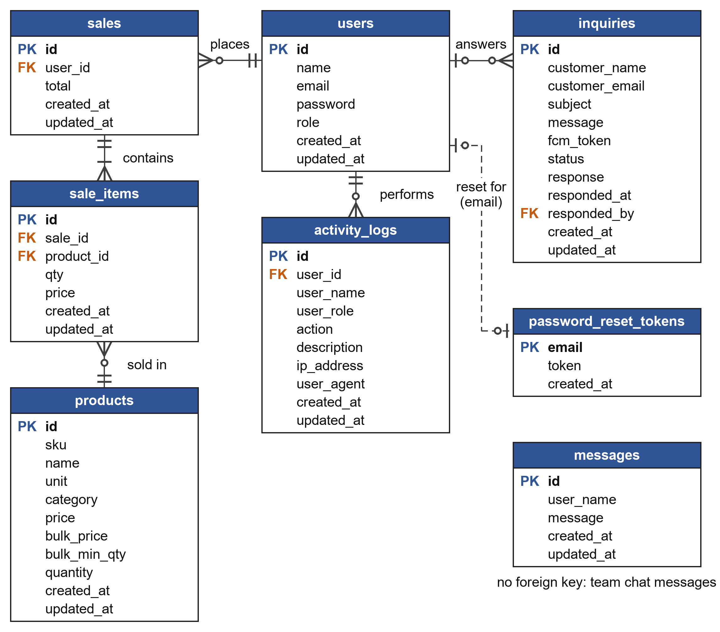
Figure 29. Entity Relationship Diagram
Table 5. Description of Database Tables
Table | Description
users | Stores account information (name, email address, hashed password) and the role of each account (administrator or customer).
products | Stores product details (SKU, name, unit, category), retail and bulk prices, the bulk quantity, and the stock quantities used for low-stock alerts.
sales | Stores each completed sales transaction, including the date, the total amount, and the user who processed it.
sale_items | Stores the products, quantities, and prices included in each sale.
inquiries | Stores customer inquiries (name, email address, subject, message), the device token for push notification, the status (pending or responded), the response, and who responded and when.
messages | Stores the messages of the team conversation in the chat support.
activity_logs | Stores the actions of administrators, customers, and guests with the user, role, details, IP address, and browser, as an audit trail.
password_reset_tokens | Stores the hashed password reset tokens with the email address and the time they were created, which determines their expiry.

Development Tools and Technologies
Table 6 lists the software and services that will be used to develop the system, and Table 7 lists the hardware requirements.
Table 6. Software Tools and Technologies
Component | Tool / Technology | Purpose
Web front-end | HTML5, CSS3, JavaScript | Interface of the admin portal and POS
Server-side | PHP | Business logic and application programming interface
Database | MySQL | Storage of all system data
Mobile application | Android Studio | Development of the Android application
Local server | XAMPP (Apache, MySQL) | Local development and testing
Code editor | Visual Studio Code | Writing and editing code
Version control | Git and GitHub | Code management and collaboration
Design tools | draw.io, Figma | Diagrams and interface layouts
Email and SMS | SMTP email service, SMS gateway | Email verification, password recovery, OTP
Online payment | GCash payment gateway | Cashless payments and digital receipts
Testing | Web browsers, Android emulator and device, Postman | Testing of web pages, mobile application, and API

Table 7. Hardware Requirements
Hardware | Specification
Development computer | Laptop or desktop computer with at least an Intel Core i5 (or equivalent) processor, 8 GB RAM, and 256 GB storage
Android device | Smartphone running Android 8.0 or higher for testing and use of the mobile application
Store computer (POS) | Desktop or laptop computer with a modern web browser
Receipt printer | Thermal or standard printer for printing receipts and reports
Network | Stable internet connection for the web portal, mobile application, email and SMS, and GCash payment

Testing Procedures
The system will be tested at four levels. Unit testing will check each function or module, such as login, product entry, and total computation, individually. Integration testing will check that connected modules work together, for example that a completed sale updates the inventory and appears in the reports. System testing will check the whole system, including the web portal, the mobile application, and the connection to the email, SMS, and GCash services. User acceptance testing will be done by the store owner, employees, and sample customers to confirm that the system meets their needs. Errors found at each level will be documented and corrected, and the affected features will be tested again. Table 8 shows sample test cases.
Table 8. Sample Test Cases
No. | Test Case | Expected Result
TC-01 | Register a customer using a valid email address | Account is created and a verification email is sent; login is allowed only after verification
TC-02 | Log in using a wrong password | Access is denied and an error message is displayed
TC-03 | Request a password reset using a registered email | Reset link or OTP is sent and expires after use or after the allowed time
TC-04 | Add a product with complete details | Product is saved and shown in the inventory list
TC-05 | Process a POS sale with items in stock | Total is computed correctly, receipt is generated, and stock is deducted
TC-06 | Enter a quantity greater than the available stock | System rejects the entry and informs the user
TC-07 | Reduce a product to its reorder level | Low-stock alert appears on the dashboard and in the merchant application
TC-08 | Pay through GCash (successful and failed payment) | Successful payment is recorded and a digital receipt is generated; failed payment does not mark the order as paid
TC-09 | Generate a daily sales report and export it to CSV | Report totals match the recorded sales and the CSV file is downloaded
TC-10 | Send a chat message from a customer | Message appears to the administrator or merchant, and the reply appears to the customer

Respondents of the Study
The respondents will be selected through purposive sampling, since only those who have knowledge of, or direct experience with, the store operations or information systems can properly evaluate the system. The IT experts will evaluate the quality of the system based on ISO/IEC 25010, while the store owner, employees, and customers will evaluate its usability. Table 9 shows the distribution of the respondents.
Table 9. Distribution of Respondents
Respondent Group | Basis of Evaluation | Number
Store owner and merchants | Usability | 2
Store employees (cashiers and staff) | Usability | 5
Customers | Usability | 30
IT experts | ISO/IEC 25010 software quality | 5
Total |  | 42

Research Instruments
The researchers will use two structured questionnaires. The first is based on the ISO/IEC 25010:2011 Systems and Software Quality Model and measures functionality, usability, reliability, efficiency, security, and maintainability. The second is a usability questionnaire patterned after the USE Questionnaire of Lund (2001), which measures usefulness, satisfaction, and ease of use and learning. Both instruments use a five-point Likert scale. Table 10 shows the criteria measured, and Table 11 shows the rating scale and its interpretation.
Table 10. Criteria Measured by the Instruments
Criterion | What is Evaluated
Functionality | Whether the features (POS, inventory, reports, chat, orders, GCash payment) are complete and work correctly
Usability (ISO/IEC 25010) | Whether the system is easy to understand, learn, and operate
Reliability | Whether the system operates consistently and keeps records correctly
Efficiency | Whether the system responds quickly and uses resources appropriately
Security | Whether accounts, data, and payment processing are protected from unauthorized access
Maintainability | Whether the system can be corrected and updated easily
Usefulness | Whether the system helps users complete store tasks and saves time and effort
Satisfaction | Whether users are pleased with using the system
Ease of Use and Learning | Whether the system is simple to operate and quick to learn

Table 11. Five-Point Likert Scale and Interpretation
Scale | Range | Verbal Interpretation
5 | 4.21 – 5.00 | Strongly Agree (Excellent)
4 | 3.41 – 4.20 | Agree (Very Good)
3 | 2.61 – 3.40 | Neutral (Good)
2 | 1.81 – 2.60 | Disagree (Fair)
1 | 1.00 – 1.80 | Strongly Disagree (Poor)

Evaluation Procedure
After the system has been developed and tested by the researchers, the evaluation will proceed as follows: (1) the researchers will secure permission from the store owner and the concerned faculty to conduct the evaluation; (2) the respondents will be oriented on the purpose of the study and how to use the system; (3) the respondents will use the web portal or the mobile application according to their roles; (4) the questionnaires will be distributed and answered after using the system; (5) the answered questionnaires will be collected, checked for completeness, and tallied; and (6) the results will be analyzed and interpreted.

Statistical Treatment of Data
The responses will be tallied and analyzed using the following statistical tools. The weighted mean will be used to determine the level of quality and usability of the system, computed as:
WM = Σ(f × x) / N
where WM is the weighted mean, f is the frequency of responses for each rating, x is the value of the rating, and N is the total number of responses. The frequency and percentage will be used to describe the distribution of the respondents, computed as:
P = (f / N) × 100
where P is the percentage, f is the frequency, and N is the total number of respondents. The computed weighted means will be interpreted using the scale in Table 11.

Ethical Considerations
The researchers will follow ethical standards throughout the study. Participation of the respondents will be voluntary, and each respondent will be informed of the purpose of the study and of their right to decline or withdraw at any time. Personal information and responses will be kept confidential, used only for academic purposes, and handled in accordance with the Data Privacy Act of 2012 (Republic Act No. 10173). The permission of the store owner will be secured before the system is tested with actual store data. Within the system itself, user passwords will be stored in hashed form, access will be limited by user role, and payment details will be processed only through the GCash payment gateway and will not be stored by the system. The researchers will also acknowledge all sources used in the study and report the results honestly.
CHAPTER IV
PRESENTATION, ANALYSIS, AND INTERPRETATION OF RESULTS
NOTE TO THE RESEARCHERS (delete before submission): No survey results have been collected yet. Every value highlighted in yellow in Chapters IV and V (respondent counts, mean scores, verbal interpretations and the findings that cite them) is SAMPLE DATA that only shows the format. Replace each value with the weighted means computed from the actual questionnaires and revise the narrative to match. Each "INSERT SCREENSHOT" box marks where a screenshot of the running system belongs.

After the system was developed and tested, it was evaluated by the respondents described in Chapter III. This chapter presents the results of the evaluation in the following order: the profile of the respondents; the functionality of the administrator dashboard, the administrator management functions, the customer website, and the Android mobile application; the software quality of the system based on ISO/IEC 25010; and the usability of the system. The responses were tallied, the weighted mean of each criterion was computed, and the results were interpreted using the five-point scale in Table 11. Criteria that a respondent did not use were marked N/A and were excluded from the computation.

Profile of the Respondents
Table 12 shows the distribution of the 42 respondents who evaluated the system.
Table 12. Profile of the Respondents
RESPONDENT GROUP | FREQUENCY | PERCENTAGE | BASIS OF EVALUATION
Store owner and merchants | 2 | 4.76% | Usability
Store employees (cashiers and staff) | 5 | 11.90% | Usability
Customers | 30 | 71.43% | Usability
IT experts | 5 | 11.90% | ISO/IEC 25010
TOTAL | 42 | 100.00%

Table 12 shows that the customers formed the largest group with 30 respondents (71.43%), followed by the store employees with 5 respondents (11.90%), the IT experts with 5 respondents (11.90%), and the store owner and merchants with 2 respondents (4.76%). The large share of customers means that the system was evaluated mainly from the point of view of its intended end users, while the store owner, the store employees, and the IT experts provided the viewpoints of those who operate the system and who assess its technical quality.

Functionality of the System
The functionality of the system was evaluated according to the interface of each type of user. The administrator portal was evaluated by the 12 respondents who used the administrator portal (the store owner and merchants, the store employees, and the IT experts), while the customer website and the Android mobile application were evaluated by the 35 respondents who used the customer website and the mobile application (the customers and the IT experts).

Administrator Dashboard
Table 13 presents the functionality of the administrator dashboard as rated by the 12 respondents who used the administrator portal (the store owner and merchants, the store employees, and the IT experts).
Table 13. Functionality of the Administrator Dashboard
CRITERIA | MEAN | VERBAL INTERPRETATION
How functional is our system in terms of displaying the Daily Sales? | 4.58 | Strongly Agree (Excellent)
How functional is our system in terms of displaying the Weekly Sales? | 4.50 | Strongly Agree (Excellent)
How functional is our system in terms of displaying the Monthly Sales? | 4.50 | Strongly Agree (Excellent)
How functional is our system in terms of displaying the Total Revenue? | 4.67 | Strongly Agree (Excellent)
How functional is our system in terms of displaying the Total Number of Products? | 4.58 | Strongly Agree (Excellent)
How functional is our system in terms of displaying the Low Stock Count? | 4.42 | Strongly Agree (Excellent)
How functional is our system in terms of displaying the Recent Sales? | 4.50 | Strongly Agree (Excellent)
How functional is our system in terms of displaying the Low Stock Alerts? | 4.75 | Strongly Agree (Excellent)
How functional is our system in terms of displaying the Seven-Day Sales Trend chart? | 4.33 | Strongly Agree (Excellent)
How functional is our system in terms of displaying the Top-Selling Products and Stock by Category charts? | 4.42 | Strongly Agree (Excellent)
TOTAL WEIGHTED MEAN | 4.53 | Strongly Agree (Excellent)

Table 13 shows that the system was rated Strongly Agree (Excellent) across all criteria by the respondents, with mean scores ranging from 4.33 to 4.75. Specifically, the system obtained 4.58 for displaying the Daily Sales, 4.50 for displaying the Weekly Sales, 4.50 for displaying the Monthly Sales, 4.67 for displaying the Total Revenue, 4.58 for displaying the Total Number of Products, 4.42 for displaying the Low Stock Count, 4.50 for displaying the Recent Sales, 4.75 for displaying the Low Stock Alerts, 4.33 for displaying the Seven-Day Sales Trend chart, and 4.42 for displaying the Top-Selling Products and Stock by Category charts. With a total weighted mean of 4.53, the overall interpretation is Strongly Agree (Excellent), which indicates that the dashboard presents the sales, revenue, product, and low-stock information of the store clearly and accurately, giving the store owner a quick view of the daily operation of the business.
[ INSERT SCREENSHOT HERE ]
Capture: Dashboard Overview page (/dashboard, logged in as administrator)
Figure 30. Administrator Dashboard
Figure 30 shows the dashboard of the administrator portal. It displays the Daily Sales, Weekly Sales, Monthly Sales, Total Revenue, the number of Products, and the Low Stock count, together with charts for the seven-day sales trend, the top-selling products, and the stock by category. The Recent Sales table lists the sale ID, cashier, timestamp, and total amount, the Low Stock Alerts list shows the products that need to be restocked, and the Quick Actions give shortcuts to POS Checkout, Inventory, Support Chat, and Sales Reports. This section helps the administrator monitor the sales and the stock of the store at a glance.

Administrator Management Functions
Table 14 presents the functionality of the management functions of the administrator portal as rated by the 12 respondents who used the administrator portal (the store owner and merchants, the store employees, and the IT experts).
Table 14. Functionality of the Administrator Management Functions
CRITERIA | MEAN | VERBAL INTERPRETATION
How functional is our system in terms of managing product records and inventory? | 4.67 | Strongly Agree (Excellent)
How functional is our system in terms of importing products from a CSV file? | 4.33 | Strongly Agree (Excellent)
How functional is our system in terms of setting bulk prices and units of measure for products? | 4.42 | Strongly Agree (Excellent)
How functional is our system in terms of processing POS sales through the cart and checkout? | 4.75 | Strongly Agree (Excellent)
How functional is our system in terms of accepting cash and GCash payments and computing the change? | 4.58 | Strongly Agree (Excellent)
How functional is our system in terms of generating and printing receipts? | 4.67 | Strongly Agree (Excellent)
How functional is our system in terms of deducting sold quantities from the inventory automatically? | 4.75 | Strongly Agree (Excellent)
How functional is our system in terms of generating weekly, monthly, and yearly sales reports and exporting them to CSV? | 4.58 | Strongly Agree (Excellent)
How functional is our system in terms of viewing top-selling products and recent transactions? | 4.50 | Strongly Agree (Excellent)
How functional is our system in terms of managing customer inquiries and sending email responses? | 4.50 | Strongly Agree (Excellent)
How functional is our system in terms of replying to customers through the support chat? | 4.42 | Strongly Agree (Excellent)
How functional is our system in terms of managing user accounts and roles? | 4.50 | Strongly Agree (Excellent)
How functional is our system in terms of monitoring activity logs? | 4.42 | Strongly Agree (Excellent)
How functional is our system in terms of managing system settings and security? | 4.50 | Strongly Agree (Excellent)
TOTAL WEIGHTED MEAN | 4.54 | Strongly Agree (Excellent)

Table 14 shows that the system was rated Strongly Agree (Excellent) across all criteria by the respondents, with mean scores ranging from 4.33 to 4.75. Specifically, the system obtained 4.67 for managing product records and inventory, 4.33 for importing products from a CSV file, 4.42 for setting bulk prices and units of measure for products, 4.75 for processing POS sales through the cart and checkout, 4.58 for accepting cash and GCash payments and computing the change, 4.67 for generating and printing receipts, 4.75 for deducting sold quantities from the inventory automatically, 4.58 for generating weekly, monthly, and yearly sales reports and exporting them to CSV, 4.50 for viewing top-selling products and recent transactions, 4.50 for managing customer inquiries and sending email responses, 4.42 for replying to customers through the support chat, 4.50 for managing user accounts and roles, 4.42 for monitoring activity logs, and 4.50 for managing system settings and security. With a total weighted mean of 4.54, the overall interpretation is Strongly Agree (Excellent), which indicates that the administrator portal effectively supports the whole workflow of the store, from the management of products and inventory and the processing of sales, to the generation of reports, the handling of customer inquiries, and the control of user accounts, activity logs, and system settings.
[ INSERT SCREENSHOT HERE ]
Capture: Inventory Management page, Product List (/products)
Figure 31. Inventory Management
Figure 31 shows the part of the system where the administrator manages the Product List. Each product is displayed with its name, category, stock quantity, and price, together with the actions for editing or deleting the product, and a search box allows a product to be located quickly. This section helps the administrator keep the product records, prices, and stock quantities of the store accurate and up to date.
[ INSERT SCREENSHOT HERE ]
Capture: Add Product form and Import Products from CSV window (/products)
Figure 32. Adding and Editing Products, Bulk Pricing, and CSV Import
Figure 32 shows the form used to add or edit a product, with fields for the Product Name, SKU, Price (PHP), Stock Qty, Unit (such as pieces, reams, packs, boxes, and kilograms), Bulk Price (PHP), and the quantity at which the bulk price starts. A separate window, Import Products from CSV, allows many products to be loaded at once. This section speeds up the encoding of the inventory and supports both retail and wholesale pricing.
[ INSERT SCREENSHOT HERE ]
Capture: Point of Sale (POS) page with items in the cart (/pos)
Figure 33. Point of Sale: Product Catalog and Cart Summary
Figure 33 shows the Point of Sale screen. The Product Catalog lists the products with their category, stock, and price and can be searched, and a product is added to the Cart Summary with one action. In the cart, the cashier can increase or decrease quantities, remove an item, or clear the cart, while products without stock are marked Unavailable and the price changes to the bulk price once the bulk quantity is reached. This section helps the cashier prepare a sale quickly and with the correct total.
[ INSERT SCREENSHOT HERE ]
Capture: Cash Tendered field, GCash QR Code window, and Receipt Ready window (/pos)
Figure 34. Point of Sale: Cash and GCash Payment and Receipt
Figure 34 shows the payment part of the Point of Sale. For a cash payment, the cashier enters the Cash Tendered (PHP) and completes the checkout, and the system computes the change. For a GCash payment, the GCash QR Code is displayed and the cashier confirms the payment. After the checkout, the Receipt Ready window shows the items, quantities, and totals with the option to Print Receipt, and the sold quantities are deducted from the inventory automatically. This section ensures that every sale is recorded, receipted, and reflected in the stock.
[ INSERT SCREENSHOT HERE ]
Capture: Sales Reports page, showing a period and the Print / CSV export options (/reports)
Figure 35. Sales Reports
Figure 35 shows the part of the system where the administrator generates sales reports. The report presents the Total Revenue, the number of Transactions, and the Average Sale for the selected period (weekly, monthly, yearly, or all records), the Top Selling Products with their category, units sold, and revenue, and the Recent Transactions with the sale ID, cashier, date and time, and total. The report can be printed or exported to a CSV file. This section helps the store owner evaluate sales performance without computing the figures by hand.
[ INSERT SCREENSHOT HERE ]
Capture: Customer Inquiries page with Inquiry History (/inquiries)
Figure 36. Customer Inquiries
Figure 36 shows the part of the system where the administrator manages the inquiries sent by customers. The inquiries can be searched and filtered by status (All inquiries, Pending, or Responded), and the Inquiry History lists the subject and message of each inquiry. The administrator writes a response and selects Save Response, which sends the reply to the customer by email and by notification, and may also mark an inquiry as Responded or Pending or delete it. This section ensures that customer questions are answered and documented.
[ INSERT SCREENSHOT HERE ]
Capture: Customer Support Chat page (/chat)
Figure 37. Customer Support Chat
Figure 37 shows the support chat workspace. The Customer Questions panel lists the latest website inquiries with their pending or responded status and provides a reply template, while the Team Conversation allows the store personnel to exchange messages. Frequently asked topics such as Store Hours, Location, Products, and Payment, and quick replies such as Hello, Available, Out of Stock, Hours, and Address, help the personnel answer common questions faster. This section supports prompt and consistent communication with customers.
[ INSERT SCREENSHOT HERE ]
Capture: User Accounts page and Create User Account window (/users)
Figure 38. User Accounts
Figure 38 shows the part of the system where the administrator manages user accounts. The page summarizes the Total Accounts, Administrators, and Customers, and a table lists each user's profile and contact details, system role, registration date, and the actions to change the role or delete the account. A form allows a new account to be created by entering the full name, email address, password, and system access role. This section controls who can access the system and what each user is allowed to do.
[ INSERT SCREENSHOT HERE ]
Capture: System Activity Logs page (/logs)
Figure 39. System Activity Logs
Figure 39 shows the part of the system where the administrator monitors the activity logs. The page shows the Total Activities and the number of Admin Actions, Customer Actions, and Guest Actions, and a table lists the timestamp, user name, role, action type, activity details, IP address, and browser of each activity, with a search option. This section supports accountability by keeping an audit trail of the actions performed in the system.
[ INSERT SCREENSHOT HERE ]
Capture: System Settings page (/settings)
Figure 40. System Settings
Figure 40 shows the part of the system where the administrator manages the system settings. It presents a System Overview of the Total Revenue, Sales Count, and Active Users, the Export & Backup option for downloading the records, the Change Admin Password form, and the Maintenance Actions for seeding demo products, resetting the sales history, and clearing the chat history. This section helps the administrator protect the account, back up the data, and maintain the system.

Customer Website
Table 15 presents the functionality of the customer website as rated by the 35 respondents who used the customer website and the mobile application (the customers and the IT experts).
Table 15. Functionality of the Customer Website
CRITERIA | MEAN | VERBAL INTERPRETATION
How functional is our system in terms of displaying the store landing page and product catalogue? | 4.60 | Strongly Agree (Excellent)
How functional is our system in terms of searching and filtering products by name, SKU, or category? | 4.54 | Strongly Agree (Excellent)
How functional is our system in terms of displaying product prices and stock status? | 4.57 | Strongly Agree (Excellent)
How functional is our system in terms of switching between the grid view and the table view of products? | 4.40 | Strongly Agree (Excellent)
How functional is our system in terms of submitting store inquiries? | 4.60 | Strongly Agree (Excellent)
How functional is our system in terms of registering and logging in, including Google sign-in? | 4.46 | Strongly Agree (Excellent)
How functional is our system in terms of recovering a forgotten password through an email reset link? | 4.49 | Strongly Agree (Excellent)
How functional is our system in terms of viewing the customer account and inquiry reply notifications? | 4.34 | Strongly Agree (Excellent)
How functional is our system in terms of providing chatbot assistance on store hours, location, products, and payment? | 4.54 | Strongly Agree (Excellent)
TOTAL WEIGHTED MEAN | 4.50 | Strongly Agree (Excellent)

Table 15 shows that the system was rated Strongly Agree (Excellent) across all criteria by the respondents, with mean scores ranging from 4.34 to 4.60. Specifically, the system obtained 4.60 for displaying the store landing page and product catalogue, 4.54 for searching and filtering products by name, SKU, or category, 4.57 for displaying product prices and stock status, 4.40 for switching between the grid view and the table view of products, 4.60 for submitting store inquiries, 4.46 for registering and logging in, including Google sign-in, 4.49 for recovering a forgotten password through an email reset link, 4.34 for viewing the customer account and inquiry reply notifications, and 4.54 for providing chatbot assistance on store hours, location, products, and payment. With a total weighted mean of 4.50, the overall interpretation is Strongly Agree (Excellent), which indicates that customers can view the products and their availability, send inquiries, manage their accounts, and receive assistance from the chatbot without having to visit the store.
[ INSERT SCREENSHOT HERE ]
Capture: Home page, Our Products section with the category filter and Grid / DataTable view (/)
Figure 41. Store Landing Page and Product Catalogue
Figure 41 shows the part of the system where customers browse the Our Products catalogue. The products can be searched by name or SKU, filtered by category, and displayed in a Grid View or a DataTable view. Each product shows its category, SKU, price, and stock status (In Stock, Only a few left, or Out of Stock). This section lets customers check the products and their availability before going to the store.
[ INSERT SCREENSHOT HERE ]
Capture: Send Store Inquiry form and the Inquiry Received confirmation (/#inquiry)
Figure 42. Store Inquiry Form
Figure 42 shows the Send Store Inquiry form, where a customer enters the full name, email address, subject, and inquiry message to ask about bulk sales, availability, or pickup schedules. A confirmation message appears once the inquiry is received, and the store location at Stall No. 18 in the Bantayan Public Market is displayed beside the form. This section gives customers a direct way to communicate with the store.
[ INSERT SCREENSHOT HERE ]
Capture: Create Account page and Sign In page with the Sign in with Google option (/register, /login)
Figure 43. Customer Registration and Login
Figure 43 shows the pages where customers create an account and log in. The Create Account form asks for the full name, email address, password, and password confirmation, while the Sign In page asks for the email address and password and also offers sign-in with a Google account. This section allows customers to track their inquiries and receive notifications through a secure account.
[ INSERT SCREENSHOT HERE ]
Capture: Reset Password page and Create New Password page (/forgot-password, /reset-password)
Figure 44. Password Recovery
Figure 44 shows the password recovery pages. The customer enters the registered email address and selects Send Reset Link, and a secure link that expires after a limited time is sent to the email. The link opens the Create New Password page, where the new password is entered and confirmed. This section allows customers to recover their accounts without the help of the administrator.
[ INSERT SCREENSHOT HERE ]
Capture: Customer Account page and Notifications page showing a reply from the store (/profile, /notifications)
Figure 45. Customer Account and Notifications
Figure 45 shows the Customer Account page and the Notifications page. When the administrator replies to an inquiry, the alert Admin Replied to your Inquiry appears in the notifications of the customer. This section keeps customers informed of the store's responses to their concerns.
[ INSERT SCREENSHOT HERE ]
Capture: Chat with Us window with the Store Hours, Location, Products, and Payment buttons
Figure 46. Chatbot Assistance
Figure 46 shows the Chat with Us window, where customers can use the quick buttons for Store Hours, Location, Products, and Payment, or type a question about a product to see its price and availability. This section gives customers immediate answers to common questions even when the store personnel are not available.

Android Mobile Application
Table 16 presents the functionality of the Android mobile application as rated by the 35 respondents who used the customer website and the mobile application (the customers and the IT experts).
Table 16. Functionality of the Android Mobile Application
CRITERIA | MEAN | VERBAL INTERPRETATION
How functional is our system in terms of downloading and installing the Android application from the store website? | 4.51 | Strongly Agree (Excellent)
How functional is our system in terms of browsing and searching products on a mobile device? | 4.60 | Strongly Agree (Excellent)
How functional is our system in terms of submitting inquiries through the mobile application? | 4.54 | Strongly Agree (Excellent)
How functional is our system in terms of receiving push notifications when the store replies to an inquiry? | 4.43 | Strongly Agree (Excellent)
How functional is our system in terms of using the chatbot on the mobile application? | 4.49 | Strongly Agree (Excellent)
TOTAL WEIGHTED MEAN | 4.51 | Strongly Agree (Excellent)

Table 16 shows that the system was rated Strongly Agree (Excellent) across all criteria by the respondents, with mean scores ranging from 4.43 to 4.60. Specifically, the system obtained 4.51 for downloading and installing the Android application from the store website, 4.60 for browsing and searching products on a mobile device, 4.54 for submitting inquiries through the mobile application, 4.43 for receiving push notifications when the store replies to an inquiry, and 4.49 for using the chatbot on the mobile application. With a total weighted mean of 4.51, the overall interpretation is Strongly Agree (Excellent), which indicates that the Android application gives customers convenient access to the catalogue of the store, to inquiries, and to notifications of the store's replies on their mobile devices.
[ INSERT SCREENSHOT HERE ]
Capture: Mera's Store customer app on an Android device (home / catalogue, inquiry, notification)
Figure 47. Android Mobile Application
Figure 47 shows the Mera's Store customer application running on an Android device. The application can be downloaded from the Download App button of the store website and opens the customer portal, where customers can browse and search the products, log in or register, send inquiries, use the chatbot, and receive a push notification when the store replies. This section highlights the portability of the system, allowing customers to use it anytime and anywhere.

Software Quality Based on ISO/IEC 25010
Table 17 presents the quality of the system as rated by the 5 IT experts according to the characteristics of the ISO/IEC 25010 Systems and Software Quality Model.
Table 17. Software Quality Based on ISO/IEC 25010
CRITERIA | MEAN | VERBAL INTERPRETATION
Functionality | 4.50 | Strongly Agree (Excellent)
Usability | 4.37 | Strongly Agree (Excellent)
Reliability | 4.28 | Strongly Agree (Excellent)
Efficiency | 4.08 | Agree (Very Good)
Security | 4.36 | Strongly Agree (Excellent)
Maintainability | 4.15 | Agree (Very Good)
TOTAL WEIGHTED MEAN | 4.29 | Strongly Agree (Excellent)

Table 17 shows that the system was rated Strongly Agree (Excellent) overall by the IT experts, with a total weighted mean of 4.29. Specifically, the system obtained 4.50 for functionality, 4.37 for usability, 4.36 for security, 4.28 for reliability, 4.15 for maintainability, and 4.08 for efficiency. Efficiency and maintainability were rated Agree (Very Good), while the other characteristics were rated Strongly Agree (Excellent). These findings confirm that the system is highly suitable and secure for the operation of the store, though there is room for improvement in efficiency and maintainability to further enhance the overall quality of the system.
[ INSERT SCREENSHOT HERE ]
Capture: POS checkout with items in the cart and the Receipt Ready window (/pos)
Figure 48. Software Best Quality Function
The figure above shows the best quality function of the system, which is functionality. In the POS checkout, the administrator adds products to the cart, receives a cash or GCash payment, and prints the receipt, while the sold quantities are deducted from the inventory automatically and the sale is recorded for the reports.

Usability of the System
Table 18 presents the usability of the system as rated by the 37 respondents composed of the store owner and merchants, the store employees, and the customers, based on the usefulness, satisfaction, and ease of use and learning of the system.
Table 18. Usability of the System
CRITERIA | MEAN | VERBAL INTERPRETATION
Usefulness | 4.35 | Strongly Agree (Excellent)
Satisfaction | 4.28 | Strongly Agree (Excellent)
Ease of Use and Learning | 4.22 | Strongly Agree (Excellent)
TOTAL WEIGHTED MEAN | 4.28 | Strongly Agree (Excellent)

Table 18 shows that the system was rated Strongly Agree (Excellent) overall, with mean scores ranging from 4.22 to 4.35. Specifically, the system obtained 4.35 for usefulness, 4.28 for satisfaction, and 4.22 for ease of use and learning. With a total weighted mean of 4.28, the findings confirm that the system provides a positive user experience, balancing usability, practicality, and satisfaction, thereby supporting effective use and adoption by the store owner, the store employees, and the customers.
[ INSERT SCREENSHOT HERE ]
Capture: Store landing page showing the product catalogue, the Log In option, and the Download App button (/)
Figure 49. Software Usability
The figure above shows the landing page of the system, where customers can view the products of the store, send an inquiry, log in or register, and download the Android application. The simple layout and the clear labels make the system easy to use and to learn for customers who have limited technical knowledge.

Summary of the Evaluation Results
Table 19 summarizes the weighted mean of each component evaluated in this study.
Table 19. Summary of the Evaluation Results
COMPONENT | RESPONDENTS | MEAN | VERBAL INTERPRETATION
Administrator dashboard (functionality) | 12 | 4.53 | Strongly Agree (Excellent)
Administrator management functions (functionality) | 12 | 4.54 | Strongly Agree (Excellent)
Customer website (functionality) | 35 | 4.50 | Strongly Agree (Excellent)
Android mobile application (functionality) | 35 | 4.51 | Strongly Agree (Excellent)
Software quality based on ISO/IEC 25010 | 5 | 4.29 | Strongly Agree (Excellent)
Usability (usefulness, satisfaction, ease of use and learning) | 37 | 4.28 | Strongly Agree (Excellent)
OVERALL WEIGHTED MEAN |  | 4.44 | Strongly Agree (Excellent)

Table 19 shows that all of the components of the system were rated Strongly Agree (Excellent), with component means ranging from 4.28 to 4.54 and an overall weighted mean of 4.44. These results show that the system was judged by its administrators, customers, and IT experts to be functional, of good quality, and easy to use.
CHAPTER V
SUMMARY OF FINDINGS, CONCLUSIONS, AND RECOMMENDATIONS

SUMMARY OF FINDINGS
This chapter presents the summary of findings, conclusions, and recommendations of the study entitled “Mera’s General Merchandise Store Management System with POS and Chat Support.” The system was developed to replace the manual handling of sales, inventory, reports, and customer communication at Mera’s General Merchandise Store by providing a web portal for the administrator, a customer website with inquiry and chatbot support, and an Android mobile application. It was developed using the Agile (Scrum-based) model and was evaluated by 42 respondents composed of the store owner and merchants, the store employees, the customers, and the IT experts, using the ISO/IEC 25010-based questionnaire and the usability questionnaire described in Chapter III.
The Chapter IV evaluation showed that the system obtained an overall weighted mean of 4.44, interpreted as Strongly Agree (Excellent). The component-level weighted means ranged from 4.28 to 4.54, indicating that the system was able to support the intended sales, inventory, reporting, and customer-communication processes of the store. The major findings are summarized below.
1. Profile of the respondents. The evaluation involved 42 respondents: 2 store owner and merchants (4.76%), 5 store employees (11.90%), 30 customers (71.43%), and 5 IT experts (11.90%). The customers were the largest group, so the system was evaluated mainly by its intended end users, while the IT experts assessed its software quality.
2. Administrator dashboard. The dashboard that displays the daily, weekly, and monthly sales, the total revenue, the number of products, the low-stock count and alerts, the recent sales, and the sales and product charts obtained a total weighted mean of 4.53. This indicates that the dashboard gives the store owner accessible and accurate information about the operation of the store. Displaying the Low Stock Alerts received the highest indicator mean of 4.75, while displaying the Seven-Day Sales Trend chart received the lowest indicator mean of 4.33, showing an opportunity for further refinement of the dashboard.
3. Administrator management functions. The functions for managing products and inventory, importing products, bulk pricing, POS checkout, cash and GCash payment, receipts, sales reports, customer inquiries, support chat, user accounts, activity logs, and system settings achieved a total weighted mean of 4.54. These results confirm that the administrator portal can support the daily transactions and record keeping of the store. Processing POS sales through the cart and checkout and deducting sold quantities from the inventory automatically received the highest indicator mean of 4.75, while importing products from a CSV file received the lowest indicator mean of 4.33, showing an opportunity for further refinement of the administrator portal.
4. Customer website. The functions for viewing and searching the product catalogue, checking prices and stock status, sending inquiries, registering and logging in, recovering a password, receiving notifications, and using the chatbot obtained a total weighted mean of 4.50. This shows that customers can obtain information from the store and communicate with it through the website. Displaying the store landing page and product catalogue and submitting store inquiries received the highest indicator mean of 4.60, while viewing the customer account and inquiry reply notifications received the lowest indicator mean of 4.34, showing an opportunity for further refinement of the customer website.
5. Android mobile application. The Android application obtained a total weighted mean of 4.51, which indicates that providing access through a mobile device supports the convenience and portability of the system, including the push notification of the store's replies to inquiries. Browsing and searching products on a mobile device received the highest indicator mean of 4.60, while receiving push notifications when the store replies to an inquiry received the lowest indicator mean of 4.43, showing an opportunity for further refinement of the mobile application.
6. Software quality based on ISO/IEC 25010. The IT experts rated the quality of the system with a total weighted mean of 4.29. Functionality received the highest mean of 4.50, while efficiency received the lowest mean of 4.08, interpreted as Agree (Very Good). The system is therefore functional, secure, and reliable for the needs of the store, with the lowest-rated characteristics offering the greatest opportunity for improvement.
7. Usability. The store owner, the store employees, and the customers rated the usability of the system with a total weighted mean of 4.28. Usefulness received the highest mean of 4.35, while ease of use and learning received 4.22. This confirms that the system is useful, satisfying, and easy to learn for the people who use it.

CONCLUSIONS
Based on the findings, the researchers conclude that Mera’s General Merchandise Store Management System with POS and Chat Support achieved its intended purpose of providing the store with a centralized and reliable platform for managing products, inventory, point-of-sale transactions, sales reports, and customer communication. The Strongly Agree (Excellent) rating of the evaluated components shows that the system can record sales accurately, deduct sold items from the inventory automatically, monitor low-stock products, produce sales reports, and respond to customer inquiries in an organized and efficient manner.
The system also supports the needs of its different users. The administrator, who handles the POS, can manage products, process cash and GCash sales, print receipts, generate reports, answer customer inquiries, and monitor user accounts and activity logs, while customers can browse the catalogue, send inquiries, receive replies, and use the chatbot through the website or the Android application. These capabilities improve the record keeping, the speed of service, and the communication of the store with its customers.
The ISO/IEC 25010 results show that the system is functional, secure, and usable, while efficiency and maintainability received lower ratings than the other characteristics. The positive usability results also confirm that the store owner, the store employees, and the customers find the system useful, satisfying, and easy to use and learn. Continued maintenance, user guidance, and regular review of records will be important to sustain the usefulness and reliability of the system after deployment.

RECOMMENDATIONS
To sustain and further improve Mera’s General Merchandise Store Management System with POS and Chat Support, the researchers recommend the following actions:
1. Improve system efficiency. Efficiency received one of the lowest quality ratings (4.08). The researchers recommend optimizing database queries, adding indexes and caching for the dashboard, reports, and product catalogue, compressing product images, and paginating long lists so that pages load and respond faster as the number of products and sales records grows.
2. Strengthen maintainability. Maintainability received a mean of 4.15. Technical documentation, consistent coding standards, and automated tests for the POS, inventory, report, and account modules should be prepared so that errors can be corrected and features can be updated with less risk. The modular structure and the version control of the code should be maintained.
3. Integrate an online payment gateway. The POS currently displays a GCash QR code and relies on the cashier to confirm the payment. Integrating an official GCash or other payment gateway will allow payments to be confirmed automatically, reference numbers to be recorded, and digital receipts to be generated, which reduces errors and speeds up the checkout.
4. Expand user roles and online ordering. Separate Cashier and Merchant accounts with limited access should be added, and customers should be allowed to place orders or reservations through the website and the mobile application. This will improve the accountability for sales and extend the system from information and inquiries to complete online transactions.
5. Enhance the mobile application and chat support. Native features of the Android application such as in-app notifications, offline viewing of the product catalogue, and an iOS version should be developed. The answers of the chatbot should be expanded and a chat history should be kept in the account of the customer.
6. Provide user orientation and support. Orientation sessions and concise user guides should be prepared for the administrator, the store employees, and the customers, particularly on POS checkout, product and stock updates, report generation, inquiry handling, account recovery, and installing the Android application.
7. Maintain security and data privacy. Hashed passwords, role-based access, and activity logs should be kept, stronger password rules should be required, the database should be backed up regularly using the Export & Backup function, and the framework and libraries should be updated regularly. Customer information should continue to be handled in accordance with the Data Privacy Act of 2012 (Republic Act No. 10173).
8. Conduct continuing evaluation. Feedback should be collected regularly from the store owner, the employees, and the customers after deployment and used to guide improvements. A future evaluation may involve a larger number of respondents and a broader ISO/IEC 25010 assessment that also covers compatibility and portability.

