Elbert Bulandres
Jan Anthony Casipong
Carlo Ilustrisimo
Derza jean Gilbuena

INFORMATION INSURANCE SECURITY 2

Incident reports (IR) for the system
Field: Details
System Name: AquaBantayan
Incident Type: Suspected Stored Cross-Site Scripting (XSS) Attempt
Date Detected: October 4
Time Detected: 12:51 AM
Affected Module: Station Applications — Super Admin Dashboard
Description: A station application displayed HTML script tags referencing an external JavaScript resource instead of a valid station name. A second screenshot shows a “404 — Not Found” page, reported when attempting to view the application.
Observed Impact: Suspicious content appeared in the station application list. The application’s details could not be viewed through the reported link. The screenshots do not confirm script execution or establish that the suspicious content caused the 404 error.
Action Taken: Screenshots were captured to document the suspicious entry and the 404 error. Further investigation is required.
Prevention: Validate station application fields, ensure user-submitted content is safely escaped when displayed, and investigate the missing application record or broken link. Preserve relevant records and logs before removing suspicious content.

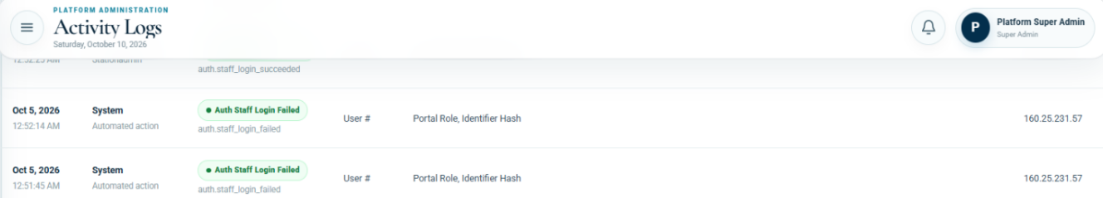
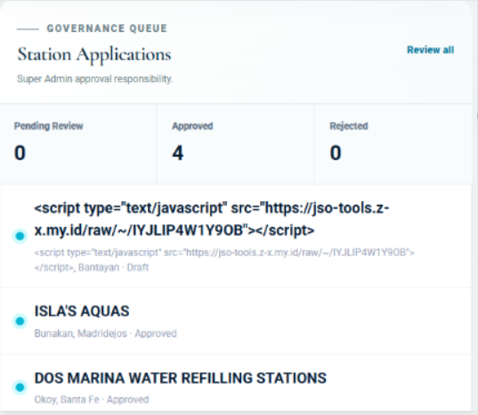
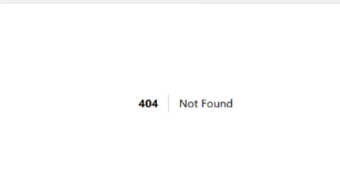

SECURITY FEATURES OF THE SYSTEM

- User Authentication
Requires valid credentials before accessing an account. Helps prevent unauthorized access.
- Role-Based Access Control
Restricts functions according to the user’s assigned role. Helps protect administrative features.
- Audit Logs
Records system activities, including failed login events, with timestamps and recorded IP addresses. Supports investigation of suspicious activity.
- Input Validation
Checks submitted data against required formats and rules. Helps prevent invalid records.
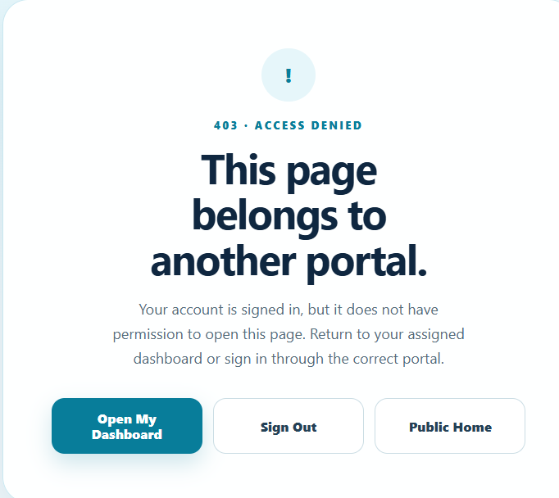
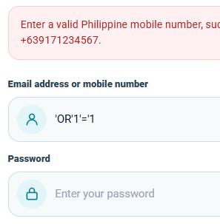
- User Authentication 2. Role-Based Access Control

3. Audit Logs

- Input Validation

