MUSHRA Listening Test Instructions

Overview
- The following experiment is a MUltiple Stimuli with Hidden Reference and Anchor (MUSHRA) listening test.
- In this listening test, you will be asked to evaluate and assign grades to test signals that were processed with different spatial sound reproduction algorithms.
- The test includes XX screens, in each screen you will be presented with YY test signals and compare them to a known reference signal.
- In each screen a different stimulus signal will be presented: speech or castanets.
- You will be asked to rate the relative differences between the reference and the test signal on a scale from 0 to 100.
- A score of 100 means that the signal is not differentiable from the reference. Values downwards 0 mean larger difference with respect to the reference.
- Differences can be either spatial artifacts, time varying artifacts or spectral artifacts.
- The experiment includes two phases: a Training phase and an Evaluation phase.

Training Phase
- The training phase includes two parts: user interface training and signals familiarization.
- The purpose of the training phase is to assist you, as an evaluator, to achieve the followings:
  - User interface training: to learn how to use the test equipment and the grading scale; and
  - Signals familiarization: to become familiar with all the test signals and their quality level ranges.
- Interface training
  - The user interface training includes 2 screens that are similar to the screens in the evaluation phase (see figure 1).
  - In each screen you will be asked to rate the relative differences between 3 test signals (including a hidden reference) and the reference signal.
  - You should rank the test signals in order that reflects their audible impairments compared to the reference.
  - A feedback will be given after each screen. If the ranking order is incorrect, a warning message will be displayed, and the same screen will be shown again.
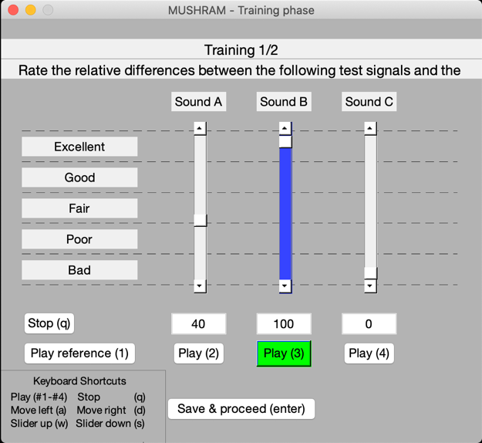
Figure 1. Interface training GUI – the current playing signal is highlighted in green

- Signals familiarization
  - In this stage you will be presented with all test signals that you will evaluate in the listening test (see figure 2).
  - The goal of this stage is to expose you to the full range and nature of impairments that you will experience during the test.
  - Each row of buttons corresponds to one of the 2 stimuli.
  - The leftmost button of each row plays the reference stimulus, and the other buttons play the 6 different variations that you will have to evaluate during the test trials.
  - Note that the signals are listed in a random order.
  - You must listen at least once to each signal.
  - You can spend as much time as you like in this stage. When ready, click ‘Proceed to evaluation’.
  - Please adjust the volume level to a comfort level during the training and don't change it during the evaluation phase.

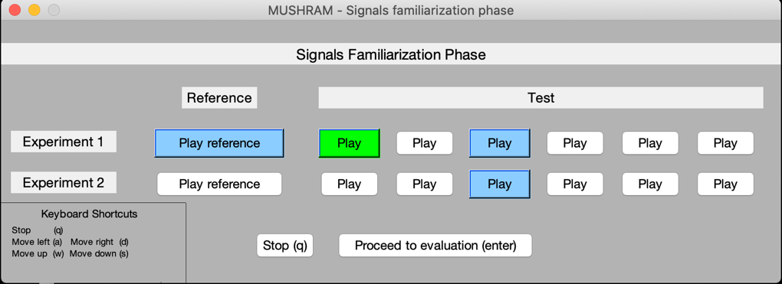
Figure 2. Signals familiarization GUI – the current playing signal is highlighted in green. Signals that have been played before are highlighted in blue.

Evaluation Phase

- After the training is complete, the evaluation phase will start.
- This phase includes XX screens with YY test signals in each screen.
- Each screen will evaluate different stimulus: speech or castanets. The screens will appear in a random order.
- In each screen, you will have YY sliders (see figure 3). Each slider has an audio stimulus associated with it. You must listen to each audio stimulus by clicking the corresponding button, compare them against the reference, and rate them from 0 (‘bad’) to 100 (‘excellent’).
- At least one signal should be rated 100, because a hidden reference signal is included as one of the signals to be graded.
- It is possible to give the same score to several signals.
- Please use the scale widely. Your grades should reflect your subjective judgement of the quality level for each of the presented test signals.
- You may listen to the signals in any order, any number of times.
- Please do not move your head while listening.

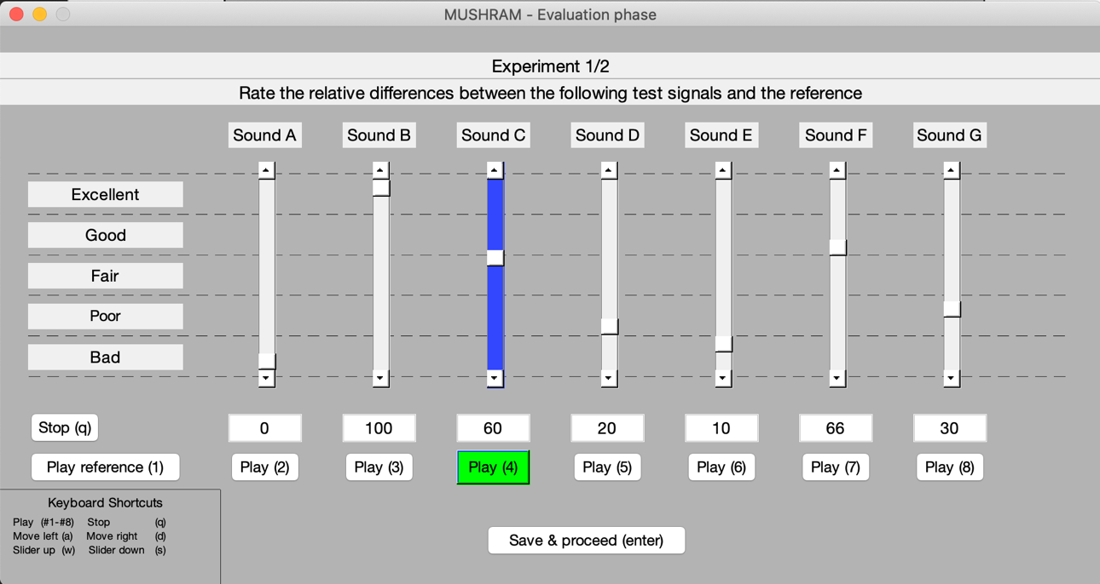
Figure 3. Evaluation phase GUI – the current playing signal is highlighted in green.

Controls
- You can operate the user interface with mouse and/or keyboard.
- Mouse: just click the buttons and drag and drop the sliders.
- Keyboard: (in each screen you will have a keyboard shortcut guide at the left bottom of the screen)
  - The keys for the user interface training and the evaluation phase:
Command | Key
Play | # of play button
Stop | q
Change to play the signal to the left | a
Change to play the signal to the right | d
Move highlighted slider up | w
Move highlighted slider down | s
Save and proceed | enter

  - The keys for the signal familiarization:
Command | Key
Play (start playing the first reference) | d
Stop | q
Change to play the signal to the left | a
Change to play the signal to the right | d
Change to play the signal above | w
Change to play the signal below | s
Proceed | enter

NOTE: you can switch between stimuli while they are playing, which may be helpful for your task.

