**B23 Ex03 Class Hierarchy**

**Roi Sasson 208633677**

**Or Gamliel 209161603**

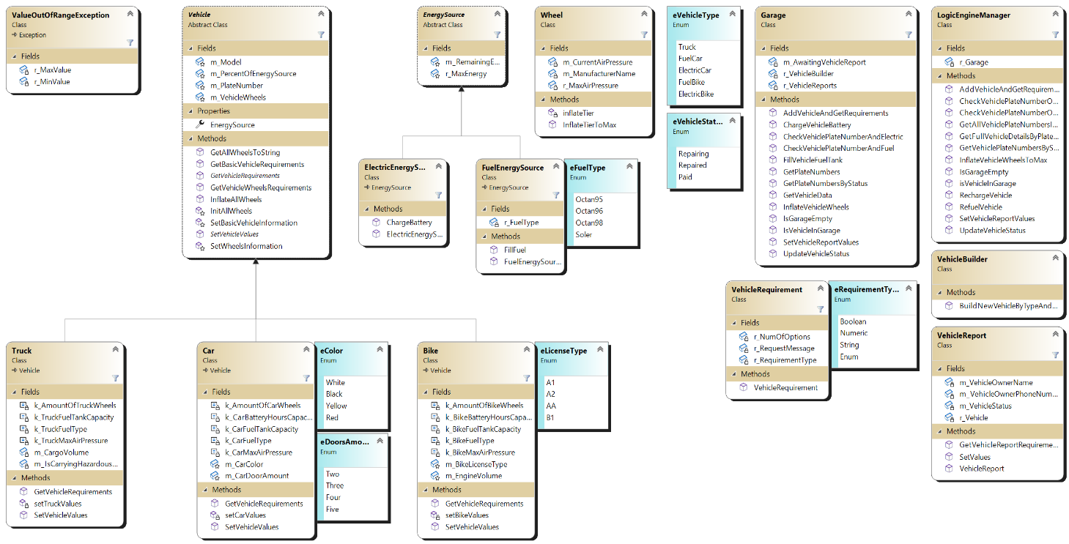Zoom in to see all details:

**Class Vehicle:**  
The Vehicle class is an abstract class that serves as a base class for the different types of vehicles in a garage management system.

**Class Bike**  
The Bike class represents a bike vehicle and extends the Vehicle base class.

It has constants for the number of bike wheels, the maximum air pressure of the bike wheels, the bike fuel type, the bike fuel tank capacity, and the bike battery hours capacity.

**Enum eLicenseType:**

Defines four different types of bike license: A1, A2, AA, B1.

**Class Car**  
The Car class represents a car vehicle and extends the Vehicle base class.

The class has constants for the number of car wheels, the maximum airpressure of the car wheels, the car fuel type, the car fuel tank capacity, and the car battery hours capacity.

**Enum eColor:**

Defines four different types of colors of the car: White, Black, Yellow, Red.

**Enum eDoorsAmount:**

Defines four different doors amount in the car: 2,3,4,5.

**Class Truck**  
The Truck represents a truck vehicle and extends the Vehicle base class.

The class has constants for the number of truck wheels, the maximum air pressure of the truck wheels, the truck fuel type, the truck fuel tank capacity, and additional members for indicating whether the truck is carrying hazardous materials and the cargo volume.

**Class EnergySource:**The EnergySource class is an abstract class, it serves as a base class for deriving specific energy source classes: FuelEnergySource and ElectricEnergySource used in vehicles.

**Class FuelEnergySource**  
The FuelEnergySource class is a derived class of the EnergySource class and represents a fuel-based energy source for a vehicle It encapsulates the functionality related to fuel energy sources for vehicles and provides a way to fill the fuel tank and retrieve information about the fuel level and type.

**Enum eFuelType:**

The eFuelType enum defines four different types of fuel: Octan95, Octan96, Octan98, and Soler.

**Class ElectricEnergySource**  
The ElectricEnergySource class represents an electric energy source used in vehicles. It is a derived class of the EnergySource base class.

**Class Garage**  
The Garage class serves as the central component for managing vehicles and their reports within the garage management system. It provides a range of operations to add, update, retrieve, and interact with vehicles in the garage.

**Class VehicleBuilder**  
The VehicleBuilder class is responsible for creating and returning instances of different vehicle types based on the provided vehicle type and plate number.

**Class Wheel**The Wheel class represents a wheel of a vehicle in the garage management system. It stores information about the manufacturer name, current air pressure, and maximum air pressure allowed for the wheel.

**Class LogicEngineManager**The LogicEngineManager class serves as an interface between the user interface and the garage management system. It provides a simplified set of methods that interact with the Garage class to perform various operations on vehicles in the garage.

**Class VehicleReport**The VehicleReport class represents a report for a specific vehicle in the garage management system. It contains information such as the vehicle owner's name, phone number, vehicle status, and a reference to the vehicle itself.

**Class VehicleRequirement**  
The VehicleRequirement class represents a requirement for a specific vehicle attribute or input in the garage management system. It encapsulates information about the requirement type, the request message for user input, and the number of options (if applicable).

**Enum eRequirementType**:  
The eRequirementType enum is used to represent different types of requirements.

**Class ValueOutOfRangeExeption**  
the ValueOutOfRangeException calss defines a custom exception class. This exception is used to represent a situation where a value is out of a specified range.

It inherits from the base Exception class. It has two private read-only fields: r_MaxValue and r_MinValue, which represent the maximum and minimum values of the range, respectively.

**UI:**

**Enum eUserInterfaceOptions:**  
The eUserInterfaceOptions enum represents the available options for a user interface menu .Each enum value corresponds to a specific action or functionality.