MapReduce Design Exercises
  - Short assignment version: define the algorithm, not the worked solution.

Exercise 1: Filtering Pattern - Count Errors by Service
Problem. A large API log contains records of the form (timestamp, service, status, latency_ms). Count server-side errors for each service, where an error is any record with status >= 500. The main design goal is to avoid sending non-error records through the shuffle.
Formal objective. Err(s) = sum_{r in logs} 1[service_r = s and status_r >= 500]

Given
- Input: log records (ts, service, status, latency_ms).
- Output: one pair per service: (service, error_count).
- Assume that log rows may be distributed across many mappers.

Student task
- Design a MapReduce algorithm for this problem.
- Specify the mapper input and emitted key/value pairs.
- Specify the reducer key, reducer input values, and final output.
- Explain whether a combiner is correct, and why.
- Explain how your design reduces shuffle volume.
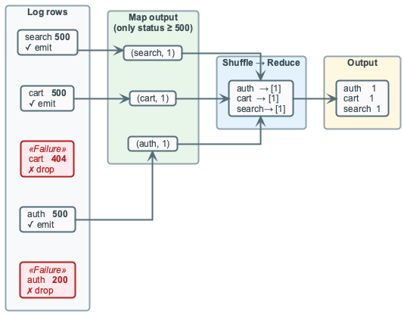
Diagram: mapper-side filtering keeps successful requests out of the shuffle.

Exercise 2: Inverted Index - Term to Document Postings
Problem. A document collection contains records of the form (doc_id, text). Build an inverted index that maps each normalized term to the documents containing it and the term frequency in each document.
Formal objective. tf(t,d) = sum_{token in d} 1[token = t]; I(t) = [(d, tf(t,d))]

Given
- Input: documents (doc_id, text).
- Tokenization rule: lowercase, split on whitespace, keep duplicates.
- Output: for each term, a postings list such as term -> d1:c1, d2:c2.

Student task
- Design a MapReduce algorithm for constructing the index.
- Define the intermediate key so that repeated terms in the same document are counted correctly.
- Specify how the reducer creates posting entries and orders them.
- Explain whether a combiner should be used, and what it is allowed to combine.
- State how your algorithm handles duplicate terms within a document.
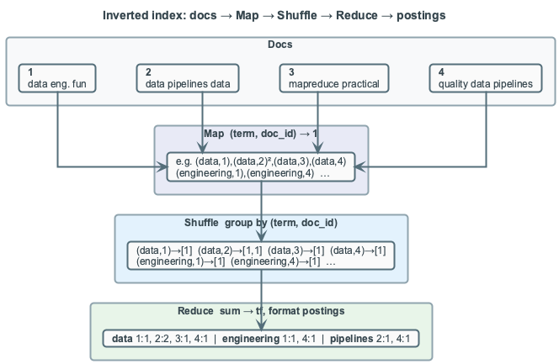
Diagram: token occurrences are grouped into term-document counts.

Exercise 3: Matrix-Vector Multiplication
Problem. A sparse matrix A is represented by records (i, j, A_ij), and a vector v is represented by records (j, v_j). Compute the output vector y where each row i is the dot product of row i in A with v. The join is naturally by column j, while the final aggregation is by row i.
Formal objective. y_i = sum_j A_ij * v_j

Given
- Input 1: sparse matrix entries (i, j, A_ij).
- Input 2: vector entries (j, v_j).
- Output: one pair per row: (i, y_i).

Student task
- Design a MapReduce algorithm for computing y = A v.
- Decide whether the solution needs one job or two jobs, and justify your choice.
- For each job, specify mapper emissions, shuffle keys, reducer logic, and output.
- Explain how vector values are matched with matrix entries.
- Explain where a combiner is useful or not useful.
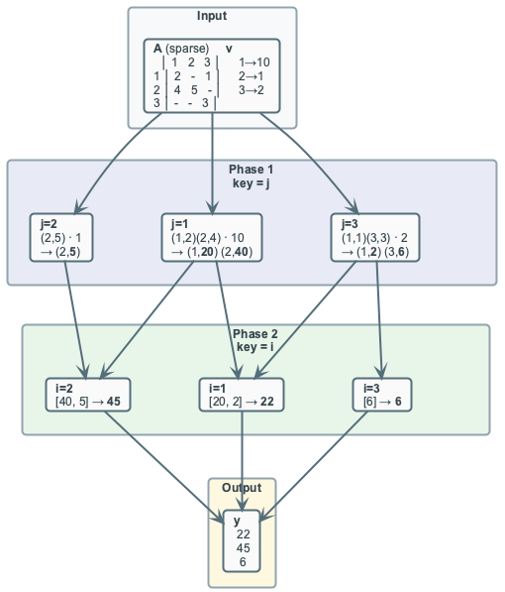
Diagram: first match by column j, then aggregate partial products by row i.

Exercise 4: PageRank - One Iteration with Damping
Problem. A directed graph represents pages and links. Each page has a current rank PR_0(p) and an adjacency list of outgoing links. Design one MapReduce iteration that distributes rank contributions, preserves the graph structure, handles dangling pages with no outgoing links, and applies damping.
Formal objective. PR_1(p) = (1-d)/N + d * (S_in(p) + D/N)

Given
- Input: page records (page, PR_0(page), adjacency_list).
- Definitions: N is the number of pages, d is the damping factor, D is total dangling rank mass.
- Output: updated records (page, PR_1(page), adjacency_list).

Student task
- Design a MapReduce algorithm for one PageRank iteration.
- Specify what each mapper emits for pages with outgoing links.
- Specify how dangling pages are handled so rank mass is not lost.
- Specify how reducers combine incoming contributions and preserve adjacency lists.
- Explain which values a combiner may combine without corrupting graph structure.
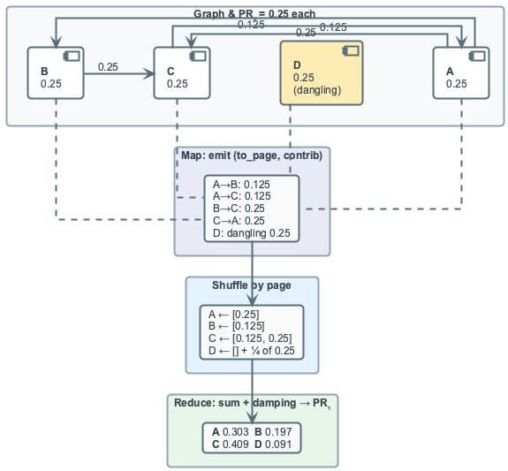
Diagram: rank contributions, dangling mass, and adjacency preservation.

