**Draft of Dashboard Design:**

1. Main page – Overview

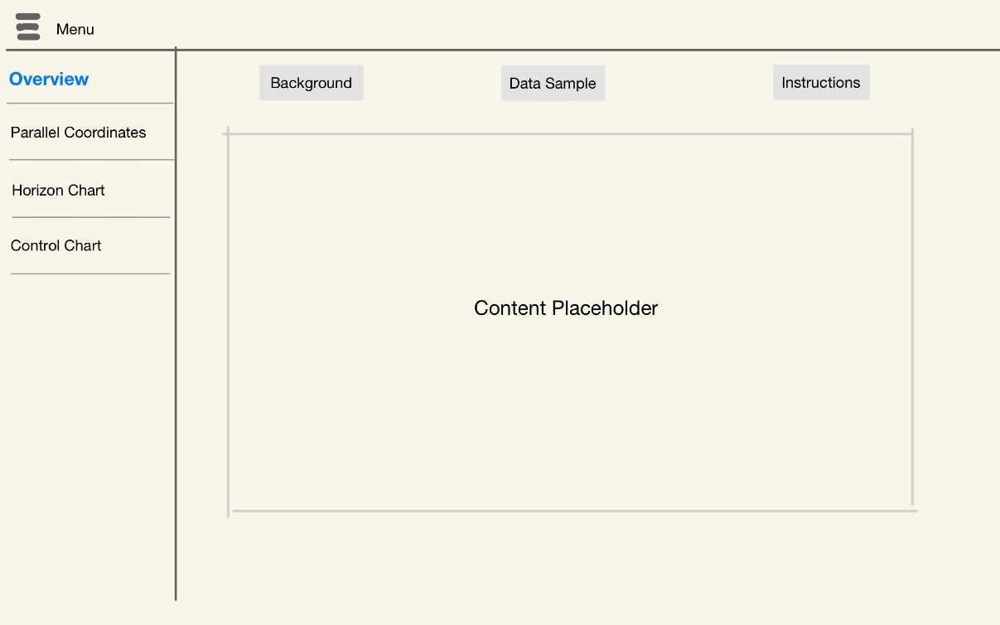

1. Parallel Coordinates

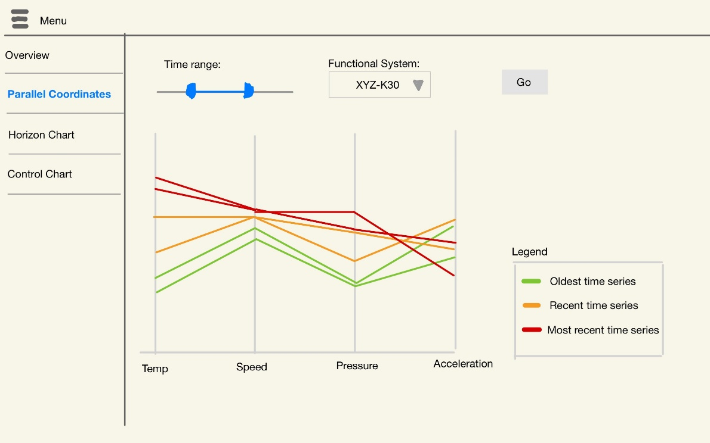

1. Horizon Chart

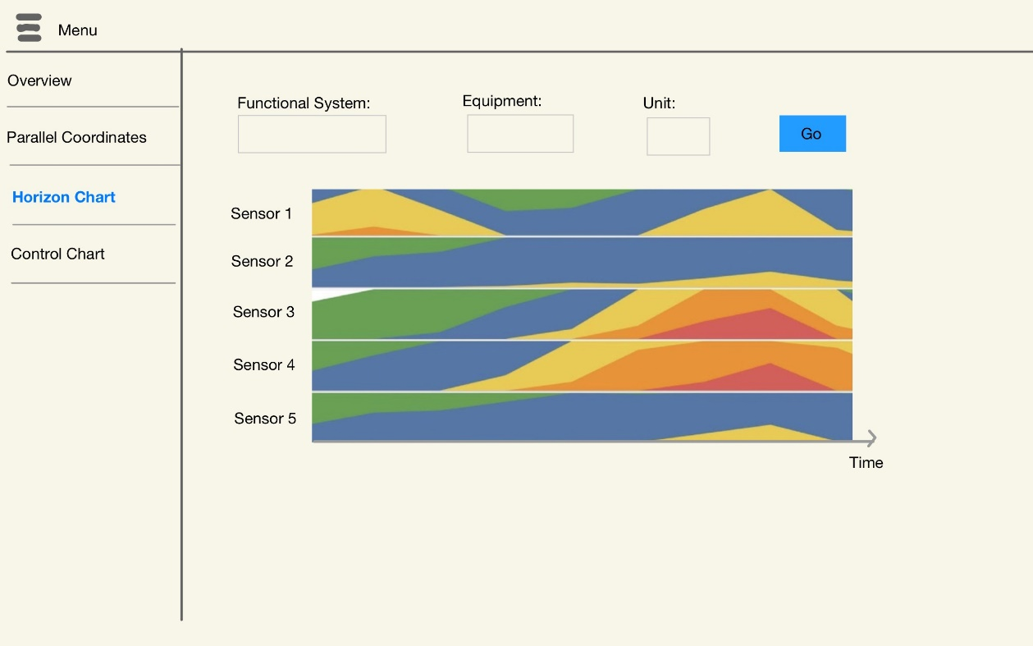

4. Control chart

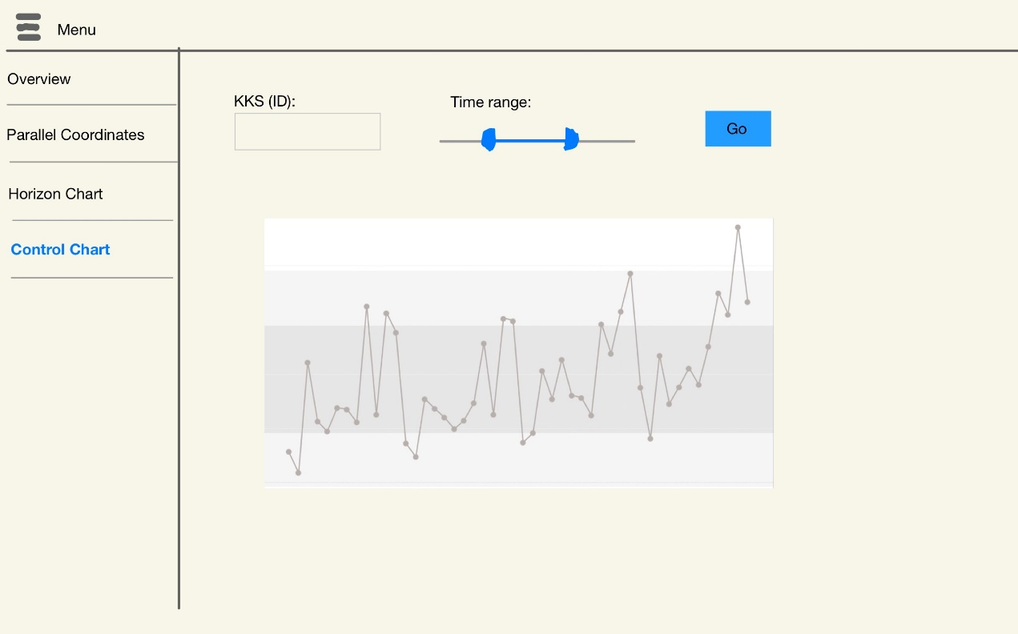

**Project Timeline:**

|  |  |  |
| --- | --- | --- |
| Milestone | Start Date | End Date |
| 1. Data Preparation | 08 Jul 19 | 15 Jul 19 |
| 1. Dashboard UI Main Page | 14 Jul 19 | 19 Jul 19 |
| 1. Dashboard UI + Functionality – Parallel Coordinates | 19 Jul 19 | 02 Aug 19 |
| 1. Dashboard UI + Functionality – Horizon Chart | 19 Jul 19 | 02 Aug 19 |
| 1. Dashboard UI + Functionality – Control Chart | 19 Jul 19 | 02 Aug 19 |
| 1. Research Paper | 02 Aug 19 | 18 Aug 19 |
| 1. Poster Design | 11 Aug 19 | 14 Aug 19 |
| 1. Testing / Presentation Preparation | 14 Aug 19 | 17 Aug 19 |