Derive Asset Location from Payables Invoice ship-to Location

Contents
Derive Asset Location from Payables Invoice ship-to Location 2
How to enable 2
Map Asset Location to HR Location 3
Create Mapping 3
Create location mapping using the Update Fixed Assets Configuration spreadsheet. 3
Create Location Mapping using the Export /Import Service. 4
Review Mapping 4
Create Invoice and Verify in Edit Asset page. 5

Derive Asset Location from Payables Invoice ship-to Location
When you add an asset, the asset location is a required attribute that you had to enter manually for each asset before release 21B. From release 21B onward, Assets allows automatic defaulting of the asset location to invoices transferred from Payables based on the ship-to location in the invoice line.
Assets locations are now derived based on the ship-to location entered in Assets Invoices in Payables. The Create Mass Additions process transfers ship-to location information from Payables invoices to Assets. If you defined location mappings, the Prepare Assets Transaction Data process automatically assigns the asset location to each Payables invoice line based on the HR location to asset location mapping.

How to enable
To use this feature you must enable the lookup “FA_MASS_ADD_PREPARE_RULES”.
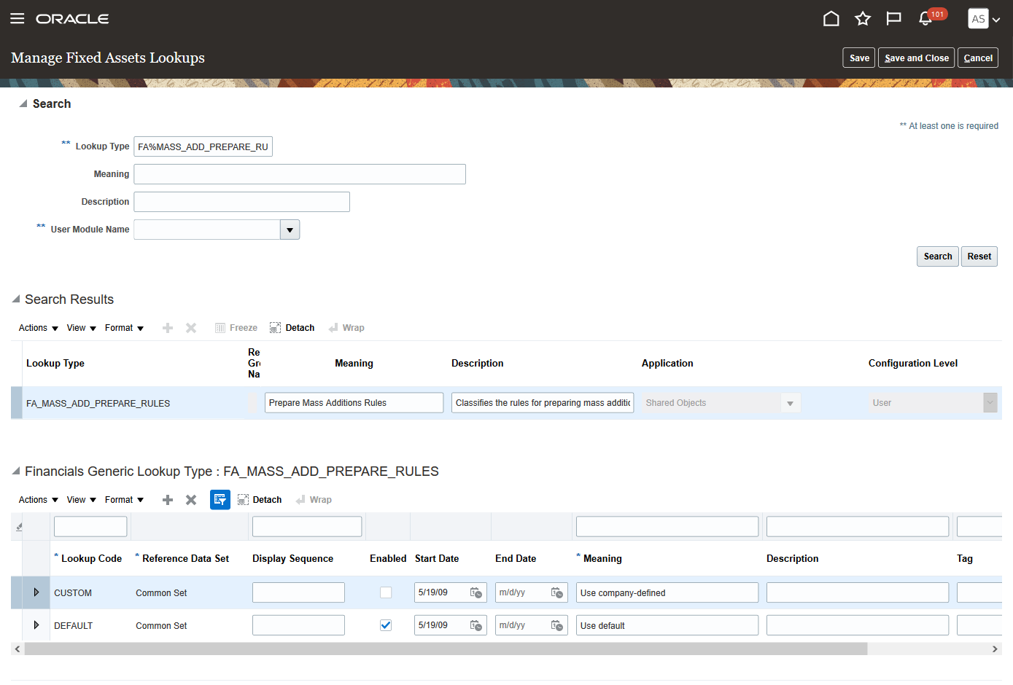

Map Asset Location to HR Location

The asset location and ship-to location setup in HR Location must be mapped to automatically populate the asset location for each invoice line. You must first set up all of the asset location combinations and HR locations, and then create the mapping between them in Assets.

Create Mapping
You can create a mapping between the asset location and HR location using:
- Update Fixed Assets Configuration in Spreadsheet setup task.
- Asset Location Export and Import Setup Service.

To create the mapping between the asset location and HR location, enter the asset location and HR location code. Alternatively, you can also select the HR location code from the list of values against the asset location. You can download the asset locations and the existing mapping by clicking “Map Asset Location to HR Location” in the header region of the Update Fixed Assets Configuration spreadsheet. The Upload Fixed Assets Configuration process creates the mapping.
To create the mapping through the Export Import Service enter the asset location and HR Location Code.
Note:
- You must enable the macros.
- Asset Location and HR Location must both exist and be active.

Create location mapping using the Update Fixed Assets Configuration spreadsheet.

- Navigate to “Setup and Maintenance” and search for the task “Update Fixed Assets Configuration in Spreadsheet”, and download the spreadsheet.
- Enter the asset location and HR location code in the “Location Mapping worksheet”, and upload the generated .csv file in the File Export Import page.
- Run the “Upload Fixed Assets Configuration “process from the Scheduled Processes page.
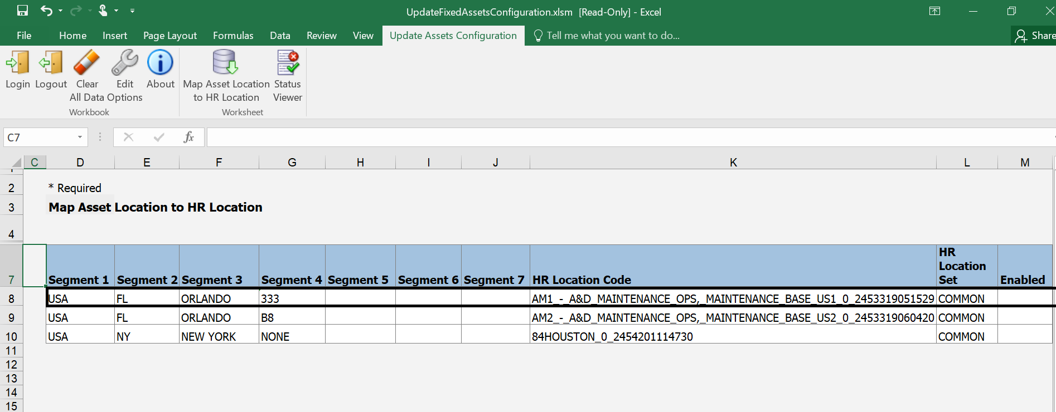

Create Location Mapping using the Export /Import Service.
- Navigate to Setup and Maintenance and select the Financials offering.
- Select Fixed Assets and search for the “Manage Asset Locations” task.
- From the Actions menu click “Export from csv” and download the “Manage Asset Locations” zip file.
- Edit the “ORA_FA_ASSET_LOCATION_TO_HR_LOCATION_MAPPING.CSV” file and enter the asset location and HR code and zip the file.
- From the Actions menu click Import from csv file and select “Create New”.
- Browse and attach the zip file and submit.

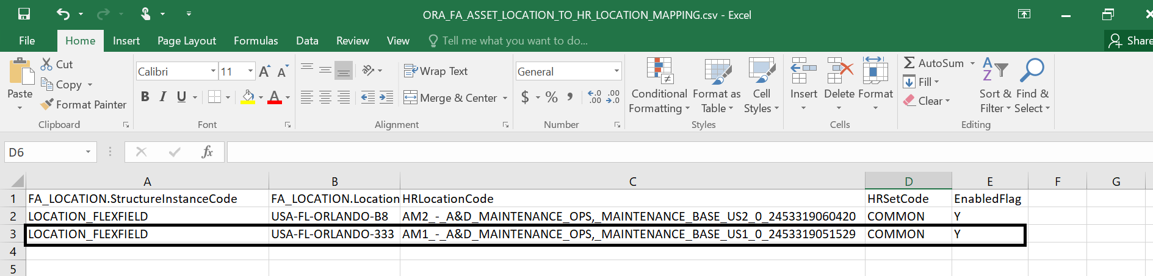

Review Mapping

You can view the mapping of the asset location and HR location in the Manage Asset Locations page by clicking “View Mapped Location”.
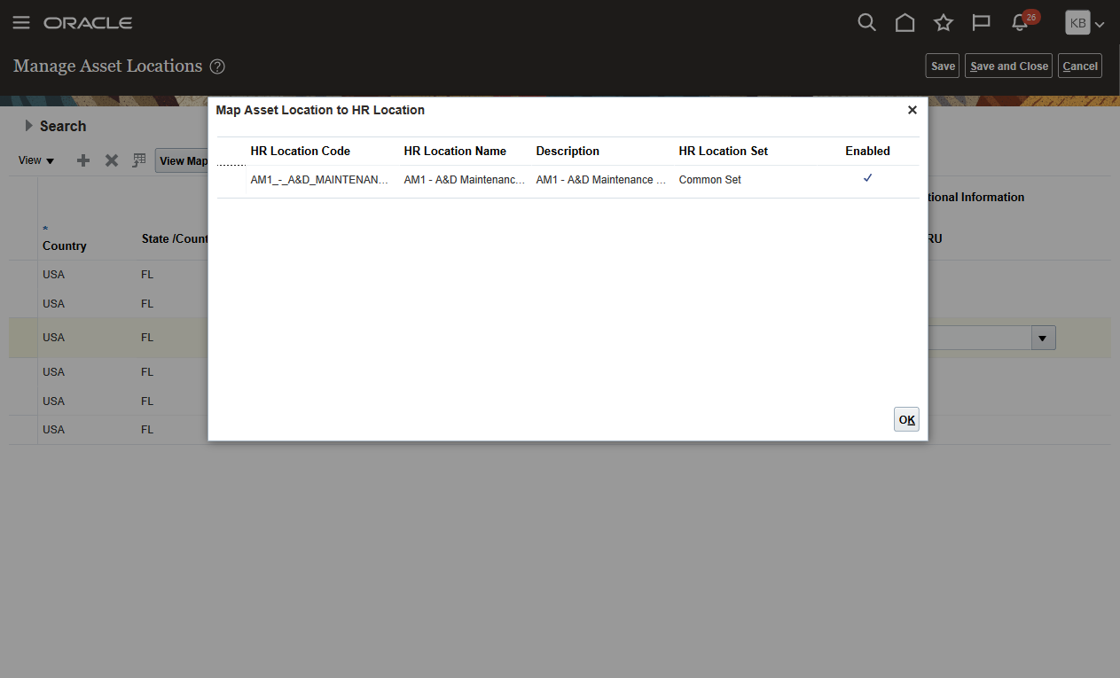

Create Invoice and Verify in Edit Asset page.

Create Payables invoices with the same ship-to location using the mapped HR location, and run the Create Mass Additions process. The “Prepare Assets Transaction Data” automated process derives the mapped asset location.

