New Validations to identify Essbase Restricted Characters in Cube ESS processes

Table of Contents
Cause 1
Solution Steps 2
Case (i) 2
Case (ii) 2

Cause
We have a lot of restricted keywords and characters that are not to be used in Essbase cubes. No restricted characters / reserved words are allowed in Rapid Implementation and Import Segment Values and Hierarchies FBDI solution. However, every now and then some restricted characters skip all our validations. Probably, these values with restricted characters were created from Value Set Values UI, where restrictions are not in effect. These values can potentially result in issues in various Essbase features like Inquiry UIs, Drilldown from SV / FR, FR Reports, Allocations etc. to name a few and in the past have resulted in several data fix cases.
The restrictions are now enforced in Essbase Cube Build/Rebuild/Publish jobs to prevent these restricted values from causing any downstream failures and avoid data fixes.

Solution Steps

Case (i): Balances exists for account combinations with problematic Segment values. This can be the case where customer posted transactions with problematic segment values before upgrade to R13.18.05.
Though it is not recommended to have use restricted values, given that they are already using them and haven’t hit any issues (probably because they not using specific features that restricts those segment values), they could continue using them by following below steps to skip the specific segment values in the validations.
- Create a new lookup type GL_SKIP_ESSBASE_VALUE_CHECK
- Add the problematic segment values as lookup codes into this lookup type as shown below:
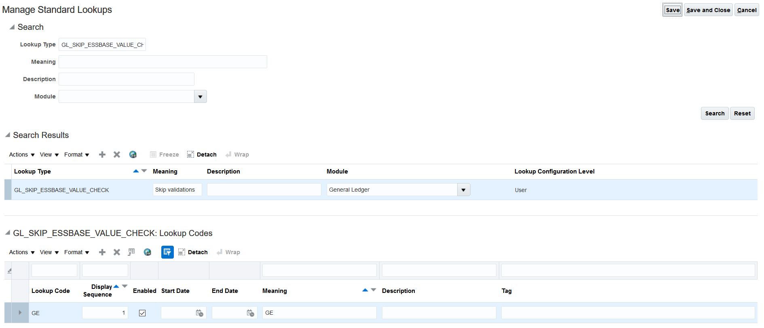
To add lookup codes that contain spaces or ‘_’ at the beginning, please enclose the value in ‘#’.
Example:
a. To add a space ‘ ‘ to a lookup code from UI add # #
b. For value _123 add #_123#
Case (ii): Either account combinations do not exist with problematic segment values OR Balances do not exist for account combinations with problematic Segment values.
- Disable the problematic segment values that are causing validation failures.
- Mark the disabled problematic values as Parent and make sure they are not used in any tree version so that they do not go to cube while publishing the tree or tree version.
- Run the ‘Inherit Segment Value Attributes’ ESS process to disable respective account combinations with problematic segment values. Ensure to verify that all account combinations using problematic segment values were disabled after the job is completed.
- Run the ‘Publish Chart of Account Dimension Members and Hierarchies to Balances Cubes’ ESS job with ‘Publish Detail Values Only’ set to YES.
- Un-publish all the tree versions that were earlier using the problematic value.
- Re-publish all the tree versions, which were impacted in above step.
- Verify that users can no more enter transactions using the problematic values in Journals UI.

