Tidings Technologies

API Gateway with Rate Limiting & Caching



# Outlining the **architecture** and **step-by-step implementation plan**.

ggg

# Architecture Overview

cg

|  |  |  |
| --- | --- | --- |
| Architecture Name | Platform | Purpose |
| Gateway Service | Golang | – Manages incoming API requests and routes them efficiently. |
| Rate Limiter | Redis | – Prevents excessive requests per user/IP to maintain system integrity. |
| Caching Layer | Redis | – Stores frequently accessed API responses to reduce backend load. |
| Monitoring | Python + Prometheus/Grafana | – Tracks API performance and usage analytics. |
|  | 0,000.00 |  |

Implementation Steps

### ****1️⃣ Set Up the API Gateway (Golang)****

* Use **Fiber** or **Gin** framework for high-performance request handling.
* Implement **reverse proxy** to forward requests to backend services.
* Create middleware for request validation and authentication.

### ****2️⃣ Implement Rate Limiting (Redis + Golang)****

* Use **token bucket algorithm** to limit excessive API calls.
* Track request count per user/IP in Redis.
* Configure adaptive rate limits based on user role (free vs. premium).

### ****3️⃣ Add Caching for Faster API Responses (Redis)****

* Store frequently accessed API responses in Redis.
* Implement **TTL (Time-To-Live)** for cache expiration.
* Optimize cache invalidation strategies to avoid stale data.

### ****4️⃣ Deploy Monitoring Tools (Python + Prometheus/Grafana)****

* Set up **Prometheus** to collect API usage metrics.
* Configure **Grafana dashboards** for real-time monitoring.
* Track **latency, error rate, and cache efficiency**.

## Suggested Repository Structure

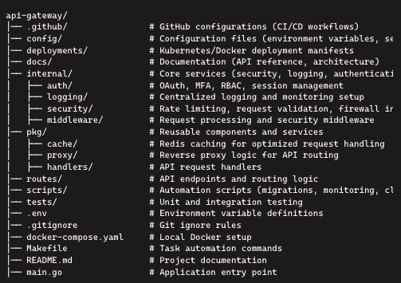

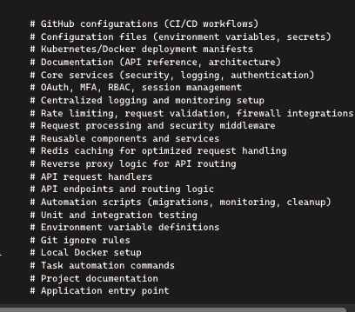

## ****Step 1 ️⃣: Set Up a Basic API Gateway in Golang****

## ****What Is an API?****

An **API (Application Programming Interface)** is a set of rules and protocols that allows different software applications to communicate with each other. Think of an API as a bridge that enables one system to interact with another in a structured and controlled way.

### 🔹 ****How APIs Work****

APIs expose functions and data that other applications can request or interact with. Here’s how the process generally works:

1. A client (e.g., a web app, mobile app, or service) **sends a request** to the API.
2. The API **processes the request** by interacting with databases, third-party services, or internal logic.
3. The API **returns a response** (usually in JSON or XML format) with the requested data or status.

### 🔹 ****Types of APIs****

1. **REST API**: Uses HTTP methods (GET, POST, PUT, DELETE) to transfer data over the web.
2. **GraphQL API**: Allows clients to request specific data structures instead of predefined endpoints.
3. **SOAP API**: Uses XML-based messaging for structured communication.
4. **WebSocket API**: Enables real-time communication between a client and a server.

### 🔹 ****Example of an API Request****

If you're fetching user data from an API:

GET https://api.example.com/users/123

Response from the API:

{

"id": 123,

"name": "John Doe",

"email": "john@example.com"

}

This response contains structured data that applications can use.

## 🚪 ****What Is an API Gateway?****

An **API Gateway** is a centralized system that manages, routes, secures, and optimizes API requests between clients and backend services. It acts as a middle layer, helping developers control access, monitoring, and request handling efficiently.

### 🔹 ****Why Use an API Gateway?****

1. **Request Routing**: Directs incoming requests to the appropriate microservices or backend systems.
2. **Security & Authentication**: Implements security measures like OAuth, JWT, and role-based access control.
3. **Rate Limiting**: Prevents excessive API calls to protect resources.
4. **Caching**: Improves performance by storing frequent responses.
5. **Load Balancing**: Distributes requests across multiple servers for better reliability.
6. **Monitoring & Logging**: Tracks API usage and detects anomalies.

### 🔹 ****API Gateway Architecture****

1. **Client (Frontend/App)** → Sends a request to the API Gateway.
2. **API Gateway** → Validates the request, applies security measures, and routes it to the backend.
3. **Backend/Microservices** → Process the request and send a response back through the API Gateway.

### 🔹 ****Example of API Gateway Usage****

Instead of exposing multiple microservices directly, an API Gateway unifies access:

Client → API Gateway → Authentication Service

→ Product Service

→ User Service

🔥 **Key Difference: API vs API Gateway**

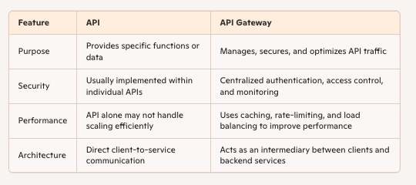

## ****Why Is an API Gateway Important for Scalable Systems?****

Since you're focused on building **secure and scalable API Gateways**, using an API Gateway enables better control, security, and performance optimization—especially when dealing with **microservices** or **large-scale applications**.

### 📌 ****What We'll Do****

We'll create a simple **Golang API** that acts as a **gateway** to handle incoming requests.

### 🛠 ****Implementation****

1. Install Golang and dependencies.
2. Set up a basic **Fiber** or **Gin** server.
3. Create routes for handling API requests.

Fiber and Gin are two popular web frameworks for building APIs and servers in Golang. They both provide efficient request handling, routing, and middleware support but differ in their design and performance characteristics.

## 🌟 ****Fiber vs. Gin: An Overview****

### 🔹 ****Fiber****

Fiber is built on top of fasthttp (<https://github.com/valyala/fasthttp>) , which is the fastest HTTP engine for Golang. It's designed for high performance and minimal memory usage, making it a great choice for microservices and API gateways handling high traffic.

**Key Features of Fiber:**

* ⚡ **High Performance**: Uses fasthttp, making it faster than the standard net/http.
* 🏗 **Express-like Syntax**: Inspired by Node.js' Express framework, making it easy to use.
* 🛠 **Built-in Middleware**: Comes with built-in middleware like CORS, compression, and authentication.
* 📦 **Lightweight & Minimal Memory Usage**: Optimized for speed and scalability.
* 💡 **Automatic JSON Parsing**: Makes working with request and response payloads easier.

**Example Fiber Server:**

package main

import (

"github.com/gofiber/fiber/v2"

)

func main() {

app := fiber.New()

app.Get("/", func(c *fiber.Ctx) error {

return c.SendString("Hello from Fiber!")

})

app.Listen(":8080")

}

### 🔹 ****Gin****

Gin is one of the most widely used web frameworks in Golang. It is built on the standard net/http package and optimized for performance while maintaining simplicity.

**Key Features of Gin:**

* ⚡ **Fast Routing Engine**: Uses a trie-based router for efficient request handling.
* 🔒 **Robust Middleware Support**: Allows logging, authentication, and error handling.
* 🛠 **JSON Handling**: Supports automatic binding of JSON data from requests.
* 🔄 **Flexible & Modular**: Can be extended with third-party middleware.
* 🔥 **Good for Traditional APIs**: Well-suited for structured API services and general backend applications.

**Example Gin Server:**

package main

import (

"github.com/gin-gonic/gin"

)

func main() {

r := gin.Default()

r.GET("/", func(c *gin.Context) {

c.String(200, "Hello from Gin!")

})

r.Run(":8080")

}

🆚 **Comparing Fiber & Gin**

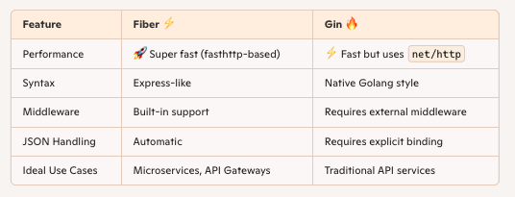

## 💡 ****Which One Should You Use?****

* **Use Fiber** if performance is your top priority and you need something lightweight and fast for a microservice or API gateway.
* **Use Gin** if you prefer a more traditional Go framework with better middleware support and a structured approach.

Since you're working on an API Gateway, **Fiber** might be a great choice due to its speed and efficiency.

### Code Implementation

package main

import (

"github.com/gofiber/fiber/v2"

)

func main() {

app := fiber.New()

app.Get("/", func(c *fiber.Ctx) error {

return c.SendString("Welcome to the API Gateway!")

})

app.Listen(":3000") // Runs on port 3000

}

Step-by-Step Breakdown

package main

* This defines the **main package** in Go. The main package is the entry point of a Go program. Every Go application must have one main package that contains a main() function, which executes the program.

import ( "github.com/gofiber/fiber/v2" )

* This **imports Fiber**, a fast web framework built on fasthttp. By importing "github.com/gofiber/fiber/v2", you're enabling the use of Fiber functions like route handling, request processing, and server management.

func main() {

* **Defines the main function**, which serves as the execution starting point for the program.

app := fiber.New()

* This **creates a new Fiber app instance** using fiber.New(). The app variable now holds the Fiber application, which manages HTTP requests and responses.

app.Get("/", func(c *fiber.Ctx) error { return c.SendString("Welcome to the API Gateway!") })

* **Defines an HTTP GET route** at the root ("/") of the API.
* When a client makes a GET request to /, this function is triggered.
* c *fiber.Ctx represents the request context, allowing access to request and response data.
* c.SendString("Welcome to the API Gateway!") sends a **plain text response** back to the client.

**Why the keyword** error **appears** in the function signature inside app.Get().

### 🔹 ****Why**** error ****Is Used in Fiber Route Handlers****

In Fiber, route handlers must return an error because Fiber internally manages errors for proper logging, response handling, and debugging.

#### ✅ ****Breaking Down the Function Signature****

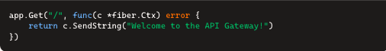

Let's analyze each part:

1. func(c *fiber.Ctx) error: This function:
   * Accepts **one parameter** (c *fiber.Ctx), which represents the **request context** (request/response object).
   * Returns **an error** (error), which tells Fiber if something went wrong during execution.
2. return c.SendString("Welcome to the API Gateway!"):
   * c.SendString() sends a **string response** to the client.
   * Since SendString() itself **returns an error**, the function signature matches (error return type).

#### 🔥 ****Why Does Fiber Require an Error Return?****

1. **Error Handling & Logging**: If c.SendString() fails (e.g., invalid response type), Fiber will **catch and log the error** automatically.
2. **Middleware & Custom Error Responses**: Fiber can process errors through middleware (e.g., custom error pages, logging systems).
3. **Maintains Go's** error **Pattern**: Go typically uses explicit error handling (func() error), which Fiber follows for consistency.

#### 🔹 ****Example: Handling Errors in Fiber****

If an operation fails, you can **explicitly return an error**:

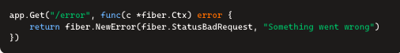

This returns:

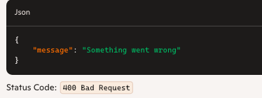

### ****Key Takeaways****

* ✅ Fiber requires route handlers to **return an** error for proper error handling.
* ✅ Functions must return an error type so Fiber can **log or manage failures**.
* ✅ c.SendString() and similar methods return an error, ensuring consistency.

Example HTTP request to this route:

GET http://localhost:3000/

Response:

Welcome to the API Gateway!

app.Listen(":3000") // Runs on port 3000

* **Starts the server** and listens for requests on port 3000.
* When you run the program (go run main.go), it activates the API Gateway on http://localhost:3000/.

Now that we have a basic API gateway running, the next step is to **implement rate limiting** to control excessive requests and prevent abuse.

## ****Step 2️⃣: Implement Rate Limiting with Redis****

### 📌 ****What We'll Do****

* Add **Redis** for tracking request counts.
* Apply **token bucket rate limiting** to manage API traffic.
* Prevent users from exceeding a request quota within a time window.

### 🔹 ****What Is Redis?****

Redis (**Remote Dictionary Server**) is an **open-source, in-memory data store** that can be used as a **database, cache, message broker, and real-time analytics system**. It's known for its **speed, efficiency, and scalability**, making it a popular choice for handling high-performance applications.

## 🚀 ****Why Is Redis So Fast?****

Unlike traditional databases that store data on disk, **Redis operates entirely in memory**, which allows for **lightning-fast read and write operations**. When needed, Redis can also **persist data to disk** using different backup strategies.

## 🔹 ****Key Features of Redis****

1️⃣ **In-Memory Storage** – Data is stored in RAM, making access extremely fast. 2️⃣ **Key-Value Database** – Uses a simple but powerful **key-value data structure**. 3️⃣ **Support for Multiple Data Types** – Unlike traditional key-value stores, Redis can handle:

* **Strings**
* **Lists**
* **Sets**
* **Hashes**
* **Sorted Sets**
* **Bitmaps**
* **HyperLogLogs** 4️⃣ **Persistence Options** – Supports **snapshotting (RDB)** and **append-only logging (AOF)** for durability. 5️⃣ **Pub/Sub Messaging** – Redis can act as a **message broker**, enabling real-time notifications. 6️⃣ **Atomic Operations** – All commands are **atomic** (executed fully or not at all). 7️⃣ **Replication & Clustering** – Supports **master-slave replication** and **clustered setups** for scalability. 8️⃣ **Transactions & Scripting** – Allows **Lua scripting** for custom operations.

## 🔹 ****1️⃣ In-Memory Storage****

Unlike traditional databases that store data on disk, **Redis keeps all data in RAM**. This allows **instantaneous reads and writes**, making Redis much faster than disk-based databases like MySQL or PostgreSQL.

* **How It Works:** Since RAM access is much quicker than disk I/O operations, Redis achieves **millisecond-level latency** even under high loads.
* **Downside:** Because data is stored in memory, Redis **requires persistence settings** to prevent data loss during crashes or restarts.
* **Use Case:** Ideal for caching frequently used data, session storage, and real-time analytics.

Example:

SET user:123 "John Doe"

GET user:123 # Instantly retrieves the value

## 🔹 ****2️⃣ Key-Value Database****

Redis is a **NoSQL key-value store**, meaning it stores data in a **key-value format** instead of structured tables like SQL databases.

* **Keys:** Unique identifiers for stored data (e.g., "user:123").
* **Values:** Can be simple strings or complex data types (lists, sets, hashes, etc.).
* **Advantage:** Easy to **store, retrieve, and expire** data dynamically.

Example:

SET session:abc123 "active"

GET session:abc123 # Returns "active"

## 🔹 ****3️⃣ Support for Multiple Data Types****

Unlike simple key-value stores, Redis offers **various data structures**:

1. **Strings** → Simple text/numeric values

SET username "Alice"

GET username # Alice

1. **Lists** → Ordered collection (like an array)

LPUSH messages "Hello" "World"

LRANGE messages 0 -1 # ["World", "Hello"]

1. **Sets** → Unique values with no duplicates

**SADD colors "red" "blue" "green"**

**SMEMBERS colors # {"red", "blue", "green"}**

1. **Hashes** → Key-value pairs (like JSON objects)

HSET user:100 name "Bob" age "30"

HGET user:100 name # "Bob"

1. **Sorted Sets** → Ordered ranking (e.g., leaderboards)

ZADD scores 100 "Alice" 200 "Bob"

ZRANGE scores 0 -1 WITHSCORES # [["Alice", 100], ["Bob", 200]]

## 🔹 ****4️⃣ Persistence Options****

Since Redis is **in-memory**, it provides two persistence methods to prevent data loss:

1. **RDB (Redis Database Snapshot)**
   * Periodically saves the dataset as a snapshot (dump.rdb file).
   * Efficient for backups but may lose recent data.
2. **AOF (Append-Only File)**
   * Logs every command executed (appendonly.aof file).
   * **Safer persistence** but requires more disk space.

Enable AOF:

CONFIG SET appendonly yes

## 🔹 ****5️⃣ Pub/Sub Messaging****

Redis can act as a **message broker**, enabling real-time notifications and data streams.

1. **Publish a message to a channel:**

PUBLISH news "Breaking: Redis is amazing!"

1. **Subscribe to that channel:**

**SUBSCRIBE news**

Any connected subscriber will receive the published message instantly!

**Use Case:** Chat applications, live event streaming, notifications.

1. **cv**

### 🛠 ****Implementation Steps****