[PROJECT TITLE]

BY

[STUDENT NAME]
[STUDENT ID]

DEPARTMENT OF COMPUTER SCIENCE
FACULTY OF COMPUTING
NILE UNIVERSITY OF NIGERIA, ABUJA

[MONTH, YEAR]


[PROJECT TITLE]
BY
[STUDENT FULL NAME]
[STUDENT ID]

SUPERVISED BY
[SUPERVISOR FULL NAME]

A PROJECT SUBMITTED TO THE DEPARTMENT OF COMPUTER SCIENCE, FACULTY OF COMPUTING, NILE UNIVERSITY OF NIGERIA. IN PARTIAL FULFILMENT FOR THE AWARD OF BARCHELOR OF SCIENCE HONOURS (B.Sc. HONS) DEGREE IN COMPUTER SCIENCE

[MONTH, YEAR]

DECLARATION
I hereby declare that this project titled [PROJECT TITLE] is my original work and has not been presented for any other qualification anywhere. Information from other sources (published or unpublished) has been duly acknowledged.

_____________________ __________________
[STUDENT NAME] SIGNATURE/DATE
[STUDENT ID]

CERTIFICATION
This is to certify that this final project titled [PROJECT TITLE] was undertaken by [STUDENT NAME] with student ID Number [STUDENT ID] has been read and approved by the undersigned signatories for meeting the requirements for the award of BACHELOR OF SCIENCE HONORS (B.SC. HONS) IN COMPUTER SCIENCE by the DEPARTMENT OF COMPUTER SCIENCE.

[SUPERVISOR NAME] _______________________
PROJECT SUPERVISOR SIGNATURE & DATE

ASSOC. PROF. MUHAMMAD ALIYU. SULEIMAN ________________________
HOD, COMPUTER SCIENCE DEPARTMENT SIGNATURE & DATE

PROF. JOSHUA ABBAH ________________________
DEAN, FACULTY OF COMPUTING SIGNATURE & DATE

ASSOC. PROF. ALHASSAN ADAMU _______________________
EXTERNAL SUPERVISOR SIGNATURE & DATE

DEDICATION
I dedicate this project too...

ACKNOWLEDGEMENT

ABSTRACT
Contains 150–300 words. It should provide readers with a clear overview of the study without requiring them to read the full report.
Structure of an Undergraduate Project Abstract
1. Background/Introduction (1–2 sentences)
Briefly introduce the problem or topic being investigated and explain why it is important.
Example:
The increasing use of online learning platforms has transformed educational delivery in higher institutions. However, concerns remain regarding student engagement and academic performance in virtual learning environments.
2. Problem Statement (1 sentence)
State the specific problem that motivated the study.
Example:
Despite widespread adoption of online learning systems, many students experience challenges that affect their learning outcomes.
3. Aim/Objectives (1–2 sentences)
State the purpose of the study and the main objectives.
Example:
This study aimed to evaluate the impact of online learning on the academic performance of undergraduate students at XYZ University.
4. Methodology (2–3 sentences)
Summarize the research design, data collection methods, sample size, and analytical techniques.
Example:
A quantitative research design was adopted. Data were collected from 200 undergraduate students using structured questionnaires and analyzed using descriptive statistics and regression analysis.
5. Key Findings/Results (2–3 sentences)
Present the most important findings of the study.
Example:
The findings revealed a significant positive relationship between student participation in online learning activities and academic performance. Internet connectivity and digital literacy were identified as major factors influencing learning outcomes.
6. Conclusion and Recommendations (1–2 sentences)
State the major conclusion and, if appropriate, a recommendation.
Example:
The study concluded that online learning can enhance academic performance when supported by adequate technological infrastructure. It is recommended that universities invest in reliable internet services and digital skills training for students.
General Template
Abstract
This study investigated [research topic] in [study area/location]. The study was motivated by [problem being addressed]. The aim of the research was to [research aim], while the objectives were to [list key objectives briefly]. A [research design] approach was adopted, and data were collected from [sample size/population] using [instrument/method]. The collected data were analyzed using [analysis technique]. The findings revealed that [major findings]. Based on these findings, the study concluded that [main conclusion]. The study recommends [recommendation] to improve [relevant outcome].
.
Table of Contents
DECLARATION i
CERTIFICATION ii
DEDICATION iii
ACKNOWLEDGEMENT iv
ABSTRACT v
LIST OF TABLES ix
LIST OF FIGURES x
CHAPTER ONE 1
1 INTRODUCTION 1
1.1 Background of the Study 2
1.2 Problem statement 4
1.3 Aim and objectives 5
1.4 Motivation of the study 6
1.5 Significance of the Study 6
1.6 Scope of the study 7
1.7 Limitations 7
1.7.1 Technical limitations 7
1.7.2 Social limitations 8
1.8 Research Questions 8
1.9 Definitions of term use 9
CHAPTER TWO 10
2 LITERATURE REVIEW 10
2.1 Existing Literature 11
2.2 Existing Gaps 12
x2.2.1 Ai in Educational Gaming 12
2.2.2 Use of AI in Gamification: 13
2.3 Existing Systems 16
2.4 Propose System and Expected Impact 23
2.5 Key Technologies and their Roles 26
CHAPTER THREE 28
3 METHODOLOGY 28
3.1 Case Study 29
3.2 Software Development Life Cycle (SDLC) 29
3.2.1 possible / candidate methodologies 29
3.3 Requirements Engineering 32
3.3.1 Requirements gathering for the System 32
3.3.2 Functional Requirements 32
3.3.3 Non Functional Requirements 33
3.4 System Analysis 35
3.4.1 System Architecture 35
3.4.2 High-Level Design: 37
3.4.3 Low-Level Design: 39
CHAPTER FOUR 48
4 IMPLEMENTATION, RESULTS AND DICUSSION 48
4.1 System Implementation 48
4.2 Results Presentation 50
4.3 System Testing and Validation 58
4.4 Discussion of Results 60
4.5 Performance Evaluation 61
CHAPTER FIVE 62
5 SUMMARY, CONCLUSSION AND RECOMMENDATION 62
5.1 Summary of the study 62
5.2 Conclusion 62
5.3 Contribution of this study 63
5.4 Limitation of the study 64
5.5 Recommendations 64
References 65

LIST OF TABLES
Table 2-1 Comparison between AI and Traditional Approaches 15
Table 2-2 Analysis of Existing Systems 24
Table 3-1 Functional Requirement 32
Table 3-2 Non-Functional Requirement 33
Table 4-1 XP Reward System 57
Table 4-2 Sample generated questions 58
Table 4-3 System Test Case 59

LIST OF FIGURES
Figure 3-1 System Architecture 36
Figure 3-2 Use-case Diagram 38
Figure 3-3 Class Diagram 39
Figure 3-4 Activity Diagram 40
Figure 3-5 Sequence Diagram 41
Figure 3-6 Entity Relation Diagram 42
Figure 4-1 Login page interface 51
Figure 4-2 Main Dashboard interface 52
Figure 4-3 Ai study assistant interface 53
Figure 4-4 Gamified Learning interface 54
Figure 4-5 Neural Nexus quiz interface 55
Figure 4-6 Flash Blitz interface 56
Figure 4-7 User Profile Interface 57

CHAPTER ONE

INTRODUCTION

Background of the Study

Problem statement

Aim and objectives

Motivation of the study

Significance of the Study

Scope of the study

Limitations

Technical limitations

Social limitations

Research Questions

Definitions of term use

CHAPTER TWO

LITERATURE REVIEW

Existing Literature

Existing Gaps

Ai in Educational Gaming

Use of AI in Gamification:
Table 2-1 Comparison between AI and Traditional Approaches
Dimension | AI-based Education | Traditional Education
Personalization | High (adaptive content and pacing) | Limited (depends on teacher capacity)
Feedback Speed | Immediate and continuous | Slower, depends on human  availability
Teacher Role | Facilitator and overseer | Central instructor and mentor
Critical Thinking | Risk of reduced practice when misused | Strong emphasis through guided exploration
Interaction and Social  Skills | Less inherent human contact | Rich in interpersonal engagement
Equity and Access | Can widen gaps if tech is not accessible | More equitable where tech is limited

Existing Systems

Propose System and Expected Impact

Key Technologies and their Roles

CHAPTER THREE

METHODOLOGY

Software Development Life Cycle (SDLC)

possible / candidate methodologies

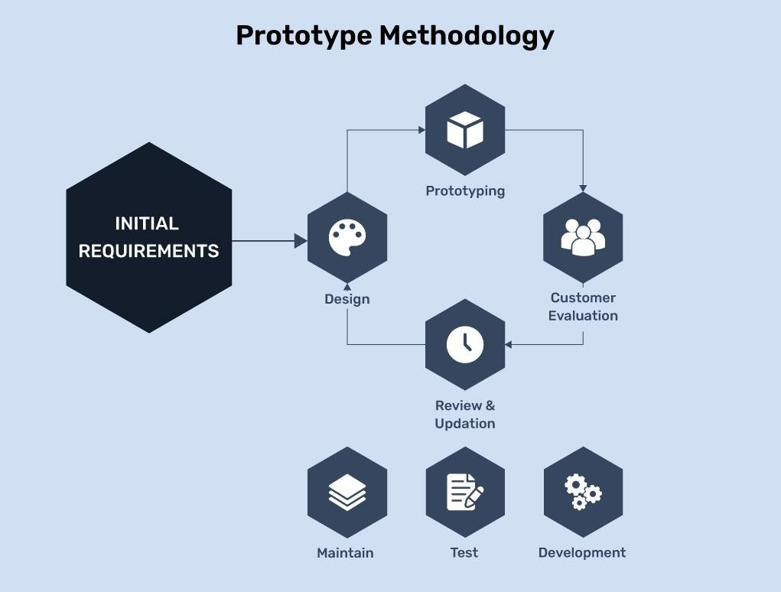
Figure 1: prototype method

Requirements Engineering

Requirements gathering for the System

Functional Requirements

Non Functional Requirements

System Analysis

System Architecture

High-Level Design:

CHAPTER FOUR

IMPLEMENTATION, RESULTS AND DICUSSION

System Implementation

Results Presentation

System Testing and Validation

Discussion of Results

Performance Evaluation

CHAPTER FIVE

SUMMARY, CONCLUSSION AND RECOMMENDATION

Summary of the study

Conclusion

Contribution of this study

Limitation of the study

Recommendations

References

[1] | S. Ibrahim and M. Rafiq, "AI in education and intelligent tutoring / study assistance," Frontiers in Education, vol. 9, no. 1391485, 2024.
[2] | X. Chen, "Artificial intelligence in education: A systematic literature review. Expert Systems with Applications," 2024.
[3] | M. V. I.-R. O. Bond, "A meta systematic review of artificial intelligence in higher education. Frontiers in Education.," 2024.
[4] | O. N. Adegboye, A systematic review of artificial intelligence in higher education in South Africa. Social Sciences and Education Research Review, 2024.
[5] | V. C. C. Nwosu, "Artificial intelligence in higher education. IOSR," 2023.
[6] | M. Garcia, "Gamification of e-learning in African universities," African Journal of Information Systems, vol. 14(3), pp. 55-72, 2022.
[7] | Orizon, "Duolingo’s gamification secrets: How streaks and XP boost learning and motivation.," 2025.
[8] | Gamizign, "The ultimate AI gamification learning tool".
[9] | M. M. V. I. Z.-R. O. Bond, "meta systematic review of artificial intelligence in higher education," Frontiers in Education., 2024.
[10] | F. i. Psychology, "Exploring the effects of artificial intelligence on student and academic well-being in higher education," vol. 16, 2025.
[11] | F. Dalpiaz, "Requirements engineering for artificial intelligence systems," 2022.
[12] | F. J. García-Peñalvo, "Gamification in higher education: A systematic literature review," Tecnologie Didattiche, vol. 32, p. 1=23, 2024.
[13] | h. E. s. battles, "Gamification in higher education," 2023.
[14] | M. D. Cortés-Vega, "ntegrating AI and gamification in higher education for e-learning optimization and soft skills assessment through a cross-study synthesis," vol. 7, 2025.
[15] | W. S. Cheah, "eveloping a gamified AI-enabled online learning application to promote engagement and learning outcomes," vol. 7, p. 11.
[16] | A. R. Nour, "AI-driven gamification models for long-term educational engagement".
[17] | R. A. A. Alshammari, The effect of AI gamification on students’ engagement and performance, 2024.
[18] | S. C.-E. V. C. B. A. O. Eze, "E-learning implementation challenges in Nigeria. Social Sciences and Education Research Review," African / resource-constrained HE and edtech context, vol. 7, p. 2, 2020.
[19] | E. A. I. Okorigba, "Benefits, challenges and prospects of integrating".

