**R. Oral Robert**

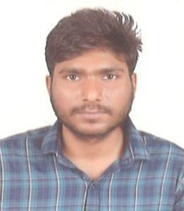

7304795580 - oralrobert96@gmail.com

Room no 203, B wing , Vaishnavi Plaza, Opp. Moreshwar complex, Samarth Nagar,

Diva, Mumbai, India - 400612

**ABOUT ME**

To build a strong and meaningful career that would help me explore different aspects of Information technology . And developed communication &interpersonal skills, strong analytical skills, & problem solving. Result oriented responsible professional with a matured approach and able to make an effective contribution to the performance of a team with good leadership and motivating capabilities.

**Education Skills**

**Data software engineer course** ,2024 1.Leadership&supervisory **Bachelor in Commerce**, 2020 2.Ethic Adaptability&Flexibility

**HSC** Passing Year, 2014 3.Team work

**SSC** Passing Year, 2012 4.Good Communication

**Software&Technical Skills Languages known**

**Progamming language :** Basics in Java script & Python 1. Tamil

**Web Designing :** HTML & CSS 2. Hindi

**DataBase :** Foundation in SQL 3. English

**Work Expieience**

1. **Tata Business Support Service (TBSS)** (2016 – 2017 – *10 Months)*

Process: HDFC LWCC / Designation: Sales Consultant

*2.* ***5 paisa*** *(*2021 – 2022 – *1 year 5 Months Experience)*

Process : Sales Department /Designation : Customer Care Executive.

3.  **Fujitec** ( 2023 – 11 months)

Process: Sales Departmen /Designation: Contract Sales person

**Declaration :**

I, R. Oral Robert, hereby declare that the information contained herein is true and correct to the best of my knowledge and belief.

**R.Oral Robert**

**Place : INDIA**