Loan Approval Prediction
A Machine Learning Approach for HDFC Bank
Mini Project Report
AI for Engineers (UCS321)
Department of Electronics and Communication Engineering

1. Problem Statement and Objective
HDFC Bank currently processes loan applications manually. This manual review is slow, resource-intensive, and prone to inconsistency between different officers assessing similar applicants. The bank needs a faster and more consistent way to screen applications and to understand which applicant characteristics most strongly influence the final decision.

Objective
- Prediction: Build a supervised machine-learning model that predicts whether a loan application should be Approved or Rejected.
- Interpretation: Identify and interpret the factors that most strongly drive the approval decision, so the bank gains insight, not just an output.

Problem Framing
Aspect | Description
Problem type | Classification (predicting a category: Approved / Rejected)
Target variable | loan_status
Inputs | Income, loan amount & term, CIBIL score, dependents, education, employment, asset values
Output | A binary decision — Approved (1) or Rejected (0)

2. Dataset Source and Description
The project uses the Loan Approval Prediction Dataset, publicly available on Kaggle (author: Archit Sharma). It contains 4,269 loan applications described by 13 columns, with no missing values. The dataset was loaded directly from a GitHub mirror so that every group member works from an identical copy.
Column | Meaning
no_of_dependents | Number of people financially dependent on the applicant
education | Graduate / Not Graduate
self_employed | Whether the applicant is self-employed
income_annum | Annual income of the applicant (in rupees)
loan_amount | Requested loan amount
loan_term | Loan repayment term (in years)
cibil_score | Applicant's credit score (300–900)
asset values (4 cols) | Residential, commercial, luxury and bank asset values
loan_status | Target — Approved or Rejected

3. Data Preprocessing
Because the dataset contains no missing values and no duplicate rows, preprocessing focused on preparing the data for modelling rather than cleaning it. Every decision was made with a clear justification.
- Whitespace fix: The dataset stores column names and text values with leading spaces. These were stripped first; otherwise every category mapping would silently fail and produce blank values.
- ID removal: The loan_id column was removed because it is a unique label with no predictive value.
- Encoding: education, self_employed and the target loan_status were mapped to 0/1. Encoding the target numerically (rather than as text) also allows the F1 scorer to work correctly during hyperparameter tuning.
- No imputation: No values were imputed or dropped, because the dataset is already complete — fabricating data would only introduce noise.
- Scaling: Numerical features were standardised using StandardScaler, fitted on the training split only, so that large-valued columns (income, assets) and small ones (dependents) are treated on a comparable scale.

4. Exploratory Data Analysis and Key Observations
Visualisations were used to answer specific questions about the data rather than to produce decorative charts. Each observation below is supported by a graph in the accompanying notebook.
- Target balance: About 62% of applications are approved and 38% rejected — a mild class imbalance that justifies reporting precision, recall and F1 rather than accuracy alone.
- CIBIL vs status: Approved applicants have a far higher average CIBIL score (≈ 703) than rejected applicants (≈ 429). Credit score is the clearest separator in the data.
- The key insight: There is a sharp approval cliff at a CIBIL score of roughly 550. Below 550, only about 10.6% of applications are approved; above 550, approval rises to about 99%. The decision is almost entirely governed by crossing this threshold.
- Correlation: Income and asset columns correlate with one another but only weakly with the approval decision, confirming that credit history dominates.

5. Feature Selection and Engineering
Two new features were engineered to better represent how a lender actually evaluates an application. These were added deliberately, not merely to increase the number of columns.
- Loan-to-Income Ratio: loan_amount ÷ income_annum. This expresses the repayment burden in a single number — a large loan against a small income signals higher risk.
- Total Assets: The sum of the four asset-value columns, summarising the applicant's overall collateral and financial backing.
The value of this step is confirmed empirically: the engineered Loan-to-Income Ratio emerged as the third most important feature in the final model, ahead of raw income — demonstrating that it captures genuine signal.

6. Model Development
The data was split 80/20 into training and test sets using stratified sampling, so the approve/reject ratio is preserved in both. A majority-class baseline was established first, and three classifiers were then trained and compared.
- Baseline: A DummyClassifier that always predicts the majority class ('Approved') achieves 62% accuracy. Any real model must beat this to be worthwhile — this is also why accuracy alone is not a sufficient metric.
- Logistic Regression: A simple, interpretable baseline model suited to a binary decision.
- Decision Tree: Captures non-linear, rule-based patterns and is easy to explain.
- Random Forest: An ensemble of many trees; it delivered the strongest performance and also provides feature-importance scores.
The Random Forest was further refined using GridSearchCV (a systematic search over tree settings, scored by F1), and its stability was confirmed with 5-fold cross-validation. The algorithm choice was justified by results, not popularity.

7. Evaluation and Model Comparison
Models were evaluated with multiple metrics — accuracy, F1-score and ROC-AUC — so that no single number is trusted in isolation.
Model | Accuracy | F1-Score | ROC-AUC
Baseline (Dummy) | 0.62 | — | 0.50
Logistic Regression | 0.91 | 0.93 | 0.97
Decision Tree | 0.99 | 0.995 | 0.99
Random Forest (tuned) | 0.995 | 0.996 | 1.00

- Result: Every model comfortably beats the 62% baseline. The tuned Random Forest is the best performer on every metric.
- Stability: 5-fold cross-validation gave a mean accuracy of 0.996 with a standard deviation of only 0.003, confirming the result is stable and not an artefact of one lucky split.
- Errors: The confusion matrix shows only a handful of misclassifications out of 854 test applications.

8. Interpretation of Results
A good model result is only meaningful when translated into insight and decision. The feature-importance analysis makes the model's reasoning transparent.
- What matters most: CIBIL score is by far the most important feature (importance ≈ 0.80), consistent with the approval cliff seen during EDA.
- Secondary factors: Loan term is second, and the engineered Loan-to-Income Ratio is third — repayment burden matters more than raw income.
Insight to decision: credit score effectively acts as a gatekeeper. Applicants just below the ~550 threshold are almost always rejected. Rather than issuing a flat rejection, HDFC could route these borderline applicants towards credit-building guidance or secured-loan alternatives, recovering potentially good customers while managing risk.

9. Limitations and Improvements

Limitations
- Synthetic data: The dataset is synthetic and heavily CIBIL-dominated, so the near-perfect accuracy reflects the simplicity of the data rather than real-world difficulty. On genuine applicant data the accuracy would be lower.
- Limited features: The data contains few behavioural features and no repayment-history or economic context.
- Policy bias: The model learns the existing approval policy; if that policy carries bias, the model will reproduce it.

Possible Improvements
- Real data: Validate the pipeline on a real, noisier dataset to obtain an honest accuracy estimate.
- More models: Add a gradient-boosting model such as XGBoost to the comparison.
- Fairness: Perform a fairness check across demographic groups before any real deployment.

10. Conclusion
This project built a complete machine-learning pipeline to predict loan approval for HDFC Bank, from problem definition through to a working prediction tool. A tuned Random Forest achieved approximately 99.5% accuracy (F1 ≈ 0.996, ROC-AUC ≈ 1.0) and comfortably outperformed a majority-class baseline, with cross-validation confirming the result is stable.
More importantly, the project moved beyond a score to a genuine insight: the approval decision is overwhelmingly driven by the applicant's CIBIL score, with a decisive threshold near 550, followed by loan term and the engineered loan-to-income ratio. We also report honestly that the very high accuracy is a consequence of a clean, synthetic, credit-score-dominated dataset rather than exceptional modelling — which is itself an important analytical observation. The result is a model that is accurate, stable, interpretable, and defensible.

Appendix — Project Workflow Diagram
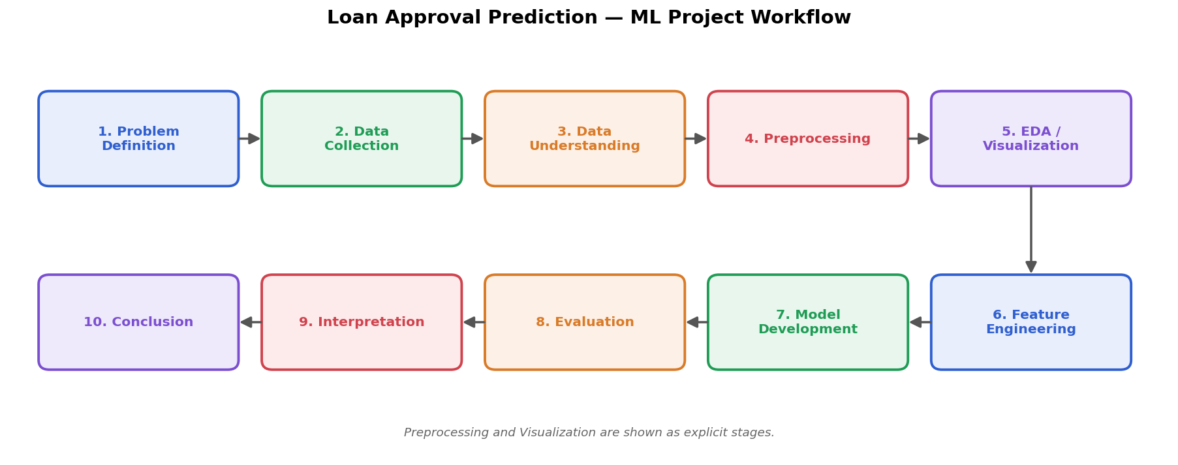
Figure 1 — Complete ML project workflow, from problem definition to conclusion.

