**Casino ServiceDetails**

**1. SavePlayerDetails**

URL : <http://localhost:9090/omni-rank/playerdetails>



Method : POST

Request :



{

"playerName":"Babloo",

"depositingAmount":100.20

}

Response :

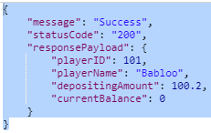

{

"message": "Success",

"statusCode": "200",

"responsePayload": {

"playerID": 101,

"playerName": "Babloo",

"depositingAmount": 100.2,

"currentBalance": 0

}

}



**2.Deduction Money Service Details**

URL : <http://localhost:9090/omni-rank/moneydeduction>



Method :POST

Request :

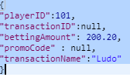

{

"playerID":101,

"transactionID":null,

"bettingAmount": 200.20,

"promoCode" : null,

"transactionName":"Ludo"

}

Response :

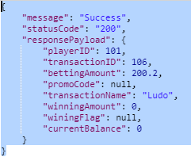

{

"message": "Success",

"statusCode": "200",

"responsePayload": {

"playerID": 101,

"transactionID": 106,

"bettingAmount": 200.2,

"promoCode": null,

"transactionName": "Ludo",

"winningAmount": 0,

"winingFlag": null,

"currentBalance": 0

}

}





**3. Winning Service Details**

**3.1> If WinningFlag=Y**

URL : [http://localhost:9090/omni-rank/winningdetails](http://localhost:9090/omni-rank/winningdetails#)

Method : PUT

Request :

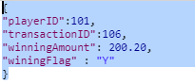

{

"playerID":101,

"transactionID":106,

"winningAmount": 200.20,

"winingFlag" : "Y"

}

Response:

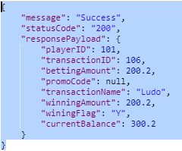

{

"message": "Success",

"statusCode": "200",

"responsePayload": {

"playerID": 101,

"transactionID": 106,

"bettingAmount": 200.2,

"promoCode": null,

"transactionName": "Ludo",

"winningAmount": 200.2,

"winingFlag": "Y",

"currentBalance": 300.2

}

}





**3.2> If WinningFlag=N**

**Request :**

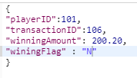

**Response :**

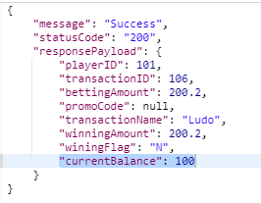





**4.Deduction Money Service Details with coupon**

**Initial Value:**



**BettingAmount =200.2**

After applying coupon: ("promoCode" : "xyrankwfrs")

URL : <http://localhost:9090/omni-rank/moneydeduction>



Method : POST

Request :

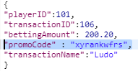

{

"playerID":101,

"transactionID":106,

"bettingAmount": 200.20,

"promoCode" : "xyrankwfrs",

"transactionName":"Ludo"

}

Response :

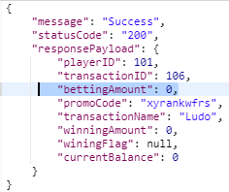

{

"message": "Success",

"statusCode": "200",

"responsePayload": {

"playerID": 101,

"transactionID": 106,

"bettingAmount": 0,

"promoCode": "xyrankwfrs",

"transactionName": "Ludo",

"winningAmount": 0,

"winingFlag": null,

"currentBalance": 0

}

}

