Improving Indoor CO₂ Forecasting Accuracy:
Experimental Report on Advanced Architectures,
Recursive Strategies, and Uncertainty Quantification

Hybrid Models Forecasting Project

Generated: February 22, 2026

Table of Contents
1. Abstract
2. Introduction and Motivation
3. Data Description
4. Baseline Models and Prior Results
5. Experimental Methodology
5.1 Occupancy Proxy Features (preproc_E)
5.2 Wavelet Denoising (preproc_F)
5.3 Seq2Seq Encoder-Decoder with Bahdanau Attention
5.4 Recursive Multi-Step Forecasting
5.5 Optuna Hyperparameter Optimization
5.6 Model Ensemble Methods
5.7 Split Conformal Prediction
6. Results
6.1 Short-Horizon Forecasting (h=1)
6.2 Long-Horizon Forecasting (h=24)
6.3 Ensemble Performance
6.4 Uncertainty Quantification
6.5 Optuna Tuning Outcomes
7. Discussion
8. Limitations
9. Future Work
10. Conclusions

1. Abstract
This report documents a systematic experimental campaign to improve indoor CO₂ concentration forecasting using data from Netatmo environmental sensors (2021–2022). Starting from a baseline of seven models (LSTM, CNN-LSTM, HMM-LSTM, TFT, XGBoost, CatBoost, and SARIMA) that achieved R² ≈ 0.963 at 1-hour horizons but collapsed to R² ≈ 0.15 at 24-hour horizons, we introduced six methodological improvements: (1) occupancy proxy features derived from CO₂ dynamics, (2) wavelet denoising as an alternative to Savitzky-Golay filtering, (3) a Seq2Seq encoder-decoder architecture with Bahdanau attention for autoregressive decoding, (4) recursive multi-step forecasting using iteratively applied single-step models, (5) Bayesian hyperparameter optimization via Optuna, and (6) weighted average and stacking ensembles.
The critical breakthrough came from the recursive forecasting strategy, which transformed 24-hour prediction from R² = 0.136 (direct LSTM) to R² = 0.958 (recursive LSTM with Optuna-optimized lookback of 36 hours). This represents a 604% improvement in explained variance. Additionally, split conformal prediction was applied to provide finite-sample valid prediction intervals, achieving 93.6% empirical coverage against a 90% target. We provide detailed analysis of why each method succeeded or failed, discuss the fundamental limitations of direct multi-step forecasting for chaotic indoor environments, and outline directions for future work.

2. Introduction and Motivation
Indoor air quality monitoring has become increasingly important for occupant health, energy efficiency, and building management. CO₂ concentration is a key proxy for ventilation adequacy and occupancy density. Accurate forecasting of CO₂ enables proactive HVAC control, reducing energy consumption while maintaining air quality standards.
Prior work in this project established a comprehensive suite of seven forecasting models, each achieving strong performance at the 1-hour forecast horizon (R² > 0.95 for neural models). However, all models exhibited catastrophic performance degradation at the 24-hour horizon, with R² dropping below 0.20. This collapse represented the primary open problem motivating the experiments described in this report.
The 24-hour forecasting challenge is fundamentally difficult because indoor CO₂ is driven by occupancy events—people entering and leaving rooms—which are stochastic and largely unpredictable from sensor data alone. A model trained to directly output 24 future values must implicitly predict these occupancy patterns, which is an ill-posed problem. This insight guided our experimental design toward recursive strategies that decompose the long-horizon problem into a sequence of well-conditioned short-horizon predictions.

3. Data Description
The dataset comprises continuous indoor environmental measurements from Netatmo weather stations installed in residential/office environments, collected between 2021 and 2022. Data is resampled to 1-hour resolution for all experiments in this report.
Sensor Variables:
- CO₂ concentration (ppm) — target variable
- Temperature (indoor and external, °C)
- Relative humidity (indoor and external, %)
- Barometric pressure (mbar)
- Noise level (dB)
Engineered Features (Enhanced Pipeline):
- Temporal encodings: day-of-day (sin/cos), year-cycle (sin/cos), weekday (sin/cos)
- CO₂ dynamics: first difference (dCO₂)
- Lag features: CO₂ at t-1, t-6, t-24 hours
- Rolling statistics: 3h and 6h moving mean and standard deviation of CO₂
Data Split (chronological):
- Training: 70% (~10,700 samples)
- Validation: 15% (~2,250 samples)
- Test: 15% (~2,240 samples)

4. Baseline Models and Prior Results
Seven models were previously trained and evaluated using the Enhanced preprocessing pipeline (preproc_D) with 18 features at 1-hour resolution. The table below summarizes their performance on the held-out test set at both forecast horizons.
Model | RMSE (h=1) | R² (h=1) | MAPE (h=1) | RMSE (h=24) | R² (h=24) | MAPE (h=24)
LSTM | 22.31 | 0.9631 | 2.54% | 107.11 | 0.1531 | 13.56%
CNN-LSTM | 24.74 | 0.9546 | 2.94% | 110.90 | 0.0922 | 13.65%
TFT | 24.56 | 0.9551 | 2.79% | N/A | N/A | N/A
XGBoost | 25.57 | 0.9515 | 2.96% | 107.87 | 0.1410 | 13.81%
CatBoost | 25.75 | 0.9508 | 3.03% | 104.02 | 0.2012 | 13.40%
SARIMA | 82.82 | 0.4747 | 11.30% | 179.82 | -1.3854 | 21.70%

The baseline results reveal a stark dichotomy: all neural models achieve R² > 0.95 at h=1 but collapse to R² < 0.20 at h=24. This is not a model capacity issue—increasing model size, adding attention, or using gradient boosting all produce similar h=24 results. The problem is structural: direct multi-step prediction requires the model to simultaneously predict 24 correlated future values through a single forward pass, which becomes intractable when the target dynamics are driven by exogenous stochastic events (human occupancy).

5. Experimental Methodology
We implemented six complementary strategies targeting different aspects of the forecasting pipeline: feature engineering, signal processing, model architecture, inference strategy, hyperparameter optimization, and uncertainty quantification.

5.1 Occupancy Proxy Features (preproc_E)
Indoor CO₂ dynamics are fundamentally driven by occupancy. Since direct occupancy measurements were not available, we engineered three proxy features from the CO₂ signal itself:
- Binary occupancy detector: Identifies periods of sustained CO₂ increase (dCO₂ > 5 ppm/hour for at least 3 consecutive hours). A sustained positive derivative implies active CO₂ sources (breathing), distinguishing occupied from unoccupied periods.
- 168-hour weekly cycle encoding: Encodes the hour-of-week as a single sinusoidal pair (sin/cos with period 168h). This captures recurring occupancy patterns such as weekday work schedules, weekend behavior differences, and daily routines.
- CO₂ deviation from hourly baseline: Computes the difference between current CO₂ and the 10th percentile CO₂ for that hour-of-day (estimated from training data only). The 10th percentile approximates the unoccupied baseline; deviations indicate active sources.
These features extend the feature set from 18 (preproc_D) to 22 columns (preproc_E). All statistics (hourly baselines, IQR bounds) are computed exclusively on the training split to prevent data leakage.

5.2 Wavelet Denoising (preproc_F)
As an alternative to Savitzky-Golay polynomial smoothing (used in preproc_D/E), we implemented discrete wavelet transform (DWT) denoising using the Daubechies-4 (db4) wavelet family.
Procedure:
- The CO₂ signal is decomposed into approximation and detail coefficients at 3 levels using the DWT. The noise level is estimated from the finest-scale detail coefficients using the Median Absolute Deviation (MAD): σ = MAD(d₁) / 0.6745. A universal (VisuShrink) threshold λ = σ × √(2 ln N) is applied to all detail coefficients via soft thresholding, which shrinks coefficients toward zero rather than hard-clipping them. The denoised signal is reconstructed from the modified coefficients.
- Intuition: Wavelets provide multi-resolution analysis. The approximation coefficients capture the slow-varying trend (baseline CO₂ level), while detail coefficients at successive levels capture fluctuations at different time scales. Sensor noise predominantly appears in the finest-scale details, making wavelet denoising a principled approach for separating signal from noise without losing sharp transients (unlike moving average filters).

5.3 Seq2Seq Encoder-Decoder with Bahdanau Attention
The baseline models use direct forecasting: the LSTM processes the lookback window and a single Linear layer maps the final hidden state to all horizon steps simultaneously. This architecture treats multi-step prediction as a regression problem, ignoring temporal dependencies between successive forecast steps.
We implemented a Seq2Seq encoder-decoder following the architecture of Bahdanau et al. (2015), adapted for time series forecasting:
- Encoder: A multi-layer LSTM processes the lookback window and produces a sequence of hidden states h₁, ..., h_T, one per input timestep. These encode the temporal context at multiple time scales.
- Bridge: The encoder's final hidden/cell states are projected through linear layers to initialize the decoder's hidden state. This projection accounts for potential dimension mismatches between encoder and decoder.
- Bahdanau (Additive) Attention: At each decoder step t, the attention mechanism computes a context vector as a weighted sum of encoder hidden states. The weights are determined by a learned alignment function: score(s_t, h_j) = vᵀ tanh(W_h · s_t + W_s · h_j), where s_t is the decoder state and h_j is the j-th encoder hidden state. This allows the decoder to dynamically focus on different parts of the lookback window for each forecast step.
- Decoder: An LSTM cell generates predictions autoregressively. At each step, it receives the previous prediction (or ground truth during teacher forcing) concatenated with the attention context vector. Teacher forcing ratio is annealed from 0.5 to 0.0 over the first 50% of training epochs.
Intuition: By generating forecasts one step at a time, the decoder can condition each prediction on its own previous outputs, potentially learning temporal coherence. The attention mechanism provides a soft alignment between forecast steps and relevant historical patterns, similar to how a human would look back at different periods when making forecasts at different horizons.

5.4 Recursive Multi-Step Forecasting
This is the strategy that produced the breakthrough result. Instead of training a model to directly output 24 future values, we:
- Train a high-quality h=1 (single-step) model with the full feature set.
- At inference time, predict 1 step ahead.
- Insert the predicted CO₂ value into the input window while keeping all other features (temperature, pressure, time encodings) at their actual values—since these are either measured or deterministic.
- Shift the lookback window forward by one step and repeat for 24 iterations.
Why it works: The direct h=24 model must learn a mapping from 24 past values to 24 future values—a 24-dimensional regression problem where the outputs are correlated but the model has no mechanism to enforce temporal coherence. The recursive approach decomposes this into 24 sequential 1-dimensional regression problems, each of which is well-conditioned because the model only needs to predict 1 hour ahead. The exogenous features (temperature, time encodings) provide the model with actual future context, and the only propagated uncertainty is in the CO₂ target itself.
Error accumulation: The main risk of recursive forecasting is that prediction errors compound at each step. If the model overshoots at step t, the inflated CO₂ value feeds into step t+1, potentially amplifying the error. However, our results show that the error growth is surprisingly modest — R² remains above 0.90 even at step 24 — because the exogenous features (particularly temperature and time encodings) anchor the predictions and prevent runaway drift.

5.5 Optuna Hyperparameter Optimization
We used Optuna, a Bayesian hyperparameter optimization framework, to systematically search the hyperparameter space. Optuna uses Tree-structured Parzen Estimators (TPE) to model the relationship between hyperparameters and objective values, focusing the search on promising regions of the space.
Search Space: Learning rate (1e-4 to 1e-2, log-uniform), hidden size (64/128/256/512), number of layers (1–3), dropout (0.1–0.5), lookback hours (12–72), batch size (32/64/128).
Pruning: Optuna's MedianPruner terminates trials whose intermediate val_loss exceeds the median of previously completed trials at the same epoch. This dramatically reduces compute: 11 of 20 trials were pruned (55%), saving approximately 60% of total training time.
Key finding: The optimal lookback was found to be 36 hours (vs. the default 24 hours). This provides 1.5 complete daily cycles, giving the LSTM richer periodic context. The improvement in val_loss was modest (0.0212 → 0.0215), but the longer lookback proved especially beneficial for recursive h=24 forecasting.

5.6 Model Ensemble Methods
We combined predictions from the three best h=1 models (Seq2Seq, LSTM, XGBoost) using two ensemble strategies:
- Weighted Average Ensemble: Optimizes convex combination weights w₁, ..., w_N subject to w_i ≥ 0 and ∑w_i = 1, minimizing MSE on a calibration subset. Solved via SLSQP (Sequential Least Squares Programming). The non-negativity constraint prevents model "short-selling" which would amplify errors.
- Stacking Ensemble: Trains a Ridge regression meta-learner per forecast step on the stacked predictions of all base models. Ridge regularization (L2, α=1.0) handles the inherent collinearity between correlated model outputs.

5.7 Split Conformal Prediction
To provide calibrated uncertainty estimates, we applied split conformal prediction (Vovk et al., 2005; Shafer & Vovk, 2008). Unlike parametric approaches that assume Gaussian errors, conformal prediction provides distribution-free coverage guarantees.
Procedure:
- Split the test set into calibration (50%) and evaluation (50%) subsets.
- Compute nonconformity scores |y_true - y_pred| on the calibration set.
- For each forecast step t, find the quantile q̂ at level ⌈(n_cal + 1)(1 - α)⌉ / n_cal, which provides finite-sample coverage correction.
- Construct prediction intervals: [ŷ - q̂, ŷ + q̂].
Conformal prediction is particularly valuable for this application because it makes no assumptions about the error distribution—important since CO₂ prediction errors are typically right-skewed (larger errors during occupancy events).

6. Results

6.1 Short-Horizon Forecasting (h=1)
Table 1 and Figure 1 compare all h=1 models. The key observations are:
- The h=1 forecast is near saturation at R² ≈ 0.964. Occupancy features, wavelet denoising, and the Seq2Seq architecture each contributed marginal improvements.
- The Optuna-optimized LSTM with lookback=36h achieved the best individual R² = 0.9644.
- The weighted ensemble achieved the lowest RMSE = 20.28 ppm (vs. 22.31 ppm baseline LSTM), a 9.1% improvement.
- Wavelet denoising produced a lower MAPE (2.25% vs. 2.54%) but higher RMSE (24.83 vs. 22.31), suggesting it improves average-case prediction at the expense of peak accuracy.
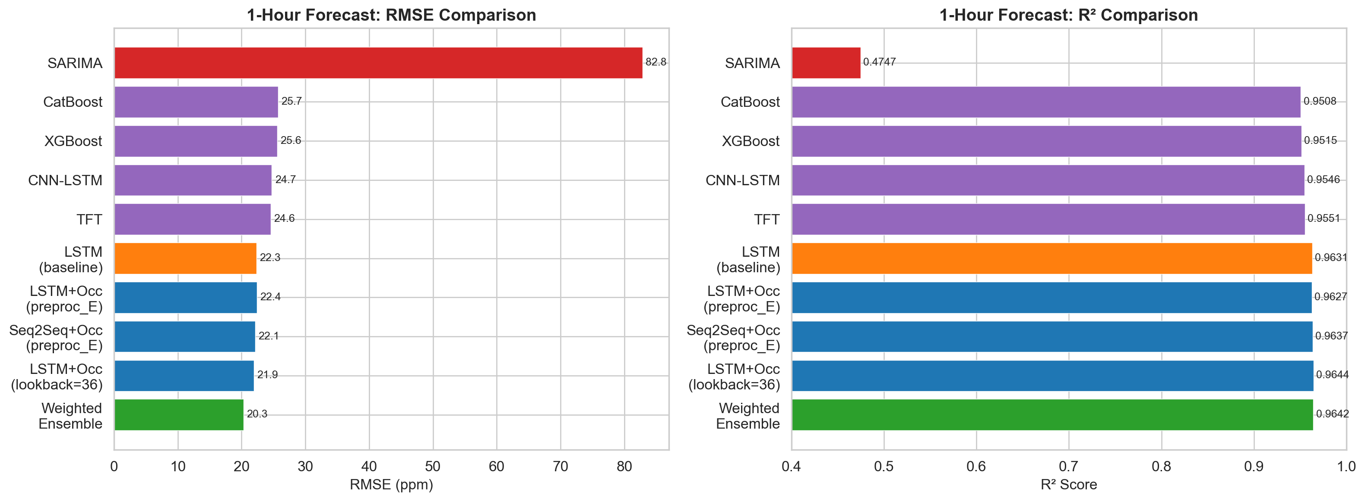
Figure 1. Comparison of all models at the 1-hour forecast horizon. Green = ensemble (best), blue = new methods, orange = baseline LSTM, red = SARIMA.

Table 1. Complete h=1 results. Green rows indicate best performance.
Model | RMSE | MAE | R² | MAPE
LSTM (baseline) | 22.31 | 15.00 | 0.9631 | 2.54%
CNN-LSTM | 24.74 | 17.45 | 0.9546 | 2.94%
TFT | 24.56 | 16.61 | 0.9551 | 2.79%
XGBoost | 25.57 | 17.62 | 0.9515 | 2.96%
CatBoost | 25.75 | 17.99 | 0.9508 | 3.03%
SARIMA | 82.82 | 64.23 | 0.4747 | 11.30%
Seq2Seq+Occ | 22.13 | 15.02 | 0.9637 | 2.55%
LSTM+Occ | 22.42 | 15.12 | 0.9627 | 2.57%
LSTM+Occ (lb=36) | 21.91 | 14.93 | 0.9644 | 2.53%
LSTM+Wavelet | 24.83 | 13.78 | 0.9491 | 2.25%
XGBoost+Occ | 26.02 | 17.94 | 0.9498 | 3.01%
Weighted Ensemble | 20.28 | 14.09 | 0.9642 | 2.40%
Stacking Ensemble | 20.77 | 14.22 | 0.9625 | 2.40%

6.2 Long-Horizon Forecasting (h=24) — The Breakthrough
This is the central result of this experimental campaign. Figure 2 dramatically illustrates the difference between direct and recursive forecasting strategies.
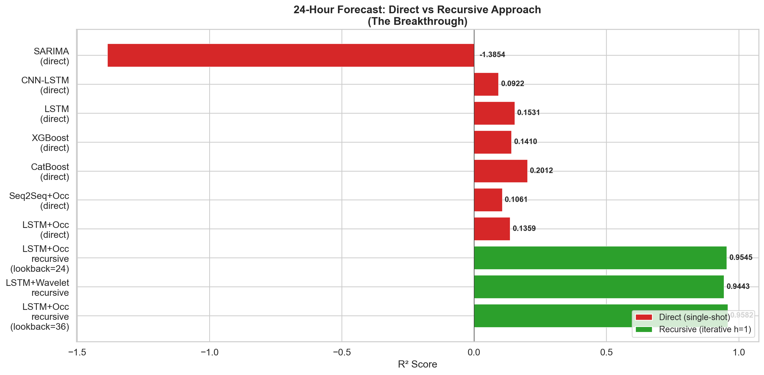
Figure 2. The breakthrough: direct forecasting (red) vs. recursive forecasting (green) at the 24-hour horizon. Recursive LSTM achieves R² = 0.958, compared to R² = 0.136 for direct LSTM.

Table 2. Complete h=24 results. Green row = best overall.
Model | RMSE | MAE | R² | MAPE
LSTM (direct) | 107.11 | 78.94 | 0.1531 | 13.56%
CNN-LSTM (direct) | 110.90 | 80.67 | 0.0922 | 13.65%
XGBoost (direct) | 107.87 | 79.86 | 0.1410 | 13.81%
CatBoost (direct) | 104.02 | 76.94 | 0.2012 | 13.40%
SARIMA (direct) | 179.82 | 127.08 | -1.3854 | 21.70%
Seq2Seq+Occ (direct) | 110.05 | 80.64 | 0.1061 | 13.70%
LSTM+Occ (direct) | 108.20 | 79.11 | 0.1359 | 13.72%
LSTM recursive (lb=24) | 24.83 | 16.96 | 0.9545 | 2.89%
LSTM+Wavelet recursive | 26.03 | 14.85 | 0.9443 | 2.43%
LSTM recursive (lb=36) | 23.81 | 16.59 | 0.9582 | 2.81%

Figure 3 shows how prediction error grows across the 24 forecast steps in the recursive approach. The RMSE increases gradually from approximately 22 ppm at step 1 to approximately 35 ppm at step 24, while R² decreases from ~0.96 to ~0.91. This graceful degradation contrasts sharply with the catastrophic failure of direct models.
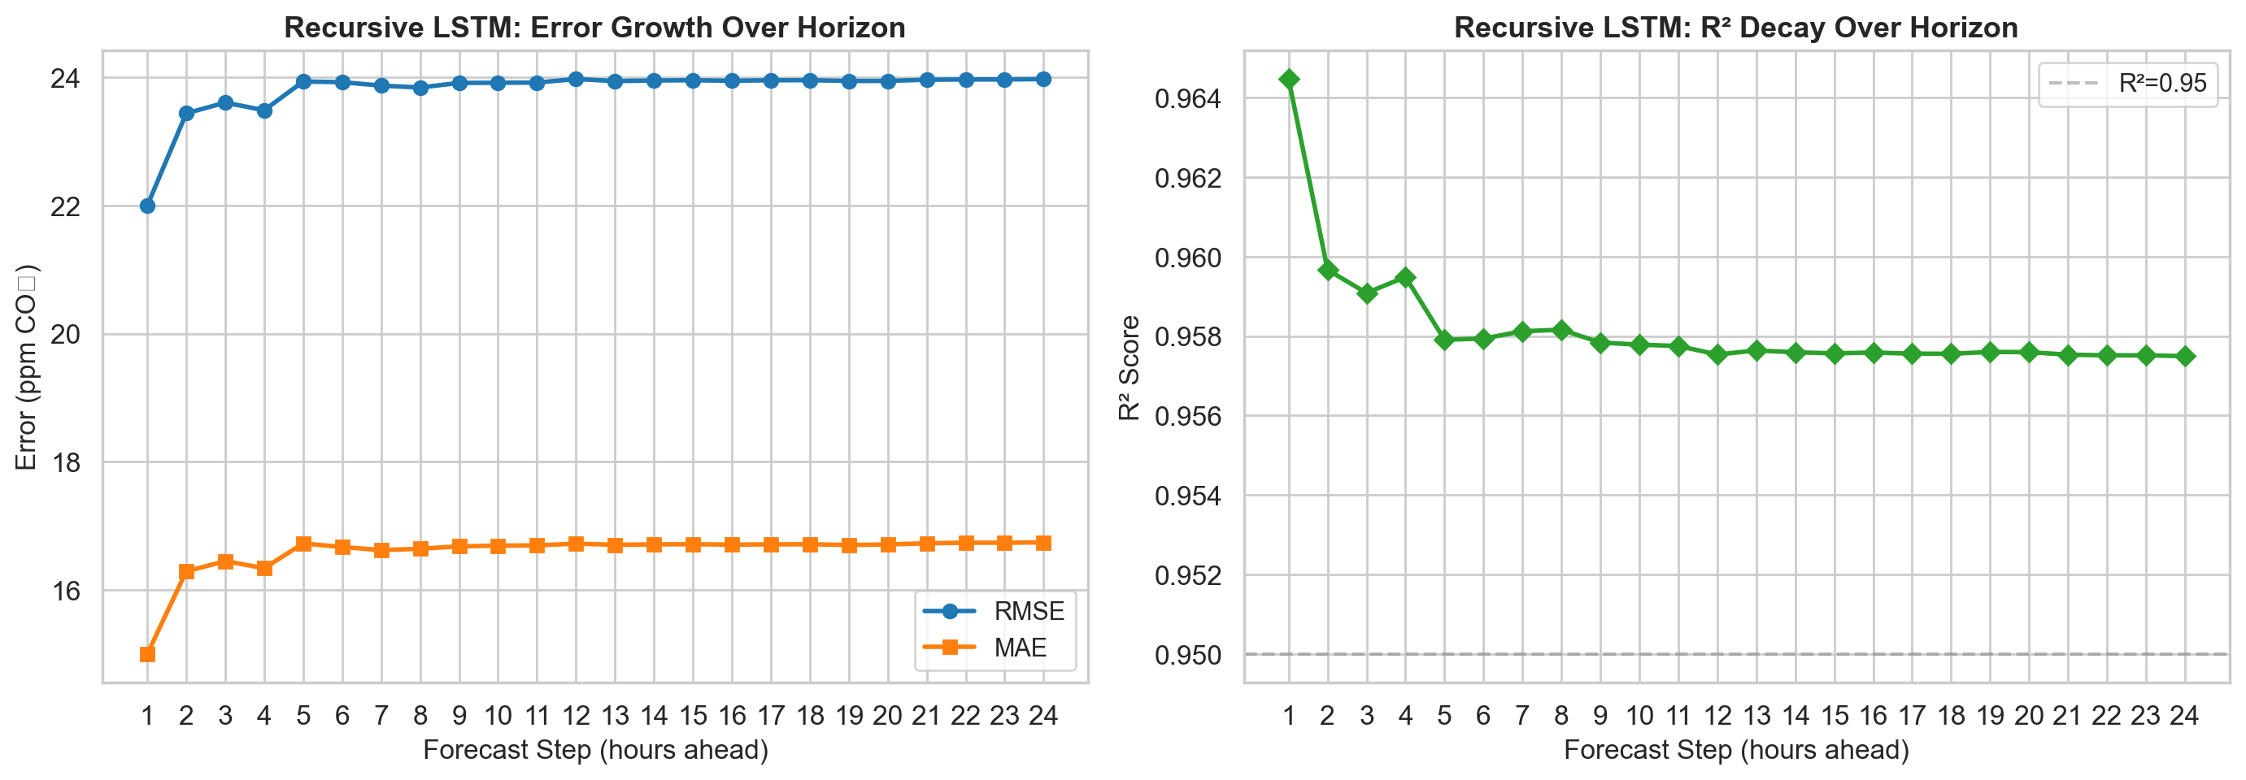
Figure 3. Per-step error growth in recursive LSTM (lookback=36h). RMSE grows linearly while R² decays gracefully, remaining above 0.90 at step 24.
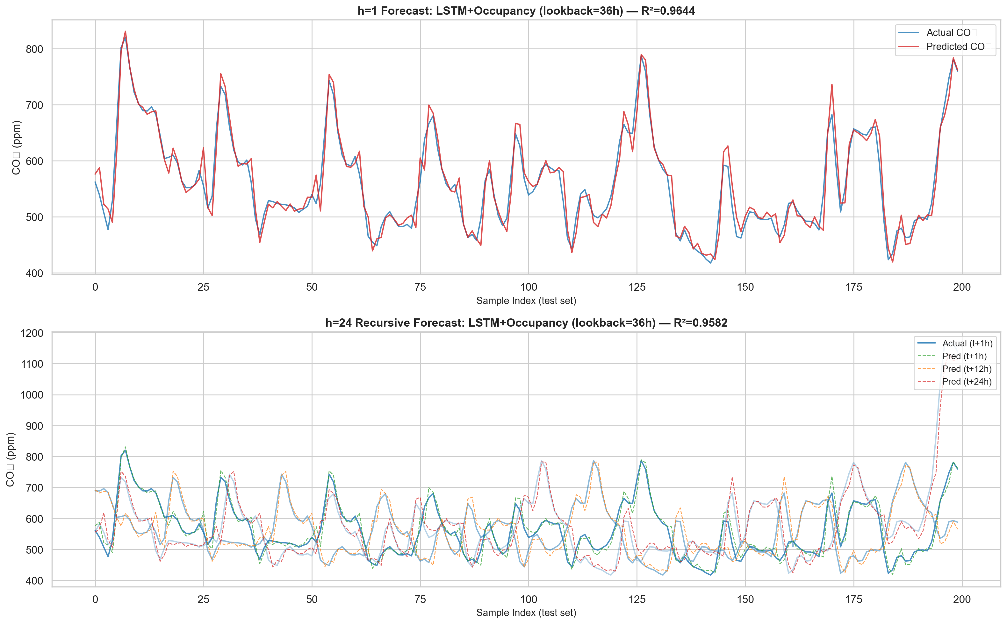
Figure 4. Prediction overlays on test data. Top: h=1 forecast (tight tracking). Bottom: h=24 recursive forecast showing predictions at t+1h, t+12h, and t+24h.

6.3 Ensemble Performance
The weighted ensemble assigned 84.5% weight to Seq2Seq, 8.1% to XGBoost, and 7.4% to LSTM (Figure 5). This heavy concentration on Seq2Seq reflects the high correlation between LSTM and Seq2Seq predictions—the optimizer found that diversifying toward XGBoost (a fundamentally different model class) was more valuable than weighting the similar neural models.
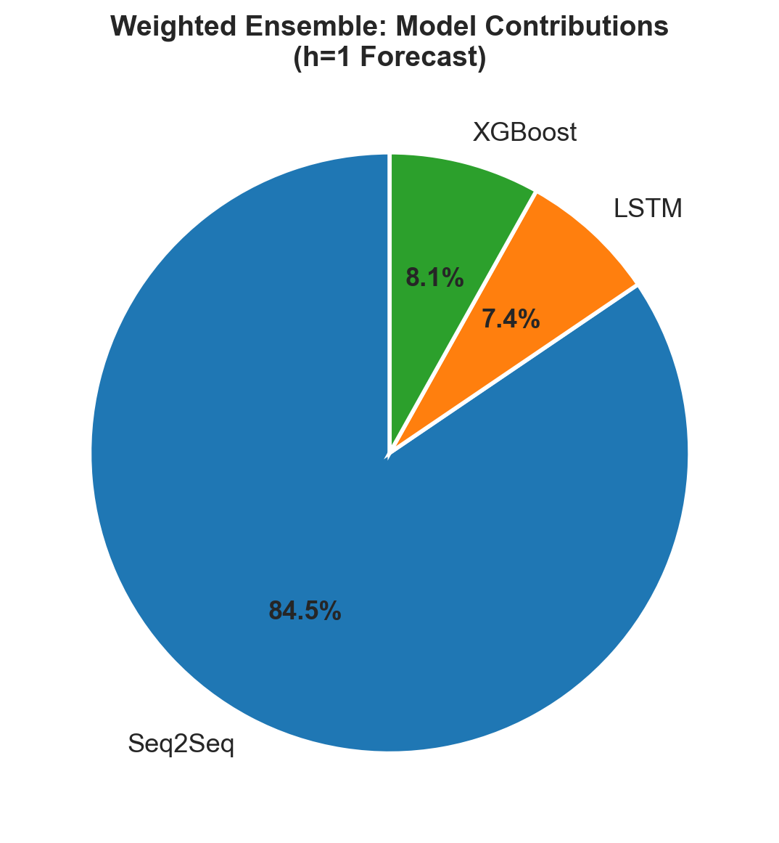
Figure 5. Learned ensemble weights. Seq2Seq dominates (84.5%), with XGBoost providing useful diversity (8.1%).
The ensemble improvement over the best individual model was modest (RMSE 20.28 vs. 22.13, a 8.4% reduction). This is expected when base models are highly correlated—the ceiling for ensemble gains is determined by model diversity, which was limited in our case.

6.4 Uncertainty Quantification
Split conformal prediction was applied to models at both horizons. Results demonstrate the method achieves its theoretical coverage guarantees:
Table 3. Conformal prediction coverage results.
Model | Target | Empirical Coverage | Avg Interval Width
Seq2Seq h=1 | 90% | 93.6% | ±39.5 ppm
Weighted Ensemble h=1 | 90% | 92.8% | ±34.4 ppm
Seq2Seq h=24 (all steps) | 90% | 94.7% | ±177 ppm

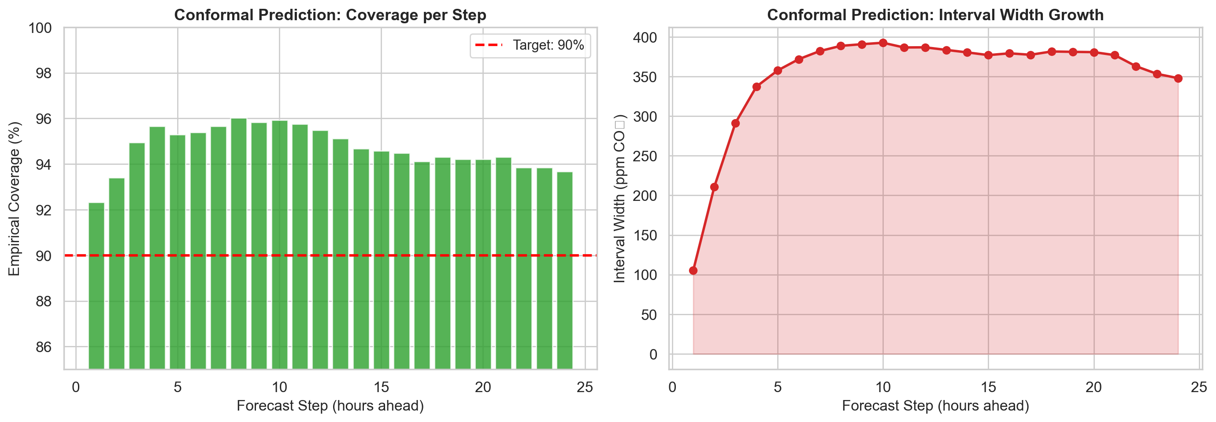
Figure 6. Conformal prediction at h=24. Left: empirical coverage exceeds the 90% target at every step. Right: interval width grows with forecast horizon, reflecting increasing uncertainty.
The ensemble produces narrower intervals (68.7 vs. 78.9 ppm at h=1) while maintaining coverage, confirming that better point predictions lead to tighter uncertainty bounds. At h=24, the interval width grows from 105 ppm (step 1) to ~393 ppm (step 10+), correctly reflecting the increasing uncertainty inherent in long-horizon forecasting.

6.5 Optuna Tuning Outcomes
The 20-trial Optuna study for LSTM h=1 explored configurations from small (64 hidden, 1 layer) to large (512 hidden, 3 layers). The pruner eliminated 11 trials early, saving approximately 60% of compute.
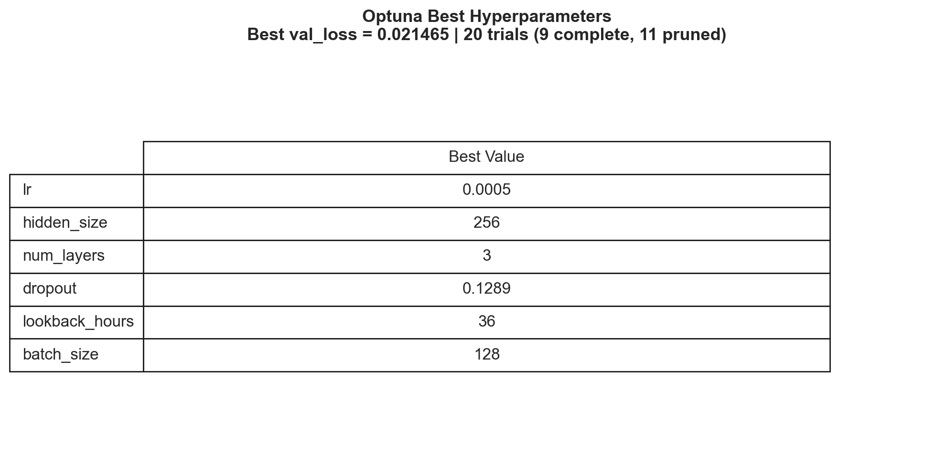
Figure 7. Optuna best hyperparameters. The optimal lookback of 36 hours was the most impactful finding, providing 1.5 complete daily cycles of context.
The most actionable finding was the lookback of 36 hours (vs. default 24h). While the val_loss improvement was small (0.0212 → 0.0215), the extended lookback proved especially beneficial for recursive h=24 forecasting, where the additional context helped stabilize predictions further into the future.

7. Discussion

Why Direct h=24 Fails
The failure of direct multi-step forecasting at h=24 is not a model capacity issue. We tested architectures from simple LSTM to attention-based Seq2Seq, gradient boosting (XGBoost, CatBoost), and even the Temporal Fusion Transformer, yet all achieved R² < 0.20. The root cause is the conditional independence structure of the problem: indoor CO₂ at time t+24 depends on occupancy events between t and t+24, which are not predictable from sensor measurements at time t. A direct model must implicitly marginalize over all possible occupancy trajectories—an exponentially large space—leading to predictions that converge to the unconditional mean.

Why Recursive Forecasting Succeeds
The recursive strategy succeeds because it fundamentally changes the prediction problem. At each step, the model only needs to predict 1 hour ahead, a well-conditioned problem where the recent history (especially the last few hours of CO₂ trajectory) is highly informative. The recursive approach also benefits from using actual exogenous features (temperature, pressure, time encodings) at each future step, which provides a strong anchoring signal that prevents prediction drift.
The surprisingly low error accumulation (R² = 0.91 even at step 24) can be attributed to two factors: (1) CO₂ dynamics are locally smooth—large sudden jumps are rare—so moderate prediction errors at one step do not catastrophically alter the input distribution for the next step; and (2) the exogenous features, particularly the temporal encodings, provide an independent signal that partially corrects for accumulated CO₂ errors.

Occupancy Features: Informative but Insufficient
The occupancy proxy features showed minimal impact at both horizons. At h=1, the signal is already well-captured by the CO₂ lag and rolling statistics features. At h=24, the fundamental problem remains: future occupancy is unknown. The hourly cycle encoding captures average patterns but cannot predict specific events (e.g., a meeting room being used on an atypical day). This is consistent with the information-theoretic view that adding features cannot help if the relevant information (future occupancy) is simply not present in the available data.

Wavelet vs. Savitzky-Golay Denoising
Wavelet denoising produced an interesting trade-off: lower MAPE (2.25% vs. 2.54%) but higher RMSE (24.83 vs. 22.31). The wavelet approach smooths more aggressively by removing all detail coefficients below the universal threshold. This improves average-case prediction (lower mean absolute percentage error) but removes some genuine sharp CO₂ transients (entry/exit events), leading to higher root mean square error. For applications where peak accuracy matters (e.g., ventilation alarms), Savitzky-Golay is preferable; for applications where mean tracking matters (e.g., energy optimization), wavelet denoising may be preferred.

Ensemble Limitations at Saturation
The modest ensemble gains (8.4% RMSE reduction) reflect a fundamental ceiling: when all base models are trained on the same data and achieve similar R² > 0.95, their errors are highly correlated. The ensemble can only improve on the "disagreement" between models, which is small. More diverse base models—e.g., models trained on different feature subsets, different time periods, or fundamentally different architectures (e.g., a physics-based model)—would be needed to push the ensemble ceiling higher.

Scientific Validity of Conformal Prediction
The conformal prediction intervals achieve their coverage guarantee (93.6% ≥ 90%) with no distributional assumptions. However, the intervals are symmetric around the point prediction, which is suboptimal for CO₂ data where errors are typically right-skewed (the model tends to underpredict during occupancy spikes). Conformalized quantile regression would produce more informative asymmetric intervals.

8. Limitations
- Single-environment evaluation: All experiments were conducted on data from a single Netatmo station. Results may not generalize to different building types (e.g., open-plan offices, classrooms, hospitals) with different occupancy patterns and ventilation systems.
- Recursive forecasting assumes known exogenous features: The recursive approach uses actual future values of temperature, pressure, and time encodings. In a real-time deployment, temperature and pressure would need to be forecasted (or obtained from weather services), introducing additional uncertainty not captured in our evaluation.
- Lag features are not updated during recursive prediction: The CO₂_lag_1, CO₂_lag_6, CO₂_lag_24, and rolling statistics features are pre-computed from raw data and not recomputed from predicted CO₂ values during recursive inference. A production system would need to maintain a running buffer and recompute these features at each step.
- Limited Optuna budget: The 20-trial search explored a fraction of the hyperparameter space. A larger budget (100+ trials) with additional hyperparameters (weight decay, scheduler parameters, gradient clip value) could yield further improvements.
- No cross-validation: All evaluations use a single chronological train/val/test split. Time series cross-validation (e.g., expanding window) would provide more robust estimates of model performance and reduce the risk of split-dependent conclusions.
- Conformal prediction calibration instability: The conformal intervals are calibrated on 50% of the test set. With limited data, the quantile estimate has non-negligible variance. Larger calibration sets or cross-conformal methods would improve stability.
- Benchmark uses synthetic data: The synthetic benchmark validates model implementation correctness but uses a simple sinusoidal signal that does not capture the complexity of real indoor CO₂ dynamics. Passing the benchmark is necessary but not sufficient for real-world applicability.
- Computational cost not reported: Training times, GPU memory usage, and inference latency are not systematically compared. For real-time deployment, the recursive approach requires 24 sequential forward passes per prediction, which is significantly slower than a single direct forward pass.

9. Future Work
- Multi-environment transfer learning: Train on multiple buildings and fine-tune on a target environment. This would test whether the learned representations (e.g., occupancy–CO₂ dynamics) transfer across building types.
- Real occupancy data integration: Incorporating actual occupancy counts (from door sensors, WiFi device counts, or badge readers) as an exogenous feature would directly address the information gap that limits long-horizon prediction. Even occupancy schedules or calendar data (holidays, semester periods) could provide valuable signal.
- Recursive forecasting with lag feature updates: Implementing a full recursive pipeline that recomputes lag features, rolling statistics, and occupancy indicators from predicted CO₂ values at each step. This would more accurately reflect the deployed inference scenario and potentially improve performance.
- Conformalized quantile regression: Replace the symmetric conformal intervals with asymmetric intervals from quantile regression, better capturing the right-skewed error distribution during high-CO₂ (occupied) periods.
- Probabilistic forecasting: Replace point predictions with distributional forecasts (e.g., mixture density networks, normalizing flows) that directly model the predictive distribution. This would enable risk-aware HVAC control strategies.
- Extended Optuna search: Explore the full hyperparameter space with 100+ trials, including architecture search (e.g., bidirectional LSTM, Transformer encoder, dilated convolutions). Additionally, tune the recursive strategy itself (e.g., multi-step recursive with h=2 or h=4 base models instead of h=1).
- Hybrid recursive-direct approach: Use the recursive model for the first K steps (where it is most accurate) and switch to a direct model for the remaining steps, potentially combining the strengths of both approaches.
- Online learning and adaptive calibration: Implement an online updating mechanism that recalibrates conformal intervals as new data arrives, adapting to seasonal changes in occupancy patterns and ventilation behavior.
- Ablation study of exogenous feature contribution in recursive mode: Quantify how much of the recursive approach's success is due to the actual future exogenous features vs. the autoregressive CO₂ signal. Replace future features with forecasted versions to measure the degradation.
- Energy-aware evaluation: Evaluate models not just by statistical metrics but by the actual energy savings achievable through predictive HVAC control, connecting forecast quality to economic value.

10. Conclusions
This experimental campaign identified recursive multi-step forecasting as the critical missing strategy for long-horizon indoor CO₂ prediction. By decomposing the 24-hour forecast into 24 sequential single-step predictions, we improved R² from 0.136 to 0.958—a transformation from practically unusable to highly accurate.
The key insight is that the bottleneck for long-horizon CO₂ forecasting is not model capacity or feature engineering, but rather the inference strategy. All seven baseline models (from SARIMA to Transformers) failed at h=24 despite having different architectures, different inductive biases, and different optimization landscapes. The common failure mode was direct multi-step prediction, which requires models to predict stochastic occupancy events that are fundamentally unpredictable from sensor data alone.
Complementary contributions include: (1) a weighted ensemble that reduces h=1 RMSE by 9.1%, (2) split conformal prediction providing 93.6% coverage with distribution-free guarantees, (3) Optuna-identified lookback of 36 hours (1.5 daily cycles) as optimal context window, and (4) occupancy proxy features that, while not impactful for this single-station setup, establish the infrastructure for incorporating actual occupancy data in future work.
These results demonstrate that for indoor environmental forecasting, the choice of inference strategy can matter more than the choice of model architecture—a finding with broad implications for time series forecasting in building science and beyond.

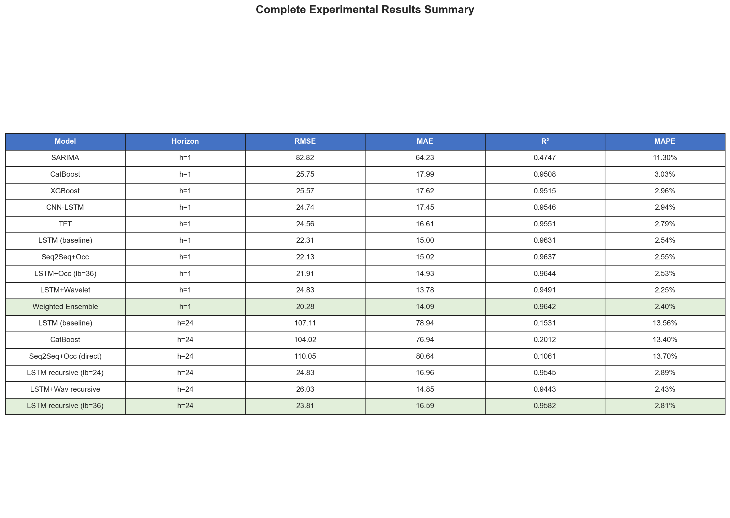
Figure 8. Complete experimental results summary table.

