Occupancy Inference from Indoor CO₂ Measurements:
A Comparative Study of Rule-Based, HMM,
and Physics-Informed Approaches

SalonBM Dataset — Hourly CO₂, Noise, and Derived Features

Generated: February 22, 2026

Table of Contents
- 1. Abstract
- 2. Introduction
- 3. Dataset and Features
- 4. Rule-Based Occupancy Detectors
- 4.1 Detector Descriptions
- 4.2 Consensus Evaluation
- 4.3 Actual vs. Predicted CO₂
- 5. HMM-Based Occupancy Detection
- 5.1 Gaussian HMM Baseline
- 5.2 HMM with Temporal Features (sin/cos)
- 5.3 Mixed Gaussian–von Mises HMM
- 6. Physics-Informed Switching AR-HMM
- 6.1 Model Formulation
- 6.2 Occupancy Mapping Strategy
- 6.3 Experimental Results
- 7. Comparative Analysis
- 8. Discussion
- 9. Limitations
- 10. Future Work
- 11. Conclusions

1. Abstract
Occupancy detection in buildings is critical for energy-efficient HVAC control, demand-driven ventilation, and smart building management. This report presents a comprehensive evaluation of occupancy inference methods using indoor CO₂ concentration measurements from the SalonBM dataset, a residential living room monitored at hourly intervals. We compare six rule-based detectors, Gaussian Hidden Markov Models (HMMs) with various feature sets, a custom Mixed Gaussian–von Mises HMM for circular temporal features, and a physics-informed Switching Autoregressive HMM grounded in the CO₂ mass-balance equation.
In the absence of ground-truth occupancy labels, we adopt a majority-vote consensus among the six rule-based detectors as a pseudo-ground-truth reference. The best performing approach is the Gaussian HMM using CO₂, dCO₂/dt, and noise level (κ = 0.53 vs. consensus), while adding temporal features consistently degrades performance. The physics-informed Switching AR model offers superior interpretability through learned ventilation time constants and CO₂ generation rates, and achieves the highest agreement with the rate-of-change detector (κ = 0.70), but scores lower against consensus (κ = 0.32). These findings highlight a fundamental tension between dynamics-based and level-based occupancy definitions.

2. Introduction
Indoor air quality monitoring has become increasingly important for occupant health, energy management, and building automation. CO₂ concentration serves as a reliable proxy for human presence because metabolic respiration directly generates CO₂, causing measurable increases relative to the outdoor baseline (~420 ppm). When occupants leave, ventilation dilutes the indoor CO₂ back toward ambient levels.
The key challenge is that CO₂ is a lagging indicator: concentrations remain elevated after occupants depart (due to the ventilation time constant τ) and may not rise immediately upon arrival (due to the slow accumulation rate relative to sampling frequency). This makes simple thresholding unreliable, motivating more sophisticated approaches that consider dynamics (rate of change), temporal patterns (time of day), and physics-based models (ventilation equations).
This report evaluates four families of approaches across a common dataset and evaluation protocol:
- Rule-based detectors: Six heuristic methods ranging from absolute CO₂ thresholds to state machines and the literature-based Diarra method.
- Gaussian HMM: Standard multivariate Gaussian emission HMM with exhaustive binary mapping search over state-to-occupancy assignments.
- Mixed Gaussian–von Mises HMM: A custom HMM combining Gaussian emissions for continuous features with von Mises distributions for circular temporal features.
- Physics-informed Switching AR-HMM: An autoregressive model derived from the CO₂ mass-balance ODE, with learned ventilation and generation parameters.

3. Dataset and Features
The SalonBM dataset contains continuous sensor measurements from a residential living room in France, resampled to 1-hour intervals. The test set comprises 2,260 hourly observations (~94 days). No ground-truth occupancy labels are available.

Sensor Variables
- CO₂ (ppm): Indoor carbon dioxide concentration; primary occupancy indicator
- dCO₂/dt (ppm/h): First derivative of CO₂; captures arrival/departure dynamics
- Noise (dB): Ambient sound level; secondary human activity indicator

Derived Temporal Features
- Day_sin, Day_cos: 24-hour cycle encoded as sin/cos of 2π·hour/24
- Weekday_sin, Weekday_cos: 7-day cycle encoded as sin/cos of 2π·weekday/7
- hour_weekday_sin/cos: 168-hour combined weekly cycle
- hour (angle): Hour of day as an angle in [0, 2π) for von Mises distributions
- day-of-week (angle): Day of week as an angle in [0, 2π) for von Mises distributions

4. Rule-Based Occupancy Detectors

4.1 Detector Descriptions
Absolute Threshold. The simplest approach: occupied = CO₂ > 500 ppm. Effective when ventilation is stable but unable to distinguish sustained elevated CO₂ after departure from active presence.
Rate of Change. Occupied when the smoothed dCO₂/dt > 5.0 ppm/h (3-step rolling window). Captures arrival events through rising CO₂ but misses stable high-occupancy periods where the rate flattens.
Adaptive Threshold. Learns per-hour CO₂ thresholds from training data as the 75th percentile + 50 ppm margin. Most conservative detector, yielding only 10.4% occupancy.
Hybrid. OR-gate fusion: occupied = (absolute threshold) OR (rate of change). Reduces false negatives by combining level and dynamics signals.
State Machine. Four-state finite automaton (UNOCCUPIED → ONSET → OCCUPIED → DECAY) with configurable thresholds (onset dCO₂ > 5 ppm/h, sustain CO₂ > 500 ppm, 6-step timeout, 2-step minimum onset). The stickiest detector at 91.8% occupancy.
Diarra (Diarra et al., Sensors 2023). Four-state classification using CO₂, dCO₂, and noise simultaneously: prolonged absence (CO₂ low, dCO₂ ≤ 0, noise low), presence (CO₂ > 600 ppm OR dCO₂ > 5 OR noise > 55 dB), absence (dCO₂ < 0, noise low), and inactive presence (CO₂ high, dCO₂ ≤ 0, noise low). Thresholds tuned for SalonBM.

4.2 Consensus Evaluation
Without ground-truth labels, we define the consensus as a majority vote across all six detectors: a timestep is labeled as occupied if at least four of six detectors agree. This provides a pseudo-ground-truth that balances diverse detection philosophies.

Table 1. Occupancy rates by detector (actual CO₂).
Detector | Occupancy Rate
Absolute Threshold | 75.9%
Rate of Change | 36.9%
Adaptive Threshold | 10.4%
Hybrid | 82.3%
State Machine | 91.8%
Diarra | 65.5%
Consensus (majority vote) | 61.8%

The inter-detector agreement measured by Fleiss' kappa is 0.1311, indicating weak overall agreement. This is expected given the fundamentally different detection philosophies: the rate-of-change detector fires only during dynamic events (36.9% occupancy), while the state machine is sticky by design (91.8%). The mean consistency (fraction of timesteps where a majority agrees) is 73.3%.

Table 2. Pairwise Cohen's kappa between detectors (actual CO₂).
 | Absolute | Rate of | Adaptive | Hybrid | State Ma | Diarra
Absolute Thr | 1.00 | 0.09 | 0.07 | 0.81 | 0.41 | 0.39
Rate of Chan | 0.09 | 1.00 | 0.03 | 0.22 | 0.00 | 0.37
Adaptive Thr | 0.07 | 0.03 | 1.00 | 0.05 | 0.02 | 0.11
Hybrid | 0.81 | 0.22 | 0.05 | 1.00 | 0.32 | 0.44
State Machin | 0.41 | 0.00 | 0.02 | 0.32 | 1.00 | 0.14
Diarra | 0.39 | 0.37 | 0.11 | 0.44 | 0.14 | 1.00

The strongest pairwise agreement is between the Absolute Threshold and Hybrid detectors (κ = 0.81), which is expected since the Hybrid includes the absolute threshold as one of its two components. The weakest agreement is between the Rate of Change and State Machine detectors (κ ≈ 0.00), reflecting their fundamentally different operating principles.
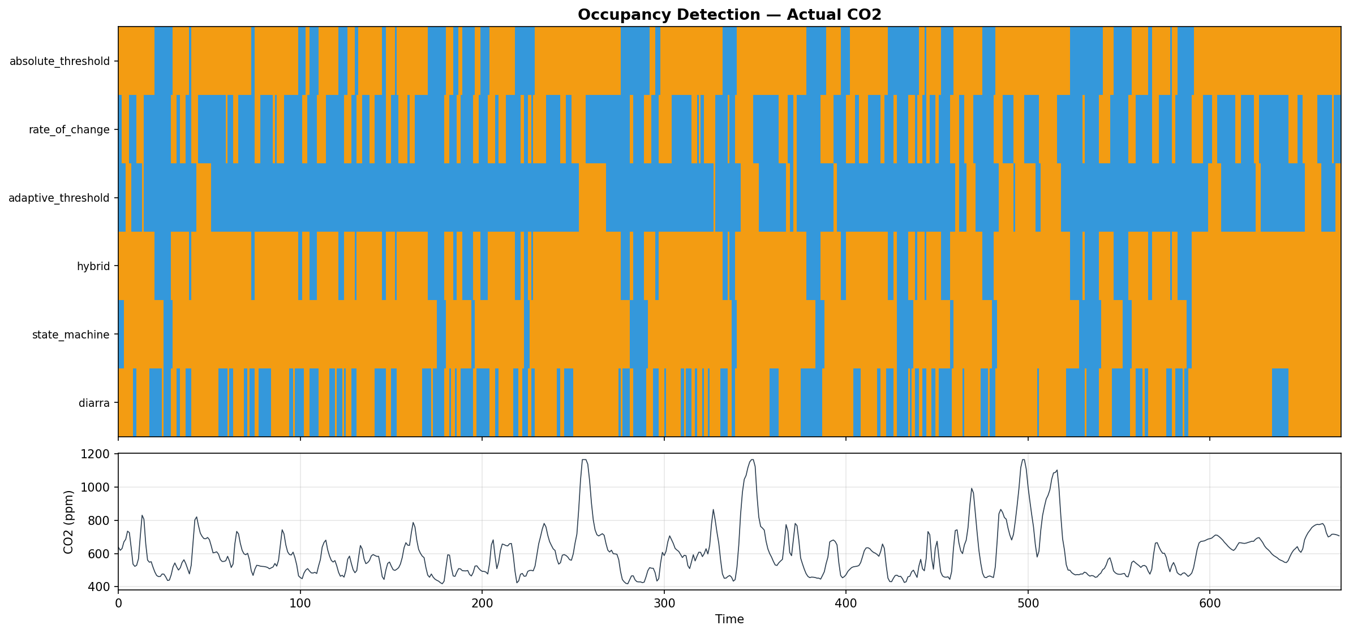
Figure 1. Timeline of all six detector outputs on actual CO₂ test data.
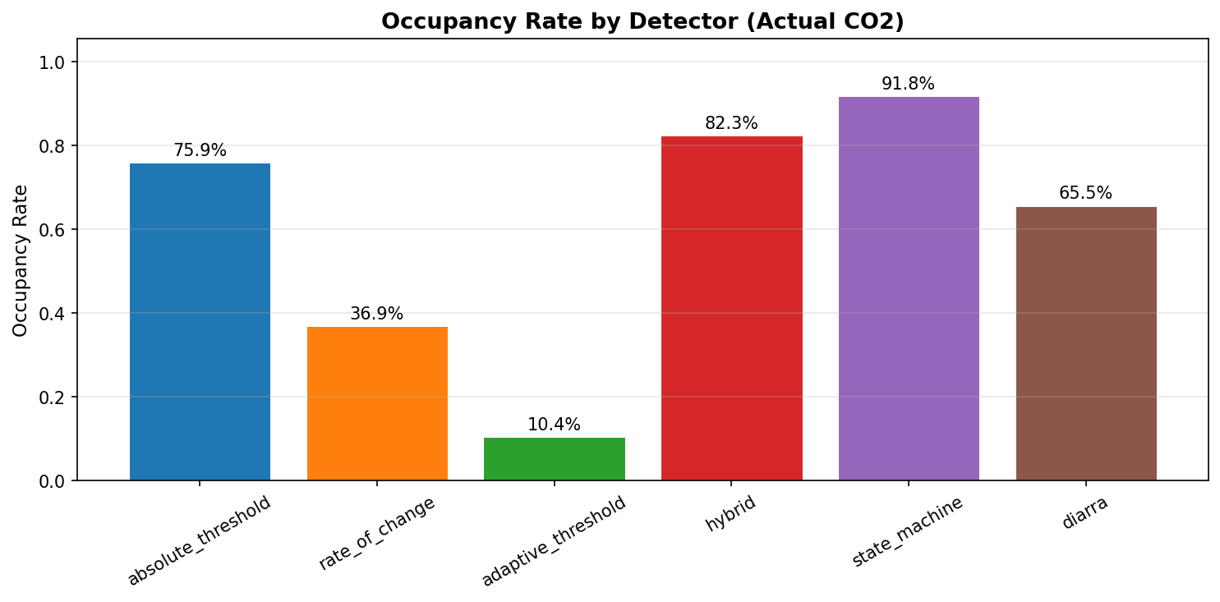
Figure 2. Comparison of occupancy rates across detectors.
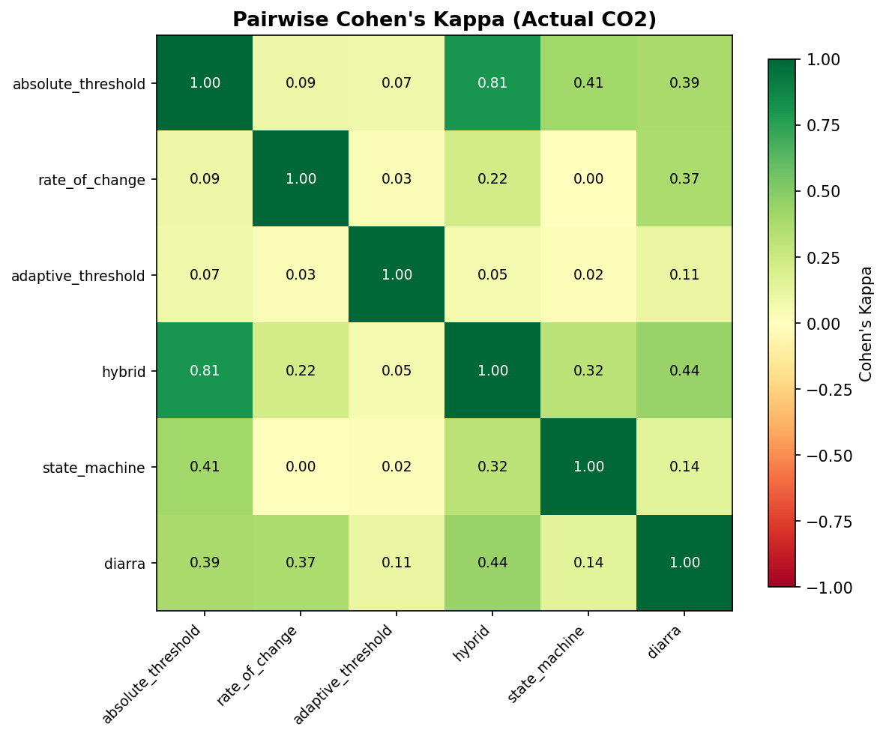
Figure 3. Heatmap of pairwise Cohen's kappa between detectors.

4.3 Actual vs. Predicted CO₂
To assess whether a forecasting model's predicted CO₂ preserves occupancy-relevant information, we run all six detectors on predicted CO₂ and compare the resulting occupancy labels to those from actual CO₂.
Table 3. Agreement between actual and predicted CO₂ occupancy detections.
Detector | Cohen's κ | Raw Agreement
Absolute Threshold | 0.8690 | 95.3%
Rate of Change | 0.7850 | 90.0%
Adaptive Threshold | 0.8647 | 97.5%
Hybrid | 0.8117 | 94.6%
State Machine | 0.7309 | 96.1%
Diarra | 0.7284 | 87.8%

All detectors show strong agreement (κ > 0.73) between actual and predicted CO₂, indicating that the forecasting model successfully preserves occupancy-relevant signal characteristics. The adaptive threshold achieves the highest raw agreement (97.5%) due to its conservative nature.
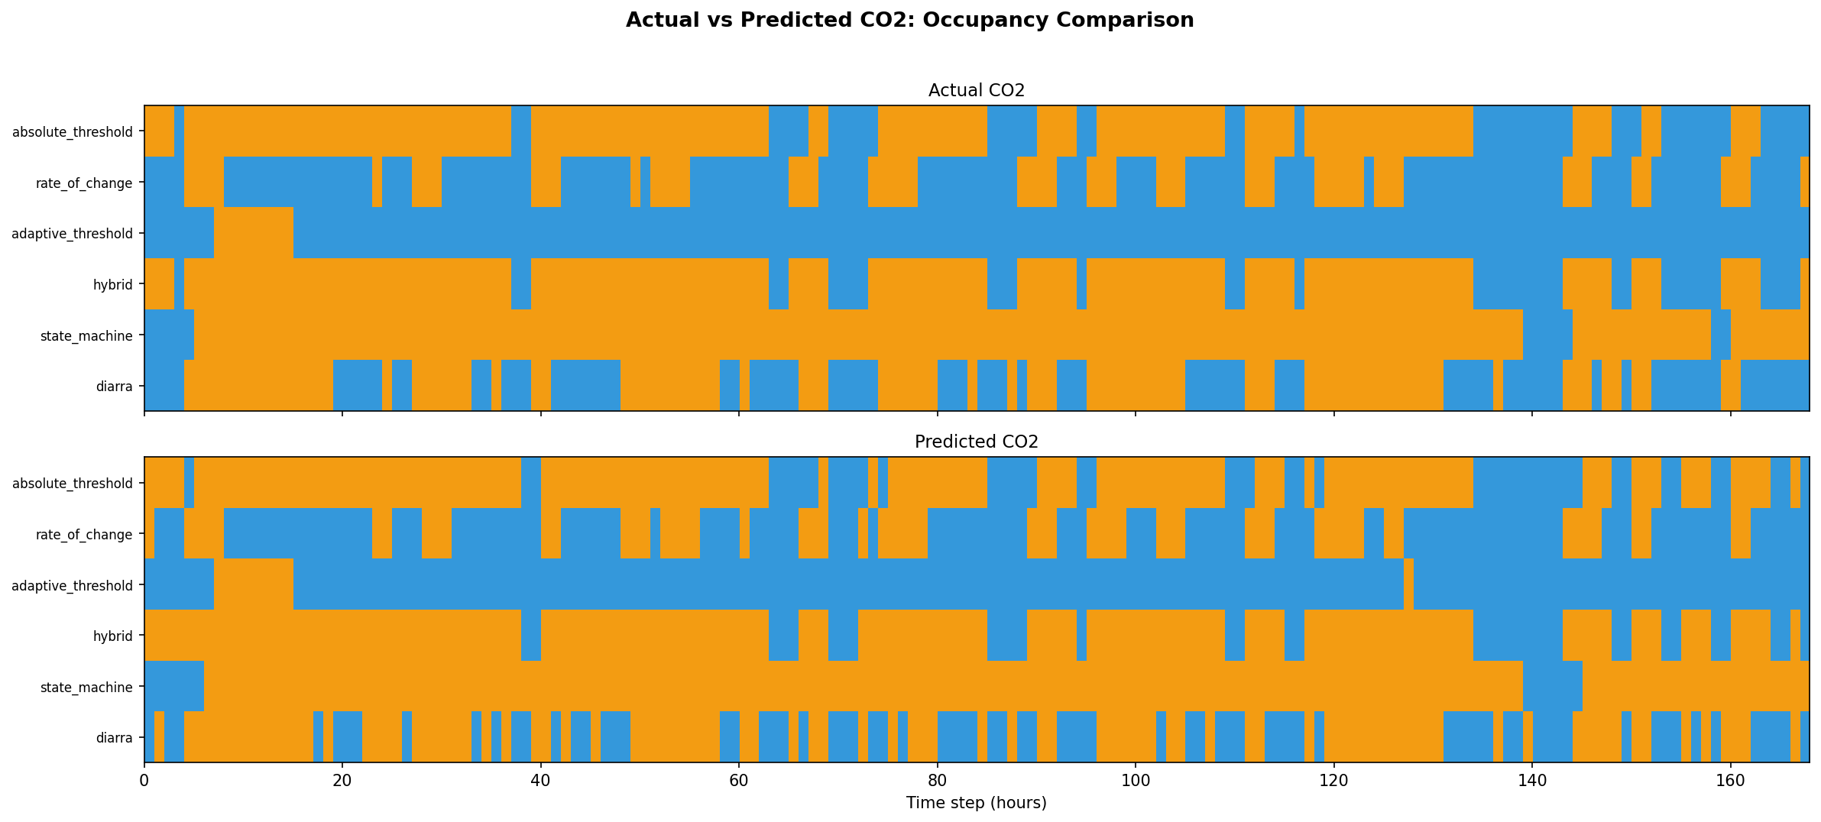
Figure 4. Actual vs. predicted CO₂ occupancy detection comparison.

5. HMM-Based Occupancy Detection
Hidden Markov Models offer a principled probabilistic framework for occupancy detection. Each HMM state implicitly captures a distinct CO₂ regime (e.g., unoccupied baseline, occupied with rising CO₂, decay after departure). The state-to-occupancy mapping is determined post-hoc via exhaustive search over all 2ᴷ − 2 possible binary assignments of K states to {occupied, unoccupied}, selecting the mapping that maximizes Cohen's kappa against the consensus.

5.1 Gaussian HMM Baseline
The Gaussian HMM baseline uses three features (CO₂, dCO₂/dt, Noise) with K=4 states. After training on the training set and decoding the test set via the Viterbi algorithm, exhaustive bitmask search yields the best consensus agreement at κ = 0.5324 with an occupancy rate of 71.3%.

Table 4. Gaussian HMM baseline state profiles (4 states, CO₂+dCO₂+Noise).
State | Time % | CO₂ (ppm) | dCO₂/dt | Noise (dB) | Consensus Occ.
0 | 28.7% | 485 | +0.2 | 50.4 | 48%
1 | 37.5% | 657 | +9.8 | 55.8 | 95%
2 | 2.7% | 592 | +2.3 | 47.9 | 100%
3 | 31.2% | 608 | -12.4 | 51.1 | 95%

The four states have clear physical interpretations: State 0 represents unoccupied baseline (CO₂ ≈ 485 ppm, 47.7% consensus), State 1 captures active occupancy with rising CO₂ (657 ppm, +9.8 ppm/h, 95.4% consensus), State 2 is a rare high-CO₂ state (2.7% of time, 100% consensus), and State 3 represents post-occupancy decay (608 ppm, −12.4 ppm/h, 94.6% consensus).

5.2 HMM with Temporal Features (sin/cos)
We hypothesized that encoding time-of-day and day-of-week as sin/cos features would help the HMM discover occupancy-aligned states by learning diurnal and weekly patterns. Seven configurations were tested with 4–6 states.
Table 5. Gaussian HMM occupancy results with temporal features.
Features | K | κ vs. Consensus | Occ. Rate | Occupied States
CO₂+dCO₂+Noise | 4 | 0.5324 | 71.3% | [1, 2, 3]
+Day sin/cos | 4 | 0.0687 | 42.7% | [0, 3]
+Day+Weekday | 4 | 0.0705 | 46.1% | [1, 3]
+hour_weekday | 4 | 0.0435 | 70.9% | [0, 1, 2]
+All temporal | 4 | 0.0489 | 10.0% | [0, 1, 3]
+Day sin/cos | 5 | 0.0855 | 41.7% | [0, 4]
+Day+Weekday | 6 | 0.1011 | 64.2% | [0, 2, 3, 4]

All temporal feature configurations degrade performance relative to the baseline. The worst degradation occurs with the 168-hour weekly cycle (Exp3, κ = 0.04), where the HMM learns to segment by time-of-day rather than by CO₂ dynamics. Even with additional states (Exp5: 5 states, Exp6: 6 states), temporal features fail to recover baseline performance.
The root cause is that Gaussian HMM treats sin/cos features as independent Gaussian dimensions, ignoring their circular topology. The HMM can learn that State A occurs when Day_sin ≈ −0.87 (morning) and State B when Day_sin ≈ 0.87 (evening), but this temporal segmentation overrides the CO₂-based occupancy signal rather than complementing it.
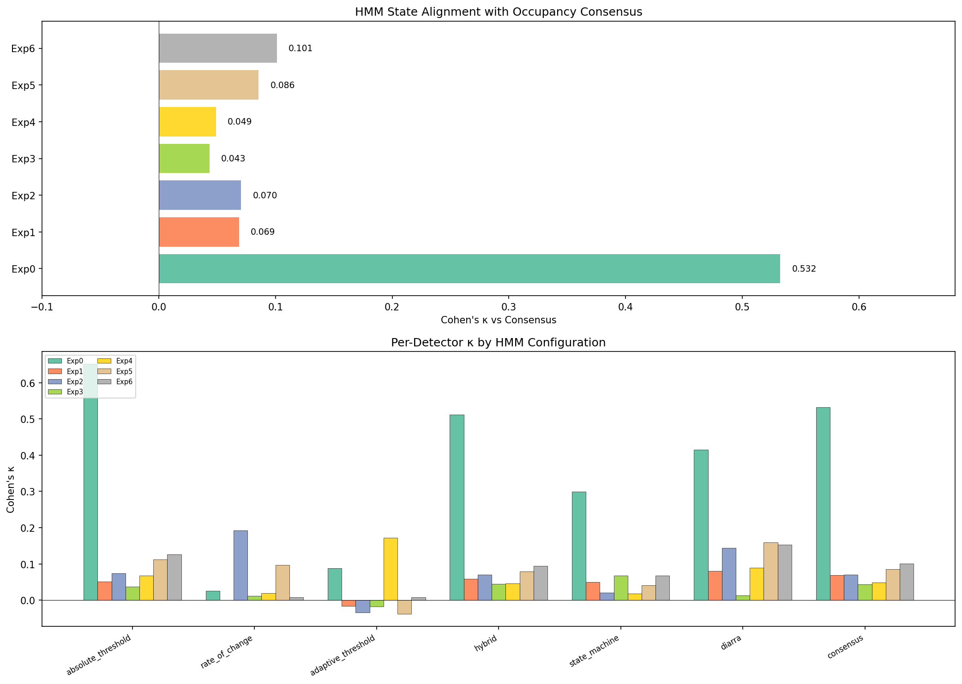
Figure 5. HMM kappa vs. consensus across temporal feature configurations.

5.3 Mixed Gaussian–von Mises HMM
To properly handle circular temporal features, we implemented a custom HMM that combines Gaussian emissions for continuous features (CO₂, dCO₂, Noise) with von Mises emissions for circular features (hour of day, day of week). The von Mises distribution is the circular analogue of the Gaussian, parameterized by a mean direction μ ∈ [0, 2π) and concentration κ ≥ 0.
f(θ | μ, κ) = exp(κ · cos(θ − μ)) / (2π · I₀(κ))
where I₀ is the modified Bessel function of the first kind of order zero.
Table 6. Gaussian vs. Mixed Gaussian–von Mises HMM comparison.
Configuration | K | κ vs. Consensus | Occ. Rate
Gaussian: CO₂+dCO₂+Noise | 4 | 0.5324 | 71.3%
Gaussian: +Day sin/cos | 4 | 0.0687 | 42.7%
Gaussian: +Day+Weekday | 4 | 0.0705 | 46.1%
Mixed: +hour(VM) 4st | 4 | 0.1613 | 44.4%
Mixed: +hour(VM) 5st | 5 | 0.1843 | 47.7%
Mixed: +hour(VM) 6st | 6 | 0.2665 | 73.2%
Mixed: +hour+dow(VM) 4st | 4 | 0.1634 | 44.4%
Mixed: +hour+dow(VM) 5st | 5 | 0.2709 | 66.4%
Mixed: +hour+dow(VM) 6st | 6 | 0.2495 | 73.1%
Mixed: +hour(VM) 8st | 8 | 0.2398 | 77.0%

The Mixed Gaussian–von Mises HMM partially recovers the performance lost by treating temporal features as Gaussian. The best Mixed configuration achieves κ = 0.2709, approximately 3–4× better than the Gaussian equivalent with sin/cos features (κ ≈ 0.07), but still below the baseline Gaussian HMM without temporal features (κ = 0.53).
This indicates that while the von Mises distribution correctly models the circular topology, temporal features are fundamentally uninformative for occupancy detection in this dataset. The CO₂ dynamics alone (level and rate of change) carry the essential occupancy signal.
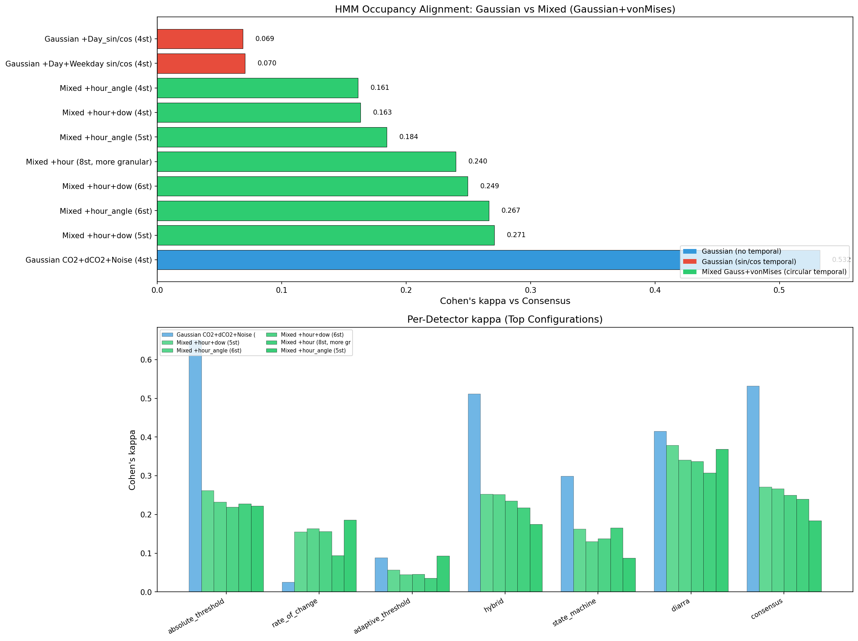
Figure 6. Gaussian vs. Mixed HMM kappa comparison across configurations.
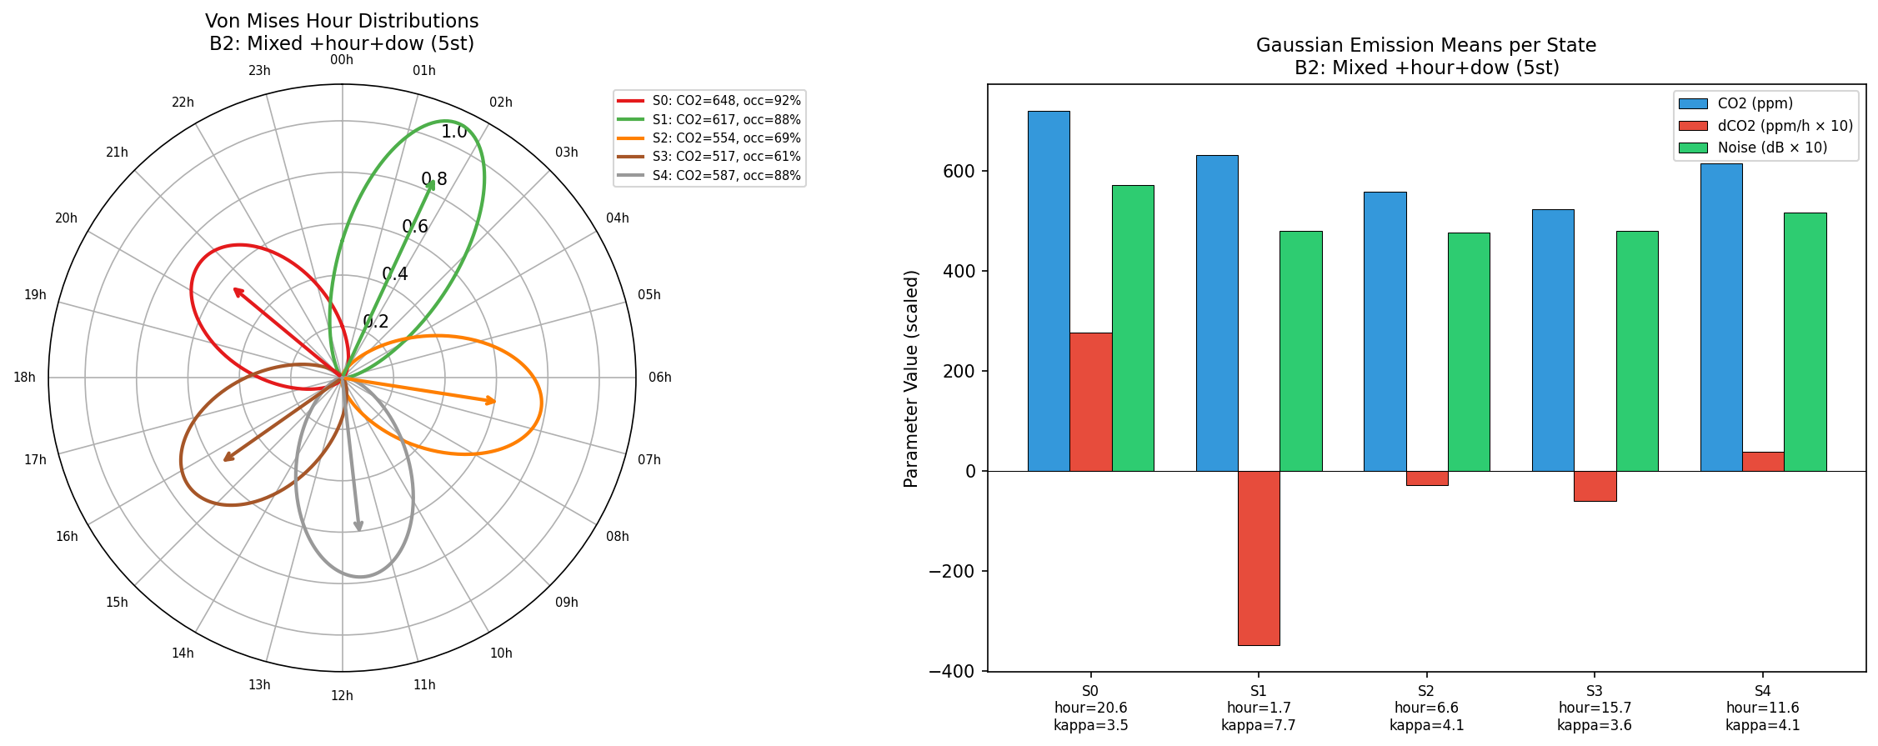
Figure 7. Von Mises circular state interpretation (polar plot).

6. Physics-Informed Switching AR-HMM

6.1 Model Formulation
The Switching Autoregressive HMM is grounded in the indoor CO₂ mass-balance ordinary differential equation. The underlying continuous-time model describes the CO₂ concentration y(t) as:
dy/dt = −(1/τ) · y(t) + n(t) · r
where τ is the ventilation time constant (hours), n(t) is the number of occupants, and r is the per-person CO₂ generation rate (ppm/h). Discretizing with time step Δt gives a first-order autoregressive model:
yₜ = cₖ · yₜ₋₁ + μₖ + εₜ
where the regime-specific parameters are:
- cₖ = exp(−Δt/τₖ): the autoregressive coefficient, encoding the ventilation time constant τₖ. Physically constrained to (0, 1).
- μₖ = (1 − cₖ) · r · nₖ: the drift term, encoding occupancy-driven CO₂ generation. Positive μ implies active CO₂ sources (people present); negative or zero μ implies decay toward ambient (unoccupied).
- εₜ ~ N(0, σ²ₖ): regime-specific observation noise.
The model is trained via the Expectation-Maximization algorithm with the forward–backward algorithm computed in log-space for numerical stability. The M-step uses weighted least squares with Cramer's rule to update (cₖ, μₖ) from the 2×2 normal equations. Global initialization uses Yule–Walker estimation of the AR(1) coefficient from the sample autocorrelation at lag 1.

6.2 Occupancy Mapping Strategy
Two mapping strategies are evaluated:
Physics-based (Otsu on μ). Apply Otsu's thresholding to the K drift parameters μₖ to find the binary split that minimizes within-class variance. A physical floor enforces μₖ > 0 for occupied states (negative drift means CO₂ is decaying, implying no occupants). This approach is fully unsupervised and physically interpretable.
Exhaustive bitmask search. Try all 2ᴷ − 2 possible state-to-occupancy mappings and select the one maximizing κ vs. consensus. This provides an upper bound on the model's state segmentation quality, independent of the mapping strategy.
An initial implementation using Otsu thresholding on the generation rate μ/(1−c) was found to be numerically unstable when c → 1, as (1−c) → 0 causes the generation rate to explode. The μ-based approach avoids this issue.

6.3 Experimental Results
Table 7. Switching AR-HMM results: physics-based vs. exhaustive bitmask mapping.
Model | κ (physics) | Occ% (phys) | κ (bitmask) | Occ% (bitmask) | Bitmask States | Iter.
K=3 | 0.1059 | 19.9% | 0.1059 | 19.9% | [2] | 20
K=4 | 0.1018 | 19.2% | 0.3576 | 65.8% | [0, 2, 3] | 40
K=5 | 0.3045 | 46.4% | 0.3213 | 58.5% | [0, 3, 4] | 136
K=6 | 0.1709 | 29.3% | 0.2993 | 44.8% | [3, 4, 5] | 113
K=8 | 0.2952 | 45.2% | 0.3443 | 54.9% | [1, 4, 5, 6, 7] | 133

The best configuration (K=4) achieves κ = 0.3576 against consensus via exhaustive search, and κ = 0.1018 via physics-based mapping.

Table 8. Switching AR K=8: per-detector Cohen's kappa (physics-based mapping).
Detector | κ
Absolute Threshold | 0.2279
Rate of Change | 0.7013
Adaptive Threshold | 0.1175
Hybrid | 0.2844
State Machine | 0.0574
Diarra | 0.5257
Consensus | 0.2952

The switching AR model achieves its highest agreement with the Rate of Change detector (κ = 0.70), which is the single highest model-detector agreement across all experiments. This reflects the AR model's strength in capturing CO₂ dynamics rather than absolute levels.

Table 9. Switching AR K=5 learned physical parameters.
State | Time% | CO₂ | c | μ (ppm) | σ | Gen. rate | Label
0 | 12.1% | 583 | 0.8432 | -21.95 | 29.7 | -140 | unoccupied
1 | 14.7% | 538 | 0.8927 | -8.70 | 8.4 | -81 | unoccupied
2 | 26.8% | 546 | 0.9337 | +0.78 | 5.6 | +12 | unoccupied
3 | 27.0% | 604 | 0.9262 | +19.74 | 8.9 | +267 | occupied
4 | 19.3% | 679 | 0.9637 | +54.60 | 40.2 | +1503 | occupied

The learned parameters are physically interpretable: states with high c (slow ventilation) and positive μ (CO₂ generation) correspond to occupied periods, while states with low c (fast ventilation) and negative μ correspond to unoccupied periods with active air exchange.
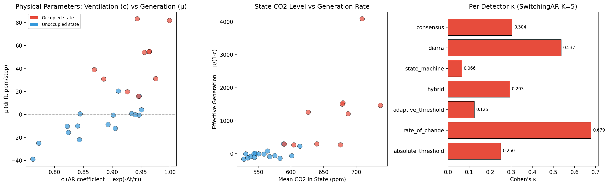
Figure 8. Switching AR-HMM learned physical parameters across K values.
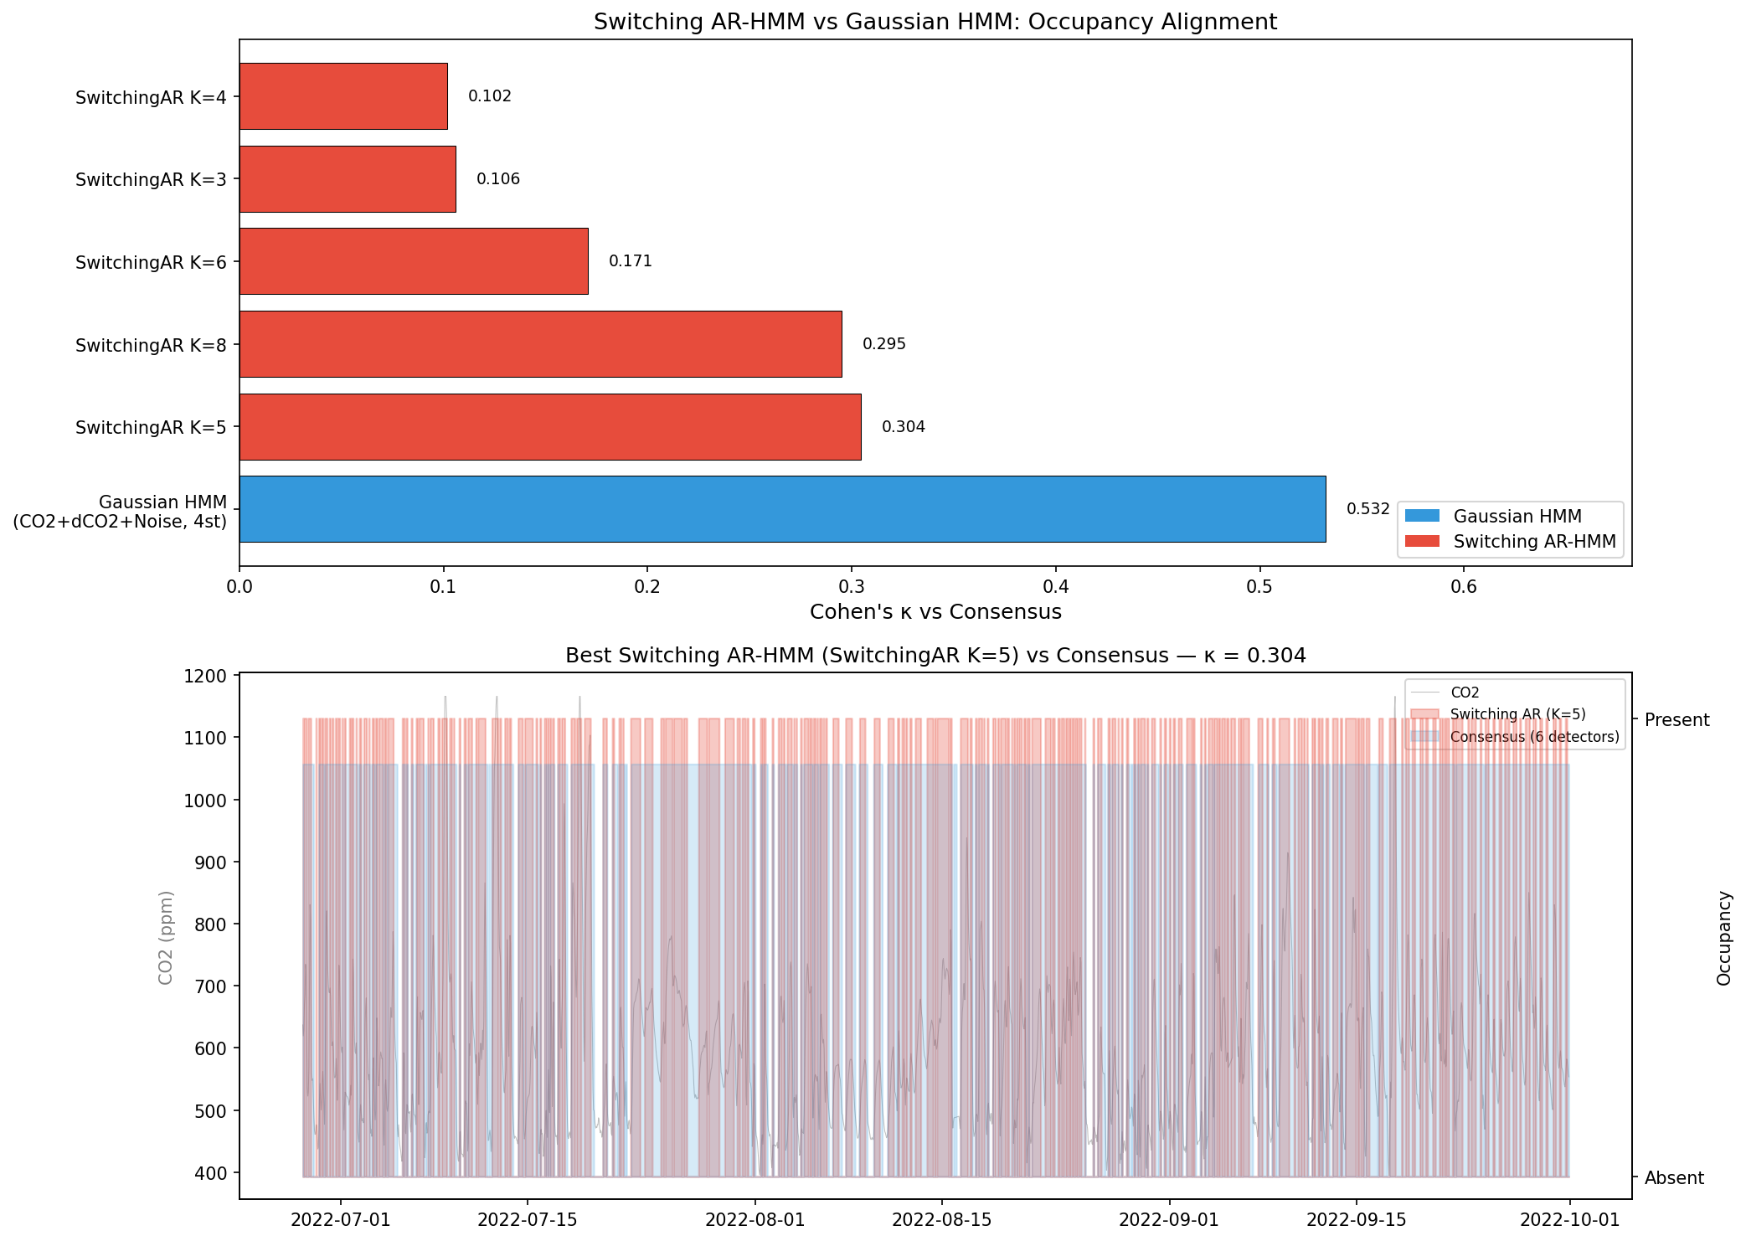
Figure 9. Switching AR-HMM vs. Gaussian HMM baseline comparison.

7. Comparative Analysis
The following table summarizes the best result from each method family.
Table 10. Summary of best results across all method families.
Method | κ vs. Consensus | Occ. Rate | Mapping
Gaussian HMM (CO₂+dCO₂+Noise, K=4) | 0.5324 | 71.3% | Exhaustive bitmask
Mixed Gauss-VM HMM (best) | 0.2709 | 66.4% | Exhaustive bitmask
Gaussian HMM + sin/cos (best) | 0.0855 | 41.7% | Exhaustive bitmask
Switching AR-HMM (best bitmask) | 0.3576 | 65.8% | Exhaustive bitmask
Switching AR-HMM (best physics) | 0.3045 | 46.4% | Otsu on μ

The ranking is clear: the Gaussian HMM with sensor features only (CO₂, dCO₂/dt, Noise) outperforms all other approaches on consensus agreement. Adding temporal features degrades all HMM variants. The Mixed von Mises HMM partially recovers the damage caused by Gaussian sin/cos encoding but cannot exceed the non-temporal baseline. The Switching AR model brings unique advantages in physical interpretability but scores lower on the consensus metric.

8. Discussion

Why temporal features hurt
Occupancy events in the SalonBM dataset do not follow strict temporal patterns. Being a residential environment, occupant behavior is irregular—people may be home at any hour. When temporal features are added, the HMM preferentially segments by time-of-day (morning/afternoon/evening/night) rather than by CO₂ dynamics, producing states that are temporally coherent but occupancy-irrelevant.

The consensus paradox
The consensus is dominated by 'sticky' detectors (absolute threshold at 75.9%, state machine at 91.8%, hybrid at 82.3%) that maintain occupied status as long as CO₂ remains elevated. The rate-of-change detector (36.9%) only fires during dynamic events. The Switching AR model aligns well with rate-of-change (κ = 0.70) because both capture CO₂ dynamics, but this means the AR model disagrees with the sticky majority that defines the consensus.

Physical interpretability
Despite lower consensus κ, the Switching AR model provides uniquely valuable insights. The learned ventilation time constants τ range from ~5 hours (fast ventilation states) to ~27 hours (poor ventilation/high occupancy), and the drift parameters μ cleanly separate active CO₂ generation from passive decay. These parameters are directly actionable for HVAC control—for example, estimating the number of occupants from the generation rate.

Von Mises: correct distribution, wrong information
The Mixed Gaussian–von Mises HMM demonstrates that the circular distribution is mathematically appropriate for temporal features (3–4× better than Gaussian sin/cos). However, the fundamental issue is that temporal information adds no occupancy-relevant signal beyond what CO₂ dynamics already capture.

9. Limitations
1. No ground-truth occupancy labels: All results are measured against a pseudo-consensus that may not reflect true occupancy. The consensus inherits the biases of its constituent detectors.
2. Single-room residential dataset: The SalonBM dataset represents one specific environment. Results may not generalize to offices, classrooms, or multi-zone buildings with different ventilation characteristics.
3. Hourly resolution: The 1-hour sampling interval limits the ability to detect brief occupancy events (< 1 hour) and blurs transition dynamics.
4. Static ventilation assumption: The Switching AR model assumes that ventilation rates change only between regimes. In reality, window opening and HVAC activation can change ventilation within a regime.
5. Otsu threshold sensitivity: The physics-based mapping depends on the distribution of μ values across K states, which varies with K. No single mapping strategy is optimal across all K values.
6. No multi-occupant modeling: The current framework detects binary occupied/unoccupied without estimating the number of occupants.
7. Consensus weighting: All detectors contribute equally to the consensus. Weighting by detector reliability could improve the reference standard.
8. EM convergence: The Switching AR model's EM algorithm may converge to local optima. Multiple restarts with different initializations are not currently implemented.

10. Future Work
- Multi-feature Switching AR: Extend the AR model to incorporate noise level as an additional observation, combining physics-based CO₂ dynamics with acoustic occupancy indicators.
- Supervised calibration: Use a small labeled dataset (even a few days) to calibrate the state-to-occupancy mapping, bridging the gap between physics-based and consensus-based evaluation.
- Multi-occupant estimation: Extend the Switching AR framework to estimate the number of occupants n(t) from the generation rate μ/(1−c), given known per-person CO₂ generation rates.
- Transfer learning across rooms: Test whether learned ventilation time constants generalize across rooms or require per-room calibration.
- Hierarchical HMM: Model occupancy at multiple timescales (hourly events nested within daily patterns) using a hierarchical HMM structure.
- Real-time deployment: Implement online versions of the detectors and HMM for real-time occupancy inference in smart building controllers.

11. Conclusions
This study presents a comprehensive evaluation of occupancy inference methods using indoor CO₂ measurements. The key findings are:
1. The Gaussian HMM with sensor features only (CO₂, dCO₂/dt, Noise) achieves the highest consensus agreement (κ = 0.53), outperforming all temporal-enriched and physics-based variants.
2. Adding temporal features (sin/cos or von Mises) consistently degrades HMM performance. The von Mises distribution is mathematically correct for circular features but the temporal signal is uninformative for occupancy in this residential dataset.
3. The physics-informed Switching AR-HMM provides uniquely interpretable parameters (ventilation time constant τ, CO₂ generation rate μ) and excels at capturing CO₂ dynamics (κ = 0.70 vs. rate-of-change detector), but scores lower against the level-dominated consensus (κ = 0.34).
4. The consensus metric is not neutral: it favors detectors that track CO₂ levels over those that track dynamics. This highlights the need for ground-truth occupancy labels to fairly evaluate all approaches.
5. Predicted CO₂ from forecasting models preserves occupancy-relevant information well (κ > 0.73 for all detectors), enabling downstream occupancy inference from model outputs.

