# Report

## Basic function (Grayscale Photomosaic)

* Read the source image and the photo tiles:

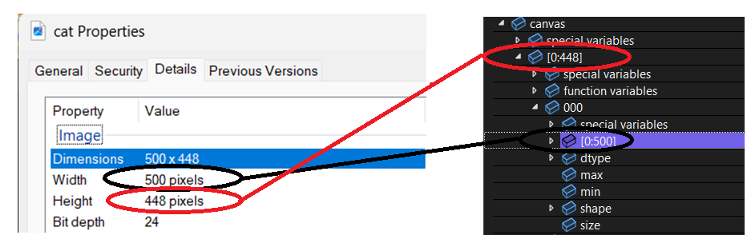

The program will first read the image by cv2.imread(canvas_path).astype(float), then it will generate a 2D-array[Height][Width], and store the RGB value. (Given)

* Bilinear interpolation to resample the input image

## Enhancements