Analýza mnohorozmerných a veľkých údajov

Príprava datasetu na analýzu
Do headeru som vložil potrebné atribúty datasetu

Štatistická analýza dát
cor(data[,3:9], method="pearson")

MYCT MMIN MMAX CACH CHMIN CHMAX
MYCT 1.0000000 -0.3356422 -0.3785606 -0.3209998 -0.3010897 -0.2505023
MMIN -0.3356422 1.0000000 0.7581573 0.5347291 0.5171892 0.2669074
MMAX -0.3785606 0.7581573 1.0000000 0.5379898 0.5605134 0.5272462
CACH -0.3209998 0.5347291 0.5379898 1.0000000 0.5822455 0.4878458
CHMIN -0.3010897 0.5171892 0.5605134 0.5822455 1.0000000 0.5482812
CHMAX -0.2505023 0.2669074 0.5272462 0.4878458 0.5482812 1.0000000
PRP -0.3070994 0.7949313 0.8630041 0.6626414 0.6089033 0.6052093
PRP
MYCT -0.3070994
MMIN 0.7949313
MMAX 0.8630041
CACH 0.6626414
CHMIN 0.6089033
CHMAX 0.6052093
PRP 1.0000000

plot(data)
corrplot(cor(data[,3:9], method = "spearman"), method = "number", tl.col = "black")
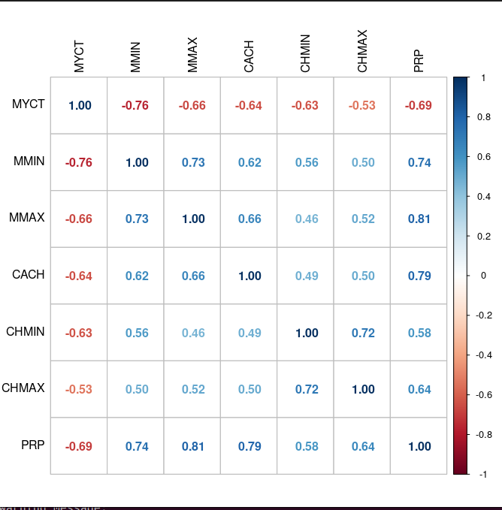
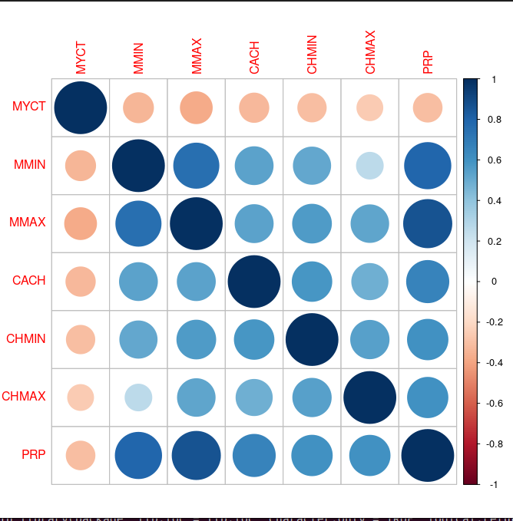
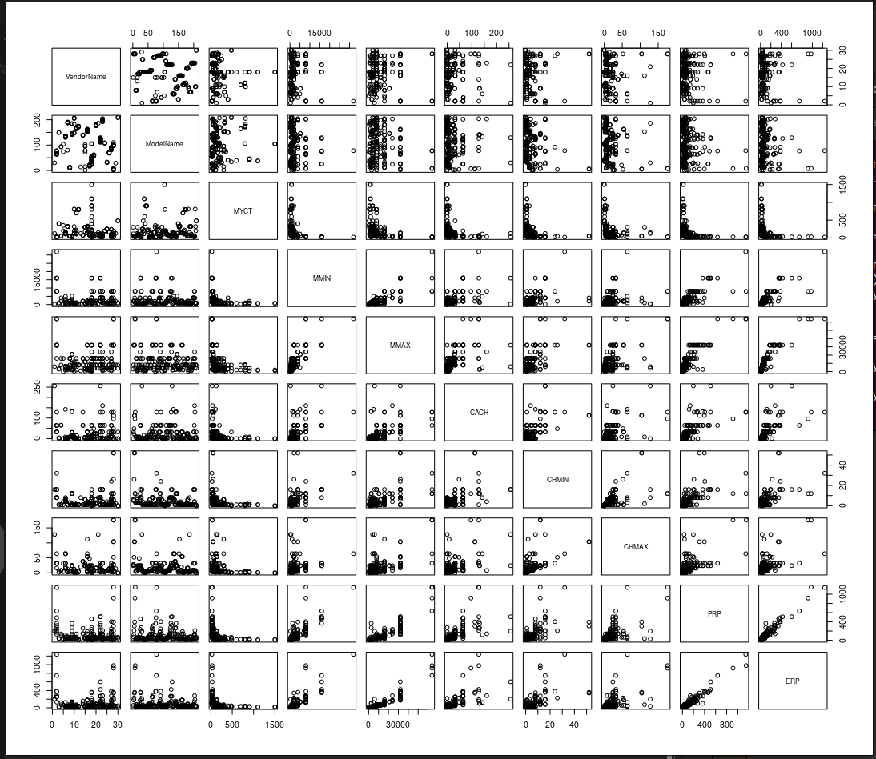

Exploratívna analýza dát
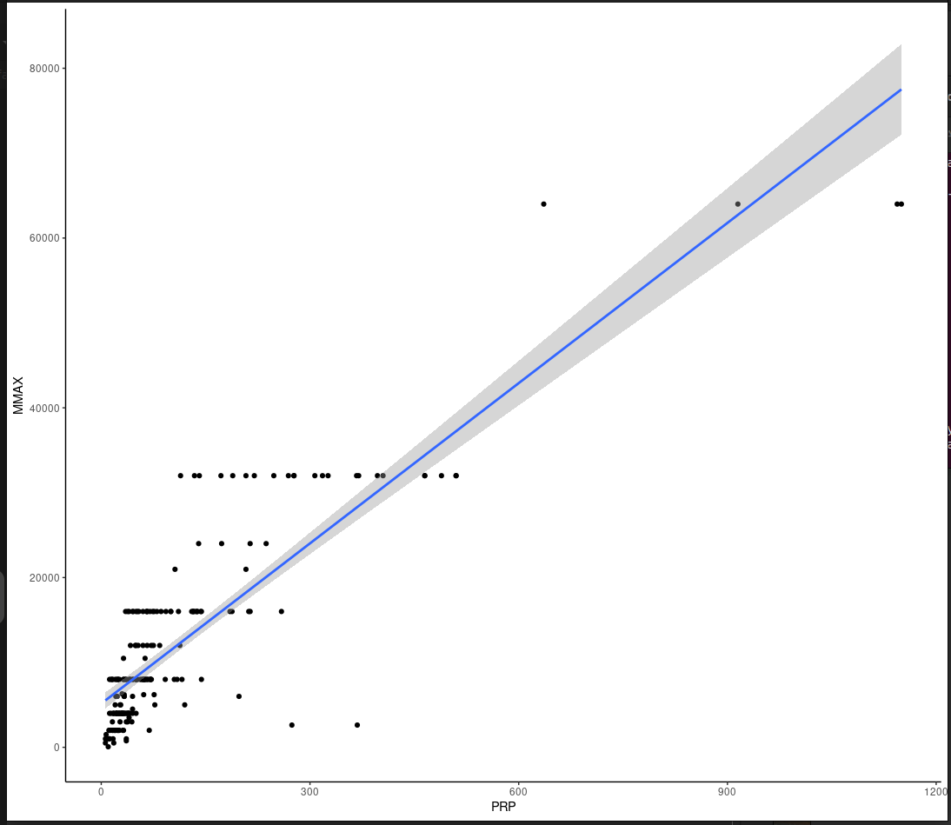
ggplot(data, aes(x = PRP, y = MMAX)) + geom_point() + theme_classic() + geom_smooth(method = lm)
ggplot(data, aes(x = PRP, y = MMAX)) + geom_point() + theme_classic()
ggplot(data, aes(x = PRP)) + geom_boxplot() + theme_bw()
Odľahlé hodnoty na atribúte PRB
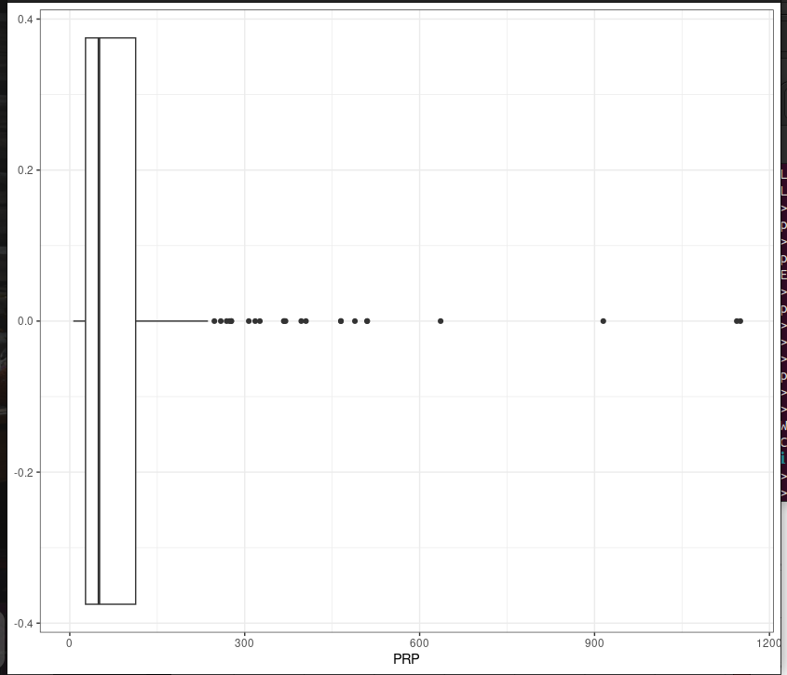
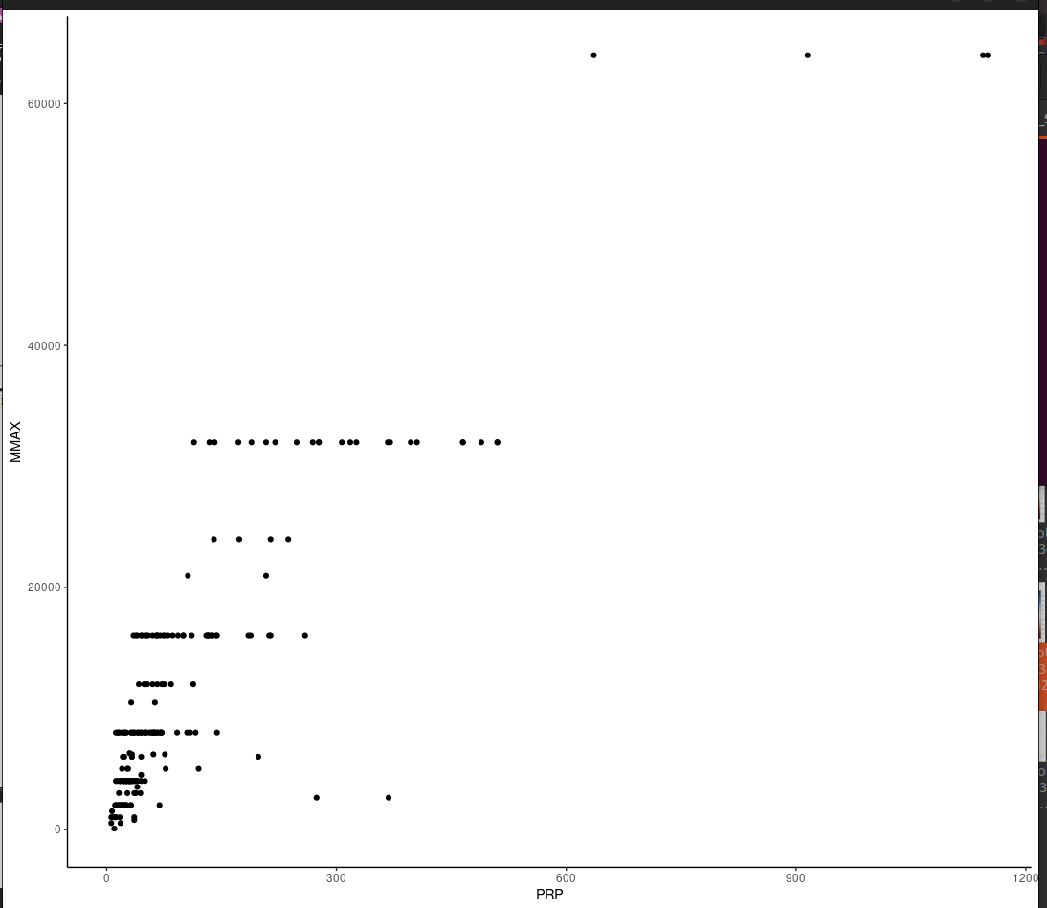

Prediktívna analýza dát
Zvolil som si LM model
model <- lm(PRP ~ MMAX, data = data)
novy_vstup <- data.frame(MMAX = 15700, MYCT = 50, MMIN = 1900, CACH = 32)
predict(model, novy_vstup, se.fit = FALSE)
1
151.8286

Exploratívna Analýza dát

Zvolil som si PCA metódu
farby <- ifelse(data$MYCT > 100, "steelblue", ifelse(data$MYCT < 100, "red", "lightgreen"))

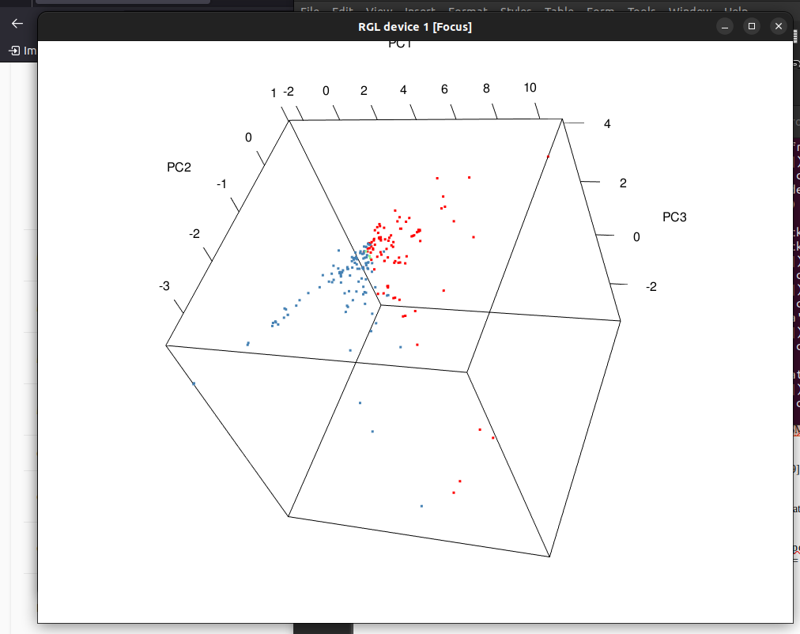

pca <- prcomp(data[,3:9], scale = TRUE)

pca$rotation <- pca$rotation*-1
pca$x <- -1*pca$x

trieda <- as.data.frame(pca$x)
plot3d(trieda[,1:3], col = farba)

ggplot(data, aes(x = PRP, y = MMAX)) + geom_point()

mapa <- tsne(data[,3:9], initial_dims = 2, max_iter = 100)
sigma summary: Min. : 0.177536841850454 |1st Qu. : 0.277210871679108 |Median : 0.346460070245607 |Mean : 0.411116762081726 |3rd Qu. : 0.478841892315925 |Max. : 1.00816314856951

plot(mapa, cex = 0.5, col = “red”)

farba <- ifelse(data$MYCT > 100, "red", "lightgreen")
plot(mapa, cex = .5, col = farba)

