AAE 575

Introduction to Satellite Navigation and Positioning

Homework 2

October 17, 2011

Josh Wildey

**Objective:**

A 5ms sample of raw data from a GPS signal has been provided that has already been down converted. From this sample, the objective is to see if satellites with PRN 22 and 27 are present in the data. If they are, then the approximate Doppler Shifts and Time delays are to be measured. To do this, a locally generated signal of PRN 22 and 27 are to be generated along with its in-phase and quadrature signals. Once the in-phase and quadrature signals are produced locally, these need to then be calculated with a range of Doppler Shifts and cross correlated with the sample data. From these cross correlations, the Doppler Shift and the Time delay can be estimated. Lastly, the signal to noise ratio is to be calculated, again, from measurements of the cross correlation data.

**Given Data:**

*Sample Rate: fS = 5.714286 MHz*

*IF Carrier Frequency: fI = 1.405 MHz*

*Quantization: “1.5 bits”, meaning the data is quantized to the values of {-1, 0, 1}*

*Length of data: 5ms (28570 samples)*

**Problem 1:**

Using the program from homework 1, the C/A codes are generated for PRN 22 and 27. These C/A codes are generated at a sampling rate of 1023 kHz, so they were then resampled at the sampling rate of the homework data which is 5.714286 MHz using the MATLAB command “resample”. The BPSK of the codes are then generated and repeated for the length of the data sample (28570 data bits). Once this is complete, the In-Phase and Quadrature signals are generated in accordance to the following equations.

$$I_{L}\left(t\right)=\sqrt{2}\sin\left[2π\left(f_{I}+{\hat{f}}_{D}\right)t\right]s(t-\hat{τ})$$

$$Q_{L}\left(t\right)=\sqrt{2}\cos\left[2π\left(f_{I}+{\hat{f}}_{D}\right)t\right]s(t-\hat{τ})$$

At first these signals are produced with ${\hat{f}}_{D}$ and $\hat{τ}$ equal to 0 to compare them to the graphs given in the homework 2 document to make sure they are being generated correctly. See Figures 1-1 and 1-2 for verification.

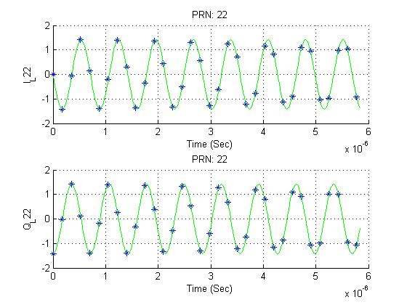

Figure Error! No text of specified style in document.‑-1 In-Phase and Quadrature Signals for PRN 22

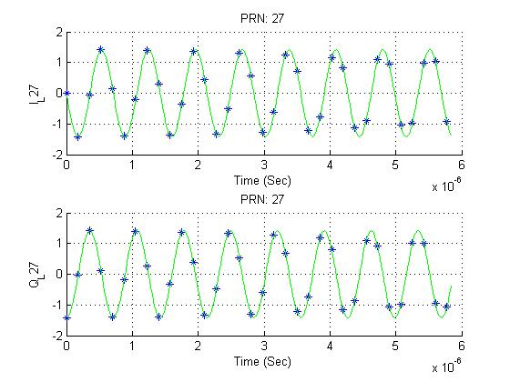

Figure 1‑Error! No text of specified style in document.‑ In-Phase and Quadrature Signals for PRN 27

**Problem 2:**

Now that the correct In-Phase and Quadrature signals are being produced, they need to be calculated with a range of Doppler Shift delays and cross correlated with the sample data. The parameters that were used to determine the approximate Doppler Shifts and Time delays will be explained in Problem 3. The results from the search revealed that both PRN 22 and 27 were present in the data. PRN 22 was measured to have a Doppler Shift of 1000 Hz indicating that the satellite is moving away from the receiver. This value was found by finding the maximum value of the correlation from all of the test Doppler shift frequencies. The time delay for PRN 22 was found to be -.00038412 seconds and was found by locating the maximum value from the correlation of the sample data and the locally generated signals at the estimated Doppler shift of 1000 Hz. The array was 28570 samples long and the maximum value was found at the 12090th value. The 28570 samples each represent one step size of the 5ms sample with the step size being 1/*fS* which is .175 μs. The delay is also centered on 0 so the delay was found by taking 12090 and subtracting half of 29580 and multiplying by the step size. The final delay was calculated to be -.38412 ms. Using the method mentioned above, the Doppler shift and time delay for PRN 27 were -3800 Hz and -.32305 ms respectively. Below are figures which support this data.

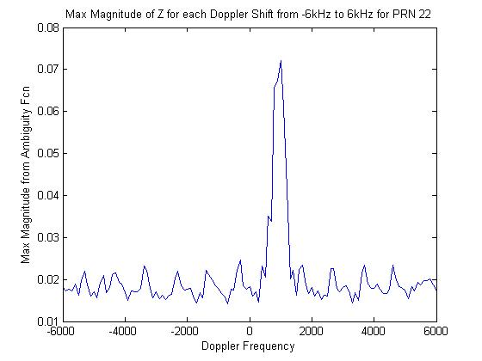

Figure 2-1 Doppler Shift graph for PRN 22

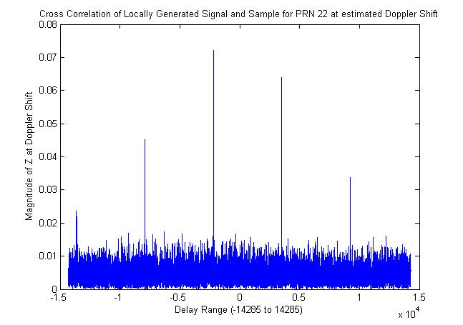

Figure 2-2 Time Delay of PRN 22

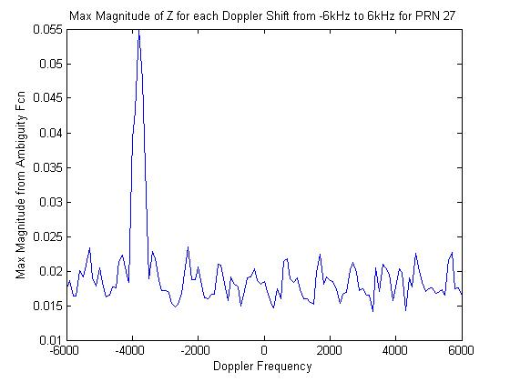

Figure 2-3 Doppler Shift for PRN 27

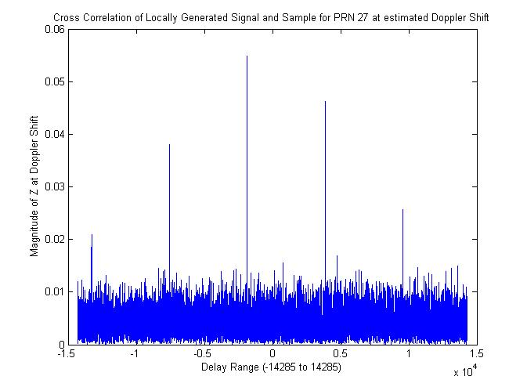

Figure 2-4 Time Delay for PRN 27

Some notable issues that were found while figuring out the cross correlations were in relation to the circcorr function provided for homework 1. All of the time vectors and signal vectors were generated as column vectors. When column vectors were passed to the circcorr function the magnitude of Z plot were getting values of upwards of approximately 400. This was because the circorr function was using the size of the input vector assuming that it was a row vector as opposed to a column vector. A quick fix was made in the circcorr.m file and can be seen in Appendix A.

**Problem 3:**

The integration time, *TI*, was chose to be the entire length of the sample data which is 5ms. The results probably could have been found with only a 1 ms integration time because that is the length of the period, but 5 ms was chosen for ease programming.

The range of frequencies was chosen according to Misra and Enge [2011]. In chapter 11.2.5, it is stated that the maximum Doppler shifts are between -6000 Hz and 6000 Hz. It also said that the typical bin size that is used is 500 Hz, but for this problem 100 Hz was chosen for better accuracy. Had this program been implemented in a real GPS receiver, 500 Hz would have been chosen for processing time and power consumption reasons.

**Problem 4:**

The *C/N0* ratio for PRN 22 and 27 were found to be 2904.2 Hz and 2416.1 Hz respectively. To find these values the following equation was used.

$$SNR=\frac{C_{R}}{P_{N}}=\frac{C_{R}}{N_{0}}T_{I}$$

where $C_{R}$ is the maximum value found from the cross correlation plots at the estimated Doppler shifts. These values were .0722 and .0549 for PRN 22 and PRN 27 respectively. $P_{N}$ is the noise power which can be estimated from the mean of the plot from which $C_{R}$ was pulled. These values were 0.005 for PRN 22 and 0.0045 for PRN 27. With these values the SNR for PRN 22 and PRN 27 were calculated as follows.

$${SNR}_{PRN 22}=\frac{C_{R}}{P_{N}}=\frac{.0722}{.005}=14.5208$$

$${SNR}_{PRN 27}=\frac{C_{R}}{P_{N}}=\frac{..0549}{.0045}=12.0804$$

With some rearranging of variables and using $T_{I}$ of 5 ms the *C/N0* ratio can be found.

$${PRN}_{22}: \frac{C}{N_{0}}= \frac{{SNR}_{PRN 22}}{T_{I}}=\frac{14.5208}{.005}=2904.2 Hz$$

$${PRN}_{27}: \frac{C}{N_{0}}= \frac{{SNR}_{PRN 27}}{T_{I}}=\frac{12.0804}{.005}=2416.1 Hz$$

**Conclusion:**

In conclusion, satellites with PRN 22 and 27 were both found in the sample data. The satellite with PRN 22 was found to have an estimated Doppler shift of 1000 Hz indicating that it is travelling away from the receiver, a time delay of -.38412 ms, and a carrier to noise ratio of 2904.2 Hz. The satellite with PRN 27 was found to have an estimated Doppler shift of -3800 Hz indicating that it is travelling toward the receiver, a time delay of -.32305 ms, and a carrier to noise ratio of 2416.1 Hz.

**Appendix A: MATLAB Code**

**hw2.m:**

%%%%%%%%%%%%%%%%%%%%%%%%%%%%%%%%%%%%%%%%%%%%%%%%%%%%%%%%%%%%%%%%%%%%%%

% Author: Josh Wildey

% Class: AAE57500

% Homework 2 - 10/17/2011

%%%%%%%%%%%%%%%%%%%%%%%%%%%%%%%%%%%%%%%%%%%%%%%%%%%%%%%%%%%%%%%%%%%%%%

close all

clear all

clc

load hw2_data.mat

hw2_data = transpose(hw2_data);

%Initialize some variables

fdhat = 0;

taohat = 0;

fi = 1.405e6;

fs = 5.714286e6;

Ts = 1/fs;

fL1 = 1575.42e6;

%Generate C/A Codes

ca = cacodegen([22 27]);

%Generate time vectors

tv1023 = 0:1/1.023e6:.9999e-3;

tv5714 = 0:1/fs:.9999e-3;

t = 0:Ts:4.9996e-3;

tvrt = 0:1/50e6:.9999e-3; %Real Time to produce solid line on graph

%Resample C/A codes to desired rates

ts1 = timeseries(ca,tv1023);

ts2 = resample(ts1,tv5714,'zoh');

tsrt = resample(ts1,tvrt,'zoh');

bpsk = BPSK(ts2.data(:,:));

bpsk = [bpsk bpsk bpsk bpsk bpsk];

bpskrt = BPSK(tsrt.data(:,:));

%IL & QL Calculation

Il22 = sqrt(2)*sin(2*pi*(fi+fdhat)*t).*bpsk(1,:);

Ql22 = sqrt(2)*cos(2*pi*(fi+fdhat)*t).*bpsk(1,:);

Il27 = sqrt(2)*sin(2*pi*(fi+fdhat)*t).*bpsk(2,:);

Ql27 = sqrt(2)*cos(2*pi*(fi+fdhat)*t).*bpsk(2,:);

Il22rt = sqrt(2)*sin(2*pi*(fi+fdhat)*tvrt(1:293)).*bpskrt(1,1:293);

Ql22rt = sqrt(2)*cos(2*pi*(fi+fdhat)*tvrt(1:293)).*bpskrt(1,1:293);

Il27rt = sqrt(2)*sin(2*pi*(fi+fdhat)*tvrt(1:293)).*bpskrt(2,1:293);

Ql27rt = sqrt(2)*cos(2*pi*(fi+fdhat)*tvrt(1:293)).*bpskrt(2,1:293);

%Plot the Inphase and Quadrature Signals

%PRN 22

figure(1)

subplot(2,1,1)

hold on

plot(tv5714(1:34),Il22(1:34),'*'),grid on

plot(tvrt(1:293),Il22rt,'g')

title('PRN: 22'),xlabel('Time (Sec)'),ylabel('I_L22')

hold off

subplot(2,1,2)

hold on

plot(tv5714(1:34),Ql22(1:34),'*'),grid on

plot(tvrt(1:293),Ql22rt,'g')

title('PRN: 22'),xlabel('Time (Sec)'),ylabel('Q_L22')

hold off

%PRN 27

figure(2)

subplot(2,1,1)

hold on

plot(tv5714(1:34),Il27(1:34),'*'),grid on

plot(tvrt(1:293),Il27rt,'g')

title('PRN: 27'),xlabel('Time (Sec)'),ylabel('I_L27')

hold off

subplot(2,1,2)

hold on

plot(tv5714(1:34),Ql27(1:34),'*'),grid on

plot(tvrt(1:293),Ql27rt,'g')

title('PRN: 27'),xlabel('Time (Sec)'),ylabel('Q_L27')

hold off

%Homework 2 Problem 2

fd = -6e3:100:6e3;

for n = 1:length(fd)

hw2Il22(n,:) = sqrt(2)*sin(2*pi*(fi+fd(n))*t).*bpsk(1,:);

hw2Ql22(n,:) = sqrt(2)*cos(2*pi*(fi+fd(n))*t).*bpsk(1,:);

hw2Il27(n,:) = sqrt(2)*sin(2*pi*(fi+fd(n))*t).*bpsk(2,:);

hw2Ql27(n,:) = sqrt(2)*cos(2*pi*(fi+fd(n))*t).*bpsk(2,:);

[R_I_prn22(n,:), I22_lag] = circcorr(hw2_data,hw2Il22(n,:),Ts);

[R_Q_prn22(n,:), Q22_lag] = circcorr(hw2_data,hw2Ql22(n,:),Ts);

[R_I_prn27(n,:), I27_lag] = circcorr(hw2_data,hw2Il27(n,:),Ts);

[R_Q_prn27(n,:), Q27_lag] = circcorr(hw2_data,hw2Ql27(n,:),Ts);

end

Z_prn22 = sqrt(R_I_prn22.^2 + R_Q_prn22.^2);

Z_prn27 = sqrt(R_I_prn27.^2 + R_Q_prn27.^2);

[m n] = size(Z_prn22);

for c = 1:m

max_Z_prn22(c,:) = max(Z_prn22(c,:));

max_Z_prn27(c,:) = max(Z_prn27(c,:));

end

% Find Doppler Shift Frequency by finding max of Z and its index

[a22 i22] = max(max_Z_prn22);

[a27 i27] = max(max_Z_prn27);

prn22_dop_lag = fd(i22)

prn27_dop_lag = fd(i27)

% Find Time Delay by finding max of Z at the doppler frequency shift and

% its index

[b22 j22] = max(Z_prn22(i22,:));

[b27 j27] = max(Z_prn27(i27,:));

prn22_t_lag = (j22-14285)*Ts

prn27_t_lag = (j27-14285)*Ts

%Plot the Doppler Shift for PRN 22

figure(3)

plot(fd,max_Z_prn22)

title('Max Magnitude of Z for each Doppler Shift from -6kHz to 6kHz for PRN 22')

xlabel('Doppler Frequency')

ylabel('Max Magnitude from Ambiguity Fcn')

%Plot the Time Delay for PRN 22

figure(4)

plot(I22_lag/Ts,Z_prn22(i22,:))

title('Cross Correlation of Locally Generated Signal and Sample for PRN 22 at estimated Doppler Shift')

xlabel('Delay Range (-14285 to 14285)')

ylabel('Magnitude of Z at Doppler Shift')

%Plot the Doppler Shift for PRN 27

figure(5)

plot(fd,max_Z_prn27)

title('Max Magnitude of Z for each Doppler Shift from -6kHz to 6kHz for PRN 27')

xlabel('Doppler Frequency')

ylabel('Max Magnitude from Ambiguity Fcn')

%Plot the Time Delay for PRN 27

figure(6)

plot(I22_lag/Ts,Z_prn27(i27,:))

title('Cross Correlation of Locally Generated Signal and Sample for PRN 27 at estimated Doppler Shift')

xlabel('Delay Range (-14285 to 14285)')

ylabel('Magnitude of Z at Doppler Shift')

%Calculate SNR and CR/No Ratio

SNR22 = a22/(mean(Z_prn22(i22,:)))

SNR27 = a27/(mean(Z_prn27(i27,:)))

No22 = a22/SNR22*5e-3;

No27 = a27/SNR27*5e-3;

CrNo_rat22 = a22/No22

CrNo_rat27 = a27/No27

**Modified circcorr.m function:**

function [R, lag] = circcorr(x, y, Ts)

%

% Circular correlation of two vectors, x and y, through FFT methods.

%

% Output is R(lag), where R is the cross correlation of x and y and

% Lag is in the same dimesnions as Ts.

%

% Prof. Jim Garrison, Purdue University, AAE575 Fall 2009

%

[~, npts] = size(x); %for row vectors

%npts = size(x,1); %for column vectors

X = fft(x);

Y = fft(y);

FTXY = X.*conj(Y);

R = fftshift(ifft(FTXY))/npts;

lag = (-floor(npts/2):floor((npts-1)/2))*Ts;

return

**C/A Code generator from homework 1:**

function ca = cacodegen(sv)

%%%%%%%%%%%%%%%%%%%%%%%%%%%%%%%%%%%%%%%%%%%%%%%%%%%%%%%%%%%%%%%%%%%%%%

% Author: Josh Wildey

% Class: AAE57500

% Homework 1 - 9/23/2011

%

% This function will accept a SV ID and generate a 1023 chip C/A code for

% the specified satellite.

%

% Ex) For PRN 22 and 27:

% g = cacodegen([22 27])

%

%%%%%%%%%%%%%%%%%%%%%%%%%%%%%%%%%%%%%%%%%%%%%%%%%%%%%%%%%%%%%%%%%%%%%%

%Store G2i or value

ph_sel = [2 6;

3 7;

4 8;

5 9;

1 0;

2 10;

1 8;

2 9;

3 10;

2 3;

3 4;

5 6;

6 7;

7 8;

8 9;

9 10;

1 4;

2 5;

3 6;

4 7;

5 8;

6 9;

1 3;

4 6;

5 7;

6 8;

7 9;

8 10;

1 6;

2 7;

3 8;

4 9;

5 10;

4 10;

1 7;

2 8;

4 10];

% Initialize g1 and g2

% G1 LFSR: 1+ x^3 + x^10

s = [0 0 1 0 0 0 0 0 0 1];

n = length(s);

g1 = ones(1,n);

%G2 LFSR: 1 + x^2 + x^3 + x^6 + x^8 + x^9 + x^10

t = [0 1 1 0 0 1 0 1 1 1];

g2 = ones(1,n);

%Define variables for homework

chips = 2^n - 1;

ca = zeros(2,chips);

%Generate 1023 Chip long C/A Code

for cnt = 1:chips

%G1 is the 10th bit

g1out = g1(n);

%G2 is the XOR of 2 chips chosen by the PRN/sv

g2out = xor(g2(ph_sel(sv,1)),g2(ph_sel(sv,2)));

%C/A Code is the XOR of g1out and g2out

ca(:,cnt) = xor(g1out,g2out);

%Shift G1 left by 1 and XOR chips 3 and 10

g1 = [mod(sum(g1.*s),2) g1(1:9)];

%Shift G2 left by 1 and XOR chips 2,3,6,8,9,10

g2 = [mod(sum(g2.*t),2) g2(1:9)];

end

**BPSK function from homework 1:**

function bpsk = BPSK(cacode)

%%%%%%%%%%%%%%%%%%%%%%%%%%%%%%%%%%%%%%%%%%%%%%%%%%%%%%%%%%%%%%%%%%%%%%

% Author: Josh Wildey

% Class: AAE57500

% Homework 1 - 9/23/2011

%

% This function will convert a binary C/A code to its BPSK

%

%%%%%%%%%%%%%%%%%%%%%%%%%%%%%%%%%%%%%%%%%%%%%%%%%%%%%%%%%%%%%%%%%%%%%%

bpsk = zeros(size(cacode));

for i = 1:length(cacode)

%For First row

if cacode(1,i) == 0

bpsk(1,i) = 1;

else

bpsk(1,i) = -1;

end

%For Second row

if cacode(2,i) == 0

bpsk(2,i) = 1;

else

bpsk(2,i) = -1;

end

end