AAE 575

Introduction to Satellite Navigation and Positioning

Homework 4: Satellite Orbits

December 2, 2011

Josh Wildey

**Objective:**

Using the ephemeris and almanac data, calculate the satellite’s position in orbit, and then compare the calculated values to the precise data from the International GPS Service.

**Given Data:**

*Ephemeris Data*

*Almanac Data*

*IGS Data*

**Problem 1:**

The ephemeris data is to be used to calculate the satellite orbit positions from the given data. The equations used to calculate the satellite’s position in orbit are located in table 30-II in the IS-GPS-200E specification document on page 150. For SV3, the errors in the xyz components ranged from close to zero up to a max of about 580 m. The error in magnitude for SV3 only varied from close to zero up to about 125 m. For SV5, the errors in the xyz components ranged from close to zero up to about 260 m. The error in magnitude for SV5 only varied from close to zero up to about 115 m. The time started at 172800 s since the sample time started at midnight on a Tuesday and ran through 258300 s, 15 min before midnight Wednesday. The time of applicability, toe, is the reference time for the ephemeris and is updated every 1-2 hours and is 252000 s and 208784 s for SV3 and SV5 respectively. It can be observed that as the time approaches toe, the errors minimize, while far away from toe the errors greatly vary. The results can be found in the following figures.

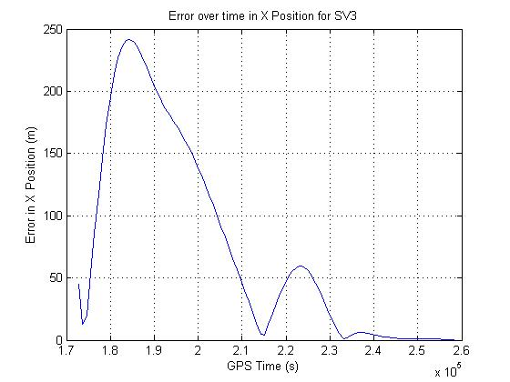

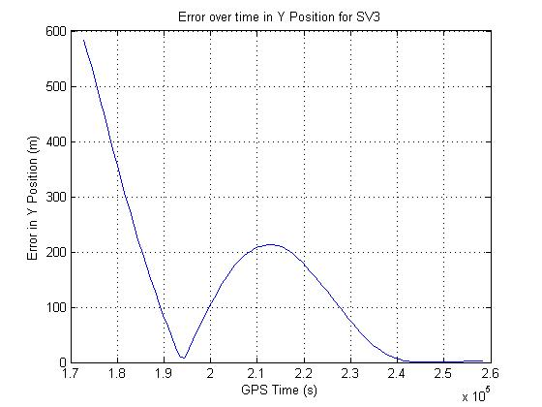

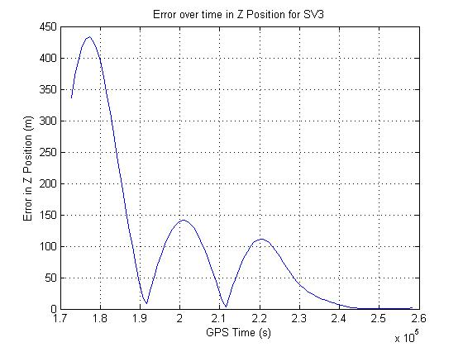

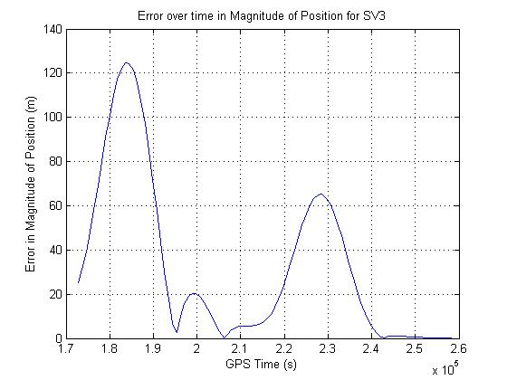

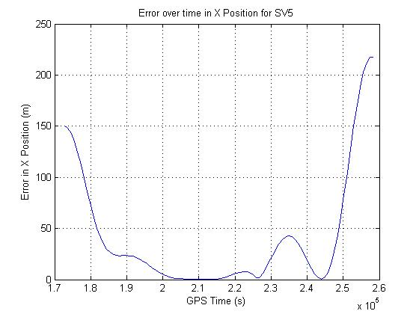

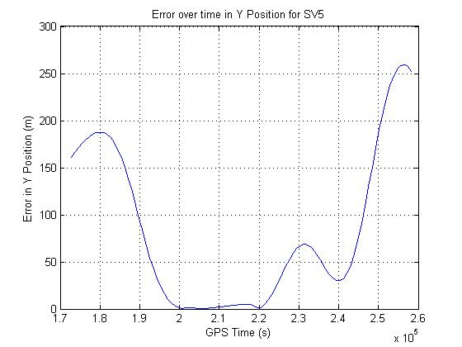

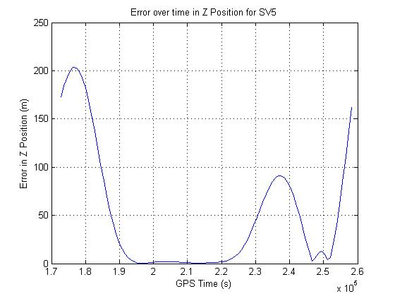

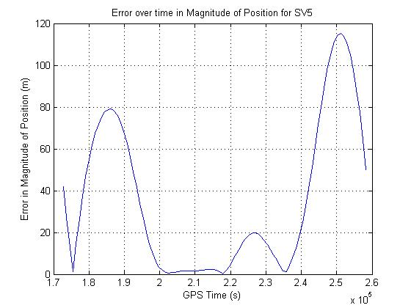

**Problem 2:**

The almanac data is to be used to calculate the satellite orbit positions from the given data. Using the same equations as problem one, the orbit was calculated from the given data. The only difference here is that some of the variables were undefined and were therefore set to zero. These variables include Δn, i0-n-DOT, Cis-n, Cic-n, Crs-n, Crc-n, Cus-n and Cuc-n. Because of this difference, the errors were much larger because the secular correction and harmonic corrections were not applied to the orbital elements. The errors produced using the almanac values also behave in a similar fashion in that the errors mitigate as the time approaches toe. The results can be found in the following figures.

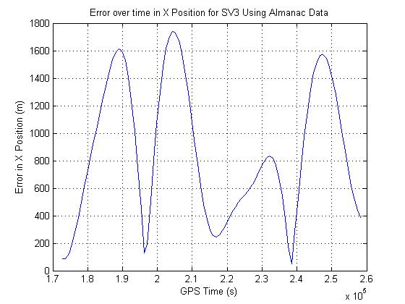

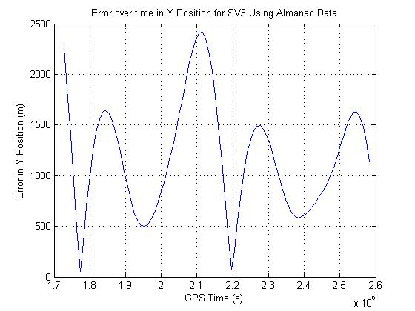

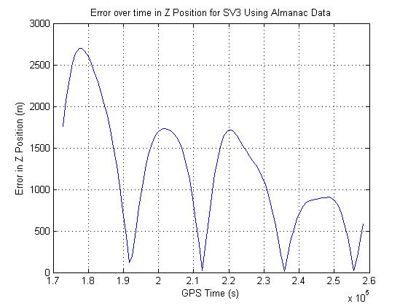

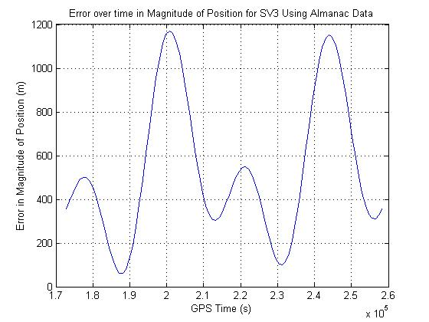

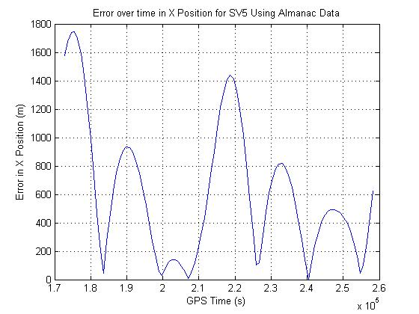

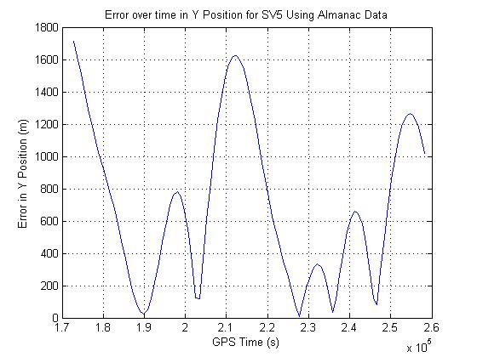

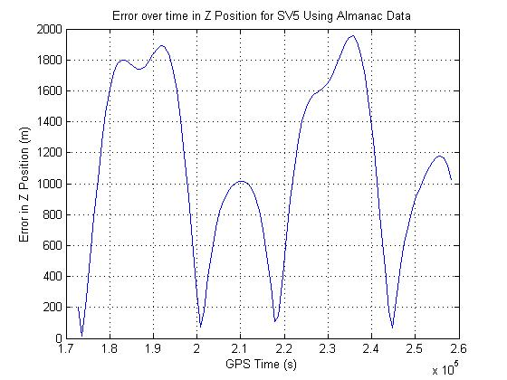

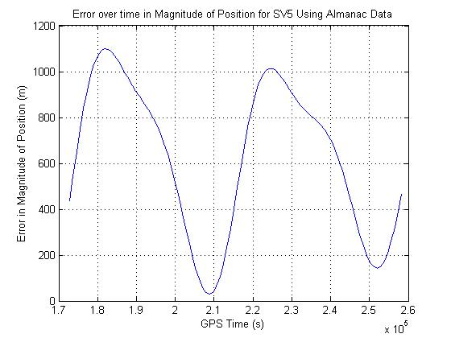

**Conclusion:**

In conclusion, using both the given data sets for SV3 and SV5 it can be found that as time approaches the time of applicability the error in position mitigates. It can also be said that using the ephemeris data is more accurate giving errors in the range of hundreds of meters as opposed to the almanac data giving errors in the range of almost 2 km. This increase in error is in part, due to the fact that the secular and harmonic corrections are not factored in to the position equations.

**Appendix A: MATLAB Code**

%%%%%%%%%%%%%%%%%%%%%%%%%%%%%%%%%%%%%%%%%%%%%%%%%%%%%%%%%%%%%%%%%%%%%%

% Author: Josh Wildey

% Class: AAE57500

% Homework 4 - 12/2/2011

%%%%%%%%%%%%%%%%%%%%%%%%%%%%%%%%%%%%%%%%%%%%%%%%%%%%%%%%%%%%%%%%%%%%%%

close all

clear all

clc

format long

%%%%%%%%% Problem 1: %%%%%%%%%

% **** Week 114 ephemeris for SV- 3 ************

e = 2.547537326e-03; %[] Eccentricity

toe = 2.520000000e+05; %[s] Time of Applicability

I_0 = 9.352987781E-01; %[rad] Orbital Inclination

omega_dot = -8.748578750E-09; %[rad/s] Rate of Right Ascen

sqrt_a = 5.153688175E+03; %[m^.5] SQRT(A)

omega_0 = -2.256728681E+00; %[rad] Right Ascen at TOA

omega = 5.176493009E-01; %[rad] Argument of Perigee

M_0 = 8.667702313E-01; %[rad] Mean Anom

delta_n = 5.394510616E-09; %[rad/s] mean motion diff

I_dot = 3.117986980E-10; %[rad/s] Rate of inclin

Cuc = 4.906207323E-06; %[rad] lat cosine ampl

Cus = 4.069879651E-06; %[rad] radius sin ampl

Crc = 2.845625000E+02; %[m] inclin cos ampl

Crs = 9.250000000E+01; %[m] radius sin ampl

Cic = 1.862645149E-08; %[rad] inclin cos ampl

Cis = -1.862645149E-09; %[rad] inclin sin ampl

omega_dot_e = 7.2921151467e-5; %[rad/sec] Number from IS-GPS-200E

mu = 3.986005e14; %[m^3/s^2] Number from IS-GPS-200E

t = 172800:900:258300; % Time vector for when sample data was taken

sv3_ephemeris = xlsread('SV3-Ephemeris');

t_k = t - toe; % Time from ephemeris refence time

A_k = sqrt_a^2; % Semi-Major Axis

n_0 = sqrt(mu/A_k^3); %[rad/s] Computed Mean Motion

n = n_0 + delta_n; % Correct Mean Motion

M_k = M_0 + n*t_k; % Mean Anomaly

E_k = kepler_E(e,M_k); % Eccentric Anomaly

v_k = 2*atan(sqrt((1+e)./(1-e)).*tan(E_k/2)); % True Anomaly

phi_k = v_k + omega; % Argument of latitude

% Second Harmonic Perturbations

delta_u_k = Cus*sin(2*phi_k) + Cuc*cos(2*phi_k); % Argument of latitude Correction

delta_r_k = Crs*sin(2*phi_k) + Crc*cos(2*phi_k); % Radial Correction

delta_i_k = Cis*sin(2*phi_k) + Cic*cos(2*phi_k); % Inclination Correction

u_k = phi_k + delta_u_k; % Corrected Argument of Latitude

r_k = A_k*(1-e*cos(E_k)) + delta_r_k; % Corrected Radius

i_k = I_0 + (I_dot)*t_k + delta_i_k; % Corrected Inclination

% Positions in Orbital plane

x_kprime = r_k.*cos(u_k);

y_kprime = r_k.*sin(u_k);

% Corrected Longitude of Ascending Node

omega_k = omega_0 + (omega_dot - omega_dot_e)*t_k - omega_dot_e*toe;

% Earth Fixed Coordinates of SV antenna phase center

x_k_sv3 = x_kprime.*cos(omega_k) - y_kprime.*cos(i_k).*sin(omega_k);

y_k_sv3 = x_kprime.*sin(omega_k) + y_kprime.*cos(i_k).*cos(omega_k);

z_k_sv3 = y_kprime.*sin(i_k);

% Error in individual X,Y,Z positions

x_error_sv3 = abs(x_k_sv3/1000-sv3_ephemeris(:,2)').*1000; %[m]

y_error_sv3 = abs(y_k_sv3/1000-sv3_ephemeris(:,3)').*1000; %[m]

z_error_sv3 = abs(z_k_sv3/1000-sv3_ephemeris(:,4)').*1000; %[m]

% Compute True Magnitude of Position

R_true_mag_sv3 = sqrt(sv3_ephemeris(:,2).^2 + sv3_ephemeris(:,3).^2 + sv3_ephemeris(:,4).^2)'; %[km]

% Compute Calculated Magnitude of Position

R_mag_sv3 = sqrt(x_k_sv3.^2 + y_k_sv3.^2 + z_k_sv3.^2)/1000; %[km]

% Error in Magnitude

R_error_sv3 = abs(R_true_mag_sv3-R_mag_sv3).*1000; %[m]

figure(1)

plot(t,x_error_sv3),grid on

xlabel('GPS Time (s)'),ylabel('Error in X Position (m)'),title('Error over time in X Position for SV3')

figure(2)

plot(t,y_error_sv3),grid on

xlabel('GPS Time (s)'),ylabel('Error in Y Position (m)'),title('Error over time in Y Position for SV3')

figure(3)

plot(t,z_error_sv3),grid on

xlabel('GPS Time (s)'),ylabel('Error in Z Position (m)'),title('Error over time in Z Position for SV3')

figure(4)

plot(t,R_error_sv3),grid on

xlabel('GPS Time (s)'),ylabel('Error in Magnitude of Position (m)'),title('Error over time in Magnitude of Position for SV3')

% **** Week 114 ephemeris for SV- 5 ************

e = 3.250250011E-03; %[] Eccentricity

toe = 2.087840000E+05; %[s] Time of Applicability

I_0 = 9.363323970E-01; %[rad] Orbital Inclination

omega_dot = -8.031405763E-09; %[rad/s] Rate of Right Ascen

sqrt_a = 5.153571037E+03; %[m^.5] SQRT(A)

omega_0 = 2.969759636E+00; %[rad] Right Ascen at TOA

omega = 4.894296521E-01; %[rad] Argument of Perigee

M_0 = -2.098179373E+00; %[rad] Mean Anom

delta_n = 4.731982806E-09; %[rad/s] mean motion diff

I_dot = 4.857345429E-11; %[rad/s] Rate of inclin

Cuc = 1.855194569E-06; %[rad] lat cosine ampl

Cus = 1.207739115E-05; %[rad] radius sin ampl

Crc = 1.338750000E+02; %[m] inclin cos ampl

Crs = 3.593750000E+01; %[m] radius sin ampl

Cic = -4.284083843E-08; %[rad] inclin cos ampl

Cis = -2.421438694E-08; %[rad] inclin sin ampl

omega_dot_e = 7.2921151467e-5; %[rad/sec] Number from IS-GPS-200E

mu = 3.986005e14; %[m^3/s^2] Number from IS-GPS-200E

sv5_ephemeris = xlsread('SV5-Ephemeris');

t_k = t - toe; % Time from ephemeris refence time

A_k = sqrt_a^2; % Semi-Major Axis

n_0 = sqrt(mu/A_k^3); %[rad/s] Computed Mean Motion

n = n_0 + delta_n; % Correct Mean Motion

M_k = M_0 + n*t_k; % Mean Anomaly

E_k = kepler_E(e,M_k); % Eccentric Anomaly

v_k = 2*atan(sqrt((1+e)./(1-e)).*tan(E_k/2)); % True Anomaly

phi_k = v_k + omega; % Argument of latitude

% Second Harmonic Perturbations

delta_u_k = Cus*sin(2*phi_k) + Cuc*cos(2*phi_k); % Argument of latitude Correction

delta_r_k = Crs*sin(2*phi_k) + Crc*cos(2*phi_k); % Radial Correction

delta_i_k = Cis*sin(2*phi_k) + Cic*cos(2*phi_k); % Inclination Correction

u_k = phi_k + delta_u_k; % Corrected Argument of Latitude

r_k = A_k*(1-e*cos(E_k)) + delta_r_k; % Corrected Radius

i_k = I_0 + (I_dot)*t_k + delta_i_k; % Corrected Inclination

% Positions in Orbital plane

x_kprime = r_k.*cos(u_k);

y_kprime = r_k.*sin(u_k);

% Corrected Longitude of Ascending Node

omega_k = omega_0 + (omega_dot - omega_dot_e)*t_k - omega_dot_e*toe;

% Earth Fixed Coordinates of SV antenna phase center

x_k_sv5 = x_kprime.*cos(omega_k) - y_kprime.*cos(i_k).*sin(omega_k);

y_k_sv5 = x_kprime.*sin(omega_k) + y_kprime.*cos(i_k).*cos(omega_k);

z_k_sv5 = y_kprime.*sin(i_k);

% Error in individual X,Y,Z positions

x_error_sv5 = abs(x_k_sv5/1000-sv5_ephemeris(:,2)').*1000; %[m]

y_error_sv5 = abs(y_k_sv5/1000-sv5_ephemeris(:,3)').*1000; %[m]

z_error_sv5 = abs(z_k_sv5/1000-sv5_ephemeris(:,4)').*1000; %[m]

% Compute True Magnitude of Position

R_true_mag_sv5 = sqrt(sv5_ephemeris(:,2).^2 + sv5_ephemeris(:,3).^2 + sv5_ephemeris(:,4).^2)'; %[km]

% Compute Calculated Magnitude of Position

R_mag_sv5 = sqrt(x_k_sv5.^2 + y_k_sv5.^2 + z_k_sv5.^2)/1000; %[km]

% Error in Magnitude

R_error_sv5 = abs(R_true_mag_sv5-R_mag_sv5).*1000; %[m]

figure(5)

plot(t,x_error_sv5),grid on

xlabel('GPS Time (s)'),ylabel('Error in X Position (m)'),title('Error over time in X Position for SV5')

figure(6)

plot(t,y_error_sv5),grid on

xlabel('GPS Time (s)'),ylabel('Error in Y Position (m)'),title('Error over time in Y Position for SV5')

figure(7)

plot(t,z_error_sv5),grid on

xlabel('GPS Time (s)'),ylabel('Error in Z Position (m)'),title('Error over time in Z Position for SV5')

figure(8)

plot(t,R_error_sv5),grid on

xlabel('GPS Time (s)'),ylabel('Error in Magnitude of Position (m)'),title('Error over time in Magnitude of Position for SV5')

%%%%%%%%% Problem 2: %%%%%%%%%

% **** Week 114 Almanac for SV- 3 ************

e = 2.558708191E-003; %[] Eccentricity

toe = 4.055040000E+005; %[s] Time of Applicability

I_0 = 9.353532195E-001; %[rad] Orbital Inclination

omega_dot = -8.263201678E-009; %[rad/s] Rate of Right Ascen

sqrt_a = 5.153633301E+003; %[m^.5] SQRT(A)

omega_0 = -2.258039713E+000; %[rad] Right Ascen at TOA

omega = 5.173110962E-001; %[rad] Argument of Perigee

M_0 = -1.875895619E+000; %[rad] Mean Anom

delta_n = 0; %[rad/s] mean motion diff

I_dot = 0; %[rad/s] Rate of inclin

Cuc = 0; %[rad] lat cosine ampl

Cus = 0; %[rad] radius sin ampl

Crc = 0; %[m] inclin cos ampl

Crs = 0; %[m] radius sin ampl

Cic = 0; %[rad] inclin cos ampl

Cis = 0; %[rad] inclin sin ampl

omega_dot_e = 7.2921151467e-5; %[rad/sec] Number from IS-GPS-200E

mu = 3.986005e14; %[m^3/s^2] Number from IS-GPS-200E

t_k = t - toe; % Time from ephemeris refence time

A_k = sqrt_a^2; % Semi-Major Axis

n_0 = sqrt(mu/A_k^3); %[rad/s] Computed Mean Motion

n = n_0 + delta_n; % Correct Mean Motion

M_k = M_0 + n*t_k; % Mean Anomaly

E_k = kepler_E(e,M_k); % Eccentric Anomaly

v_k = 2*atan(sqrt((1+e)./(1-e)).*tan(E_k/2)); % True Anomaly

phi_k = v_k + omega; % Argument of latitude

% Second Harmonic Perturbations

delta_u_k = Cus*sin(2*phi_k) + Cuc*cos(2*phi_k); % Argument of latitude Correction

delta_r_k = Crs*sin(2*phi_k) + Crc*cos(2*phi_k); % Radial Correction

delta_i_k = Cis*sin(2*phi_k) + Cic*cos(2*phi_k); % Inclination Correction

u_k = phi_k + delta_u_k; % Corrected Argument of Latitude

r_k = A_k*(1-e*cos(E_k)) + delta_r_k; % Corrected Radius

i_k = I_0 + (I_dot)*t_k + delta_i_k; % Corrected Inclination

% Positions in Orbital plane

x_kprime = r_k.*cos(u_k);

y_kprime = r_k.*sin(u_k);

% Corrected Longitude of Ascending Node

omega_k = omega_0 + (omega_dot - omega_dot_e)*t_k - omega_dot_e*toe;

% Earth Fixed Coordinates of SV antenna phase center

x_k_sv3_almanac = x_kprime.*cos(omega_k) - y_kprime.*cos(i_k).*sin(omega_k);

y_k_sv3_almanac = x_kprime.*sin(omega_k) + y_kprime.*cos(i_k).*cos(omega_k);

z_k_sv3_almanac = y_kprime.*sin(i_k);

% Error in individual X,Y,Z positions

x_error_sv3_almanac = abs(x_k_sv3_almanac/1000-sv3_ephemeris(:,2)').*1000; %[m]

y_error_sv3_almanac = abs(y_k_sv3_almanac/1000-sv3_ephemeris(:,3)').*1000; %[m]

z_error_sv3_almanac = abs(z_k_sv3_almanac/1000-sv3_ephemeris(:,4)').*1000; %[m]

% Compute Calculated Magnitude of Position

R_mag_sv3_almanac = sqrt(x_k_sv3_almanac.^2 + y_k_sv3_almanac.^2 + z_k_sv3_almanac.^2)/1000; %[km]

% Error in Magnitude

R_error_sv3_almanac = abs(R_true_mag_sv3-R_mag_sv3_almanac).*1000; %[m]

figure(9)

plot(t,x_error_sv3_almanac),grid on

xlabel('GPS Time (s)'),ylabel('Error in X Position (m)'),title('Error over time in X Position for SV3 Using Almanac Data')

figure(10)

plot(t,y_error_sv3_almanac),grid on

xlabel('GPS Time (s)'),ylabel('Error in Y Position (m)'),title('Error over time in Y Position for SV3 Using Almanac Data')

figure(11)

plot(t,z_error_sv3_almanac),grid on

xlabel('GPS Time (s)'),ylabel('Error in Z Position (m)'),title('Error over time in Z Position for SV3 Using Almanac Data')

figure(12)

plot(t,R_error_sv3_almanac),grid on

xlabel('GPS Time (s)'),ylabel('Error in Magnitude of Position (m)'),title('Error over time in Magnitude of Position for SV3 Using Almanac Data')

% **** Week 114 Almanac for SV- 5 ************

e = 3.262042999E-003; %[] Eccentricity

toe = 4.055040000E+005; %[s] Time of Applicability

I_0 = 9.362700582E-001; %[rad] Orbital Inclination

omega_dot = -7.897472010E-009; %[rad/s] Rate of Right Ascen

sqrt_a = 5.153512695E+003; %[m^.5] SQRT(A)

omega_0 = 2.968166113E+000; %[rad] Right Ascen at TOA

omega = 4.932729602E-001; %[rad] Argument of Perigee

M_0 = 1.460322738E+000; %[rad] Mean Anom

delta_n = 0; %[rad/s] mean motion diff

I_dot = 0; %[rad/s] Rate of inclin

Cuc = 0; %[rad] lat cosine ampl

Cus = 0; %[rad] radius sin ampl

Crc = 0; %[m] inclin cos ampl

Crs = 0; %[m] radius sin ampl

Cic = 0; %[rad] inclin cos ampl

Cis = 0; %[rad] inclin sin ampl

omega_dot_e = 7.2921151467e-5; %[rad/sec] Number from IS-GPS-200E

mu = 3.986005e14; %[m^3/s^2] Number from IS-GPS-200E

t_k = t - toe; % Time from ephemeris refence time

A_k = sqrt_a^2; % Semi-Major Axis

n_0 = sqrt(mu/A_k^3); %[rad/s] Computed Mean Motion

n = n_0 + delta_n; % Correct Mean Motion

M_k = M_0 + n*t_k; % Mean Anomaly

E_k = kepler_E(e,M_k); % Eccentric Anomaly

v_k = 2*atan(sqrt((1+e)./(1-e)).*tan(E_k/2)); % True Anomaly

phi_k = v_k + omega; % Argument of latitude

% Second Harmonic Perturbations

delta_u_k = Cus*sin(2*phi_k) + Cuc*cos(2*phi_k); % Argument of latitude Correction

delta_r_k = Crs*sin(2*phi_k) + Crc*cos(2*phi_k); % Radial Correction

delta_i_k = Cis*sin(2*phi_k) + Cic*cos(2*phi_k); % Inclination Correction

u_k = phi_k + delta_u_k; % Corrected Argument of Latitude

r_k = A_k*(1-e*cos(E_k)) + delta_r_k; % Corrected Radius

i_k = I_0 + (I_dot)*t_k + delta_i_k; % Corrected Inclination

% Positions in Orbital plane

x_kprime = r_k.*cos(u_k);

y_kprime = r_k.*sin(u_k);

% Corrected Longitude of Ascending Node

omega_k = omega_0 + (omega_dot - omega_dot_e)*t_k - omega_dot_e*toe;

% Earth Fixed Coordinates of SV antenna phase center

x_k_sv5_almanac = x_kprime.*cos(omega_k) - y_kprime.*cos(i_k).*sin(omega_k);

y_k_sv5_almanac = x_kprime.*sin(omega_k) + y_kprime.*cos(i_k).*cos(omega_k);

z_k_sv5_almanac = y_kprime.*sin(i_k);

% Error in individual X,Y,Z positions

x_error_sv5_almanac = abs(x_k_sv5_almanac/1000-sv5_ephemeris(:,2)').*1000; %[m]

y_error_sv5_almanac = abs(y_k_sv5_almanac/1000-sv5_ephemeris(:,3)').*1000; %[m]

z_error_sv5_almanac = abs(z_k_sv5_almanac/1000-sv5_ephemeris(:,4)').*1000; %[m]

% Compute Calculated Magnitude of Position

R_mag_sv5_almanac = sqrt(x_k_sv5_almanac.^2 + y_k_sv5_almanac.^2 + z_k_sv5_almanac.^2)/1000; %[km]

% Error in Magnitude

R_error_sv5_almanac = abs(R_true_mag_sv5-R_mag_sv5_almanac).*1000; %[m]

figure(13)

plot(t,x_error_sv5_almanac),grid on

xlabel('GPS Time (s)'),ylabel('Error in X Position (m)'),title('Error over time in X Position for SV5 Using Almanac Data')

figure(14)

plot(t,y_error_sv5_almanac),grid on

xlabel('GPS Time (s)'),ylabel('Error in Y Position (m)'),title('Error over time in Y Position for SV5 Using Almanac Data')

figure(15)

plot(t,z_error_sv5_almanac),grid on

xlabel('GPS Time (s)'),ylabel('Error in Z Position (m)'),title('Error over time in Z Position for SV5 Using Almanac Data')

figure(16)

plot(t,R_error_sv5_almanac),grid on

xlabel('GPS Time (s)'),ylabel('Error in Magnitude of Position (m)'),title('Error over time in Magnitude of Position for SV5 Using Almanac Data')

**Kepler Equation Solver Function:**

function E = kepler_E(e, M)

% ------------------------------------------------------------

%

% This function uses Newton’s method to solve Kepler’s

% equation E - e*sin(E) = M for the eccentric anomaly,

% given the eccentricity and the mean anomaly.

%

% E - eccentric anomaly (radians)

% e - eccentricity, passed from the calling program

% M - mean anomaly (radians), passed from the calling program

% pi - 3.1415926...

%

% User M-functions required: none

% ------------------------------------------------------------

%...Set an error tolerance:

error = 1.e-12;

%...Select a starting value for E:

if M < pi

E = M + e/2;

else

E = M - e/2;

end

%...Iterate on Equation 3.14 until E is determined to within

%...the error tolerance:

ratio = 1;

while abs(ratio) > error

ratio = (E - e.*sin(E) - M)./(1 - e.*cos(E));

E = E - ratio;

end

% ˜˜˜˜˜˜˜˜˜˜˜˜˜˜˜˜˜˜˜˜˜˜˜˜˜˜˜˜˜˜˜˜˜˜˜˜˜˜˜˜˜˜˜˜˜˜˜˜˜˜˜˜˜˜˜˜˜˜˜˜