Cultural Differences and Ethics

This document is to talk about the Cultural Differences and Ethics I have experienced.

# The Exercise

Think about a situation in the past (around your study, job or hobby) where you interacted with a person or group of people from a different culture. Think about what the context was, from what culture that person was, wat you found out during your contact and how you decided to handle it.  
I do not really have too much experience in interacting with other cultures for work or school, but I do travel sometimes. I’ve been to Sweden, Canada, Bulgaria and Egypt, and it’s that last one that I will be doing this exercise with. This is because from anywhere that I have been, this one felt the most different and it’s my most recent trip, so I still have some memories from that time. I will be referring to “we” because I was with my brother most of the time in Egypt.  
My Experience  
I have had a few experiences in Egypt that would be very different here in the Netherlands.

To begin when we were walking in Egypt, and then mainly the very touristy places (Like the tombs, the pyramids, etc), I noticed that there are a lot of street shops, where they just push stuff in your hand and they want to sell it. Luckily during our visit to the Valley of the Kings, we had a tour guide that stopped those street vendors to annoy us into buying stuff. That’s where I really noticed how people reacted to our tour guide, they acted like our tour guide was “in charge”, they weren’t scared but they backed off quickly.

Talking about my tour guide, she was very determined into being our tour guide. When we were at the Valley of the Kings, she let us loose to explore it for our own and meet up at a specific place later. She mentioned earlier that someone close to her passed away recently, so when we were ready to meet up she was being comforted by what I assume were friends of hers. My brother and I decided to wait for her to be ready. Eventually when it looked like she was ready we met up and she was sorry for making us wait. While me and my brother were like doesn’t matter, someone close to you passed away so you should be able to mourn when you want to.  
It was really showing how Egyptians were very work-driven. They really wanted to do their job without thinking about their personal life.  
  
Using Hofstede’s Country Comparison Tool we can compare Egypt and the Netherlands. We can see what I talked about before about the fact that those street vendors listened to our tour guide when she said they had to stop. It’s because Egyptians are very aware of a power hierarchy.  
For the fact that our Tour Guide was more focussed on guiding us than mourning is what you see with Indulgence. They aren’t very indulged, they don’t put much emphasis on leisure time or in our case mourning time. They have the perception that they are restrained by social norms and feel like indulging themselves is somewhat wrong

Figure | Country Comparison between Egypt and the Netherlands source: [Hofstede Country Comparison Tool](https://www.hofstede-insights.com/country-comparison-tool?countries=egypt%2Cnetherlands)

# The Lewis Model

The Lewis Model shows that certain cultures have different kind of behaviours. With these behaviours being Linear-Active, Muli-Active and Reactive. Figure 2 shows the differences between the three types.

**Linear-Active:** Task-oriented, highly organized planners, who prefer getting things done, one task at a time in a planned sequence.

Figure | Explaining differences between the three types of behaviours  
source: [CrossCulture](https://www.crossculture.com/the-lewis-model-dimensions-of-behaviour/)

**Multi-Active:** Emotional and impulsive who see family, feelings and relationships ahead of following an agenda.

**Reactive**: Polite, attentive listeners, who rarely initiate action or discussion, instead react to it and for their own opinion.

Source: <https://redtangerine.org/the-lewis-model/>

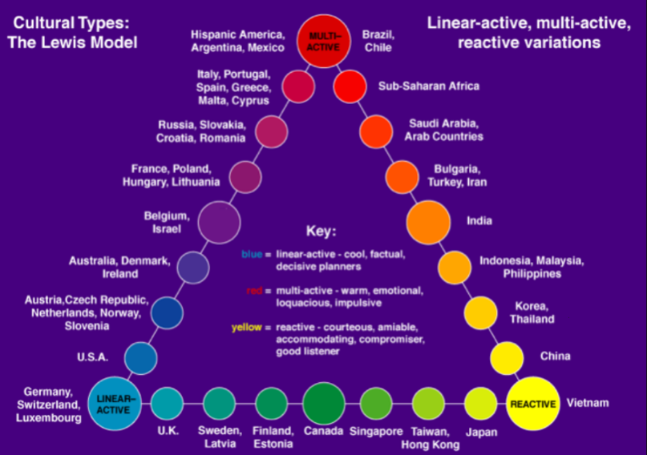Based on what I experienced Egyptians talk a lot, trying to sell us all kinds of things, they interrupt a lot of the time and are very impatient. Based on the Lewis Model in Figure 3. They aren’t directly mentioned but Egypt falls under **“Saudi Arabia, Arab Countries”.** These are located close to “Multi-Active”. Which in my eyes make sense based on what I just said. They weren’t showing lots of feelings or were emotional, which are features of multi-active, then again Egypt isn’t completely in Multi-Active so it’s entirely possible that they do fall close to the Multi-Active behaviour.

Figure | The Lewis Model  
source: [CrossCulture](https://www.crossculture.com/the-lewis-model-dimensions-of-behaviour/)