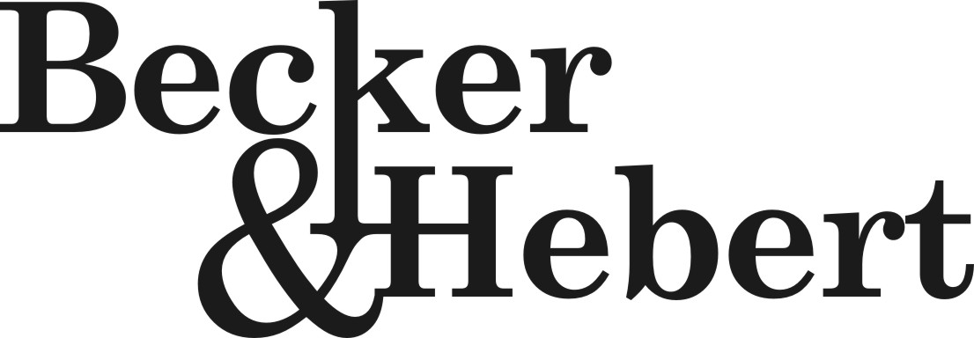 Post Office Drawer 52085, Lafayette, Louisiana 70505

Attorneys and Counselors at Law 910 Harding Street, Lafayette, Louisiana 70503
Phone: 337.233.1987 Fax: 337.235.1748
Email: Jeremy@lawbecker.com
Richard L. Becker* ______
Jeremy A. Hebert Of Counsel
Yvette E. Dumas Talbott P. Ottinger
Adam A. Abdalla

*Admitted in Louisiana and
The District of Columbia
June 14, 2011

VIA U.S. MAIL
Jason’s Deli
149 Arnould Boulevard
Lafayette, Louisiana 70506

Re: Lease Agreement with Belle Realty of Lafayette, LLC (“Belle”)
Proof of Certificate of Insurance and Monthly Maintenance Contact with Butcher Air Conditioning

Dear Lessee:

This is just a reminder that in accordance with the Lease Agreement, the following items must be delivered to Belle. If you have already delivered proof of the following to Belle, please disregard this correspondence. If you have not, please send copies of the following to me at your earliest convenience.

1) A copy of your Certificate of Insurance naming Belle as the additional insured. The proper additional insured language on the Certificate of Insurance should read as follows:

“Belle Realty of Lafayette, LLC
its successors or assigns
101 Arnould Boulevard
Lafayette, Louisiana 70506”

2) Proof that a Monthly Maintenance Contract is in force and effect with Butcher Air Conditioning, 101 Boyce Road, Broussard, Louisiana 70518 whose telephone number is 337-837-2000.

For your convenience, you can either fax or scan/email the above information directly to me. My email address is adam@lawbecker.com and my fax number is 337-235-1748

Sincerely,

Adam A. Abdalla

AAA:rla

