
Franklin Financial
Serving Our Neighbors Since 1941

SENT OVERNIGHT

September 1, 2015

Mr. Stuart R. Breaux Becker & Hebert 201 Rue Beauregard
Lafayette, LA 70508
337-233-1987

Re: 1st Franklin Financial Corporation - #4674 On The Boulevard Shopping Center Lafayette, LA 70508

Dear Mr. Breaux:

Enclosed is your fully executed copy of the lease for the above location along with your copy of the Service Provider Agreement.

I would like to take this opportunity to thank you for your cooperation during the negotiations of this lease. If you have any questions, please contact me at 706-282-1679.

Very truly yours,

Merri Loy
Director of Property Management

POST OFFICE BOX 880 135 EAST TUGALO STREET 706-886-7571 TOCCOA, GEORGIA 30577



THE BOULEVARD SHOPPING CENTER LEASE AGREEMENT
This Lease Agreement (the "Agreement") is entered into as of the day or dates set forth below, but effective for all purposes as of the 1st day of September, 2015 (the "Effective Date"), by and between:
BELLE REALTY OF LAFAYETTE, L.L.C., a Louisiana limited liability company, domiciled in the Parish of Lafayette, State of Louisiana, whose current mailing address is 101 Arnould Boulevard, Lafayette, Louisiana, 70506 (hereinafter referred to as the "Lessor"); and
1ST FRANKLIN FINANCIAL CORPORATION, a corporation chartered under the laws of the State of Georgia, authorized to do business in the State of Louisiana, whose principal business establishment in the State of Georgia is located at 135 E. Tugalo Street, Toccoa, GA 30577 (hereinafter referred to as the "Lessee").

WITNESSETH:
WHEREAS, Lessor is the owner of that certain real property together with improvements located thereon known as The Boulevard Shopping Center located in Lafayette, Lafayette Parish, Louisiana ("Boulevard Shopping Center Property"); and
WHEREAS, Lessee wishes to lease a certain portion of the Boulevard Shopping Center Property from Lessor according to the terms and conditions set out herein.
NOW, THEREFORE, in consideration of the foregoing and other good and valuable consideration herein, the sufficiency of which is hereby acknowledged, the parties hereto agree as follows:
Section 1.01 - Premises:
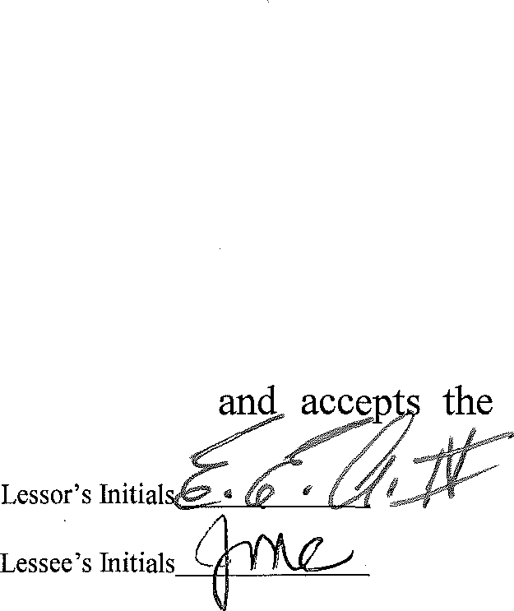
Lessor does hereby lease to Lessee, and Lessee hereby leases from Lessor the following premises (hereinafter called the "Premises"), more particularly described as follows:
One thousand nine hundred and seventeen (1,917) square feet located in the On the Boulevard Shopping Center Property as shown on the plat attached hereto as Schedule A and having the dimensions set forth thereon. The Premises have a municipal address 143 Arnould Boulevard, Lafayette, Louisiana 70508
- Lessee warrants and represents that it has inspected the Premises

R:\Data\ 00 Becke!\EJELLE REALTY\143.0-First Franklin FinanciaN.ease Agreement-Final.doc Page 1 of27

Premises, including the building and improvements, in their present state and without any representation or warranty by Lessor whatever as to the condition of the Premises. Lessor shall not be responsible for the condition of the Premises.

- Lessor makes no covenant, representation or warranty as to the suitability of the Premises for any purpose or use whatsoever or as to the physical condition thereof. Lessee acknowledges that it has inspected the Premises, observed its physical characteristics, determined its compliance with requirements imposed by any governmental agency having jurisdiction over the Premises, except ADA restroom and water fountain requirements, which Lessee agrees to bring up to current codes, and examined its existing conditions and has had the opportunity to conduct such investigation and study on and of the Premises as it deems necessary for its intended use and occupancy under this Agreement. Lessee hereby waives any and all objections to or complaints about the physical characteristics and existing conditions of the Premises. Lessee further acknowledges and agrees that the Premises are being leased to, and accepted by Lessee in its present condition "AS IS" with all faults and Lessee hereby assumes the risk that its adverse physical characteristics and existing conditions may not have been revealed by its inspection or investigation of the Premises; provided, however, that Lessor warrants that all mechanicals, equipment and fixtures, including but not limited to electrical, plumbing and HVAC systems exclusively serving the Leased Premises will be in good working condition upon Lessee taking possession. Should any condition or insufficiency be found during Lessee's renovation phase with respect to the foregoing, Lessee will notify Lessor immediately and Lessor will take all actions necessary to correct the problem. By taking possession of the Premises, Lessee accepts the Premises as suitable for the purpose for which the same are leased and accepts the Premises and each and every acceptance thereof and Lessee, by said acts, waives any and all defects therein.

Section 2.01 - Use:

The Premises shall be used by Lessee during the term hereof as offices for a consumer finance company. Lessee agrees that any change in the use of the Premises shall require the prior written consent of the Lessor.

Section 3.01 - Term:

The term of this Agreement shall commence on September 1, 2015 ("Commencement Date") and shall expire at midnight, Lafayette, Louisiana time on January 31, 2021 ("Initial Term").

Section 4.01 - Rent:

- Base Rent. During the InitialTerm, the Lessee shall pay to the Lessor a monthly base rent which is ("Base Rent"), which is calculated as follows:

Lease Months 1-5 $00.00 per square foot of the Premises annually,
payable monthly ($00.00 per month)

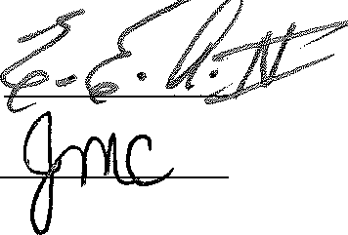

Lease Months 6-65 $16.00 per square foot of the Premises annually, payable monthly ($2,556.00 per month)

- Additional Rent. During the Initial Term, the Lessee shall pay to the Lessor, as additional rent ("Additional Rent"), the following amounts.

  - Common Area Maintenance Charges. The Lessee shall pay to the Lessor, the Lessee's Pro Rata Portion (as hereinafter defined) of the Common Area (as hereinafter defined) maintenance charges ("Common Area Maintenance Charges"). The Common Area Maintenance Charge shall mean the aggregate of all costs and expenses payable by Lessor in connection with the operation and maintenance of the Common Area in the Boulevard Shopping Center Property, including but not limited to landscaping costs, parking area maintenance costs (including repairing, resurfacing, .cleaning and striping), utility costs (including water, sewer, electricity and gas), security system costs, life and safety systems costs, electronic monitoring system costs, compensation (including employment taxes and benefits) of all persons who perform duties connected with the operation and maintenance of the Common Area and any other reasonable costs incurred by the Lessor with respect to the Common Area and not otherwise reimbursed by the Lessee hereunder. Common Area shall mean all areas, space, equipment and special services provided by the Lessor for the common or joint use and benefit of the Lessee and other tenants, their employees, agents, servants, suppliers, customers and other invitees, including but not limited to retaining walls, fences, landscaped areas, parking areas, curbs, driveways, sidewalks, private roads, green spaces, landscape areas, patios, service areas and all common areas and other areas all as shown on the site plan attached hereto as Schedule B.

  - Tax and Insurance Charges. The Lessee shall pay to the Lessor, the Lessee's Pro Rata Portion (as hereinafter defined) of the annual charges incurred by the Lessor for taxes and insurance coverage for the Boulevard Shopping Center Property ("Taxes and Insurance Charges"). Tax charges shall include all real property taxes, personal property taxes, improvement bonds and other charges or assessments which are levied upon or with respect to the Boulevard Shopping Center Property, including any increase in such taxes or a reassessment of the value of the Boulevard Shopping Center Property, licenses fees, or other taxes or fees levied in connection with the Lessor's leasing or rental of the Boulevard Shopping Center Property, but shall not include any federal or state income tax imposed upon the Lessor. Insurance charges shall include the cost of any insurance obtained by the Lessor in connection with the Boulevard Shopping Center Property, including but not limited to fire, casualty and liability insurance policies.

  - Payment of Additional Rent. The Lessee's Pro Rata Portion of the Common Area Maintenance Charges and the Taxes and Insurance Charges to be paid monthly as

Lessor's Initials -I"----'------'. ,

Additional Rent shall be one-twelfth of the applicable amounts of said charges multiplied by a number whose numerator is the square footage of the Premises (as set forth in Section 1.01) and whose denominator is the total of number of square feet of rentable floor area within the buildings located in the Boulevard Shopping Center Property.

Prior to the commencement of each calendar year, the Lessor shall provide to the Lessee an estimate of the Common Area Maintenance Charges and the Tax and Insurance Charges for the forthcoming calendar year. In the event the Commencement Date is a date other than the first day of a calendar year, then the Lessor shall provide to the Lessee on the Commencement Date, the estimate of the Common Area Maintenance Charges and the Tax and Insurance Charges for the balance of the calendar year in which the Commencement Date occurs. Beginning with the Commencement Date, and continuing on the first day of each calendar month thereafter, the Lessee shall pay to the Lessor, as Additional Rent, one twelfth of the Lessee's Pro Rata Portion of the Common Area Maintenance Charges and one twelfth of the Lessee's Pro Rate Portion of the Taxes and Insurance Charges as set forth on the estimate provided by the Lessor. The estimate of the Common Area Maintenance Charges for the period beginning with the Commencement Date and ending January 31, 2021, is $1.35 per square foot of the Premises annually, payable monthly as provided herein. The estimate of the Taxes and Insurance Charges for the period beginning with the Commencement Date and ending January 31, 2021, is $1.15 per square foot of the Premises annually, payable monthly as provided herein.

At the end of each calendar year, the Lessor shall furnish to the Lessee a statement showing the actual total Common Area Maintenance Charges and the Taxes and Insurance Charges and the Lessee's Pro Rata Portion of each respective charge for the calendar year just ended. If the amount of the estimated Common Area Maintenance Charges and the Taxes and Insurance Charges for any year during the Initial Term are less than the actual Common Area Maintenance Charges and the Taxes and Insurance Charges, then the Lessee shall pay to the Lessor, within thirty (30) days of the Lessee's receipt of the Lessor's statement, as Additional Rent, the Lessee's, Pro Rata Portion of the amount by which the actual Common Area Maintenance Charges and the Taxes and Insurance Charges exceed the estimated Common Area Maintenance Charges and the Taxes and Insurance Charges. In the event the estimated payments made by the Lessee are greater than the actual charges, then such excess shall be credited toward the Lessee's next due payment of Additional Rent. In the event the Initial Term of this Agreement expires or this Agreement is otherwise terminated, Lessor shall compute the excess, if any, due to the Lessor to the date the lease expired or was terminated and may add such amount to the amounts due under this Agreement.

Provided however, notwithstanding anything contained herein to the contrary, beginning in the second year of the Initial Term the amount of the estimated or

Lesso,'s miti,ls

actual Common Area Maintenance Charges for any calendar year thereafter shall not exceed the prior calendar year actual Common Area Maintenance Charges by more than four percent (4%).

The Total Monthly Rental Payment Amount of this Agreement shall be calculated as follows:

Months 1 through 5 of the Initial Term

Base Rent
Common Area Maintenance Charges Tax and Insurance Charge

Total Monthly Rental Payment
$ 00.00
$ 215.66
$ -183.71-
$ 399.37

Months 6 through 65 of the Initial Term

Base Rent $
Col1Jlll-- enan Jij $ Tax and,Ins1:1rance Charge $ -
2,556.00
al ,,66
183.71-

Total Monthly Rental Payment $ 2,955.37

Payment of Rent. The monthly payments of the Base Rent and Additional Rent (collectively, the "Total Monthly Rental Payment") shall be due on the first day of each calendar month.

Except as provided herein, all rental payments are due on the first day of each calendar month. In the event the Lessor does not receive the Total Monthly Rental Payments on or before the tenth day after receipt of notice from the Lessor of failure to pay Rent, as set forth in Section 18.0l(B), Lessee shall be assessed a late fee in the fixed amount of
$100.00, plus an additional late fee of $25.00 per day for each day thereafter that Lessee fails to remit the Rent to Lessor.

All rental payments due hereunder shall be made to the Lessor by mailing or hand delivery to 101 Arnould Boulevard, Lafayette, Louisiana 70506 or such other place, as the Lessor shall designate in writing.

Section 5.01 - Real Property Taxes:

Lessee shall be responsible for and shall pay before delinquency, its Pro Rata Portion of all real property taxes and assessments levied and assessed against the Premises, and shall make such payment in accordance with paragraph 4.01 B hereof.

Section 6.01 - Personal Property Taxes:
Lessor's Initial 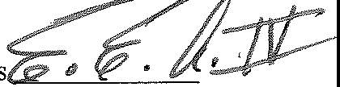
Lcs e's I,itials--F--

Lessee shall be responsible for and shall pay, before delinquency, all taxes, assessments, license fees, and other charges that are levied and assessed against Lessee's personal property installed or located in or on the Premises, and that become payable during the Initial Term or any renewal thereof.

Section 7.01 - Limitations on Use:

Lessee shall not do, bring or keep anything in or about the Premises that will cause the cancellation of any insurance covering the Premises. If the rate of any insurance carried by Lessor is increased, as a result of Lessee's use, Lessee shall reimburse Lessor for the amount of such increase.

- Lessee shall not permit any activity on the Premises which may in law constitute a nuisance, public or private, or which may constitute a violation of any environmental laws, or any other laws, ordinances or regulations.

- Lessee shall not operate all or any portion of the premises as a "place of public accommodation", as such term is defined under the Americans With Disabilities Act, 42
U.S.C. 12101 et seq., (the ADA) and the regulations pursuant to such act.

Section 8.01 - Assignment and Subletting:

Lessee shall not sell, mortgage, transfer, assign or sub-let all or any portion of the Premises without the prior written consent of the Lessor, which consent shall be in the sole discretion of the Lessor. Provided however, the Lessor shall not be obligated to consent to any assignment, transfer or sub-let in the event the proposed transferee's use of the Premises would be in conflict with the provisions of any other lease in the Boulevard Shopping Center Property. Notwithstanding the above, the Tenant shall have the absolute right to assign this Lease or sublet all or any part of the Premises to any other corporation which is an affiliate, subsidiary or parent of the Tenant, or to any entity which merges or consolidates with, or acquires substantially all of the assets of the Tenant, without the consent, either written or oral, of the Landlord, provided that the Use shall remain the same as that set forth in Section 2.01 of this Agreement. Further provided, that in no event shall Lessor's consent to an assignment or subletting by construed as (i) relieving Lessee from the obligation to obtain Lessor's express written consent to any further assignment or subletting or (ii) releasing Lessee from any liability or obligation hereunder whether or not then accrued, and Lessee shall continue to be, fully, jointly and severally liable hereunder. The Lessor may sell, mortgage, transfer or assign its interest in this Agreement at any time without the consent of the Lessee, subject to rights of Lessee under this Lease.

Section 9.01 - Maintenance, Repairs:

Lessee acknowledges that the Premises are in good order and repair. Lessee shall, at his own expense and at all times, maintain the Premises in good and safe condition, make all necessary repairs and replacements including, but not limited to the heating and air conditionin systems

Lessor's Initials ' Z
Lessee's Initials---F---

and components thereof serving the Premises, and shall surrender the same at termination hereof, in as good condition as received, normal wear and tear excepted. Lessee shall be responsible for all repairs required, excepting the roof, exterior walls, doors, plate glass and structural foundations including any utilities that may be run through the subfloor or foundations, which shall be maintained by Lessor. Lessee shall also be responsible for keeping at all times areas immediately adjacent to the Premises, such as sidewalks and parking areas free and clear of trash and other refuse. Lessee shall promptly repair any damage to any part of the building in which the Premises is located in the event such damage is caused by or attributable to the actions or inactions of Lessee, its employees, officers, directors, shareholders, members, partners, representatives, agents, customers, guests, invitees or licensees, to the extent to which such is not covered by insurance under Section 15.01. Notwithstanding the foregoing, the Lessor shall be responsible for the repair and replacement, if necessary, of the heating and air conditioning ("HVAC") systems servicing the Premises provided that (i) the Lessee shall pay the first $500.00 for each repair visit and/or the first $500.00 toward the replacement cost of the HVAC systems or any component thereof and (ii) the Lessee maintains, at its own expense, for the full term of this lease and any renewal or extensions thereof, a monthly maintenance contract with Butcher Air Conditioning or other reputable A/C contractor for regular routine maintenance to the HVAC systems and components thereof. Further provided, in the event it is determined by the HVAC maintenance provider the HVAC systems or any component thereof must be replaced and such replacement is made within fifteen (15) days of a repair visit made by such HVAC maintenance provider ("Preceding Repair Visit") (not including a routine maintenance visit pursuant to a monthly maintenance contract), then the amount paid by the Lessee toward the cost of the Preceding Repair Visit shall be credited toward the Lessee's obligation to pay the first $500.00 toward the replacement cost of the HVAC systems.

Lessee further agrees to maintain the Premises in clean and healthful condition and to comply with all laws, ordinances, orders, rules and regulations (state, federal, municipal and any other agencies or bodies having any jurisdiction thereof) with respect to the use, condition or occupancy of the Premises.

In discharging the responsibilities hereunder, Lessee shall utilize the services of bonded, licensed contractors to perform all maintenance or repair work to the Premises.

Lessee agrees to hire Butcher Air Conditioning or other reputable A/C contractor to perform all maintenance, repairs and replacements of the heating and air conditioning systems and components servicing the Premises; Lessee agrees to hire Magnon Electric to perform all maintenance, repairs and replacements of the electrical system and components servicing the Premises provided the rates of both Butcher Air Conditioning and Magnon Electric are comparable to other similar providers ofHVAC and electrical service in the immediate area.

Section 10.01 - Alterations:

Lessee shall not make any additions, improvements or alterations, structural or otherwise, to the Premises without Lessor's written consent, which consent shall be in the sole discretion of the Lessor. In making any improvements, additions or alterations that require the consent of Lessor,

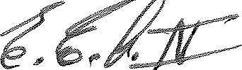
Lessor's Initials -- •
Leswc's 1n;1;,1,-P--

Lessee, after obtaining Lessor's consent, shall comply with the following:

- The improvements or alterations shall not be commenced until seven (7) days after Lessor has received written notice from Lessee stating the date the alternations are to commence and Lessor has consented to same.

- The improvements or alterations shall be in conformance with all applicable local, state or federal laws and regulations.

The Lessee shall not cause or permit any mechanic's liens to be filed against the Premises, and Lessee shall indemnify, hold harmless, and defend the Lessor from and against any and all such liens.

Moreover, any additions, alterations and improvements made by Lessee, with or without consent of the Lessor, no matter how attached to the premises, shall remain the property of the Lessor unless otherwise stipulated herein, and Lessee expressly waives any right to compensation or reimbursement for any such additions, alterations or improvements which may be made on the premises. Notwithstanding the above, however, Lessee may remove from the premises its office supplies, movable office furniture and movable equipment not attached to the leased premises provided (a) such removal is made prior to the termination of the term of the lease; (b) Lessee is not in default of any obligation or covenant under this lease at the time of such removal; and (c) Lessee promptly repairs all damage, no matter how slight, caused by the installation, use or removal of such furniture or equipment. Furthermore, Lessee, or any of its hired architects, engineers, contractors, subcontractors or employees, shall not remove or discard any component, fixture or flooring, movable or immovable, etc., without first consulting the Lessor and obtaining Lessor's written permission.

Section 11.01 Utilities and Janitorial Services:

Lessee shall pay before same becomes delinquent, all utility and service charges for utilities or services furnished to the Premises or used by the Premises or the Lessee, including, without limitation, electricity, gas, water, telephone service and trash collection. Lessee shall be responsible for maintaining the Premises in accordance with the terms hereof and shall be responsible for the payment of any costs or expense with respect to any janitorial services provided to the Premises and Lessee shall be responsible for the trash or refuse disposal services to the trash or refuse generated by or related to the Premises.

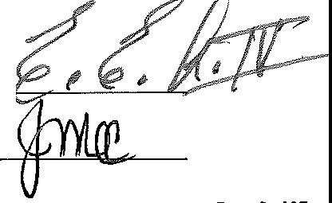
At the commencement of the Term, Lessee shall immediately transfer electric utility service from the name of Lessor to the name of Lessee. If the Lessee fails to immediately transfer electric utility service to the name of Lessee, Lessor may, at its discretion, (i) direct the electric utility provider to discontinue service to the Premises in Lessor's name, or (ii) make electric utility payments on behalf of Lessee and require that Lessee remit to Lessor full reimbursement for such payments together with a $100.00 administrative fee for each payment required to be made by Lessor.

Lessor's Initials +-.,......L.-""-. ,

Lessee's Initials

Section 12.01 - Signs:

Lessee, at its cost shall have the right to place, construct and maintain an exterior sign on the Premises advertising its business conducted on the Premises. Such sign shall be located on the front exterior wall of the Premises above the front canopy extending from the front wall. Lessor shall have the right to approve such signs prior to their placement on the Premises, which approval shall not be unreasonably withheld, and any sign that Lessee has the right to place, construct and maintain shall comply with all applicable laws or regulations including, but not limited to the rules and regulations attached hereto as Schedule C and the design criteria attached hereto as Schedule D. Upon termination of the tenancy herein created, Lessee shall remove any sign so placed and repair any damage or injury to the Premises or the exterior thereof caused by such removal. In the event the Lessee does not remove its sign as provided herein, then the Lessor shall have the right to remove the sign or signs and the Lessee shall be responsible for the payment of such removal and such cost or expense shall be considered as rent due hereunder.

In addition, Lessee must obtain prior written approval from Lessor of all Lessee exterior signage.

Should Lessee choose to place a sign under the Premises walkway, it must be erected by Hubbard Sign Company and paid for by the Lessee.

Section 13.01 - Access:

Lessor and its authorized representatives shall have the right after 12 hours notice to Lessee, to enter the Premises during Lessee's business hours and at all other reasonable times with such prior notice for the purpose of:

- Determining whether the Premises are in good condition and whether Lessee 1s complying with its obligations under this Agreement;

- Doing any necessary maintenance and to make any restoration or repair to the Premises or the building and other improvements in which the Premises are located that Lessor has the right or obligation to perform.

- Posting "for rent" or "for lease" signs during the last three (3) months of the term of the lease or any renewal thereof

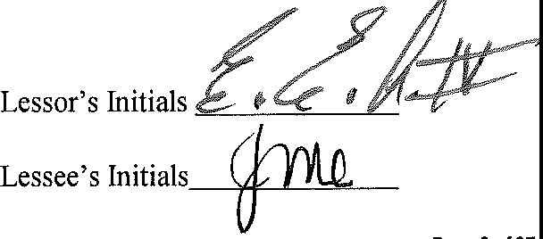
Due to stringent Federal and State Privacy and Confidentiality laws, Landlord agrees that in all situations wherein Landlord or Landlord's employees, agents, contractors or subcontractors enter the premises for any purpose, except in cases of emergency, Landlord will ensure that a representative of Tenant is present during such entry and/or work performed, and/or Landlord shall give Tenant such advance notice of proposed entry and/or work to be performed after hours that Tenant may ensure that all Tenant's customer's private and confidential information is protected from view by Landlord or Landlord's employees, agents, contractors or subcontractors.

Section 14.01 - Indemnity:

Lessee shall hold Lessor harmless from all damages arising out of any loss, theft, injury or damage to any person or property (as the case may be) occurring within the Premises except for damages resulting from the gross negligence or willful conduct of Lessor. Lessee shall be liable to Lessor for damages resulting from the acts or omissions of Lessee, its employees, officers, directors, shareholders, members, partners, representatives, agents, customers, guests, invitees and licensees or of Lessee's, its employee's, officer's, director's, shareholder's, member's, partner's, representative's, agent's, customer's, guest's, invitee's and licensee's negligence, gross negligence or willful conduct. Lessor shall be liable to Lessee for damages resulting from the acts or omissions of Lessor, its employees, officers, directors, shareholders, members, partners, representatives, agents, customers, guests, invitees and licensees or of Lessor's, its employee's, officer's, director's, shareholder's, member's, partner's, representative's, agent's, customer's, guest's, invitee's and licensee's gross negligence or willful conduct. Lessee's and Lessor's obligations under this paragraph to indemnify and hold the other party harmless shall be limited to the sum that exceeds the amount of insurance proceeds, if any, received by the Lessor. The indemnitee shall give prompt notice to the indemnitor of any claim to which this indemnity applies.

Section 14.02 - Hazardous Substances:

Lessee warrants and covenants that neither the Lessee, nor its employees, agents, officers, shareholders, partners, members, invitees, guests or customers shall use, deposit, store, transport, locate, bring on to or cause to be brought on to the Premises any Hazardous Substances and further warrants and covenants that neither Lessee nor employees, agents, officers, shareholders, partners, members, invitees, guests or its customers shall release, discharge, spill, dispose, emit or permit the breakage of, Hazardous Substances in, on or under the Premises.

Lessee agrees to indemnify and hold harmless Lessor from any and all claims, damages, fines, judgments, penalties, costs, liabilities, or losses (including, without limitation, any and all sums paid for settlement of claims, attorneys' fees, consultant and expert fees) arising during or after the term of this Agreement or any renewal hereof from or in connection with the presence or suspected presence of Hazardous Substances in or on the Premises, which Hazardous Substances were brought onto the Premises during the term of the lease or any renewal thereof by the Lessee, its agents, officers, representatives, employees, invitees or licensees or become deposited or otherwise become present of the Premises during the term of this Agreement or any renewal thereof. Without limiting of the foregoing, this indemnification shall include any and all costs incurred due to any investigation of the site or any cleanup, removal, or restoration mandated by a federal, state, or local agency or political subdivision.

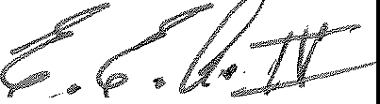
For purposes of this section, the term "Hazardous Substances" shall be interpreted broadly to include, but not be limited to, substances designated as hazardous under the Comprehensive Environmental Response, Compensation and Liability Act of 1980, as amended, 42 U.S.C. 9601, et seq., the Resource Conservation and Recovery Act, 42 U.S.C. 2201, et seq., and any applicable State or federal law or regulation. The term shall also be interpreted to include b t not

Lessor's Initials.........- ­ Lessee's Initials

be limited to any substance which after release into the environment and upon exposure, ingestion, inhalation or assimilation, either directly from the environment or directly by ingestion through food chains will or may reasonably be anticipated to cause death, disease, behavior abnormalities, cancer and/or genetic abnormalities, and oil and petroleum based derivatives.

Lessee shall have no responsibility for and Lessee's indemnity to Lessor shall not include any Hazardous Substance violations which have occurred prior to the Commencement Date of this Agreement, or, to the extent that the same is not attributable to Lessee, violations which occur after the termination, for any reason whatsoever, of the Lease and any renewal or extension thereto.

The provisions of this section shall be in addition to any other obligations and liabilities Lessee may have to Lessor at law or in equity and shall survive the termination of this Agreement.

Section 15.01 - Insurance:

Lessee, at its cost, shall maintain comprehensive general liability insurance in a mm1mum amount of $1,000,000.00 for each occurrence with a $2,000,000.00 general aggregate, including
$1,000,000.00 personal and advertising coverage, $100,000.00 in fire legal liability, and
$5,000.00 in medical payments, insuring against all liability of Lessee arising out of and in connection with Lessee's use or occupancy of the Premises. All such insurance policies shall name the Lessor as an additional insured. At the Commencement Date and thereafter upon request, Lessee shall supply to Lessor a certificate that such insurance is in force and the requisite premiums have been paid. Lessee's insurance policies and coverage shall be endorsed to apply on a primary basis. It is further provided that Lessee's insurance policies and coverage shall contain (either directly in the policy or by endorsement) a provision that provides that the Lessor shall be entitled to thirty (30) days prior written notice of cancellation and/or non renewal of such policy or coverage of the Lessee.

Lessor shall maintain fire, casualty and extended coverage insurance on the Boulevard Shopping Center Property and improvements thereon, and upon written request from the Lessee, the Lessor shall supply to Lessee a certificate establishing that such insurance is in force and the requisite premiums have been paid.

Section 16.01 - Waiver of Subrogation:

To the extent that a loss is covered by insurance in force and recovery is made for such loss, the Lessor and Lessee hereby mutually hold harmless and release each other from liability and waive all right of subrogation against each other for any loss or damage to their respective properties. Each party shall cause each insurance policy obtained by it to provide that the insurance company waives all right of recovery by way of subrogation against either party in connection with any damage covered by any policy.

Section 17.01 - Damage or Destruction:

Lessor's Initials >
Lessee's Initials L

If the Premises are so damaged or destroyed by fire, flood, earthquake, the elements, casualty, war, riot, public disorder, acts authorized or unauthorized by the government (including a condemnation proceeding) or any other cause or happening so as to render the Premises unusable for Lessee's operations, as determined by the Lessor acting in good faith and in a commercially reasonable manner, this Agreement shall terminate immediately and any unearned rent paid by Lessee shall be refunded without demand, setoff or reduction as of the date of such destruction or damage. However, there shall be no termination and no refund of unearned rent, except to the extent provided for or compensated for by Lessor's insurance, paid by Lessee, if the damage is caused by the negligence, willful misconduct or gross negligence of Lessee, its employees, officers, directors, shareholders, members, partners, representatives, agents, customers, guests, invitees or licensees.

If the Premises are partially damaged or rendered partially unusable by fire or other casualty, as set forth above, Lessee shall give Lessor written notice of the damage and if repairs are not undertaken by the Lessee within thirty (30) days from the date of such notice to Lessor, Lessor may terminate this Agreement by giving written notice to the Lessee. If Lessor elects not to terminate, this Agreement shall continue in full force and effect and the damages to the Premises shall be repaired by and at the expenses of Lessee, except to the extent provided for or compensated for by Lessor's insurance. Moreover, until such repair is substantially completed so that full use and occupancy of the Premises by Lessee is possible, the rent shall be apportioned according to the portion of the Premises which remains usable. If such repairs are not completed within one hundred eighty (180) days from the date of written notice of the casualty to Lessor, the Lessor may terminate this Agreement by the giving of written notice to the other party within ten (10) days of the expiration of the 180-day period.

If the building in which the Premises is located, or any portion thereof, provided such damaged portion contains all or a portion of the Premises, is partially damaged or rendered partially unusable by fire are other casualty set forth above, as determined by the Lessor acting in good faith and in a commercially reasonable manner, Lessor shall undertake the repair of the building and the Premises (except if such damage is caused by the negligence, willful misconduct or the gross negligence of the Lessee, its employees, officers, directors, shareholders, members, partners, representatives, agents, customers, guests, invitees, or licensees, in which case the Lessee shall be responsible for the repair of the building and the Premises, except to the extent provided for or compensated for by Lessor's insurance) within thirty (30) days from the date of the damages. If the said damages occur during the final six (6) months of the Lease Term or any renewal or extension thereof, then Lessor must notify Lessee within thirty (30) days from the date of the casualty of the estimated time required to repair or restore the Premises or the Building, and either party at its sole discretion and without further liability may terminate this Lease, as of the date of the casualty by giving written notice to the other party not more than sixty (60) days after the casualty. This Agreement shall continue in full force and effect during the period of the repair and/or until this Agreement is terminated as provided herein. Moreover, until such repair is substantially completed so that full use and occupancy of the Premises by the Lessee is possible, the rent shall be apportioned according to the portion of the Premises remaining usable. If such repairs are not completed within one-hundred twenty (120) days from the date that the repair work begins, either party may terminate this Agreement by giving written notice o the

Lessor's Initials ...!!l
c"""--''---V.

Lessee's Initials

other party within ten (10) days of the expiration of the 120 day period.

Section 18.01 - Lessee's Default:

The following events shall be deemed to be events of default by Lessee under this Agreement:

- Lessee shall be adjudged bankrupt, or shall file a voluntary petition in bankruptcy or make a general assignment for the benefit of Lessee's creditors, or a receiver by appointed for Lessee's property, or if execution be issued against Lessee's interest in this Agreement, or if Lessee's interest in this Agreement shall by operation of law pass to any person other than Lessee; or

- Lessee shall fail to pay the rental due hereunder or any other amount payable to Lessor hereunder within ten (10) days after Lessee's receipt of written notice from Lessor that such installment is overdue; or

- Lessee shall fail to perform any requirements of this Agreement, other than a failure described in subsection 18.0l(B) above, and Lessee shall such failure to cure the same within thirty (30) days after receipt by Lessee of written notice of such failure from Lessor, or in the event such failure to comply cannot reasonably be cured within thirty
(30) days, Lessee fails to commence and diligently pursue such curative action as may be reasonably required to effect such cure.

Upon the occurrence of any one or more of such events of default, at the option of Lessor, (i) this Agreement shall cease and terminate immediately and Lessee shall quit and surrender the Premises to Lessor, or (ii) Lessor may pursue any remedy available to Lessor, whether by law or contract, or in equity, including without limitation the repossession of the Premises by Lessor without terminating the Agreement, in which event Lessee shall be liable for all rent payable through the date of repossession, plus rent required to be paid by Lessee during the remainder of the initial term (or, if applicable, the any renewal term), diminished by any sums thereafter received by Lessor through reletting the Premises during said period. If this Agreement shall be been terminated by Lessor pursuant to this Section 18.01, Lessor may at any time thereafter resume possession of the Premises by any lawful means and remove Lessee and Lessee's property therefrom. Lessee hereby waives all requirements to give written notice to vacate the premises in accordance with the provisions of Articles 4701 through 4705 of the Louisiana Code of Civil Procedure. Time is of the essence with respect to all matters described in this Section 18.01.

Section 19.01 - Lessor's Default:

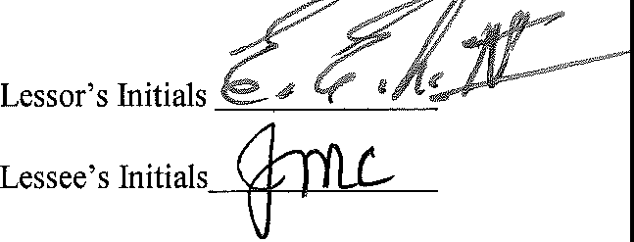
Lessor shall be in default of this Agreement if it fails or refuses to perform any provision of this Agreement that it is obligated to perform if the failure to perform is not cured within thirty (30) days after written notice of the default has been given by Lessee to Lessor. If the default cannot reasonably be cured within thirty (30) days, Lessor shall not be in default of this Agreement if Lessor commences to cure the default within the thirty-day period and in good faith continues to cure the default. In the event the Lessor fails to cure a default as provided hereina ove d the

continuance of such default results in the interruption of the Lessee's peaceable enjoyment of the Premises, then the Lessee shall be entitled to the abatement of the monthly rent payable under this Agreement and the amount of such abatement shall be in the same proportion as the amount of the Premises rendered unusable by Lessor's default is to the totality of the Premises.

Section 20.01 - Surrender of Premises:

Upon termination of this Agreement by lapse of time or otherwise, Lessee shall immediately surrender the Premises in as good condition as they were in at the beginning of the term, ordinary wear and tear and alterations, changes and additions made in compliance with this Agreement, acts of God, and other casualty excepted. In the event the Lessee retains possession of the Premises after the termination date of this Agreement, then the Lessee shall pay to the Lessor a monthly rental amount equal to 150% of the monthly rental amount set forth in Section 4.01 hereof for each month or part thereof that the Lessee retains possession of the Premises after the termination date of this Agreement.

Section 21.01 - Notice:

Any notice, demand, request, or consent that either party describes or is required to be given hereunder shall be in writing and shall be deemed sufficient if sent by United States first class mail, return receipt requested:

LESSOR:

LESSEE:
BELLE REALTY OF LAFAYETTE, L.L.C.
101 Arnould Boulevard
Lafayette, Louisiana 70506 with copy to:
Richard L. Becker, Esq. BECKER AND HEBERT, LLC
201 Rue Beauregard
Lafayette, Louisiana 70508

1ST FRANKLIN FINANCIAL
135 E. Tugalo Street or P. 0. Box 880
Toccoa, GA 30577
Attn: J. Michael Culpepper, EVP, COO with copy to:
Merri Loy
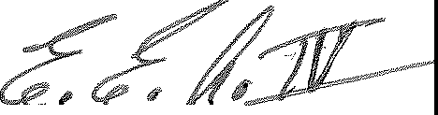1st Franklin Financial 4322 River Mill Drive Duluth, GA 30097

---=------'"--------"---­

Lessor's Initials
Lessee's Initials t

Either party may notify the other in writing of any different address for notice purposes.

All such notices shall be deemed given on the date of receipt at the applicable address as evidenced by the return receipt.

Section 22.01 - Common Area, Non-Exclusive Cross Use Easement and Parking:

Lessor shall have the sole and exclusive control of the Common Area as well as the right to make changes to the Common Area. However, notwithstanding the foregoing, Lessor shall not be responsible for any harm or damage to the Lessee, its officers, employees, directors, shareholders, members, partners, representatives, agents, customers, guests, invitees or licensees as a result of the use by any person or persons of the Common Area unless directly resulting from the gross negligence or willful conduct of Lessor, its officers, employees, director's, shareholders, members, partners, representatives, agents, customers, guests, invitees or licensees. Lessee will not be responsible for any claims or occurrences that happen outside the building including anything that happens in the parking lot unless directly resulting from the negligence, gross negligence or willful conduct of Lessee, its employees, officers, directors, shareholders, members, partners, representatives, agents, customers, guests, invitees and licensees. Lessor's rights with respect to the Common Area shall include, but not be limited to, the right to (i) restrict the use of the Common Area by unauthorized persons (ii) utilize from time to time any portion of the Common Area for promotional and related matters, (iii) temporarily close any portion of the Common Area for repairs, renovations, alterations or otherwise (iv) limit the activities or uses of the Common Area by the Lessee, its agents, invitees, and employees.

Each lessee of the Boulevard Shopping Center Property shall have a non-exclusive right to use and enjoy the Common Area, subject to the provisions contained in this Agreement. Provided however, in no event shall there be any overnight parking or storage of any boats, automobiles, trucks, recreational vehicles, campers or trucks larger than those having six wheels on the Boulevard Shopping Center Property. In addition, no lessee shall perform or permit to be performed any maintenance on any vehicles in the Common Area. All delivery vehicles owned and operated by any lessee in connection with its business located in the Boulevard Shopping Center shall be parked at all times, during business and non business hours in the rear of the lessee's leased premises.

Section 23.01 - Interpretation:

This Agreement shall be construed and interpreted in accordance with the laws of the State of Louisiana.

Section 24.01 - Waiver:

No delay or omission by either party in exercising any right occurring upon any noncompliance or default by the other party with respect to any of the terms hereof shall impair any such or be construed to be waiver thereof. A waiver by either party of any of the covenants and agreements
Lessor's Initials %r
Lessee's mit;,1s

to be performed by the other shall not be construed to be a waiver of any succeeding breach thereof or of any other covenants or agreements herein contained.

Section 25.01 - Heirs and Successors:

Subject to the provisions hereof pertaining to assignment and subletting, the covenants and agreements of this Agreement shall be binding upon the heirs, legal representatives, successors and assigns of the parties hereto.

Section 26.01 - Integrated Agreement; Modification:

This Agreement contains all of the agreements of the parties and cannot be amended or modified except by a written agreement signed by the Lessor and the Lessee.

Section 27.01 - Recordation:

This Agreement shall not be recorded, except that if either party requests the other party to do so, the parties shall execute a memorandum of lease in recordable form.

Section 28.01 - Captions:

The captions used in this Agreement shall have no effect of its interpretation.

Section 29.01 - Severability:

The unenforceability, invalidity, or illegality of any provision of this Agreement shall not render the other provisions unenforceable, invalid or illegal.

Section 30.01 - Attorney's Costs:

If by reason of any default on the part of Lessee, any attorney is employed to protect any rights of the Lessor under this lease, Lessee will pay the reasonable fee of that attorney. Lessee further agrees to pay all court costs, if any.

Section 31.01 - Option to Renew:

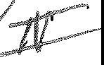
Provided that Lessee is not in default in the performance of this Agreement, Lessee shall have the option to renew the lease for one (1) additional term. The First Option (First Renewal Term) shall be for five (5) years commencing on the next day following the expiration of the Initial Term. All of the terms and conditions of this Agreement shall apply during the renewal term except that the monthly rental amount shall be negotiated and subject to increase, but in no event shall the monthly rental amount increase by more than ten (10%) percent.. The option(s) to renew shall be exercised by written notice given to Lessor by Lessee not less than sixty (60) days prior to the expiration of the Initial Term or Renewal Term as the case may be. If notice is not given in the manner provided herein and within the time specified, this option to renew sh ' ate.

- Lessor's Initials .4'

Lessee's Initials

substance of this Agreement or the lease set forth herein.

Section 38.01 - Law Revision/License Contingency:

If, during the Term of the Lease or any renewal or extension thereof, (a) any law or regulation specific to the banking, financial, lending and/or consumer finance industry, whether local, State or Federal in nature, becomes effective which, in the reasonable opinion of Tenant, will make it unprofitable for Tenant to continue to operate its business under Tenant's current branch network structure, and Tenant decides to cease the operation of Tenant's business in the Premises solely as a result of such new law or regulation, or (b) in the event Tenant does not receive the license(s) or permits which, in its opinion, are necessary to conduct its business at the Premises within sixty (60) days after the execution of this Lease; then, in any such event and provided Tenant is not in default beyond applicable notice and cure periods, Tenant shall have the right to terminate the Lease, by delivering written notice thereof to Landlord (which notice shall, in case of (a) include a copy of such law or regulation), in which event the Lease shall terminate and be null and void and of no further force and effect ninety (90) days following Landlord's receipt of Tenant's termination notice (the "Tenant Termination Date"), provided Tenant pays to Landlord, on or prior to the Tenant Termination Date, (i) all Rent due under the Lease, up to and including the Tenant Termination Date, and (ii) in the case of (a) an early termination fee equal to the amount of Rent that would have accrued under the Lease, as amended hereby, during the first one hundred eighty (180) days following the Tenant Termination Date had Tenant not terminated the Lease.

[SIGNATURES APPEAR ON THE FOLLOWING PAGES]

List of Exhibits:

Exhibit A - Plat of Leased Premises Exhibit B - Site Plan of Common Area Exhibit C - Rules & Regulations
Exhibit D - Design Criteria for Lessee Signs

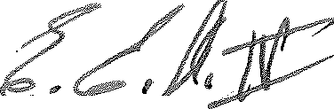
Lessor's Initials-=--------"---"-­ Lessee's Initials.

IN WITNESS WHEREOF the parties hereto have executed this Agreement the day and year first above.

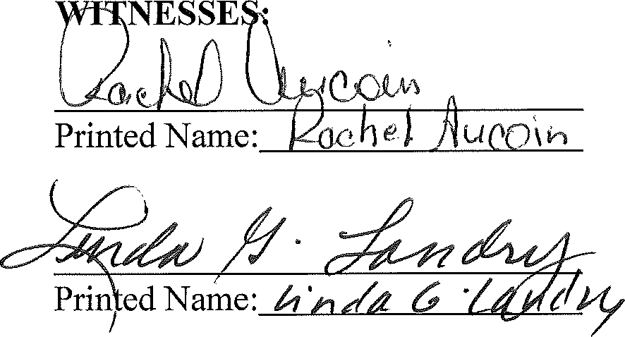
LESSOR:

BELLE REALTY OF LAFAYETTE, L.L.C.,
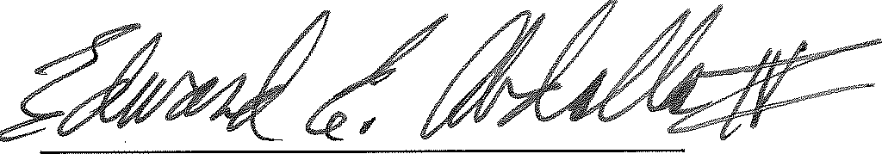
a Louisiana limited liability company

By:

Edward E. Abdalla, IV Managing Member

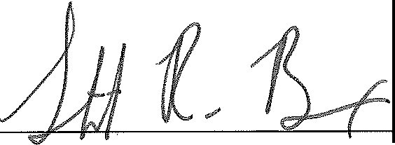
Notary Public

STUART R. BREAUX NOTARY PUBLIC STATE OF LOUISIANA BAR NO. 33741
MY COMMISSION IS ISSUED FOR LIFE

Lessor's Initials _

Lessee's Initfals-F--

IN WITNESS WHEREOF the parties hereto have executed this Agreement the day and year first above.

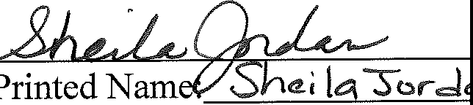
WITNESSES: LESSEE:

1ST FRANKLIN FINANCIAL
CORPORATION, a Georgia Corporation

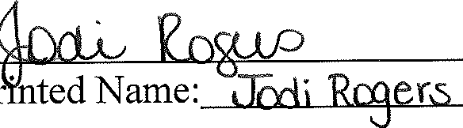
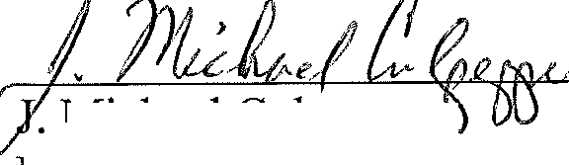
By:
. Michael Culpepper
EVP, Chief Operating Officer


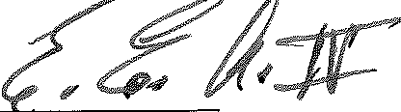
Lessor's Initials ­

Lessee's Jnili,ls

R:\Data\ 00 BeckeN3ELLE REALTY\143.0 -First Franklin Financial.Lease Agreement- Final.doc Page 20 o/27

SCHEDULE A

BOULEVARD SHOPPING CENTER PROPERTY PLAT SHOWING PREMISES LEASED

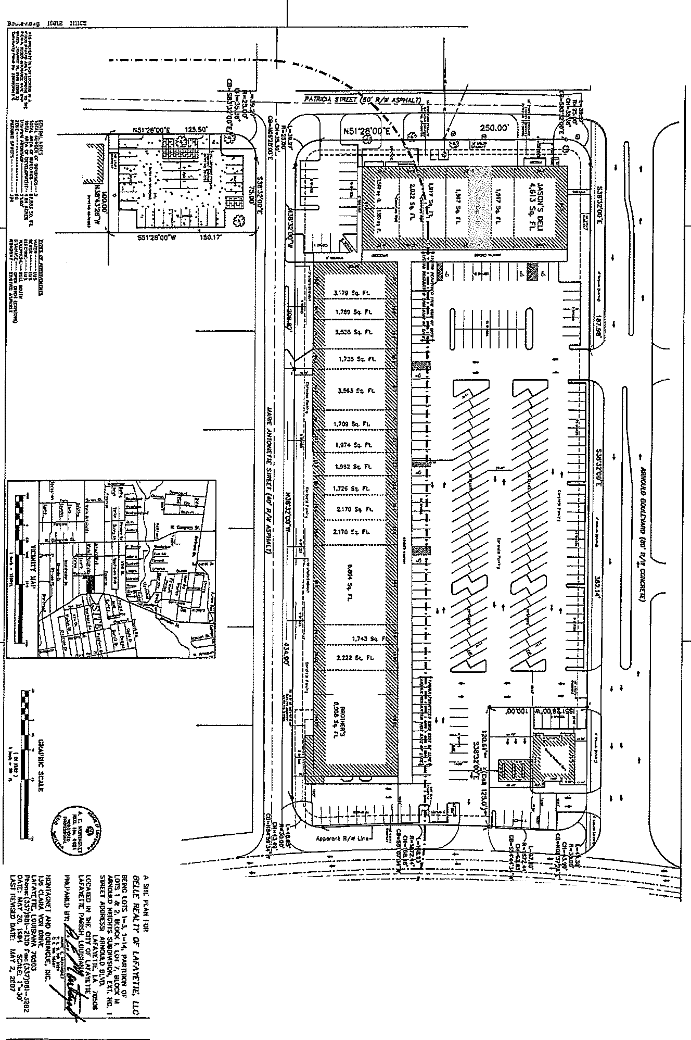
I
--:-;-:::::i:=:=:== ---·-· .;... :=:::;_:=:=:=::::::=..-.;
.tOltNSTON smw (I.JS Hwy 1r;1J (J:100- A;.1111
/

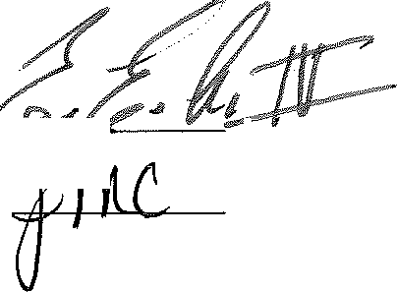
Lessor's Initial.,._ "'-'""'--...:::...-• Lessee's Initials
R:\Data\ 00 Beckel\BELLE REALTY\143.0 - First Franklin Financia/11.ease Agreement -Final.doc Page 21 o/27

SCHEDULE B

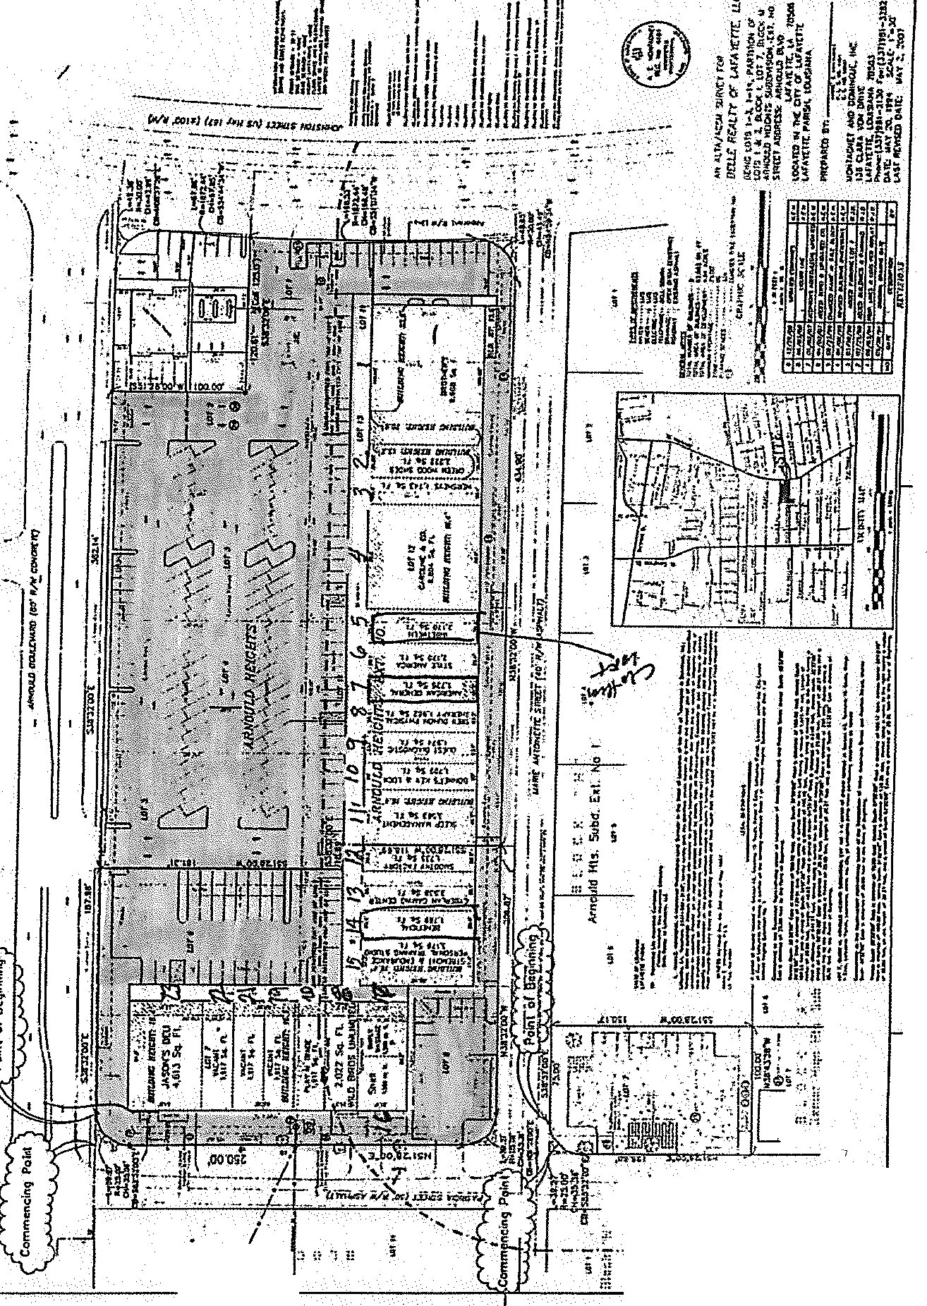BOULEVARD SHOPPING CENTER PROPERTY SITE PLAN SHOWING COMMON AREA
I
" .
6 ,•
;
.. i -,
.m"
: ·;i

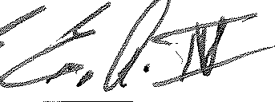
Lessor's Initials ­
Lessee's Initials C,

R:\Data\ 00 BeckeN3ELLE REALT'M43.0 -RISI Franklin Financial.Lease Agreement - Final.doc Page 22 of 27

SCHEDULEC

THE BOULEYARD SHOPPING CENTER PROPERTY RULES AND REGULATIONS

All loading and unloading of goods shall be done only at such times, in the areas, and through the entrances, designated for such purposes by Lessor.

The delivery or shipping of merchandise, supplies, and fixtures to and from the Premises shall be subject to such rules and regulations, which in the sole judgment of Lessor are necessary for the proper operation of the Premises or the Boulevard Shopping Center (the "Shopping Center").

All garbage and refuse shall be kept in the kind of container or receptacle specified by Lessor, and shall be placed in the area outside of the Premises prepared for collection in the manner and at the times and places specified by Lessor.

No radio or television or other similar device shall be installed without first obtaining, in each instance, Lessor's prior consent in writing. No aerial or antenna of any kind shall be erected on the roof or exterior walls of the Premises, the building in which the Premises is located or on the grounds of the Shopping Center, without, in each instance, the prior written consent of the Lessor. Any aerial or antenna so installed without such written consent shall be subject to removal by the Lessor without notice at any time.

No loud speakers, televisions, phonographs, radios, or other devices shall be used in a manner so as to be heard or seen outside of the Premises without the prior written consent of Lessor.

If the Premises are equipped with heating facilities separate from those in the remainder of the Shopping Center, Lessee, during winter months shall keep the Premises heated at a temperature sufficient to prevent freezing of water in pipes and fixtures located within the Premises.

The exterior areas immediately adjoining the Premises shall be kept clean and free from snow, ice, dirt, trash, refuse and rubbish by Lessee to the satisfaction of Lessor, and Lessee shall not place or permit any obstruction or merchandise in such areas.

The plumbing facilities within the Premises shall not be used for any other purpose than that for which they are designed, and no foreign substance of any kind shall be thrown therein, and the expense of any breakage, stoppage, or damage resulting from a violation of this provision shall be borne by Lessee.

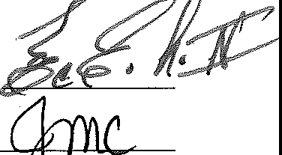
Lessee shall use, at Lessee's cost, a qualified pest extermination contractor as may reasonably be required, whose services shall be scheduled so as not to reasonably interfere with the operation of the Shopping Center.

Lessor's Initials

Lessee shall not bum any trash or garbage of any kind in or about the Premises, the Shopping Center, or within one mile of the outside property lines of the Shopping Center.

Lessee and Lessee's employees shall park their cars only in those parking areas designated for that purpose by Lessor provided Lessee has been given a map showing said designated areas..

Lessee shall not make noises, cause disturbances, or create odors, which may be offensive to other tenants of the Shopping Center or their officers, employees, agents, servants, customers or invitees.

Lessee shall not place any type or kind of electrical power extension cord or light fixture outside of the Premises. The Lessee shall use only UL approved, ground faulted power strips to facilitate electrical power sources within the Premises.

Lessee shall not, without the prior written consent of the Lessor, hang or cause to be hung, any banner, sign, display or any other items of any kind outside of the Premises (including the lattice which is part of the building in which the Premises is located).

Lessee shall not, without the prior written consent of the Lessor, stand, erect, construct or otherwise place any display or any other thing of any kind whatsoever in front of the Premises.

Lessee's retail business operation located within the Premises shall be open for business five (5) days per each calendar week, Monday through Friday. Lessee's hours of operation shall be consistent with its other offices within the state, typically from 8:30 a.m. until 5:30 p.m., with the exception of Wednesday, where the operation shall be open for business from 8:30 a.m. until 1:30 p.m. Nothing contained herein shall prevent the Lessee from opening for business on Sunday of each calendar week.

If Tenant closes its business in the Demised Premises (except by reason of fire, casualty, or causes beyond Tenant's control) and does not re-open for business within thirty (30) days after receipt of written notice from Landlord, such closing shall not be deemed a default under this Lease, but Landlord shall have the right to terminate this Lease effective as of the expiration of that thirty (30) day period by giving written notice of termination to Tenant. If Landlord does not exercise its termination right then Tenant shall remain obligated to pay rent and fulfill all other obligations of this Lease.

In the event the Lessee displays any clock or other time keeping device on the Premises which is visible from the exterior, the same shall be maintained in a manner to display the accurate time at all times, including the adjustment of such time to reflect daylight savings time and standard time and to compensate for any power outages which may have affected such clock or time keeping device.

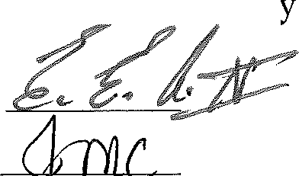In the event the Lessee displays or otherwise employs a sign which is lighted by electrical current or otherwise, then the Lessee shall ensure that such signs are lighted as
of dusk each da

,. ,.

Lessor's Initials

(adjusted for seasonal changes in such time) and remain lighted until midnight each day.

Lessee shall cause its name and address to be placed on the rear door of the Premises and shall, at its own expense, provide for security lighting to be placed on or about the rear door, which security lighting shall remain illuminated all night, every night.

Lessee shall not, nor shall Lessee permit any of its employees, contractors, customers or invitees to, solicit business or otherwise from any person or persons located on the Shopping Center property. Further, Lessee shall not respond or otherwise encourage or facilitate the solicitation by any outside person or persons on the Shopping Center property.

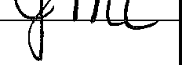
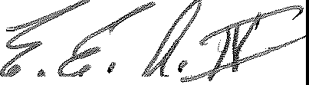Lessor's Initials ---'-,sL--=: ,

---'c...:

SCHEDULED

DESIGN CRITERIA FOR LESSEE SIGNS AT THE BOULEVARD SHOPPING CENTER

Lessee's sign or signs shall be store identity signs only, and must be placed on the exterior fa9ade of the canopy which covers the sidewalk in front of the Premises (the "Canopy") in the area designated for signs. No signs shall be suspended from the underside of the fa9ade, but may, subject to the approval of the Lessor, be suspended from the underside of the Canopy.

No freestanding signs shall be permitted.

Lessee's signage shall be Individual Channel Illuminated letters, interior light with single 12mm white neon, five and one-half (5 ½") inch deep Channel letters using .040 aluminum with bronze factory baked enamel finish, plastic facing, using l" Jewelite gold Trim cap.

Letter style may be of the Lessee's choice, subject to review and written approval by Lessor prior to the sign order being placed with the company.

Lessee's sign shall be limited to letters not to exceed twenty-six (26") inches in height. The maximum length of Lessee's lettering may be 80% of the frontage of the Premises, but no letters shall be nearer than two (2') feet to either corner of the Premises. No exposed neon light shall be used on signs without Lessor's prior written approval.

All neon on interior of letters to be UL48 specifications, PK housing, electrical conduit, etc. Letters to be mounted on a raceway, shall not exceed store identity name with cabinet being a maximum eight (8") inches width and eight (8") inches depth (transformers mounted in raceway); the raceway shall be painted the same color of the building fascia to which it will be attached.

Lessee's lettering on doors, windows or show windows may not be illuminated and may not exceed six (6") inches in height.

Lessee's shall not employ paper signs to be applied to the interior or exterior faces of the store front glass or other material. Lessee shall not employ any flashing action, moving action or audible signs.

Lessee's sign shall be in accordance with ordinances of governing bodies having jurisdiction over the Shopping Center, the Premises and/or the Lessee.

Lessee's signs shall operate in a manner which automatically turns the sign(s) on at dusk and turns the sign(s) off at 12:00 midnight each day.
;:?,
Lessor's Initial

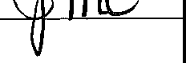
Lessor's approval of Lessee's plans and specifications for space improvement work shall not be deemed to constitute approval by Lessor of any of Lessee's sign work. Lessee shall submit separate drawings and specifications, including colors, for all its proposed sign work. The drawings shall clearly show the location of all signs on the storefront elevation drawing, graphic, color and construction and attachment details. Within a reasonable time after the receipt of such drawings and specifications, Lessor shall return one set thereof to Lessee with its approval and/or any suggested modifications from Lessor. Lessee shall be deemed to have agreed to and approved all suggested modifications.

All Lessee signs must be fully approved in writing by Lessor prior to installation.

In the event that Lessee places or otherwise erects a sign or signs in any place other than within the Premises without the prior written approval of the Lessor, the Lessor shall have the right to remove such sign or signs and the costs or removal shall be the responsibility of the Lessee. The Lessee shall reimburse the Lessor for such costs within five (5) days of receipt of an invoice from the Lessor for the costs of removal of the sign or signs. The cost of such removal shall be considered rent due hereunder and the non-payment by the Lessee shall be considered non­ payment of rent and entitle the Lessor the exercise its rights for non-payment of rent.

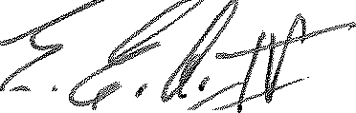Lessor's Initial

J ,__ ,.c

