Luis Morales
Assignment 13
July 5,2020
==================== B.) Design Documents ===================
START

Ask user to enter 3 coefficients

Display quadratic equation with user provided coefficients

Invalid response
Use algorithms to preform calculations

Display results

END

==========================================================
=============== C.) Screenshots of program runs ================
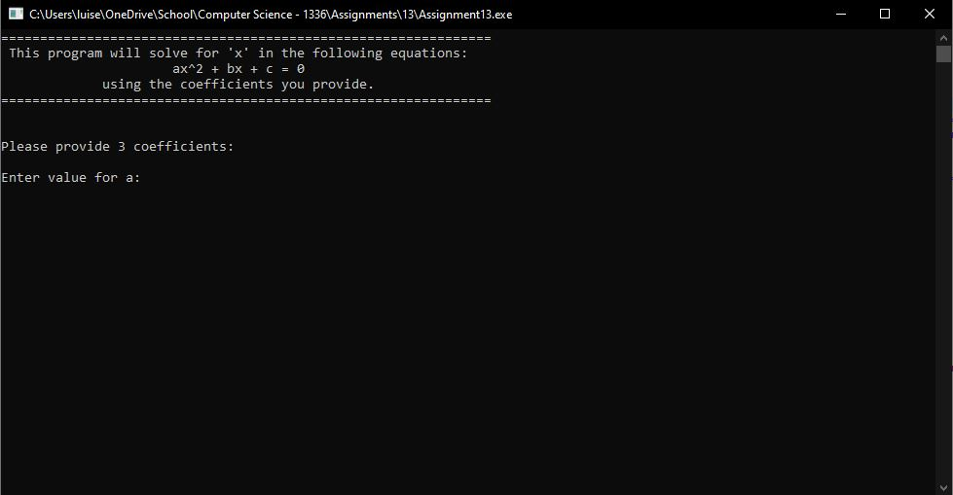
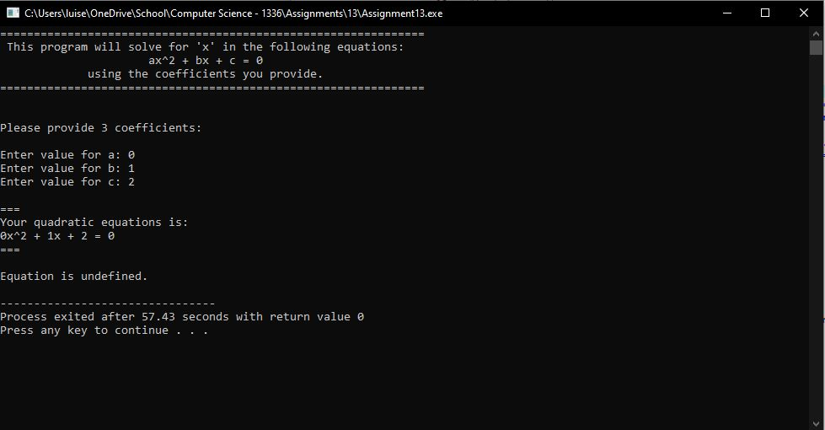

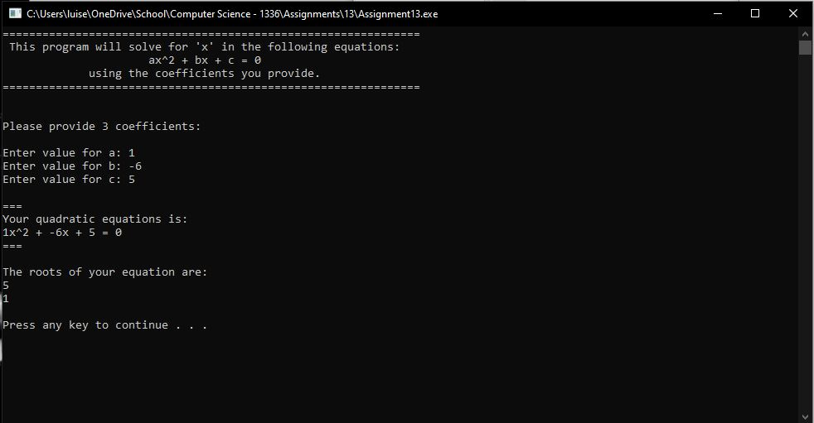
===========================================================
===================== D.) This document ======================
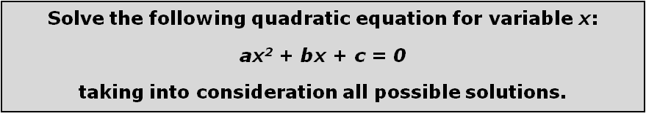

Program 12 Quadratic
- Clearly state the problem.
- Find roots using the quadratic formula

- What values need to be supplied by the user of the program?
- The coefficients need to be supplied by the user

- Do you need to place any restrictions on user input (input validation)? If so, specify the conditions.
Yes, the denominator can not be zero, therefore “A” can not equal 0.

- Analyze different kinds of methods (at least 3) that can be used solve a quadratic equation. (If your math is rusty, do some internet research or dig up your old algebra book.) Is any one of the methods more suitable than the others, from the software development point of view? If so, which one, and why?
- No

- Select the most suitable method for solving this problem. Are there any 'special cases' that you need to consider? If so, enumerate them.
- No

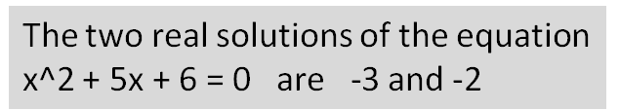
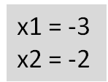
- Analyze different ways of presenting output to the user. For example, compare the difficulty of presenting the solution in these two forms:

Select an output representation (possibly, but not necessarily one of the above) that balances programming complexity and user friendliness.
---------------

- Use instructor-designated design-stage tool(s) to specify the complete algorithm.
--------------

- Are there any calculations performed several times? If so, design your program so the repetition is avoided.
---------------

- Implement your program. Test your program thoroughly.

---------------

- Turn in your
- source code (.cpp) file,
You may put all items required in B, C, and D, into one document…
- completed design document(s),
- screenshots of program runs,
- as well as this document with all questions answered.

References used:
- https://sciencing.com/roots-quadratic-8116675.html

You are free to use your textbook, other books and internet as resources, except you should not view and must not duplicate, any program or program segment found, related to this assignment topic. Make sure that you list all the resources, as precisely as possible (i.e. if it is a book - title, author, edition and exact page numbers, if it is an internet resource - exact url, etc.). Verify credibility of internet resources.





