Supplementary material
This supplement accompanies the revised manuscript on region selection and acquisition order for CAI assessment. All numerical results, intervals, trajectories and diagnostic arrays were already saved. This revision performs deterministic source binding, formatting and plotting only. No optimizer update, research-model forward, new bootstrap draw, seed, reserved-partition evaluation or checkpoint selection was performed.

S1. Data identity, partitions and evaluation units
The six paired-image collections and strength labels are the existing references [1,2,9–15] in the main article. A specimen record binds its laminate configuration, specimen ID, registered image pair and CAI label. Capture groups were formed before splitting from shared source/crop identities, then retained within partitions. The split contains 276 physical specimens (161 training, 50 development validation and 65 reserved), with 152/48/59 capture groups. The reserved partition was not evaluated. The same 50 development specimens selected checkpoints and estimated effects; all intervals are conditional on that selection.
Table S1. The complete 50-specimen evaluation cohort. Specimens are identified by layer count, layup and specimen number; dimensions and area clocks remain in cohort_manifest.csv. The full 276-row partition metadata are provided as S1_all_partition_metadata.csv. Reading split labels is not reserved-set evaluation.
Specimen | Capture group | CAI (MPa)
8-layer cross-ply / c8-12 | cg_306e4a499acc46c1 | 197.97145080566406
8-layer cross-ply / c8-13 | cg_f6941b7d17a6b65f | 266.5553894042969
8-layer cross-ply / c8-16 | cg_f6941b7d17a6b65f | 264.1634521484375
8-layer cross-ply / c8-2 | cg_8ffe4fd6a878d7f3 | 163.86158752441406
8-layer cross-ply / c8-21 | cg_49d6f1237b716b24 | 263.10400390625
8-layer cross-ply / c8-28 | cg_a983245f10699099 | 282.8260803222656
8-layer cross-ply / c8-3 | cg_8ffe4fd6a878d7f3 | 213.09927368164062
8-layer cross-ply / c8-39 | cg_ff43edde8af2ccdb | 168.51828002929688
8-layer cross-ply / c8-43 | cg_a37dc8a00cc334eb | 199.83413696289062
24-layer quasi-isotropic / q24-11 | cg_02fd3fc8caefe377 | 300.3553771972656
24-layer quasi-isotropic / q24-22 | cg_54890e18ff2b2669 | 415.8692932128906
24-layer quasi-isotropic / q24-24 | cg_39bf4ddc679c9a42 | 428.6219482421875
24-layer quasi-isotropic / q24-30 | cg_d3f7feef05d5a66a | 283.3366394042969
24-layer quasi-isotropic / q24-44 | cg_9ba3cd5fb00ea91f | 109.75041198730469
24-layer quasi-isotropic / q24-47 | cg_523711040788bde2 | 119.86738586425781
24-layer quasi-isotropic / q24-48 | cg_5549ad4618fa66a9 | 136.6800079345703
24-layer quasi-isotropic / q24-6 | cg_344fc945dcb88757 | 348.28472900390625
24-layer quasi-isotropic / q24-9 | cg_2cc9cac1c5baaf14 | 262.2107238769531
16-layer quasi-isotropic / q16-14 | cg_73ef27ab04a735de | 404.2454528808594
16-layer quasi-isotropic / q16-2 | cg_ff2d01cab2de3ddc | 304.9983215332031
16-layer quasi-isotropic / q16-29 | cg_94a031a5fc453cba | 338.54833984375
16-layer quasi-isotropic / q16-3 | cg_3361913654df8b27 | 352.2940673828125
16-layer quasi-isotropic / q16-33 | cg_a37eab4f5b7beb12 | 257.2702331542969
16-layer quasi-isotropic / q16-38 | cg_a052ba6f5200ee4f | 344.6358337402344
16-layer quasi-isotropic / q16-43 | cg_6853c8e74a68016b | 302.281982421875
16-layer quasi-isotropic / q16-6 | cg_ce4d6a48a6968060 | 418.267333984375
24-layer cross-ply / c24-37 | cg_a01963fde121eda0 | 381.1910705566406
24-layer cross-ply / c24-39 | cg_d72ecf3171227da2 | 246.54722595214844
24-layer cross-ply / c24-42 | cg_a5c5defb812088ae | 301.55389404296875
24-layer cross-ply / c24-47 | cg_954e3ed61c8db0a4 | 480.5938415527344
24-layer cross-ply / c24-50 | cg_59e95410b683945f | 292.1376647949219
24-layer cross-ply / c24-51 | cg_7e1c8f7865d73e78 | 263.2923583984375
24-layer cross-ply / c24-52 | cg_b98b3f9ca1bfb997 | 252.29762268066406
24-layer cross-ply / c24-56 | cg_06ec34425b30c2e6 | 230.2566680908203
24-layer cross-ply / c24-9t | cg_0d1994d0164384d4 | 278.2536315917969
16-layer cross-ply / c16-12 | cg_5a80e5179694ff19 | 268.03814697265625
16-layer cross-ply / c16-14 | cg_efd8928c6d17de81 | 508.2288818359375
16-layer cross-ply / c16-16 | cg_cd055af98e2ea119 | 499.259765625
16-layer cross-ply / c16-17 | cg_f64812b6759e7d2b | 512.5420532226562
16-layer cross-ply / c16-24 | cg_354aea2e84731e86 | 523.44140625
16-layer cross-ply / c16-39 | cg_514ca9d914207c05 | 234.76339721679688
16-layer cross-ply / c16-42 | cg_cb9c6f640f08aee7 | 322.6684265136719
16-layer cross-ply / c16-5 | cg_7f9fe4a18a151cd4 | 270.7127685546875
8-layer quasi-isotropic / q8-15 | cg_60c6812942ba2332 | 260.08502197265625
8-layer quasi-isotropic / q8-2 | cg_93e604617899fa5f | 219.15264892578125
8-layer quasi-isotropic / q8-22 | cg_ca08b9786e924e66 | 235.01319885253906
8-layer quasi-isotropic / q8-33 | cg_a841812423416444 | 215.7657928466797
8-layer quasi-isotropic / q8-34 | cg_f28b9720dbc7e026 | 235.4805145263672
8-layer quasi-isotropic / q8-37 | cg_a064df3d047f4519 | 248.33407592773438
8-layer quasi-isotropic / q8-8 | cg_8fd87d72a8d71b83 | 184.39810180664062
Random contributes five saved trajectories per specimen; the other five methods contribute one each. Thus 500 archived trajectories and 7,849 acquisition events are repeated observations of these 50 specimens, not additional independent samples. Fixed-final-set analysis adds seven conditions per specimen (original, reverse, five permutations), giving 350 conditions on the same cohort. Paired intervals resample capture groups within six source groups, carrying each group’s specimens together.

S2. Model identity, representation and learning protocol
The frozen actor is SpatialCAIActor with use_vlm=False and use_feedback=True. The method key is NO_VLM_SPATIAL_FEEDBACK; its seed is 2026091302, selected update 1000 after 1250 completed updates. The frozen readout is MeanSCPredictor (MEAN_SC), selected at update 1750 after 2000 updates. The actor contains 378,978 parameters including its training value head. The model-identity lock records the checkpoint and state-dictionary identities and whether local checkpoint bytes could be rehashed. A manifest-only checkpoint verification is not represented as a new model load.
Table S2. Frozen architecture and observable-input contract.
Component | Specification
Local encoder | Frozen ResNet18; independently crop each cell before encoding; 512 features per region
Grid / native area | 8 × 8 row-major, indices 0–63; edges rint(linspace(0, native dimension, 9)); integer pixels
Surface registration | Frozen orientation; clockwise 90° once; maximum edge 1024 before local extraction
Actor local projections | Surface 512 → 48; visible/learned-unknown internal 512 → 48
Actor regional input (102) | 48 surface + 48 internal + 2 coordinates + 1 measured + 1 ordinal/64 + 2 zero VLM placeholders
Actor global input (6) | Acquired area, remaining area, standardized CAI, measured-cell fraction, 2 zero VLM placeholders
Actor contextualizer | 64 regional + 1 global tokens; width 128; 2 layers; 4 heads; feed-forward 256; dropout 0
Actor heads | Concatenate local/global tokens → 128 → 1 score; separate global value head during training
Readout local cell | Two 512 → 64 affine projections; concatenate with mask and coordinates (131 inputs); 131 → 64 → 64 GELU
Readout pooling / output | Mean of all 64 cells + mean of measured cells + acquired area (129 inputs); 129 → 64 → 1; training-only target scaling
Readout missing input | Internal descriptor is zero-masked BEFORE affine projection, retaining bias; measured-cell mean is zero at empty mask
Readout order dependence | Set-based; no ordinal or history input. Same final set and area imply the same terminal input.
The actor uses a learned unknown internal descriptor and an explicit measurement indicator. It never treats an unmeasured internal cell as known image evidence. Its two reserved regional channels and two reserved global channels are constant zero in this model. The predictor instead masks raw internal descriptors before its affine projection, so an unmeasured cell still contributes the projection bias to the all-cell summary. These are different missing-input mechanisms. Surface descriptors are available initially; measured CAI enters training costs or retrospective metrics only, never an execution decision.
Predictor mask training uses the frozen mixture: 10% empty masks; 60% masks with 1–16 cells drawn from random or fixed geometric orders; 20% random masks with 17–48 cells; 10% full masks. The standardized residual is fitted with Huber loss. Three capture-group cross-fitted training predictors provide policy cost: a training specimen is scored only by the predictor excluding its fold. The common evaluation predictor is fitted on the training partition. This description documents the completed training; the revision does not execute it.
Policy optimization used AdamW with learning rate $3×{10}^{−4}$, weight decay ${10}^{−4}$, batch size 16 and gradient-norm limit 1. Training sampled feasible categorical actions. Evaluation used deterministic feasible-score argmax. Candidate checkpoints were compared every 250 updates on development process A; an earlier candidate was replaced only for an improvement exceeding ${10}^{−12}$. The following scores are the existing job history, not a new candidate comparison.
Table S3. Archived actor-selection history.
Update | Development A (MPa)
250 | 47.276
500 | 46.461
750 | 44.911
1000 | 43.597
1250 | 44.451

S2.1. Derivation and cost-minimization sign
All 13 original numbered display equations remain in the main article; equation_map.csv records their locations. To derive Eqs. (9–10), substitute the signed error identity below into the interval sum in Eq. (7). Each completed event contributes to every later interval, with total length B − c_j including final carry. Unequal cell areas and negative decreases are retained.
$$e_{t}=e_{0}−\sum_{j=1}^{t}{Δ}e_{j}, \sum_{k=j}^{T−1}{(}c_{k+1}−c_{k})+(B−c_{T})=B−c_{j}.$$
$$A(B)=e_{0}−\sum_{j=1}^{T}{(}1−c_{j}/B)Δe_{j}, J=(1+λ_{T})e_{0}−\sum_{j=1}^{T}{(}1−c_{j}/B+λ_{T})Δe_{j}.$$
The trajectory baseline e₀ is constant for a fixed specimen and predictor. An earlier favorable event has more remaining integration length, whereas an adverse event contributes negatively. At c_j = B the process contribution vanishes and the terminal weight λT = 0.25 remains. Equation (11) divides remaining process-plus-terminal cost by the training target scale. Equation (12) has a positive log-probability sign because it minimizes cost: above-baseline sampled cost reduces that action’s probability under gradient descent. The advantage is stopped for actor differentiation; actor terms sum decisions within an episode and average episodes, while squared-value errors and entropy average within episodes before batch aggregation. Total loss adds 0.5 times value loss and subtracts entropy weight, linearly reduced from 0.01 to zero.

S3. Caps, acquired area, intervals and quality targets
A requested reporting cap queries the latest completed prediction at or below that cap on the single path planned for total B = 0.25. No policy is replanned for a smaller cap. Predictions are right-continuous step functions; the initial or final estimate is carried until the next event or total cap. MAE and RMSE pool physical specimens; Random averages absolute and squared losses within specimen before pooling. Process A and event-stage quantities average repeats within specimen, then specimens within source group, then the six source groups equally. These weights differ because development group sizes are 9,9,8,9,8,7.
Table S4. All five-cap results and actual acquired fractions (MAE in MPa). Full-precision RMSE and R² remain in same_cap_metrics.csv.
Method | Cap | MAE | Mean area | Min area | Max area
Center-first | 0.0 | 58.551 | 0.000000 | 0.000000 | 0.000000
Center-first | 0.0625 | 47.885 | 0.062350 | 0.061399 | 0.062407
Center-first | 0.125 | 48.827 | 0.111012 | 0.109491 | 0.125000
Center-first | 0.1875 | 49.094 | 0.172513 | 0.171900 | 0.187121
Center-first | 0.25 | 48.027 | 0.234759 | 0.234676 | 0.235577
Geometry-spread | 0.0 | 58.551 | 0.000000 | 0.000000 | 0.000000
Geometry-spread | 0.0625 | 50.221 | 0.062018 | 0.061399 | 0.062130
Geometry-spread | 0.125 | 46.189 | 0.124548 | 0.123164 | 0.124629
Geometry-spread | 0.1875 | 46.555 | 0.187336 | 0.186034 | 0.187407
Geometry-spread | 0.25 | 46.910 | 0.249970 | 0.249269 | 0.250000
Serpentine | 0.0 | 58.551 | 0.000000 | 0.000000 | 0.000000
Serpentine | 0.0625 | 49.731 | 0.062379 | 0.062130 | 0.062407
Serpentine | 0.125 | 48.773 | 0.124592 | 0.124260 | 0.124629
Serpentine | 0.1875 | 48.343 | 0.186805 | 0.186391 | 0.186851
Serpentine | 0.25 | 48.013 | 0.249184 | 0.248521 | 0.249258
Random | 0.0 | 58.551 | 0.000000 | 0.000000 | 0.000000
Random | 0.0625 | 53.156 | 0.053603 | 0.046897 | 0.062500
Random | 0.125 | 49.153 | 0.118768 | 0.109307 | 0.125000
Random | 0.1875 | 48.108 | 0.186646 | 0.171598 | 0.187500
Random | 0.25 | 46.886 | 0.246943 | 0.234492 | 0.250000
Learned-static | 0.0 | 58.551 | 0.000000 | 0.000000 | 0.000000
Learned-static | 0.0625 | 46.465 | 0.062401 | 0.062130 | 0.062500
Learned-static | 0.125 | 48.064 | 0.124803 | 0.124260 | 0.125000
Learned-static | 0.1875 | 46.784 | 0.187400 | 0.187130 | 0.187500
Learned-static | 0.25 | 46.993 | 0.235297 | 0.234674 | 0.249991
Proposed | 0.0 | 58.551 | 0.000000 | 0.000000 | 0.000000
Proposed | 0.0625 | 43.324 | 0.057700 | 0.046897 | 0.062500
Proposed | 0.125 | 43.164 | 0.119824 | 0.109120 | 0.124998
Proposed | 0.1875 | 42.928 | 0.182555 | 0.171415 | 0.187407
Proposed | 0.25 | 42.385 | 0.247174 | 0.234492 | 0.250000
Table S5. Saved paired differences, proposed minus control. Negative error differences favor proposed; these are existing 95% intervals, conditional on selection.
Control | Metric | Estimate | 95% low | 95% high | Improved n
Center | A | -4.878 | -9.109 | -0.764 | 29
Center | early_A | -3.050 | -6.935 | 1.000 | 34
Center | MAE | -5.642 | -10.912 | -1.012 | 27
Geometry | A | -3.714 | -7.283 | 0.337 | 33
Geometry | early_A | -3.109 | -7.690 | 1.943 | 27
Geometry | MAE | -4.525 | -8.276 | -0.670 | 29
Serpentine | A | -5.314 | -9.973 | 0.296 | 33
Serpentine | early_A | -3.399 | -8.155 | 2.096 | 28
Serpentine | MAE | -5.628 | -10.306 | -0.477 | 34
Random | A | -5.997 | -9.134 | -2.601 | 35
Random | early_A | -5.346 | -8.934 | -1.375 | 33
Random | MAE | -4.502 | -7.953 | -0.950 | 34
Static | A | -4.380 | -8.405 | -0.199 | 25
Static | early_A | -4.175 | -8.881 | 0.490 | 29
Static | MAE | -4.608 | -8.628 | -0.656 | 33
FULL_SCAN | MAE | 0.695 | -4.009 | 5.327 | 27
The percentile intervals use the existing 5,000 paired capture-group draws within source groups. Neither checkpoint selection nor multiple comparisons is adjusted. No interval is newly generated. The partial-minus-full MAE contrast of +0.695 MPa [−4.009, 5.327] is a difference estimate; no prespecified equivalence/noninferiority margin was tested. The area-cost axis measures supplied image pixels rather than measured scanner time.
Table S6a. Five-cap first-attainment caps for every preset target, including the full-input anchor. NR = not reached by 0.25; 0 = initially met; † = later recrossing. Relative saving is undefined if either method is NR or control cost is zero. All statuses and savings are preserved in matched_quality.csv.
Target | Center-first | Geometry-spread | Serpentine | Random | Learned-static | Proposed
41 | NR | NR | NR | NR | NR | NR
42 | NR | NR | NR | NR | NR | NR
43 | NR | NR | NR | NR | NR | 0.187500
44 | NR | NR | NR | NR | NR | 0.062500
45 | NR | NR | NR | NR | NR | 0.062500
46 | NR | NR | NR | NR | NR | 0.062500
47 | NR | 0.125000 | NR | 0.250000 | 0.062500† | 0.062500
48 | 0.062500† | 0.125000 | NR | 0.250000 | 0.062500† | 0.062500
49 | 0.062500† | 0.125000 | 0.125000 | 0.187500 | 0.062500 | 0.062500
50 | 0.062500 | 0.125000 | 0.062500 | 0.125000 | 0.062500 | 0.062500
51 | 0.062500 | 0.062500 | 0.062500 | 0.125000 | 0.062500 | 0.062500
52 | 0.062500 | 0.062500 | 0.062500 | 0.125000 | 0.062500 | 0.062500
53 | 0.062500 | 0.062500 | 0.062500 | 0.125000 | 0.062500 | 0.062500
54 | 0.062500 | 0.062500 | 0.062500 | 0.062500 | 0.062500 | 0.062500
55 | 0.062500 | 0.062500 | 0.062500 | 0.062500 | 0.062500 | 0.062500
56 | 0.062500 | 0.062500 | 0.062500 | 0.062500 | 0.062500 | 0.062500
57 | 0.062500 | 0.062500 | 0.062500 | 0.062500 | 0.062500 | 0.062500
58 | 0.062500 | 0.062500 | 0.062500 | 0.062500 | 0.062500 | 0.062500
59 | 0.000000 | 0.000000 | 0.000000 | 0.000000 | 0.000000 | 0.000000
60 | 0.000000 | 0.000000 | 0.000000 | 0.000000 | 0.000000 | 0.000000
61 | 0.000000 | 0.000000 | 0.000000 | 0.000000 | 0.000000 | 0.000000
41.690 | NR | NR | NR | NR | NR | NR
Table S6b. Event-union first-attainment caps for every preset target, including the full-input anchor. NR = not reached by 0.25; 0 = initially met; † = later recrossing. Relative saving is undefined if either method is NR or control cost is zero. All statuses and savings are preserved in matched_quality.csv.
Target | Center-first | Geometry-spread | Serpentine | Random | Learned-static | Proposed
41 | NR | NR | NR | NR | NR | NR
42 | NR | NR | NR | NR | NR | 0.078844†
43 | NR | NR | NR | NR | NR | 0.062591†
44 | NR | NR | NR | NR | NR | 0.062222
45 | NR | NR | NR | NR | NR | 0.046897†
46 | NR | 0.109120† | NR | NR | 0.062407† | 0.031203†
47 | NR | 0.093426 | NR | 0.249630 | 0.062407† | 0.031203†
48 | 0.062407† | 0.077732 | NR | 0.217830 | 0.062407† | 0.031203
49 | 0.046897† | 0.077732 | 0.109120† | 0.125001 | 0.062130 | 0.015715
50 | 0.046897 | 0.062038† | 0.062407 | 0.109304 | 0.046713 | 0.015715
51 | 0.046897 | 0.030700† | 0.046713† | 0.093610 | 0.046713 | 0.015715
52 | 0.031065 | 0.015509 | 0.015509† | 0.077732† | 0.046713 | 0.015694
53 | 0.015694 | 0.015509 | 0.015509 | 0.047337† | 0.046713 | 0.015694
54 | 0.015694 | 0.015509 | 0.015509 | 0.031431 | 0.031203 | 0.015694
55 | 0.015694 | 0.015509 | 0.015509 | 0.031203 | 0.031203 | 0.015509
56 | 0.015694 | 0.015509 | 0.015509 | 0.031019 | 0.015902 | 0.015509
57 | 0.015350 | 0.015350 | 0.015350 | 0.015715 | 0.015715 | 0.015509
58 | 0.015350 | 0.015350 | 0.015350 | 0.015694 | 0.015694 | 0.015350
59 | 0.000000 | 0.000000 | 0.000000 | 0.000000 | 0.000000 | 0.000000
60 | 0.000000 | 0.000000 | 0.000000 | 0.000000 | 0.000000 | 0.000000
61 | 0.000000 | 0.000000 | 0.000000 | 0.000000 | 0.000000 | 0.000000
41.690 | NR | NR | NR | NR | NR | NR
At q = 47 MPa, five-cap attainment is 0.0625 for proposed and learned-static, 0.125 for geometry and 0.25 for Random. The 50% reduction applies to geometry on this grid only. At q = 42 MPa the proposed event curve first crosses at 0.078844 and later recrosses; the five-cap grid is NR. The 41.690 MPa full-input anchor is not attained by 0.25. These are cohort first crossings, not an execution-time specimen-level stopping rule or engineering certification.

S4. Event contributions and fixed-set order interventions
Stage 1–4 completion intervals are (0,.0625], (.0625,.125], (.125,.1875] and (.1875,.25]. A raw decrease is previous absolute error minus updated absolute error. Its weighted contribution multiplies that decrease by (1 − completion fraction / B). Both retain adverse events. The sum of weighted decreases equals initial error minus process A. Archived methods use their original float64 area clock; fixed-set order intervention uses integer cumulative native pixels divided by total crop pixels. The two identity families remain separate; small native-replay differences from archived predictions are not silently mixed.
Table S7. All saved paired stage contrasts (MPa), proposed minus control; positive favors proposed. No direction change is applied to this already correct source table.
Control | Stage | Type | Gain | 95% low | 95% high
Center-first | 1 | weighted | 4.176 | -1.056 | 9.054
Center-first | 1 | raw | 4.552 | -1.246 | 10.032
Center-first | 2 | weighted | 0.572 | -2.116 | 3.205
Center-first | 2 | raw | 0.727 | -3.500 | 4.848
Center-first | 3 | weighted | 0.161 | -0.705 | 1.027
Center-first | 3 | raw | 0.457 | -1.753 | 2.608
Center-first | 4 | weighted | -0.031 | -0.244 | 0.194
Center-first | 4 | raw | -0.590 | -2.359 | 1.054
Geometry-spread | 1 | weighted | 5.926 | -0.117 | 11.095
Geometry-spread | 1 | raw | 6.865 | 0.362 | 12.502
Geometry-spread | 2 | weighted | -2.475 | -6.110 | 1.112
Geometry-spread | 2 | raw | -4.084 | -9.387 | 1.182
Geometry-spread | 3 | weighted | 0.199 | -0.619 | 0.942
Geometry-spread | 3 | raw | 0.635 | -1.626 | 2.672
Geometry-spread | 4 | weighted | 0.063 | -0.083 | 0.217
Geometry-spread | 4 | raw | 0.842 | -0.597 | 2.243
Serpentine | 1 | weighted | 5.562 | -0.805 | 11.071
Serpentine | 1 | raw | 6.282 | -0.580 | 12.239
Serpentine | 2 | weighted | -0.340 | -2.653 | 2.159
Serpentine | 2 | raw | -1.004 | -4.757 | 2.916
Serpentine | 3 | weighted | -0.032 | -0.886 | 0.830
Serpentine | 3 | raw | -0.051 | -2.323 | 2.196
Serpentine | 4 | weighted | 0.125 | -0.046 | 0.305
Serpentine | 4 | raw | 0.116 | -1.293 | 1.664
Random | 1 | weighted | 8.617 | 4.194 | 12.678
Random | 1 | raw | 9.707 | 4.862 | 14.131
Random | 2 | weighted | -2.314 | -4.549 | 0.070
Random | 2 | raw | -3.998 | -7.409 | -0.326
Random | 3 | weighted | -0.286 | -0.954 | 0.347
Random | 3 | raw | -0.724 | -2.547 | 1.021
Random | 4 | weighted | -0.019 | -0.191 | 0.165
Random | 4 | raw | -0.713 | -2.124 | 0.736
Learned-static | 1 | weighted | 3.341 | -1.651 | 8.050
Learned-static | 1 | raw | 3.063 | -2.381 | 8.149
Learned-static | 2 | weighted | 1.254 | -0.919 | 3.350
Learned-static | 2 | raw | 1.597 | -1.752 | 4.860
Learned-static | 3 | weighted | -0.365 | -1.225 | 0.505
Learned-static | 3 | raw | -0.971 | -3.312 | 1.405
Learned-static | 4 | weighted | 0.150 | -0.035 | 0.330
Learned-static | 4 | raw | 0.694 | -0.874 | 2.160
Table S8. Normalized fixed-set contrasts. N = native/original; C = comparator. Error rows are comparator minus native. Contribution rows are native minus comparator. All positive values favor native under these distinct definitions.
Contrast | Metric | Direction | Estimate | 95% low | 95% high
Primary permutation | A | C−N error | 1.486 | -0.658 | 3.384
Primary permutation | Early A | C−N error | 1.628 | -2.190 | 5.180
Primary permutation | J | C−N error | 1.486 | -0.658 | 3.384
Primary permutation | Final error | C−N error | 0.000 | 0.000 | 0.000
Primary permutation | Weighted S1 | N−C contribution | 3.074 | -0.578 | 6.502
Primary permutation | Weighted S2 | N−C contribution | -1.255 | -3.355 | 0.899
Primary permutation | Weighted S3 | N−C contribution | -0.325 | -0.940 | 0.250
Primary permutation | Weighted S4 | N−C contribution | -0.008 | -0.167 | 0.167
Secondary reverse | A | C−N error | 3.929 | 0.145 | 7.405
Secondary reverse | Early A | C−N error | 3.328 | -1.527 | 7.979
Secondary reverse | J | C−N error | 3.929 | 0.145 | 7.405
Secondary reverse | Final error | C−N error | 0.000 | 0.000 | 0.000
Secondary reverse | Weighted S1 | N−C contribution | 6.348 | 0.695 | 11.784
Secondary reverse | Weighted S2 | N−C contribution | -1.742 | -4.553 | 1.118
Secondary reverse | Weighted S3 | N−C contribution | -0.291 | -1.385 | 0.844
Secondary reverse | Weighted S4 | N−C contribution | -0.387 | -0.744 | -0.011
The legacy order_paired_contrasts.csv contains eight weighted-stage rows labeled comparator-minus-native. Only those contribution rows are negated in the derived normalized table, with CI [lo,hi] transformed to [−hi,−lo]. Eight error/objective rows remain unchanged. source_* columns preserve the original values and source Git blob 23a65f8d481797298b25bb228d1b2fd91181c65f. Applying normalization twice is identical to applying it once. The four normalized stage differences sum to the corresponding A difference within ${10}^{−8}$ MPa. Because final error is invariant within each fixed set, J − A differences also close. DIRECTION_CORRECTION.json records residuals.
The original-order intervention reproduced the archived predictions within the saved maximum deviation 6.104 × ${10}^{−5}$ MPa. All 350 terminal-set checks preserved the same terminal input and prediction. This is expected from a set-based predictor and validates the intervention; it is not an endpoint accuracy gain caused by order. The primary permutation A interval [−0.658,3.384] crosses zero, whereas the secondary reverse interval [0.145,7.405] is positive. Both early-A intervals cross zero. No component-specific causal claim or additive percentage decomposition follows.

S5. Six fixed cases and saved information-use diagnostics
The six cases were fixed before this revision and are all retained, including adverse residuals. Initial preferences are feasible-action softmax probabilities, not regional damage probabilities. The attribution maps are already saved L1 sensitivity of the selected action’s log probability to local surface descriptors, including the path through the current strength prediction. Attention maps are the saved global-query-to-regional attention among fused tokens. These three quantities have different meanings and units; none is a regional mechanical ground truth. The displays below use only the initial, NO_VLM model’s saved arrays. No attribution or attention was regenerated.
Table S9. All six cases; CAI values and errors in MPa.
Specimen | First cell | Actions | CAI target | Initial | Final | Final abs. error
8-layer cross-ply / c8-16 | 62 | 16 | 264.163 | 301.366 | 232.095 | 32.068
24-layer quasi-isotropic / q24-48 | 31 | 16 | 136.680 | 302.099 | 258.932 | 122.252
16-layer quasi-isotropic / q16-29 | 14 | 15 | 338.548 | 326.638 | 335.890 | 2.658
24-layer cross-ply / c24-9t | 27 | 16 | 278.254 | 225.969 | 233.148 | 45.105
16-layer cross-ply / c16-24 | 63 | 15 | 523.441 | 388.144 | 406.717 | 116.725
8-layer quasi-isotropic / q8-22 | 63 | 16 | 235.013 | 245.533 | 244.583 | 9.570
Nine of 94 recorded decisions departed from the highest initially scored cell still feasible on the actual path: c8-16 (2), q16-29 (2), c16-24 (4), q8-22 (1); q24-48 and c24-9t retained their initial feasible ranking. The comparison removes measured and unaffordable cells at every actual state. This describes specimen-specific initialization and selective reordering in six cases only. Changing internal evidence, history, progress and prediction are coupled, so the departures do not isolate internal-feedback causality.

S5.1. 8-layer cross-ply / c8-16
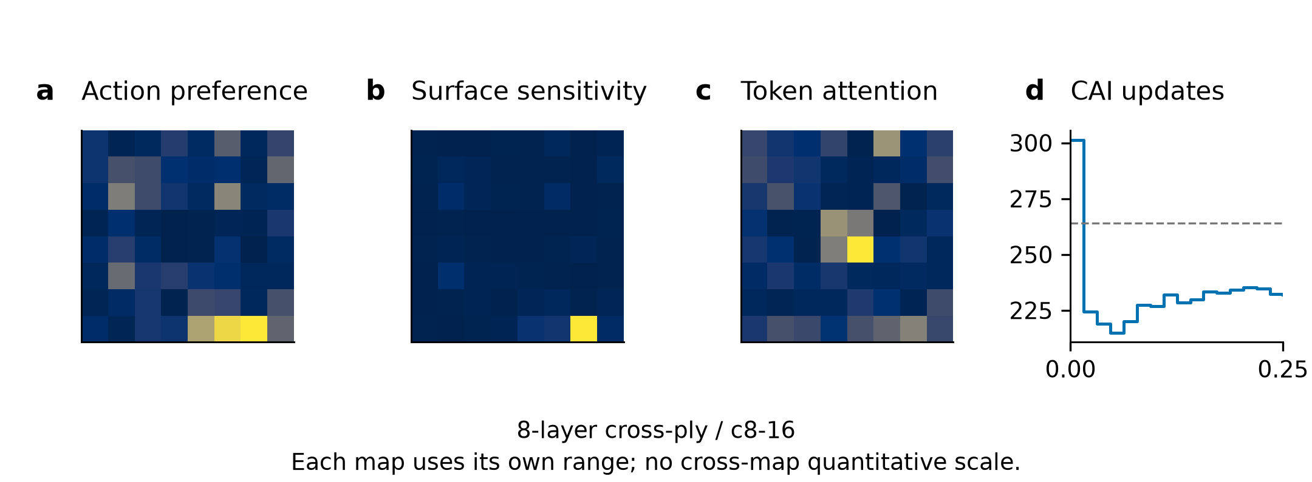
Figure S5.1. Initial NO_VLM state and saved CAI trajectory. (a) Feasible-action preference; (b) surface L1 sensitivity for the selected-action query (first saved target); (c) first-layer global-query regional attention (first saved layer); (d) saved CAI predictions with measured strength dashed. Maps retain all 64 cells and use independent ranges. Values and target/layer indices are in figure_data/cases.json; selected cell 62. Final absolute error: 32.068 MPa.

S5.2. 24-layer quasi-isotropic / q24-48
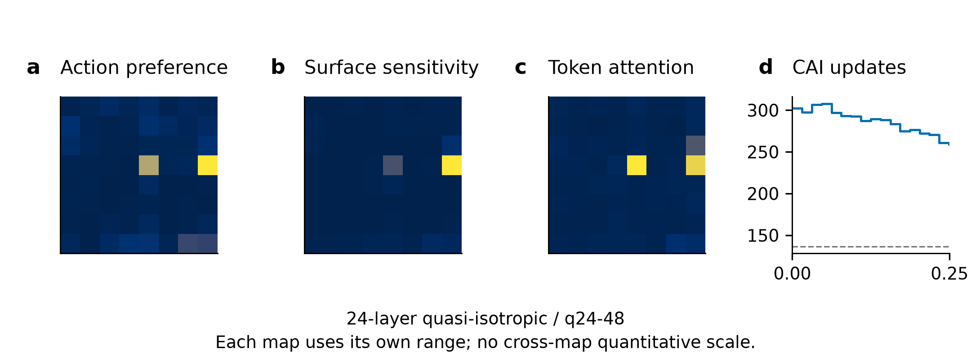
Figure S5.2. Initial NO_VLM state and saved CAI trajectory. (a) Feasible-action preference; (b) surface L1 sensitivity for the selected-action query (first saved target); (c) first-layer global-query regional attention (first saved layer); (d) saved CAI predictions with measured strength dashed. Maps retain all 64 cells and use independent ranges. Values and target/layer indices are in figure_data/cases.json; selected cell 31. Final absolute error: 122.252 MPa.

S5.3. 16-layer quasi-isotropic / q16-29
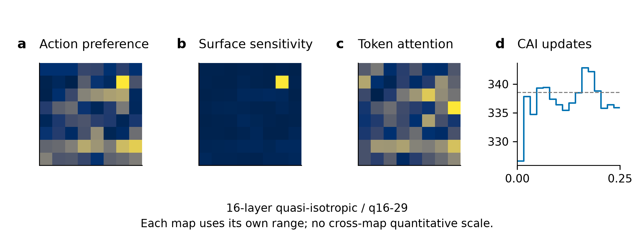
Figure S5.3. Initial NO_VLM state and saved CAI trajectory. (a) Feasible-action preference; (b) surface L1 sensitivity for the selected-action query (first saved target); (c) first-layer global-query regional attention (first saved layer); (d) saved CAI predictions with measured strength dashed. Maps retain all 64 cells and use independent ranges. Values and target/layer indices are in figure_data/cases.json; selected cell 14. Final absolute error: 2.658 MPa.

S5.4. 24-layer cross-ply / c24-9t
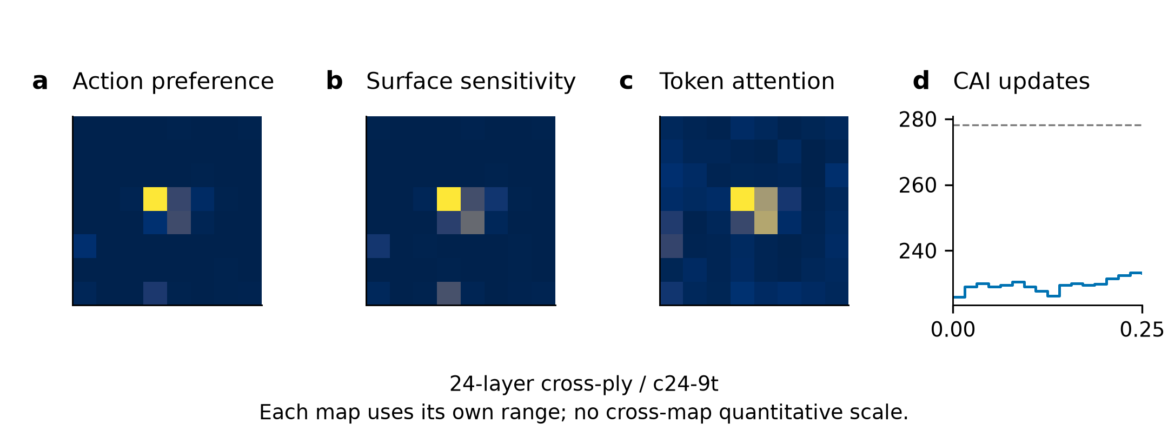
Figure S5.4. Initial NO_VLM state and saved CAI trajectory. (a) Feasible-action preference; (b) surface L1 sensitivity for the selected-action query (first saved target); (c) first-layer global-query regional attention (first saved layer); (d) saved CAI predictions with measured strength dashed. Maps retain all 64 cells and use independent ranges. Values and target/layer indices are in figure_data/cases.json; selected cell 27. Final absolute error: 45.105 MPa.

S5.5. 16-layer cross-ply / c16-24
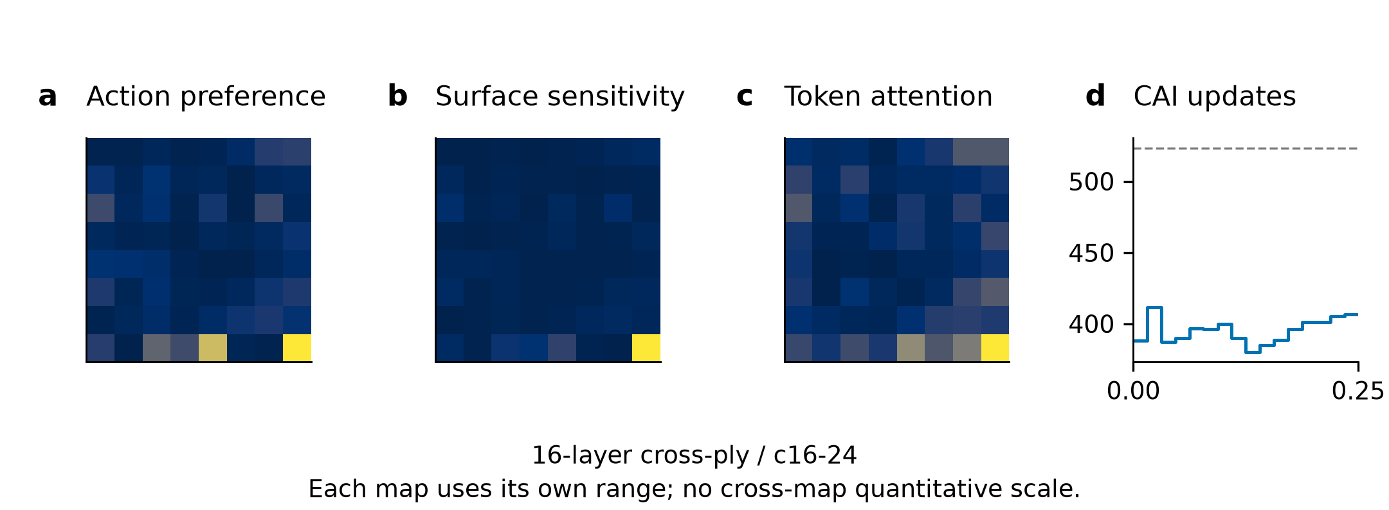
Figure S5.5. Initial NO_VLM state and saved CAI trajectory. (a) Feasible-action preference; (b) surface L1 sensitivity for the selected-action query (first saved target); (c) first-layer global-query regional attention (first saved layer); (d) saved CAI predictions with measured strength dashed. Maps retain all 64 cells and use independent ranges. Values and target/layer indices are in figure_data/cases.json; selected cell 63. Final absolute error: 116.725 MPa.

S5.6. 8-layer quasi-isotropic / q8-22
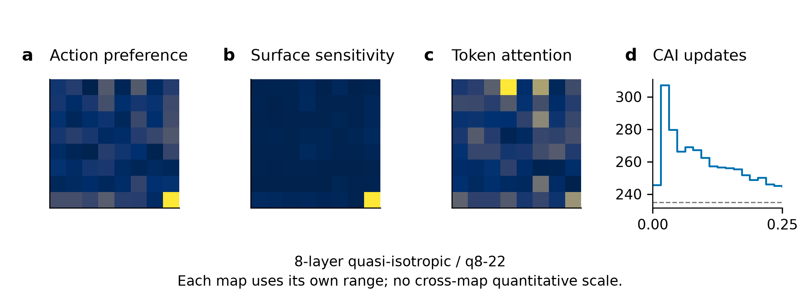
Figure S5.6. Initial NO_VLM state and saved CAI trajectory. (a) Feasible-action preference; (b) surface L1 sensitivity for the selected-action query (first saved target); (c) first-layer global-query regional attention (first saved layer); (d) saved CAI predictions with measured strength dashed. Maps retain all 64 cells and use independent ranges. Values and target/layer indices are in figure_data/cases.json; selected cell 63. Final absolute error: 9.570 MPa.

S5.7. Real-image provenance and reproducible displays
Main Fig. 6 uses the c8-16 (8-layer cross-ply) and q24-48 (24-layer quasi-isotropic) image pairs from the corresponding Mendeley Data version 1 collections (Hasebe, Higuchi, Yokozeki and Takeda, 2022; CC BY 4.0). The candidate manifest resolves each surface and registered C-scan path with SHA256 and native dimensions. Surface orientation follows the frozen clockwise-90° transform and maximum-edge-1024 display resize. The registered C-scan pixels are unchanged; overlays use rint native grid edges and the saved action ordinals. Grey overlays mark unavailable cells. The full-image backdrop is explicitly retrospective and was never supplied to the actor. assets.json records source URLs, hashes, dimensions, transformations and attribution. No damage outline, scale calibration or physical length measurement is invented.
The delivered scripts bind, prepare, render, build and verify this frozen-evidence package. Machine-readable trajectory ledgers provide all 500 archived paths and all 350 fixed-set conditions, without duplicating weights or feature shards. The eight document outputs provide English and aligned bilingual main text and supplement. Reference numbering is inherited from the main article; this supplement introduces no new references. Author names, affiliations, funding, competing interests and final journal submission metadata require author confirmation before submission; the package is a revision delivery, not a journal submission.

