|  |
| --- |
| CAEE PROJECT |
| Numerical Solutions of Equations of Motions For a Double Pendulum |
|  |

|  |
| --- |
| S  [Pick the date] |

CAEE PROJECT

Submitted to: Dr A.K. Panchal

By: Chhavi Sharma (U16EE022)

Harnish Rajput (U16EE035)

Academic Session 2017-18

Even Semester

PROBLEM STATEMENT:

Imagine two masses suspended from a fixed point and free to rotate in the vertical plane including above the pivot point.

Given: Masses, lengths and initial values (i.e velocities, orientation and acceleration at time t=0s) of the pendulum.

Tasks:

i) Plot the graph of motion of the tip of the second pendulum in the vertical plane.

ii) Time in which it will stop oscillating.

Steps involved:

1) Getting the Differential Equations by applying Newton’s laws of motion to the system.

2) Applying Numerical Methods and plotting the graphs.

3) Finding time after which it will no more move.

The above work will be done for both:

i) Double Pendulum

ii) Compound Pendulum

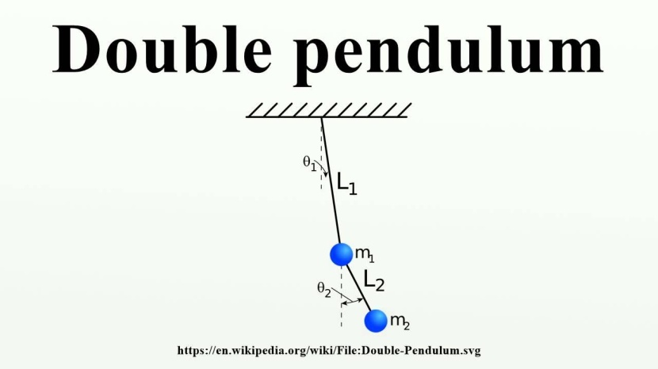

OBJECTIVE:

Different types of pendulums are used to model many phenomena in various disciplines. To drive the differential equation that governs the motion of double pendulum can be derived from Newton’s law of physics. This yields a system of two second order differential equation for a double pendulum. So Euler’s method for Numerical Solution and Runga-Kutta numerical solution techniques are used for solution.

The purpose of this project is to generate a math model for double pendulums. This involves using concepts of physics to derive second order differential equations that describe the motion of pendulums, and simplify those equations to systems of first order equations. Once simplified, Euler and Runge-Kutta numerical solvers are implemented to describe the approximate motion of the double pendulums.

Mathematical Solution:

Consider a double pendulum with stiff masses and mass less rods of lengths l1 and l2 and masses m1 and m2 attached to the ends.

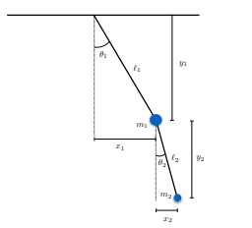

Using trigonometric relationship

x1 = l1 sin(θ1),

y1 = l1 cos(θ1),

x2 = x1 +l2 sin(θ2),

y2 = y1 +cos(θ2).

The velocity is the derivative with respect to time of the position, so

*x*1' = *θ*1' *l1* cos *θ*1

*y*1' = *θ*1' *l1*sin *θ*1

*x*2' = *x*1' + *θ*2' *l2* cos *θ*2

*y*2' = *y*1' + *θ*2' *l2*sin *θ*2

The acceleration is the second derivative, so

|  |  |
| --- | --- |
| *x*1'' = −*θ*1'2 *l1* sin *θ*1 + *θ*1'' *l1*cos *θ*1 |  |

|  |  |  |
| --- | --- | --- |
|  | *y*1'' = *θ*1'2 *l1*cos *θ*1 + *θ*1'' *l1* sin *θ*1 |  |

|  |  |  |
| --- | --- | --- |
|  | *x*2'' = *x*1'' − *θ*2'2 *l2*sin *θ*2 + *θ*2'' *l2*cos *θ*2 | 3) |

|  |  |  |
| --- | --- | --- |
|  | *y*2'' = *y*1'' + *θ*2'2 *l2*cos *θ*2 + *θ*2'' *l2*sin *θ*2 |  |

Forces in Double Pendulum:

We treat the two pendulum masses as point particles. Begin by drawing the free body diagram for the upper mass and writing an expression for the net force acting on it. Define these variables:

* *T* = tension in the rod
* *m* = mass of pendulum
* *g* = gravitational constant

The forces on the upper pendulum mass are the tension in the upper rod *T*1 , the tension in the lower rod *T*2 , and gravity −*m*1 *g* . We write separate equations for the horizontal and vertical forces, since they can be treated independently. The net force on the mass is the sum of these. Here we show the net force and use Newton's law *F* = *m a* .

|  |  |  |
| --- | --- | --- |
|  | *m*1 *x*1'' = −*T*1 sin *θ*1 + *T*2 sin *θ*2 | (5) |

|  |  |  |
| --- | --- | --- |
|  | *m*1 *y*1'' = *T*1 cos *θ*1 − *T*2 cos *θ*2 − *m*1 *g* | (6) |

For the lower pendulum, the forces are the tension in the lower rod *T*2 , and gravity −*m*2 *g* .

|  |  |  |
| --- | --- | --- |
|  | *m*2 *x*2'' = −*T*2 sin *θ*2 | (7) |

|  |  |  |
| --- | --- | --- |
|  | *m*2 *y*2'' = *T*2 cos *θ*2 − *m*2 *g* | (8) |

In relating these equations to the diagrams, keep in mind that in the example diagram *θ*1 is positive and *θ*2 is negative, because of the convention that a counter-clockwise angle is positive.

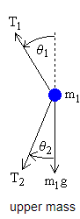 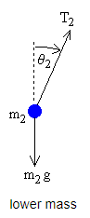

Direct Method for Finding Equations of Motion:

Now we do some algebraic manipulations with the goal of finding expressions for *θ*1'', *θ*2'' in terms of *θ*1, *θ*1', *θ*2, *θ*2' . Begin by solving equations (7), (8) for *T*2 sin *θ*2 and *T*2 cos *θ*2 and then substituting into equations (5) and (6).

|  |  |
| --- | --- |
| *m*1 *x*1'' = −*T*1 sin *θ*1 − *m*2 *x*2'' | 9) |

|  |  |  |
| --- | --- | --- |
|  | *m*1 *y*1'' = *T*1 cos *θ*1 − *m*2 *y*2'' − *m*2 *g* − *m*1 *g* |  |

Multiply equation (9) by cos *θ*1 and equation (10) by sin *θ*1 and rearrange to get

|  |  |  |
| --- | --- | --- |
|  | *T*1 sin *θ*1 cos *θ*1 = −cos *θ*1 (*m*1 *x*1'' + *m*2 *x*2'') | 11) |

|  |  |  |
| --- | --- | --- |
|  | *T*1 sin *θ*1 cos *θ*1 = sin *θ*1 (*m*1 *y*1'' + *m*2 *y*2'' + *m*2 *g* + *m*1 *g*) | 12) |

This leads to the equation

|  |  |  |
| --- | --- | --- |
|  | sin *θ*1 (*m*1 *y*1'' + *m*2 *y*2'' + *m*2 *g* + *m*1 *g*) = −cos *θ*1 (*m*1 *x*1'' + *m*2 *x*2'') | (3) |

Next, multiply equation (7) by cos *θ*2 and equation (8) by sin *θ*2 and rearrange to get

|  |  |  |
| --- | --- | --- |
|  | *T*2 sin *θ*2 cos *θ*2 = −cos *θ*2 (*m*2 *x*2'') | ) |

|  |  |  |
| --- | --- | --- |
|  | *T*2 sin *θ*2 cos *θ*2 = sin *θ*2 (*m*2 *y*2'' + *m*2 *g*) |  |

which leads to

|  |  |  |
| --- | --- | --- |
|  | sin *θ*2 (*m*2 *y*2'' + *m*2 *g*) = −cos *θ*2 (*m*2 *x*2'') |  |

Next we need to use a computer algebra program to solve equations (13) and (16) for *θ*1'', *θ*2'' in terms of *θ*1, *θ*1', *θ*2, *θ*2' . Note that we also include the definitions given by equations (1-4), so that we have 2 equations (13, 16) and 2 unknowns ( *θ*1'', *θ*2'' ). The result is somewhat complicated, but is easy enough to program into the computer.

|  |  |
| --- | --- |
| *θ*1'' = | −*g* (2 *m*1 + *m*2) sin *θ*1 − *m*2 *g* sin(*θ*1 − 2 *θ*2) − 2 sin(*θ*1 − *θ*2) *m*2 (*θ*2'2 *L*2 + *θ*1'2 *L*1 cos(*θ*1 − *θ*2)) |
| *L*1 (2 *m*1 + *m*2 − *m*2 cos(2 *θ*1 − 2 *θ*2)) |

|  |  |
| --- | --- |
| *θ*2'' = | 2 sin(*θ*1 − *θ*2) (*θ*1'2 *L*1 (*m*1 + *m*2) + *g*(*m*1 + *m*2) cos *θ*1 + *θ*2'2 *L*2 *m*2 cos(*θ*1 − *θ*2)) |
| *L*2 (2 *m*1 + *m*2 − *m*2 cos(2 *θ*1 − 2 *θ*2)) |

These are the equations of motion for the double pendulum.

NUMERICAL SOLUTION:

The above equations are now close to the form needed for the Runga Kutta method. The final step is convert these two 2nd order equations into four 1st order equations. Define the first derivatives as separate variables:

* *ω*1 = angular velocity of top rod
* *ω*2 = angular velocity of bottom rod

Then we can write the four 1st order equations:

*θ*1' = *ω*1

*θ*2' = *ω*2

|  |  |
| --- | --- |
| *ω*1' = | −*g* (2 *m*1 + *m*2) sin *θ*1 − *m*2 *g* sin(*θ*1 − 2 *θ*2) − 2 sin(*θ*1 − *θ*2) *m*2 (*ω*22 *L*2 + *ω*12 *L*1 cos(*θ*1 − *θ*2)) |
| *L*1 (2 *m*1 + *m*2 − *m*2 cos(2 *θ*1 − 2 *θ*2)) |

|  |  |
| --- | --- |
| *ω*2' = | 2 sin(*θ*1−*θ*2) (*ω*12 *L*1 (*m*1 + *m*2) + *g*(*m*1 + *m*2) cos *θ*1 + *ω*22 *L*2 *m*2 cos(*θ*1 − *θ*2)) |
| *L*2 (2 *m*1 + *m*2 − *m*2 cos(2 *θ*1 − 2 *θ*2)) |

RK-4:

clear all;

clc;

tic

% declarations

time=zeros(100,1);

theta1=zeros(100,1);

theta2=zeros(100,1);

x1=zeros(100,1);

x2=zeros(100,1);

y1=zeros(100,1);

y2=zeros(100,1);

w1=zeros(100,1);

w2=zeros(100,1);

% initial values

theta1(1)=0.9948; % 57 degree

theta2(1)=0.4363; % 25 degree

% constants

l1=1;

l2=1;

g=9.80;

m1=0.1;

m2=0.1;

% by geometry

x1(1)=l1*sin(theta1(1));

x2(1)=x1(1)+(l2*sin(theta2(1)));

y1(1)=-(l1*cos(theta1(1)));

y2(1)=y1(1)-(l2*cos(theta2(1)));

% stepsize

h=0.01;

% four single degree equations

F1=inline('w1','w1');

F2=inline('w2','w2');

F3=inline('((-g*((2*m1)+m2)*sin(theta1))-(m2*g*sin(theta1-2*theta2))-(2*sin(theta1-theta2)*m2*((w2)^2*l2 + (w1)^2*l1*cos(theta1-theta2))))/(l1*((2*m1)+m2-m2*(cos(2*theta1-2*theta2))))','theta1','theta2','w1','w2','g','m2','m1','l1','l2');

F4=inline('(2*sin(theta1-theta2)*((w1)^2*l1*(m1+m2)+g*(m1+m2)*cos(theta1)+(w2)^2*l2*m2*(cos(theta1-theta2))))/(l2*((2*m1)+m2-m2*cos(2*theta1-2*theta2)))','theta1','theta2','w1','w2','g','m1','m2','l1','l2');

% number of iterations

n=99;

for j=1:1:n

% k1

k11=F1(w1(j));

k12=F2(w2(j));

k13=F3(theta1(j),theta2(j),w1(j),w2(j),g,m1,m2,l1,l2);

k14=F4(theta1(j),theta2(j),w1(j),w2(j),g,m1,m2,l1,l2);

% k2

k21=F1(w1(j)+(h*k13)/2);

k22=F2(w2(j)+(h*k14)/2);

k23=F3(theta1(j)+(h*k11)/2,theta2(j)+(h*k12)/2,w1(j)+(h*k13)/2,w2(j)+(h*k14)/2,g,m1,m2,l1,l2);

k24=F4(theta1(j)+(h*k11)/2,theta2(j)+(h*k12)/2,w1(j)+(h*k13)/2,w2(j)+(h*k14)/2,g,m1,m2,l1,l2);

% k3

k31=F1(w1(j)+(h*k23)/2);

k32=F2(w2(j)+(h*k24)/2);

k33=F3(theta1(j)+(h*k21)/2,theta2(j)+(h*k22)/2,w1(j)+(h*k23)/2,w2(j)+(h*k24)/2,g,m1,m2,l1,l2);

k34=F4(theta1(j)+(h*k21)/2,theta2(j)+(h*k22)/2,w1(j)+(h*k23)/2,w2(j)+(h*k24)/2,g,m1,m2,l1,l2);

% k4

k41=F1(w1(j)+(h*k33));

k42=F2(w2(j)+(h*k34));

k43=F3(theta1(j)+(h*k31),theta2(j)+(h*k32),w1(j)+(h*k33),w2(j)+(h*k34),g,m1,m2,l1,l2);

k44=F4(theta1(j)+(h*k31),theta2(j)+(h*k32),w1(j)+(h*k33),w2(j)+(h*k34),g,m1,m2,l1,l2);

% values

theta1(j+1)=theta1(j)+(h*(k11+2*k21+2*k31+k41))/6;

theta2(j+1)=theta2(j)+(h*(k12+2*k22+2*k32+k42))/6;

w1(j+1) = w1(j)+(h*(k13+2*k23+2*k33+k43))/6;

w2(j+1) = w2(j)+(h*(k14+2*k24+2*k34+k44))/6;

x1(j+1)=l1*sin(theta1(j+1));

x2(j+1)=x1(j+1)+(l2*sin(theta2(j+1)));

time(j+1)=time(j)+h;

y1(j+1)=-(l1*cos(theta1(j+1)));

y2(j+1)=y1(j+1)-(l2*cos(theta2(j+1)));

end

% plotting graphs

plot(time,theta1,time,theta2);

plot(time,w1,time,w2);

toc

h=0.001

|  |  |  |  |  |
| --- | --- | --- | --- | --- |
| Time | Theta1 | Theta2 | W1 | W2 |
| 1 | 0.9948 | 0.4363 | 0 | 0 |
| 2 | 0.9947999495 | 0.4363000221 | -0.0010091622 | 0.0004416838 |
| 3 | 0.9947997982 | 0.4363000883 | -0.0020183245 | 0.0008833678 |
| 4 | 0.9947995459 | 0.4363001988 | -0.0030274869 | 0.0013250522 |
| 5 | 0.9947991927 | 0.4363003533 | -0.0040366494 | 0.0017667371 |
| 6 | 0.9947987385 | 0.4363005521 | -0.0050458122 | 0.0022084228 |
| 7 | 0.9947981835 | 0.436300795 | -0.0060549753 | 0.0026501095 |
| 8 | 0.9947975276 | 0.4363010821 | -0.0070641387 | 0.0030917974 |
| 9 | 0.9947967707 | 0.4363014134 | -0.0080733024 | 0.0035334866 |
| 10 | 0.9947959129 | 0.4363017888 | -0.0090824666 | 0.0039751774 |
| 11 | 0.9947949542 | 0.4363022084 | -0.0100916314 | 0.0044168698 |
| 12 | 0.9947938946 | 0.4363026722 | -0.0111007966 | 0.0048585643 |
| 13 | 0.994792734 | 0.4363031801 | -0.0121099625 | 0.0053002608 |
| 14 | 0.9947914726 | 0.4363037323 | -0.013119129 | 0.0057419597 |
| 15 | 0.9947901102 | 0.4363043285 | -0.0141282963 | 0.0061836611 |

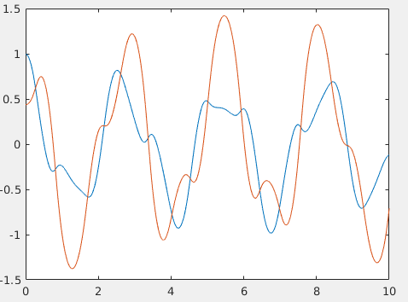 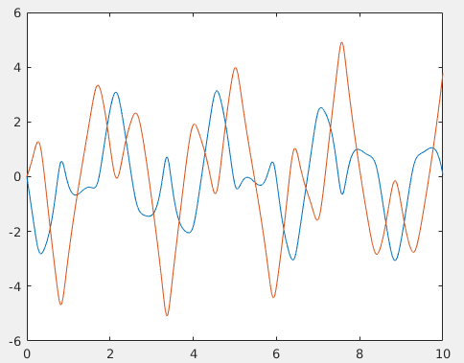

Fig time vs. th1 &th2 time vs. w1 &w2

h=0.1

|  |  |  |  |  |
| --- | --- | --- | --- | --- |
| Time | Theta1 | Theta2 | W1 | W2 |
|  | 0.9948 | 0.4363 |  |  |
|  | 0.9942953958 | 0.4365209224 | -0.1009254453 | 0.0442005654 |
|  | 0.992781307 | 0.437184654 | -0.2019060773 | 0.0885938298 |
|  | 0.990256909 | 0.4382940766 | -0.3029961955 | 0.1333701574 |
|  | 0.9867208429 | 0.4398539537 | -0.404248245 | 0.1787151244 |
|  | 0.9821712388 | 0.4418708698 | -0.5057116847 | 0.2248068243 |
|  | 0.9766057533 | 0.4443531399 | -0.6074316007 | 0.2718127986 |
|  | 0.9700216207 | 0.4473106874 | -0.7094469633 | 0.3198864477 |
|  | 0.9624157254 | 0.4507548812 | -0.8117884161 | 0.3691627575 |
|  | 0.9537846983 | 0.4546983272 | -0.914475466 | 0.4197531599 |
|  | 0.9441250453 | 0.4591546024 | -1.017512936 | 0.4717393268 |
|  | 0.9334333156 | 0.4641379211 | -1.120886522 | 0.5251656822 |
|  | 0.9217063197 | 0.4696627188 | -1.224557308 | 0.5800304191 |
|  | 0.9089414073 | 0.4757431383 | -1.328455078 | 0.6362748285 |
|  | 0.8951368196 | 0.4823923992 | -1.432470343 | 0.6937708095 |

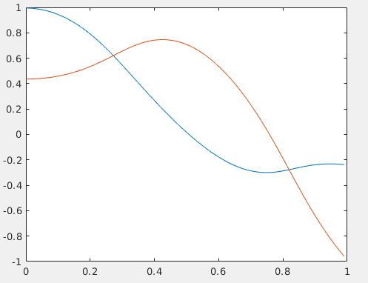

Fig time vs. th1 &th2

RK-2 :

clear all;

clc;

tic

% declaration

time=zeros(100000,1);

theta1=zeros(100000,1);

theta2=zeros(100000,1);

x1=zeros(100000,1);

x2=zeros(100000,1);

y1=zeros(100000,1);

y2=zeros(100000,1);

w1=zeros(100000,1);

w2=zeros(100000,1);

% initial values

theta1(1)=0.9948; % 57 degree

theta2(1)=0.4363; % 25 degree

% constants

l1=1;

l2=1;

g=9.80;

m1=0.1;

m2=0.1;

% by geometry

x1(1)=l1*sin(theta1(1));

x2(1)=x1(1)+(l2*sin(theta2(1)));

y1(1)=-(l1*cos(theta1(1)));

y2(1)=y1(1)-(l2*cos(theta2(1)));

% stepsize

h=0.0001;

% four single degree diff equations

F1=inline('w1','w1');

F2=inline('w2','w2');

F3=inline('((-g*((2*m1)+m2)*sin(theta1))-(m2*g*sin(theta1-2*theta2))-(2*sin(theta1-theta2)*m2*((w2)^2*l2 + (w1)^2*l1*cos(theta1-theta2))))/(l1*((2*m1)+m2-m2*(cos(2*theta1-2*theta2))))','theta1','theta2','w1','w2','g','m2','m1','l1','l2');

F4=inline('(2*sin(theta1-theta2)*((w1)^2*l1*(m1+m2)+g*(m1+m2)*cos(theta1)+(w2)^2*l2*m2*(cos(theta1-theta2))))/(l2*((2*m1)+m2-m2*cos(2*theta1-2*theta2)))','theta1','theta2','w1','w2','g','m1','m2','l1','l2');

n=99999; %iterations

for j=1:1:n

% k1

k11=F1(w1(j));

k12=F2(w2(j));

k13=F3(theta1(j),theta2(j),w1(j),w2(j),g,m1,m2,l1,l2);

k14=F4(theta1(j),theta2(j),w1(j),w2(j),g,m1,m2,l1,l2);

% k2

k21=F1(w1(j)+(h*k13));

k22=F2(w2(j)+(h*k14));

k23=F3(theta1(j)+(h*k11),theta2(j)+(h*k12),w1(j)+(h*k13),w2(j)+(h*k14),g,m1,m2,l1,l2);

k24=F4(theta1(j)+(h*k11),theta2(j)+(h*k12),w1(j)+(h*k13),w2(j)+(h*k14),g,m1,m2,l1,l2);

% values

theta1(j+1)=theta1(j)+(h*(k11+k21))/2;

theta2(j+1)=theta2(j)+(h*(k12+k22))/2;

w1(j+1) = w1(j)+(h*(k13+k23))/2;

w2(j+1) = w2(j)+(h*(k14+k24))/2;

x1(j+1)=l1*sin(theta1(j+1));

x2(j+1)=x1(j+1)+(l2*sin(theta2(j+1)));

time(j+1)=time(j)+h;

y1(j+1)=-(l1*cos(theta1(j+1)));

y2(j+1)=y1(j+1)-(l2*cos(theta2(j+1)));

end

% plotting graphs

plot(time,theta1,time,theta2);

plot(time,w1,time,w2);

toc

Results:

h=0.1

|  |  |  |  |  |
| --- | --- | --- | --- | --- |
| Time | Theta1 | Theta2 | W1 | W2 |
| 1 | 0.9948 | 0.4363 | 0 | 0 |
| 2 | 0.9942954189 | 0.4365208419 | -0.1009381232 | 0.0442139338 |
| 3 | 0.9927813182 | 0.437184306 | -0.2019314635 | 0.0886206104 |
| 4 | 0.990256871 | 0.4382932796 | -0.3030343218 | 0.1334103819 |
| 5 | 0.9867207144 | 0.439852536 | -0.4042991424 | 0.1787688097 |
| 6 | 0.9821709727 | 0.4418686735 | -0.5057753793 | 0.2248739676 |
| 7 | 0.9766052941 | 0.4443500267 | -0.6075081076 | 0.2718933695 |
| 8 | 0.9700209017 | 0.4473065438 | -0.7095362783 | 0.3199803772 |
| 9 | 0.9624146648 | 0.4507496261 | -0.8118905043 | 0.3692699237 |
| 10 | 0.9537831947 | 0.45469192 | -0.9145902479 | 0.4198733696 |
| 11 | 0.9441229721 | 0.459147053 | -1.01764027 | 0.4718722916 |
| 12 | 0.9334305136 | 0.4641293023 | -1.121026182 | 0.5253109889 |
| 13 | 0.9217025884 | 0.4696531805 | -1.224708958 | 0.5801874926 |
| 14 | 0.9089364944 | 0.4757329238 | -1.328618237 | 0.6364428848 |
| 15 | 0.8951304088 | 0.4823818654 | -1.432644345 | 0.6939487967 |

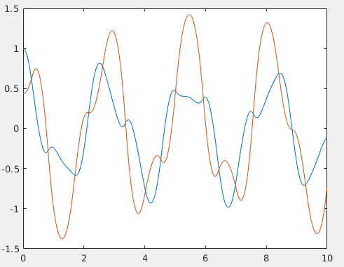 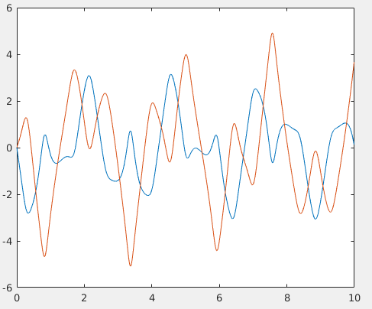 fig time vs. theta1 & theta 2 fig time vs. w1 &w2

h=0.01

|  |  |  |  |  |
| --- | --- | --- | --- | --- |
| Time | Theta 1 | Theta 2 | W1 | W2 |
|  | 0.9948 | 0.4363 | 0 | 0 |
|  | 0.9947999495 | 0.4363000221 | -0.0010091622 | 0.0004416838 |
|  | 0.9947997982 | 0.4363000883 | -0.0020183245 | 0.0008833678 |
|  | 0.9947995459 | 0.4363001988 | -0.0030274869 | 0.0013250522 |
|  | 0.9947991927 | 0.4363003533 | -0.0040366495 | 0.0017667372 |
|  | 0.9947987385 | 0.4363005521 | -0.0050458123 | 0.0022084229 |
|  | 0.9947981835 | 0.436300795 | -0.0060549753 | 0.0026501096 |
|  | 0.9947975276 | 0.4363010821 | -0.0070641387 | 0.0030917975 |
|  | 0.9947967707 | 0.4363014134 | -0.0080733025 | 0.0035334867 |
|  | 0.9947959129 | 0.4363017888 | -0.0090824668 | 0.0039751775 |
|  | 0.9947949542 | 0.4363022084 | -0.0100916315 | 0.00441687 |
|  | 0.9947938946 | 0.4363026722 | -0.0111007968 | 0.0048585644 |
|  | 0.994792734 | 0.4363031801 | -0.0121099627 | 0.005300261 |
|  | 0.9947914726 | 0.4363037323 | -0.0131191292 | 0.0057419599 |
|  | 0.9947901102 | 0.4363043285 | -0.0141282965 | 0.0061836613 |

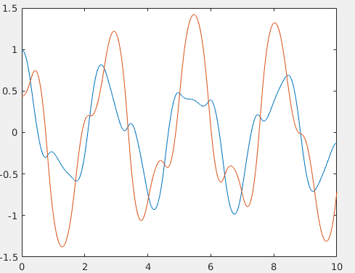 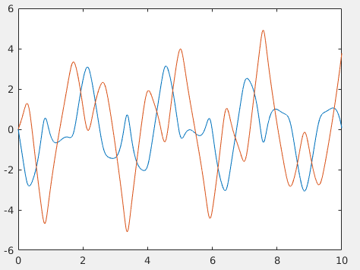

Euler’s:

clear all

k=100; % number of iterations

% declaration of variables

time=zeros(k,1);

theta1=zeros(k,1);

theta2=zeros(k,1);

w1=zeros(k,1);

w2=zeros(k,1);

x1=zeros(k,1);

x2=zeros(k,1);

y1=zeros(k,1);

y2=zeros(k,1);

% intial values

theta1(1)=0.9948; % 57 degree

theta2(1)=0.4363; % 25 degree

w1(1)=0; % pendulum released from rest

w2(1)=0;

% constants

g=9.80;

l1=1;

l2=1;

% geometry

x1(1)=l1*sin(theta1(1));

x2(1)=x1(1)+(l2*sin(theta2(1)));

y1(1)=-(l1*cos(theta1(1)));

y2(1)=y1(1)-(l2*cos(theta2(1)));

m1=0.1;

m2=0.1;

h=0.1;

% four single degree diff equation

F1=inline('w1','w1');

F2=inline('w2','w2');

F3=inline('((-g*((2*m1)+m2)*sin(theta1))-(m2*g*sin(theta1-2*theta2))-(2*sin(theta1-theta2)*m2*((w2)^2*l2 + (w1)^2*l1*cos(theta1-theta2))))/(l1*((2*m1)+m2-m2*(cos(2*theta1-2*theta2))))','theta1','theta2','w1','w2','g','m2','m1','l1','l2');

F4=inline('(2*sin(theta1-theta2)*((w1)^2*l1*(m1+m2)+g*(m1+m2)*cos(theta1)+(w2)^2*l2*m2*(cos(theta1-theta2))))/(l2*((2*m1)+m2-m2*cos(2*theta1-2*theta2)))','theta1','theta2','w1','w2','g','m1','m2','l1','l2');

n=99; % number of iterations

for j=1:1:n

theta1(j+1)=theta1(j)+(h*F1(w1(j)));

theta2(j+1)=theta2(j)+(h*F2(w2(j)));

w1(j+1) = w1(j)+(h*(F3(theta1(j),theta2(j),w1(j),w2(j),g,m1,m2,l1,l2)));

w2(j+1) = w2(j)+(h*(F4(theta1(j),theta2(j),w1(j),w2(j),g,m1,m2,l1,l2)));

x1(j+1)=l1*sin(theta1(j+1));

x2(j+1)=x1(j+1)+0(l2*sin(theta2(j+1)));

time(j+1)=time(j)+h;

y1(j+1)=-(l1*cos(theta1(j+1)));

y2(j+1)=y1(j+1)-(l2*cos(theta2(j+1)));

end

plot(time,theta1,time,theta2);

plot(time,w1,time,w2);

h=0.01

|  |  |  |  |  |
| --- | --- | --- | --- | --- |
| Time | Theta1 | Theta2 | W1 | W2 |
|  | 0.9948 | 0.4363 | 0 | 0 |
|  | 0.9948 | 0.4363 | -0.0010091622 | 0.0004416838 |
|  | 0.9947998991 | 0.4363000442 | -0.0020183245 | 0.0008833676 |
|  | 0.9947996973 | 0.4363001325 | -0.0030274868 | 0.0013250518 |
|  | 0.9947993945 | 0.436300265 | -0.0040366493 | 0.0017667364 |
|  | 0.9947989908 | 0.4363004417 | -0.0050458121 | 0.0022084217 |
|  | 0.9947984863 | 0.4363006625 | -0.006054975 | 0.0026501078 |
|  | 0.9947978808 | 0.4363009275 | -0.0070641383 | 0.003091795 |
|  | 0.9947971743 | 0.4363012367 | -0.008073302 | 0.0035334835 |
|  | 0.994796367 | 0.4363015901 | -0.0090824661 | 0.0039751734 |
|  | 0.9947954588 | 0.436301987 | -0.0100916307 | 0.0044168649 |
|  | 0.994794449 | 0.4363024293 | -0.0111007959 | 0.0048585583 |
|  | 0.994793339 | 0.4363029151 | -0.0121099616 | 0.0053002537 |
|  | 0.994792128 | 0.4363034451 | -0.013119128 | 0.0057419513 |
|  | 0.994790816 | 0.4363040193 | -0.0141282951 | 0.0061836513 |
|  |  |  |  |  |

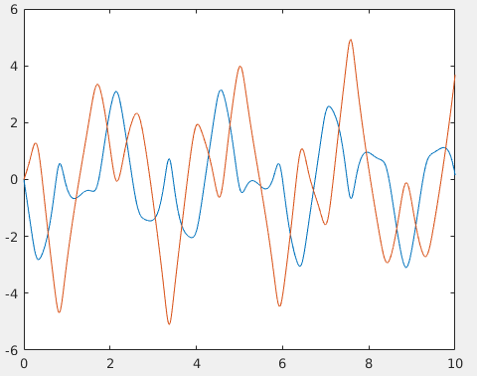 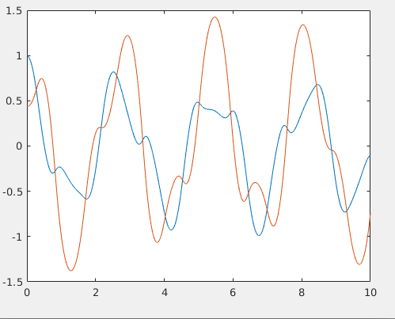

Fig time vs. w1 &w2 fig time vs. th1 &th2

h=0.1

|  |  |  |  |  |
| --- | --- | --- | --- | --- |
| Time | Theta 1 | Theta 2 | W1 | W2 |
|  | 0.9948 | 0.4363 |  |  |
|  | 0.9948 | 0.4363 | -1.009162212 | 0.4416837632 |
|  | 0.893883778 | 0.480468376 | -2.062128396 | 0.9744824836 |
|  | 0.6876709392 | 0.5779166247 | -3.188051748 | 1.72343526 |
|  | 0.3688657643 | 0.7502601507 | -4.033060261 | 2.139331793 |
|  | -0.034440261 | 0.96419333 | -3.465873115 | 0.339277365 |
|  | -0.3810275733 | 0.9981210665 | -2.844874834 | -1.812031107 |

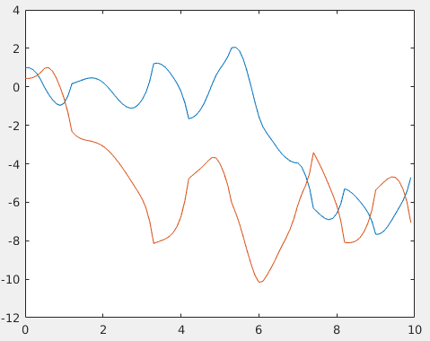 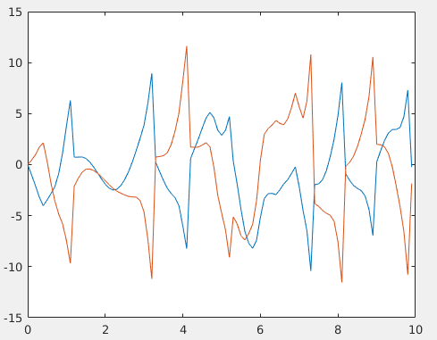

Fig time vs. th1 &th2 fig time vs. w1 &w2

Modified Eulers:

clear all

k=100000;

time=zeros(k,1);

theta1=zeros(k,1);

theta2=zeros(k,1);

% declaration

w1=zeros(k,1);

w2=zeros(k,1);

x1=zeros(k,1);

x2=zeros(k,1);

y1=zeros(k,1);

y2=zeros(k,1);

% initial values

theta1(1)=0.9948; % 57 degree

theta2(1)=0.4363; % 25 degree

% constants

l1=1;

l2=1;

g=9.80;

m1=0.1;

m2=0.1;

% equations obtained from geometry

x1(1)=l1*sin(theta1(1));

x2(1)=x1(1)+(l2*sin(theta2(1)));

y1(1)=-(l1*cos(theta1(1)));

y2(1)=y1(1)-(l2*cos(theta2(1)));

% stepsize

h=0.0001;

% 4 single degree diff equations

F1=inline('w1','w1');

F2=inline('w2','w2');

F3=inline('((-g*((2*m1)+m2)*sin(theta1))-(m2*g*sin(theta1-2*theta2))-(2*sin(theta1-theta2)*m2*((w2)^2*l2 + (w1)^2*l1*cos(theta1-theta2))))/(l1*((2*m1)+m2-m2*(cos(2*theta1-2*theta2))))','theta1','theta2','w1','w2','g','m2','m1','l1','l2');

F4=inline('(2*sin(theta1-theta2)*((w1)^2*l1*(m1+m2)+g*(m1+m2)*cos(theta1)+(w2)^2*l2*m2*(cos(theta1-theta2))))/(l2*((2*m1)+m2-m2*cos(2*theta1-2*theta2)))','theta1','theta2','w1','w2','g','m1','m2','l1','l2');

n=99999;

for j=1:1:n

% predictions

theta1_pred=theta1(j)+h*F1(w1(j));

theta2_pred=theta2(j)+h*F2(w2(j));

w1_pred= w1(j)+(h*(F3(theta1(j),theta2(j),w1(j),w2(j),g,m1,m2,l1,l2)));

w2_pred= w2(j)+(h*(F4(theta1(j),theta2(j),w1(j),w2(j),g,m1,m2,l1,l2)));

% corrected values

theta1(j+1)=theta1(j)+(h/2)*(F1(w1(j))+F1(w1_pred));

theta2(j+1)=theta2(j)+(h/2)*(F2(w2(j))+F2(w2_pred));

w1(j+1)= w1(j)+(h/2)*(F3(theta1(j),theta2(j),w1(j),w2(j),g,m1,m2,l1,l2)+F3(theta1_pred,theta2_pred,w1_pred,w2_pred,g,m1,m2,l1,l2));

w2(j+1)= w2(j)+(h/2)*(F4(theta1(j),theta2(j),w1(j),w2(j),g,m1,m2,l1,l2)+F4(theta1_pred,theta2_pred,w1_pred,w2_pred,g,m1,m2,l1,l2));

x1(j+1)=l1*sin(theta1(j+1));

x2(j+1)=x1(j+1)+(l2*sin(theta2(j+1)));

time(j+1)=time(j)+h;

y1(j+1)=-(l1*cos(theta1(j+1)));

y2(j+1)=y1(j+1)-(l2*cos(theta2(j+1)));

end

% plotting graphs

plot(time,theta1,time,theta2);

plot(time,w1,time,w2);

h=0.001

|  |  |  |  |  |
| --- | --- | --- | --- | --- |
| Time | Theta1 | Theta2 | W1 | W2 |
|  | 0.9948 | 0.4363 | 0 | 0 |
|  | 0.994799949 | 0.4363000221 | -0.0010091622 | 0.0004416838 |
|  | 0.994799798 | 0.4363000883 | -0.0020183245 | 0.0008833678 |
|  | 0.994799545 | 0.4363001988 | -0.0030274869 | 0.0013250522 |
|  | 0.994799192 | 0.4363003533 | -0.0040366495 | 0.0017667372 |
|  | 0.994798738 | 0.4363005521 | -0.0050458123 | 0.0022084229 |
|  | 0.994798185 | 0.436300795 | -0.0060549753 | 0.0026501096 |
|  | 0.994797527 | 0.4363010821 | -0.0070641387 | 0.0030917975 |
|  | 0.9947967707 | 0.436301413 | -0.0080733025 | 0.0035334867 |
|  | 0.9947959129 | 0.4363017888 | -0.0090824668 | 0.0039751775 |
|  | 0.9947949545 | 0.4363022084 | -0.0100916315 | 0.00441687 |
|  | 0.9947938946 | 0.4363026722 | -0.0111007966 | 0.0048585643 |
|  | 0.994792734 | 0.436303180 | -0.0121099625 | 0.0053002608 |
|  | 0.994791472 | 0.4363037323 | -0.013119129 | 0.0057419597 |
|  | 0.994790110 | 0.4363043285 | -0.0141282963 | 0.0061836611 |

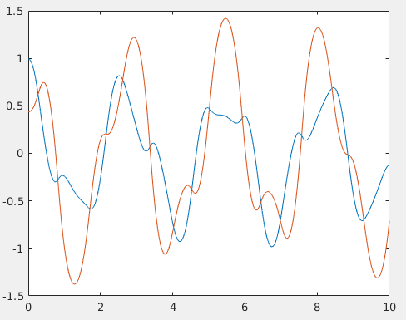 

h=0.1

|  |  |  |  |  |
| --- | --- | --- | --- | --- |
| Time | Theta1 | Theta2 | W1 | W1 |
|  | 0.9948 | 0.4363 | 0 | 0 |
|  | 0.944341889 | 0.458384188 | -1.031064198 | 0.4872412418 |
|  | 0.789543373 | 0.5336160472 | -2.079583322 | 1.086463645 |
|  | 0.5324716689 | 0.6703260497 | -2.778735609 | 1.252796708 |
|  | 0.241578251 | 0.772755941 | -2.692865346 | 0.2512504577 |
|  | -0.010165233 | 0.7301814651 | -2.227598296 | -1.174628953 |
|  | -0.2039680279 | 0.5419221543 | 1.469034621 | -2.577133997 |

 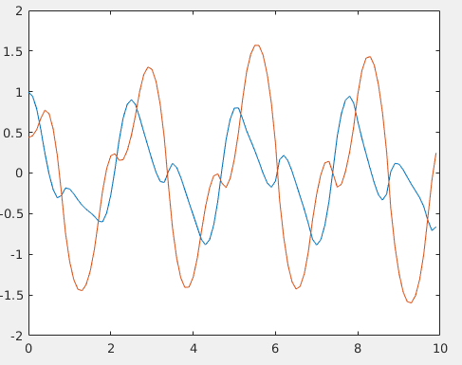

Fig time vs. w1 &w2 fig time vs. th1 &th2

Analytical Solution:

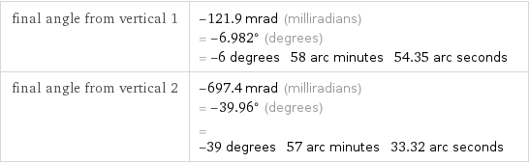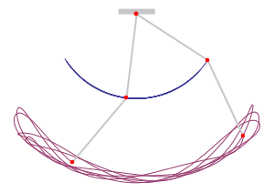 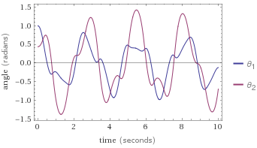

References:

# file:///C:/Users/S/Downloads/graphics.pdf

# <https://www.myphysicslab.com/pendulum/double-pendulum-en.html>

# <https://m.wolframalpha.com/input/?i=double+pendulum&lk=3>