Stock Market Prediction

Stock Market is the essential part of the industrial world. It is the key factor for the growth of public sector company.

Old Beliefs on trends of stock market
Efficient(belief 1):”Markets are efficient and unpredictable :today’s information is already reflected in price. No stock is a better buy then the other.”
Random Walk(belief 2):”Patterns of stock market are purely random. Markets are unpredictable because they are random . Playing market is a gamble!!”

“Markets are neither totally efficient, nor totally random. They are complex and chaotic.”

Consideration: The hypothesis function h() [i.e closing price] only depends on integral date on which price has to be predicted.
Machine Learning

Linear Regression

Parameters:Integral Date, Daily closing price
~ In linear regression the function of closing price is a linear function of integral date.
Training set: Closing Share prices of TATA STEEL Inc. From 1/01/2016 to 30/06/2016.
Test set: Closing Share prices of TATA STEEL Inc. From 1/07/2016 to 31/12/2016.
Integral Date: Starting from 1/01/2016 to 31/12/2016 the date is initiated with integer 1 and than it is consecutively increased by 1.
(note: saturday and sunday are neglected as on those days stock market is closed.)

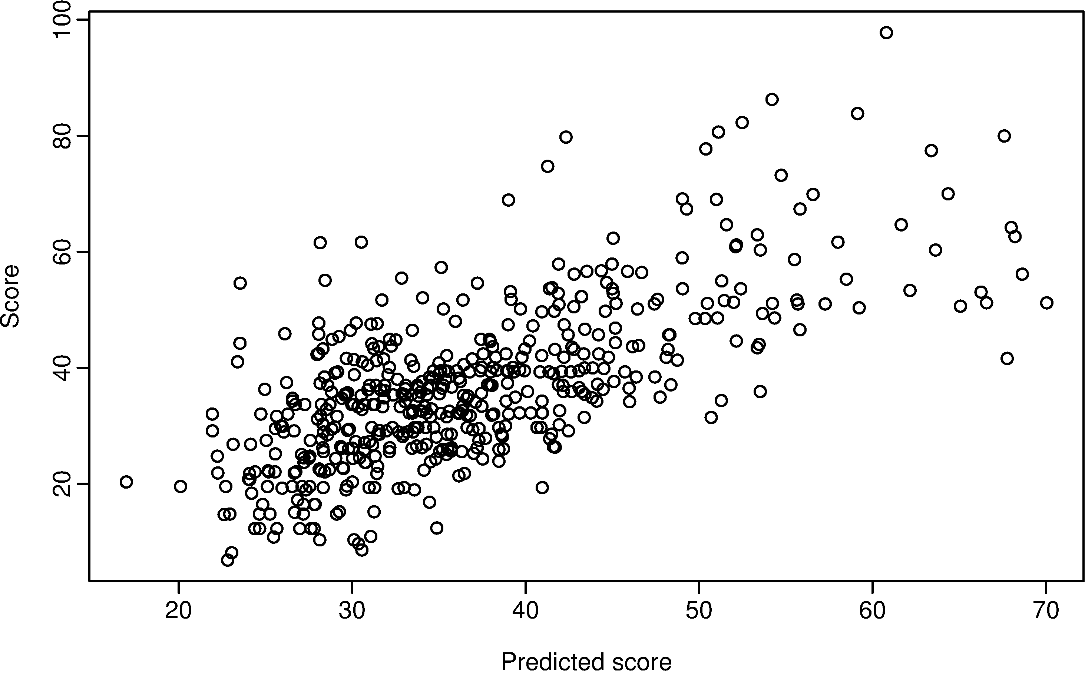

This graph gives the rough idea about what our training set looks like.

Concept:
Linear regression in 2 variable.
Equation: y=mx+c
It is the equation of the straight line in 2 Dimensions.
Here in this case y= Daily closing price in Rs.
x=Integral Date
Equivalent equation:
h_{Θ}(x)=Θ₀+Θ₁x

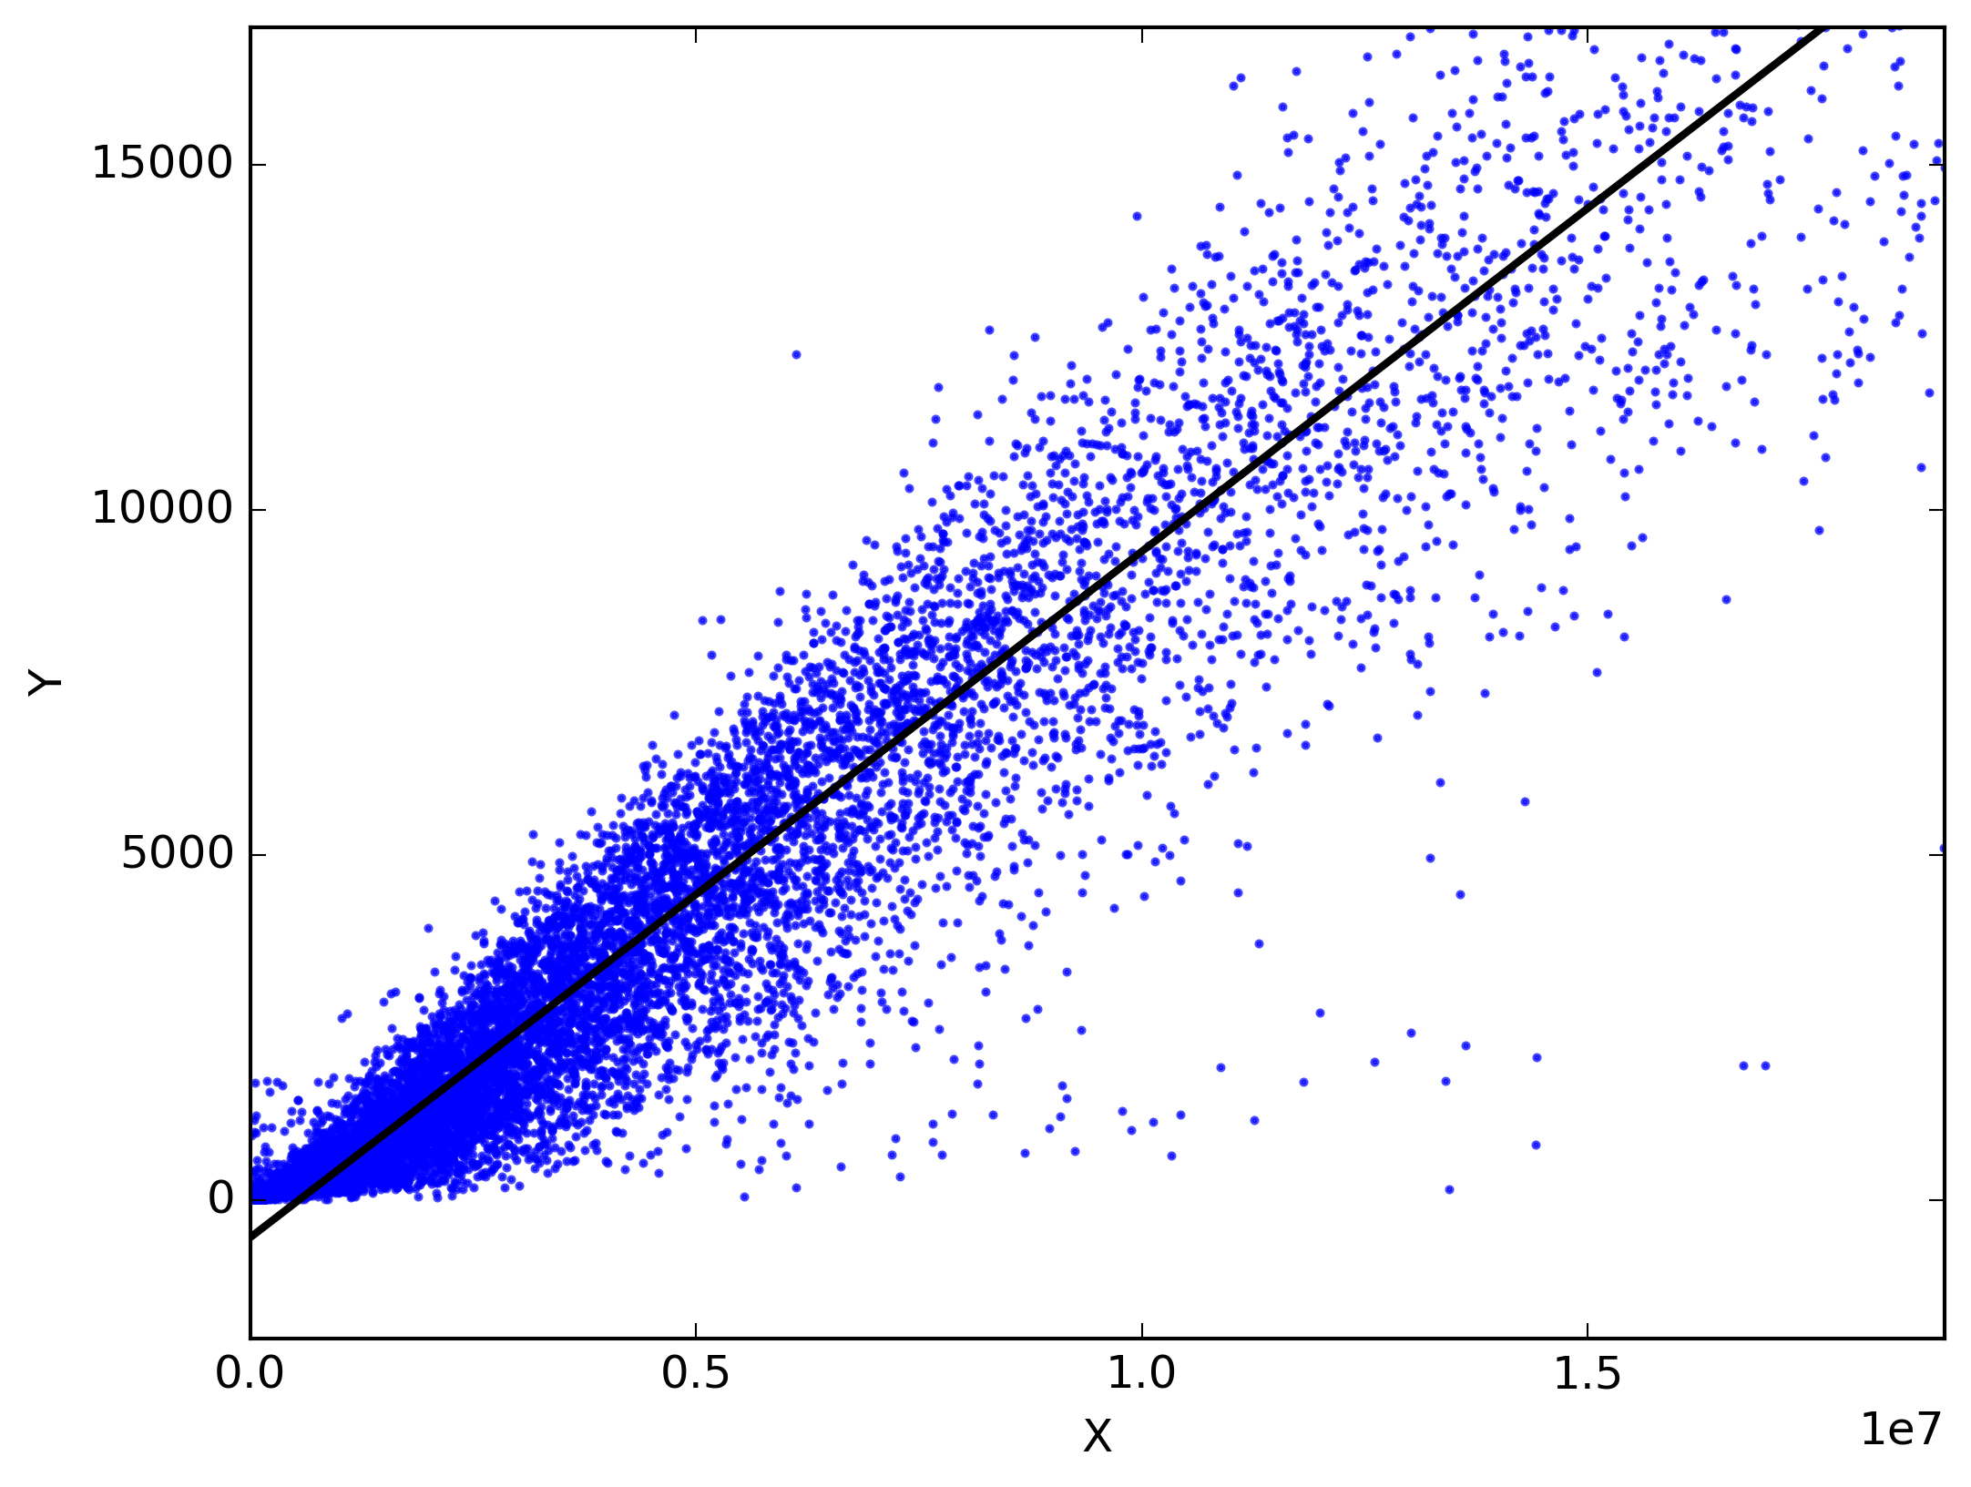
Notation: (x,y) – training example
(x^{(i)},y^{(j)})-ith training example

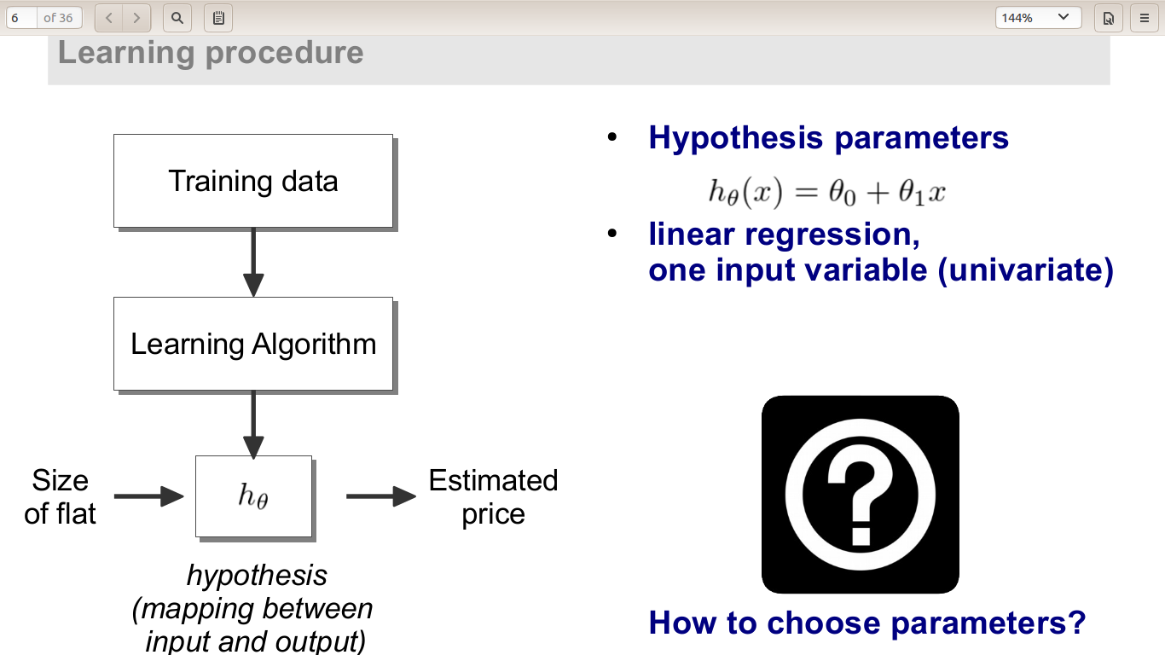

For maximum accuracy the linear curve(straight line) must be nearest to the training set points. For this we must minimize the summation of distance between the line and the traiding set points.

Cost function J
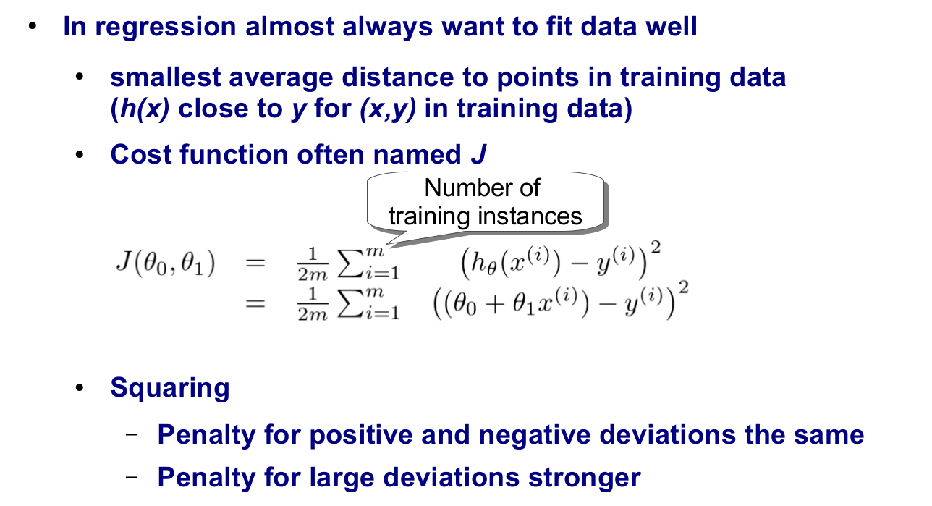
Tasks: To minimize this cost function J

Gradient Descent
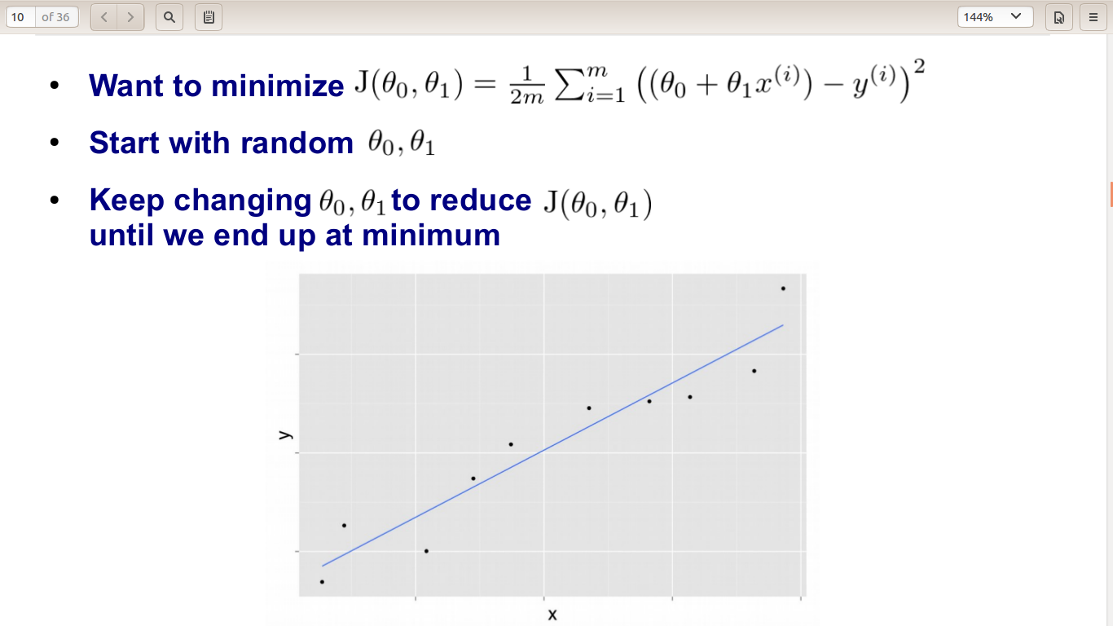
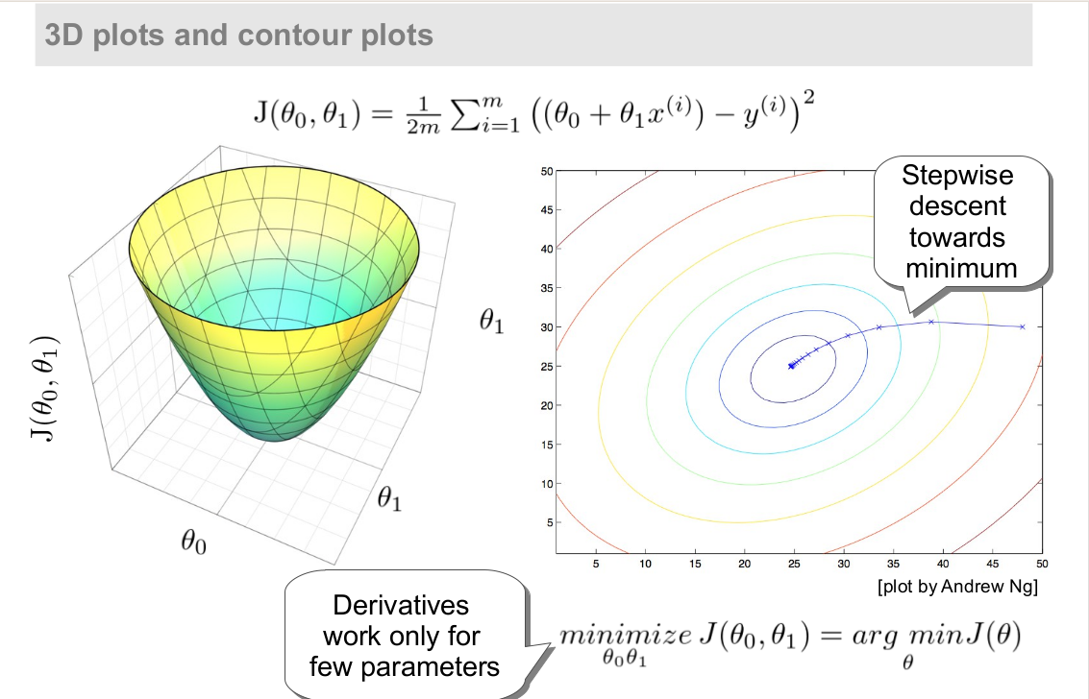

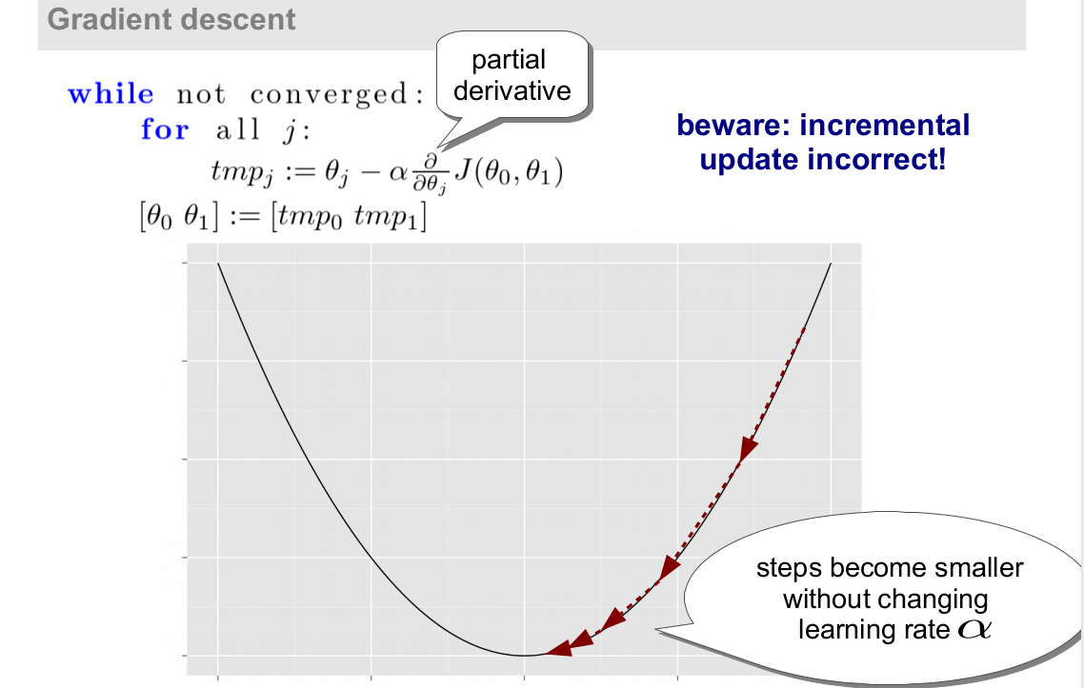

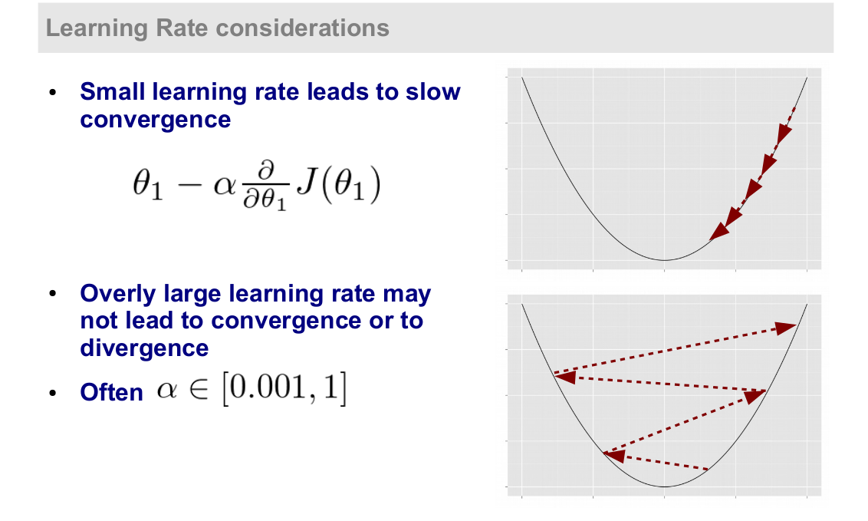

Problem in consideration:
- We considered linear relation between date integer and closing price.
- According to this consideration the stock market must increase monotonically or decrease monotonically.
- But in accordance to historical data, the monotonic behaviour of stocks is not observed. Instead, it’s behaviour is increasing at some instance of time and decreasing at another instance of time(day).
- Thus, it would be improper to apply linear regression while taking date integer and closing price as the parameters.

Solution:
- It is observed that the hybrid_closing_price=closing_price*date_integer is always increasing while Date is increasing.
- Thus, we will replace closing_price with hybrid_closing_price and date_integer will remain as it is.

