**Computer Vision assignment 1**

Adir Eliza 308124890  
Oran Ridel

1. For Projective $H=\left[\begin{matrix}a & b & c \\ d & e & f \\ g & h & i\end{matrix}\right]$ to be found, we need to find 8 parameters (because of the in variation to multiplication). Therefore 4 points are needed to solve it: $$x_{1}↔x_{1}^{'} \\ x_{2}↔x_{2}^{'} \\ x_{3}↔x_{3}^{'} \\ x_{4}↔x_{4}^{'}$$ 
For each set of points $x_{i}$ and $x_{i}^{'}$, we have $x_{i}^{'}=Hx_{i}$, Where $x_{i}=\left(\begin{matrix}v_{i} \\ u_{i}\end{matrix}\right), x_{i}^{'}=\left(\begin{matrix}v_{i}^{'} \\ u_{i}^{'}\end{matrix}\right)$. We get: $$\left\{\begin{aligned}\frac{u_{i}^{'}}{1}=\frac{H_{2}x_{i}}{H_{3}x_{i}} \\ \frac{v_{i}^{'}}{1}=\frac{H_{1}x_{i}}{H_{3}x_{i}}\end{aligned}→\left\{\begin{aligned}u_{i}^{'}H_{3}x_{i}-H_{2}x_{i}=0 \\ v_{i}^{'}H_{3}x_{i}-H_{1}x_{i}=0\end{aligned}\right.\right.$$ 
These are the 2 constrains we have from one pair of points. If we write it as a system of equations, we get: $$\left[\begin{matrix}x_{1}^{T} & 0 & -v_{1}^{'}x_{1}^{T} \\ 0 & x_{1}^{T} & -u_{1}^{'}x_{1}^{T} \\ x_{2}^{T} & 0 & -v_{2}^{'}x_{2}^{T} \\ 0 & x_{2}^{T} & -u_{2}^{'}x_{2}^{T} \\ ⋮ & ⋮ & ⋮\end{matrix}\right]\left[\begin{matrix}H_{1}^{T} \\ H_{2}^{T} \\ H_{3}^{T}\end{matrix}\right]=0$$ 
(where $H_{i}$ is the i-th row of H).

3. These are the coefficients for Naive Homography:  
 [[ 1.12313764e-03 1.64757802e-04 -9.99919579e-01]

[ 1.05119761e-05 1.05462486e-03 -1.25626989e-02]

[ 2.96941051e-07 4.35711334e-08 7.82906877e-04]]

4. The image we got for the slow forward mapping:  
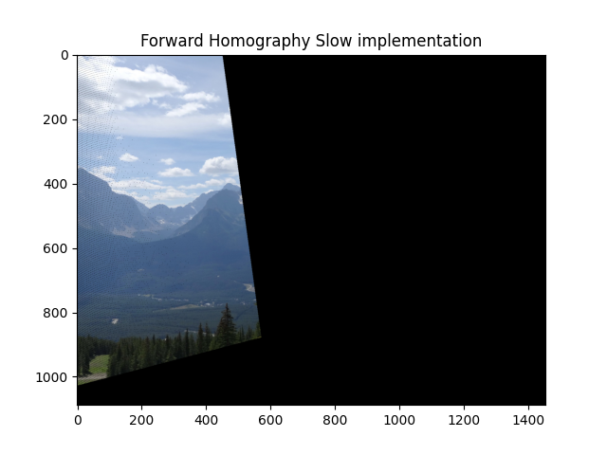

5. The image we got for the fast forward mapping:  
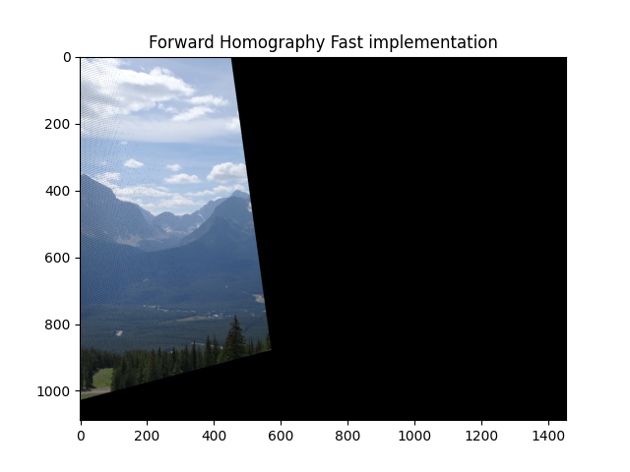

6. The problem is that the new pixel coordinates after multiplication with the Homography matrix will not always gives us an integer, therefore there might be a problem with the exact location we suppose to assign the pixel in the new image, also this can cause a problem when while rounding the float number to get an integer we can get that two pixels will be assigned to the same coordinate in the new image and will override one another.

7.   
As can seen above, we got a result for the second matches.mat matrix which contains mismatching points. We got that these points affected the final result because the Homography matrix was computed with false data and therefore gave us wrong results. This resulted in weird orientation and shape of the translated photos.