Network Security Risk Assessment Report
Detailed GRC Analysis (TryHackMe Lab)

Name: Oratilwe Valerie Masango
Date: 22 April 2026

Executive Summary
This report presents a comprehensive network security assessment conducted within a simulated environment. The objective was to identify exposed services, evaluate associated risks, and provide mitigation strategies aligned with ISO/IEC 27001 standards. The assessment revealed several critical vulnerabilities, particularly the exposure of Remote Desktop Protocol (RDP), which could allow unauthorized access and system compromise. Additional risks include insecure FTP services, web server exposure, and RPC vulnerabilities. Immediate remediation is recommended to reduce the attack surface and strengthen the organization’s security posture.

Scope
This assessment focused on a single target machine within a controlled lab environment. The evaluation included network scanning, service identification, and risk analysis of exposed services. No active exploitation was performed. The goal was strictly to assess risk exposure and recommend controls.

Methodology
The assessment was conducted using Nmap for network scanning and service enumeration. A TCP SYN scan (-sS) was used to identify open ports, while version detection (-sV) determined service details. Findings were analyzed using a risk-based approach considering likelihood and potential impact.

Evidence
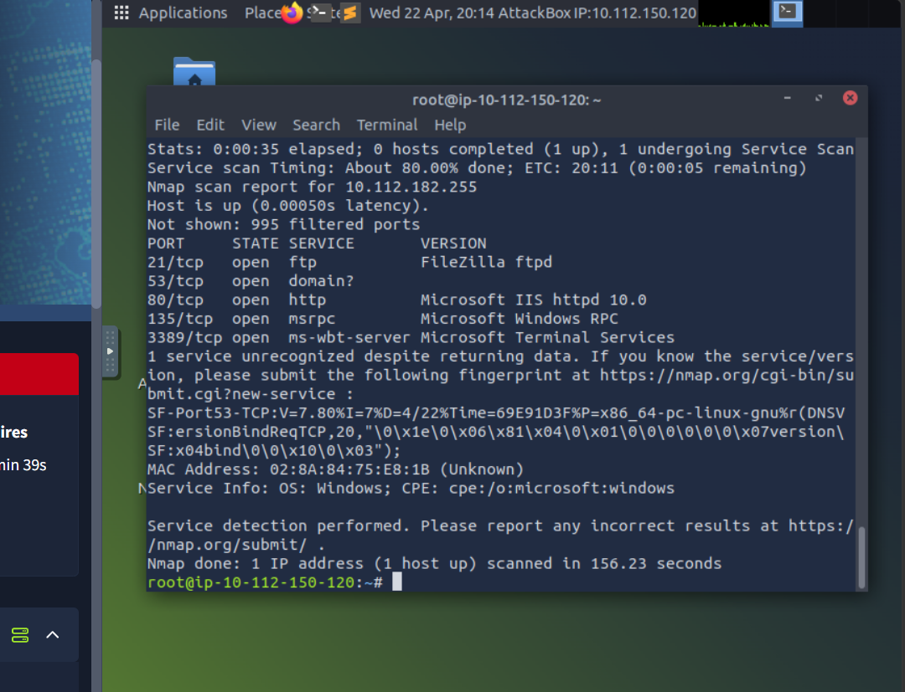

Findings
ID | Finding | Description | Risk Level
F1 | FTP Service (Port 21) | Unsecured file transfer service exposed to network | High
F2 | DNS Service (Port 53) | Potential information leakage through DNS queries | Medium
F3 | Web Server (Port 80) | Microsoft IIS server exposed to potential web attacks | Medium
F4 | RPC Service (Port 135) | Windows RPC exposure may allow exploitation | High
F5 | RDP (Port 3389) | Remote access service exposed, high risk of brute-force attacks | Critical

Risk Analysis
The most critical risk identified is the exposure of RDP services, which are frequently targeted by attackers using brute-force techniques. Successful exploitation could result in full system compromise. FTP services also present a high risk due to potential weak authentication mechanisms and lack of encryption. RPC exposure increases the attack surface for privilege escalation, while web and DNS services provide opportunities for reconnaissance and exploitation.

Risk Rating
Finding | Likelihood | Impact
FTP | Medium | High
DNS | Medium | Medium
HTTP | Medium | Medium
RPC | High | High
RDP | High | Critical

Recommendations
To mitigate identified risks, it is recommended to disable or secure FTP services, restrict RDP access using VPN or IP filtering, apply regular patching to systems, implement firewall controls, and enforce multi-factor authentication for remote access.

ISO 27001 Control Mapping
Finding | Control | Description
FTP | A.9 | Access Control
DNS | A.13 | Network Security
HTTP | A.14 | Secure Development
RPC | A.12 | Operations Security
RDP | A.9 | Access Control

Conclusion
This assessment demonstrates the importance of identifying and mitigating exposed services. By implementing recommended controls aligned with ISO 27001, organizations can significantly reduce security risks and improve resilience against cyber threats.

